432 AND ABOVE EME NEWS
OCTOBER 2020 VOL 49 #10

EDITOR: AL KATZ, K2UYH; DEPT. ELECTRICAL/COMPUTER ENGINEERING, THE COLLEGE OF NEW JERSEY, PO BOX 7718 EWING, NJ 08628, TEL (W 609-584-8424), (C 609-947-3889), E-MAIL alkatz(x)tcnj.edu
ASSOCIATE EDITOR AND Reflector/NETNEWS Matej Petrzilka, OK1TEH, Simunkova 1609/21, 18200, Praha 8, Czech Republic, TEL (+420 603 489 490), E-MAIL ok1teh(x)seznam.cz
CW INITIAL LIST G4RGK, DAVID DIBLEY, E-MAIL zen70432(x)zen.co.uk, AT: http://www.zen70432.zen.co.uk/Initials/index.html
SUN & EXTRATERRESTRIAL NOISE LIST MANAGED BY OK1TEH: http://www.ok2kkw.com/next/nl_k2uyh/sun_table.xls
EME INFORMAL NETS: 14.345, ~1500 SATURDAY AND SUNDAY, NET COORDINATOR: OPEN
ON0EME EME BEACON, 1296.000 IS QRV WHEN MOON >10°, SEND RX REPORTS TO WALTER (ON4BCB) on4bcb(x)gmail.com
DL0SHF 3 & 1.2 CM EME BEACONs, 10368.025, 24 TBD, SEND INFO & QUESTIONS TO Per (DK7LJ) per(x)per-dudek.de.
NL EMAIL DISTRIBUTION and EMAIL LIST CORD: WARREN, W2WD wbutler(x)ieee.org
THE NL WEB VERSION IS PRODUCED BY REIN, W6SZ rein0zn(x)gmail.com, AT: http://www.nitehawk.com/rasmit/em70cm.html

CONDITIONS: Autumn is the traditional start of EME Contest season. This Sept is no exception with both the ARRL Microwave (MW) and the ARI EME Autumn Trophy EME Contests. Although activity during the MW Contest seemed down from the past with many big scorers absent, the totals are actually higher this year. G3LTF reports 40x25 all on CW significantly up from last, while OK1CA reported 49 QSOs with mixed mode. 13 cm activity was again down, but 3 cm up. The ARI Contest seemed very active despite a low declination (dec) and uncooperative Faraday on 70 cm that locked out signals for long periods. There were also complains of low North American (NA) activity. OK1CA has the highest score reported by far with operation on 23 and 3 cm for a total of 58 QSOs. Coming up is the 1st ARRL 50 thru 1296 EME Contest weekend on 10/11 Oct. You don’t want to miss it as it generates the most EME activity of the year. Please don’t be shy to try for even few contacts with your tropo setup on the horizon. Because of COVID there is almost no dxpeditions new. KB7Q is putting Nevada on 222 EME on 13/14 Oct – See Gene’s report in this newsletter (NL). The ON0EME beacon is temporarily off the air – see report in this NL. It should be QRV in time for the ARRL Contest.

REPORTS

4X1AJ: Andy andybezh(x)hotmail.com sends some very unpleasant news on the end of 9 cm and 1296 activity from Israel -- Recently our Ministry of Communication announced that we had lost the 9 cm band and that the 23 cm band is limited to (1260- 1270) satellite links with no access to the EME window (1296). Power was also limited to 25 W and satellite communication using only Hebrew. We can operate on 70cm and the EU 13 cm (2320) EME band. I accepted this challenge; and now have a very strong reason to get 10 GHz and above. The 1st country to lose the 23 cm band was Ukraine over 10 years ago. I could move my TX down to 1260-1270 and try cross-band EME if it won't interfere to AMSAT. A better solution may be to have AMSAT try to reserve a part of the band near 1296 for satellite use.

DB6NT: Michael db6nt(x)gmx.de had a big signal in the ARRL MW Contest – I worked using CW on 13 cm DF3RU, RA3EME, G3LTF, UA3PTW, OM1TF, SP7DCS, SP3XBO, SA6BUN, G4CCH, WA9FWD and G3LTF (on SSB) for a total of 10x7; on 6 cm OK1CA, G3LTF, SP6JLW, SM6FHZ,
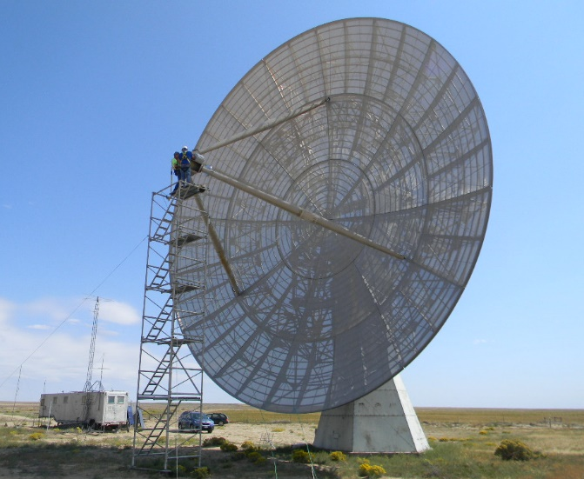
K0PRT 60’ dish to be QRV on 1296 during Oct ARRL Contest weekend - see their report

RA3EME and UA3PTW for a total of 6x5; on 3 cm W3SZ, OH2DG, 9A5AA and UA4AAV for a total of 4x4; and on 1.25 cm OK1KIR for 1x1; and an overall total of 22x17. The day before the contest I had a QSO with DK7LJ on 24 GHz. He had the strongest signal I had ever heard on 1.25 cm (569). I could also hear his SSB signal – Per SUPER congratulations!

DJ3JJ: Andreas dj3jj(x)gmx.net reports on his ARI Contest activity and PA status – I worked using CW on Saturday 19 Oct at 1330 I1NDP (579/559), 1338 OK1CA (579/559), 1349 IK3MAC (569/519), 1522 DL0SHF (579/449) and 1704 DG5CST (569/579), and on Sunday 20 Oct with some blockage at 1219 PI9CAM (559/549), 1303 OE5JFL (559/559), 1413 LZ2US (559/549) and 1443 IZ1BPN (559/519). I worked 9 stations with 3 Italian stations as multi for a total of 216 points. I will be QRV again in the ARRL EME Contest. I am working on repairing my 2nd 250 W PA module. There is a wide spread in the gains of the Chinese replacement FETs that I purchased. I have only tested 3 of the 10 that I brought; but only 1 of these is giving 18 W out with 0.5 W in. The 2 others are only delivering about 5 W at 0.5 W in. In total I only get 180 W out at 3 W in instead of the 250 W from the other module. I am hoping one of the 7 others will give the same gain as the 1st good one.

DK3WG: Jurg dk3wg(x)web.de seems to almost always QRV – During Sept I added initials using JT65B with LU1CGB and WD6Y. [See http://dk3wg.darc.de/manager for more info on Jurg’s station and the services he provides].

DL0SHF: Christoph (DF9CY) df9cy(x)web.de is active again via remote on both 1296 and 24 GHz after some very complex heart surgery – I am doing well now. As I have a lot of free time, I have done a new setup for my computer and all the software I need for remote operation. Per (DK7LJ) has done similar on his side. Nevertheless, the data rates are somewhat lower than desired from time to time. I worked on 12 Sept, on 23 cm UA9FAD (JT65C); on 13 Sept, on 23 cm SM4GGC (CW), SM5DGX (CW), N1AV (JT65C), N5BF (JT65C) and ON4QQ (JT65), and on 1.25 cm (remote operation is now possible using a 3.7 m precision dish producing echoes that are strong, but signals sound like 2 m aurora due to the spreading) OK1KIR (CW), IK2RTI (CW) and OK1KIR (JT4F) - (Per also made some 24 GHz contacts); on 19 Sept, on 23 cm during the ARI Contest, DL3EBJ (CW), SP6ITF (CW), DJ3JJ (CW), F6ETI (CW), F5KUG (CW), IK1FJI (CW), AA4MD (CW), PE1LWT (CW), IK3MAC (CW), IK2MMB (CW), I5YDI (CW), LZ2US (CW) and SM5DGX; on 20 Sept IK3COJ (CW), I5MPK (CW), DF2GB (CW), LZ1DX (CW), PI9CAM (CW), G3LTF (CW), DG5CST (CW), IZ1BPN (CW) and DF2VJ (CW). I stopped operation around 1400 due to the very bad data rate, which made receiving almost impossible. We ended with 22 QSOs. For the ARRL Contest I plan to be on as well for as long as time allows in both parts.

DL7APV: Bernd dl7apv(x)gmx.de reports lots of 432 activity in Sept on both tropo and EME – Off the Moon, a few new one (#) found their way into my log. I added DM9EE in JO41 with 8 x 11 el yagis and 75 W (750 W soon), PR8KW in GI77 with 9 el X-quad and 50 W, F1RAD in JN35 with single 21 el yagi and 75 W, LX/PA3CMC and LX/PA3FYC (counted as one initial), OH5BM in KP41 with two 15 el yagis and 300 W and EI2FG in IO61 with single 12 el yagi and 250 W. In the ARI Contest I made 32 QSOs, but worked no I stations. After 35 years I have replaced my Drake TR7, which I use in front of my DB6NT TR432 transverter with K3. I am looking forward to ARRL EME Contest and hope to see lots of new and old friends.

F2CT: Guy f2ct(x)wanadoo.fr was active on 13 cm both during the ARRL MW and ARI EME Contests – In the ARRL, I worked using CW G3LTF (559/559), G4CCH (559/559), RA3EME (559/559), UA3PTW (559/559), (569/569), UA3TCF (559/559), DL7YC (569/559), SP3XBO (559/549), OH1LRY (569/559), HB9Q (589/559), OH2DG (569/559), SP6OPN (569/579) and PA0PLY (559/559) for a total of 12x7. In the ARI also using only CW, I worked DF3RU (559/559), SP3XBO (559/549), IK3COJ (559/559) and PA0PLY (559/559) for 4 QSOs. The activity level seemed low on CW! I will be QRZ on 1296 during the next two ARRL Contest weekends.

F5KUG: Jean- Louis F6ABX f6abx(x)wanadoo.fr sends news on his group’s activity on 1296 during the ARI Contest and their new 700 W SSPA – Our contest group used a 3 m TVRO dish. Our power has been increased by + 3 dB to 700 W and we added a choke made from a pancake as described by KL6M to our septum feed. Despite these efforts, we QSO’d only 15 stations (all from EU) in 5 hours of trying. We hope to do better in the ARRL Contest! Our new PA is the result of combining two Freescale/NPX demo/test modules. The LDMOS devices in these modules are in plastic packages and operate from a 50 V drain supply. Each is able to provide 350/400 W. We use a 20/30 W driver with an MRF9045. It drives the LDMOS modules thru a 3 dB wireline coupler. The modules’ outputs are coupled by a high power DJ9BV coupler. This may not be the most up to date technology but was by far the easiest way for us to achieve 700 W of power. We are waiting for the LDMOS to reach 100 V - HI. [That may be a while]. The success of our new SSPA is the result of F5BUU efforts who deserves credit for the mechanical and high frequency constructions. [TNX to G3LTF for forwarding this report].

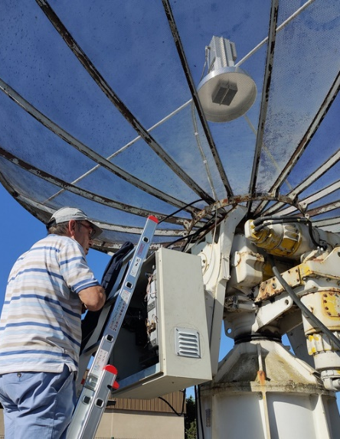
F5KUG’s 3 m dish with their new scaler ring and SSPA in box on left, and SSPA with couplers shown on right

G3LTF: Peter’s g3ltf(x)btinternet.com EME report for Sept follows -- The pattern of activity in the ARRL MW Contest is changing. This year, I decided to start at 0000 on 12 Sept on 6 cm. All QSOs were made on CW. I worked SP6JLW, JA4BLC, OK1CA, G4CCH, DL7YC, RA3EME for initial #90, SM6FHZ and OH2DG. I QRT’d at 0300, and started again at 0800 adding DB6NT, UA3PTW, SM6PGP and G4NNS. I called IK2RTI twice, but we lost each other. I changed to 13 cm at 1130 and worked UA3PTW, OH2DG, SP3XBO, OK1CA, OH1LRY, SM2CEW, PA0PLY and VE6BGT. At moonrise on 13 Oct still on 13 cm, I added RA3EME for initial #151, SP6OPN, JJ1NNJ, F2CT, G4CCH, DL7YC, DL4DTU, OM1TF, JA6AHB, DF3RU, SP7DCS, DB6NT, IK3COJ, PE1LWT, UA3TCF, SA6BUN, WA9FWD, WA6PY, and KL6M. I did not try 9 cm as looking at the HB9Q logger on several occasions, it appeared there was no activity apart from KD3UY, who I can’t work on CW. A bit strange for an ARRL Contest when the USA is trying desperately to hold on to this allocation. Scores were on 6 cm13x8 and on 13 cm 27x17 for a total of 40x25. There was increased activity on these two bands, but several regulars were missing. On 14 Sept, I was on 23 cm and worked LA3EQ, and on the 15 Sept SP6ITF. I was active in the ARI Trophy Contest on 23 cm and 70 cm. I started on 23 cm on 19 Sept and worked SM5DGX, DL3EBJ, IK3COJ, DF2GB, OH2DG, OK1CA, IK1FJI, F6ETI, SP6ITF, IK3MAC, UA6AH for initial #497, DL7UDA and I5MPK. Heard were PE1LWT and DK5AI. At 1200 I switched to 70 cm and worked LX1DB (on both CW and SSB), G0JLO, PA2V, PA3DZL, DL9KR and DL8DAU. Faraday was 90 degrees and conditions were very average. I stayed on 70 cm until my moonset, but found no NA activity. On 16 Sept, the Moon was very low; at my minimum declination and partially in the trees, but I managed to get 4 hours of operation working on 23 cm IK5VLS, LZ1DX, LZ2US, DG5CST, P19CAM, DL0SHF, IZ1BPN, OK1KIR, LA3EQ, SP7DCS, F6CGJ, SP2HMR, OK1IL and SVICAL. Heard was OM4XA. It was good to work 6 Italian stations in their contest. I end with on 23 cm 27 QSOs and on 70 cm 6 QSOs – all on CW. Since the Moon came back into N declination, the WX has been awful with strong winds and rain, but it looks more hopeful for the next ARRL leg. Let’s hope for a bit more NA CW activity on 23 and 70 cm.

G4NNS: Brian brian(x)brcg4nns.org writes on his progress on the MW bands -- With our COVID-19 lock-down, I managed to complete the rebuild of my 9 and 6 cm systems, which had been reconfigured for use with the 32 m antenna at Goonhilly for the last couple of years. Sadly, this dish is no longer available, so it's back to my 3.7 m dish. The new units fit onto the focus trolley and can be swapped quite quickly. For 9 and 6 cm the dish is prime focus and both feed horns use a dual mode septum feed. On 3 and 1.2 cm a sub reflector is fitted to the focus trolley and the dish becomes a Cassegrain system.

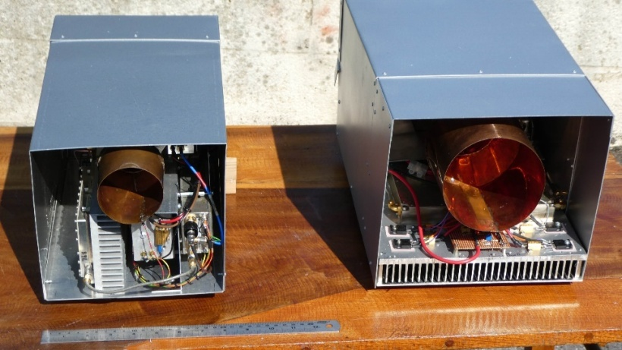
G4NNS’ 6 cm feed box is on the left and 9 cm is on right with SSPAs

The ARRL MW EME Contest provided a good opportunity to test the rebuilds. I worked using CW on 12 Sept, on 9 cm SP6OPN, SP2XBO for initial #31, DF3RU #32 and SM3BYA #33; and on 13 Sept on 6 cm RA3EME, G3LTF, OK1CA, SM6FHZ, G3CCH, SM6CKU and K2UYH for a score of 4x3 on 9 cm and 7x4 on 6 cm and a total of 11x7. For the ARI Contest on 20 Oct the sub reflector was fitted along with the 3 cm transverter to work using CW UA4AAV for initial #66, OZ1LPR, LX1DB, DL4DTU, OK1CA, OK2AQ, OK1DFC and S57RA #67 were worked for a total of 8 QSOs. Various stations that should have been easily workable on CW were heard using digital modes only.

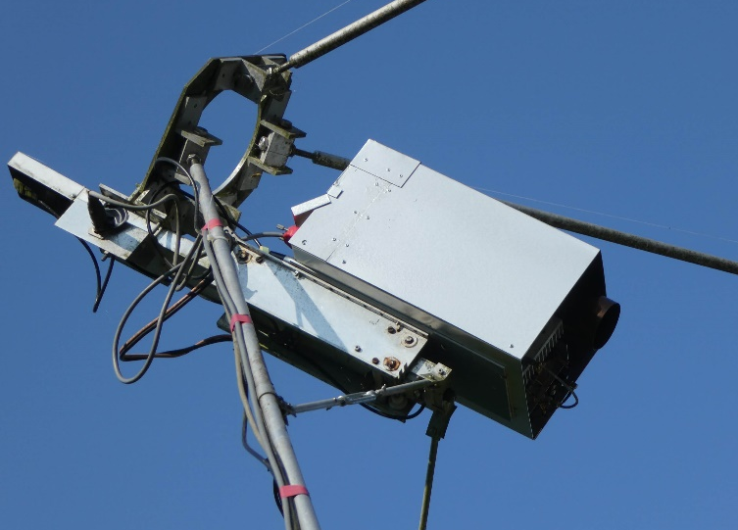
G4NNS’ 6 cm feed box in place at feed point

I0NAA: Mario mario.natali(x)gmail.com participated on 1296 ARI EME Contest for a few hours on Sunday 20 Sept. I made 13 QSOs including two CW QSOs thanks to the help of IK0PUL. I hope to have more time in the upcoming ARRL EME Contest and more help available! On the technical side, I released on my web site, http://i0naa.altervista.org/, a new program: “TotalPower”. This program is designed to be an RF Band monitor and for RF Noise measures using a low-cost RTL-SDR dongle. The program shows the noise (signal) received. It includes an analog meter that is of a great help in fine tuning antenna pointing. TotalPower also offers additional features such as a Band monitor with a peak hold function that helps in identifying impulsive RFI and an averaging mode that allows the capture of the Hydrogen line even with small antennas. Another nice feature is the possibility to produce 3D plots of the noise received while moving the antenna automatically in conjunction with PstRotator. The data can be exported and processed further with other programs such as Matlab. I would appreciate very much feedback and corrections!

IK1FJI: Valter valter_dls(x)yahoo.it writes on his ARI Contest activity -- I only participated in the contest on 23 cm CW/SSB. I made 32 QSOs, but with some DUPs. I had a nice QSO with both CW and SSB with PI9CAM - their usual strong signal. I heard only one station from North America on CW, but no QSO. I 0lost at least two stations; I sent QRZs, but they were just too weak to ID. Unfortunately, on the night of 3 Oct, I had strong wind at around 100 km/h that moved the azimuth pointing of the dish and through off my position calibration. The forecast is still for bad weather, so I don't know if I will be able to fix the dish in time for the first leg of the ARRL EME Contest.

JA4BLC: Yoshiro ja4blc(x)web-sanin.co.jp was QRV in the ARRL MW EME Contest on only 5760 – I did not change bands because of bad WX. I worked on 12 Sept SP6JLW (569/579), G3LTF (559/569), OK1CA (569/579), G4CCH (559/559), DL7YC (579/569), SM6FHZ (569/569) and OH2DG (559/569); and on 13 Sept UA3PTW (559/579) ,KL6M (559/569) and RA3EME (559/559) for a total of 10x8.
JJ1NNJ: Koichi jj1nnj(x)extra.ocn.ne.jp participated in ARRL MW EME Contest on 13 cm – I made a total of 8 QSOs x 6 mults operating on 2400; all were on CW. Worked were OK1KIR XB (2320), OK1CA XB (2320), OH2DG (2400), G3LTF XB (2320), G4CCH XB (2320) for initial #18, OH1LRY XB (2320), KL6M XB (2304) #19 and JA6AHB (2400) #20. Heard were JA8ERE, SA6BUN (partial), UA3PTW (CWNR), SP7DCS, SP6OPN (CWNR), RA3EME, DL7YC (CWNR), F2CT and HB9Q. I repaired the IDF filter on the RX converter and my Sun noise increased by 1 dB. I also increased the power of my HPA 3 dB by operating 2 modules parallel. As a result, my echoes are about 2 dB above the noise and can always be heard. I also reduced 2400 interference a little by covering the antenna side of my WIFI router with a shield plate. I just put an aluminum plate on it - HI.

K0PRT: Gary (WA2JQZ) and Ray (AA0L) gca7sky(x)aol.com announce that their group will be QRV with a newly refurbished 60’ dish on 1296 for the ARRL EME Contest in Oct -- The Deep Space Exploration Society, call sign K0PRT, is planning to participate in the ARRL EME contest on 10 Oct. We will be using our restored 60’ dish antenna for moonbounce for the first time. We will operate on 1296 with CW and SSB, and possibly also digital modes. Our antenna site is located near Haswell in southeast Colorado, grid square DM88. The Moon will be above our horizon on 10 Oct from 0540 to 2006. We also plan to participate again in the contest in Nov. Our group has been restoring the antenna since we acquired it in 2009. In 2018 we started to do astronomical measurements. We have been measuring and mapping the 21 cm neutral hydrogen in the Milky Way. We have been collaborating with K7ETI, doing simultaneous long baseline SETI observations with a 40-foot antenna at the Green Bank Observatory in WV. This year our software team succeeded in implementing fully automatic tracking. We have been successfully detecting pulsars since May, including the Vela pulsar, which only rises a few degrees above our southern horizon. This coming ARRL October contest will be our first trial to do EME. We did some tropospheric scatter to test our equipment and setup. Our dish antenna was originally built in 1957 by the National Bureau of Standards for tropospheric scatter experimenting. It was in use by them until 1974. For more info search <dses.science>.

KB7Q: Gene geneshea(x)gmail.com reports on his doings on 220 -- I’ll being putting Nevada on 222 EME on 13/14 Oct - see http://kb7qgrod.blogspot.com for details. In Sep I had an excellent time running 222 EME with my single yagi station. I worked K1WHS (21DB) on his moonset, KL6M (25DB), WA4NJP (25DB), K5DOF (27DB) single yagi to single yagi, W4ZST (17DB), and W5ZN (28DB). I plan to be doing more on 70 and possibly 1296 in the future. [222 in not the main focus of this NL; however, as no one else is covering it, we try to include it].

KL6M: Mike mike(x)kl6m.com decided work all 3 of his MW bands during the ARRL Contest’s MW weekend – Last year I skipping 6 cm and it cost me either the first or at least the second CW ranking in the overall event. However, my strategy didn't turn out well. I ended up with only 3 QSOs on 9 cm, 9 on 6 cm and 13 on 13 cm. It seemed that the overall participation was way down; but I could have just been out of sync with the activity. I installed the 13 cm feed in twilight and could not see my markings and I ended up 4 inches out of focus. It doesn't sound like much but it made a significant difference in overall performance. I also had a broken wire on my control panel and could not activate my filters so I had bad RFI to fight to hear anybody. So, 13 cm was severely handicapped. I managed to fix both problems once I had daylight, and worked a couple new ones on 13 cm. Other than 13 cm problems everything else worked perfectly. The bottom line is great fun as usual despite seemingly poor turnout. I hope to find time to work on a 3 cm system this winter. I plan to try some 144 operation too. I think we EMEers should collectively try to come up with a better format for ARRL MW EME Contest. This one was less than desirable.

KL7UW: Ed kl7uw(x)acsalaska.net is making major progress on returning to 1296 -- I just had a crew with boom truck remove my 4.9 m dish in preparation for rebuilding the dish framework and redesigned short tower-mount – see http://www.kl7uw.com/eme1296.htm. Hope to be QRV on 1296 by the end of Oct. I plan to have a 100 W 3400 station installed in the spring, if we still have ham privileges on that band.

LX/PA3CMC: Chris (PA2CHR) post(x)pa2chr.nl reports that during the ARI Contest on 19/20 Sept he, PA3FYC and Lins PA3CMC were QRV on 70 cm (and 2 m) EME from Luxemburg in JN29VW – we used both the calls LX/PA3FYC and LX/PA3CMC.On 70 cm used a single 27 el yagi horz and a 23 el yagi vert for X-pol with 400 W. Although the condx were bad, we worked several stations such as OK1KIR and DL7APV

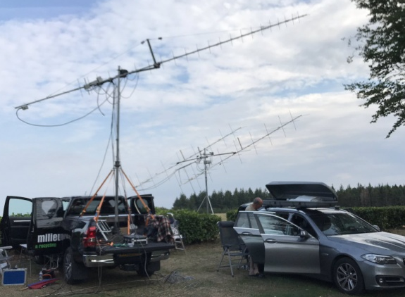
LX/PA3CMC dxpedition – 432 is upper on left

KN0WS: Carl carlhasbargen(x)q.com writes on his ARRL MW weekend experiences -- My XYL asked why I spend so much time working on EME when I have had so many problems? I reminded her that intermittent rewards like slot machines are the most reinforcing/addicting. I spent a lot of time preparing for the ARRL MW weekend. I set up and calibrate tracking for my new 2.4 m mesh dish for 6 and 9 cm. Since my 13 cm RX disappeared in May when my generator hiccupped, I purchased a new larger generator. I checked the gain on my 13 cm LNA and indeed it was gone. I ordered several backup preamps. I bought a new SignalLink sound box for digital interface to my computer. I put up new LMR-600 coaxial cable for 13 cm, since the connector of the old one was rusted. I bought new laptop power supplies, since my old ones were submerged during the flooding of my 23 cm DUBUS weekend. When I checked my larger generator, the pull-cord broke. I hoped it was not an omen. At my EME site, it was a complex setup. I used my 16’ dish for 13 cm, my new 8’ mesh dish for 9 and 6 cm and I dusted off my 4’ backyard offset dish for 3 cm. I crawled into my sleeping bag to rest and, as expected, the rain started 2 hours before moonrise. When I awoke and moved into my operating position, I discovered that water had dripped inside my tent and into the gear. My keyboard and keyer were non-functional and the new box to control my 16’ dish was damaged. So it was back to old-school pointing! Cell phone signals are too weak at my site, but I checked for text messages and my wife informed me that my 92 year old father was in the hospital, but he was doing OK and he did not want me to leave the contest. During the first moonpass, I worked on 9 cm DF3RU (5DB) and KD3UY (21DB). On 13 cm I saw OK1CA (8DB) when he was 2320, but down to (20DB) on 2304, and then worked RA3EME (10DB). I had lots of trouble with hardware and WSJT-X software. I really wanted to work JA6AHB on 13 cm, but could not see him; so only 3 QSO’s the first pass. As rain was not expected for the 2nd pass, I hoped to dry things out. The sky was clear and the Moon beautiful allowing visual pointing, but I only saw a few signals. On 13 cm, I copied UA3PTW (22DB); then switched to 6 cm and copied K2UYH (17DB); and then on to 3 cm where I heard OZ1LPR (14DB). After that the EU window ended and with zero QSO’s after 5 hours of trying, I decided to tear down and go home to check on my father. With only 3 QSOs, clearly I had hoped to do better; I have some diagnostic work to do and decisions to make. I could not be QRV for the ARI Contest because of my work schedule. For Oct I plan to be on 23 cm and with my son’s help try a new yagi to add 2 m. My thinking is to keep things simple and just stick with 23 cm and WSJT-9. The MW Contest weekend felt like a three-ring circus; and I was the only clown moving my juggling act from ring to ring - and dropping the balls! I hope to see you all on 23 cm in Oct. (My father is doing better).

N5BF: Courtney <courtney.duncan.n5bf(x)gmail.com> news on his new upgraded station – I made careful measurements on the performance of my enhanced system: increased dish dia from 3 to 3.8 m, added choke ring to my septum feed and repaired G4DDK LNA (TNX Sam). My Sun noise increased from 7.1 to 11.2 dB (SFU 50). Echoes are up from an average -17 to an -12 dB. ON0EME is up from a typical -13 to -9 dB. These measurements were all made as near perigee and at as minimum a spreading as possible. The quiet [antenna noise?] measurement with choke versus no-choke was 3.5 dB by itself. I noticed a similar improvement over past reports in JT QSOs with several stations. I worked IK7UXW (26DB/20DB) for mixed initial #183*, who I had been unable to decode before. I am hoping it all hangs together for four more days thru the ARRL EME weekend. I am looking forward to many more CW QSOs in the contest than before. I missed the ARI Fall session due to our domestic 10 GHz and up contest. The terrestrial mountain top activity in CA was subdued this year due to wildfires, but there was still a good turnout and good DX nonetheless, including my first experience with microwave rain scatter. There was no 10 GHz EME in the contest, but local W6DL was copying the DL7SHF Beacon with his 3 cm contest rig and showed the rest of us how to attempt the same.

OK1CA: Franta fr.strihavka(x)seznam.cz was QRV in this year's MW part of the ARRL EME Contest – I operated on the 13 and 6 cm bands on Saturday and on the 3 cm band on Sunday. On Saturday, I used a combined feed for 13 and 6 cm. I worked primarily using CW. On 13 cm the activity was weaker; mainly of the stations from NA were missing. I worked only WA9FWD from NA. Initials were OM1TF and DL4DTU to bring me #159. I also made 3 JT65C QSOs and an a digital initial with RA3EME {#20}. On 6 cm, I made 12 QSOs and had an initial with RA3EME for #82. On Sunday I switched to 3 cm. I did not find any stations from VK and JA, and worked 8 CW QSOs, but no initials. I also made 8 QSOs with QRA64D. Digital initials were with RA3EME, S57RA, G4BAO, W3SZ, OZ1FF, WA3RGQ and K2UYH to bring me to {#48}. On Sunday, I measured the Sun noise at 18.2 dB and Moon noise at 3.3 dB. Overall my results for the weekend were 49 QSOs and a score for the CW category of 38x28. I was also QRV in the ARI EME Trophy Contest on Saturday on 23 cm and on Sunday on 3 cm. On Saturday, I was QRV only in the first half of the EME window, about 6 hours. The activity was good and I made a total of 39 1296 QSOs of which 23 QSOs were on CW and an initial with UA6AH for #376. Using JT65C, I made 16 QSOs and had digital initials with IW8RRF, UA6AH, UA9FAD, DL7UDA, ON4BCV, I77FNW, DL1DWI, ON4QQ, OH3MCK, OM4XA, OK8HAK, LU8ENU, DL3EBJ and SM5DGX to bring me {#68}. The participation of Italian stations was excellent. I worked a total of 8 I stations. On Sunday, I was QRV on 3 cm and made a total of 19 QSOs. I worked 9 stations using CW and an initial with W3SZ for #96 at sunset. Operating using QRA64D, I made 10 QSOs and had digital initials with UA4AAV, F5VKQ, IK0HWK and F6BKB to bring me to {#52}. Overall I had 58 QSOs.

OK1DFC: Zdenek ok1dfc(x)seznam.cz did not complete his new dish in time for the ARRL MW EME Contest but was QRV for the ARI Contest -- Within a week of the ARRL Contest, I started work on my new dish and MW station. I worked second shift until late at night. I was able to set up the dish, measure whether it was geometrically correct, put everything in a "watermark" [?], and most importantly get the control system working. I use the F1EHN system, which allows you to track the antenna position to an accuracy of 0.01°. I added only power control of engine speeds, which is essential for such position differentiation. Everything was in place by the Thursday night before the ARI Contest weekend. I kept the dish on the Sun all day Friday, using noise to calibrate and store corrections in the F1EHN program’s memory. In the end, the system turned out to be so stable and solid that all I had to do was store the error correction associated with connecting the sensors. It took only one correction for the whole period! I was very surprised that I could use the same error correction for the 24 GHz band as well. Friday evening, I had time to make on 3 cm three test QSOs with OK2AQ, PA0HRK for initial #64 and IK6CAK. The antenna RX performed brilliantly; the measured parameters of Sun noise = 14.6 dB and Moon noise = 2 dB are exactly as calculated from the VK3UM calculator. It's the first system I've been within a tenth of a decibel from a calculation! So, on Saturday morning, after moonrise, I started working in the 10 GHz band. I managed to do everything planned on the band, so I decided to devote Sunday morning to the 24 GHz band test. Calibration of the antenna was not necessary as all tracking corrections matched the parameters of the 10 GHz band. I measured Sun noise = 12.5 dB, that's 2.5 dB better than the previous Prodelin antenna. As noted this new antenna is accurate to 38 GHz. In the coming days, I'll work on optimizing the feed's position. The Moon is now very low on the horizon, with a maximum of 26 degs, consequently on 24 GHz noise is degraded by atmospheric attenuation and other influence. Still, I measured 1.8 dB of Moon noise. No one was on the band; however, thanks to DL0SHF’s new EME beacon at 24 GHz, I was able to test RX of a signal as well. Everything was functioning normally. The beacon was awesome, although the spread on the signal was 360 Hz! Then, DL7YC showed up (Manfred is in JO62, so the Moon was even lower on his horizon). We waited until about 1300 when his horizon was clear. He came through with a tremendous signal with perfect decoding despite the 345 Hz spread (10DB/17DB). So, 24 GHz works too. With the new 24 GHz feed horn OK2AQ designed, I can hear my own echoes. I look forward to the trials when there's a better window. In Oct there will hopefully be a chance to do the measurements again on 47 GHz and try for some QSOs on 24 GHz. I QSO’d on 3 cm during ARI Contest on 18 Sept using digital modes unless noted PA0HRK (11DB/14DB) for digital initial {#64}, OK2AQ (7DB/11DB), IK6CAK (8DB/12DB), on 19 Sept OK2AQ (11DB/12DB), IW2FZR (10DB/14DB0, HB9DUK (7DB/12DB), UR5LX (8DB/11DB), IK6CAK (10DB/12DB), UA4AAV (8DB/10DB) {#65}, UA3TCF (10DB/12DB), SM6CKU (579/569) using CW, OZ1LPR (6DB/9DB), W3SZ (6DB/12DB), F6BKB (7DB/13DB), WA3RGQ (13DB/15DB), W3SZ (569/459) using CW for initial #48, OK2AQ (559/559) using CW and G4BAO (12DB/16DB) for a total on digital of 15 QSOs and on CW of 3. Later I worked on 20 Sept using digital on 1.25 cm DL7YC (10DB/17DB for digital initial {#12}, and on 3 cm using digital DF1SR (9DB/11DB), OK1CA (7DB/7DB) and DL4DTU (8DB/7DB), and using CW OZ1LPR (579/559), S57RA (579/569), OK1CA (579/569), LX1DB (599/579) and G4NNS (569/569), and using JT IK0HWJ (8DB/12DB). See http://www.ok1dfc.com/eme/offst260cm/offset260.htm for more.

OK1KIR: Vlada vlada.masek(x)volny.cz and Tonda report on their Sept EME activity – On Saturday, 12 Sept in the MW part of ARRL EME Contest we mainly searched for initials on 13 cm and 3 cm. We started on 13 cm and worked using CW at 0001 OK1CA (589/589), 0010 OM1TF (549/O) for initial #184 and a new DXCC, 0028 RA3EME (579/579), 0034 JA8ERE (569/579), 0042 JJ1NNJ (569/569), 0055 UA3PTW (579/589), 0135 JA6AHB (569/579), 0146 SA6BUN (579/579), 0156 SP7DCS (569/589), 0216 DL4DTU (569/579) and 0301 UA3TCF (549/549), and then using JT65C at 0112 PA0PLY (15DB/O). We left an empty 13 cm band for 3 cm and QSO’d using CW at 0711 W3SZ (569/559) for initial #138 and 1256 9A5AA (549/569), and using QRA64D at 1032 OE4WOG (10DB/10DB) for digital initial {#214} and 1249 OK2AQ (14DB/13DB). On Sunday, 13 Sept we installed 24 GHz and worked using CW at 0658 DK7LJ (588/557) during 400 Hz spreading, 0738 DL0SHF (588/525), 0755 IK2RTI (O/O), 1132 DB6NT (549/549) and 1223 WA6PY (M/M) for initial #31, DM field and CA as 2nd US state on 24 GHz; and using JT4F at 0242 JA1WQF (16DB/15DB) through rain in JA, 0845 DL0SHF (13DB/14DB) for digital initial {#47} and 1046 DC7KY (15DB/15DB). Windy and rainy WX conditions eliminated tests with OH2DG and 9A5AA. Our total was on 13 cm was 12x8, on 3 cm 4x4, and on 1.25 cm 7x4 for an overall total of 23x16. On Tuesday,15 Sept, on 3 cm we succeeded using QRA64D at 1210 CX2SC (21DB/16DB) {#215} for the 1st 3 cm CX-OK QSO and new DXCC. In the ARI EME Contest, we again searched for initials. We worked on 70 cm on Saturday,19 Sept using JT65B at 0900 VK2CMP (20DB/18DB) for digital initial {#252}, 1213 G4IDR (21DB/15DB) {#253}, 1344 LX/PA3CMC (23DB/O) {#254} - all on vertical polarization, 1425 DL4ZAG (12DB/17DB) {#255}, 1432 PA2V (7DB/7DB), 1647 YO2NAA (20DB/21DB) {#256}, 1655 G4BWP (13DB/16DB) {#257}, 1745 SM5EPO (18DB/O) and 1743 at 5 degs el PA1VBM (22DB/18DB) {#258} with 2x26 el yagis and no el; and on Sunday, 20 Sept using CW on 23 cm at 1326 UA6AH for initial {#472}, 1331 DL3EBJ (579/589), 1335 SP6ITF (559/579), 1339 I5YDI (559/539), 1344 DF2GB (569/579), 1350 IK1FJI (569/579), 1353 G3LTF (579/579) and 1555 SM5DGX (569/579), and using JT65C at 1002 IK7UXW (8DB/10DB) for digital initial {#378}, 1020 IW8RRF (11DB/11DB) {#379}, 1026 DF2VJ (8DB/3DB), 1032 IK2MBB (1DB/1DB), 1038 UA6AH (8DB/O), 1044 OH3MCK (11DB/20DB), 1054 DL3EBJ (6DB/1DB), 1103 UA9FAD (7DB/1DB), 1108 OM4XA (10DB/2DB), 1210 I7FNW (5DB/2DB), 1228 OK8HAK (1DB/12DB) {#380}, 1541 F4VTP (27DB/17DB) {#381} with a single 70 el yagi, 1656 LZ1DX (1DB/O), 1700 AA4MD (1DB/3DB) and 1712 WA3QPX (6DB/1DB) {#382}. Our total on 432 was 9 JT65C QSOs, and on 1296 8 CW and 15 JT65C QSOs for a total of 32 contest QSOs.

OK1TEH: Matej ok1tehlist(x)seznam.cz was QRV during the ARI EME Contest on 70 cm and found the condx were terrible -- I wasn't able to complete with some of the big guns such as DL9KR, G4RGK, UA3PTW and PA2V, mainly due to uncooperative Faraday rotation. However, I still made a few 70 cm contacts with VK4EME (28DB), PA3DZL (26DB), DF3RU (25DB), DL7APV (20DB), DL6SH (20DB) and SM7THS (28DB). I hope the ARRL Contest will be much better. I want to note that although PA3DZL is using only small (obviously well optimized) 3.7 m dish for 70 cm, he is able to be easily heard all the time by my of small 1 yagi station. Well done Jac!

OK2AQ: Mirek kasal(x)feec.vutbr.cz reports about his participation in both consecutive contests during a beautiful late summer -- I enjoyed both operating contests on the 3 cm band, including the week in between them when I caught OE4WOG for mixed initial #100* and PA0HRK #101*. During the ARRL Contest the Moon was very high and above the range of my dish mount, which forced me to miss the middle part of both lunar passes. Participation was not bad, but there was no one QRV from Japan, South America, Africa and Oceania. I worked using QRA64D RA3EME, UR5LX, OZ1LPR, HB9Q, F6BKB, W3SZ, G4BAO, S57RA, WA3RGQ, OZ1FF, OK1KIR, F5VKQ, OK1CA, VE4MA, IW2FZR, DF1SR, VE6TA (24DB/19DB) #91*, K2UYH and two QSOs using CW with OK1CA and SP6JLW. My total score was 19x15x100 = 28,500 points. During the contest I made precise measurement of Sun noise to cold sky (CS) = 12.2 dB at an SFU = 64 and Moon noise/CS = 0.94 dB. There was also good participation in the ARI Contest but at lower Moon declination. It is gratifying that so many stations are able to work both CW and JT. I worked on 3 cm using QRA64D OK1DFC, IW2FZR, UR5LX, UA4AAV (14DB/13DB) #102*, F5VKQ, UA3TCF, SM6CKU, OZ1LPR, F6BKB, I6CAK, W3SZ, PA0HRK, IK0HWJ, WA3RGQ, OK1CA, HB9DUK, DL4DTU and G4BAO, and using CW SM6CKU (O/O) for initial #23, OK1DFC, OK1CA, OZ1LPR, LX1DB, G4NNS and W3SZ (O/O) #24 for a total 25 QSOs. My detailed log is at http://www.urel.feec.vutbr.cz/esl/files/EME/LOG/EME_LOG_10G.htm.

ON0EME: Eddy (ON7UN) reported 7 Oct that the output of the 1296 Beacon was down about 100 W -- I went to the beacon to check on the low power. The output amplifier needs repair. We will try to get the beacon back on line in time for the ARRL Contest weekend. [Many thanks to ON7UN, ON4BCB and friends for their efforts to keep this beacon on air].

OZ1FF: Kjeld kjeld(x)oz1ff.dk reports on his Sept 10 GHz EME – In the ARRL MW EME Contest, I QSO on 12/13 Sept on 3 cm RA3EME, UA3TCF, W3SZ, S57RA, DL7YC, OZ1LPR, F6BKB, DL4DTU, HB9Q, K2UYH, OK2AQ, OH2DG, SP7JLW, IK0HWJ, WA3RGQ, DF1OI, IW2FZR, G4BAO, OK1CA and VE4MA for 3 CW and 17 QRA64 QSOs and a total of 20x15. On 16 Sept I worked PA0HRK and OK2AQ. My station consists of a 2.4 m offset dish, 50 W SSPA at feed and 0.64 dB NF LNA.

PA0HRK: Harke yrrah53(x)yahoo.com shares some material for the NL -- After 3 years of inactivity on 3 cm EME, I decided to install my small station on my balcony. The WX was good. I now have a ELAD FDM-DUO, bought second hand that I have already used on 13 cm. I use this radio directly on 144 with what I call a 2 m extension, not a transverter. The DUO is used in an undersampling mode for RX, and essentially a set of filters and amplifiers is all you need to get a very good modern 2 m SDR transceiver. Initially Sun noise was lacking because my 3 cm transverter was still tuned at my old IF of 150 MHz. A jumper did the job and I also took the opportunity to adjust the OCXO, so the frequency is now spot on. Then quickly, I got about 8 dB of sun noise with my 1.1 m dish and F1OPA LNA. The noise measurements are done with Spectravue and a FunCube Dongle. Nice to see this level confirmed on the DUO's digital S-meter. Moon noise proved to be about 0.4 dB. The DL0SHF beacon was quickly found, but I had a steep learning curve with respect to the software (SW). Windows10 and WSJT-X have their peculiarities! After a couple of days, all was set and done and I tried the Echo mode; but nothing was heard, no output. Again, some the SW needed adjustment. Then finally, I was up and running, with 30 W. I was surprised to decode DL0SHF at -11 dB. Speaker copy and in CW. The first station worked, on 16 Sept W3SZ, whom I met at the Venice EME conference. Roger was very patient to get the very last ticks correct and we worked in QRA64D (14DB/17DB). Then I worked OK2AQ (17DB/19DB) and OZ1FF (16DB/19DB). CFOM works like a charm. 17 Sept was nill as the Moon and the Sun were too close. On 18 Sept DL0SHF was even decoded at (8DB) - high power (?). Then HB9DUK (15DB/21DB) showed up, we know one-another from many hamfests, followed by F6BKB (16DB/18DB)) and OK1DFC (14DB/11DB) – amazing, his new antenna seems to work fantastic; and on 19 Sept F5VKQ (16DB/17DB), UR5LX (21DB/20DB), OZ1LPR (9DB/17DB), OK2AQ (18DB/20DB), OK1DFC (14DB/11DB), IK6CAK (18DB/19DB), W3SZ (17DB/19DB) and IW2FZR (21DB/19DB). All in all an exciting week! I now am up to mixed initial #13* on 3 cm. Next is 24 GHz.

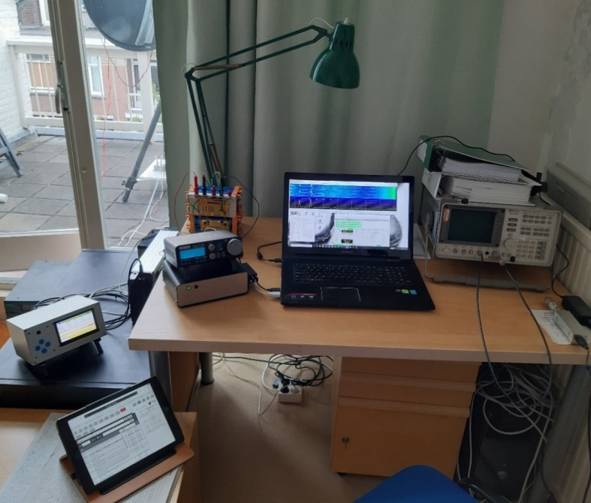
PA0HRK’s operating position. About a quarter of his dish is visible through the window, on the left is his HB antenna controller, then the DUO on top of the 2 m extension and laptop. Right is a spectrum analyzer used to adjust TX power at IF level. Below is the iPad for the HB9Q logger. All is run on batteries to allow portable operation for dxpeditions.

PA0PLY: Jan pa0ply(x)pa0ply.nl was active in both the ARRL MW and ARI Contests -- Like last year, I made the decision to be active on 13 cm for the ARRL MW Contest. I worked using JT65C UA3PTW, OK1KIR and RA3EME, then using CW OK1CA, G3LTF and G4CCH, then using JT65C OH1LRY, back on CW SP3XBO, then JT65C UA3TCF, back to CW DL4DTU for an initial (#), then JT65C again DF3RU, PE1LWT for a digital initial {#}, DL1EMA {#} with 1.5 m dish and 100 W and OM1TF {#}, and CW F2CT (#) and KL6M (#) for a total of 6 on CW, 9 on JT65C and a total of 15x10. Activity was quite low and only one station was heard from the US, K3WM (16DB) who was active in the JT mode, but he did not seem able to listen on 2320, thus no QSO. I heard from VE6BGT that there was so much satellite noise that it was almost impossible for US and Canadian hams to listen on 2320. [Satellite noise is a problem in NA on both 2304 and 2330 but it comes and goes depending on the satellite’s and Moon’s positions. It is the exception not the rule, but there is always Murphy!] In the ARI Contest I was on 13 cm as well. I worked DF3RU on JT65C and CW, IK7UXW JT65C {#}, IK3COJ JT65C, DL7YC CW and F2CT CW for a total of 5 QSOs. Due to the Moon’s low declination this weekend, the Moon was blockled by my house for a significant amount of time. Nevertheless, the activity was dramatically low in my opinion. That is disappointing for such a nice band. In the week between those contests, I worked on 13 cm using CW LX1DB (559/569) (#). I do see an increased activity on the 10 GHz band. Maybe, it is worth to consider splitting up such contests into 2 weekends and use one frequency per moonpass? I ran a 3 m dish with septum feed and 80 W at the feed with a DDK LNA.

PA2V: Peter peter(x)pa2v.com reports on his ARI Contest 70 cm results – I QSO’d on Saturday 13 stations; 3 were using CW; and on Sunday 11 stations. Conditions were terrible. Faraday to V pol made it very hard for my H-stack to make a contact. Also, the low dec contributed to my noise. Sunday morning, I had S9+60 dB QRM that sounded like static noise. I took a ride in my car with a mobile rig, but was unable to locate the source. As a result I lost the whole of my whole moonrise and all the VK/JA activity. Activity in EU was fair, but there was nearly no stations from NA. I was happy when WP4G showed just after he just finished his new antenna. This antenna performed very well. This contest is one to forget soon. Stations I normally easily work were missed because of the bad conditions. I end with a total of 33 contacts.

PA3DZL: Jac pa3dzl(x)icloud.com sends news that he is in operation on 70 cm again -- I am very happy that I finished my 432 setup and am QRV again off the Moon. This is my 6th band from my new QTH. I built a new ring feed, which I am using in my 3.7 m solid Andrew dish (f/d 0.34). This dish is small on 432, but I am surprised how good are the results. A big advantage is the ability to switch between H & V pol, which has helped me to complete a lot of QSOs. I have very little QRM here; only a few weak birdies - the low noise really helps. I already knew that this "small antenna" would work well, since PAØBAT has had very good results with his 3.7 m dish. I made my first 70 cm QSO on 5 Sept with DL7APV (of course!). The first 2 weeks I used my old LZ2US GS23b tube PA at about 600 W (x) feed due to low drive power. On 16 Sept, I finished an SSPA, and am now running 1 kW (x) feed. I am surprised that I can work small 1 yagi stations running "low" power. I was also very happy to do some CW QSOs not just with big guns but smaller stations too. In Sept I worked using JT65B unless noted DL7APV (10DB), SM5EPO, VK4EME, EA5CJ, PA2V (16DB), SV8CS for mixed initial #231*, DK3WG, SQ9CYD #232*, HB9Q (5DB), GW3TKH #233*, GM6VXB #234*, OK1TEH, SV8CS, DL6SH #235* (559) using CW and JT65B, EA5CJ, DL8DAU (21DB), IW4ARD #236*, OH6UW, GW4LWD #237*, SM7THS (14DB), UT5DL, DK5SO #238*, DL9KR (579) using CW, G3LGR #239*, ZS4TX #240*, K5QE, UX0FF, YO2NAA #241*, LU1CGB #242* and DXCC 66. So far, I have made 58 QSOs, 53 with JT65B and 5 using CW, added 25 initials and 3 new DXCCs.

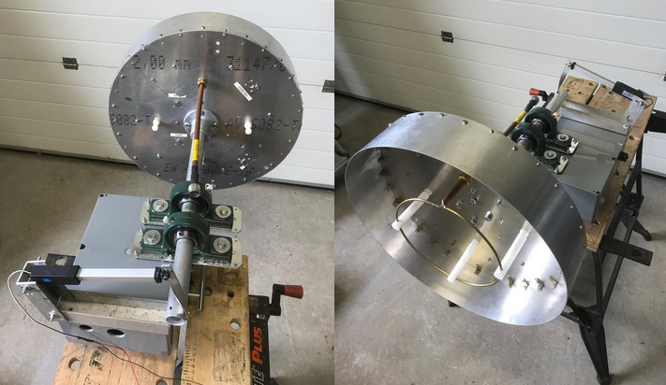
PA3DZL’s 432 ring feed and pol rotator

SM6CKU: Ben ben(x)sm6cku.se was QRV during the ARI Contest on 3 cm -- I was active on Saturday 19 Sept and worked on CW OK1DFC (559/579), IW2FZR, F4VKQ and OK2AQ. I also worked using JT4F OK2AQ. This was my first attempt using linear pol, and it seems to work as expected. The feed horn was designed by SM6FHZ and built by SM6PGP. I had my 4 m dish, 13 W output and an SMA T/R relay. I found the same performance as the circular feed, but gained 3 dB with most stations. The idea of a two-band split over the weekend is not a good for activity. I took no part in the contest on any band other than 3 cm.

SP6JLW: Andrzej sp6jlw(x)wp.pl and Jacek (SP6OPN) took part in the ARRL MW EME Contest – We decided to work on all the MW bands we have. We used SP6OPN on 13 cm and 9 cm, and SP6JLW on 3cm and on 6 cm. We only switched feeds in the middle of the day on one antenna. For the first orbit, we used the big mesh dish on 9 cm and the small dish on 6 cm. For the second orbit, the large dish was on 13 cm and the small on 3 cm. We operated in the CW multi-operator category. The WX was good; it was warm and windless. We QSO’d on 13 cm RA3EME, G3LTF, G4CCH, SM3BYA, UA3PTW, OH1LRY, SP3XBO, DF3RU, DL4DTU, IK3COJ, SA6BUN, SP7DCS, WA9FWD, F2CT and KL6M for a score of 15x10; on 9 cm (DF3RU, OH2DG, KL6M, SP3XBO, G4NNS and SM3BYA for 6x6; on 6 cm JA4BLC, OK1CA, G3LTF, SM6FHZ, G4CCH, OH2DG, RA3EME, DL7YC, DB6NT, SM6PGP, UA3PTW, IK2RTI, KL6M for 13x9; on 3 cm OK1AC, RA3EME, OK2AQ, DL4DTU, SP3XBO, OZ1LPR, OH2DG, UA3CTF, OZ1FF, S57RA, W3SZ, UA4AAV, VE4MA, IW2FZR for 14x9. Our total was 48x34. We will be QRV again and hope to hear you in the next round of the ARRL EME Contest. [TNX to OK1TEH for translation].

SP7DCS: Chris sp7dcs(x)wp.pl was active during the ARRL MW and ARI Contests – I worked using exclusively 13 cm and CW in the AARL MW event on 12 Sept SA6BUN, OK1CA, OK1KIR, UA3PTW, DL4DTU for an initial (#), RA3EME, SP3XBO, OH1LRY, OH2DG and WA9FWD, and on 13 Sept G3LTF, DB6NT (#), DF3RU, G4CCH, SM2CEW, SP6OPN and SM3BYA for a total of 18x8. In the ARI Contest my time was very limited and I was only able to be QRV for 1.5 hours. I operated on 23 cm using CW to QSO on 20 Sept PI9CAM, SP6ITF, IZ1BPN, LZ2US, G3LTF, IK1FJI, IK3MAC, F5KUG, LZ1DX, I5MPK, DL3EBJ, I0NAA, IK5VLS and SP2HMR. If the WX is OK, I plan to be QRV in ARRL EME Contest on 23 cm in Oct.

UA3PTW: Dmitry ua3ptw(x)inbox.ru was active in the ARRL MW and ARI EME Contests -- I added initials in Sept on 432 using JT65B with LX/PA3CMC, G4BWP, W3CJK, EI2FG and OH5BM; on 13 cm using CW with DL4DTU and VE6BGT, and on 6 cm using CW with RA3EME. [Thanks to DK3WG for forwarding this report].

UA6AH: Nickolay [email?] was QRV again on 1296 EME in Sept – I added initial QSOs USING cw with OK1CA, IK3MAC, G3LTF, I1NDP, PI9CAM, OE5JFL and OK1KIR, and using JT65C with UA9FAD, OK1CA, DL7UDA, LZ1DX, SM5DGX, IK5VLS, OK1KIR, SP5GDM, RA4HL, ON4QQ, IK3COJ, DF2GB and PI9CAM. [Thanks to DK3WG for forwarding this report].

UA9FAD: Victor ua9fad(x)mail.ru was on for the ARI Contest in Sept – I added initials using CW with IK3MAC, and JT65C with ON4BCV, LY3DE, RA2FGG, DL0SHF, N1AV, I7FNW, UA6LCN, PE1LWT, DL8FBD, G4FUF, UA6AH, IW8RRF, OK8HAK, UA4LCF, LZ1DX, OK1YK and SV1CAL. [Thanks to DK3WG for forwarding this report].

UR5LX: Sergey ur5lx(x)ukr.net was active in the ARRL MW and ARI EME Contests – In the ARRL MW Contest I worked on 3 cm using QRA64D on12 Sept OK2AQ, RA3EME, OZ1LRP, HB9DUK and UA3TCF, and on 6 cm using QRA64D on 13 Sept UA3PTW, KL6M and RA3EME for mixed initial #51*; and a score of 5x4 on 10 GHz and 3x2 on 5.7 GHz for a total of 8x6. In the Italian Trophy Contest on 19 Sept, on 3 cm, I worked using QRA64D OK1DFC, OK2QA, IK6CAK, IW2FZR, UA3TCF, PA0HRK for a mixed initial #114*, F5VKQ, IK0HWJ, W3SZ, OZ1LPR, WA3RGQ #115* for a total of 11 QSOs. I used in both contests my 2.5 m offset dish and on 3 cm 20 W and on 6 cm 45 W. I am interested in sked for 3 and 6 cm. Please email me.

VE3KRP: Fast Eddie was active on the past month on 23 cm EME – My recent operation has been on JT65C and 1296. On 20 Aug I worked ON4QQ, AA4MD, UA9FAD and SM5DGX for a mixed initial (#*). During the ARI EME Contest I added on 19 Sept DL3EBJ, SM5DGX, DL7UDA, KD5FZK (#*) - LOUD!, VE3NXK, WA3QPX, LU8ENU and AA4MD for a total of 8 QSOs. I hope to be QRV again during the ARRL Contest.

VE6TA: Grant ve6ta(x)xplornet.com was on the Moon for the ARRL MW weekend -- I was on 10 GHz and experimenting with my 5.5 m HB mesh dish. It was initially conceived as a 23 cm dish, but over the years, I have been able to coax it up to 3 cm. Performance falls off rapidly above 3.4 GHz, but I seem to be able to use a higher gain feed horns to find hot spots near the center of the dish that work well enough for QSO's. Currently I am trying a 0.8 f/d W2IMU feed for 3 cm on a 0.45 f/d dish. I am finding as I narrow the beamwidth that my sun noise is increasing, as well as it's becoming slightly easier to point the dish. Efficiency is going up with the more accurate parabolic surface near the center of the dish. I have used this dish from 144 to 10368; the outlier bands will always be a compromise. Stations worked in the ARRL Contest were using QRA64D unless noted HB9Q, S57RA for mixed initial #16*, W3SZ #17*, F6BKB #18*, F5VKQ #19*, RA3EME #20*, OZ1LPR on CW, OK2AQ #21*, IW2FZR #22* and VE4MA for a total of 10x9. I was very happy to have worked so many new stations. I plan to be on 23 cm for the Oct segment of the ARRL Contest.

VE3IKU: Boris borisd(x)sympatico.ca is in Toronto and new to EME -- I am setting up my first EME station and have decided on apparently challenging band, 2304 here in NA. [TX on 2320 and 2400 is also allowed in Canada]. I have a 3 m dish, 0.1 deg controller, Septum feed and 180 W into 25’ LMR-600. My sun noise is only 7 dB with SFU of 58. A bit disappointing. Cold sky noise is 182 degs K. In order to hear my echoes, I calculate that I need at least 400 W of TX power with my current noise level. I have a filter for cell towers (pass band 2300-2320) between the LNA and the post LNA amp, which works very well – without it, the LNAs are driven into saturation. I’d like to hear from others on 13 cm EME.

W2HRO: Paul w2hro.fn20(x)gmail.com has been experimenting folding dish, particularly for use on 1296 – I have started building and selling 1.8 m folding dishes using conductive fabric as a reflector surface. The dishes comes with an SM6PGP style patch feed and hybrid combiner for a circular polarized signal. I used the 1.8 m dish and patch feed during the ARI EME Contest with good results, and made 12 QSOs with 200 W. In another test, the patch feed was installed on a small 0.8 m grid dish and a JT65 QSO with K5DOG was easily completed. The patch feed housing is 3D printed with UV stable plastic and solid copper is used for the reflector, patch and baffle. I hopes these patch feeds will make it easier for new EMEers to become QRV on 23 cm.

W2HRO folding cloth 1.8 m dish (L) great for portable EME and 0.8 m dish with patch feed (R)

W5ZN: Joel w5zn(x)w5zn.org (EM45dh) is QRZ from Arkansas on 220, but is working on 1296 EME --
My plan is to completed the mounting of a 15’ (4.6 m) Scientific Atlanta dish that I have had for several years. I hope to have that fully functional sometime in Oct, but the date is dependent on obtaining a couple of things such as pinion gears.

WA6PY: Paul pchominski(x)maxlinear.com writes on the ARRL EME MW weekend and his 24 GHz activity – I was QRV on second moonpass in the MW Contest on 13 cm and QSO’d using CW SM3BYA, OH1LRY, SA6BUN, RA3EME, DF3RU, G3LTF, UA3PTW, G4CCH, OH2DG and KL6M for a score of 10x6. On 1.2 cm I QSO’d OK1KIR during high spreading conditions - libration was 350 Hz to bring my total to 11x7. The next day, 14 Sept, I had a nice QSO with W5LUA also in high spreading. I then worked on 15 Sept DL7YC and OZ1LPR, and heard very strong DK7LJ; and on 16 Sept DK7LJ and PA0BAT, and heard the DL0SHF beacon (569). On 24 GHz, I’m experiencing tracking problems with my MAB25 encoders. The actuator diving AZ is also too short and too weak, causing oscillations of the dish position in AZ. From time to time, I have to switch off tracking and move the dish manually. I have to find a longer actuator to rebuild the AZ drive mechanism. I plan to be QRV in Oct for the ARRL EME Contest.

WD6Y: Kal WD6Y(x)arrl.net is now QRV on 432 -- I have a new 1 kW linear and two 18H/18V XPOL yagis that I'm ready to try in the ARRL EME Contest and whatever else is there on 70 cm. I have so far made two QSOs with QSL confirmations from DL7APV and DK3WG. The Moon will come up in Southern CA late in EU. If anyone is willing to stay up for a new grid DM03, I will be there. I am still working to improve my RX and to sharpen my EME QSO skills.

XE1XA: Max general.manager(x)corix.us is QRV again! -- After a forced QRT period, due to my lack of Pout, I’m QRV again on 23 cm. I have now a Pout of 370 W at my flared septum feed, developed and tested on reception during my QRT period. I’m measuring an increase on average of 4 dB in my echoes over those measured when Pout was 220 W with the same path loss. Since the increase in Pout is 2.25 dB, the difference of 1.75 dB should be due to the increase in efficiency of the flared septum feed. I see an associated reduction in system noise (dish spillover). I’m very satisfied with the results.

K2UYH: I (Al) alkatz(x)tcnj.edu did not do as well this month. I awoke very early on 12 Sept to operate the MW Contest. My plan was to use QRA64D first on 3 cm. I have not spent time in a contest using WSJT on 3 cm. I tried to load WSJT, but it kept crashing. I finally decided to reboot my computer. My keyboard would not work. After many reboots and some change of USB connections, I got the keyboard working! I still had problems with WSJT; it was working with the TS2000, but very flaky. I would respond to a station and it would not TX! The relays switched, but no tones. Sometimes the tones would come on 45 sec into the TX period - crazy. I lost a number of QSOs and many hours of operating time. The "killer" was when I went on CW, my CW program would not work... I could go on and on. It was very frustrating. I did make some nice QSOs, but the computer fought me to the very end. I QSO’d on Saturday on 3 cm using QRA64D at 1006 DL7YC (10DB/14DB) for mixed initial #59*, 1030 W3SZ (14DB/15DB) #60*, 1042 DF1OI (11DB/13DB) #61*, 1053 OZ1FF (11DB/14DB) #62* and 1246 S57RA (18DB/14DB), then switched to 6 cm but delayed until EUs gone and only worked using CW at 1844 KL6M (559/559); and on 13 Sept started on 6 cm using CW at 0945 SM6FHZ (559/559), 1000 SM2CEW (559/559) for initial #59, 1007 SM6PGP (O/559) and 1015 DF3RU (559/539), then back to 3 cm using QRA64D at 1105 RA3EME (O/O) #63*, 1326 OK1CA (12DB/10DB), 1332 OK2AQ (16DB/19DB), 1336 DF1SR (16DB/15DB) #64* and 1420 VE4MA (18DB/15DB), and finally on 13 cm using CW at 1950 KL6M (559/559) for a score on 3 cm of 10x7, on 6 cm of 5x3 and 13 cm of 1x1 and 16x11 overall. The computer problems ruined my multi-band plans. I spent so much time trying to fix problems that there was no time to operate. I also seemed to be out of phase with activity peaks on the bands. One of the reasons I ended up on 13 cm was that I was hoping to find JA6AHB, but heard nil. I finally worked Toshio on 13 Oct using CW XB at 1130 JA6AHB (O/559) for initial #110. WIFI interference was a problem, but his signal cut through the noise. I had planned to be QRV in a big way for the ARI Contest, but discovered that I had family conflict that prevented my participation in the contest. I do plan to be QRV for the ARRL Oct EME Contest weekend.

NET/CHAT/LOGGER NEWS: PA5Y has one of the solid dishes offered for sale in the last NL. Conrad intends to become QRV on 23, 6 and 3 cm in that order with it. HB9Q will be QRV during Oct ARRL Contest weekend on 50 thru 1296. We plan to be QRV 50, 144, 432 and 1296 during the ARRL EME Contest weekend; however, they will not participate in the contest, but will be chasing initials. They will be QRV on 10 Oct from 0400 to 1330z and 11 Oct 0400 to 1415. Skeds can be arranged in advance by email to dan(x)hb9q.ch. WK9P will be QRV from EN61vq on 1296 CW during the ARRL contest weekend with his newly extended moon window and kW PA. WA5WCP is reported to be buying a big Kennedy dish. Announced activity for ARRL Contest - Additional stations can be found at the QRV list at: http://www.darkside.cz/eme.php.

FOR SALE: DU3T’s LNAs’ sale has been delayed due to COVID-19. All the materials are in DU but Ron is in DL and cannot travel to DU because of the virus. It is expected that LNA production will happen before the end of 2020. W2HRO has for sale 1.8 m fabric dishes that fold to a very compact package, which should be great for portable EME on 1296 and higher bands. Paul also have 3D printed patch feeds for use with his dishes. See his report and if interested contact him at w2hro.fn20(x)gmail.com. OK1DFC: have available some feed horns. They are: 24 GHz 0.6 F/D - 4 PCs, 24 GHz 0.8 F/D - 10 PCs, 47 GHz 0.6 F/D - 4 PCs and 47 GHz 0.8 F/D - 5 PCs. See http://www.ok1dfc.com/eme/47ghz/w2imu_feed.htm and
http://www.ok1dfc.com/eme/24ghz/feeds.htm. OK1TEH: has still for sale for a symbolic price his 3 m solid dish with massive ribs that is usable for EME on 24 GHz. More info via ok1tehlist(x)seznam.cz.

RADIOASTRONOMY CORNER BY OK1TEH: Although we don’t have any remarkable Radio Astronomy news, I’d like to point out an interesting article at NASA web about bouncing laser beams off of the Moon and Mars. Check out: https://www.nasa.gov/feature/jpl/nasas-new-mars-rover-is-ready-for-space-lasers; and more at ham related info at
http://www.k3pgp.org/Notebook/Mlrs/mlrs_targets.htm
http://www.k3pgp.org/lasereme.htm
http://www.k3pgp.org/laser.htm

FINAL: We are afraid this issue is a rush job. We will try to make it up next month.

►The is somewhat good news for 9 cm operation. Use of the band will be allowed at least for the near future. The bad new is that Israel has lost 9 cm and effectively 1296 EME – see 4X1AJ’s report. W5LUA has sent some interesting material on what’s going on with 9 cm band in US. If you fear that 5G networks will kill this band, see http://www.ntms.org/files/Sep2020/W5LUA_3300MHz.pdf.

► I5WBE reminds everyone to get you logs in for the ARI EME Trophy Contest i5wbe(x)i5wbe.it, [reported on in this NL]. Please send your log even if you only have one QSO. It will be appreciated. All formats are accepted, but better if in XLS-XLSX format. See http://www.eme2008.org/ari-eme/contest%202020.html.

► EME Directories - PA0PLY has decided to take EME stations who are not active (sadly many listed are SKs) off of his EME directories. Keeping the directories up to date is quite time consuming. Please send Jan your updated station information if you want to be published as active on the list. [Jan deserves much praise and great thanks for maintaining his EME Directories over many years]!
► We hope to work you in the ARRL EME Contest. We both plan to be active. 73 and GL in the contest, Al – K2UYH and Matej – OK1TEH.

