432 AND ABOVE EME NEWS
APRIL 2015 VOL 43 #4

EDITOR: AL KATZ, K2UYH; DEPT. ELECTRICAL/COMPUTER ENGINEERING, THE COLLEGE OF NEW JERSEY, PO BOX 7718 EWING, NJ 08628, TEL (W 609-584-8424) OR (H 609-443-3184), FAX (609-631-0177), E-MAIL alkatz(x)tcnj.edu
NETNEWS EDITOR (based Reflector News) REIN, W6SZ pa0zn(x)arrl.net WITH HELP OF N4PZ AND WB2BYP
INITIAL LIST G4RGK, DAVID DIBLEY, E-MAIL zen70432(x)zen.co.uk, AT: http://www.zen70432.zen.co.uk/Initials/index.html
EME INFORMAL NETS: 14.345, ~1500 SATURDAY AND SUNDAY, NET COORDINATOR: Steve Gross, N4PZ n4pz(x)live.com
ON0EME EME BEACON, 1296.000 IS QRV WHEN MOON >10°, SEND RX REPORTS TO WALTER (ON4BCB) on4bcb(x)gmail.com
DL0SHF 3 CM EME BEACON, 10368.025, SEND INFO & QUESTIONS TO Per (DK7LJ) per(x)per-dudek.de.
NL EMAIL DISTRIBUTION and EMAIL LIST CORD: WARREN, W2WD wbutler(x)ieee.org [TXT OR PDF OR "ON WEB" NOTICE]
THE NL WEB VERSION IS PRODUCED BY REIN, W6SZ AND AVAILABLE AT http://www.nitehawk.com/rasmit/em70cm.html

CONDITIONS: There is doubly sad news this month, EME old timers, K4QI and W0DRL have passed away – see the FINAL section of this newsletter (NL) for more details. On the positive side, it is now official; HB9Q has received the first 1296 DXCC Award. It is dated 29 Oct 2014. Moon activity this month focused on the 13 cm DUBUS EME Contest. Both EME conditions and weather (WX) seemed favorable. The top scores being reported are all OKs (and OH2DG) with OK1CA again in the top spot with a total of 44x39. Many stations report having fun in the 1296 SSB FUNTEST. Based on the reports received thus far it appears that F5SE/p will take over the title of “Top Fun Maker” with 31 SSB QSOs and 744 points. Svalbard Island dxpedition, JW/DF8DX and JW/DL2UD was a great success with 42 QSO on 23 cm alone! See their report later in this newsletter (NL). Hermann is on his way to S79EME, Seychelles Island dxpedition from 21 March to 2 April with activity on 70, 23, 13 and 9 cm. See their report for more details. Also coming up will be operation on 1296 from VP2/W3XS on the US Virgin Islands on 17- 19 April – see following report. Also see N4EME’s announcement of 3 cm EME from NC on 20 to 26 April. In May activity is planned by 7Q7EME from Malawi on 70 and 23 cm from 9 to 24 May. Still coming up is 9 cm EU/DUBUS CW EME Contest on 28/29 March and the BIG 23 cm EU/DUBUS CW EME Contest on 25/26 April. The next 70 cm CW activity time period (ATP) is this same weekend. The ATP is on 29 March from 1300-1500 and 2130-2330.

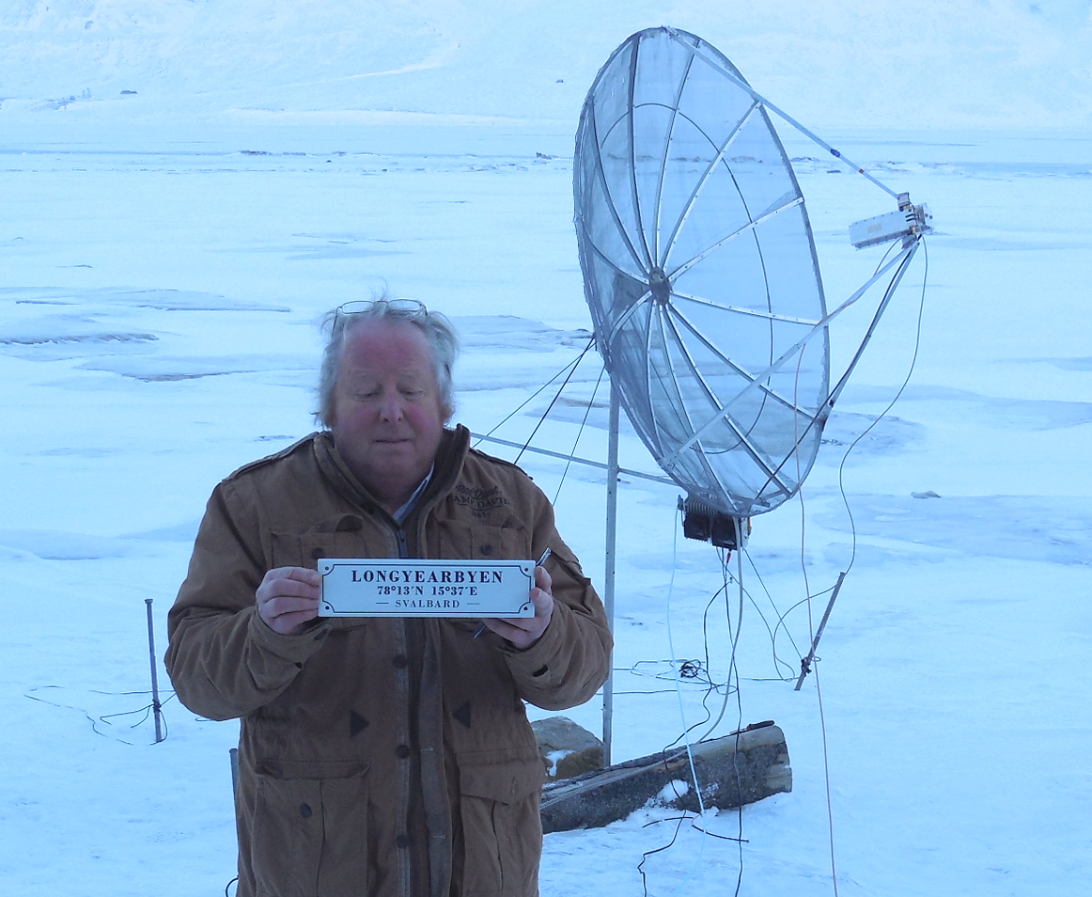
JW/DL2NUD – Hermann in front of dish – see report

DF3FI: Hubert <htdj3fi(x)t-online.de> reports on his 13 cm contest activity -- I was QRV with my 2.8 m dish and 350 W at a septum feed and DB6NT preamp. I worked on 28 Feb ES5PC, SP6OPN, OK1KIR, UA4ATS, OK1KKD, OH2DG, DF3RU and PA0BAT, and on 1 March HB9Q, UA3PTW and G3LTF. This gave me a total of 11x10. Next time I hope to make more.

DJ8FR: Juergen juergen(x)dj8fr.de had a fun time operating the 23 cm SSB contest -- Again I enjoyed this contest very much. I was not sure I could be QRV because a broken EL rotor, but because of good weather in the week before, I was able to repair it. My station on 23 cm is a 5 m mesh dish, RA3AQ feed with 300 W at the feed and HB9BBD preamp. The moon was in a good condition, so the date was chosen right. I QSO’d on 22 Feb at 1103 PI9CAM (59/58) JO, 1106 SP6JLW (55/55) JO, 1110 DK0SF (56/JO) JN, 1117 F5SE/p (58/57) JN, 1142 I5MPK (54/55) JN, 1151 UA3PTW (55/55) KO, 1157 OE5JFL (58/56) JN, 1204 HB9Q (59/59) JN, 1238 OK2DL (59/57) JN, 1341 LX1DB (59/57) JN, 1353 OZ4MM (58/56) JO, 1434 DG5CST (52/53) JO, 1445 DL1YMK (53/55) JO, 1613 UA4HTS (55/55) LO, 1621 I1NDP (59/58) JN, 1643 DF3RU (57/55) JN, 1702 K2UYH (54/55) FN, 1816 RA3AUB (54/55) KO, 1831 W6YX (55/55) CM and 1901 DL3EBJ (55/55) JO. Heard but could not work was SM7FWZ. All QSOs were SSB to SSB for a total of 40x2x6 = 240 points. Last year I worked 17 vs. 20 this year, so things are improving!

DK3WG: Jurg dk3wg(x)web.de is now active on 70 and 23 cm beside 2 m EME – I added initials in Feb with ZS6JON on JT65B, and on 1296 with IK5VLS, IK3COJ, PY2BS for DXCC 32, ES6RQ, W5LUA and VK2JDS for DXCC 33 all on JT65C.

DK7JL: Per per(x)per-dudek.de reports that he had some problems and that the 3 cm EME Beacon was off the air for a few days in March. All is back to normal and the beacon is running well at this writing. The big news, however, is Per’s plans to switch to circular polarization as a result of a visit by WA6KBL to DL0SHF. It should not take a long time with help from Jeffrey, and will be in use on 10 and 24 GHz.

DL3EBJ: Christian dl3ebj(x)t-online.de sends his 23 cm SSB contest log – I worked on 22 Feb at 0914 OK2DL (57/57) JN, 0920 OE5JFL (55/57) JN, 0923 UA3PTW (56/57) KO, 0935 HB9Q (55/58) JN, 1324 DK0SF (56/56) JN, 1357 OZ4MM (54/56) JO, 1404 LX1DB (56/58) JN, 1426 F5SE/p (54/57) JN, 1443 DG5CST (52/55) JO, 1452 PI9CAM (55/58) JO, 1457 I5MPK (55/56) JN, 1546 UA4HTS (54/56) LO, 1552 SP6ITF (55/54) JO, 1701 DF3RU (57/57) JN, 1720 K2UYH (55/57) FN, 1728 I1NDP (55/57) JN, 1821 RA3AUB (55/55) KO, 1903 DJ8FR (55/55) JO and 1938 VE6TA (44/55) DO for a total of 2x19x6 = 228 points. All QSOs were SSB to SSB. I was using my 4.8 m, f/d 0.4, dish with 400 W PA.

DL7YC: Manfred ploetz(x)snafu.de had a very successful month -- I rebuild my 24 GHz EME station, “squeezing” all of the parts behind the feedhorn – including TWT and HV power supply. The new overall result was much better than expected. My TX losses were obviously larger than I had estimated. My echoes are now “armchair” audible! I had worked only 6 different stations (DF1OI, OK1KIR, LX1DB, G4NNS, W5LUA and OZ1FF) in 3 years. Between 24 and 28 Feb I worked another 6 stations: JA4BLC (0/0), G3WDG (0/0), JA6CZD (559/559), F1PYR (0/0), JA1WQF (0/0) and IK2RTI (0/0). All were CW QSOs. In the 13 cm DUBUS Contest, I worked with limited operation time on 28 Feb UA3PTW for initial #33 and OK1CA with get aways OK1KKD, F5JWF, an SP7 and others, and on 1 March OK1KKD, HB9Q, OH2DG #34, ES5PC, UA4HTS, DL3EBJ #35, SV3AAF #36, OZ4MM #37, HB9SV, DF3RU, SP6OPN, OK1DFC #38, G3LTF, SM3BYA, PY2BS and S59DCD #39 with get aways F5JWF and PA0BAT. On the 1st, I started at 13 degs looking for VK3NX without success and also heard nil from the JAs on their new band. I contacted 18 stations including 7 initials and 2 new DXCC. Not bad, but I can do better!

F1PYR: André andre_f1pyr(x)yahoo.fr gives his thanks to JAs for the motivation the dust from his his 24 GHz transverter -- I worked on 24 GHz CW, on 21 Feb OK1CA for my initial # 6, then on 23 Feb JA6CZD, JA4BLC #7 and G3WDG #8 - last year was on JT, and on 25 Feb DL7YC #9. Unfortunately I failed with JA1WQF, but will try again with Mitsuo soon. I am still ready for skeds on 10 and 24 GHz and other microwave bands. I was disappointed by my results in the DUBUS 13 cm Contest this year. I made only 11 QSOs. After testing, I discovered that I had 3 dB less Sun noise. I now need to find and fix the cause of this loss. QSO’d were SP6OPN, OK1KIR, OK1CA, HB9Q, ES5PC, OK1KKD, UA3PTW, OH1LRY, OK1DFC, UA4HTS and DF3RU.

F5SE/p: Franck kozton(x)free.fr reports on his recent activity – On 21 Feb, I tried to get the attention of the JW/DF8DX expedition on CW. Several stations were heard on JT65 around 1296.082, but not on 1296.090 as planned by the JW crew. As I am not QRV on the digital modes, I cannot decode anything. The only thing I can report is that signals were well above noise and would have been "Q5 solid copy" on CW. Unfortunately, I can't even say if JW/DF8DX was among the signals. During the 1296 leg of the SSB Fun contest, I managed to work 31 stations in 12 grid sectors. All QSOs were on SSB-SSB for a score of 31x2x12 for 744 points. QSO’d were DF3RU (55/57), DG5CST (55/56), DJ8FR (54/57), DK0SF (55/57), DL1YMK (54/56), DL3EBJ (54/57), G4RGK (42/55), HB9Q (57/58), I1NDP (57/58), I5MPK (55/57), IK3COJ (54/55), IW2FZR (42/55), LX1DB (57/58), OE5JFL (55/56), OK2DL (57/57), OZ4MM (56/56), PA3CQE (53/54), PI9CAM (57/57), SM7FWZ (54/55), SP6ITF (42/55), SP6JLW (55/57), SV3AAF (55/55), RA3AUB (55/56), UA3PTW (55/57), UA4HTS (54/55), VE4SA (42/53), VE6TA (55/55), VK5MC (54/55), K2UYH (56/56), W6YX (55/55) and W7JM (42/55). One new station was added, DK0SF for initial #178. Once again, there was very low activity from North America. Stations quoted as "42" were just at the limit of readability - (signals averaging at 5 dB above noise on the SDR). Big guns like HB9Q, PI9CAM, OK2DL and I1NDP were peaking at 35 dB above noise at times and sounded like local signals! Back in the ARRL contest, I operated 1296 CW only, single op. I ended with a score of 87x42. New stations worked during the contest were RN3DKE (559/579) for #174, SP3XBO (429/549) #175, ON5GS (429/559) #176 and W3HMS (429/559) #177. [See Franck’s report on TM1GM later in this NL].

G3LTF: Peter g3ltf(x)btinternet.com sends his Feb report – I do not have a great deal to report this time as we were away on holiday for 2 weeks. I did not expect to be QRV in the DUBUS 13 cm CW contest but arriving back home on 1 March mid-day, and realized I could get some moon time in. After a 2 hour sleep I got the feed in the dish and the PA and PSU in place at the dish and was pleased to find that it all worked! I QSO’d 21 stations in 3 hours operating time: UA3PTW, OH2DG, OK1DFC, OK1CA, S59DCD, ES5PC, SP6OPN, OK1KKD, OK1ULQ, SP3XBO, HB9Q, DF3RU, UA4HTS, SM3BYA, F5JWF, DF3FI, DL7YC, OZ5G, WA9FWD (X band), PY2BS and VE4MA. CWNR were PE1LWT and YO2BCT, both with good signals, maybe I wasn’t quite netted. I could not listen on the JA frequency as I had not yet altered my RX converter, thinking I wouldn’t need it this time... this was dumb! I think I was called by a very QRP station that I could see faint traces of on the SDR; if so, I’d like to know who it was? I know that my ears were not at their best after a long flight. I’m now working on a new 23 cm receive converter. My next job will be to retune the JA band converter to 2400 MHz. I hope to make some interesting sun noise recordings during the coming solar eclipse, 22 March - probably on 13 cm. It will be 84% obscured here. Like everyone else, I am deeply saddened by the passing of K4QI, a real OT EMEer, an excellent CW op and a contributor to the NL of many good designs.

G3WDG: Charlie charlie(x)sucklingfamily.free-online.co.uk during Feb made more contacts on 10 and 24 GHz -- On 10 GHz, I worked VK7MO from QE49 for a new VK grid and also WA3LBI for a digital initial - both QSOs were on JT4F. Weak SSB was also copied from Jim. He would have been readable probably without the CP to linear loss as he is on CP. On 24 GHz during the midweek activity periods organized by JA1WQF, we worked JA1WQF on JT4F and had a partial on CW, JA4BLC for initial #11, JA6CZD, F1PYR and DL7YC #12, all on CW. We were running the VK1XX Doppler control software that we normally use on JT4 to keep the receiver on frequency and found this of great assistance in finding stations in the first place and not having to tune the receiver manually during the QSOs. With Mitsu’s arrangement of sked stations operating on the same TX frequency and doing their own Doppler compensation on RX, it was easy to listen to other stations’ skeds simply by entering the station’s calls into WSJT and having the rig then set to the correct RX frequency. We found this to be a better mode of CW operating than sked stations netting their echoes on their QSO partner, where the differential Doppler shifts make it more difficult for a SWL station to find the generally weaker signals on 24 GHz. Initial count on 24 GHz is now 12.

G4DDK: Sam jewell(x)btinternet.com plans to be return to EME after a few years of doing other things on 3 cm -- I have obtained a 30/40 W 10GHz GAN power amplifier and I'm waiting for a PA0 10G Hz LNAs. My intention is to use my 2.3 m TVRO dish. It is rated for 1-12 GHz, so it should be OK on 10 GHz. G3WDG has persuaded me that is is worth sticking with linear pol for the time being and that suits the feeds that I have available and 0.4 f/D dish. I am particularly interested in digital modes, although not averse to using CW where possible.

GW4FRE: Dave (formally WW2R and G4FRE) g4fre(x)g4fre.com is now settled back in the UK -- The EME gear has survived shipment from TX, including my 1 m offset dish. I am working on putting it all together to get QRV from GW0FRE (IO81kq). I plan to be first on 10 GHz. The QTH has excellent moonrise and moonset views! Station will be generator powered as it is located on a hilltop!

I1NDP: Nando i1ndp.nando(x)gmail.com 23 cm SSB Contest log has arrived – I was not very satisfied with my results, but the contest was in competition with a nice skying day on fresh snow. Not an easy decision. I am the contest was the looser. I was only on for the last part of the moon pass. It was fun anyway, I ended with 24 QSOs, 23 on SSB and on CW to SSB for a score of (23x2+1)x11 = 517 points. QSO’d on 22 Feb at 0416 UA4HTS (58/57) LO, 0417 UA3PTW (58/58) KO, 0419 DJ8FR (57/59) JO, 0422 F5SE/P (57/57) JN, 0424 SP6ITF (55/55) JO, 0426 OE5JFL (58/58) JN, 0432 OK2DL (58/58) JN, 0436 W5LUA (56/55) EM, 0444 K2UYH (57/56) FN, 0447 I5MPK (57/57) JN, 0451 PE1LWT (54/55) JO, 0504 DF3RU (57/58) JN, 0509 SV3AAF (57/57) KM, 0513 WA9FWD (56/44) EN, 0516 PI9CAM (59/59) JO, 0518 DK0SF (57/58) JN, 0519 W7JM (55/55) DM, 0521 SM7FWZ (56/57) JO, 0522 DL3EBJ (55/57) JO, 0530 SP3XBO (55/55) JO, 0639 VE6TA (57/57) DO, 0648 W6YX (55/56) CM, 0658 W3HMS (559/55) FN (CW-SSB) and 0757 LX1DB (59/59) JN.

IK3COJ: Aldo ik3coj(x)gmail.com reports Feb was a good month on EME – I had a very lucky week; I worked on 23 cm DK3WG and JW/DF8DX for my 71st country, and then the next day on 13 cm JW/DL2NUD and G4BAO. Earlier on 22 Feb, I QSO’d in the Fun SSB contest at 0940 OK2DL (57/57) JN, 0948 UA3PTW (56/56) KO, 0953 HB9Q (57/56), 1009 SP6JLW (55/54) JO, 1317 DK0SF (54/53) JN, 1346 LX1DB (58/57) JN, 1513 I5MPK (54/55) JN, 1521 F5SE/p (55/54) JN, 1525 OE5JFL (56/56) JN, 1528 PI9CAM (58/58) JN and 1534 RA3AUB (53/54) KO. A QSOs were SSB-to-SSB for a total of 11x2x3 or 66 points. I used in the contest a 4.15 m dish with 400 W.
JA4BLC: Yoshiro ja4blc(x)web-sanin.co.jp enjoyed excellent results on 24,048 and 2,400 EME in Feb -- JA1WQF kindly arranged some 24 GHz skeds with EU. JA6CZD and I joined these skeds. I worked on 19 Feb JA1WQF (O/O) for initial #5 and on 20 Feb OK1CA (O/O) #6, on 23 Feb F1PYR (O/M) #7, on 24 Feb G3WDG (O/M) #8 and on 25 Feb DL7YC (O/O) #9. I was astonished by the echo strength of JA6CZD and DL7YC. In preparation for the DUBUS 13 cm CW contest, I tried the skeds on 2400 on 25 Feb. I worked JA8IAD (559/569) and JA8ERE (559/559) on 2400, and PA3DZL (569/559) on 2320/2400. Jac uses a converter modified for 2400. In the DUBUS contest, I worked WA6PY (559/669), WD5AGO (559/559), KL6M (559/559), JA8IAD (559/559), JA8ERE (559/559), JA6CZD (559/569), VK3NX (559/579), OK1KIR (559/569), OH2DG (569/579), OK1CA (569/579), ES5PC (569/569), OK1DFC (559/559), W5LUA (559/569) and VE6TA (559/569) for a total of 14x11. I heard many stations on 2304 and 2320 and wish they could receive 2400 and look for us. Japanese operation around 2400.050 seems successful because many Europeans were on around 2320.100. Most people report the new JA segment at 2400 is quieter than 2424. K2UYH is the exception and suffers from strong WiFi QRM on 2400. I heard Al (569) on 2304, but we could not achieve a QSO.

JW/DF8DX & JW/DL2NUD: Bodo (DF8DX) df8dx(x)gmx.de writes that their dxpedition to Svaldbard was very successful – The combination of temperature and wind made working on the dish much more difficult than we anticipated. Cables are very hard frozen and connectors can’t be released because of ice. Therefore we had to bring everything inside the shack to make changes. Consequently we decided to modify our schedule to minimize feed changes. We decided to operate on 9 cm first on 21 Feb. This allowed more time on 23 and 13 cm, but unfortunately eliminated any chance of working the Americas on 9 cm. As it turned out because of WX, we were QRV only for a short time on 9 cm. We worked HB9Q, OK1KIR and ES5PC. The next day (22 Feb) we were on 23 cm and had a wonderful day. We worked 37 stations: OZ4MM, OK1DFC, HB9Q, PI9CAM, OK1KIR, UA3PTW, OK2DL, DJ9YW, JA6AHB, UA4HTS, LZ1DX, PA3CSG, DG5CST, RA3AUB, PA3CQE, DL6SH, DC9UP, PA0BAT, DK0SF, PA7JB, IK3COJ, YO2BCT, ES6RQ, IK2MMB, ES5PC, YL2GD, OH2DG, PY2BS, PE1LWT, PI9CM, G4RGK, PE1CHQ, NC1I, W6YX, W5LUA, K2UYH and K5GW. The last 2 stations were worked with the moon less than 2 degs above the horizon. On 23 Feb, we started out on 1296 and added 5 more stations, PA3FXB, DF3RU, OE5JFL, PA3DZL and SP3XBO for a total of 42. HB9Q was also worked on CW and SSB, which is quite remarkable with our small dish. We then switched to 13 cm. We were on 13 cm on 23 and early 24 Feb, but the WX was very windy and made keeping the dish pointed very difficult. Hermann keep adding ropes, but it became impossible by the end. We worked on 13 cm 14 initials and 17 QSOs with HB9Q, UA3PTW, OK1KIR, OH2DG, ES5PC, OZ4MM, PA3DZL, DF3RU, PA0BAT, IK3COJ, PA7JB, G4BAO, PY2BS and PE1LWT. On CW we put HB9Q and OH2DG in the log. The stations shown in bold were DXCC initials on any band including HF. Hermann is already on his way to his next dxpedition, S79EME from Seychelles Island.

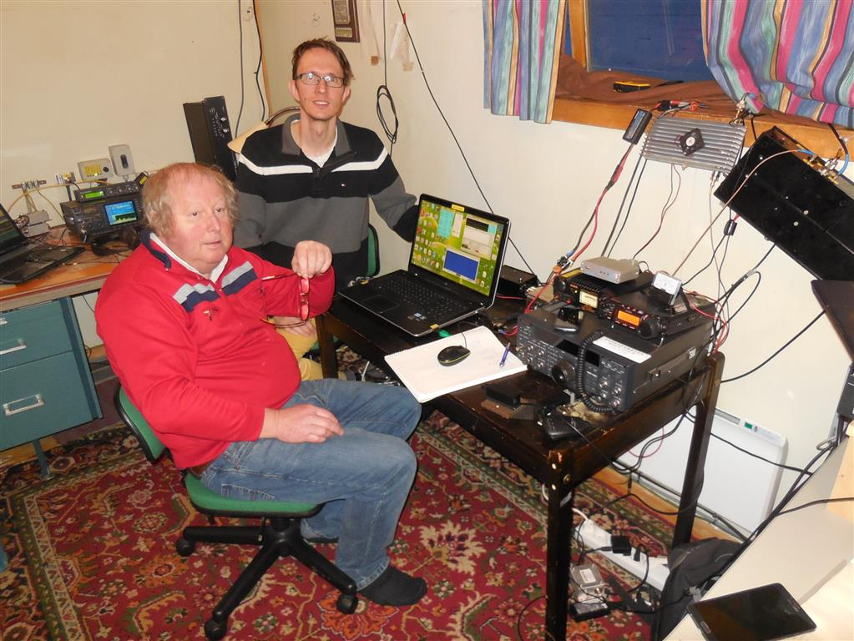
Bodo (JW/DF8DX) top and Hermann (JW/DL2NUD) inside

KL7UW: Ed is now fully QRV on 23 cm – I was unable finish for the SSB FUN test weekend, but I now have a new larger enclosure for my LNA-TR relay which is better WX-sealed and the driver amp all installed. I am thus QRV with my 4.9 m dish, IMU feed, 120 W+ from QPL SSPA and G4DDK LNA. All are going and I am ready for skeds and QSOs. Now that 1296 is working, I will next focus on 3400. My transverter is assembled and tested. It is using a A32 synth board and I have a sine-wave OCXO arriving later this month for installation in the outside dish box along with transverter and one Toshiba amp (eventually to be two amps for 120 W). I have parts ordered to modify the Toshiba amps for 60w output. My feed is VE4MA CP type, but everything will need to be mounted. I am trying to be on for the March 9 cm DUBUS contest, but am unsure if I will be ready.

N2MO: Martin (W2RWJ) mflynn(x)n2mo.org reports that the NJ 60’ big dish project is moving along. The Henry 3004 Amplifier the purchased from K6JEY made the cross-country trip to live at N2MO. The next step is pair it with their 432 EME feed on the dish. The official first EME will not be until Sunday, 10 Jan, 2016 at 11:58 AM to commemorate the 70th Anniversary of Project Diana. Prior to this event, we will be testing and using the dish in RX mode to line up the receivers and pointing.

N4BH: Pat pat(x)n4bh.com is QRV on 432 EME with 2 x 9 WL M2 yagis -– I have 200 W and a WA2ODO preamp at the power divider. I am finishing a W6PQL amp and should soon 500 W. Please pass on that I am available for skeds.

N2EME: Paul’s g6yzc(x)msn.com group has been active on 3 cm tropo, but is now seriously setting up for portable 10 GHz EME -- The EME Rovers, N4EME, are planning on being operational from FM25 NC from 20 to 26 April on 10 GHz. We will be running WA3LBI's portable 2.4 m dish and a 250 W TWTA. We hope that pretty much anyone will try to hear/work us by pointing their normally terrestrial set ups at the Moon. During station tests Jim has already worked VK7MO, who was using a 30 cm dish and 45 W. It would be nice to see how much smaller we can get. This would also be a good time for people to try out their PA0EGH LNB RX (http://www.pa0ehg.com/dl0shf2.htm) described in the Dec 2014 issue of 432 and up EME news. Our web page is http://www.emerovers. com. The ultimate aim of the EME Rovers is to put different states on the Moon and encouraging small stations to aim their 10 GHz gear skyward. Please feel free to contact us at skeds(x)emerovers.com for more information or to discuss common Moon times. We hope to publish a list of skeds on the EME Rovers web page so that people will know when to look lunar even if it is just to test their RX.

N6OVP: David n6ovp(x)pacbell.net has a very limited window to east, but did try for some QSOs in the SSB funtest -- I worked K2UYH and VE6TA SSB/CW with good signal on my CW (559). I could just copy VE6TA’s SSB enough to get his callsign. I guess my 3 meter dish is doing reasonably well. I plan to move it for a better window and shorten the hardline to 20’ feet rather than 85’ I now have. This change will gain over 100 W at the dish. Also I will see 90 AZ, so I can work EU too.

NC1I: Frank frank(x)NC1I.COM eports on his Feb activity – 23 cm activity was good on 21/22 Feb. The highlight for me was easily working JW/DF8DX, OK1TEH and EI2FG. The following 1296 stations were contacted on 21 Feb at 1514 DK0SF, 1540 SP5GDM, 1554 OK1TEH, 1602 EI2FG, 1616 PA2DW, 1624 CS7AFN, 1655 IK5VLS, 1703 LU8ENU, 1804 VE3KRP, 2149 PY2BS, and on 22 Feb at 1618 G5WQ, 1654 ES6RQ, 1704 W5LUA, 1720 PE1LWT, 1742 LU8ENU, 1756 W2LPL, 1823 IK5QLO, 2211 JW/DF8DX and 2235 W6YX, on 25 Feb at 0155 W6YX, on 27 Feb at 2039 PA3FXB, 2129 IK5EHI and 2311 UA4LCF, on 28 Feb at 0121 W6YX, 1933 DL6SH, and 2026 PA3FXB, and on 1 March at 0033 VE3KRP, 0410 K5DOG, 0637 JA6AHB, 2111 PA2DW, 2128 PA3FXB and 2136 DL6SH. All these QSOs were on JT65C. On 70 cm, I QSO’d using JT65B on 27 Feb at 0147 K5DOG, 0310 KJ7OG, 1915 ZS6JON, 1924 LU8ENU, 1944 G3LGR, 2013 PA2V and 2027 DL7APV, on 28 Feb at 2116 SM7SJR, 2141 I1NDP, 2200 DL6KAI, 2207 PA2V, 2217 G6HKS and at 2237 PA0PLY. I sure miss having polarity rotation on 70 cm. Hopefully I can get my pol repaired early this summer. I called CQ on CW during the Feb 70 cm ATP, but heard nothing other than my own booming echoes. I plan on being active again on both bands in March.

OH2DG: Eino metsamakieino(x)gmail.com sends news about his recent contest activity -- It was great to work about all of you during DUBUS/REF contests on the 70 and 13 cm bands. In the beginning on 70 cm contest, condx were quite compliant. But, I had no idea because I could not copy my own echoes at all. The stress went away after G3LTF showed up. VK3UM and others gave me (559-579) reports. The WX was really bad with a sleet storm taking place. I had to go out to clean off the dish from time to time. By the end of the contest, my echoes were back. I ended with a score of 20x20. The 13 cm leg was a much more positive experience. WX and condx were good and signals strong. It was enjoyable to work this leg. My score was 42x38. Initials on CW were S53MM, JA6CZD, DL3EBJ, OK2ULQ, DJ3FI, KL6M, SP3XBO, DL7YC and PE1LWT. TNX to JW/DF8DX and JW/DL2NUD Svalbard Island for QSOs on WSJT and CW mode.

OK1CA: Franta strihavka(x)upcmail.cz send news on his 24 and 2.3 GHz EME in Feb -- I was QRV on 24 GHz from 19 to 21 Feb, during the good days for low Moon distance and low spreading. I worked using CW on 20 Feb morning JA1WQF (O/M) for initial #7, JA4BLC (O/O) #8 and JA6CZD (O/O) #9 with very good signal (559). I tried to QSO F1PYR (O/M) for 2 hours. The WX was cloudy with a high humidity of around 80%. I had good own echoes. I also tried on 21 Feb to QSO JA1WQF on JT4F, but had no success. The problem was with my PC. I plan to be QRV from 19 to 22 March on 24 GHz again and welcome skeds on CW and JT4F. I was QRV in the DUBUS 13 cm EME Contest and made 43 QSOs at Saturday. I easily worked easy 4 JA stations on their new 2400 subband. The activity from EU was good, but I worked only 5 stations from NA. On Sunday, I worked only G3LTF for an overall score is 44x39.

OK1DFC: Zdenek ok1dfc(x)seznam.cz operated in the 13 cm DUBUS Contest -- I was QRV during the weekend. Activity from was 100% of those QRV, EU had very high activity, SA was also 100% resented by PY2BS, but I missed many stations from NA. Thanks to KL6M for DXCC 40 and an initial. I put 10 other initials in my log bring me to initial #94. My final score was 41x38. I am looking forward to the up-coming 3400 EME contest, if I can have my new transverter ready. My complete contest log is available at http://www.ok1dfc.com/eme/contest/dub13_15/ VQLogWk.htm.

OK1KIR: Vlada and Tonda vladimir.masek(x)volny.cz send a summary of their clubs Feb EME efforts – On 23 cm, we worked on 22 Feb using JT65C at 1048 JW/DF8DX (16DB/15DB) for digital initial {#211} and a new DXCC. On 13 cm, we QSO’d on 23 Feb on CW at 1550 JW/DL2NUD (O/O) for initial #142 as the 1st JW-OK 13 cm QSO and JQ field, and on 24 Feb using JT65C at 1120 IK3COJ (8DB/7DB) for digital {#23}, 1130 G4BAO (8DB/O), 1146 JW/DL2NUD (14DB/15DB) {#24}, 1404 DF3RU (9DB/O) {#25}, 1453 YO2BCT (16DB/12DB) {#26} and 1611 PE1LWT (9DB/11DB) {#27}. In the 13 cm EME contest, we were QRV only during the first moonpass. We were fascinated by the nice JA signals jumping out of the sky noise in their new 2400 band without any sign of the previous terrible WiFi interference we have had throughout the last 8 years. (We are still missing a JA station in JT mode to get Asia for completing WAC digital. On CW, we logged QSOs with DF3RU, DJ3FI, DL1YMK/A, DL3EBJ, ES5PC, F1PYR, F5JWF, HB9SV, IK3COJ, JA4BLC, JA6CZD, JA8ERE, JA8IAD, K2UYH, KL6M, LX1DB, OH2DG, OK1CA, OK1DFC, OK1KKD, OK2ULQ, OZ4MM, OZ5G, PA0BAT, S53MM, S59DCD, SM3BYA, SP3XBO #143, SP6OPN, SP7DCS, SP7JSG, SV3AAF, UA3PTW, UA4HTS, VE4MA, VE6TA, VK3NX, W5LUA, WA 6PY, WA9FWD and YO2BCT. Unfortunately we missed a few stations that were active only for a short period and were primarily searching for initials. Heard were HB9Q, IK2RTI and WD5AGO. In total we collected 41x37. On 9 cm, we worked on 21 Feb using JT65C at 1151 JW/DL2NUD (20DB/17DB) for digital initial {#7}, 1st JW-OK 9 cm QSO and JQ field.

S79EME: Peter (DJ4TC) dj4tc(x)t-online.de that plans for the Seychelles dxpedition (LI75) are on track -- I and DL1RPL will operate 2 m and 70 cm mainly, while DL2NUD will operate the microwave bands. Hermann will have his dish and should be QRV on 23, 13 and 9 cm. Parallel operation is planned on 144/432 and 1296/up. Our activity starts on 21 March and ends on 2 April. We try to be on the air on Saturday on 2 m and by Sunday have 23 cm running in parallel. We expect to have Internet at the QTH. We will use the chat pages provided by N0UK and HB9Q. You will find more information and a daily update of the log on http://www.dl1rpl.de. A schedule will be published on my Webpage, www.dl1rpl.de as soon as we know.

SM7FWZ: Ronny sm7fwz(x)arlembke.se is back on 23 cm EME after replacing my elevation actuator – My elevation rotator was destroyed in a storm earlier this year. (The same storm also destroyed my 144 EME elevation as well as 23 cm tropo system). I was able to get 1296 working again and was QRV for the "SSB fun" on 22 Feb. I worked on SSB PI9CAM, F5SE/p, SP6JLW, OK2DL, LX1DB, UA3PTW, OE5JFL, DG5CST, I5MPK, K2UYH and I1NDP for a total of 11 QSOs. My setup is 4 m solid dish, OK1DFC feed with scalar rings, 350 W SSPA at feed and G4DDK preamp.

SP6ITF: Gregory sp6itf(x)neostrada.pl was on 23 cm for the EME SSB FUNTEST – I had good fun in the contest and worked on 22 Feb at 0840 UA3PTW (55/54) KO, 0849 UA4HTS (52/52) LO, 0859 OK2DL (55/54) JN, 0904 OE5JFL (55/55) JN, 0939 HB9Q (58/55) JN, 1035 DK0SF (55/54) JN, 1105 PI9CAM (59/54) JO, 1227 F5SE/p (55/42) JN, 1330 LX1DB (59/56) JN, 1347 OZ4MM (59/54) JO, 1521 DG5CST (55/52) JO, 1528 I5MPK (55/45) JN, 1550 DL3EBJ (55/54) JO, 1624 I1NDP (55/55) JN, 1641 DF3RU (55/56) JN and 1732 K2UYH (55/54) FN for a score of 16x2x5 = 160 points.

SP6JLW: Andy sp6jlw(x)wp.pl and his group send their contest log for the SSB funtest – We worked on 22 Feb, on 1296 at 0848 OK2DL (58/58) JN, 0850 DK0SF (55/57) JN, 0857 UA4HTS (54/58) LO, 0901 UA3PTW (57/57) KO, 0914 OE5JFL (58/58) JN, 0931 HB9Q (58/57) JN, 0939 PI9CAM (58/58) JO, I5MPK (57/57) JN, 0944 VK5MC (55/55) QF, 0951 DG5CST (53/57) JO, 1008 IK3COJ (54/58) JN, 1023 SP3XBO (53/56) JO, 1025 RA3AUB (55/57) KO, 1027 F5SE/p (57/55) JN, 1106 DJ8FR (55/55) JO and 1251 SM7FWZ (54/54) JO or an overall score of 16x2x5 = 160. Operators were SP6JLW, SP6OPN and SQ6OPG. The station is a 6.5 m dish with a 16 x BLV958 1 kW SSPA and DG0VE LNA.

SV3AAF: Petros sv3aaf(x)yahoo.com found good participation during both the 23 cm funtest and 13 cm contest -- The little time that I was on for the SSB even, I never heard any CW only SSB signals near 1296! I contacted on 22 Feb on SSB at 1511 UA3PTW KO, 1517 OK2DL JN, 1531 DG5CST JO, 1539 F5SE/p JN, 1624 OE5JFL JN, 1710 I1NDP JN, 1807 K2UYH FN and 1810 I5MPK JN for a score of 8x2x4 = 64 points. During the 13 cm weekend, there were stable condx as always with a touch of "1296 like" libration sometimes. I was not on late night - went to bed, but worked OK1CA, OZ4MM, SP6OPN, OK1KKD, UA3PTW, OK1KIR, ES5PC, OH2DG, UA4HTS, HB9SV, OK1DFC, IK3COJ, DL3EBJ, DF3RU, PA0BAT, SP7DCS, DL1YMK/a, S53MM, K2UYH, LX1DB, HB9Q, DL7YC, S59DCD and SM3BYA for a total of 24x21.

TM1GM: Franck (F5SE) kozton(x)free.fr reports on the World War I (WWI) Centennial Memorial Operation/EME Test that took place from the WWI Fort, where his station is located -- The following stations were worked, on 27 Sept DL6SH (569/579), ES6RQ (569/579), G4CCH (579/589), I1NDP (579/589), I5MPK (569/579), OK1KIR (579/579), OZ6OL (569/569), PA3CQE (539/559), RA3AUB (559/569), SP6ITF (559/579), SP7JSG (559/579) and UA4HTS (569/579), and 28 Sept IK3COJ (549/569), I5MPK (579/579), ON5RR (549/559) and SP6ITF (559/579). The EME log can be found on the LoTW.QSL info on QRZ.COM. E.QSL cards as well as a special (available via bureau or direct with SASE and IRC) printed memorial QSL card. The QSL manager is F6AJM, who can be reached at f6ajm(x)orange.fr. TM1GM will be reactivated later this year. As soon as I have more info, I will let the NL know the details.

UA3PTW: Dmitry ua3ptw(x)inbox.ru made QSOs on 13 cm during the contest and also on 1296 in Feb. On both 23 and 13 cm, he added JW/DF8DX for new DXCC on JT65C. In the 13 cm contest he added initials on CW with OK1DFC (589), DL3EBJ (579), OK2ULQ, LX1DB (599), OZ5G and VE4MA for a 6x6 total. He also worked 2320 PY2BS on JT56C.

VE3KRP: Fast Eddie eddie(x)tbaytel.net has had and is still experiencing a weird winter with high winds, extreme cold temperatures and lots of snow, which has limited operating time -- As of 3 March, I have returned to work, which will limit my on air activities. I did work on 21 Feb DK0SF, NC1I, PA3CQE, PA2DW and ES6RQ – all initials on JT65C and also K2UYH on SSB for a Funtest contact. I heard EI2FG (22DB) on JT but was not able to work him. I added on 28 Feb PA3FXB, K5DOG, DK0SF, CT7AFN for an initial (#*), OE5JFL and NC1I – all on JT65C.

VE4MA: Barry ve4ma(x)shaw.ca reports on his Feb activity – It has been a very busy month with my return from Arizona for scheduled prostate surgery. I was active on 31 Jan for the 432 CW contest using my 3 m dish and 400 W. I QSO’d UA3PTW (O/549), K2UYH (O/O) and SM4IVE (529/569), and heard G3LTF and another unidentified signal (1 Feb at 0053). Later on JT65B, I worked OK1KIR (18DB) and K3MF (22DB). I then switched to 3 cm and at 0412 heard K6QPV (12DB). Greg is working on optimizing his station and we have been testing together. On 3 cm, I QSO’d on 2 Feb WA3LBI (12DB/15DB) using JT4F and circular to linear pol. His tones are very audible. I now have a circular feed available to use; however, I am going to build up a separate 10 GHz dish module for circular, so that I can go back to linear easily for small station QSOs. I did complete on 7 Feb a 3 cm QSO with K6QPV (19DB/12DB). On 8 Feb, I worked PY2BS on 432 with JT65B. I reconfigured my 3 m dish for 13 cm just before my surgery in preparation for the DUBUS contest. I had a fun time in the 13 cm contest. Although I do not have any western window, I did reasonably well and the first day QSO’d ES5PC, OK1DFC, K2UYH, VE6TA, OK1CA, OK1KIR, OH2DG, SP6OPN, F1JWF and UA3PTW. I heard OZ4MM briefly on 2320 just as one of my parallel PA modules tripped off. I bypassed the combiners and ran with ~175 W for the last of the second pass to work WA6PY and W5LUA. On the late Sunday pass, I concentrated on 2320 initially (satellite QRM is severe after about +60 deg GHA) and found G3LTF and DF3RU. Back on 2304, I worked WD5AGO and PY2BS. So I ended up with 16 QSOs. In general, I found signals very good for my little 3 m dish! Signals were best the second pass with less libration than during the first pass. I have left my 3.4 feed/rig in AZ for next fall, so I will not be QRV for the DUBUS 3.4 GHz contest, but I should be QRV for the 1296, 10 GHz & UP (I will get 24 GHz running) and 5.7 (working on RX problems ) contests in the coming months.

VK4CDI: Phil vk4cdi(x)gmail.com now has his new 5 m dish in operation –- My new dish is working well on 23 cm. I plan to also use it on 432 with a OK1DFC loop. My 3.6 m dish has the 9 cm gear permanently installed. In recent weeks, I worked PA0BAT, VE4MA/7 and K2UYH on 9 cm. It has been a quiet last couple of weeks and I will probably be out of action for a few more week as I recently had bypass surgery, and its a slow recovery.

VP2/W3XS: Al (K2UYH) alkatz(x)tcnj.edu will be teaming with Bill (W3XS) billw3xs(x)gmail.com to put the US Virgin Islands on 1296 EME. This is a very last minute dxpedition and there are still a lot of unknowns. Plans right now are to use a small dish (~ 2 m) with circular pol feed horn and about 200 W. Operation could begin as early as Thursday 16 April at about 0900, but more likely be later in the day. We plan to operate during our moon windows on 17 and 18 April. Operation near moonrise on 19 April is possible but unlikely. Please email skeds requests for 17 and 18 April with available times. We will operate at 080 and listen on our echo frequency, but as we do not know what interference will be present, may have to change this frequency. We do not know the Internet situation, but we will post last minute information on the HB9Q reflector even if we cannot actually be there real time. [The story behind this dxpedition is that I have to go to San Juan, PR on business on 12 April. I recently discovered that an old time EME friend (W3XS) was retired and living on a sailboat in the Virgin Islands. I emailed Bill about possible operation from VK2 and this dxpedition is the result. Bill is working on a dish and mount. He has found an excellent location with good moonrise and set visibility. I will be bring all the rest of the equipment including TS2000X, the feed and PA].

W5LUA: Al w5lua(x)sbcglobal.net reports on his recent doings -- On 29 Dec, I worked WA3LBI on 3 cm using JT4F for the first PA-TX 10 GHz QSO. We swapped (11DB/20DB) reports. On 14 Jan, I worked on 3 cm K6QPV in CA. VE4MA has been helping Greg achieve his first 3 cm EME QSO. I had a repeat QSO on 3 cm with WA3LBI on 23 Jan. On 31 Jan, I was able to spend a small amount of time on 70 cm CW during the DUBUS contest and worked UA3PTW, K2UYH, G3LTF, VE6TA, KL6M, SM4IVE and OK1KIR. On 22 Feb, I was able to spend a few hours on 1296 for the EME SSB Funtest. I worked I1NDP on SSB, and then went on to work on JT65C DC9UP, NC1I, DK3WG, PE1LWT, W2LPL, and JW/DF7DX. Ironically on the evening of 25 Feb, I was chasing some DX on 30 m CW and ran across JW/DF8DX. We had an easy QSO and received a nearly instant QSL on LOTW. Back to EME, on 1 March with an ice filled dish, I spent a little time on 2304 during the contest to work K2UYH, OH2DG, OK1KIR, ES5PC, VE6TA, WA6PY, VE4MA and KL6M. I also worked JA4BLC on 2400, but called many times on crossband JA8IAD, JA6CZD, and JA8ERE with no success. On the evening of 2/3 March, I listened on 2115 MHz for the lunar echoes being sent from Goldstone’s 34 m dish (DSS24) with a 20 kW transmitter. I heard their signals from about 0630 to 0900 about 40 to 45 dB dB over the noise in a 100 Hz bandwidth on the waterfall of my Flex-1500 SDR. Just before this reception, I worked KL6M on 2304.

W6YX: Robert (KG4UHM) w6yx-info(x)w6yx.stanford.edu reports on his clubs activity in the 23 cm SSB Funtest – We used the occasion to demonstrate EME to several students who have been studying for their amateur radio licenses. As a result, we only operated in the contest for about an hour, but we were pleased to have a decent QSO rate going. Our LNA and isolation relay have degraded, so our ears weren't up to par. Thank you to all the diligent callers. It was great to hear the voices of our old friends and new friends alike. The students enjoyed independently tuning around and listening to all the QSOs taking place using the three computers we had set up. They received the EME sub-band, which was being multi-casted across our network via Linrad. We made 12 contacts and 6 multipliers. QSO’d on 22 Feb were at 1731 PI9CAM (57/57) JO, 1736 F5SE/p (55/ 55) JN, 1745 OE5FJL (55/55) JN, 1749 OK2DL (56/55) JN, 1759 DK0SF J(54/55) JN, 1801 K2UYH (56/56) FN, 1806 UA3PTW (55/56) KO, 1820 W7JM (54/5?) DM, 1826 I5MPK (55/55) JN, 1832 DJ8FR (55/55) JO, 1849 I1NDP (56/55) JN and 2246 K5GW (55/56) EM. We are now starting to gear up for the DUBUS 23 and 3 cm events later this spring.

WA2FGK: Andy arfurlong(x)verizon.net and Herb (K2LNS) plan to slow down and concentrate more on EME than tropo contesting -- We have been operating and winning VHF and UHF contests for over 50 years, and those 50 years have finally caught-up with us. Maintaining our 6 towers ranging in height from 56 to 90 feet and 10 bands from 50 MHz thru 10 GHz, has proven a bit too much for our 70 year old legs. So, we have been pairing down our contest station of some equipment, which is redundant to our EME station. Herb will now concentrate on operating the low bands, while I will be building up the EME station. NO! WA2FGK is NOT throwing in the towel on Ham Radio, but will working on making WA2FGK an EME station only! As I type, WA2FGK is still active on 144 and 432, but we WILL HAVE the capability of switching feeds on our 3.6 m dish for running on 902, 1296 and 2300. We might even push the envelope a bit higher, but with 5 bands on EME, that just might be enough? Just to let the world know, our ages have changed and our priorities have changed along with them. Thanks for the many, many contacts and our 50+ years of making new friends and meeting some of the most technically competent ham operators who became mentors to us. We owe W2AZL, W2IMU and K2TKN, all SK's, for their help and inspiration. BTW, the only regret we have is not finishing WAS on 6 m. We needed Alaska and were stuck on 49 states for more than 5 years.

WA3LBI: Jim wa3lbi(x)icloud.com is now QRV on 10 GHz EME with 2.5 m dish and I believe a 250 W TWTA. He has made at least 2 QSOs and is audibly hearing the beacon strong (at sync 10 and -10 dB on JT).
WA6PY: Paul pchominski(x)maxlinear.com was QRV during 13 cm contest and sends his results – I worked ES5PC, F5JWF, JA4BLC, JA6CZD, JA8ERE, JA8IAD, K2UYH, KL6M, OH2DG, OK1CA, OK1KIR, OZ4MM, PA0BAT, S53MM, SP6OPN, SP7DCS, UA3PTW, VE4MA, VE6TA, W5LUA and WA9FWD for a total of 21x19. I couldn’t participate in the first EU window, which was still during my work hours on Friday. I was QRV for JA with a retuned down converter. Unfortunately, I discovered too late that my 2300 downconverter for VK doesn’t work. This was my very first 13 cm RX converter built in 1982. It is an old interdigital type with replaced xtal for the VK band. I found no current through the mixer and mulitpier diodes. It seems that xtal oscillator or multiplier chain didn’t work. I couldn’t get it working in the shack on the hill and due to pouring rain, I was unable to take it to the lab in the house where I have a spectrum analyzer. My window was going to the end anyway. I had only one pass to EU on Saturday. On Sunday my EU windows opened after the contest end. The new JA band 2400.100 MHz is very clean at my place. I can still see some sporadic spectrum spill from 2401 MHz due to the poor quality consumer WiFi equipment, but this is so low that it does not create QRM when aiming at the Moon. I am still using a W2IMU feed with a f/D=0.36 dish in order to lower sidelobes. I might consider revisiting using a septum feed with Kumar beam forming in order to pick up some extra illumination efficiency/gain. I should see 1 dB of Sun noise increase.

WA9WCD: John jstefl(x)wi.rr.com was active in both the 23 cm SSB and 13 cm contests – In the 23 cm SSB contest I worked OK2DL, I1NDP, OE5JFL and K2UYH for 4 QSOs. I also heard W5LUA quite well. I was only on for a short time, but this is my kind of contest! I switched feeds and operated a bit in the 13 cm contest. The first night, I worked SP6OPN, K2UYH, OK1DFC, OK1KIR, OK1CA, OH2DG, ES5PC, S53MM, F5JFW, WA6PY and K2UYH (dupe). The second pass I had to cut short due to family commitments, but was able to catch G3LTF before I had to leave. I ended with a score of 11x9. I will be switching feeds soon for the 9 cm contest. I still have no Asian window here.

WD5AGO: Tommy wd5ago(x)hotmail.com had a ruff winter weekend during the 13 cm contest – I got a late start on the first night with about 45 min of JA window left. CWNR JA8ERE and JA8IAD with good signals from the new 2400 frequency. I completed a new converter over the Christmas break and had already worked JA4BLC the month before on 2304/2400 with a clear (559) signal. Flipping back and forth from 2400/2304, heard and logged KL6M and VE6TA in the last 5 min of my window – (my house is the limit, specifically our bed room!) and JA4BLC (559). The next day, we experienced snow and ice. The dish would not turn; so I got the blow torch out and heated up the motor and gear box. This fixed it! Then, I lowered the dish for the EU window and a EL bolt broke loose. The dish fell over, but got stuck before it hit the ground. It is a good thing that it is somewhat counter balanced! I repaired the EL in the freezing/ice WX and lifted the dish back in place. NOW, I was ready for the EU window; but no signals, no nothing! I figured that I broke an RX wire someplace during the EL failure. I found one bad wire, fixed it, and was back on RX; but signal were intermittent. I called and logged SP6OPN and K2UYH, before the RX intermittent problem got worst. I am sorry for the weak station, I QRZ’d for 30 min. There was NO way to continue Saturday; I cried Uncle and yielded. I parked the dish and decided to try again Sunday afternoon. A day of rest with everything closed because of the WX, and a nap after watching NASCAR (no drag racing on TV that weekend) with slightly higher temps (-3 deg C), I took a broom and cleared the snow off of the dish. I got the other RX wire problem fixed, and with 45 min left on Sunday, was back on. I logged PY2BS, ES5PC and VE4MA. Then tick, the time rolled to 2400 and that was it for the signals. It was great fun in a twisted kind of way despite only 4 contacts. I think next time I will just work on my Electric Drag Bike, HI!

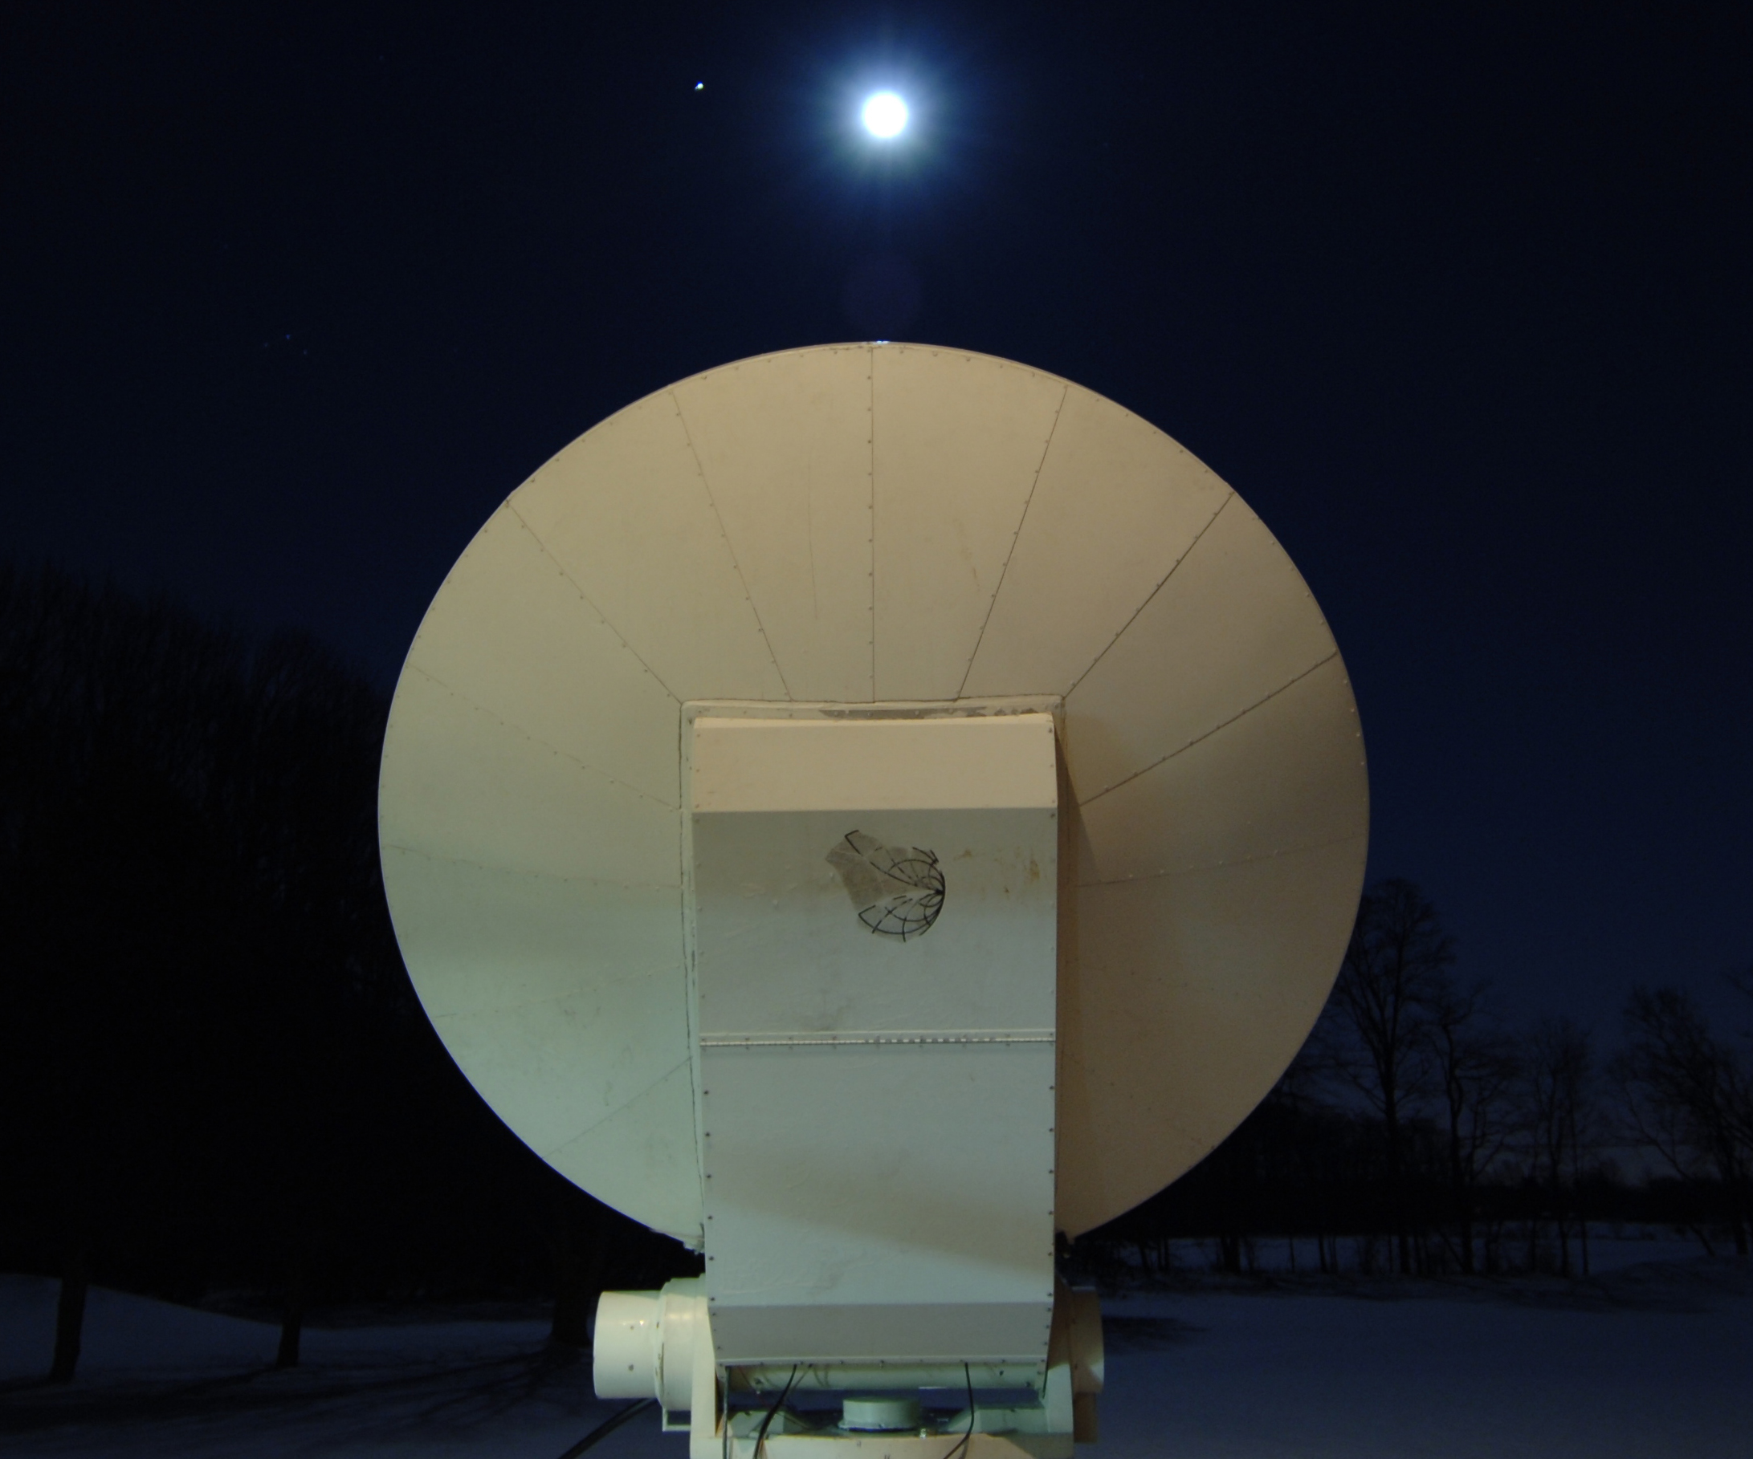
WA3LBI’s 2.5 m dish pointed at Moon
K2UYH: I alkatz(x)tcnj.edu had fun during the Feb contests and picked up another 23 DXCC. I was QRV on 21 Feb and QSO’d on 23 cm using JT65C at 1713 PA2DW (11DB/9DB), 1721 DK0SF (5DB/3DB) - new call but believed to be same station as DL6SH, 1731 LU8ENU (12DB/11DB), 1737 CS7AFN (11DEB/10DB) for mixed initial #489* and 1741 YL3EAV (14DB/12DB) #490*, and on 70 cm on CW at 1840 PA2V (559/449). I contacted the next day, 22 Feb in 1296 EME SSB contest at 2218 VE6TA (55/55) DO, 2223 VE3KRP (55/56) FN, 0336 N6OVP (559/55) CM? – CW to SSB, 1623 OK2DL (55/57) JN, 1642 I1NDP (56/57) JN, 1651 DF3RU (54/55), 1700 DJ8FR (55/55) JO, 1704 PI9CAM (56/55), 1712 UA3PTW (56/57) KO, 1715 SM7FWZ (55/53) JO, 1720 DL3EJB (55/57) JO, 1722 OE5JFL (57/57) JN, 1726 DK0SF (57/57), 1730 SP6ITF (54/55) JO, 1735 VE4SA (53/55) EN, 1740 F5SE/P (56/56) JN, 1744 W7JM (55/55) DM, 1750 RA3AUB (55/55) KO, 1801 W6YX (56/56) CM, 1806 SV3AAF (55/55) KM, 1815 WA9WCD (54/53) EN, 1834 I5MPK (55/54) JN and 1942 LX1DB (57/57) JN for a total of 22x2+1x11 = 495 points – far from my best year. K2YY joined me for part of the SSB contest and was impressed with the signal levels. After the contest ended, I worked on JT65C at 2254 JW/DF8DX (16DB/15DB) #491* and DXCC 97*. Even though their elevation was only about 1 deg, signals were very good and I also tried on SSB, but they did not copy. The next day, I was QRV on 13 cm for their only NA window, but they had problems with the wind and could not copy either my signal or those of W5LUA. The following weekend in the 13 cm contest, I QSO’d on 28 Feb at 0016 ES5PC (569/569), 0027 VE6TA (559/569), 0036 OK1DFC (569/579), 0048 VE4MA (559/569), O543 CWNR JA8ERE XB on 2400 with strong WiFi QRM, 2108 SP6OPN (569/569), 2116 OK1CA (569/569), 2119 OK1KIR (569/569), 2125 SV3AAF (559/569), 2130 OH2DG (559/569), 2141 WA9FWD (559/559), 2149 UA3PTW (559/579) XB, 2201 PA0BAT (569/569) XB, 2226 S53MM (559/559) and initial #75 and DXCC 30, 2246 UA4HTS (559/559) XB, 2252 F3JWF (559/559), 2258 SP7DCS (559/579) and 2311 OZ4MM (559/559), and on 29 Feb at 0035 WD5AGO (559/559), 0049 WA9WCD (549/559) dup, 0056 KL6M (559/559), 0104 WA6PY (569/569) and 0114 W5LUA (569/569) for a total of 21x19. NE2U joined me for part of this contest. Unfortunately I could not be on for my small window at the end because of conflicting family activities. I also missed the 70 cm CW ATP because of the 13 cm contest. I am afraid this may happen again in March as I plan to be QRV for the 9 cm contest, which conflicts. I also will be partnering with W3XS to put the US Virgin Islands (VP2) on 1296 EME during the extended weekend of 17/19 April. See report under VP2/W3XS for more details.

NETNEWS: G4BAO had a catastrophic failure of his IF transverter right before the start of the DUBUS 13 cm contest and was not able to be QRV. Hopefully he will be back on 13 cm soon. DK0SF is a club station call belonging to DL6SH. It is believed to be the same station and thus does not count as an initial. KD3UY, a new 23 cm EME station, notes he is located in MD not DE as incorrectly list in NETNEWS of the Feb NL.

FOR SALE: SMDHN announce that LABETECH 23 cm 500 W SSPAs are available. The 1000 W will be available soon. See http://www.labetech.se/en/products.php for details and to place orders. Send an email to sm4dhn(x)labetech.s for technical and financial questions. Lars sm4ive(x)telia.com is available to answer questions.

TECHNICAL FROM EA1DDO/HK1H: I have a Yaesu FT-736R with the 1296 module installed. In the past I needed to get separate TX and RX lines for easy amp and preamp setup, but I couldn´t find any information about how to do it. So, I did some research and I did it myself. Details and pictures of my modification can be found at
http://www.puertobalsillas.com/radio/Docu/YAESU_FEX_736_1.2.pdf. Hopefully you will find it useful to give some life back to this great transceiver.

ECLIPSE on March 20th: This is for the European Microwave community from G3LTF. Many will already know about the coming solar eclipse by a “super moon” at the equinox. The path of totality is up in the arctic see http://earthsky.org/tonight/supermoon-to-stage-total-eclipse-of-the-sun-on-march-20. Much of Europe will be able to observe it. Here in southern England the eclipse is from 0825 to 1040 with an 84% obscuration at 0931. (I know thats during work hours for most people.) I’m still making my plans and they will depend on the weather, especially the wind, but at present I’m thinking of measuring Sun noise in the first half on 13 cm and some of the second half on 6 cm losing about 10 minutes in a feed change. I will record the data on Spectravue continuum. I’m thinking that measurements at different microwave frequencies could yield some interesting results. Maybe some others can make measurements at 3 or even 1.25 cm?
FINAL: I found news of the deaths of both K4QI and W0DRL as I had personal relationship with both these guys. Russ or Rusty (K4QIF) as he was known back in the 60/70’s and I were involved in bringing solid-state to the microwave bands. We both had articles in QST the same month on the first transistor preamps for 1296. Russ was active on both tropo and EME. Al, W0DRL was one of the early 432 EMEers and used a 20’ stress dish. We came close to making the first MS QSO on 432 when we copied signals both ways. Al completed the first MS QSO a few weeks later with W2AZL also now an SK. Greg, WQ0P, who was a close friend, writes -- All of his stories of the early days were fascinating to listen to. Please see http://www.legacy.com/obituaries/cjonline/obituary.aspx?n = alfred-tyler&pid=174298788&fhid=25019. They will be greatly missed. Russ and Al RIP.

W5LUA reports about copying radar tests by Goldstone Radar, see http://www.amsat-dl.org/index.php/news-mainmenu-97/236-radarvermessung-asteroid-2004bl86 for more details. There are a lot of satellite and space relating tests going on that microwave EME stations may be interested in.

EME-MUD Convention Announcement – K6JEY sends an early warning to attend the 2015 Microwave Update on15-18 Oct at the Crown Plaza Hotel in San Diego. It is being hosted by The San Bernardino Microwave Society with some special programs on Sunday for EME'ers. For information see website http://www.ham-radio.com/sbms/mud2015/ or contact Doug, K6JEY directly.

VK3UM has announced that he has added additional conveniences and features to his EME Planner. He has added to the Month Data option (a month [selectable] of moon data at a glance in chart display format): Declination, Path Loss, Distance, Libration, Illumination, Rise and Set times (local and UTC), Rise and set azimuth bearings, and coincident Moon/Sun times (text format). In addition you can select (or deselect), as a composite display, most of the above the options as you wish, e.g. select Declination and path loss and you find they will not coincide until July 2017 or the peak Moon declination will not occur until Oct 2023 at ~29.15° or the lowest path loss for this year will/has occurred on the 15th Feb. If you have obstructions on your Moonrise or set, you can choose days that suit your situation as well. Detailed information for the day, hour and minute is available from the planner option as usual. Be sure to down load the latest version to see what you are missing.

The new JA 13 cm window at 2400 seems to be working out very well for everyone except me. The old JA frequency at 2424 had minimal interference. The new is a disaster. I can tell signals are there and in some cases get calls, but copy is very difficult. Some of the JA’s can operate at both parts of the band. I am glad it has worked for most. For me the best solution is to arrange for those that can to call at the higher band.

I5WBE asked me to remind you about the WW EME Italian Marathon 2015. All QSOs from 0000 1 Jan to 2400 31 Dec 2015. The rules are at http://www.eme2008.org/ari-me/Marathon%20EME%20ARI%202015.pdf

The pretty much covers the news for this month. Please keep the reports and technical material coming. It sure looks like a busy few months ahead. It is going to be hard to fit everything in. I hope to see some of you on for the 9 cm contest and on 1296 from VP2. 73, Al – K2UYH



