**432 AND ABOVE EME NEWS**

**April 2021 VOL 51 #3**

EDITOR: AL KATZ, K2UYH; DEPT. ELECTRICAL/COMPUTER ENGINEERING, THE COLLEGE OF NEW JERSEY, PO BOX 7718 EWING, NJ 08628, TEL (W 609-584-8424), (C 609-947-3889), E-MAIL [alkatz(x)tcnj.edu](mailto:alkatz@tcnj.edu)

ASSOCIATE EDITOR AND Reflector/NETNEWS Matej Petrzilka, OK1TEH, Simunkova 1609/21, 18200, Praha 8, Czech Republic, TEL (+420 603 489 490), E-MAIL [ok1teh(x)seznam.cz](mailto:ok1teh@seznam.cz)

CW INITIAL LIST G4RGK, DAVID DIBLEY, E-MAIL [zen70432(x)zen.co.uk](mailto:zen70432@zen.co.uk), AT: <http://www.zen70432.zen.co.uk/Initials/index.html>

SUN & EXTRATERRESTRIAL NOISE LIST MANAGED BY OK1TEH: <http://www.ok2kkw.com/next/nl_k2uyh/sun_table.xls>

EME INFORMAL NETS: 14.345, ~1500 SATURDAY AND SUNDAY, NET COORDINATOR: OPEN

EME DIRECTORY BY JAN, PA0PLY AT [www.pa0ply.nl/directory.htm](http://www.pa0ply.nl/directory.htm)

ON0EME EME BEACON, 1296.000 IS QRV WHEN MOON >10°, SEND RX REPORTS TO WALTER (ON4BCB) [on4bcb(x))gmail.com](mailto:on4bcb@)gmail.com)

DL0SHF 3 & 1.2 CM EME BEACONs, 10368.025, 24 TBD, SEND INFO & QUESTIONS TO Per (DK7LJ) [per(x)per-dudek.de](mailto:per@per-dudek.de).

NL EMAIL DISTRIBUTION and EMAIL LIST CORD: WARREN, W2WD [wbutler(x)ieee.org](mailto:wbutler@ieee.org)

THE NL WEB VERSION IS PRODUCED BY REIN, W6SZ [rein0zn(x)gmail.com](mailto:rein0zn@gmail.com), AT: <http://www.nitehawk.com/rasmit/em70cm.html>

**VK3UM MEMORIAL DUBUS 1296 CW EME CONTEST**

**15/16 May 2021**

**CONDITIONS:** This is a transitional newsletter (NL) with pieces we missed in the last NL. The added reports on the 9 cm Dubus Contest gives the lead to OK1KIR with a total of 24x20. We have not included information on the 3 cm Dubus Contest or KB7Q’s AR/MS/AL State dxpedition taking place as we write – see Gene’s report. They will be covered next time. Coming up on 24/25 April is the ARI EME Spring Contest. The Rules can be found at <http://www.eme2008.org/ari-eme/contest2021.html>, and on **15/16 May the Dubus 1296 CW VK3UM Memorial Contest. This is the BIG ONE, you will not want to miss.** Dxpedition wise, SV5/HB9COG will be QRV from Rhodes stating on 23 May on 23 cm and continue up the bands to 3 cm on 30 May and back to 1296 on 31 May. See Dan’s report in this NL. HS0ZOP expects to be QRV on 1296 by the end of May.

**Microwave Activity Weekends (MWAWs):** The idea is to get all those with capability on a specific MW band to come on and make QSOs, run tests for those needing signals, test new feeds, preamps etc. No pressure, no scoring, use the reflector, use any mode, just be active on the band and make QSOs. G3LTF has proposed MWAWs on 3-4 July for 3.4 GHz, 31 July-1 Aug 2.3/2.4 GHz and 28-29 Aug for 5.7 GHz. The dates at times of at low spreading for 10 and 24 GHz have passed. [See OK1DFC’s comment in FINAL section. We suspect more dates 10 and 24 will be added for the summer].

**Q65** is increasingly being used on all the EME bands. On the upper microwave bands (10 & 24 GHz), it appears to have totally replaced QRA64. Many comments on Q65 are in this NL. In particular see KA1GT’s report. **The following are comments on Q65 sent in by K1JT:** Q65 takes advantage of many EME-inspired features in WSJT-X, including full Doppler control and better sensitivity than JT65, especially in conditions with large Doppler spread. As noted in the last NL, Q65 has a large number of permissible submodes: 22 of them in all, optimized to cover a wide variety of propagation types including tropospheric scatter, rain scatter, ionospheric scatter, and TEP, as well as EME. This can lead to confusion about which submode should be used for EME on each band. It will be a big help if EME users can come to agreement about the default Q65 submode to be used on each band. It's also useful to have recommended default Q65 frequencies as the "meeting place" on each band. Our current recommendations for Q65 submode and default frequency is near the bottom of page 2 of the Q65 Quick-Start Guide <https://physics.princeton.edu/pulsar/k1jt/Q65_Quick_Start.pdf>.   
[For the 432 up bands, they are on 70 cm Q65-60B, on 23 thru 9 cm Q65-60C, and on 6 cm and 3 cm Q65-60D. Joe does not make a recommendation for 1.25 cm and above; and notes his group would be happy to adopt different recommendations and asks for feedback from the EME community].

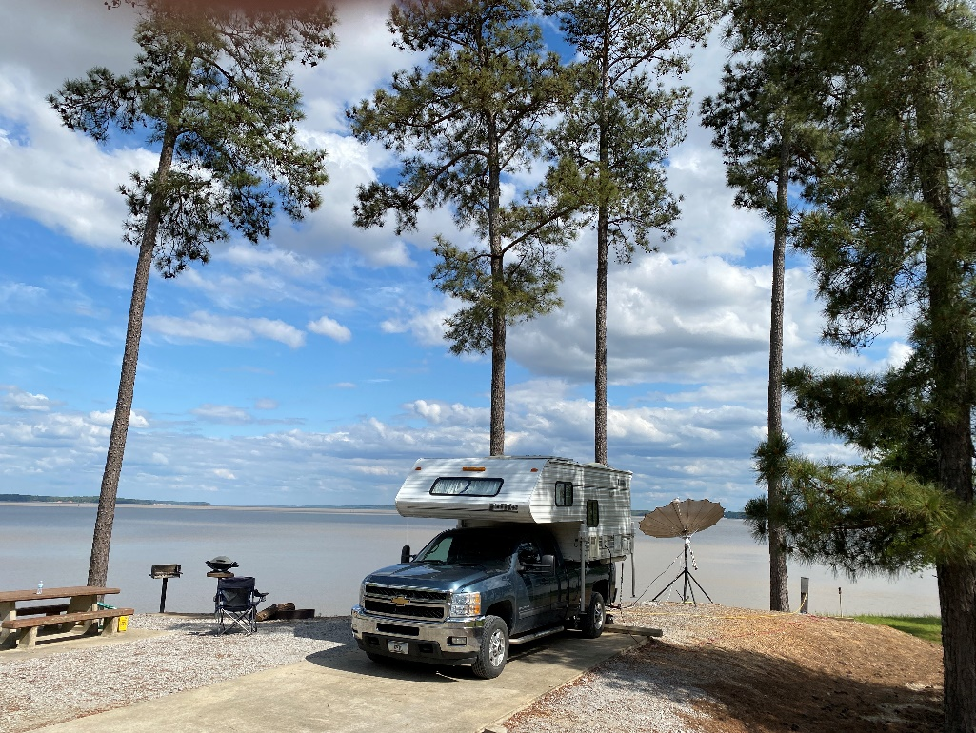

**KB7Q’s camper and 2.4 m folding dish in Mississippi**

**REPORTS:**

**DK3WG:** Jurg [dk3wg(x)web.de](mailto:dk3wg@web.de) reports – I worked in March on 70 cm using JT65B JG2TSL with 50 W for **mixed initial #900\*** and N5NHJ; but no initals on 23 cm.

**DL0SHF:** Christoph (DF9CY) <df9cy(x)web.de> writes that the 23 cm station at DL0SHF has not had a TX for several months – There were no QSOs made since Nov. Hopefully, this situation will change soon as a new driver amp is on its way. However, the station was heavily used by the WSJT team (led by G3WDG) for testing and development of Q65. Charlie wrote in his report about the superiority Q65. I found Q65 worked very well on 6 and 2 m, where I used it from my home station. On 432, I have put 2 X 9 el DK7ZB yagis on a telescope mount for easy Moon tracking. I plan to become QRV on 70 cm EME and am looking for some equipment – [see For Sale section].

**F2CT:** Guy [f2ct(x)wanadoo.fr](mailto:f2ct@wanadoo.fr) is now QRV on 3 cm -- After two years of hard work, I have my 10 GHz system optimized and working well with my 4 m solid dish. I received for the first time Sun noise at 16.8 dB. The tracking and position accuracy is 0.4 degs and the dish’s beam width is 0.56 degs at +/- 3 dB. I will be QRV during the REF-Dubus and ARI EME Contests on 10 GHz only. A big TNX to all those who made 3 cm possible.

**G4BAO:** John [john(x)g4bao.com](mailto:john@g4bao.com) plans to be on 10 GHz for the Dubus Contest and the following week – I’m looking for skeds on any mode. I have 1.1 m offset dish with 20 W and a 0.7 dB NF. Due to trees, my Moon window begins after 191 degs AZ, although I have another short window from about 98 to 125 degs depending on dec.

**G4RGK:** Dave’s [zen70432(x)zen.co.uk](mailto:zen70432@zen.co.uk) was missed last month but is here now -- At the end of Dec I was able to work HS0ZOP for DXCC #106 on 70 cm. Work, WX and family pressures kept me off EME for most of Jan. In Feb, I was QRV in the Dubus 432 CW Contest, but had some equipment problems, which along WX limited my activity. Conditions seemed quite good with excellent echoes. I started on Saturday 20 Feb soon after moonrise and worked I2FHW (O/O), DL6SH (559/569), OE5JFL (549/559), DG5CST (559/549) for an initial (#), OH2DG (559/559), OZ4MM (569/549) and OK1KIR (559/559). I was forced to close down by high winds at 1640 and lost the rest of the pass. On Sunday, I came on in the afternoon after the winds had dropped and added UA3PTW (579/579), NC1I (579/569), ES5PC (O/O), VE6TA (559/549) and WA6PY (O/O) after about 30 minutes of trying – TNX for really satisfying QSO. I ended with a score of 12x12. There were many regular stations who were missing, but the WX in Northern EU was particularly bad.

**HS0ZOP:** Alex (HB9DRI) [hb9dri(x)emeham.com](mailto:hb9dri@emeham.com) brings us up to date on his Thailand dxpedition -- After a success operation on 70 cm, where I accumulate 24 DXCCs and 168 QSOs; I’m now preparing my 23 cm station. I know many of you are still awaiting QSLs. I can confirm receipt of many QSL cards at HB9Q. Actually, I manage to be in Switzerland for 5 weeks, and am waiting for the my cards to arrive from a print shop in Germany. I expect to send all of them by the end of April. My permit to operate EME has been extended and soon will be extended for third time to allow to operate on 23 cm. The AZ/EL system is running and soon my 4 m dish will be up. I must quarantine in Bangkok after my arrival. This means that I should start working on the antenna around mid May. I hope to be in operation by the end of May. Some people have request me to go on 6 m; unfortunately, my permit dose not cover 50 MHz and I have no equipment for 6 m. On 23 cm, I will operate with 500 W at the feed and am expecting good signals.

**IK1FJI:** Valter [valter_dls(x)yahoo.it](mailto:valter_dls@yahoo.it) says he was not very active in March but still made some nice QSOs on 1296 -- I worked the following stations using CW and SSB: DU3T (559/559) for an initial (#) and DXCC, DG5CST (579/579), PY2BS (569/579), DU3T (559/569) again, PA3DZL (569/569), OK2PE (O/O) (#), IK3MAC (579/569) and (56/55) on SSB, PA3FXB (559/569), OK2PE (559/579), ON5GS (549/559) and on SSB and OM4XA (O/O) (#). I also made some QSOs using JT65C. My activity, however, was limited by some problems with my TX/RX cables. I hope to have these fixed before the ARI Contest. If all is OK, I will be QRV on 23 cm CW/SSB during the contest.

**KA1GT:** Bob [ka1gt(x)hotmail.com](mailto:ka1gt@hotmail.com) reports on his results on 1296 with Q65 -- In the last two months I've been concentrating on 1296 EME using Q65-30B. For the last month I've been running on 1/2 power (~ 140 W at the feed) since I'm working on the PA indoors rather than having it out at the base of my 3 m dish. Despite the lower power, I can still make Q65-30B contacts with just about anyone I can hear/see. I have made around 100 QSOs. Q65-30B is fast, pretty sensitive (only about 2 dB less than Q65-60C or JT65C with Deep Search enables), it doesn't report false decodes, it has auto-sequencing and effective averaging. Q65 also has the option of 60s, 120s and 300s modes for EME if signals get really weak. It can also decode multiple signals in the audio passband. Q65 also has shorthand tones (decoded by eye) if you really want them, but so far, I've never needed them. Despite these features, the vast majority of 1296 stations are still using JT65C for some reason. If you haven't tried it yet, download WSJTX 2.4.0 - rc4 (or whatever the current rc). See <https://bobatkins.com/radio/Q65-basics.html> for a basic summery of Q65 operation. As of 16 April. I've worked KB7Q, on his dxpedition in grid squares DM52, EM45, DM25 and DN45, using both Q65-30B and JT65C and I'll be looking for him on the rest of his trip. Great work Gene!

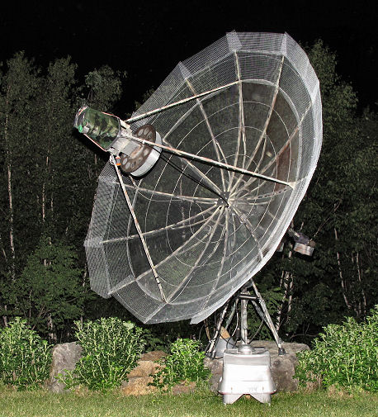

KA1GT’s extended dish with 23 cm feed

**KB7Q:** Gene [geneshea(x)gmail.com](mailto:geneshea@gmail.com) is already on his way to Arkansas (15/17 April), the first stop of his 1296 WAS dxpedition to Ark, Mis, Alb and KY – I put New Mexico (DM52) on the Moon on 28/29 March with great success. I camped right on the Continental Divide at 6,400’ in cool, but calm WX with open skies. A full Moon made it even nicer. I made 34 contacts using JT65C unless noted in total with a 2.4 m folding dish and 275 W. Logged were K5LA on ground wave (115 miles), DG5CST (9DB), UA3PTW (12DB), HB9Q (1DB), OK1KIR (5DB), ON4AOI (17DB), N1AV (17DB), ES3RF (21DB), DL8FBD (19DB), SM6CKU (11DB), DK4RC (7DB), OK1IL (15DB), OM3XA (21DB), PA3FXB (17DB), SM5DGX (16DB), VA6EME (17DB), DK5YA (22DB), DG5CST (429) on CW, OK1KIR (419) on CW, W2HRO (27DB), K2UYH (11DB), DF2VJ (25DB), KA1GT (19DB) using Q65-30B, PA0BAT (21DB), K4EME (25DB), OK1DFC (23DB), VE3KRP (24DB), PA3DZL (14DB), DF3RU (10DB), CX2SC (19DB), OM4XA (24DB), SP5GDM (23DB). KB2SA (25DB) and W2HRO (22DB). **I will then head over to Arkansas (EM45) on 16/17 April – moonrise 1500/1530, Mississippi (EM53) on 19/20 April – moonrise 1730/1800, Alabama (EM64) on 22/23 April – moonrise 2000/2000, and Kentucky (EM77) on 23/24 April - MR 2100/2200**. See <http://kb7qgrid.blogspot.com> for last minute information.

**OK1CA:** Franta’s [fr.strihavka(x)seznam.cz](mailto:fr.strihavka@seznam.cz) full report on the 9 cm Dubus Contest follows; there was a partial report in the Mach NL -- When I planned to participate in the DUBUS 3400 Contest, I assumed that the weather would be decent in March. Unfortunately, winter returned. On Saturday morning, when I installed my feed with TRX, my 10 m dish was frozen at a temperature -5º C. My first QSO was VK3NX (XB) 3398/3400. This was followed by QSOs with OK1KKD, OK1KIR, OH1LRY, OZ5G, SP3XBO, PA3DZL, DL4DTU for initial #67, ES5PC, DF3RU, G4NNS, G4CCH, W5LUA, PA0BAT, WA9FWD, VE6TA and W5AFY #68. Outside the Contest, I worked using JT65C KN0WS. On Sunday, I was only QRV for the first 3 hours and added OK1CS, OK1DFC and VK4AFL. I ended with a contest score of 20x15, and was pleased with two new stations, both with nice signals.

**OK1KIR:** Vlada [vlada.masek(x)volny.cz](mailto:vlada.masek@volny.cz) and Tonda send info on their end of March report -- On Friday, 19 March, before the 9 cm DUBUS Contest, we worked on 23 cm using CW at 1056 DU3T (569/559) for initial #477 and a new CW DXCC & PK field, 1443 LA3EQ (549/569) and 1502 LA1TN (549/579) #478; and using JT65C unless noted at 0948 RA9FLW (25DB/16DB) for digital initial {#408}, 1007 EW7CC (22DB/20DB) {#409}, 1641 VE3NXK (14DB/11DB), 1648 AA4MD (1DB/7DB), 1701 SM3KPX (15DB/17DB), 1715 ON4LX (11DB/O), **1755 4X1AJ (16DB/5DB) XB 1268/1296**, 1946 W2LPL (10DB/17DB), 2009 KB7Q dxpedition in DM23 NM (14DB/10DB) {#410}, 2021 KB2SA (4DB/9DB) {#411} and 2215 KA1GT (5DB/6DB) using Q65-30B. We QSO’d using CW in the 9 cm part of the Dubus Contest, on Saturday 20 March at 0910 VK3NX (559/559), 0919 OK1CA (579/579), 0944 OH1RLY (559/579), 0950 OK1KKD (559/579), 1020 SP3XBO (559/559), 1117 DF3RU (569/569), 1124 PA3DZL (569/569), 1144 ES5PC (569/579), 1231 DL4DTU (559/569) for initial #85, 1343 HB9Q (579/559), 1420 G4NNS (569/569), 1511 PA0BAT (569/559), 1551 G4CCH (569/579), 1816 W5LUA (579/569), 1826 WA9FWD (569/559) and 2017 VE6TA (569/569); and on Sunday 21 March at 1000 VK4AFL (559/559), 1025 OK1CS (549/559), 1034 OK1DFC (549/559), 1359 OZ5G (569/559), 1919 OH2DG (569/569), 2004 VE4MA (559/559), 2030 LX1DB (579/569) and 2044 K2UYH (569/579) for a contest total 24x20. In addition, we were heard at K8ZR. Off the contest we worked with JT65C on 20 March at 1405 OZ5G (4DB/O) and 1901 KN0WS (16DB/O), and on Sunday 21 March at 1941 G4DDK (17DB/10DB) for digital initial {#41} and 2016 VE4MA (6DB/7DB) {#42} and a new JT DXCC. During 10/24 GHz AW on 26/27 March, we combined CW QSOs with Q65-60D. We worked on 3 cm on Friday 26 March using CW at 1634 IW2FZR (549/559), 1735 DB6NT (569/569), 1901 IK6CAK (549/559) for initial #139, 1920 HB9BBD (569/569), 1929 UR5LX (449/559), 2222 CT1BYM (O/559) #140 and 2103 IK0HWJ (569/559) - for 7 CW QSOs; in between using Q65-60D at 1642 HB9DUK (5DB/7DB), 1649 IZ4BFA (13DB/11DB) for digital initial {#216}, 2004 ON4BHM (19DB/4DB) {#217} as his 1st QSO on 3 cm with 3.7 m dish and 3.5 W, 2054 IK0HWJ (4DB/7DB), 2231 W3SZ (7DB/7DB), 2237 OE4WOG (7DB/9DB) and 2241 CX2SC (16DB/11DB) {#218} new from GF25; and on Saturday 27 March using Q65-60D at 0045 CX2SC (14DB/8DB) repeat with nice signal after rig upgrade. We were heard on 27 March by 3B8DU (13DB) with a 3 m dish in Mauritius. We never made it on 24 GHz due to some troubles and coming intense rain. We returned to 23 cm to work 27 March using CW at 1927 I5YDI (559/549) and 2006 DL1AT (O/O) #79 and using JT65C at 1936 I7FNW (1DB/1DB), 1942 YO5BIN (12DB/19DB) {#412}, 2028 ON4BCV (13DB/16DB) and 2049 DK1KW (15DB/12DB) {#413}, and early on 28 March using JT65C at 0116 KB7Q (6DB/6DB) {#414} from DM52 in NM and later repeated with CW at 0328 KB7Q (O/O) #480.

**PA0PLY:** Jan [pa0ply(x)pa0ply.nl](mailto:pa0ply@pa0ply.nl) is relocating -- I'm in the process of moving to the eastern part of the Netherlands, approx 10 km from the German border. My 70 cm array is already down and went PA3DOL. I am taking my dish with me, but do not expect any RF activity until the end of the year.

**PA2V:** Peter’s [pa2v(x)advipe.nl](mailto:pa2v@advipe.nl) log was also missing from the March NL; which was an excellent month for him on EME – On 432, I worked using JT65B unless noted on 13 Feb at 1048 HS0ZOP (20DB/20DB), 1524 KU4XO (27DB/15DB) and 1804 OZ1SKY (24DB/18DB), on 15 Feb at 1820 OZ1SKY (21DB/16DB), on 16 Feb at 1823 DL8DAU (24DB/22DB) using Q65, 1833 EA5CJ (20DB/22DB) using Q65, NC1I (1DB/6DB) and 1938 KU4XO (23DB/17DB), on 17 Feb at 1733 F5OAU (20DB/20DB), 1915 VE6TA (15DB/14DB), 2009 DL7APV (6DB/16DB) using Q65 and 2125 9A5M (27DB/24DB) and 2023 PA3DZL (13DB/9DB), on 20 Feb at 1307 VK4EME (17DB/19DB) using Q65, 1405 JJ3JHP (27DB/14DB), 1457 7M2PDT (19DB/27DB) using Q65, 1513 DL8DAU (24DB/19DB) using Q65, 1658 OK1KIR (559/559) using CW, 1619 OZ4MM (559/559) using CW, 1633 I2FHW (559/529) using CW, 1951 VP8EME (27DB/27DB), 2013 SP6JLW (O/O) using CW, 2045 UA3PTW (579/579) using CW, 2107 DL7APV (579/579) using CW, 2143 W7MEM (18DB/17DB), 2155 DN5HR (18DB/12DB), 2204 N0AKC (25DB/O), 2212 VE6TA (539/559) using CW and 2238 WP4G (28DB/20DB), on 21 Feb 1451 DL9KR (579/579) using CW, 1511 HS0ZOP (17DB/18DB) using Q65, 1535 JA6AHB (17DB/7DB) using Q65 and 1541 ES3RF (20DB/13DB) using Q65, on 22 Feb at 1949 PA4VHF (17DB/8DB), on 23 Feb at 2011 UB4UAA (25DB/13DB) using Q65, on 24 Feb at 1723 G4YTL (20DB/15DB), 1729 G4YTL (19DB/13DB) using Q65, 1741 OK2AQ (28DB/23DB) using Q65 and 1933 SM5EPO (24DB/23DB), on 25 Feb 1643 DG5CST (8DB/16DB) and 2023 SM3KPX (26DB/17DB using Q65, on 27 Feb at 0535 KU4XO (25DB/16DB), 0546 NC1I (1DB/2DB), 0605 PA4VHF (15DB/4DB), 0625 DL8DAU (26DB/19DB), 2131 EA5CJ (29DB/11DB) and 2139 OK2AQ (26DB/22DB), and on14 March 1005 BD9BU (27DB/19DB). I was very happy to add 9A5M with his small EME setup and no elevation. VP8EME was a good surprise. I caught him when he was trying to work a DL station and a bid of trying was able to make the QSO. In March we had some terrible weather with big storms and wind gusts up to 110 km/hr. It was scarry to see the yagis dancing in the wind, but gladly they survived, and I remain QRV and looking for more QSOs.

**PA3DZL:** Jac [pa3dzl(x)icloud.com](mailto:pa3dzl@icloud.com) sends info on activity in March and April – After the 9 cm contest reported on last month, I switched to 23 cm and was very happy to work some nice initials on CW with DU3T for mixed initial #385* and DXCC 80 and OK2PE #386*, and using JT65C with OM4XA #387*, DL1RMW #388*, RA9FLW #389*, DK1KW #390*, LA1TN #391*, KB7Q from New Mexico #392* and a new State, RJ3DC #393*, JH3AZC #394*, IK7EZN #395*, KD5FZX #396* - very strong and IK7UXW #397*. During the last few months, the WX was bad; in spring, I hope to test a new 23 cm feed. I am still using my old VE4MA feed with polarizer screws. I build it back in 1990 for use at our Radio Observatory in Hoeven. I have to finish my 24 GHz EME rig and am looking forward to being QRV soon. PA7JB who has now made 2 QSOs on 1.25 cm, has been a great motivator. I plan to be QRV on 3 cm for the upcoming Dubus Contest.

**SV5/HB9COG:** Dan (HB9Q) [dan(x)hb9q.ch](mailto:dan@hb9q.ch) on his May microwave dxpedition to Rhodes -- Although the Covid-19 situation is not good in EU, we still hope to be able to fly to Rhodes on 8 May. Tickets and rented home are paid for. Everything is ready. We will keep the community informed. Look for updates on our web-page. Operation will begin on 23 May on 1296.100 using JT65C (1st, RX on own echo) 0330 to 1630, 24 May on 2320.100 JT65C SV5/HB9COG (1st, RX on own echo) 0415 to 1730 (2301.990, 2400.100, 2304.100 by request), 25 May on 3400.100 JT65C (1st RX on own echo) 0500 to 1800 (3399.990 on request), 29 May on 5760.100 Q65 0900 to 2130, 30 May 10368.100 Q65 SV5/HB9COG 1010 to 2200 (10450.100 on request), and 31 May 1296.100 JT65C (1st RX on own echo) 1115 to 2245.

**TX7EME:** Giulio (IW3HVB) [giulio(x)iw3hvb.it](mailto:giulio@iw3hvb.it) sends good news about his postponed 23 cm dxpedition to French Polynesia -- I am preparing for it, and believe it will happen this time. A new 2 m dish is ready, along with the feed and cables. I will bring a couple of 300 W SSPAs just to be sure. I have the license, call TX7EME confirmed again. I will be active from Rangiroa Atoll (BH65ea) with optimum moonrise on the ocean, right in front of my bungalow. I should arrive on 28 Aug and will leave on 4 Sept. There should be enough time to give new ones on 1296 to many stations. The EU windows will be quite short, so, I expect roaring pileups at moonrises. For NA and JA there will be plenty of time to enjoy the QSOs. I will have HB9Q logger at hand. Let's hope Mr. Murphy take a vacation.

**UA3PTW:** Dmitry [ua3ptw(x)inbox.ru](mailto:ua3ptw@inbox.ru) was active on 432 EME in March and added initials using JT65B with F1RJ, DC2TH, G8UDI, N5NHJ and KC9FFV; and on 1296 using CW DU3T in Philippines and on

JT65C KB2SA, YO5BIN, DK1KW, DL1AT, KB7Q in AZ (DM52) and RJ3DC.

**VE3KRP:** Fast Eddie [eddie(x)tbaytel.net](mailto:eddie@tbaytel.net) reports on his March 1296 activity -- I haven't been too active due to bad winter WX conditions (high winds etc.), but I did manage to be on for KB7Q in New Mexico and Arkansas for new WAS States. I worked on 23 cm using digital modes KB7Q, OK1DFC, CX2SC, ES3RF and KB2SA for a mixed initial (#)*. On 16 April working KB7Q (AR) was a tough go as I later found out due to my elevation being off due to ice. Then on 17 April I added using JT65C AA4MD, DF3RU, IK7EZN (#), KD5FZX, IK3COJ and RA4HL. I heard OK1USW calling, but lost him.

**VE6TA:** Grant [ve6ta(x)xplornet.com](mailto:ve6ta@xplornet.com) reports on his Dubus 9 cm Contest effort – I QSO’d using CW VE6BGT, VK4AFL, VK3NX, DF3RU, OK1CA, ES5PC, OK1KIR, OH1LRY, PA0BAT, W5LUA, PA3DZL, G4NNS, G4CCH, K2UYH, OK1CS and VE4MA for a score of 16x14. After the contest, I worked VE6BGT and OK1DFC on both CW and JT65 to bring me to initial #55 on 3400. There was a good turnout this year, but unfortunately not a lot of NA stations. I plan to be on 10 GHz for the Dubus CW Contest, and will keep my fingers crossed that a few can hear my CW signal off of my homebrew dish.

**W5LUA:** Al [w5lua(x)sbcglobal.net](mailto:w5lua@sbcglobal.net) sends his March/April report for the NL -- On 19 March I made my first Q65-60D QSO on 3 cm by working IW2FZR. During the 9 cm Dubus operating event, I worked OK1KIR, DF3RU, SP3XBO, OK1CA, WA9FWD, OH1LRY, G4CCH, ES5PC, PA0BAT, OK1KKD, PA3DZL, G4NNS, W5AFY, VE6TA, K2UYH, OH2DG, VE4MA and OK1CS all using CW for at total of 18x14. On JT65C, I worked KN0WS, G4DDK and OK1DFC. I worked on 27 March, on 24048 OK2DFC using both CW and Q65-60D modes; and on 28 March, on 10368 CX2SC using Q65-60D. **With regard to my 47 GHz project,** I have spent the last few months modifying a VPW2874 TWT power supply for my Hughes 932H. This power supply is working and my tube puts out 28 W on 47 GHz, but I think I am taxing the limits of a 15 kV Rowe high voltage connector. My collector voltage is 14.3 kV, and I am having some arcing issues. I am considering going with individual HV connectors for each of the 6 HV leads. Tests are continuing. [Al has short presentation related to his power supply work at [http://www.ntms.org/files/ Feb2021/W5LUA_47GHz_TWT_Powersupply.pptx](http://www.ntms.org/files/%20Feb2021/W5LUA_47GHz_TWT_Powersupply.pptx)].

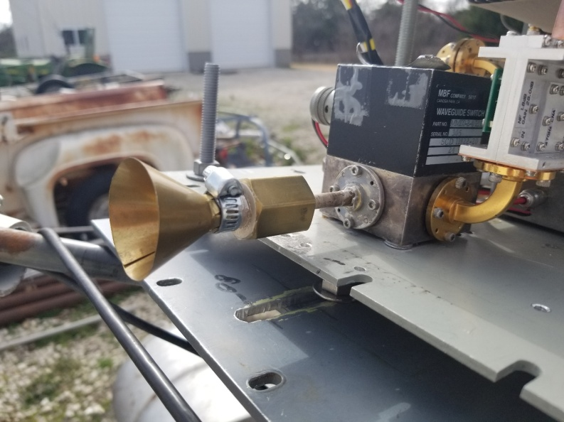

**W5LUA’s 47 GHz EME feed with W2IMU feed with flare and JA8CMY’s 2 dB NF LNA**

**K2UYH:** I (Al) [alkatz(x)tcnj.edu](mailto:alkatz@tcnj.edu) believe I have solved my preamp failure problem but lost a few more LNAs in the process. It turned out to be a wall wart type power supply that was intermittent and finally failed. I worked on 10 April on 1296 using JT65C unless noted at 1350 AA4MD (6DB/6DB), 1355 DK1KW called but lost, 1401 LA3EQ (11DB/O), 1410 IK7UXW (14DB/O) for mixed initial #655*, 1432 G4CCH (569/579) using CW and 1457 G4FQI (1DB/4DB), and on 432 using JT65B at 1557 PA1BVM (20DB/26DB) for mixed initial #1030* - horiz only; on 11 April still on 432 using JT65B unless noted at 1359 PY2BS (10DB/O), 1412 DL8DAU (11DB/25DB), 1425 ZS4TX (6DB/22DB), 1444 S57M (5DB/14DB) #1031*, 1538 DL2HWA (10DB/19DB), 1545 S57M (559/559) CW for initial #748, 1556 9A5M (27DB/24DB) #1032* and 1608 KD2LGX (23DB/O); and on 14 April on 432 using JT65C at 2108 W2HRO (10DB/11DB. I will be focusing on KB7Q’s States dxpedition, as Gene is going to the last 3 States I need for WAS. As a result, I will probably miss the 10 GHz contest. It will depend on timing. I will try to be on for the ARI contest.

**NET/CHAT/LOGGER NEWS: UA4AQL** worked on 432 using JT65B ON4AOI for an initial – [TNX DK3WG for forwarding info]. **K6JEY** is working on a new portable 23 cm station. Doug has a 6' umbrella dish and 150 W. Look for him this fall on the digital modes. **N6OVP** is already preparing for the 1296 VK3UM Memorial (Dubus) CW Contest in May. David is also interested in 23 cm skeds and can be reached at [n6ovp(x)pacbell.net](mailto:n6ovp@pacbell.net). **PY2BS** is back on 70 cm, still using his 5.1 m dish and 600 W at the feed. Bruce will be on the HB9Q logger looking for QSOs. **CX2SC** is finalizing his 6 cm EME system and hopes to be QRV soon. He sends his thanks to those who have helped him. **UR5LX** is preparing to get start with 24 GHz EME.

**FOR SALE:** **DF9CY** is looking for a 28/432 transverter 28/432 and an SSPA with > 300 W. Contact Christoph at [df9cy(x)web.de](mailto:df9cy@web.de). **CX2SC** is looking for a 5.7GHz driver and/or SSPA. If you can help contact Rick at [cx2sc.base(x)gmail.com](mailto:cx2sc.base@gmail.com).

**47 GHz EME – what’s new:** [written by OK1TEH]. 47 GHz EME experiments are often done in the Northern Hemisphere during later winter when there is low humidity and low temperatures. In April, WX has started to warm and spring arrived with rain and thunder storms. So, most tests have stopped and will continue again in autumn.

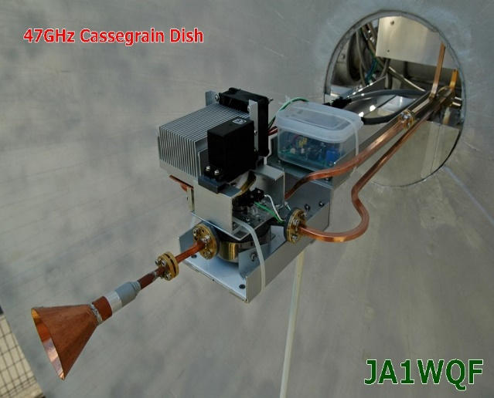

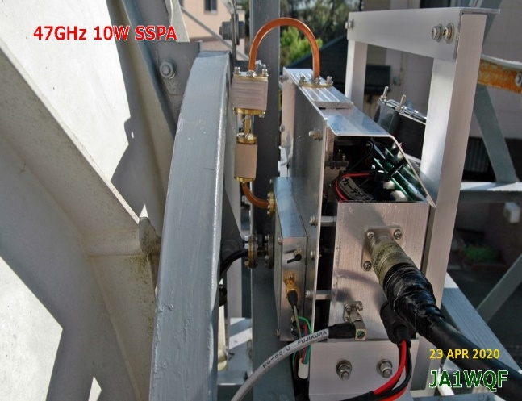

Solid state high power amplifiers remain major obstacle to 47 GHz EME success. There are available 10 W chips; however, getting the heat from them is a big problem. Thus far only JA8CMY and JA1WQF have reported success with a 10 W SSPA (9 W at antenna). DC7KY and DL7YC have bought 20 W TWTAs; and are right now trying to make a QSO using Q65-60E. They saw each other in March, so a QSO should be near. DK3UC is working on 38 GHz TWTA, as well as VE4MA. PA0EHG bought a 40 W Hughes 8000 TWTA for 38 GHz, which he is trying to retuning to 47 GHz – see <http://pa0ehg.com/47ghzeme.htm>.

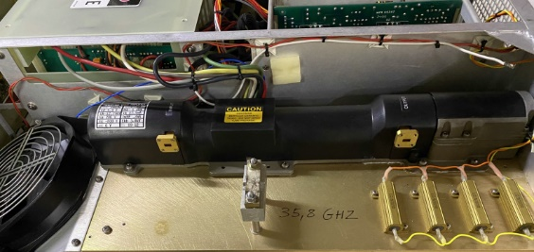

**PA0EHG’s 38 GHz 40W TWTA with WR22 output**

JA1WQF has sent a few pictures from his experimetns with DC7KY and DL7YC.

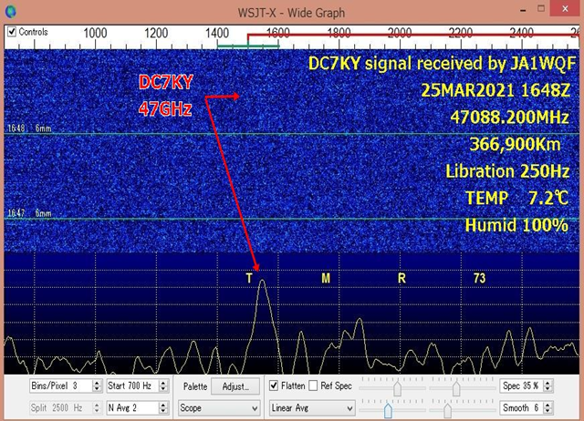

**ASTRONOMICAL CORNER (led by OK1TEH) Here is a short but interesting report regarding Pulsars: As is well known, Pulsars are spinning neutron stars created by a supernova explosion. Thanks to their rotation, they flash at us frantically in the radio spectrum, in visible light, and also as X-rays and gamma rays. We know of almost 2800 such pulsars. But, only a handful of them occasionally fire a so-called giant radio pulse, which lives up to its name. These are extremely short and energetic emissions of radio radiation many times stronger than typical pulsar radio pulses.**

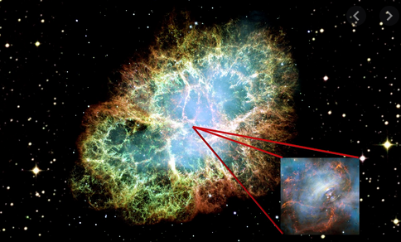

**Crab Pulsar (PSR B0531+21) (7175 LY from Earth)**

**at RA: 05 h 34 m 31.97 s, DEC: +22° 00' 52.1"**

**One of the few pulsars that can deliver giant radio pulses is the Crab Pulsar, the remnant of a supernova from 1054 that now dominates the Crab Nebula. It is a neutron star with a diameter of about 25 kilometers, which rotates about once every 33 milliseconds. It is located in the constellation Taurus, about 175 light-years away. It is one of the brightest pulsars in the sky in both the X-ray and radio spectrums. Between Aug 2017 and Aug 2019, lead scientist Teruaki Enoto (at the RIKEN Cluster for Pioneering Research in Wako, Saitama prefecture, Japan) and his colleagues used NICER (NASA’s Neutron star Interior Composition Explorer) to repeatedly observe the Crab pulsar in X-rays with energies up to 10,000 electron volts, or thousands of times that of visible light. While NICER was watching, the team also studied the object using at least one of two ground-based radio telescopes in Japan – the 34 m dish at the Kashima Space Technology Center and the 64 m dish at the Japan Aerospace Exploration Agency’s Usuda Deep Space Center, both operating at a frequency of 2 GHz. Researchers analyzed these observations and derived from them the energy of giant radio flashes. In the end, they came to the conclusion that these flashes were several hundred times more energetic than we thought. Experts have so far estimated that they are a hundred to a thousand times stronger than standard pulsar radio pulses! “We still don’t understand how or where pulsars produce their complex and wide-ranging emissions, and it’s gratifying to have contributed another piece to the multiwavelength puzzle of these fascinating objects,” Enoto said. The full article can be seen at:**

<https://arxiv.org/pdf/2104.03492.pdf>

<https://www.nasa.gov/feature/goddard/2021/nasa-s-nicer-finds-x-ray-boosts-in-the-crab-pulsar-s-radio-bursts/>

I0NAA sends the following results of his Hydrogen line observations. Mario used his 5 m dish and RX chain optimized for 1296. 4 peaks (x) 1420 MHz are clearly visible. The software used was TotalPower downloadable from : <http://i0naa.altervista.org/>. The Radio Eyes program (http://www.radiosky.com/ ) in the background shows the antenna pointing direction.



**FINAL:** This is a short turn around NL, but at least it is out before May!

► We just missed the April 70 cm CW activity time period (ATP) on 18 April from 0830-1030 and 1830-2030. The next one is 16 May from 0800-1000 and 1700-1900, which conflicts the 1296 Dubus CW contest.

► **VP8EME** has a video on his station on UTube, see <https://www.youtube.com/watch?v=URwjprUrAww>.

► We also missed the 10/24 GHz AW proposed for the weekend 26-28 March. OK1DFC suggested that the window Friday - Saturday window should be dedicated to 24 GHz due to the lower spread and the window Saturday - Sunday to 10 GHz.

► The good news is that DK7LJ has announced the 10 GHz Beacon is back in operation. However, there is no news on the 1296 Beacon.

► The Moon reflector that most of us rely on for the latest EME information was looking for donations to support its operating costs. If you want to contribute send your contribution via Paypal to ejespers at telenet.be <http://moonbounce.info/mailman/listinfo/moon> (please indicate your call sign). The list of the 2018 contributors can be found at: <http://moonbounce.info/mailman/listinfo/moon>.

► We will be looking for you off the Moon in the ARI and VK3UM 1296 Dubus Contests. 73 and stay well, Al – K2UYH and Matej – OK1TEH.

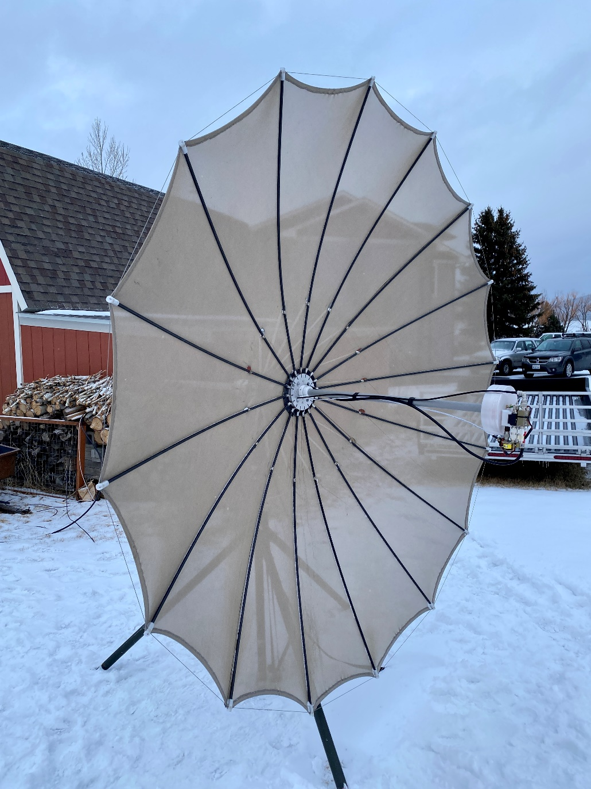

**KB7Q 2.4 m portable folding dish with patch feed**

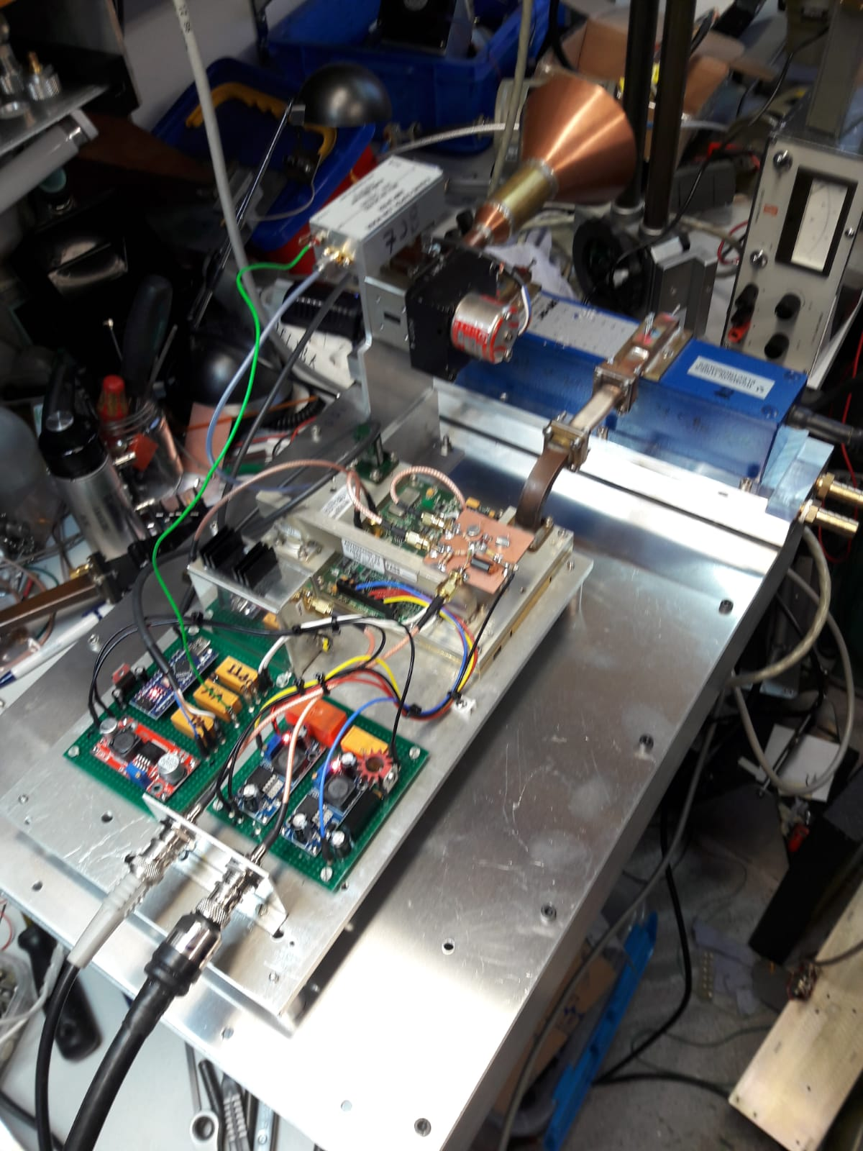

PA7JB’s system under test used for his first 24 GHz EME QSO in March