432 AND ABOVE EME NEWS
AUGUST 2014 VOL 42 #7

EDITOR: AL KATZ, K2UYH; DEPT. ELECTRICAL/COMPUTER ENGINEERING, THE COLLEGE OF NEW JERSEY, PO BOX 7718 EWING, NJ 08628, TEL (W 609-584-8424) OR (H 609-443-3184), FAX (609-631-0177), E-MAIL alkatz(x)tcnj.edu
NETNEWS EDITOR (based Reflector News) REIN, W6SZ pa0zn(x)arrl.net WITH HELP OF N4PZ AND WB2BYP
INITIAL LIST G4RGK, DAVID DIBLEY, E-MAIL zen70432(x)zen.co.uk, AT: http://www.zen70432.zen.co.uk/Initials/index.html
EME INFORMAL NETS: 14.345, ~1500 SATURDAY AND SUNDAY, NET COORDINATOR: Steve Gross, N4PZ n4pz(x)live.com
ON0EME EME BEACON, 1296.000 IS QRV WHEN MOON >10°, SEND RX REPORTS TO WALTER (ON4BCB) on4bcb(x)gmail.com
NL EMAIL DISTRIBUTION and EMAIL LIST CORD: WARREN, W2WD wbutler(x)ieee.org [TXT OR PDF OR "ON WEB" NOTICE]
THE NL WEB VERSION IS PRODUCED BY REIN, W6SZ AND AVAILABLE AT http://www.nitehawk.com/rasmit/em70cm.html

CONDITIONS: There is not a lot to report on this month as the best operating conditions/times and high declinations were fully out of alignment. The one dxpedition on 70 cm, HP/KG7HF was rained out – see Paul’s report. He will be trying again in Aug (16-25) from HK. Some other dxpeditions (5B4/PE1L and Z21EME) have been announced, but will not take place until Sept and Oct respectively – see reports. Both the 1296 and 10 GHz EME beacons were down part of the past month – see info in this NL. Moon conditions will not be much better this month, but there is more happening. The July 70 cm Activity Time Period (ATP) has not yet occurred. It is scheduled for 19/20 July from 2330 to 0130 and 20 July from 0830 to 1030. (The Aug ATP is on 16 Aug 2230-0030 and 17 Aug 0730-0930). The DUBUS 70 cm Digital EME Campionship is this same weekend. See the end of this Newsletter (NL) for more details. There is also the ARRL’s UHF Contest (Tropo) on 2/3 Aug, but as in other ARRL VHF contests EME contacts count as valid contest QSOs. The difference is in the UHF contest only bands 222 and up count. Look for extra North American (NA) EME during this contest. The biggest upcoming event is EME2014 in France on 25/26 Aug. Hopefully we will see you there.

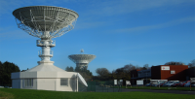
Site of EME2014 – You do not want to miss it!

5B4/PE1L: Rene (PE1L) hasperrene(x)gmail.com sends news that he and PA3FPQ and SP4K will put Cyprus on 1296 EME for the Saturday 13 Sept moonpass. (They will also be on 144). Their frequency will be 1296.090 and RX on their echo. They plan to be use the HB9Q logger for last minute information.

DL0SHF: Per (DK7LJ) <dudek(x)per-dudek.de> reports the 10 GHz EME Beacon was down for repair of the 50 W PA and changing it over to water cooling at the end of June. Per expected to have the beacon QRV again before this NL arrives (end of the first week of July).

G3LTF: Peter’s pkb100(x)btinternet.com July EME report -- Not much happening in the CW EME world this month. I did work on 20 June on 432 SP/OK5EME for initial #453 followed by ES3RF #454, and on 21 June UT5DL, and a little later in the 432 ATP OZ4MM, DL9KR, SM2CEW, DF3RU and K2UYH. I have been working on my dual dipole 432 feed. I found that the seam across the two halves of the reflector was not very effective, and RF leaky. Replacing the 4 screws with a 1” spaced line of rivets improved the sun noise by nearly 1dB to 15.6 dB at SF 104. I have discovered that my polar mount is able to point at Cygnus over a wider range than I previously thought. Thus, I have been revisiting my G/Tsys measurements at 70 cm to13 cm with the aid of Spectravue and my softrock SDR.

HB9Q: Dan (HB9CRQ) dan(x)hb9q.ch seends news on his groups EME plans -- We have rebuild our 432 feed; the new one uses a 7 el cross-yagi from FLA (on our 15 m dish). We now are working on the optimization the RX path. We plan to be ready by Sept and we expect a somewhat better performance than with the 14 year old feed system. On 23, 13 and 9 cm, our 10 m solid dish is performing very well, and we enjoy being QRV on random SSB, CW and JT65C. We are QRV weekdays and weekends (on short notice) looking for new initials and especially QRP or even QRPP stations. We always are on standby with an eye on HB9Q logger during our activities. If someone wants to work us, he is very welcome to email me a sked request. For more information about our equipment, capabilities and our stations worked visit www.hb9q.ch.

HP/KG7HF: Paul kg7hf(x)comcast.net unfortunately never made it on 70 cm EME during his stay in Panama. He had planned to be QRV the last day, but ran into bad luck with the weather (WX) -- This morning was a wonderful morning in Panama, the WX was calm, pleasant and simply beautiful. I did some final tuning on the 70 cm array and reconnected the amplifier, as I was about to start testing I noticed the darkest clouds start to roll in. These were the same sorts of clouds we met on the first day that soaked every piece of equipment. The skys went completely black and the winds started blowing madly. I hurriedly disconnected the equipment as the lightning started to strike nearby in rapid succession, then came the rain in buckets. At this point, I decided that I have had enough as our flight departs tomorrow morning, and assembled and packed the station. I am so sorry I did not get a chance to work 70 cm. I have learned quite a bit about what works, and what does not work, and will circulate a "lessons learned". – Paul is now back home, but will try again from Columbia on 16 - 25 Aug. Hopefully he will schedule his 70 cm operation on a day that does not conflict with the EME conference. [Paul’s story on setting up for 2 m EME on his 2nd day -- My wife and I are still on New England time, and while Panama is only one hour difference in time zones, we are used to starting out day before 6 am. It should be noted that breakfast time here generally starts at about 10:30 am. Our rental is in the banking district, so we walked to a panadera (bread store) to have breakfast; however, they only had some leftover bread. We did buy one piece for $0.20 and walked further to another store to have empanadas (pastries filled with meat and cheese), served hot, made from flakey pie crust. I get these at home, since my wife is Colombian, they are always good. After breakfast, I made arrangements to move the EME equipment from our balcony to a better location at the top of the building. We then walked around the town again waiting for the building administration to open so we could get the key to what was a heliport on the building’s roof. The building administrator was quite interested in what we were doing and of course wanted to make it "safe". What could possibly go wrong at the top of a high rise building 30 stories up with no railings, it makes me a bit sick to my stomach just thinking about it, let alone setting things up. We finally agreed upon a good place to operate and hauled the equipment up. My wife was very helpful with this and it went much faster with two people. One of the difficulties has been power. Finding outlets is difficult; I am very glad I brought long thick extension cords because I have needed over 100' of power cable to get to the operating position. After running the new power cords and taping everything down, I started reassembling the station, it went together quickly. Nothing seems easy in the heat though, 34 deg C and so much humidity. I was afraid I would short out the equipment with sweat droplets! After setting up and connecting all the cables, it was lunchtime (our lunch) so we went to have lunch before moonrise. This was a huge mistake! As we were eating lunch, it started raining, then raining more until you could not see in front of you because of the thick rain. It did not matter if we walked or ran, we would be soaked. We waited for a break and ran back to the room, only to see the skies open up even harder and the lightning begin. There was a huge bolt and crack directly in front of the condo, you could see the "impact" on the ocean water. My wife wanted to go check on the radio setup, and for good reason, when we got to the top floor, even though the radio equipment was covered by a concrete overhang and shelter, it was all soaked through completely. This made my heart sink. I did have the for sight to disconnect all power, but the water was everywhere. Once again, I disconnected everything and took it in to dry off. The radio was soaked inside water was dripping out. I opened the cases and used my wife's hair dryer to dry all the equipment out. Even still, the radio would come on but did not have a display. After about an hour I was able to get the radio dry enough to operate correctly. Moonrise was approaching so it was time to get things connected again. But the sequencer was always keying the transmitter. After a few minutes of trouble shooting, I can only guess that somehow that large bolt of lightning found its way into the fourth channel of the sequencer. This is ok, I have a spare channel and switched to the extra channel for the radio. All was operational. About that time, John, K1OR texted me asking when I was starting. "now" was the answer and a few sequences later, I could see the screen was filled with traces. It was on now for sure! that was the last time I called CQ for quite a few hours to work though all of the calling stations.]

JA4BLC: Yoshiro’s ja4blc(x)web-sanin.co.jp EME report -- I worked on 3 cm, on 29 June UA4HTS (O/O) for initial #21and on 2 July JA6CZD (559/569). For a couple of months I suffered from weaker echos (several dBs lower than before). I mounted the power meter and 150 W dummy at the feed and found 4 dB lower power than measured at TWTA output. I checked all WR90 components between the TWTA
and the feed, and found the E bend lossy. The faulty was a loosened screw (M2.6, 10 mm), which fully penetrated into the waveguide; probably due to the vibration of the WG switch. Once the screw was eliminated, the loss disappeared and my echoes were heard normally.

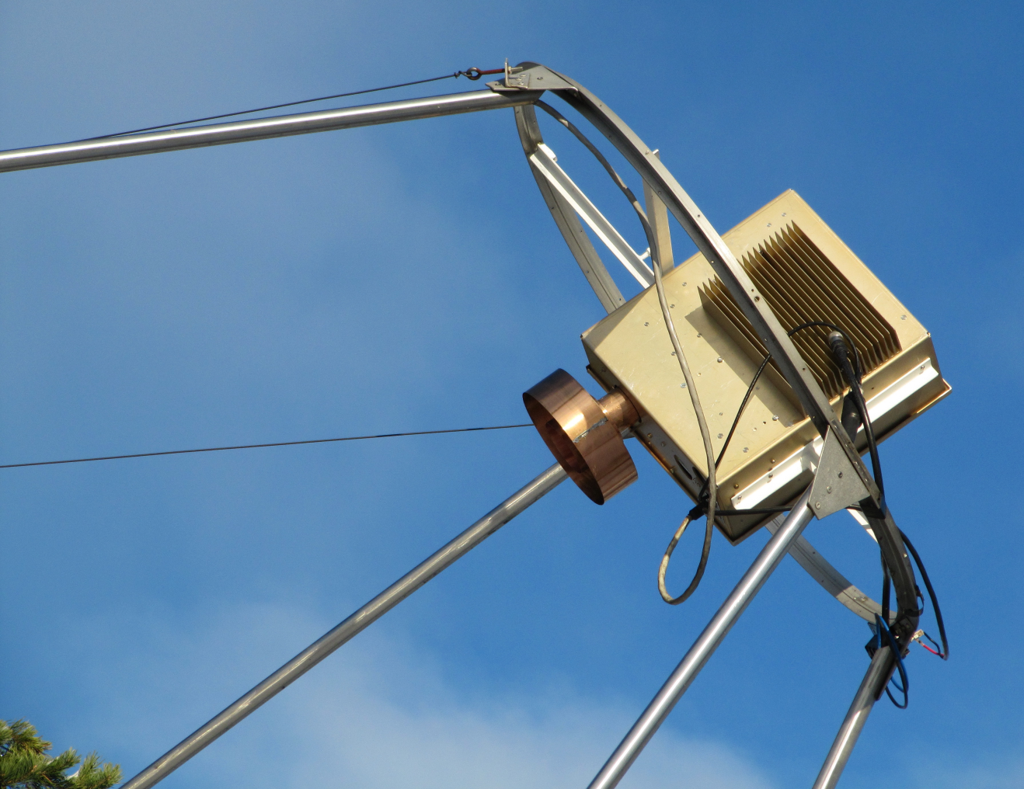
OH2DG’s 9 cm feed arrangement – includes RA3AQ feed, DB6NT transverter and 4 x Ionica 40 W SSPAs

OK1KIR: Vlada and Tonda vladimir.masek(x)volny.cz send a mini report for their June/July MW EME activity -– On 432 we worked on 18 June at 2348 4K/UT6UA (16DB/0) on JT65B for digital initial {#112} and mixed DXCC 102, which we followed on 19 June on 1296 at 0127 4K/UT5UAS (13DB/12DB) (using linpol and WSJT7) and at 0308 again as 4K4K (14DB/14DB). At all times the 4K was best on vertical pol. During 4K operation, there were experienced and widely discussed troubles with the newer versions of WSJT and MAP65, while WSJT 7 worked properly having preserved the possibility to add another prefix to the table of available prefixes. While waiting for 3 days for the HP/KG7HF dxpedition to come on 70 cm, we worked on 7 July at 2141 K5DOG (19DB/22DB), 2205 LU8ENU (15DB/21DB) and 2247 F6APE (21DB/22DB) {#113}.

ON0EME: Eddy (ON7UN) ejespers(x)telenet.be reports the 1296 EME Beacon experienced some problems and is currently offline -- One of the two PA blocks failed. Initially the beacon continued operation with only one of the two PA blocks active; power was 3 dB down (250 kW EIRP). We decided to rebuild the complete beacon, and the beacon in now offline. We expected to be QRV by now but the WX has been awful. We now expected to have the changes complete on 18 July and back to normal by 19 July. We do not feel too bad of the extra repair time as during the last 27 months the moon beacon was active every moon pass up to this problem. We have made a number of changes. In the past not all modifications where implemented as neatly as we would have liked, so we had some "spider" configurations to eliminate. We also wanted to replace all of the many fans used in the beacon to reduce the possibility of a failure. The Monitoring and Control systems did lock up once in a while, so new hardware actually prepared for some time, will now be in place. The PAs were also rebuilt.

VE3KRP: Eddie eddie(x)tbaytel.net writes about his status and operation on 23 cm -- I have been doing great here. My mobility has greatly increased, though I had to buy an SUV vehicle to make it easier to get in and out. This summer, I have been busy outdoors more than indoors. On 1296, I QSO’d back on 31 May PI9CAM, UA3PTW, F5SE/P, OZ4MM, OK1CA and K2UYH, all on CW. Bad WX and winds did limited contest activity both weekends. I added on 1 Jun I1NDP, DL0SHF, OE6JFL and G3LTF – all on CW, on 28 June GM4PMK, LU8ENU, I1NDP and CWNR’d DJ2DY – all on JT65C, and 29 June PA7JB on JT65C for a digital initial {#} finally after chasing each other for 2 years and heard PE1DAB - very weak.

WA2FGK: Herb wa2fgk(x)yahoo.com is planning to be more active on EME in the future, but has had his dish woes –- We will do EME on 1296 and 2304, but our 12’ dish came down for a 2nd time this spring. We had a very bad ice storm with 60 mph winds. We are going to give it one more try, but if this mount breaks again, I'm going to take a saw to the dish. I will also remain available on 432 EME with the 4 x 33el M2 yagis on a short tower. I see no 902 expect possibly on the horizon, but will need a better filter.

Z21EME: Lins (PA3CMC) pa3cmc(x)martensmilieu.nl sends news of a EME dxpedition to Zimbabwe (KG58gh) -- From 31 Oct to 7 Nov, we will be QRV on 6 and 2 m and 70 and 23 cm. On 70 cm we will have 2 x 38 el M2 yagis and 500 W, and on 23 cm a 67 el yagi and 150 W. The team will include me/Z21CMC, ZS6JON/Z21EME, PA2CHR/Z21CHR and ZS6NK/Z21NK. [Zimbabwe will not be a new DXCC for those of us who worked ZE5JJ in old days of EME, but still great fun for all. The group is still looking help with equipment for 23 cm. They need a driver amp and a good transverter.]

K2UYH: My a.katz(x)ieee.org report for June/July is a bit shorter than in May/June. On 1296, I worked on 28 June at 1428 DJ2DY (19DB/15DB) who is using a single yagi for mixed initial #472*, 1458 GM4PMK (12DB/9DB), 1503 PA3FXB (9DB/7DB), and 1515 I1NDP (7DB/5DB) – all on JT65C, on 29 June at 1706 ON5GS (15DB/9DB) JT65C #473* and 1715 ON5GS (559/559) CW for initial #360, and on 4 July at 2000 NC1I (O/O) testing on JT65C. On 432, I worked on 5 July at 2208 EA5CJ (14DB/19DB) JT65B for mixed initial #869* and partial 2220 EA5CJ (559/-) CW - Jacinto had a problem with JT’s CW mode but should be very workable on CW in the future, on 11 July at 0224 W5LUA (16DB/21DB)– while looking for HP/KG7HF and 0320 NC1I (9DB/9DB) both on JT65B, and 13 July at 0402 KD5CHG (11DB/O) JT65B #870* and 0450 KD5CHG (559/O) CW #731 – Matt’s 1st CW EME QSO. I plan to be on for the July 432 CW ATP coming on 19/20 July.

NETNEWS: ON5RR is back on 23 cm with a 6 m dish. Marc’s email is moonbouncer(x)skynet.be. K6PF in AZ has a 16’ dish and is working on becoming QRV sometime during the coming year. XE1XA is temporarily off the air as a result of a lightning strike that took out his preamp.

FOR SALE: W8BYA has a 8.5’ Birdview solid aluminum dish for sale. Any reasonable offer will be considered. Gedas can be reached at w8bya(x)mchsi.com and is located in Ft. Wayne, IN. K3WC has heavy a duty tower For Sale that is idea for mounting EME antennas. He has four 20’ sections of heavy duty tower, 24” on a side, similar to Rohn 65. Four sections are priced at $200 each, pick-up in Camp Hill, PA. Unfortunately he is not interested in selling single sections at this time. Contact Dusty at 717-761-2763 or k3wc(x)verizon.net. IZ0CLS has a Parabolic dish kit for sale. The dish is 3 m and f/d 0.4. It consists of 8 ribs, 8 angular reinforcement structures, 1 central drum, tubes for circumference, all associated hardware, and a CD with photo-mounting instructions. All hardware is stainless steel and numbered. The mesh is not included in the kit. The price of 700.00 euro is not negotiable and does not include the cost of shipping. If you are interested, contact Fabrzio, iz0cls(x)libero.it. Pictures are available. K6PF has a 432 antenna system consists of 8 x K1FO 25 el yagis (17' booms - 16.5 dB gain), heavy duty H-frame (2 wide x 4 high), all Andrews LDF4-50A phasing lines and power dividers. Also included is a very heavy duty M^{^2} MT-3000A elevation rotor & control box along w/ 90' rotor cable & connector. Bob is asking $1,240 and because of the size/weight suggests local pick up. He is near Prescott, AZ. If interested contact Bob at k6pf(x)sbcglobal.net.

TECHNICAL: I found the following info in my files. I do not think this material has been previously published in the NL. See OH2DG’s version for 3400 earlier in this NL.

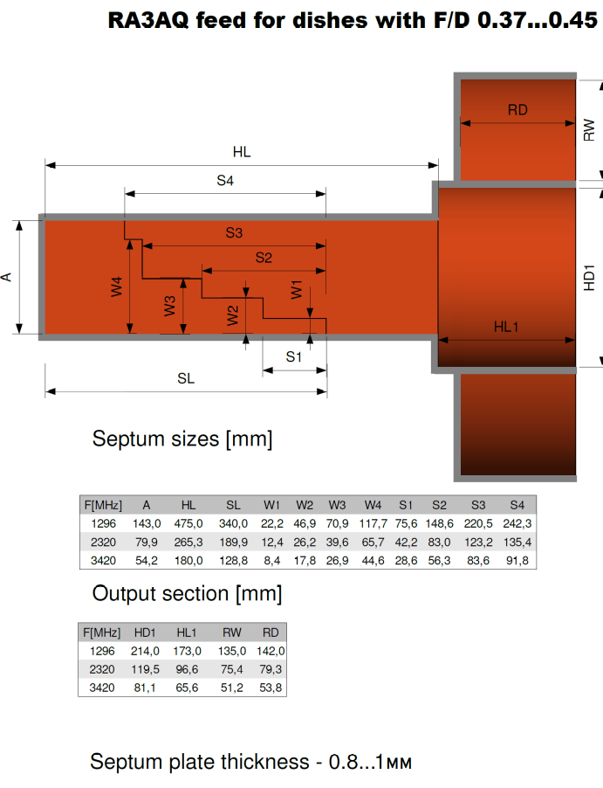

FINAL: EME 2014 - If you are in traveling distance of Pleumeur-Bodou in Britiany, and not already planning to be at the conference, you should consider coming, even if only for one day. Guy, F2CT writes that there is still space for 10 additional delegates, and asks that you please register quickly. See www.eme2014.fr for the latest info.

EME2016 – The ARI (I5WBE) has put together a very attractive proposal to bring the 2016 Conference to Venice. If your group wants to be considered to host EME2016 you should have a proposal for presentation at EME2014.

The DUBUS 70 cm Digital EME Championship is a new contest and exclusively for 432 operation. It is on the weekend of 16/17 Aug and follows rules very similar to their other EME contest in terms of multipliers and score, but there are no restrictions on the use of loggers and cluster and self spotting! Also DUBUS is offering a 1 year free DUBUS subscription and a 200 € shopping voucher from InnovAntennas to the top 10 entries. Logs must be received within 7 days (24 Aug) at DUBUS(x)t-online.d to be eligible for the awards.

Registration is now open for the Mid-Atlantic VHF Conference, 26-28 Sept at the InnPlace Hotel, Bensalem, PA ($79/night). There are: many EME related talks with W1GHZ, K1JT and K2UYH on the speakers list, equipment/NF testing, antenna gain contest, mini flea market/hospitality, banquet and more. Early bird registration is $40 (includes lunch) at http://dataandwireless.com/packrat/2014_vhf_registration.php. Questions or paper/presentation submissions to rick1ds(x)hotmail.com or call Rick (K1DS) at 215-284-5517.

Our plans are in place for EME2014. We will be arriving in Brittany early, and as a consequence I will try to get the next NL (Sept) out early – before I leave for the conference. I will be looking for you off the Moon in the mean time. 73, Al – K2UYH
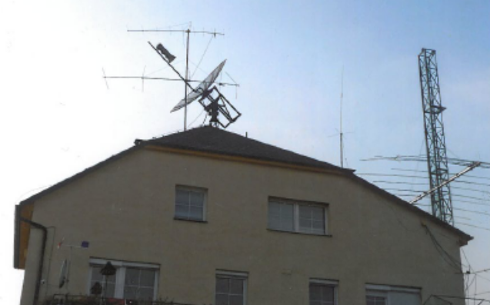
OK1CS dish for used on 1296

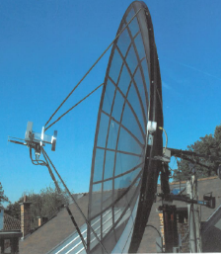
ON5TA dish with 6 cm feed
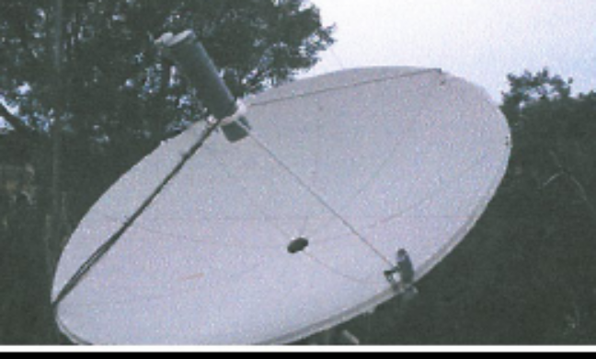
SV1DNU’s 3 m dish and 1296 feed
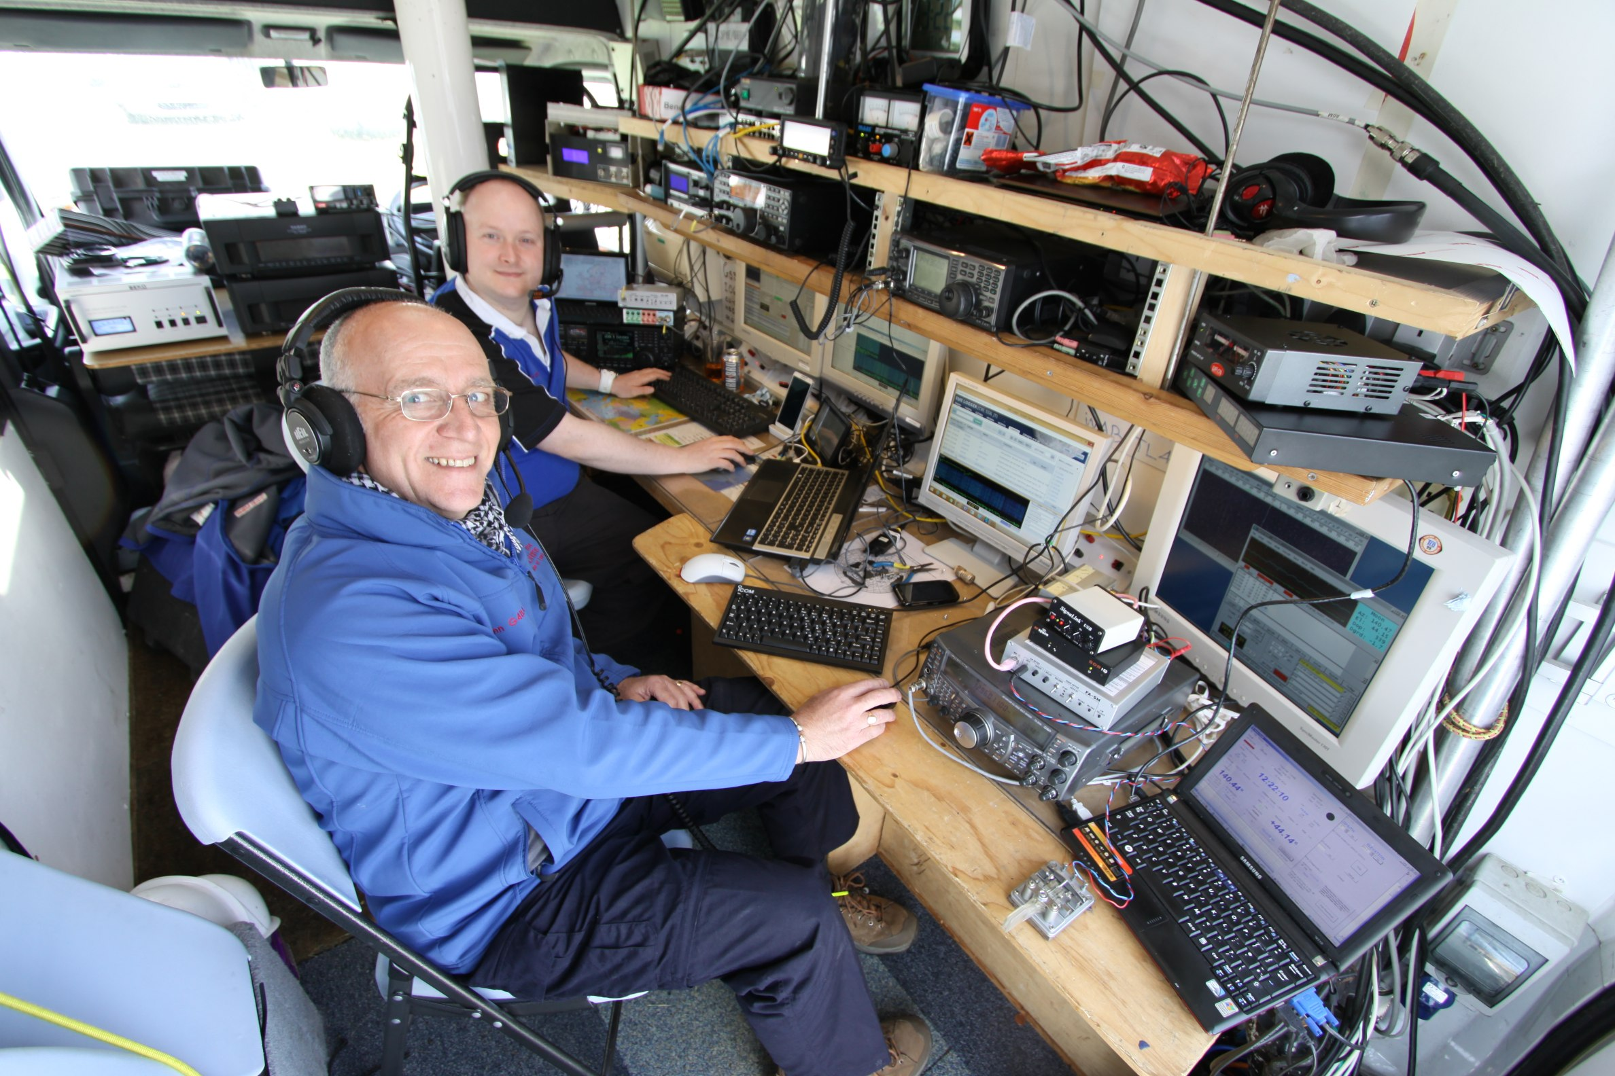
GS3PYE’s Shack

