432 AND ABOVE EME NEWS
AUGUST 2017 VOL 46 #7

EDITOR: AL KATZ, K2UYH; DEPT. ELECTRICAL/COMPUTER ENGINEERING, THE COLLEGE OF NEW JERSEY, PO BOX 7718 EWING, NJ 08628, TEL (W 609-584-8424) OR (H 609-443-3184), FAX (609-631-0177), E-MAIL alkatz(x)tcnj.edu
ASSOCIATE EDITOR AND NETNEWS (based Reflector News) Matej Petrzilka, Simunkova 1609/21, 18200, Praha 8, Czech Republic, TEL (+420 603 489 490), E-MAIL ok1teh(x)seznam.cz
CW INITIAL LIST G4RGK, DAVID DIBLEY, E-MAIL zen70432(x)zen.co.uk, AT: http://www.zen70432.zen.co.uk/Initials/index.html
SUN & EXTRATERRESTRIAL NOISE LIST MANAGED BY OK1TEH: http://www.ok2kkw.com/next/nl_k2uyh/sun_table_2017.xls
EME INFORMAL NETS: 14.345, ~1500 SATURDAY AND SUNDAY, NET COORDINATOR: OPEN
ON0EME EME BEACON, 1296.000 IS QRV WHEN MOON >10°, SEND RX REPORTS TO WALTER (ON4BCB) on4bcb(x)gmail.com
DL0SHF 3 CM EME BEACON, 10368.025, SEND INFO & QUESTIONS TO Per (DK7LJ) per(x)per-dudek.de.
NL EMAIL DISTRIBUTION and EMAIL LIST CORD: WARREN, W2WD wbutler(x)ieee.org [PDF OR "ON WEB" NOTICE]
THE NL WEB VERSION IS PRODUCED BY REIN, W6SZ rein0zn(x)gmail.com AND AT http://www.nitehawk.com/rasmit/em70cm.html

CONDITIONS: Activity definitely slowed a bit in July as can be seen in the reports. There were no contests or microwave (MW) activity weekends (MWAWs). The only dxpedition activity was on 10 GHz by VK7MO. Rex is running a marathon Australian roving grid locator dxpedition that started on 22 July and will continue to mid-Sept. He also plans some 24 GHz operation. See Rex’s and OK1KIR’s reports in this newsletter (NL). Aug will be a different story. Other MW EME events taking place in Aug and documented in this NL are GB6GHY’s activity from the 32 m Goonhilly dish on 25/26 Aug on 9 and 6 cm, and SP/OK5EME to be QRV on 19 Aug on 3 cm at the Polish EME and MW meeting. Also coming up is the 9 cm MWAW on 12/13 Aug. Interest in 9 cm is growing. This MWAW will be a good time to check out your equipment or even make your first 9 cm EME QSO in preparation for the ARRL MW EME Contest on 9/10 Sept. The 19/20 Aug is also proposed for a 13 cm AW and should result in extra activity on this band. On 20 Aug KN0WS will put NE on 1296 EME. Carl will only be on for one day, but will use a 12’ dish. This could be your only chance to work this state on 23 cm! See his report. The following day will be the great Solar Eclipse. Carl is in NE to view the Eclipse. Although not a great day for EME, many stations will be on to measure sunnoise levels – see the following. Don’t forget the 70 cm CW Activity Time Period (ATP) on 20 Aug 0400-0600 and 1300-1500.

SOLAR ECLIPSE BY G3LTF: I’m sure all the EME community are aware of the solar eclipse coming on 21 Aug - see https://eclipse2017. nasa.gov/eclipse-maps. During the 2015 eclipse in NW EU, a number of stations were able to make some quite nice measurements of effective solar diameter at microwave frequencies by plotting sunnoise against time. This time the place to be is in US. The Sun is less active now and so there is less chance of sunspot flares influencing the measurements. I gave a paper on this at 2015 the Swedish EME meeting, http:// moonbouncers.org/Eclipse%20measurements.pdf. Please note that I am NOT an expert on this and for the full background you should refer to the references at the end by F1EHN and DL0SHF. My paper gives the basic math that is needed and you can get the Moon-Sun separation from several programs. If you can’t make a full series of measurements (it is a working day) then the pre-eclipse level of sun noise to quiet sky, the time of first on-set and the level and time of maximum drop in noise are the most interesting data set. I think there could be quite a few microwave stations within range of at least a 60% sun obscuration. Measurements above 13 cm would be most useful but its a fun thing to do at any band. A few hints. The NASA site has lots if information and its easy to find the exact optical obscuration level for your location. You really need a wideband receiver such as an SDR or a noise meter, examples are at http://www.vk3nx.com/files/Noise_Meter.pdf or http://www.g3pho.free-online.co.uk/microwaves/noiseamp.pdf. An SDR is ideal because it it easy (certainly with Spectravue) to record the result as a csv file. Do a trial run to make sure that it will all work for 2 hours; ideally running the dish through the sector where the measurement will be taken to check for interference, you only get one shot at this. I also strongly reccomend doing a practice run of recording and saving the SV csv file. I seem to remember that its very easy to lose the file. I lost mine and was only left with the 13 cm screen-shot. I recall that on completion, you need to make a copy into a separate folder before changing anything in SV. [Is there anyone interested in receiving the data and compiling the results for publication in the NL]?

3DA0MB: Lins (PA3CMC) info(x)pa3cmc.nl announces that Swaziland (KG53mn) will be QRV all region 1 bands 6 m to 3 cm thanks to addition of HB9COG (chief engineer of HB9Q) and HB9CRQ/KT9Q to the dxpedition team. This will be the first ever 8 band EME DX expedition. Operation will be from 13 to 21 Oct. 70 cm they will be QRV from 13 to 18 Oct with a single 38 el m² yagi. On 23, 13, 9, 6 and 3 cm they will be QRV from 13 to 21 Oct using a 1.5 m dish (1x2 mm mesh with automatic AZ and EL control, with 100 W on 1296, 80 W on 2300 (all sub-bands), 3400 and 5760 circular pol; and 50 W on 10368 (and 10450) vert lin pol. Both JT65 and CW will be available on all bands. The team consists of 3DA0VV, PA3CMC, ZS6JON, ZS6EME, PA2CHR, ZS6AVH, HB9COG, HB9CRQ/KT9Q and ZS4TX. Donations are welcome to Paypal info(x)pa3cmc.nl, Bank IBAN NL58INGB0006770934 BIC INGBNL2A. QSL is direct or via buro. Direct should include an SAE and EUR2 or $2 to L Berben, Simonshoek 2, 5768 CS Meijel, Netherlands. For the latest news look on pa3cmc.nl or MMonVHF.de.

DK3WG: Jürgen dk3wg(x)web.de sends news that during the past month he added no new stations on 432, but on 1296 CW he worked OK8WW, and using JT65C added PA0PLY, partial F6APE and W1PV.

F6KRK: Bruno (F1MPQ) f1mpq(x)orange.fr writes that he and F4BUC are QRV on 23 cm with a 2 m dish and 250 W. [Suggest you email for skeds].

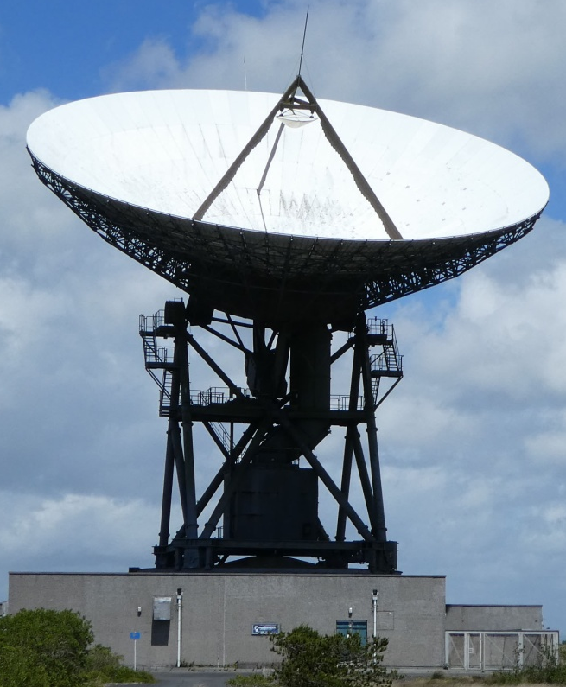
GB6GHY 32 m dish to be used on 3 and 6 cm in Aug

GB6GHY: Brian (G4NNS) brian-coleman(x)tiscali.co.uk announces operation with the big 32 m Goonhilly Down dish on 9 and 6 cm -- A small group of hams including me are planning to operate on 3.4 and 5.7 GHz using the 32 m GHY6 antenna on Friday and Saturday 25 and 26 Aug. Our moonrise will be at about 1000 on the 25th and 1100 on the 26th. We hope to be QRV until about 2100 on 25th but will have to close earlier on 26th (~1800). We will have a special call sign GB6GHY and will use the HB9Q logger. See http://www.goonhilly.org/ and http://www.goonhilly.org/antennas/antenna-list for more details of the site and antennae. We would like to have as many QSOs as possible. We should be a fairly big signal. I haven’t measured the isolation between the feeds for the 2 bands yet, so we won’t try simultaneous operation, but change over should be very quick. I’ll come up with a plan for splitting operation between bands before we go. It will probably be mainly on 9 cm on 25th and mainly on 6 cm on 26th.

HB9MFG: Christoph christoph.wildfeuer(x)googlemail.com reports from Switzerland on his reception of the 23 cm Beacon -- HB9SCT and HB9MFG received successfully from 1200 to 1230 on 27 July the ON0EME beacon. We heard the beacon with some fading around S1. We used a 5 m dish that was under-illuminated with a linear pol feed and a Kuhne 0.4 dB NF LNA at the Bleien Radio Observatory (https://en.wikipedia.org/wiki/Bleien_Radio_Observatory) in JN47bl. Our RX was a AOR AR5000. We observed a Doppler shift of approx +1.3 kHz. The beacon was very helpful for checking our system performance. Unfortunately we did not record the signal, but we will do that another time. [TNX ON4BCB for forwarding this report].

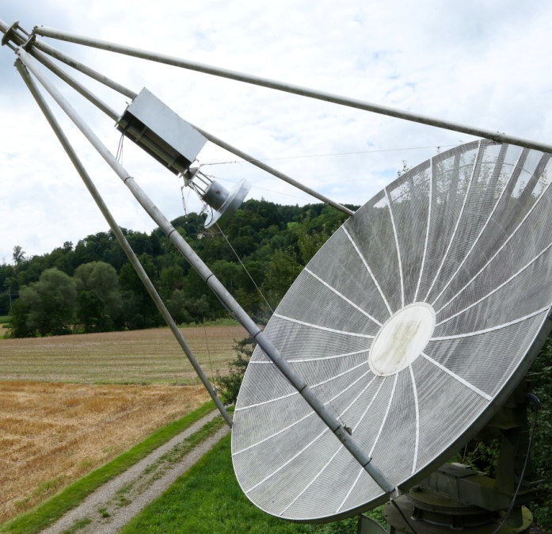
HB9MFG’s 5 m dish at Bleien Radio Observatory

I0NAA: Mario mario.natali(x)gmail.com updates us on his recent efforts -- On the EME side, I was able to reach 152 points in the ARI’s spring EME Trophy on 1.2 GHz thanks to 4 SSB and 24 JT QSOs and put me first place (B-mixed class). I am very pleased and will be trying my best in the upcoming ARRL contest on 23 cm, even if my CW learning curve is very slow. I used my 5 m dish with IMU feed, 250 W SSPA, G4DDK LNA, Flex 1500, DB6NT xverter with GPS disciplined 10 MHz Ref. My system noise Temp is ~43K! On the radioastronomy side (Pulsars!), I am working hard to increase the pointing precision of my system and have designed and built a dual dipole feed for 410 MHz that seems to perform very well. I also made available an updated version of my Murmur (4.4.0) software with several bug corrections and new features, such as culmination calculations. Feedback, inputs and comments are welcome! The program is at https://www.dropbox.com/s/pchl5mzen440awn/ Murmur%20%204.4.0.exe?dl=0.
I0NAA’s 400 MHz Pulsar feed
JA4BLC: Yoshiro ja4blc(x)web-sanin.co.jp was active on 10 GHz in July -- I worked on 28 July SA6BUN crossband (XB) for initial #39. The nxt day, 29 July JA1WQF and JA8ERE also worked SA6BUN and JA8IAD worked SA6BUN on 30 July.

KA1GT: Bob ka1gt(x)hotmail.com is now using a newly motorized 432 antenna (2 x 28 el yagis) -- It now also has motorized polarization rotation. I worked 4 stations while testing (PA2V, NC1I, FR2DN and DL9KR). The contact with DL9KR was on CW. I last worked Jan off the Moon, on 432, on CW, using the same 2 x 4CX250B amplifier just over 35 years ago! It was a lot easier this time. The ability to remotely rotate pol between TX and RX was needed for the contacts with PA2V and FR2DN. The Faraday + spatial was around 90 degs - so it's doing its job. I will be QRT in Aug, but back on in Sept. I have also installed a base for a 2.4 m dish that I intended to use on 1296.

KL6M: Mike is now QRV on 222 EME with his 30’ dish and 1.5 kW -- I plan on being QRV around 11-14 Aug, and am trying to promote activity. It appears there are a number of stations interested in working me. VE6TA, K5QE, WA4NJP, W7MEM, K2UYH, among others.

KN0WS: Carl carlhasbargen(x)q.com plans to put Nebraska (EN00) on 1296 EME on 20 Aug starting as soon as he can after moonrise at 1030 -- I was born in NE and have an uncle who still lives there. I plan to visit him for the total solar eclipse on 21 Aug. Because the Moon is so close to the Sun on 21st, EME operation will not be possible. However on Sunday morning 20 Aug, the day before the eclipse, there is a reasonable separation (> 15 degs) and QSOs should be possible with many stations. I will be using my 12’ stress dish on a portable polar mount, a new septum feed and 150 W. To enable QSOs with the maximum number of stations, I have set up skeds every 20 minutes starting at 1200 ZS6JON, 1220 HB9Q, 1240 OK1KIR, 1300 DK3WG, 1320 G4CCH, 1340 K2UYH, 1400 open, 1420 PY2BS, 1440 NC1I, and open until 1540 G3LTF (CW). I will always TX first on 070 and RX on my echo. I will begin on JT65C. As soon as I complete a QSO with a sked station, I will call others heard on random or CQ if no one else is heard. If I am able to work anyone before their sked time, it will free up the slot for random calls. I expect to be on the HB9Q reflector. I may be able to start before 1200, but do not know how early I will have a clear shot to the Moon. I will begin operation as soon as possible. You should hear me at 1296.070 plus our mutual Doppler. If your RIT is set to your own self Doppler, I should hear you on my echo. If you do not have a sked, PSE call at least +/- 200 Hz from my echo freq. I will call you after I finish the sked. (If there is local interference at .070, I may have to change my TX freq. If I have to change freq, I will announce the change on HB9Q). I will work JT65C until my G3LTF sked, when I will switch to CW. If I complete with Peter, I will look for other CW QSOs. G4CCH has asked to try CW, and will look for him next. Very honestly, I do not know how well I will do with the CW (it is always an adventure) but if things go well, I will try CW from then until I break down the gear at 1700. Thank you for your interest in working me in NE. I hope the WX and gear cooperate!

KW2T: Dan dpedtke(x)hotmail.com sent the following to the ON0EME Beacon – I want to let you guys know that having your beacon is what mainly motivates me to get my EME system up. I'm an RF engineer and want to build everything myself, so I don't buy any commercial equipment (one exception - a 20 year old HF transceiver for IF). Knowing that I can test the dish and antenna and LNA with your beacon as a first step is what makes this project possible for me. It's amazing that you have kept it running, when others have failed. Also amazing that even from Belgium, I have plenty of visibility here by Boston, MA. Knowing the beacon is there, made me start this project. I hope to be able to listen in a few weeks… I scrounged a 12' dish for free, welded up a frame and mount, built a flat SM6FHZ feed, ATF54143 LNA from ap note, etc. Do you take PayPal donations? [TNX ON4BCB for forwarding this report].

OK1KIR: Vlada vlada.masek(x)volny.cz reports on club EME activity during the past month -- Our only EME in July was on 10 GHz. VK7MO prepared a second big dxpedition around the VK mainland – not bad for a lone 75 year old guy! Rex started his 3 cm operation in PG field and will continue further to the north. We worked him on 24 July at 0530 VK7MO (14DB/17DB) for digital initial {#108} in PG77 with JT4F, at 0552 VK7MO (18DB/14DB) in PG77 and repeated with QRA64D and CFOM. Later, Rex moved to PG67, and we worked him at 0646 VK7MO (14DB/17DB) {#109} with JT4F and at 0724 VK7MO (15DB/14DB) using QRA64D. It was agreed we’d use QRA64D and CFOM. We QSO’d on 25 July at 0622 VK7MO (15DB/14DB) {#110} in PG76 and 0820 G3WDG (8DB/11DB), on 26 July at 0748 VK7MO (15DB/14DB) {#111} in PG68 and at 0838 VK7MO (15DB/17DB) {#112} in PG78, then 2 days later on 28 July at 1118 VK7MO (16DB/17DB) {#113} in PH61, (the DL0SHF beacon was 9DB on QRA64D at this time), on 29 July at 1148 VK7MO (16DB/14DB) {#114} in PH62, on 30 July at 1240 VK7MO (16DB/16DB) {#115} in PH63, 1505 OK2AQ (13DB/13DB), 1531 partial OH3LWP (22DB/15DB) using JT4F and 1554 OK2AQ (16DB/13DB) with JT4F (testing different modes for Doppler compensation), and on 31 July at 1352 VK7MO (17DB/17DB) {#116} in PH65. On 1 Aug, Rex was in PH67 with a good Moon takeoff, but close to an airport defense area. Unfortunately just after working W5LUA during the night, he was arrested as a potential terrorist by the local police and only after several hours and phone calls was he freed with a “do not repeat again” warning. He decided to stop any night operation from the country as a result of this incident. After some car service and rest in Darwin, he is continuing his drive to the south towards Katherine and further to west. He plans to continue operation if he finds a suitable operating place. [See VK7MO’s report later in this NL].

OK8WW: Richard ok8ww(x)hotmail.com is a new 23 cm EME station operating from (JN79dv) – On Friday 21 July, I finished my 23 cm EME station and made my first QSO with OK2DL (559/559) on CW followed by RA3AUB, SP6ITF, PI9COM, OZ4MM, G4CCH and IK3COJ all on CW. I plan to also operate JT65 later. I am running a 12’ mesh dish with 600 W SSPA to an OM6AA septum feed, G4DDK 0.3 dB NF LNA, SDR Afedri/IC-736 plus DB6NT MKU13G3-28 PRO.

OK8WW’s new 12’ dish for 23 and 13 cm

PA0PLY: Jan pa0ply(x)pa0ply.nl after 7 years concentrating on 70 cm EME is adding 3 cm -- I recently completed a new feed support, a’ la PY2BS, for my 3 m dish, and a new dish controller system designed by VK5DJ. However, my transverter and LNA were both water soaked and out of order. It was very disappointing to find the LO had failed and needed replacement. Many other parts were rusted including the WG relay. The latter was reconditioned by PA3ACJ, who is a mechanical expert. As a consequence, I decided to put the 23 cm station in a box behind the dish and calibrate the new tracking system on 23 rather than 3 cm. I almost immediately found the ON0EME beacon and copied several stations including I1NDP and VA6EME. The dish seemed to be tracking quite well in the western part of the sky. Checking my TX section resulted in only 10 W at the feed. The RF output from the SSPA was OK. I finally found the culprit, an N-type bulkhead that was absorbing more than 100 W due to moisture in the connector. With a new bulkhead all the RF power did arrive at the feed, and I completed some QSOs without any pain. Dish tracking to the east side was also within the beamwidth for 23 cm. After the summer holidays, I will work on a new SSPA to bring me to 300 W. [See dish picture at end].

SM6FHZ: Ingolf ingolf.fhz(x)gmail.com is interested in completing more 70 cm CW QSOs from his city QTH -- I have so far worked 13 initials with SM4IVE, SM2CEW, DF3RU, UA3PTW, DL7APV, DK3WG, OH2PO, DL9KR, PI9CAM, DL6SH, G3LTF, HB9Q and OH2DG. I have no-one from outside my own continent despite tring with a number of other stations. The Rx-side seems to be my weak point due to local noise and the fact that this is my tropo/aurora station with the LNA is indoors. So, it is a challenge and it was meant to be. It was just for fun that I am trying to see what can be done with a limited station via CW EME. Actually, I have worked more EME QSOs than aurora QSOs with this station. But I am hoping for more aurora (and EME) QSOs.

SP/OK5EME: Zdenek (OK1DFC) ok1dfc(x)seznam.cz will be QRV on 10 GHz on 19 Aug from the Polish EME and MW meeting (18 to 20 Aug in JO80kg). See http://www.vhf.cz/soubory/dokumenty/ukw-treffen-morawa -2017.pdf for conference info. I will be testing my portable 3 cm EME setup. I may be on 13 cm if all goes as planned. See also http://www. ok1dfc.com/peditions/sp_10_2017/sp_10_2017.htm. [Zdenek will be QRV from CN2R on 70 through 3 cm in Oct]!

TI2AEB: Armando ti2aeb(x)gmail.com was active in July primarily using JT on 23 cm EME; and sends a note on how he uses ON0EME to check his station – 1) I check the accuracy of my antenna azimuth and elevation indicators by turning my antenna to highest signal and confirm how good are calibration. Using ON0EME seems to give a better calibration of the antenna position than sunnoise. 2) Very important, I check the accuracy of my frequency calibration using the Doppler offset from ON0EME. It gives much better result than my counter (modest unit). (Yes, I bought an ultra stable 10 MHz crystal oscillator reference to lock my transverter, but what about any error from my TS2000?). Frequency calibration is a must for EME QSOs. 3) I recently had to reload WSJT, and decided to upgrade to WSJT10. But, I lost the grid of the Beacon and had a problem finding it. It is JO21jg in case you have a problem finding it.

VE3KRP: Fast Eddie eddie(x)tbaytel.net writes -- There was not super active here, but I did work two initials on 1296. I QSO’d both using JT65C on 22 July G4DML {#} and N5BF {#}. Also I have been playing with the WSJT FT8 mode. [Is it useful on 23 cm EME]?

VK7MO: Rex rmoncur(x)bigpond.net.au has been running another of his famous Australian 10 (and 24) GHz (roving grid locator dxpeditions -- I have been on the road since 22 July and will continue to mid-Sept. The grids I am operating from have not previously been activated and are mostly in the Northern Territory and the Northern part of Western Australia. Typically one or two grids can be worked each Moon pass. One of my goals is to QRV the OH field, which only just touches the coast of Australia by around 200 m. Another goal is to extend the 10 GHz EME distance record from Southern Western Australia to WA3LBI, when he is portable in Delaware in Sept. The grids so far activated are PG76, PG67, PG77, PG68, PG78, PH71, PH63, PH65 and PH57. Stations worked at most of the grids are OK1KIR, HB9Q, G3WDG and OZ1LPR. W5LUA has been worked but the North American window is very short. The method of operation is to use Constant Frequency on the Moon (CFOM) Doppler correction so all stations appear on the same frequency independent of their Doppler. This means all stations can copy each other. The mode is QRA64-D. [This is a new WSJT-X mode that is more sensitive than JT4F and other EME modes]. I am running a 77 cm dish with Hpol and 50 W on 10368.2 MHz first period. Coordination is generally via the HB9Q logger, but the Internet is not always available. A number of grids have been worked without the use of the logger. 24 GHz is also available and will be used at some of the new grid fields. [See OK1KIR’s report for more insight into the problems Rex has had to overcome and the magnitude of his achievement]. While I did complete a QSO with W5LUA, we did run into a trap that is worth noting. Initially I saw Al's 1000 Hz tone close to 1000 Hz and all seemed OK. But when he started TXing I got no decodes at all although Al was decoding me. I initially thought this might be timing, but the timing that Al was receiving was OK. I thought Al’s transmission might be delayed, but could not detect this by ear and this was not the case. When we moved to JT4f, I could see his 4 tones starting up around 1500 Hz (not 1 kHz). Once this was fixed, I decoded Al OK. The problem with QRA is that you cannot see the tones on a weak and/or spread signal. Thus you are not aware that someone is not TXing on frequency. The other problem is that the program transmits 1000 Hz correctly independent of the frequency setting of TX; and so you think the other station is on frequency. I normally do run with Ftol= 200 Hz and do not decode a station up on 1500 Hz. Al was copying me OK as I was transmitting on 1000 Hz as normal. By re-decoding the files with Ftol set to 500 Hz, I decoded them all OK. I guess the thing to note is that if you are not decoding, set Ftol to 1000 Hz just in case the other station is transmitting off freq. On the transmit side, it is important to check that TX is set to 1000 Hz and not locked to RX. A question is why was Al TXing at 1500 Hz? I suspect that in echo mode WSJT-X transmits at 1500 Hz and sometimes does not return to 1000 Hz when you change to QRA or JT4f - this might be the explanation. The trap to note is that just because someone is transmitting single tones on frequency does not mean that they are transmitting messages on frequency. I am not sure there is an easy answer to this as the variable frequency of TX was deliberately included to allow us to move down to 800 Hz for QRA64E and is also used at VHF to separate multiple stations.

UA3PTW: Dmitry ua3ptw(x)inbox.ru during the past month reports only a CW initial on 23 cm with OK8WW. [TNX DK3WG for forwarding this report].

UR5LX: Sergey ur5lx(x)uy0ll.ampr.org newly QRV on 3 cm with a 2.4 m offset dish and 20 W made his first QSO in July using digital mode (JT4F?) with G3WDG. [TNX DK3WG for forwarding this report].

WA3RQG: Don donhawbaker(x)comcast.net reports on his EME activity from FL -- After working 23 cm EME for a year, this summer I put together a system for 13 cm. I am using a 3 m dish with a RFHamDesign septum feed, 60 W Spectrian PA and a WD5AGO preamp. At first there was some interference from cell service, but that was resolved by pipe cap filtering after the preamp. I have QSO’d thus far HB9Q, ON4AOI, OK1KIR and K2UYH. Travel this summer has prevented further activity, but I have upgraded to 180 W and look forward to soon getting back to my winter QTH and the fall contests. The echoes are really strong and I think I will be able to make many contacts. I still need to install 2320 switching. I am also hoping to have a 9 cm station soon on the air. The best news is thanks to help from K2TXB and the W2DRZ controller, I was able to replace the reed switch sensors in my SPID RAS with incremental encoders and now I finally know where my 3 m dish is pointing.

XE1XA: Max general.manager(x)corix.us sends news about his recent activity on 1296 -- I now have my system operating on both CW/SSB and JT65C. I think I have worked most if not all the stations currently active on this band; since I always predictably receive good copy of my own echoes. I have been working to improve the G/T of my system, and I’m quite satisfied with the results. The Sy G/T is 15 dB (16.5 dB with the LNA alone connected straight at the RX port of the feeder), and my echoes are averaging 15+ dB with a 150 Hz BW. I have put a Funcube in parallel with my TS2000X to be able to monitor the 23 cm band. During the week, I unfortunately arrive home from QRL after almost all of the EU activity has ended, as I can see on the HB9Q reflector. I find most of the time that I am alone on the band. I hope to be able to find in the future more activity from the US and Canada during the week. If there is somebody still needing Mexico, I will be awaiting for your email request.

ZL3RC: Roger zl3rc(x)corbie-solutions.co.nz sends more information on his 1296 EME reported in the last NL -- I need to correct a couple of things form last month. My yagi’s are not loop yagis but horz pol G4CQM design yagis, which seem to be working very well. I am running a G4DDK preamp up at the antenna and have about 400 W from some XRF286s. I’m now hooked on 23 cm EME! Things will improve station wise here as time becomes available. The array is currently down to install elevation control, and to replace the preamp with one that is better optimized. I’m not going to be able to setup a dish for some time, but I do have one and a mount for use in the future. I am also interested in the higher bands, and hopefully I can put ZL back on the EME map. [Please use the email address above to communicate with Roger].

K2UYH: I (Al) alkatz(x)tcnj.edu had planned to concentrate on 3 cm this month, but disaster struck in the form of a surprise storm. My 10 GHz system was at feed of my dish, while I was at a local ham club meeting. My xverter, power supplies and control circuitry were all damaged. I hope to be QRV on 3 cm again soon, but it is not looking good. I will be on for the 9 cm MWAW and the other MW events in Aug – especially NE on 1296. I finally received my 9 cm WAC certification in July and looking forward to the 3AD0MB Africa dxpedition in Oct to finish WAC on 6 cm.

NET AND REFLECTOR NEWS: DK7JL reports that the 10 GHz beacon is repaired and working well. Per per(x)per-dudek.de is interested in reports on its strength. Please send to Per.

FOR SALE: N4PZ has available a large 24 volt motorized rotor, which originally was part of a 16 foot TVRO dish. The main motorized part is 11” in dia and 11” high. It's set up to accept a 10’ dish. No mounting arrangement for the dish is needed. It includes a 4” pipe with a plate that bolts to the bottom of the rotor. There is no controller. It Is heavy and large so shipping could be a problem. Any reasonable offer considered. WA2ODO has for sale some excellent NOS 7-16 adapters never used from Suhner and Narda. Types are 7-16M to Nm, 7-16F to Nf, 7-16 90deg angle M to F, 7-16 F to Nm, 7-16 M to M, 7-16 F to F, 7-16 M to F (connector savers), 7/16 M to Nf. Price is $14.50 each + shipping, buy over 6 only $13.50 each. Contact Pete at pmanfre(x)gmail.com. The F6KRK Radio Club is looking for a 3 m mesh dish. Please contact Bruno (F1MPQ) f1mpq(x)orange.fr with any info.

EME 35 & 25 Years Ago BY PETER, G3LTF: 35 years ago in Aug 1982 SSB on 1296 was a big topic with VE7BBG’s “30 minute rag-chew” QSOs with PA0SSB and SM6CKU. K2UYH got in on the act by running his 432 SSB into a varactor tripler to drive his UPX4 6 tube ring. The result was a QSO but with a Q1 report! Yoshiro, JA4BLC had installed a 20’ dish producing a big improvement in signals over the 4 yagis he had been using. The JA allocation on 13 cm had just been moved to 2400-2450 MHz, and on 1296 efforts were underway to get high power (>1.5 W!) permits. GW3XYW made the first GW-K QSO on 1296 with K2UYH. There were several reports of the “UPX4” ring amplifiers, mostly made by OZ9CR, being put in operation. With water cooling and properly setup these would (still do) give up to 600 W, with most being run at 400 W. The technical section described a 400 Hz supply suitable for powering ex aircraft selsyns. 25 years ago in July 1992 there were reports of high levels of activity on 432 and 1296, and increasing activity on 2300 plus WA7CJO/KY7B reaching initial #11 on 10 GHz. Several 1296 stations were now using big single tubes, TH328, TH308 and YL1050. The NL had details of the Russian tubes, which were now appearing - GU35B, GS35B. A note from UB4LL reported that he would be bringing some to the up-coming Thorn conference. OZ4MM appeared on 2300 with 40 W at the feed, and OE9PMJ was up to initial #28 on that band. On 432 KG6UH/DU1 [Louis SK in 2016] was worked by some before his move to Korea. The NL had a picture of KB4WM’s 432 24 x 15 el full polarization rotation yagi array, ~29 dBi… Not many like that are around these days!

FINAL: Aug is turning into a very jam packed EME month, especially on the MW bands. There will be lots of feed switching with 2 MWAWs, NE on 1296 for one day and other competing events. I guess this will be good practice for the ARRL MW Contest in Sept and the ARI’s Sept Trophy Competition (16/17 Sept)!

The results of the 2017 ARI EME Trophy - Spring Session are at http://www.ari.it/images/stories/VHF2017/ResultsEMETrophySpring2017.pdf. Congratulations to all the winners.

If you are thinking about a summer holiday trip, the SP Microwave/EME meeting at Morawa near to the OK/SP border on 18-20 Aug is recommended. It's popular meeting and the hotel is really big so there will be space for more participants including family members. Info is at http://www.ok2kkw.com/more/morawa_2017_en.htm.

EME 2018 NETHERLANDS - Start making your plans for next summer’s EME Conference. The website for 2018 International EME meeting is up and running at www.eme2018.nl.

I [Al] had a wonderful time at the CSVHF Conference in Albuquerque, NM where I tried to generate more MW EME activity from NA. There seemed to be interest. We’ll see how well I did over the next year. [Matej is enjoying IS0]. Do keep the news and tech information coming. These are certainly interesting times on EME. We will be hoping to CU off the Moon on 70, 23, 9, 6, 3 cm… 73, Al - K2UYH and Matej - OK1TEH

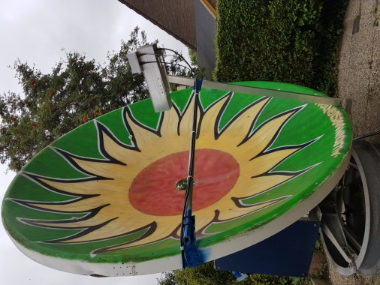
PA0PLY’s new 3 m dish with 23 cm feed

