432 AND ABOVE EME NEWS
AUGUST 2018 VOL 47 #7

EDITOR: AL KATZ, K2UYH; DEPT. ELECTRICAL/COMPUTER ENGINEERING, THE COLLEGE OF NEW JERSEY, PO BOX 7718 EWING, NJ 08628, TEL (W 609-584-8424), (C 609-047-3889), E-MAIL alkatz(x)tcnj.edu
ASSOCIATE EDITOR AND Reflector/NETNEWS Matej Petrzilka, Simunkova 1609/21, 18200, Praha 8, Czech Republic, TEL (+420 603 489 490), E-MAIL ok1teh(x)seznam.cz
CW INITIAL LIST G4RGK, DAVID DIBLEY, E-MAIL zen70432(x)zen.co.uk, AT: http://www.zen70432.zen.co.uk/Initials/index.html
SUN & EXTRATERRESTRIAL NOISE LIST MANAGED BY OK1TEH: http://www.ok2kkw.com/next/nl_k2uyh/sun_table.xls
EME INFORMAL NETS: 14.345, ~1500 SATURDAY AND SUNDAY, NET COORDINATOR: OPEN
ON0EME EME BEACON, 1296.000 IS QRV WHEN MOON >10°, SEND RX REPORTS TO WALTER (ON4BCB) on4bcb(x)gmail.com
DL0SHF 3 CM EME BEACON, 10368.025, SEND INFO & QUESTIONS TO Per (DK7LJ) per(x)per-dudek.de.
NL EMAIL DISTRIBUTION and EMAIL LIST CORD: WARREN, W2WD wbutler(x)ieee.org [PDF]
THE NL WEB VERSION IS PRODUCED BY REIN, W6SZ rein0zn(x)gmail.com, AT http://www.nitehawk.com/rasmit/em70cm.html

CONDITIONS: The OK1KIR team is again the top reported scorer in EU/DUBUS 3 cm and Up CW EME Contest with totals on 3 cm of 32x30 and on 1.25 cm of 4x4 for a overall total of 36x34 on both bands. In comparison to 2017, these figures are a slight increase on 10 GHz with the same number of QSOs but 2 more multipliers, but a big increase for 24 GHz where only one QSO was made last year. The AA1KK 1296 dxpedition was a great success. It provided a gigantic 67 initials with a nice mix of JT and CW QSOs. The full report follows in this newsletter (NL). Also, in this NL is a surprise dxpedition by VA3ELE/VE2 to Zone 2 on 432 - Peter says he plans to repeat his 2100 km trip to provide Zone 2 QSOs on 1296; and the finally of VK7MO’s amazing grid dxpedition in Queensland during which Rex provided 140 QSOs and 22 new grids. There is little dxpedition activity until Sept when PQ0F will be QRV from the island of Fernando de Noronha (HI36te) on 31 Aug to 13 Sept, on 2 m thru 3 cm; and 4U1ITU will be on 432 thru 24 GHz from 22 Sept to 1 Oct - see the June NL for more details on both these dxpeditions. The low dxpedition activity in Aug is now doubt due to the biannual EME Conference, EME2018 in Holland taking place on 17-19 Aug. Just about every 432 Up EMEer will be there! See more info at the end of this NL and previous NLs. Proposals are being sought for EME2020. We had hoped to get this NL out in time to promote the 9 cm DUBUS Contest Weekend, but it is taking place as we finish this NL. There are no contests in Aug. There was a 9 cm Microwave Activity Weekend (MWAW) on 7/8 July that is reported on in this NL. The 13 cm MWAW is on 4/5 Aug and is early enough to allow participation before we all leave for EME2018. The next 70 cm CW ATP (activity time period) is on 12 Aug from 0630-0930 and 1500-1700.

AA1KK: Bob (W1QA) bob(x)w1qa.com reports on his group’s recent 23 cm RI EME dxpedition -- NC1I, KA1QFE and I went to the dxpedition site the previous weekend to get everything set up. All went pretty well until we attempted RX tests and found the RX system not working. Three hours later, we figured out that a 1 A fuse for the 12 VDC supply used for the feed mounted preamp had blown. We had earlier checked the voltage at the BIAS-T and feed and measured the correct voltage – we even swapped the preamp with a spare. The DC power distribution is a Rig Runner unit (with Anderson power pole connectors) and has a small LED to indicate when a fuse is blown. We were measuring voltage through the
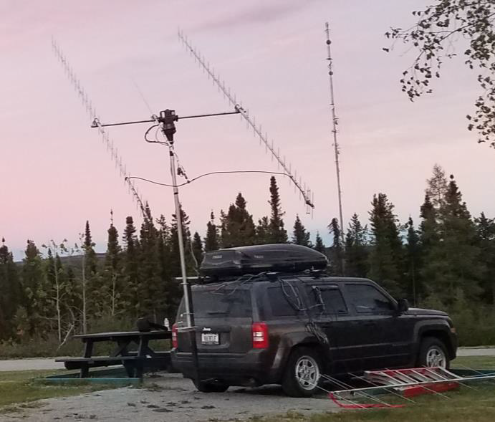
VA3ELE/VE2 in Zone 2 on 432

LED – but it wouldn’t pass enough current to power the preamp. Ugh! NC1I and I returned on Thursday and fired up the station. As usual we had our European friends all ready to work us … and the screen was bright with signals. About two hours and 20 QSO’s later all went quiet when our 20 kW diesel generator shut down. (This is a field day like operation with no connection to the mains/grid.) It took approximately three hours to troubleshoot the problem – luckily in daylight and with good weather conditions. The generator controller shut down due to low output voltage (just over 180 VAC and it should have been 220 VAC). We actually experienced this problem before – caused by failed capacitors in the generator voltage regulation circuit. I got a bypass working and ran it with the lower output voltage. We ended up also running the camper’s 5 kW generator as well because the Alpha SPID controller didn’t like the +/- 90 VAC input and the on-board camper air conditioner needed the higher voltage. Even with the unexpected down time on Thursday, we ended the day with more QSO’s than we had expected. Come Friday morning we woke to heavy overcast skies and pretty chilly temps. During the day it actually struggled to reach 16 degs C/60 degs F. As I didn’t bring a jacket and only had short sleeve shirts we actually turned the heat on in the camper as the equipment we were running just didn’t generate enough heat (especially with the kW amp mounted at the base of the tower). During the day we had off and on rain, but nothing detrimental for our operation. Right before our lunch break we were thrilled to work PA3DZL. Jac was using a single 67 el yagi and 120 W – nice QSO! After lunch we made our first experiments with WSJT-Xv1.9 and using the QRA64 mode completed QSO’s with KA1GT. The rain tapered off and later in the day; and KA1QFE and KU1RT flew by to make some aerial photographs of our location. It was a pleasure to close out the day with some setting moon VK and JA contacts. After a good rest we returned back to the site for Saturday’s operation. As expected it was a bit slower but enough activity that we were kept busy. At our lunch time W9JJ joined us and stayed for the remainder of the operation. This allowed Frank to make the 2+ hour drive (each way) home to work us from his home station. Frank stayed home overnight on Saturday and drove back to RI on Sunday morning. After he picked me up at the hotel, we heard a strange noise in his vehicle, which got worse by the time we got to the site. It turned out to be a front wheel bearing. We had to have his vehicle towed back to his home garage. Good thing this did not happen when we were towing the 2700+ kg / 6000+ pound trailer with generator, tower, dish, etc. back home! Compared to Friday, Sunday’s WX was hot and miserable 35 degs C/95 degs F – probably even worse if you were standing on the side of the highway! Our Sunday activities were constrained by personal schedules. We had originally planned on breaking down early and heading home. We were fortunate to be able to get on for a couple of additional hours at our Sunday moonrise and put a few more contacts in the log. At the end of the operation we had 67 initial contacts, 9 stations worked on CW, 22 DXCC countries and 7 US states. This exceeded our expectations. It also exceeded our QSO count last fall as N1H from NH. Over the next week or two we’ll try to gather all our photos and choose something for a QSL card. Probably we will take a couple of additional weeks after that before we have them in the mail. We will QSL 100% direct to your QRZ.COM address. If you would like your card sent elsewhere please drop me an email off-line. If you’d like to send us a card please send to NC1I either at his QRZ.COM address or via the bureau if that is easier. Envelopes and donations are not necessary. One thing that was different for us during this dxpedition: It was our first use of the Elecraft K3S rig. Previously we had been using a Yaesu FTDX-5000MP. The big difference is < 2 kg versus 25 kg! We were very pleased with the WSJT performance of this radio. It certainly performs as well as the 5000. We had a little more difficulty on CW probably in part due to the fact that we had no familiarity with operating CW with this rig. At some point we’ll set the rig up at the NC1I’s QTH and get a better handle on the CW RX settings. We also ran less power this time being more conservative with the amp and its power supply sitting outside at the base of the tower and the (almost) summer Sun. Another project I hope to accomplish this summer will be building much if not all the shack components into rack-mount cases that will facilitate setup, breakdown and storage of the equipment. This would include just about everything you see on the operating position table along with all the components that are mounted on a board that we clamp to the back of the table. Special kudos to KA1QFE who’s contributions include not only the camper (caravan) that we operate out of but also the outboard generator and antenna tower and mounting system that he designed. He also threw in a couple of comfy arm chairs for us to relax in as well. (After all, we are old timers!) We hope to do something again before the end of the year; stay tuned for more details on when, where and which band. The following stations were worked on 14 June (note all QSO’s are JT unless noted otherwise): DJ9YW, DG0FE, G4YTL, OH2DG, K5DOG, DL7UDA, PA3FXB, EA8DBM, I5YDI, IK1FJI, G4DML, W2HRO, DK3WG, KA1GT, DL6SH, UA3PTW, N5BF, DL8FBD, LA3EQ, DL6SH (CW), W1PV, JA6AHB and K5DN, on 15 June F1RJ, OK1YK, G4CDN, IK1FJI (CW), OK1IL, DK5YA, ON4AOI, VE3KRP, ZS6JON, VA6EME, I1NDP, EW1AA, ZS4TX, OK2DL, OK1KIR (JT & CW), OK2DL (CW), G3LTF (CW), OT7K (not counted as an initial as same as ON4AOI), DF2VJ, G4CCH (JT & CW), PE1CHQ, LA3EQ (dupe), DF2GB, PA3DZl (1 x 67 element & 120 W!), and at KA1GT (dupe, our first QRA64 QSO), on 16 June VK4CDI, JA8SZW, VE6TA (CW), VK2JDS, RA3AUB, SM7FWZ, ON5GS, DL3EBJ, DK0SF (same as DL6SH – not counted as an initial), DL6SH (dupe), ES6FX, GM4PMK, VE4MA, RU4HU, IK3COJ, SP6ITF, DF3RU (JT & CW), SP6ITF (CW), IK3COJ (CW), I7FNW, XE1XA, OH3LWP, VE3NXK, NC1I, and K5DOG (dupe), and on 17 June KL6M (CW), OK1DFC, LA3EQ (dupe), ON5GS (dupe), PA0BAT, IK5EHI, and RA3EC.

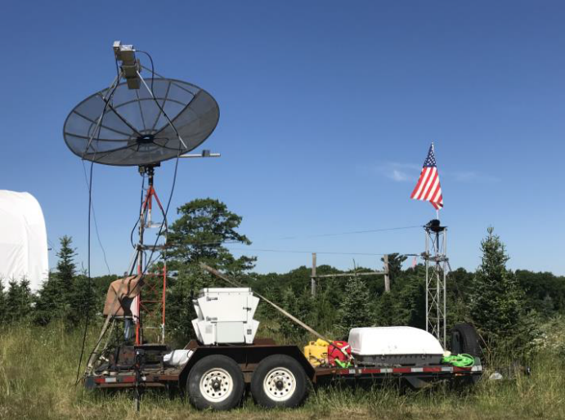
AA1KK on 1296 EME from RI

BD4SY: Zhu bd4sy(x)126.com is now QRV on 3 cm as well as all the lower microwave EME bands – I ran my first test on 3 cm on 16 June using my 3 m TVRO dish and 8 W, and was able to QSO HB9Q, OK1KIR and OZ1LPR using JT4F. My output power is small, actually less than 8 W, and my antenna tracking system is not good. I do cannot set the dish accurately enough for its very small beam angle. I'm trying to solve these problems. I am also QRV on 6 cm, and can hear my echoes there very well. Either JT4F or QRX64D are OK for skeds.

BG6LQV: Jianglei 254350(x)qq.com is SWLing on microwave EME as his radio license does not allow him to TX at frequencies above 432 -- I bought a 1.8 m mesh dish and made a spiral feed for RX of the 1.7 GHz HRPT weather. I used this feed to receive HB9Q, OK1CA and UA3PTW on 1296. Their JT65C signals were clearly visible in my spectrum display. I was very happy. I built a 2.3 GHz OK1DFC Septum feed. I asked HB9Q to help with a test signal, and Dan readily agreed. I clearly received a signal from Dan on 2320. I have also made a 3.4 GHz OK1DFC's feed. Although I can't TX on the frequency, I am very happy to listen for stations. But I do have a limited window due to many high-rise buildings. I can't work below 30° el to the east and below 20° el to the west.

DK3WG: Jurg dk3wg(x)ok.de was QRV in June off the Moon – I QSO’d on 432 using JT65B initials with AA4ZZ, R1NW, KE7NR/p, R18ARG (same as R6CS) and YU7C; and on 1296 using JT65C for the AA1KK dxpedition.

DL9KR: Jan Bruinier(x)t-online.de writes on his recent successes on 432 CW -- Over the last months I was happy to make a few nice CW QSOs. I worked on 26 Dec JA4UMN for initial #1043 and VK3NX in a new loc #1044, on 2 Jan N0AKC #1045, on 25 Feb in the DUBUS Contest ES5PC, G3LTF, JA6AHB, OH2DG, OZ4MM, SM5EPO, DL6KAI, LZ1DX, DL8DAU, UA4AAV #1046, IK2OFO, G4ALH, NC1I, VA3ELE and K2UYH, on 3 March TD9CHR #1047 for CW DXCC 143, on 27 March CR2EME - strong #1048, on 21 April BD9BU #1049 and Zone 23, on 22 April PI9CAM with 2 W out (!), on 22 May XE2AT #1050, on 10 June K5QE and AE5VB (same as K5QE), on 15 June BD9BU again, on 7 July G3LGR #1051 - finally after Mike upped his power to 250 W. During the last ATP, I called CQ a couple of times but obviously missed G3LTF and the others. I am looking forward to the upcoming expeditions, especially PQ0F. I flew over PY0 more than 100 times.

G3LTF: Peter’s g3ltf(x)btinternet.com June EME report --- I do not have too much this month. I was on 1296 and worked on CW on 15 June AA1KK for initial #451, followed by W2HRO #452, and KA1GT #453 and IK1FJI. On 13 cm, on 19 June, I had an amazing QSO with PA3DZL on CW. Jac was using a single 20 dBi yagi and 350 W. It took 2 tries on different days, but we exchanged O’s and 73. Both of us agreed (as you would expect) that copying the other’s call was the hardest part. Definitely the smallest system I’ve worked on 13 cm. During the 3400 AW, 7/8 July, I was not able to be QRV on Saturday due to a system fault, but on Sunday I worked HB9Q, SM6PGP, OZ5G, K2UYH, OZ6OL, LX1DB and VE6BGT. I still haven’t found the fault, which is intermittent but I will before next weekend!

IK1FJI: Valter valter_dls(x)yahoo.it sends his latest report for 23 and 70 cm – I was QRV on 1296 and worked on 10 June OZ4MM (579/579) CW and OZ4MM (56/55) SSB, and on 14 June DL6SH (579/569) CW, on 15 June AA1KK (O/O) CW for initial #107, OK1KIR (579/569) CW, G3LTF (579/569) CW and OE5JFL (579/579), and 24 June XE1XA (569/559) and some JT65C QSOs including AA1KK - very good dxpedition! On 432 I worked using JT65B on 10 June HB9Q (23DB/12DB) and DL7APV (22DB/16DB). On 432 I was using a single 7.7 wl yagi, 180 W and 0.5 dB NF LNA.

JA4BLC: Yoshiro ja4blc(x)web-sanin.co.jp sends his June EME news -- In the DUBUS 3 cm CW EME Contest, I worked 7 stations with my 3 m dish. QSO’d on 16 June were JA1WQF (569/549), OK1CA (559/559) and OH2DG (569/449), and on 17 June IW2FZR (559/559), OK1KIR (559/559), ES5PC (559/559) and SA6BUN (569/549) for a total of 7x6.

JA6XED: Hisao htk3138ja6xed(x)kumin.ne.jp is now on 3 cm EME – I am using my old 5 m dish used years ago on 432 with the center covered with a fine 2.5 mm mesh over 3 m x 3 m. It works quite well; I have made 14 QSOs with it on 3 cm and am looking for more. I have a 70 W SSPA made by JA8CMY at the focus. My location is very good. I can hear echoes from an elevation angle of about 8 degs.

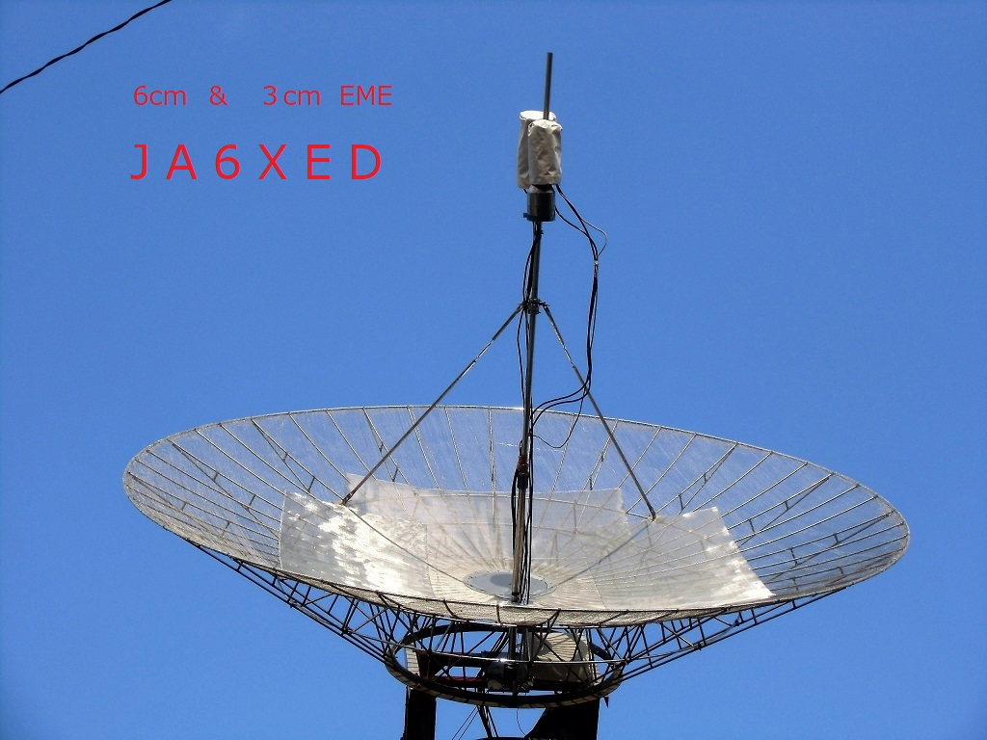
JA6XED 5m dish with added fine mesh for 3 cm EME

KA1GT: Bob ka1gt(x)hotmail.com did not make any major changes to his system this month -- I just fine tuning the 1296 feed and made some improvements to the cable connections. Sun noise is around 9 dB. All new contacts were on 1296. I'm typically running between 150 and 250 W at the feed of my 2.7 m dish. I worked DL6SH, G3LTF, G4CCH and OK1KIR on CW. I'm still using WSJT-10 CW mode for CW contacts. I also added 18 initials on JT65C and am now up to initial # 52 on 23 cm (as of 7/7/18). I worked AA1KK in RI on both JT65C and QRA64.

MX0CNS: Tom m0aba1970(x)gmail.com continues his small antenna testing on 432 -- I have been again testing with my tiny DG7YBN GTV antennas. My object is to hopefully encourage a few more to give EME a go with whatever equipment they may already have. The capabilities of the bigger stations make it possible to do things that maybe in the past were thought to be impossible. I also want to show the capabilities of the newer generation of low noise antennas. Who would have believed that I can regularly make contacts using nothing more than 7 or 8 el antenna? I can hear all the bigger stations on antennas as small as 2 elements! Last time I tested with DL7APV and HB9Q it took us 7 months to achieve a contact on just 2 elements. This time, thanks to the great work Bernd has done on his supper array (128x11 GTV antennas), we only needed two sessions before a contact was made on 16 June (23DB/25DB) with 60 W at my the feedpoint. After the contact just for fun I pulled the reflector from the GTV2 and used just its bent dipole. Bernd was received at (26DB). Bernd’s array can really be called a super array - EME reception on a dipole!

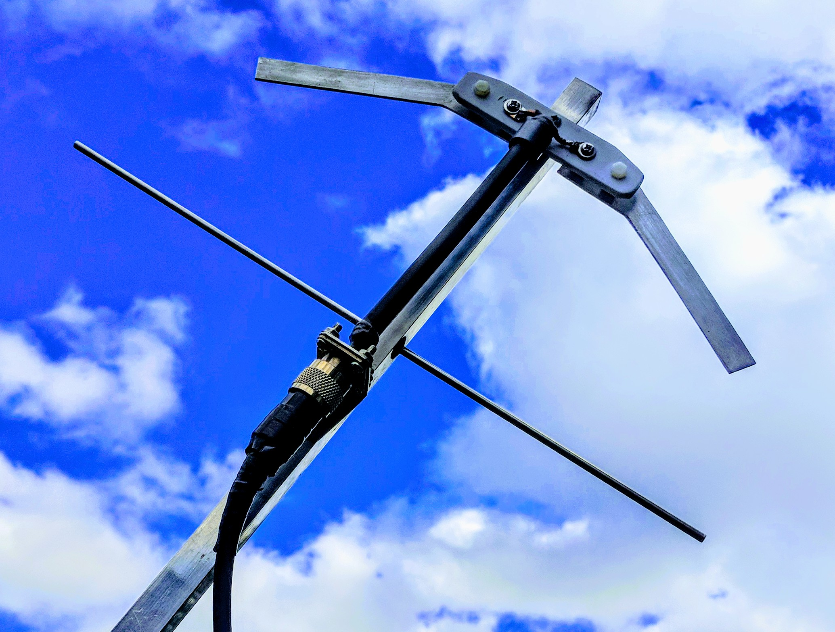
MX0CNS 2 el yagi used for 70 cm EME QSO

N5BF: Courtney courtney.duncan.n5bf(x)gmail.com (DM04vf) writes on his 1296 EME activity -- A death in the family consumed most of June, but I got Rhode Island for State #15, working the AA1KK expedition for mixed initial #128* and DL8FBD #129* the same morning. On the weekend of 7 July I changed over from running WSJT for Mac (from ZS6TW) on a 2010 Macintosh to the latest WSJT-X on Windows 10 on a shiny new PC. Everything looks familiar and I have all of the rig hookups working well enough to go on the air but quite a bit has changed in the last four years of development, so I'll be slow for a while.

NC1I: Frank’s frank(x)NC1I.COM June report is shorter than normal due to his AA1KK 23 cm RI dxpedition -- I only have one QSO to report from the home station. I was unable to find a guest op to go to my house and work our AA1KK station in RI; so I made the return trip and made the QSO myself. On 16 June at 2159 I worked AA1KK (11DB/09DB) on 23 cm. I expect to be active from home on both 23 cm and 70 cm in July.

OE5JFL: Hannes oe5jfl(x)aon.at focuses this month on his radio astronomy -- My EME activity has been reduced recently; one of the reasons was that I had concentrated on pulsar observations since the end of 2016. The initial idea came from I0NAA, including his software Murmur, very useful for observation planning. I also came across the webpage of Andrea, IW5BHY, who regularly can receive the pulsar B0329+54 on 420 MHz with a corner reflector antenna, equivalent to a 2.5 m dish. On the occasion that I had an EME QSO with him, I decided to ask him by email about what I would additionally need, how to start, and so on. Andrea was (and is) extremely helpful. He told me what hardware to use and let me use the software he has written, which performs excellent. At the beginning I had not expected the possibilities with my 7.3 m dish. Now I am up to 54 detected pulsars, 48 on 70 cm, 18 on 23 cm, 11 on both bands! All the detailed information is on my webpage at http://www.qsl.net/oe5jfl/ pulsar/pulsar.htm. With a 3 m dish at my home, I could detect 4 pulsars on 70 cm. The strongest (B0329+54) I also detected on 23 cm – see http://www.qsl.net/oe5jfl/ pulsar/pulsar_3m_dish.htm. Together with my Italian friends I will present the results at the EME2018 conference in Aug.

OK1CA: Franta strihavka(x)upcmail.cz was QRV in the EU/DUBUS 3 cm Up EME Contest -- I installed my rig on Friday, 16 June, and measured ground noise at 5.2 dB, Sun noise at 18.1 dB (SFU 70.8) and Moon noise at 3.2 dB. I began operation on 3 cm on Saturday and worked JA1WQF, JA8IAD and JA4BLC all crossband (XB) - 10450/10368. My overall result on Saturday was 21 QSOs with initials to SA6BUN, DF1SR and HB9BBD. I began at Sunday with a out of contest QSO with VK7MO (15DB/23DB) using QRA64D in QH23. I then continued on CW with JF3HUC for initial #89, JA8ERE and JA6XED #90. The JA station activity was very good; their signals were also good and there was no problem due to the XB operation. I finished my activity on 3 cm with F1PYR. I had overall score of 25 QSOs. I heard only VE4MA, DL6ABC and LX1DB. I QSY’d to 24 GHz on Sunday afternoon and worked OK1KIR. I heard LX1DB and OZ1LPR. I measured 1.5 dB of Moon noise on 24 GHz, and heard my own echoes weak in overcast.

OK1KIR: Vlada’s vlada.masek(x)volny.cz and Tonda’s club’s EME in July – On 1296 during the AA1KK dxpedition in RI, we worked using CW on 15 July at 1522 AA1KK (549/539) for initial #432, 1612 W2HRO (O/O) #433, 1623 IK1FJI (569/579), 1855 KA1GT (549/539) #434 and 1902 DF2GB (569/569), and using JT65C at 1510 AA1KK (4DB/10DB) for digital initial {#306}, 1545 W1PV (1DB/9DB) {#307}, 1639 KA1GT (3DB/7DB) {#308}, 1654 RC18SR (18DB/O) and 1711 LA3EQ (3DB/8DB). On 10 GHz in DUBUS Contest, we worked using CW on 16 June at 0709 SP6JLW (589/569), 0723 HB9Q (569/559), 0730 ES5PC (549/559), 0734 OH2DG (559/559), 0744 JA1WQF (559/569), 0754 JA8IAD (549/549), 1046 HB9BBD (549/539) for initial #122, 1051 SA6BUN (569/569), 1111 DL7YC (569/579), 1155 OK1CA (569/579), 1210 DL6ABC (559/559), 1214 SM6CKU (559/569), 1221 UR5LX (O/O), 1234 OZ1LPR (589/579), 1308 DB6NT (569/569), 1357 DL0EF (559/449), 1407 IW2FZR (549/559), 1432 SP3XBO (549/569), 1519 DF1SR (559/559), 1637 OK2AQ (O/O), 1710 VE4MA (549/549), 1735 WA6PY (559/569), 1818 SM2CEW (O/O), 1824 IZ2DJP (O/559) and (2046) K2UYH (559/569) - after turning to H pol from V pol, Al unreadable weak), and on 17 June at 0743 JA8ERE (559/569), 0953 JF3HUC (549/559), 1007 JA4BLC (559/559), 1032 JA6XED (559/559), 1247 LX1DB (579/569), 1301 F1PYR (559/579) and 1918 W5LUA (579/579). Our total contest count was 32x30. On 24 GHz in the DUBUS Contest on 17 June we worked using CW at 1417 OH2DG (O/O), 1745 LX1DB (559/569), 1753 OZ1LPR (O/O) and 1825 OK1CA (O/O) - just before dark clouds and wind approached. Our total count was 4x4. Unfortunately, we listen at a good “O” IK2RTI in QSO with OH2DG, but after QSO we CWNR. No success either with S57NML due to Andrej’s limited window. We were unable to find his weak CW signal at time of maximum spreading. Outside of the contest activity, on 3 cm, we continued following VK7MO’s grid dxpedition through Australian Queensland. With QRA64D we worked on 1 June at 2248 VK7MO in QG45 (13DB/15DB) for digital initial {#161}; on 2 June at 2325 VK7MO in QG35 (13DB/12DB) {#162}; on 3 June at 2350 VK7MO in QG46 (12DB/13DB) {#163); on 5 June at 0014 VK7MO in QG36 (11DB/12DB) {#164}; on 7 June at 0108 VK7MO in QG56 (15DB/13DB) {#165}; on 10 June at 0204 VK7MO in QG37 (19DB/19DB) {#166}; on 11 June at 0222 VK7MO in QG38 (12DB/12DB) {#167} and 0314 VK3NX (12DB/11DB); on 12 June at 0359 VK7MO in QG39 (13DB/14DB) {#168}; on 13 June at 0354 VK7MO in QH30 (12DB/14DB) {#169}; on 15 June at 0557 VK7MO in QH31 (11DB/14DB) {#170}; on 16 June at 0656 VK7MO in QH32 (11DB/11DB) {#171}; on 17 June at 0844 VK7MO in QH23 (10DB/12DB) {#173} and 2018 K6QPV (10DB/10DB); on 19 June at 1022 VK7MO in QH24 (12DB/12DB) {#174}; on 20 June at 1152 VK7MO in QH16 (14DB/15DB) {#175}; on 21 June at 1306 VK7MO in QH17 (11DB/13DB) {#176} and 1556 UN6PD (11DB/9DB); and on 22 June at 1430 VK7MO in QH19 (11DB/13DB) {#177}. In summary we worked during May-June 22 new VK grids. It was another fantastic VK dxpedition by Rex. It brought us to a total of 127 VK grids on 3 cm! Furthermore usig JT4F we worked on 16 June at 1023 BD4SY (18DB/12DB) {#172} for the first BY-OK 3 cm QSO. Zhu used a 3 m dish and only a 10 W SSPA. On 20 June at 1339 we worked with JT4F HA/G3WDG (17DB/18DB) and continued with QRA64D at 1349 HA/G3WDG (13DB/12DB). When Charlie back at home on 22 June repeated with QRA64D at 1608 G3WDG (16DB/17DB). On 432 we worked on 30 June at 0336 using JT65B VA3ELE (23DB)/ 23DB) for digital initial {#221} in FO13 during his Zone 2 EME dxpedition. Peter was all the time best around V pol. We had worked Zone 2 already in 1987 with CW – [see historic note later in this NL]. This was the first Zone 2 and FO field using digital (WSJT) operation! We also finally received our WAC awards for 3 cm CW and digital modes, both were dated 15 June, 2018 (applied for in Dec 2017). We now have WAC on 23, 13, 9, 6 and 3 cm!

OK1TEH: Matej ok1teh(x)seznam.cz was QRV on 70 cm EME with his small single yagi in June -- I limited my EME operation due to the very hot summer temperatures in my ham shack. However, I'd like to ask my friends from the EME world if anybody would be interested in 70 cm Meteor Scatter tests/skeds with me using FSK441/JTMS during the Perseids peak around 12 Aug. I'm especially looking for new UA/OH QSOs in range of 1800 – 2300 km; any takers? More about 70 cm MS can be seen at my web page ok1teh.nagano.cz or in the last Dubus issue in F8DO's article - very well written!

OK2AQ: Mirek’s kasal(x)feec.vutbr.cz June report follows -- On 3 cm, I worked on Sunday morning, 10 June, at 0223 VK7MO (17DB/21DB) from QG37te for mixed initial # 45*, then on Monday from QG38kl (16DB/DB19) # 46*, followed by VK3NX (15DB/16DB), and VK7MO again the next several days, always in the mornings, along with others, from grid squares QG39dw, QH30fa, QH31ar, QH32qh and QH23ua for initials # 47* to 51*. Rex's grid dxpedition to Qeensland was very fascinating. With daily regularity, the VK7MO’s window opened to the US and then EU from a new locator. During the DUBUS 3 cm Contest I worked using CW SP6JLW (O/O), OK1KIR (O/O), OK1CA (O/549), OZ1LPR (579/529) and DL7YC (O/O) # 52*. Outside the contest using QRA64D I worked K6QPV (14DB/16DB) # 53*. The following week Rex continued north into grids QH24fk, OH16ob, OH17hu and this great expedition ended at the most northerly Australian grid, QH19ec. All my QSOs were successful with him. Thank you very much, Rex. I also finally worked on 22 June at 1512 using QRA64D UN6PD #58* and DXCC 23 and ended using JT4F in a test QSO with G3WDG.

ON5GS: Dirk dirk.reyners(x)telenet.be was active on 23 cm off the Moon in June – I worked on 16 June using JT65C RA3AUB (5DB), AA1KK (8DB), KA1GT (9DB) and DL8FBD (13DB), and on 17 June JA8SZW (8DB), IK1FJI (9DB), PA3FXB (9DB), OK2DL (5DB), RC18SR (19DB), SM3KPX (18DB), AA1KK (8DB), F1RJ (8DB), K5DOG (8DB) and VE6TA (7DB). I hope to see all of you at EME2018 in the Netherlands.

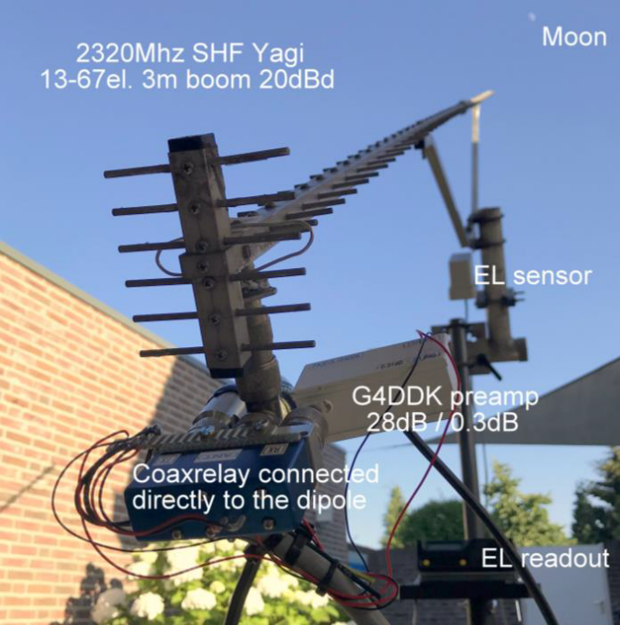
PA3DZL small yagi used to work G3LTF on 23 cm CW

PA3DZL: Jac pa3dzl(x)ziggo.nl 23 and 13 cm activity report -- I made some nice QSOs in June. I am still using my single yagis – [See Jac report in the last NL]. On 23 cm on 15 June I worked the AA1KK dxpedition on JT65C for mixed initial #306* and the State of RI with very nice signals (24DB) and an easy QSO with my SHF 67 el yagi, 120 W and G4DDK 0.25 dB NF LNA. So far this is the smallest station I have worked up to now - AA1KK used a 2.4 m dish. On 13 cm, I had an amazing QSO with G3LTF using CW. Our first test was on 19 June but signals were just a little too weak. I heard only some parts of both callsigns, so we could not complete. At this time, I had about 200 W at the feedpoint ant and a 40 cm long coax from the dipole to the relay. As we were just missing about a dB, I was able to improve signals by connecting the relay directly to the dipole and using a better relay. We tried again the day, 20 June and managed to complete a good CW QSO! My rig is SHF Yagi 67 el yagi (3 m boom – 20 dBd), 325 W at the feedpoint and a G4DDK 0.3 dB NF LNA.

SA6BUN: Michael sa6bun(x)gmail.com received special permission to operate on 9 cm for a limited time period – On 13 July, right before the start of the 13 cm DUBUS Contest I made my first 9 cm QSOs with VE6TA and DL7YC from SM (JO78cp). With the help of two good Swedish friends, I received one of the rare experimental 9 cm high power permits for a limited period of time. A prolongation after expiration is very unlikely, as the Swedish PTS does not consider 9 cm to be a ham radio band, and shortly 5G licenses in SM will be auctioned. The contest weekend offered a good opportunity to work a new initial from SM. I used my 9 cm portable dxpedition equipment, which is lashed up provisionally under my 3 m solid PF dish. It is the same dish I successfully used for 6 and 3 cm EME.

SM6CKU: Ben ben(x)sm6cku.se report on his 10 GHz operation – I QSO’d before the DUBUS 3 cm Contest, on 15 June DL7YC and UR5LX for an initial (#), then during the contest on 16 June SA6BUN, OH2DG, HB9BBD (#), SP6JLW, DL7YC, ES5PC, OK1CA, OK1KIR, OZ1LPR, HB9Q, DF1SR (#) and finally WA6PY, and on 17 June UR5LX, LX1DB and F1PYR. I ended with a score of 15x13. Heard but not worked on Saturday were DL6ABC, IW2FZR and DB6NT, and on Sunday SP3XBO, SM2CEW and IZ2DJP. All contacts were on CW. I am still using my 4 m dish and 15-18 W with CP.

UR5LX: Sergey ur5lx(x)ukr.net (KO70wk) was active on 3 cm in June – On 10 GHz, I use a 2.4 offset dish and 20 W. I participated in VK7MO’s grand grid dxpedition and worked Rex in grids QG45, QG35, QG46, QG36, QG56, QG37, QG38, QG39, QH30, QH31, QH32, QH23, QH24, QH16, QH17 and QH19 using QRA64D. All these QSOs were new mixed initials. I also added initials using CW with VK3NX and SM6CKU. In the DUBUS 3 cm EME Contest I made a total of 18 QSOs. Initials on CW were SA6BUN, DF1SR, SP3XBO, JA8IAD and IZ2DJP. After the contest I worked on 18 June UA4AAV on CW. Victor is using a 7.5 m dish and 15 W. I am now up to mixed initial #74*, and am very interested in 3 cm skeds on both CW and digital (QRA64D). Please email.

VA3ELE/VE2: Peter va3ele(x)gmail.com reports on his 432 Zone 2 dxpedition -- I drove up to FO13et as a dual-purpose trip. The first part was to do some Meteor Scatter on 144, and the other was to put Zone 2 on 432 EME for the first time in many years. As I am a fairly new 432 EME operator, I was not sure if it has ever been on before. My equipment consisted of 2 x M2 9 wl yagis, a Glenayre 97 Series SSPA with about 300 W to the array feedpoint, a WA2ODO 0.45 dB NF LNA and a TS2000. I also had a rotator, PC interface and everything else I could think of to keep the station working up in the north and far from any help. (I had to drive 2100 km to get to the dxpedition location and then back again). Amazingly everything seemed to work quite well with no hiccups. The only disturbance was a little bit of noise (2 dB) on moonrise and the fact that the Moon was near apogee at the time of the dxpedition (2.9 ~ 2.7 dB degradation). On 30 June I worked using JT65B NC1I (24DB), HB9Q (18DB), DL7APV (18DB), OK1DFC (18DB), OK1KIR (23DB) and W5LUA (22DB), and on 1 July UT6UG (19DB), ON4AOI (23DB), K2UYH (29DB) and W7MEM (18DB) - fell asleep during part this QSO. Overall, I was pretty pleased with my results and will try another dxpedition, possible on 1296 to Zone 2 in the future.

VE6BGT: Skip macaulay.skip(x)gmail.com is just about ready to go on 6 cm EME – I finished my new 6 cm 100 W SSPA and producing some real power. The design is by SM6PGP and uses two CREE GaN FETs. The driver is also using a CREE device. It is delivering 100 W with no problem. I was on for the 9 cm MWAW on 7/8 July. It was fun, but I found getting up so early has taken a toll on me. I worked VE6TA, HB9Q, K2UYH, G3LTF and LX1DB. If I had gotten on earlier I would have worked a few more. I am now looking forward to the 9 cm DUBUS Contest weekend coming right up. It’s a new band for me and my setup seems to work well with the PA at the feed with 50 W into my 21.5’ dish.

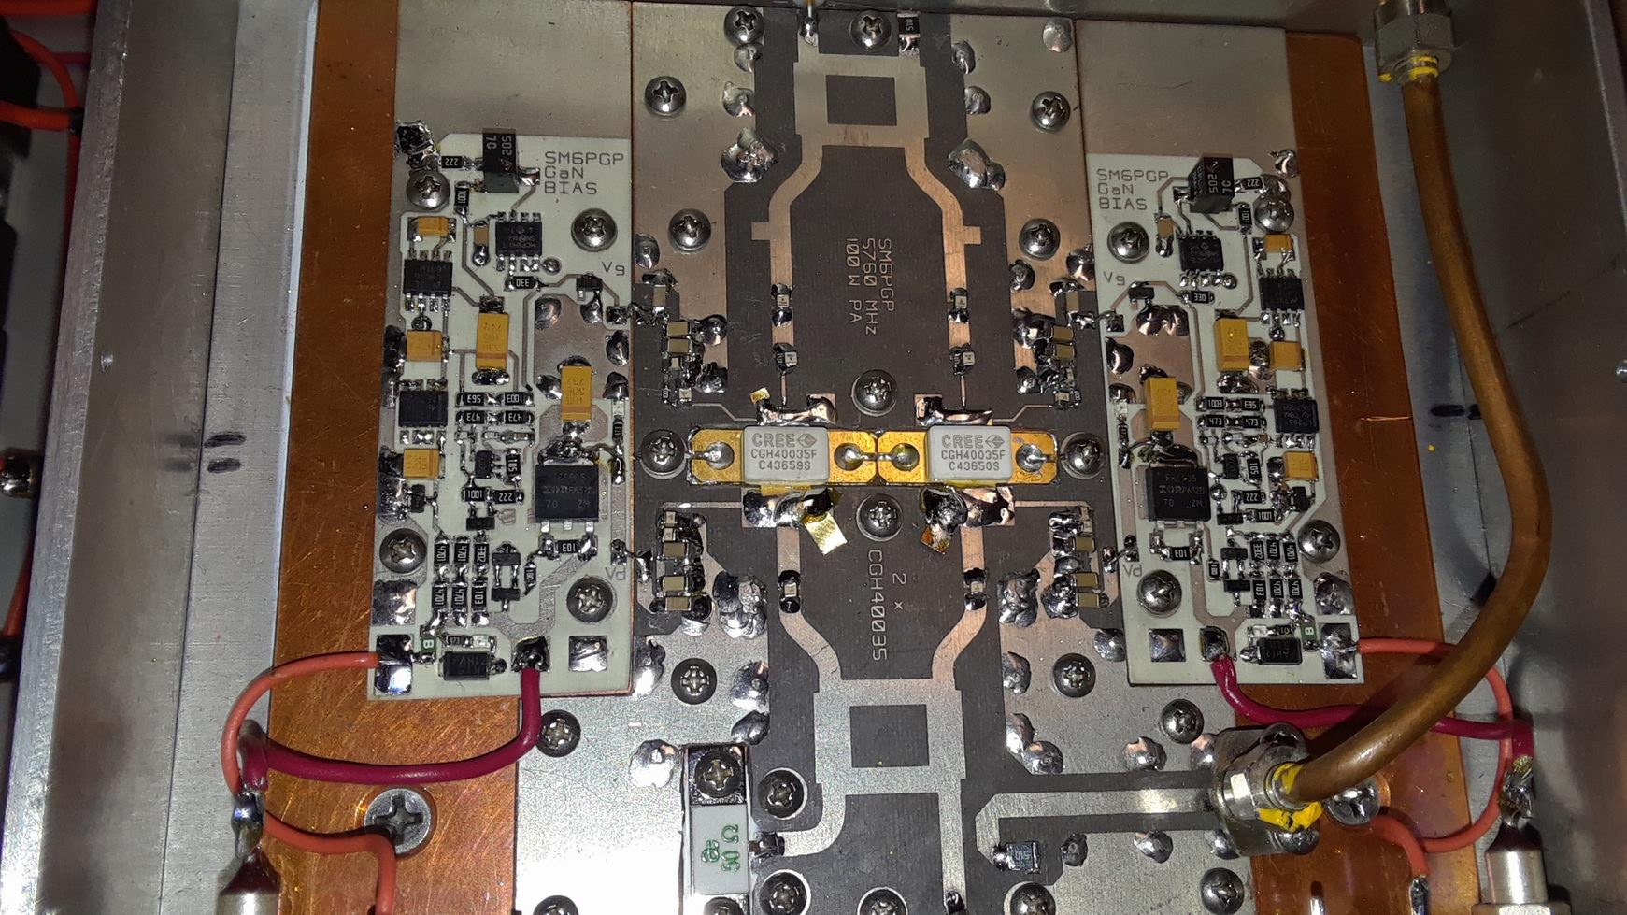
VE6BGT’s new 100 W 6 cm SSPA (SM6PGP design)

VK7MO: Rex rmoncur(x)bigpond.net.au completed in July the 3 cm Queensland Australian grid dxpedition reported on in the last NL -- A total of 22 new grid locators were activated between 20 May and 26 June as shown in Green on OK1KIRs web Map at Fig 1. QG62 had been previously activated but was again activated for a demonstration of portable EME at the Wireless institute of Australia Annual General Meeting. A key achievement was the activation of QH19 (Fig 2), the most Northerly grid in Australia, which involved a round trip of some 1400 km on mainly rough dirt, and much of the time badly corrugated, roads. Typically, 6 stations completed QSOs at each grid with a maximum of 8. In some situations, there was no access to the Internet and stations were worked on random. Text messaging via EME proved useful to provide information on plans when the Internet was not available. Stations who participated were W5LUA, VK3NX, UR5LX, OK1KIR, OK2AQ, OK1DFC, OK1CA, HB9Q, OZ1LPR, G3WDG, HA/G3WDG, and UN6PD. A total of 140 QSOs were completed. A difficult issue was to operate both moonrise to North America and moonset to Europe and to find accommodation at each site with suitable take-offs. Nevertheless, all stations that were available were worked at each grid. In some cases, the only suitable accommodation meant sleeping in the car. I used a new portable system based on a 95 W GaN SSPA and a 1.13 m dish with linear horiz pol. All operation was with the QRA64D mode in WSJT-X with CFOM or Constant Frequency On the Moon. A big advantage of CFOM is that all stations can tune to the same frequency and copy all activity without retuning. The smallest stations worked were OK2AQ, 1.2 m dish and 40 W, HA/G3WDG, 1.2 m dish and 50 W and UR5LX, 2.4 m dish and 20 W (10 W at QH24 due to PA overheating). These three small stations completed under even poor conditions of libration spreading over 100 Hz and Lunar degradation up to 1.5 dB. From these tests it was concluded that 2 portable stations using 1.2 m (or 4’) dishes and 50 W can reliably work each other under even the worst conditions of spreading and lunar degradation, providing one of the stations can adjust polarization to correct for spatial offset. While some may argue that the solution is circular polarization there are good reasons for small 3 cm EME stations to use linear pol. These include less blockage of small dishes to switch from clockwise to anticlockwise circular, the fact that small portable stations are also used for terrestrial, and as G3WDG has noted there is a performance advantage of around 1 dB. [See picture at the end of NL].

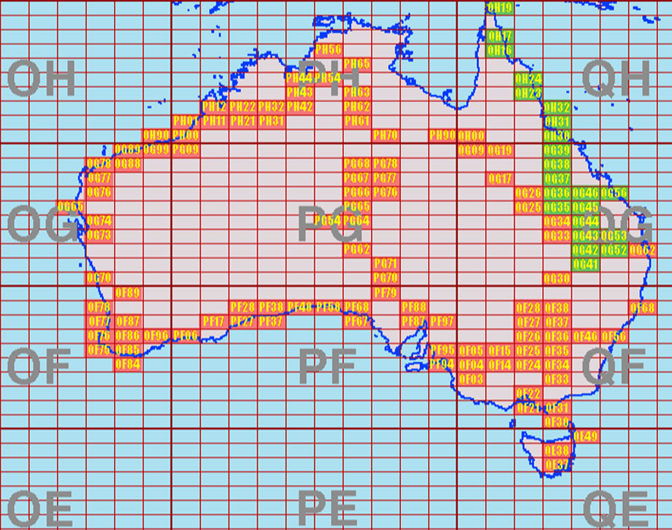
VK7MO grid map – green shows grids worked this trip

W2HRO: Paul w2hro.fn20(x)gmail.com has added 70 cm EME – On 1296 I worked both recent dxpeditions AA1KK and EA6/HB9COG. I decided to take advantage of a lull in 1296 dxpedition activity and give 432 a try. I'm now QRV on 432 EME using a loop feed mounted in a commercially available baker's pan, based on a OK1DFC’s design, with my 3 m dish - f/d = 0.37. On TX, I am using a TE Systems 180 W SSPA. Stations worked to date on 70 cm include DL7APV, HB9Q, NC1I, DK3WG, DL6SH and UA3PTW with JT65B, and DL9KR using CW. I have also heard K2UYH and tried with the VA3ELE/VE2 Zone 2 dxpedition but could not quite make it. I'm planning to expand my 3 m dish to at least 4 m for a bigger signal on 432.

WA6PY: Paul pchominski(x)maxlinear.com reports on both his May and June operation – I was QRV in last Moon pass of DUBUS 6 cm Contest on 20 May 20 and QSO’d DF3RU, ES5PC, G3LTF, KL6M, OH2DG, OZ1LPR, PA0BAT, SA6BUN, SM6CKU, UR7DWW, VE6TA and WA9FWD. My total was 12x12. On 16/17 June in 3 cm DUBUS Contest I worked ES5PC, IW2FZR, OK1CA, OK1KIR, OZ1LPR, RB5LX, SA6BUN, SM6CKU, SP3XBO, SP6JLW and W5LUA. I also heard HB9BBD. My overall score was 11x10. I plan to be QRV for the 9 cm contest.

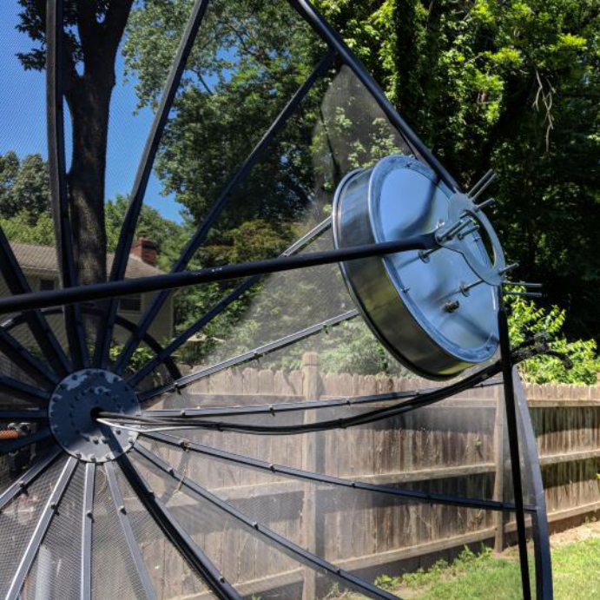
W2HRO’s 432 Cake Pan feed [Based OK1DFC’s feed design but using a standard available cake pan to ease construction]

XE2AT: Alvaro (DL81uu) who is well known from 2 m EME is trying 70 cm operation – I have 4x13 el yagis and 500 W, but need to improve my RX. I have a long cable to my LNA. This will be changed soon. So far I have worked several stations including OH3LWP (25DB/26DB). Look for me on the HB9Q 432 EME chat.

K2UYH: Al’s alkatz(x)tcnj.edu Moon time was limited in June because of his involvement in the International Microwave Conference that was attended by attended by several EMEers including N2UO, WA6PY, K1DS and K1JT – Because of conflicts I was only QRV for the 3 cm DUBUS Contest for about an hour and worked on 16 June at 1623 HB9Q (559/559), 1638 SP6JLW (559/559) and 1645 OK1KIR (569/559) for a total of only 3x3. I missed the AA1KK dxpedition completely but did catch on 1 July at 0437 VA3ELE/VE2 (16DB/16DB) for FO13 and mixed initial #965*. I was on for the 9 cm MWAW and worked using CW on 7 July at 1325 VE6BGT (569/559), and on 8 July at 0950 SM6PGP (569/569), 1002 G3LTF (569/569), 1027 OZ6OL (559/559), 1034 OZ5G (559/559) for initial #46 and1058 LX1DB (579/579). I plan to be QRV for the DUBUS 9 cm Contest. I also did some experimentation with operation on 10450 and made my first direct 3 cm QSO with a JA on 9 July at 2010 JA1WQF (23DB/15DB) using JT4F. The QSO was more difficult than expected because the 10 MHz reference cable broke but we made it anyway despite the large drift. I hope to CU on 13 cm in the MWAW on 4/5 in Aug and later at EME2018.

NETNEWS: UA3PTW worked the AA1KK dxpedition using JT65C. FR5DN is working on his 1296 system and trying to optimize the feed location for his 3.6 m (F/d = 0.36) dish. Phil hopes to be on RX very soon. HB9Q was QRV during VK7MO’s latest grid dxpedition. Dan was up to grid 70 in VK on 19 June. VK3NX has a serious QRN on 3400. Under new Australian regulations he (and all VKs) must TX below 3400. He will always be calling on 3398.100 and listening for your TXing XB on 3400.100. Please be patient as he will try to tailor his QRG, filters and NB to hear through the QRM. VK4AFL is QRV again (QG62om) and now on 9 cm. He planned to be active DUBUS Contest TXing on 3399.800 and RXing on 3400.050 to.080 with a 3.7 m dish and 50 W at the feed. VK4CDI will also be QRV on 9 cm for the contest. Phil will TX on 3399.800 or 3398.100 and RX around 3400.100. BG6LQV is now QRV on 9 cm and has made his first QSO with HB9Q. G3WDG/HA made is first 6 cm QSO from Hungry with OZ1LPR. He hopes to be activate from HA again on 6 cm in the near future. BD9SU is QRV on 70 cm EME from (OM33od) with 2 x 13 el Vpol DK7ZB yagis, HL250UDX SSPA and ATF54143 LNA. DL4ZAG (JN49it) is a new station on 70 cm EME with 4 x 13 el yagis and 10 kW ERP. R3VE is active on 70 cm EME with a single 26 el 4 wl yagi and 60 W. YU7C (JN95) used on 432 EME 2 x 27 el yagis and 200 W. Voja is looking for QRO PA. RK2P is QRV 70 cm EME with 2 x 18 el yagis, Hpol and 150 W. Nicola says more UA are soon to start on 70 cm EME.

FOR SALE: KK4X has a very clean 1296 1 kW Kuhne SSPA with heatsink and fans for sale with a 50 V 50 amp power supply for 2000 US dollars. If interested contact Ed at <kk4x(x)tampabay.rr.com>. DF6NA is selling a brand new TWT (AEG YH1151) capable of up to 2 kW on 23 and 13 cm and 900 W on 9 cm, at a good price. See https://www.ebay.de/itm/132705371652 and contact Rainer at df6na(x)df6na.de if interested. G4DDK has updated his Iceni 70 cm xverter design for greater dynamic range and a lower NF. Sam will provide details in his EME2018 talk. He will bring VLNA preamp kits and some transverter kits to sell at the conference. Else email Sam at jewell(x)btinternet.com. AA4MD has for sale a brand new 1296 150 W W6PQL SSPA - used less than one hour. If interested contact Jim AA4MD(x)aol.com. KC4SW has Scientific Atlanta AZ over EL mount for I precision dish pointing that he wants to get rid of. It weighs 500 pounds. The mount should move a 10M dish easily. and it’s taking up a pallet location on our floor. For more details contact Steve in Carson City, Nevada, (775) 882-5117 office, (775) 720-6020 mobile, s.hanselman(x) datagatesystems.com. OE5JFL has 70 & 23 cm YL1050 PAs for sale. More details are on Hanne’s web page at http://mailman.pe1itr.com/pipermail/moon-net/2018-July/036720.html.

SOME PIECES OF EME HISTORY: 31 years ago K1RQ with KA1ABC and WA1IVB traveled from Main to southern Labrador to put Zone 2 on 432 EME. [TNX OK1KIR Club].

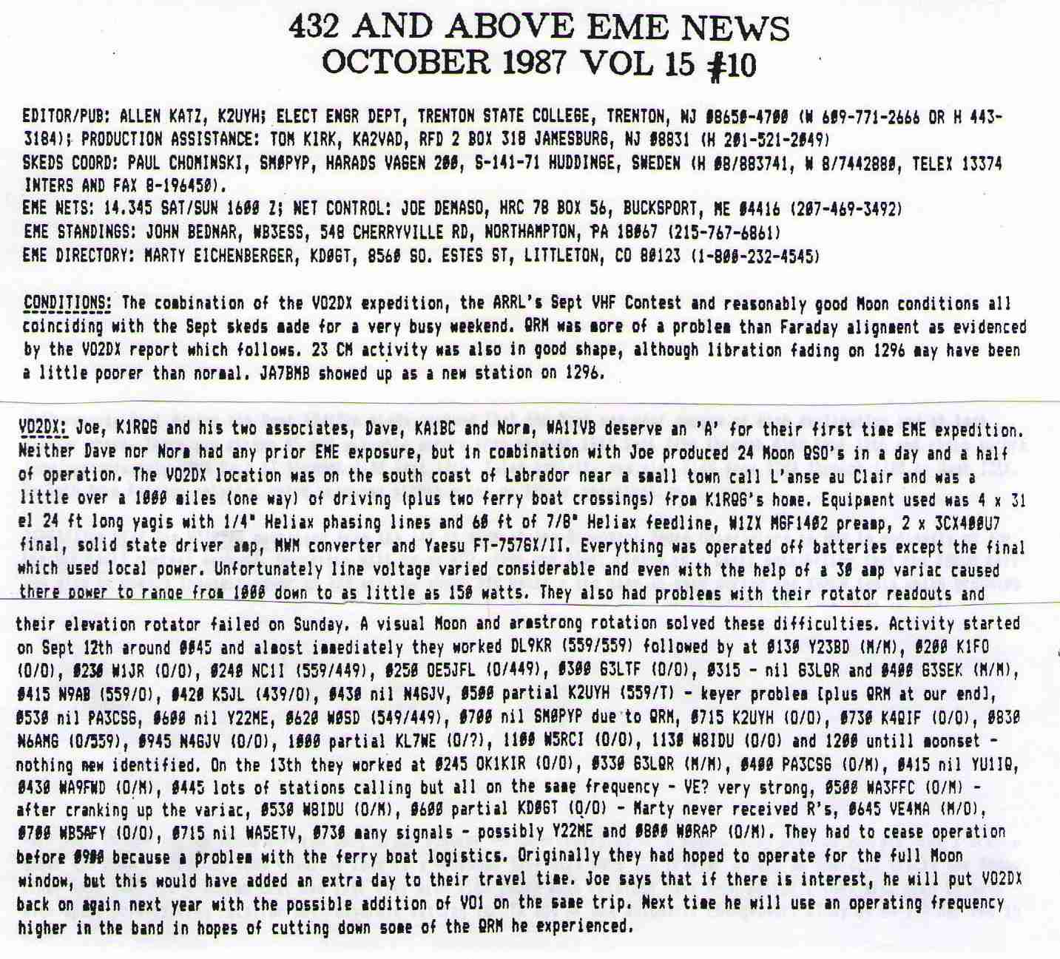Text from the Oct 1987 EME NL

JJ (F1EHN) reminds us that thirty yeas ago was the 1st and great EME expedition by the F6KSX group to Andorra. The callsign was C30BVA; active in July 1988, See for details http://f1ehn.pagesperso-orange.fr/pages_ f6ksx/eme1988.htm.

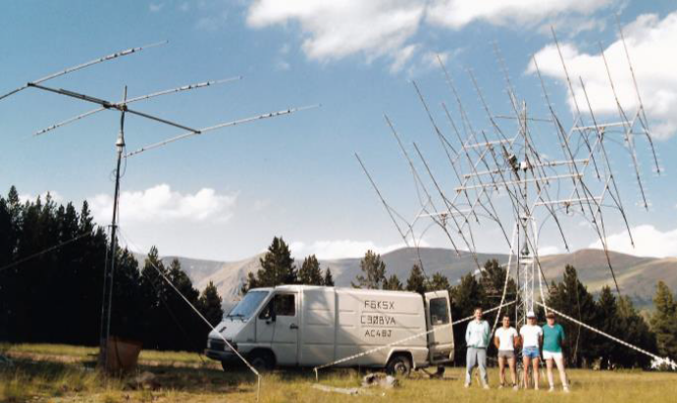
C30BVA 432 dxpedition to Andorra in July 1988

RADIO ASTRONOMY CORNER: Radio astronomy measurements of Pulsars were discussed in the last few NLs. One reason for such measurements that has not yet been discussed is using pulsars as an astrophysical laboratory for test of possible alternative gravity theories. On 4 July 2018, the result of such measurements was announced in Nature magazine. They proved that general relativity also works in an environment of crushing gravity. This result is important because Einstein's classical general relativity predicts that gravitational laws are independent of velocity and time-space. How could such a measurement be done? Anne Archibald of the University of Amsterdam and the Netherlands Institute for Radio Astronomy (ASTRON) and her team tested the strong principle of equivalence in the harshest test of history. They used a unique pulsar PSR J0337+1715 which is about 4200 LY away from us (RA: 03 h 37 m & 43.82589 s, DEC +17° 15' 14.8280”, Bright: ~2 mJy at 1.4 GHz), which is orbited by two close white dwarfs. This pulsar transmits at an average frequency of 365.953363096 (11) Hz, i.e. it rotates about its axis once in about 2.73 milliseconds. Pulsars have an extremely fast and extremely stable rotation so that all the continuous changes in their observed frequency go to the Doppler's effect, when at the moment pulsar when circulating around its companion in the "approach phase with respect to Earth", its frequency is higher than in the opposite phase. This makes it possible to determine with great precision the orbit parameters and many more. For such a triple systems where the times and distances of each component differ in several orders (which is the case of the PSR triple system J0337 + 171, for which the "internal" binary system has a period of 1.6 days, while the "outer" with a period of 327 days), it is also possible to determine with great precision the orbital times of the individual components (short-term changes in the frequency indicate the running time of the internal binary system containing as one of its two pulsar components, while the long-term frequency changes indicate the external coordinating of time). If the general relativity did not apply, the neutron star and the inner white dwarf would fall differently in the outer white dwarf's gravitational field. The inner white dwarf is lighter than the neutron star and therefore includes less gravitational binding energy. Detailed analyzes of the PSR pulse J0337 + 1715 showed that there are no measurable differences between the acceleration of the neutron star and the internal white dwarf. If there are any, there will be a maximum of 3 out of 1 million. According to the study's authors, this means very strict restrictions for alternatives to general relativity. The result of a unique experiment in deep space is ten times more accurate than the best-ever gravitational test. More at: https://public.nrao.edu/news/neutron-stars-fall/ and https://arxiv.org/pdf/1807.02059.pdf. See picture at http://www.caastro.org/files/37/2220866122/sransom_perth_2013_gbt350mhz.pdf (page 21).

FINAL: We had hoped to get this NL distributed before the 9 cm EU/DUBUS EME Contest, but it did not workout. We will have reports on the contest in the next NL.

► EME 2018 Holland is almost here! For those who have not made their reservations, it may be still possible to attend -- see the website www.eme2018.nl and contact Jan (PA3FXB), jvm(x)netvisit.nl. The program is in the last NL. Hope to CU soon in Egmond aan Zee.

Proposals are being sought for EME2020. The decision will be made at the end of EME2018. If you think you might like to host EME2020 contact Jan (PA3FXB), jvm(x)netvisit.nl.
► Enrico I5WBE reports that the results of the ARI EME Trophy Spring Contest can be found at http://www. eme2008.org/ari-eme/Results%20Trophy%20Spring %202018.pdf. The next contest will be on 8/9 Sept.

► An error exists in the Doppler correction of the original WSJT-X code when the button to allow TX (frequency) changes is not checked. (Only certain rigs as the TS2000 require a “not checked”). There will be a new public release (1.9.2) fairly soon, which will incorporate the correction. See K1JT’s web page for info on updates. Also https://drive.google.com/file/d/16OeUDb658425JYC8TFm88g9eEeV5eEkV/view?usp=sharing for more info on using WSJT-X.

► The 1296 and up WAC Club is starting to take shape. Dave (G4RGK) at zen70432(x)zen.co.uk has volunteered to keep track of WAC data. If you have note done so already please email Dave the bands you have WAC and the date you received your certificate. OK1KIR confirmed that they had finally received their certificate for 3 cm. I will report on the WAC Club at EME2018.

► TNX for tech info and reports. We are going to try to get the next NL out before we leave for EME2018. We are looking forward to seeing you all in Egmond aan Zee. 73, Al - K2UYH and Matej – OK1TEH

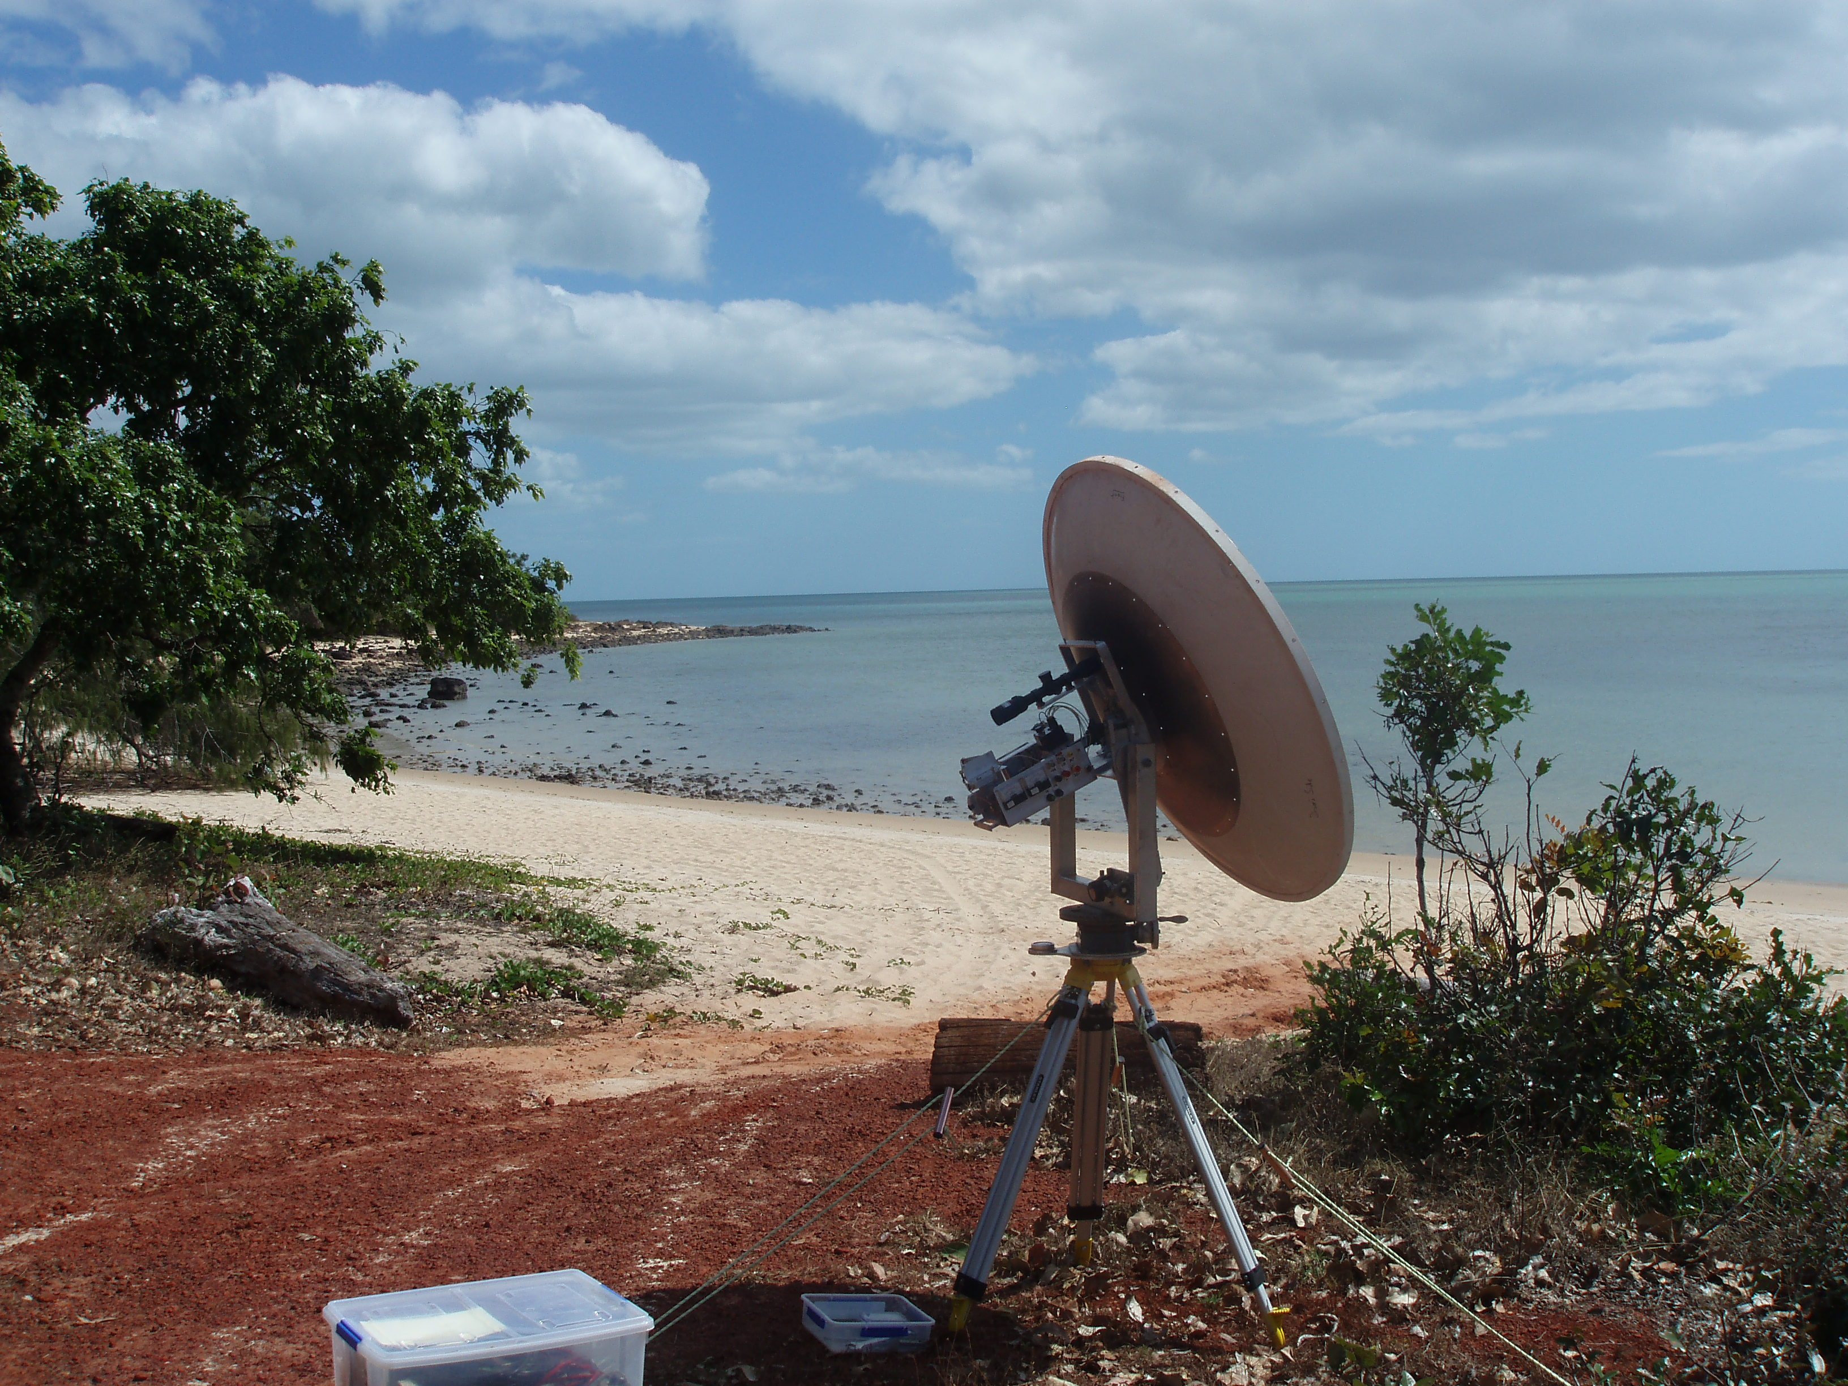
View at VK7MO’s operating site at north most grid in VK
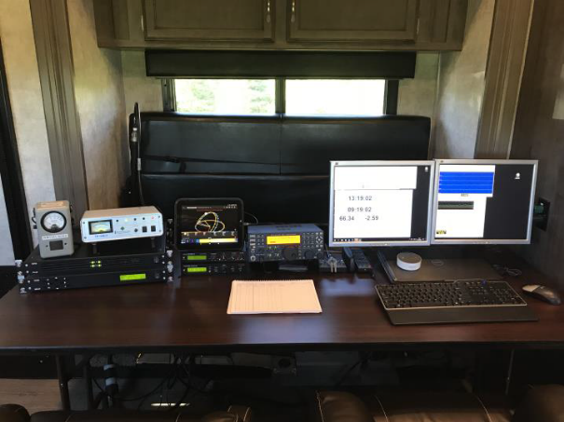
AA1KK dxpedition operating position (in van)

