432 AND ABOVE EME NEWS
AUGUST 2019 VOL 48 #8

EDITOR: AL KATZ, K2UYH; DEPT. ELECTRICAL/COMPUTER ENGINEERING, THE COLLEGE OF NEW JERSEY, PO BOX 7718 EWING, NJ 08628, TEL (W 609-584-8424), (C 609-947-3889), E-MAIL alkatz((x))tcnj.edu
ASSOCIATE EDITOR AND Reflector/NETNEWS Matej Petrzilka, Simunkova 1609/21, 18200, Praha 8, Czech Republic, TEL (+420 603 489 490), E-MAIL ok1teh((x))seznam.cz
CW INITIAL LIST G4RGK, DAVID DIBLEY, E-MAIL zen70432((x))zen.co.uk, AT: http://www.zen70432.zen.co.uk/Initials/index.html
SUN & EXTRATERRESTRIAL NOISE LIST MANAGED BY OK1TEH: http://www.ok2kkw.com/next/nl_k2uyh/sun_table.xls
EME INFORMAL NETS: 14.345, ~1500 SATURDAY AND SUNDAY, NET COORDINATOR: OPEN
ON0EME EME BEACON, 1296.000 IS QRV WHEN MOON >10°, SEND RX REPORTS TO WALTER (ON4BCB) on4bcb((x))gmail.com
DL0SHF 3 CM EME BEACON, 10368.025, SEND INFO & QUESTIONS TO Per (DK7LJ) per((x))per-dudek.de.
NL EMAIL DISTRIBUTION and EMAIL LIST CORD: WARREN, W2WD wbutler((x))ieee.org [PDF]
THE NL WEB VERSION IS PRODUCED BY REIN, W6SZ rein0zn((x))gmail.com, AT http://www.nitehawk.com/rasmit/em70cm.html

CONDITIONS: July/Aug was a special. There were no contests, but the Celebration of the 50th Anniversary of the Moon Landing and a dxpedition to 5 rare States (really 6) more than made up! There were two major Celebration events. One was on 6 cm that had the Goonhilly 32 m dish and the Parks 28 m dish communicating off the Moon 50 years after their involvement as Apollo ground stations – see reports from GB6GHY and VK6DSL in this newsletter (NL). The second had SSTV bouncing off the Moon from around the world. See PI9CAM’s report and that of others. [We recommend this event be made annual to celebrate the Moon landing with EME SSTV transmissions]. The K6MG dxpedition on both 23 and 13 cm was a great success. See the details in their report. There was also a Microwave Activity Weekend (MWAW) for both 13 and 9 cm. The 13 cm day was somewhat upstaged by the K6MG dxpedition, but the overall consensus was very positive. Coming up this month on 24/25 Aug is the 3/6 cm MWAW with 3 cm on Saturday and 6 cm on Sunday. There are no additional dxpeditions in Aug, but on 1 Sept KB7Q will put WY on 70 EME – see report, and on 21 Sept to 1 Oct A21EME will be on 70 thru 3 cm. The Aug 70 cm Activity Time Period (ATP) is on 25 Aug 0000 to 0200 and 0900 to 1100. On 21/2 Sept is the ARRL EME MW Contest and 28/29 Sept the ARI Autumn Trophy EME Contest.

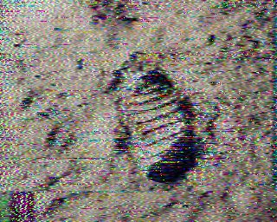
Fist steps on Moon received from PI9CAM by DL0EF

DL0EF: Gerd (DJ5BV) gerd(x)dj5bv.de reports on the Astropeiler dish group’s celebration of the 50th anniversary of the Apollo 11 Moon landing – We spent the night of 21 July watching SSTV (Martin2) color pictures coming down from the Moon on 1296. Many were from the Camras group, PI9CAM, in the Netherlands operating from the 25 m Dwinggeloo dish. The quality of the SSTV pictures as received on our 25 m dish was very good. Numerous visitors at our station enjoyed the event.

F2CT: Guy f2ct(x)wanadoo.fr completes 23 cm WAC --
On 9 June I worked using CW at 1200 VK5MC (559/559) for WAC – all on CW! I am interested in 1296 CW skeds. My rig is a 4 m solid dish with 700 W at the feed and a 0.3 dB NF LNA.

G3LTF: Peter g3ltf(x)btinternet.com submits his July/August EME report -- I did get on the Moon on 6 cm for the Apollo 11 Anniversary. With the dish at its lowest declination setting and the Moon just clearing the trees, I copied VK6DSL/P in his tests with GB6GHY and had a CW QSO with SM6FHZ. I worked on 26 July, on 23 cm using CW SM4GGC, F5KUG, LA3EQ, and K6MG in Neb for initial #476, and on 27July on 13 cm OH2DG, OK1KIR and VE6BGT but could only barely detect K6MG, unfortunately not strong enough for a CW QSO. I found no other activity during the 13 cm MWAW. I really don’t think it is worth holding one. We restarted the MWAWs for 6 and 9 cm where it still seems to make sense. I QSO’d on 28 July during the 9 cm MWAW SM3BYA, OH2DG, OK1KIR, G4NNS, SM6PGP, VE6TA and G4LDR. Quite a few initials were made by the people who were on. The next day I was delighted to work on 9 cm VK4AFL for initial #74, and later on 23 cm K6MG in SD for initial #477. I worked on 1296, on 30 July K6MG in ND #478, on 2 Aug K6MG in MT #479 and LZ2US and IK1FJI, and on 3 Aug FR5DN, SM4GGC, ES3RF #480 and K6MG in WY #481. Gary and Jim did a fine job with this dxpedition working the larger stations on CW in relatively quick QSOs to start with. I am now operational on the Oscar 100 satellite and hope to meet some EMEers there. I plan to be active on 25/26 Aug for the 3 cm and 6 cm MWAWs on Saturday and Sunday respectively.

G4LDR: Neil g4ldr(x)btinternet.com is now QRV on microwave EME with a 3 m dish – I was active on 9 cm for the MWAW on 28 July and worked on CW OK1KIR, G3LTF, VE6TA and OH2DG. I’m not set up for digital modes yet, so apologies to the stations who wanted to try a digital QSO. My equipment was a 3 m dish with RA3AQ feed (loaned by G3LTF), 70 W on TX and 0.8dB NF LNA.
carrying out some measurements on my system suggested by G3LTF. For the Apollo 11 weekend I managed to get my 6 cm system ready just in time. My 6 cm Sun noise was 5 dB less than predicted; so, I still have work to do. I copied VK6EME and GB6GHY on 20 July and just after the public event at Goonhilly concluded. I had a sked with them and they copied my CW FB. The day before, I was able to do some tests with GB6GHY over a 300 km path with my terrestrial 6 cm system. This enabled the team to ensure their system was working correctly. Their 32 m dish was set to near zero elevation. My equipment on 6 cm is a 3 m dish with a W2IMU dual mode feed (loaned by G4NNS), 100 W on TX and 0.8 dB NF RX. [Was the circular pol a problem, as on direct path there is no reversal]?

GB6GHY: Brian (G4NNS) bcg4nns(x)gmail.com reports on Apollo 50 at Goonhilly -- For the 50th anniversary of the Apollo 11 Moon landing, the owners of the Goonhilly Earth Station arranged for a concert featuring the band Public Service Broadcasting and DJ group Orbital. (Search YouTube for “PSB Go” to get a flavour of the music). Our EME group who have been activating the 32 m antenna as GHY6 were asked to provide an EME element to the event.
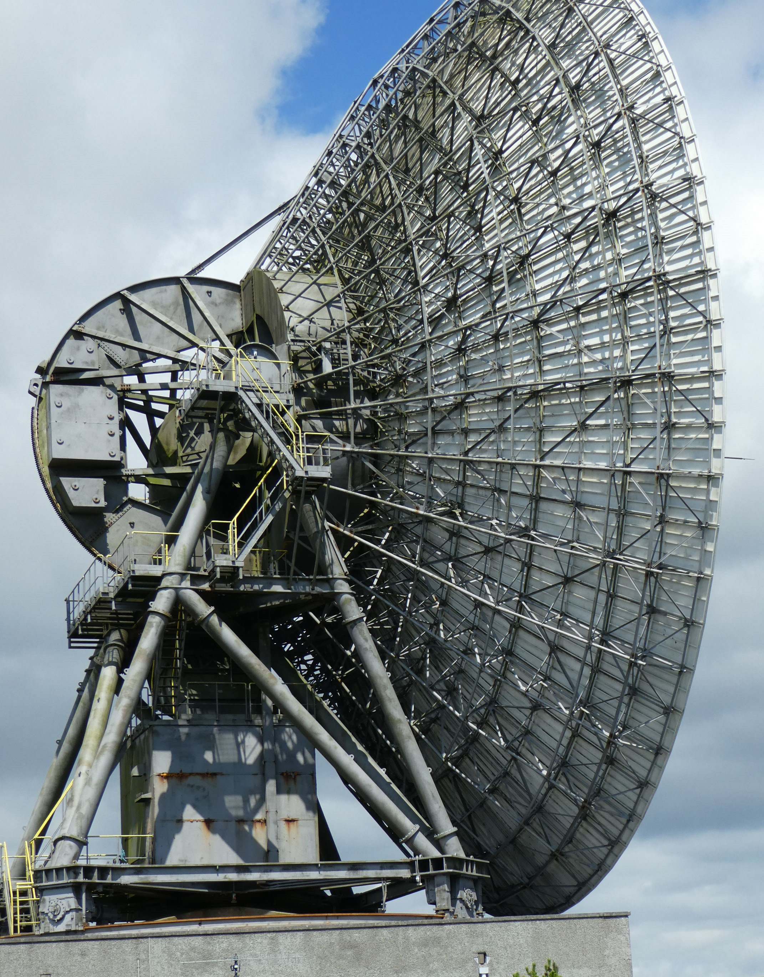
GB6GHY Goonhilly dish used for Apollo celebration

The concert was held just outside the secure area of this extensive satellite ground station, about 500 m from the antenna. We had to remote the EME system from the concert stage. This we did with a duplex link on 70 cm. We cleared some issues that became apparent during our rehearsals the night before the concert and all went well on the night with our EME show taking place just as the Moon rose behind the stage. We started by receiving a call from a ground station in Perth Western Australia before bouncing some greetings messages off the Moon for members of the audience, something that is permitted with the special event call sign, we had arranged, GB6GHY.
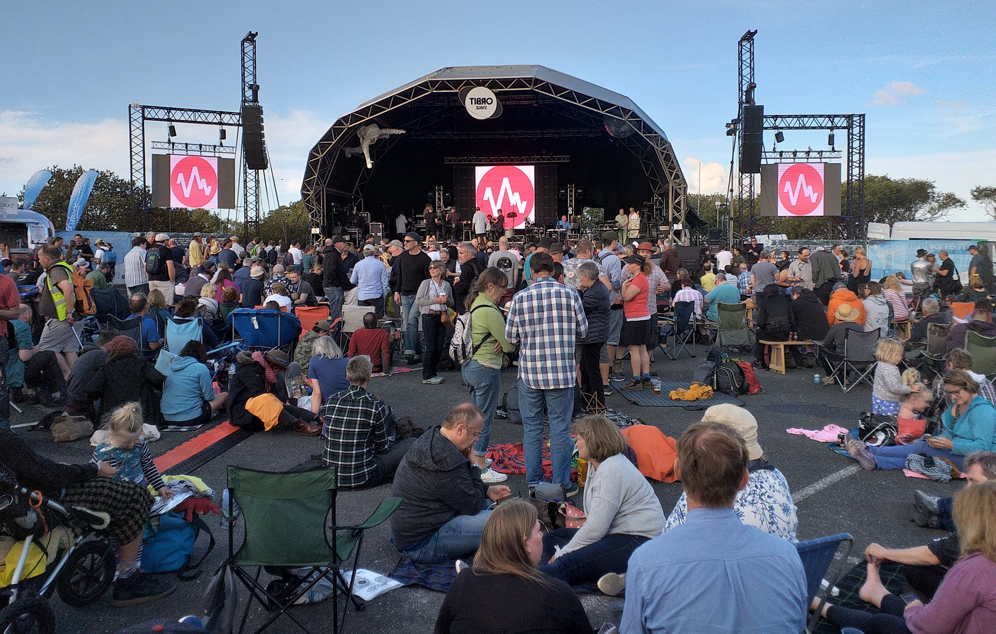
50th Apollo landing Celebration at Goonhilly

The connection with Australia, where the first TV images from the Moon landing were received by the Parkes radio telescope in New South Wales was described, as was the part played by Goonhilly, which had relayed the “live” video from the US to Europe. A recording of the signals from the VK station running 400 W to the 28 m antenna at Perth, as received with the 32 m antenna at Goonhilly, made during our rehearsals can be found at http://www.brcg4nns.org/Sounds/Ghy6VK6DSLa.wav. The audience of near 4,000 were delighted and one even proposed to his girlfriend via the Moon. The team at Goonhilly was led by G8GTZ, assisted by G3VZV, M0DNY and G4NNS. We operated on 5.7 GHz with 40 W. Thanks are due to VK6DSL and his team at the Perth ground station. [See their story later in this NL].
G4RFR: John (G0API) john.g0api(x)gmail.com sends a catch up report on his club’s (Flight Refueling ARS in IO90as) 10 GHz EME activity -- We worked on 6 June M0EYT in IO80 and F5VKQ using QRA64D. Paul (M0EYT) is a club member, but has his own 2.8 m system and 30 W. The ground distance is about 3 km! We added on 10 June contacts also using QRA64D with OZ1FF, F5VKQ and DF1YW, and on 31 July with K6QPV in DM12 using JT4G. G3YGF and I spent some time modifying the TWTA control system, which allowed operate with 95 W via a 3 m of EW90 waveguide into our Super VE4MA feed. This feed is well matched to our 3.4 m dish. With our modified locked Octagon LNB we are getting echoes peaking at 53 on SSB. We were able to use on 4 Aug our new TWTA. It needed 55’ of shielded HT supply and control cable - all made up in house! This Tube’s output passes directly to a 4-port switch and via a WG adaptor and 3 stub matching guide section to the EW90 semi-flexible waveguide to our feed. We QSO’d UN6PO (MN69jn) and DL6ABC with QRA64D. DL6ABC was also worked on CW along with DB6NT, IW2FZR and G3WDG. We concluded by working G3WDG on SSB - our first 2 way on SSB. It comes 25 years since our first 2 way CW QSO also with G3WDG back in 1994. Our next step is to match the guides and slowly increase power to the 200 W, which we have seen in lab tests. Our thanks to all we worked and the help given by G4NNS and G3WDG over the years.
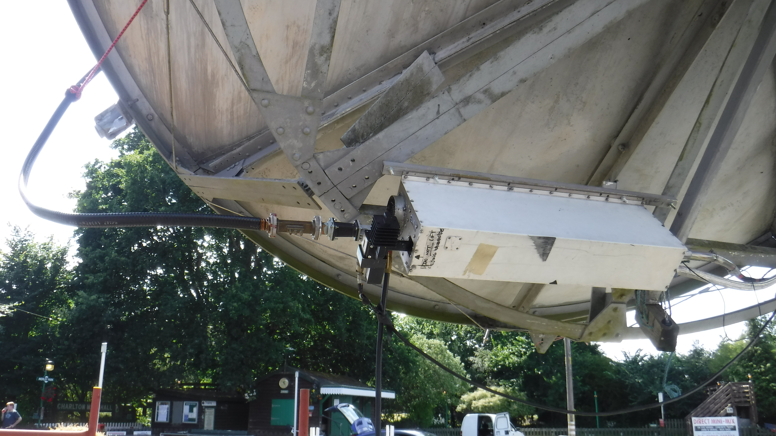
G4RFR’s new TWT mounted behind their dish

IK1FJI: Valter valter_dls(x)yahoo.it is active again on 23 cm -- After a few months of standby because of a problem with my PA, I am again QRV. My PA is working properly, but I plan to change the tube in the PA. On 2 Aug, I had QSOs using CW with JA6AHB (579/579), K6MG (O/O) (#) in MT (DN76), G3LTF (569/579), 1654 SM2CEW (569/579), K7CA (569/569), PA0BAT (559/569) and 1804 G4CCH (579/579), on 4 Aug ON5GS (559/549), SM4GGC (559/559) and W2HRO (549/559), and on 5 Aug SM6CKU (579/579). I also had some JT65C QSOs. I hope to see you all in ARI and ARRL tests.

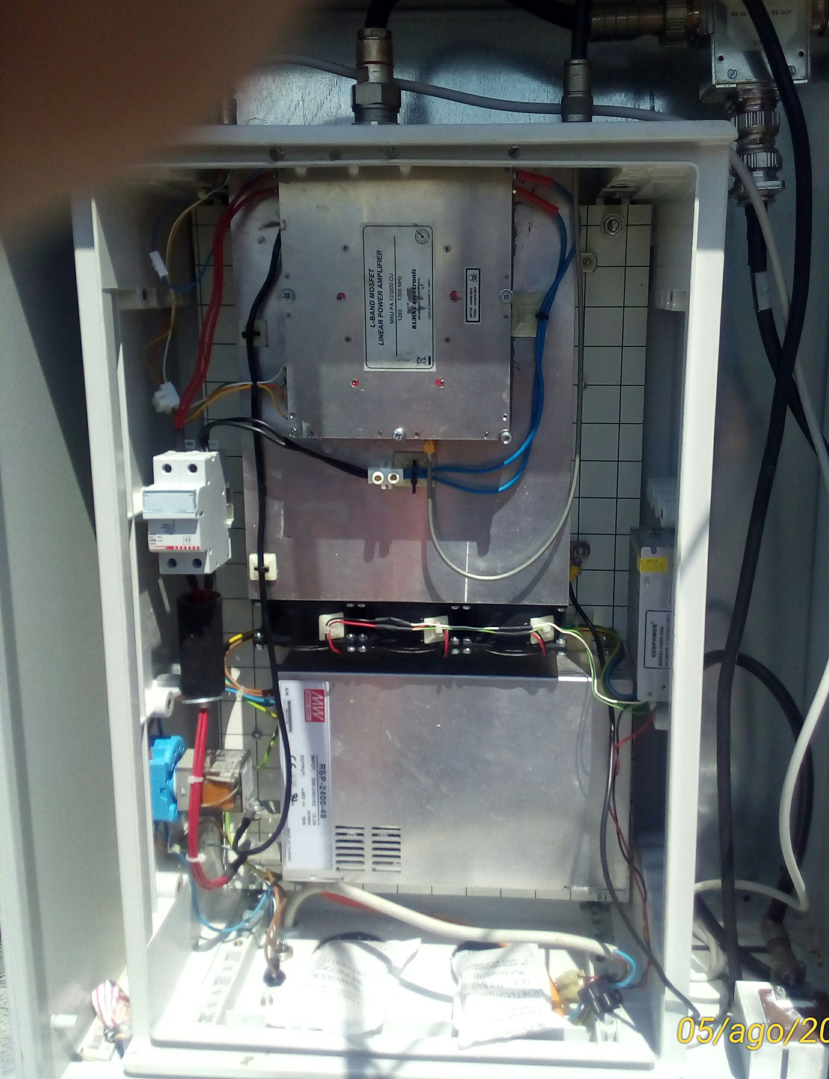
IK1FJI’s tube PA (850 W) is in operation again

K6MG: Gary ad6fp(x)lbachs.com and N9JIM report on their highly successful dxpedition -- Were glad to be home after 2 weeks on the road activating five Western US states on 1296 and 2304 EME. We drove just over 5,000 miles, and in the process visited Lincoln Nebraska, Freeman South Dakota, Ellendale North Dakota, Wibaux Montana and Sundance Wyoming. A total of 219 QSOs were achieved, 75 on CW, 144 using JT, with 54 unique call signs. 22 QSOs were on 2304, and 197 on 1296. To simply reporting, we have put together a table showing every station worked and the bands, states and modes that they worked us.

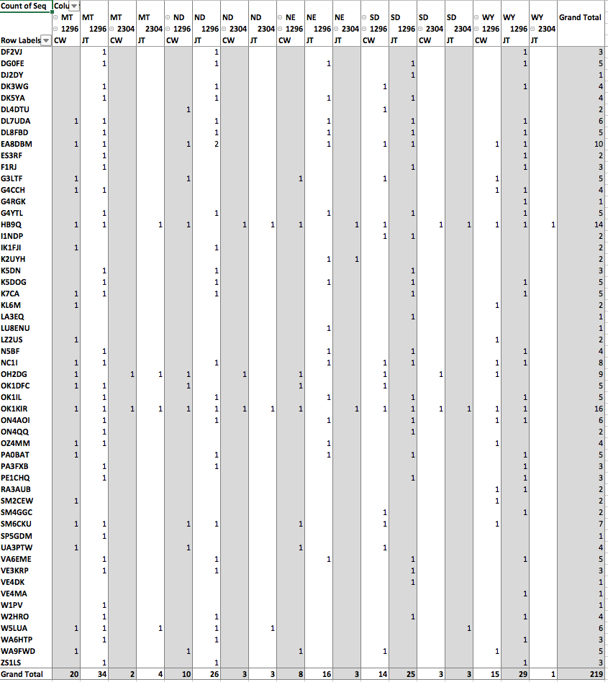
We overcame a fair bit of adversity during the trip. The mini-van blew a head gasket outside of Freeman SD forcing us to rent a truck to pull the trailer mounted dish. This calamity also required a change in plans; we had to drop the visit to Idaho, which would have been on the way back to California and instead circled back to South Dakota to pickup the minivan after it was repaired. In total we traversed South Dakota three times! We also had problems with 2304 transverter drift, the 2304 PA cutting out after 20 seconds of keying, one side of the azimuth H-Bridge driver failing, the audio connection to the laptop for WSJT and a bunch of smaller issues. A major rebuild of the station is underway to make it more robust and much faster to setup. The current configuration takes about 2 hours to setup and 2 hours to tear down, along with operating 5-6 hours and driving to the next stop, it makes for a very long day. Thanks to W5LUA and VE4MA who helped debug the WSJT setup at the CSVHF conference, our first stop. Al noticed that the microphone was still enabled on the laptop and that we were decoding JT65 through the air! It worked much better with a wired audio connection. It was a thrill to hear the pileups calling us; not something we’re used to hearing on EME. We did manage to fit in some sightseeing along the way. The National Minute Man Missile Museum, an old car museum, Wall Drug and Devil’s Tower Wyoming. Jim refused to let me tell onlookers in Wyoming that we were guiding in an alien spacecraft with the dish (a reference to “Close Encounters of the Third Kind”). After all is said and done it was a very satisfying dxpedition. Our QSL cards will be available direct from K6MG (Gary Lauterbach, 128 Bridgton Ct., Los Altos, CA 94022 USA). The inclusion of an SASE will be greatly appreciated.

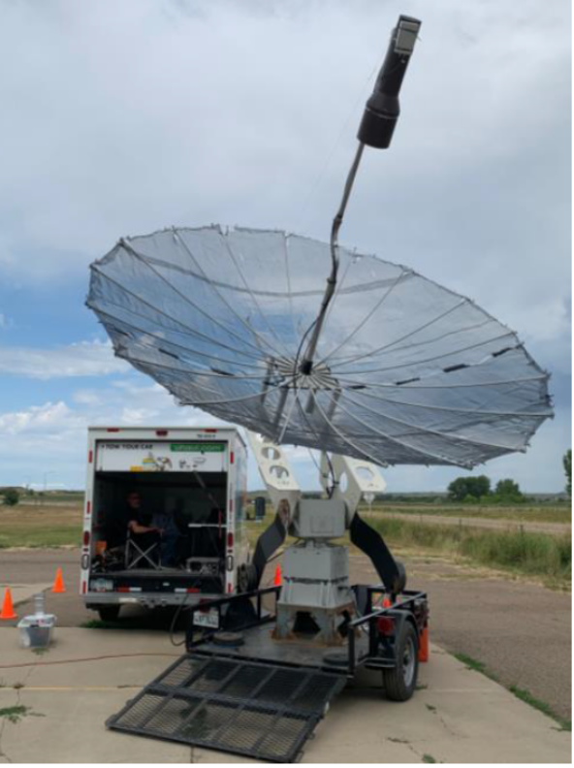
K6MG operating from Wibaux, MT

KA1GT: Bob ka1gt(x)hotmail.com report for July/Aug follows -- Not a lot of activity on 1296 this month. I did work a few new stations using JT65C including GM0PJT (23DB) and SP6ITF (8DB). I also copied most of the Apollo 11 SSTV images from PI9CAM. The images were noisy but quite recognizable. I now have a small dish (85 x 90cm) operational on 10 GHz for RX only. I'm GPS locked and have Doppler tracking. Currently I'm seeing about 5.7 dB of sunnoise and (coincidentally) about the same amount of cold sky to ground noise. I can hear, copying and decoding DL0SHF at -13 dB (1dB DGRD). In tests with G3WDG (3 m, 50 W) I copied and decoded his QRA64D signals at -14 dB (1db DGRD). I have not been around for other activity on 10 GHz, but I monitor the HB9Q reflector when I'm in the shack so I'll be looking out for activity. I don't anticipate having TX capability anytime soon.

KB7Q: Gene geneshea(x)gmail.com is planning 70 cm dxpedition activity – I intend to put PJ2T, Curacao on 70 cm EME this winter. On 1 Sept, I plan to be QRV from WY in DN54fw (rare grid). I built up a station to test my Curacao equipment before the snow flies here. The station consists of a single 13 wl yagi, 500 W LDMOS PA, WD5AGO LNA and a spanking new IC-9700 with GPSDO. I put the station on the air on 3/4 Aug from a friend’s ranch and was pleased to work a few 4 x yagi stations, and one 2 x yagi station. Logged were HB9Q, PA2V, ZS4TX, ZS6JON, G4RGK, UA3PTW, XE2AT, DL9DBJ, G4YTL and DL7APV. Regarding my new IC-9700, I like it a lot. It’s a bit smaller than a K3, and about the same weight, which is dandy for me with all my portable outings. It needs a GPSDO to be stable enough for JT65B on 70 cm, and has an SMA connector for this purpose. Who knows, having this rig means 1296 might be next from Curacao. (If anyone is interested in helping me setup on 23 cm for Curacao, please email me).

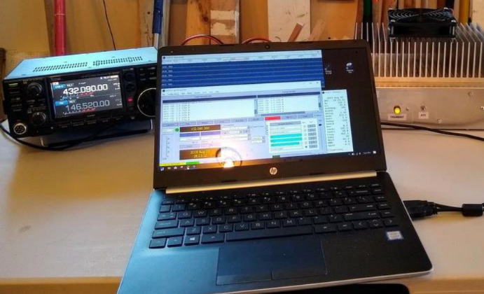
KB7Q’s 70 cm EME portable setup

KD3UY: Bob kd3uy(x)comcast.net (FM19lg) is making significant progress improving his 9 cm EME capabilities. I have reduced the surface error of my dish, and changed the covering from half inch mesh to 1/4 inch mesh. But, perhaps the most important change was correcting a pointing error. I found the elevation pivot of my dish mount was slightly tilted. This meant that the azimuth angle was changed when the elevation was changed. Once I understood the problem, the fix was relatively easy. My dish’s AZ/EL position is controlled by an Arduino processor. I just added some code to correct for the error! I worked 4 new ones during the 9 cm MWAW to bring me to mixed initial #8*. The highlight was OZ5G. Niels has a 4.5 m dish and 100 W. He copied me at (16DB). So, my system is working much much better. Now the bad news is that was with about 20 W at the feed, or 24 W out of my amp. I think I damaged my SSPA. I probably blew one of the final devices due to overheating. The amp is class A, and I mistakenly left the voltages on. I can get away with this on my other bands where the amps are not class A. The good news is that Maryland seems to be a rare State on 3400. It is nice to be DX for a change, Hi. For now, I am just on JT65C or QRA64. CW should be a possibility once I get more power. My current system is a 2.7 m HB dish, OK1DFC septum feed, 20 W at feed, and G4DDK LNA at the feed. I would very much appreciate sked requests. Please email me.

KF4MYT TESTS: Carmelo ccpampillonio(x)gmail.com is doing an EME related research project -- I will be doing a residency at Wave Farm in Acra, NY, where my collaborators and I will be conducting a series of one-way EME transmissions to KF4MYT at the Pisgah Astronomical Research Institute (PARI) in NC. We will be transmitting SSB at 1296 using a single M2 23CM49 yagi, and the 26 m radio telescope at PARI will be receiving and recording. We are looking to record the changes to transmitted voice and sounds as modified by the EME
communications channel. I am currently studying for my Technician license exam next week and am uncertain if I will have it in time for this project, but I will have a licensed control operator with me at Wave Farm. I'm writing to see if any club members and/or contacts could be of help in one of two ways. We are looking to loan of 1) a 23 cm yagi that can work on 1296, and a phasing harness that would allow it to be stacked with our yagi; 2) a 23 cm amplifier of 100 W or more. Due to various recent circumstances, we've had to settle for a Down East Microwave 23 cm 60 W linear amplifier, which we know will be marginal; and so we're still looking for something with a little more power. Alternatively, if anyone simply knows a ham with an EME setup who would be interested in helping out, that would be incredible! Any assistance or information would be sincerely appreciated, as these would be game-changing assets to our project. I'm available for a phone chat if preferred at (704) 999-8867. Our Aug moonbounce windows will most likely be: 24 Aug 1100 to 1500, 25 Aug 1115 to 1530, 29 Aug 1400 to 2000, 30 Aug 1515 to 2100, 31 Aug 1600 to 1930 [times are in GMT]. We are planning additional tests from Pioneer Works (Governors Island, NYC) on 2 to 5 Sept (times TBD).

KN0WS: Carl’s carlhasbargen(x)q.com has been making great progress on CW and with his 1.8 m dish from his home QTH -- I decided since I had not been on the moon since 12 May that I would head to my dish property to fire up the 23 cm system. There were no ticks out, but I think I fed more mosquitoes this weekend than I had before in my entire life! I wondered if it would be worse to die of mosquito bites or from inhaling all the bug repellant I was using. I definitely need to buy some netting to wear, if it is like this again. The plastic fuel filter on one of my generators broke and I had to drive into the nearest town to look for one. No hardware stores, but I went to the lumber yard and bought a brass nipple to connect the fuel lines together without a filter for the weekend - field engineering, Hi! On 27 July I worked RA3AUB, PA3FXB, DF2VJ, K5DOG and VE3KRP. I also had initials with F1RJ, 4X1AJ, GM0PJD, DJ2DY and DL0SHF. The signal from DL0SHF was so strong that I tried CW and had success! I had thought 28 July would be the day everyone would be trying to work K6MG in SD on 23 cm and that I would join in. It was one of their days off. I have to admit that I have had thoughts of doing a dxpedition through SD, ND, MT and WY myself, since I live in the upper Midwest. Not knowing where I might set up in those states has slowed me down. I wish K6MG well with the effort. On 28 July, I did work W2HRO, GM4PMK, OK1DFC, K7CA and G4YTL. I had initials with PE1CHQ, G4FQI and a CW initial with OK1DFC. It was my 6th 23 cm CW QSO and my 10th EME CW QSO ever. Thanks, guys for being patient with me. I have been also working on my 1.8 m back yard dish. I have had a series of troubles with my linear actuators. I had wanted to be on for the 13 and 9 cm MWAW. I hope to have things fixed for the Sept ARRL MW EME Contest weekend. I was able to power the dish mount up on 29 July; and it pointed to the Moon properly right away. I heard DL0SHF at (12DB). My best with the 1.2 m dish was (15 dB), which seems to be a nice improvement. Then on 3 Aug I was able to work F5VKQ (20DB/19DB) and G3WDG (21DB/15DB)). These were my 3rd and 4th QSO’s on 3 cm. I am now hopeful that things are finally coming together. I will try to be QRV for the MW AW on both 6 and 3 cm.

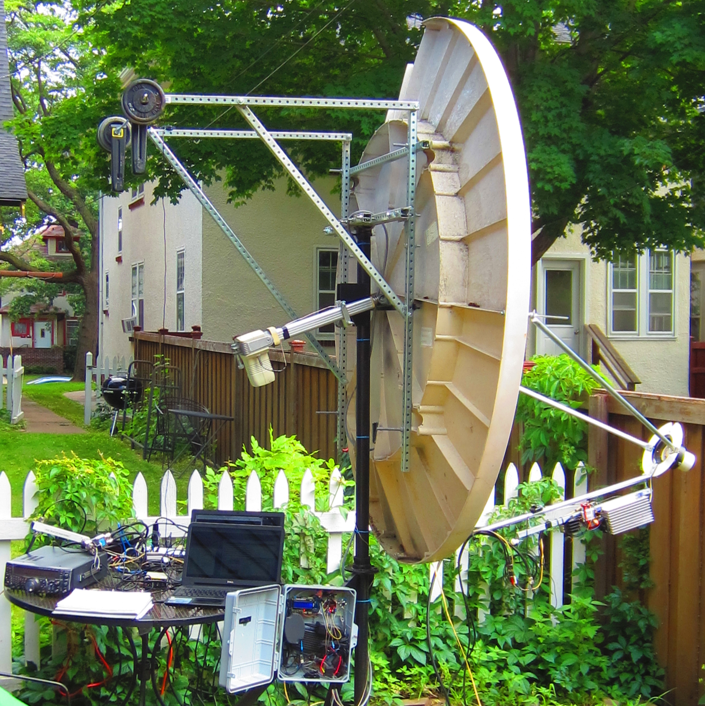
KN0WS’s dish at home QTH for use on 6 and 3 cm

M0ABA/MX0CNS: Tom m0aba1970(x)gmail.com tells of sending Apollo 11 celebration message off the Moon -- Peter from the online amateur radio website 'Essexham' was contacted by Dr. David Whitehouse author of the book 'Apollo 11 - the inside story'. He wanted to know if there was a way to send the book title to the Moon? As this could be seen as commercial in nature, it was decided that we could send a personal greetings message. It was decided to send the message of 27 July as it was not long after the date of the Apollo 11 splash down. As I am a QRP station, we needed a big gun on the RX end. DL7APV stepped in to do the receiving. Bernd and I have tested so much that he was the obvious choice with his 128x11 GTV Super Array. EME conditions were not the best on the day selected, but we had faith in Bernd’s ability to my signal. The message was sent in 7 sequences in order to read well on the received screen – see below. All went very well. David pleased that his message had touched the Moon. Amateur radio was again put in the limelight. My thanks to peter (x) essexham, G7OED, M0LMR, M0SSK, and especially to DL7APV!

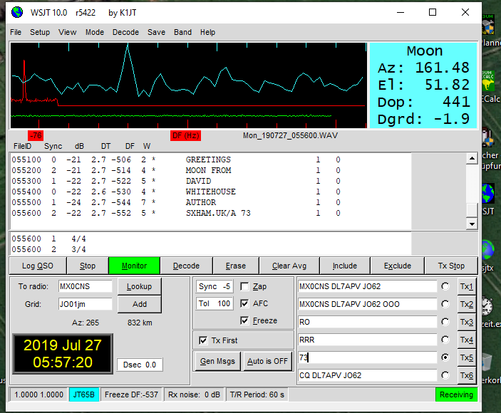
N5BF: Courtney’s courtney.duncan.n5bf(x)gmail.com July 23 cm EME report -- After testing, I still have lower sunnoise than expected, I but went ahead and operated… If you don't call, you don't work! Station improvement plans are in progress, but not very quickly due to lack of time. My current target for completion of upgrades is the spring 23 cm DUBUS Contest, which is all CW. I will operate as is this fall with a possible LNA upgrade. Due to the low declination, the Apollo 11 event at PI9CAM ended about an hour before my moonrise in DM04. During the K6MG dxpedition, I picked up NB for State 18 and mixed initial #151*, SD #152* and State 19, MT #154* and State 20, and WY #158* and State 21. (I am look forward to working them terrestrial on 10 GHz this coming weekend and in upcoming tropo contests 17/18 Aug and 21/22 Sept as they also rove in the microwave contests in this region). Other initials added since my last report are ZS1LS (23DB/15DB) #153*, SM2CEW (549/559) on CW #155*, PA0BAT (14DB/10DB) #156, ES3RF (28DB/24DB) #157* - very near my eastern limit and WA9FWD (549/549) on CW #159* and State 22. All QSO were on JT65C unless noted.

NC1I: Frank frank(x)NC1I.COM writes on his Aug/July activity -- First off, I would like to congratulate and thank K6MG and N9JIM on their incredibly successful Western States dxpedition! I was fortunate enough to have JT QSO with them from all the States they activated and also added CW QSO’s with them from several of the States. My recent activity has been very limited and only on 23 cm. In addition to the K6MG QSO’s, I also worked the following stations between 1 and 3 Aug K7CA, ES3RF for an initial (#*), FR5DN, F1RJ, ON4QQ (#*), LU8ENU and G4RGK. All QSOs were on JT65C. I continue to have RX issues on both 70 cm and 23 cm. Each band is down by about 4 dB. I believe the problems are only on RX; however, my SWR is up some on 70 cm, so perhaps there is a bigger problem on that band. I am not sure when I will have time to do significant troubleshooting.

OK1DFC: Zdenek ok1dfc(x)seznam.cz is going temporary QRT on EME while he renovates his station to allow him to focus more on microwave EME -- My 10m dish is down and been moved to DG5CST. Sebastian put the antenna to good use on EME. I plan to become QRV again soon with a new setup. I will start on 24 and 10 GHz with a 2.5 m offset dish. I hope to be in operation before the end of Aug. I will be in the USA on business the last week of Aug, and will do my best be QRV before I leave. I will then follow up with a 6 m professional offset dish that was used for satellite uplink on 18 GHz. I plan to use it for bands for 13, 9 and 6 cm; and extended the surface with mesh to 9 m for 70 and 23 cm operation. In the worst case, to not miss anything important, I will temporarily operate with my 3.2 m portable dish assembled in the garden. I expect to be QRV on 10 and 24 GHz in the ARRL MW contest. Details of my 24 GHz setup and new dish can to be found at http://www.ok1dfc.com/eme/24ghz/24_ghz_page.htm and http://www.ok1dfc.com/eme/offsetdish/offset.htm. Before shutting down, I worked K6MG from all states; all of which I needed for 1296 WAS except WY. I now need only 9 states (AR, LA, TN, DE, WV, SC, MS, AL and HI). Any help will be apprecfiated?

OK1IL: Ivan ivaknn(x)gmail.com contributes the following to the NL -- Since my last report in May, I have added on 1296 SV9/HB9CRQ to my log for my 59th DXCC. I also worked VE2TWO in Zone 2, and K6MG during Gary and Jim’s very exciting dxpedition in the 5 prairie states of NE, SD, ND, MT and WY. I worked them in all States on JT65C with good signal ranging from (18DB to 14DB). They were on the edge but should have been workable with a little time on CW too. I did not try as did not want ruin the chances of other stations trying for a QSO. My 23 cm WAS count is now 22, so I still have a way to go. I also added initials with OK8HAK and WA6HTP for mixed initials #191* and #192*.

OK1KIR: Vlada and Tonna vlada.masek(x)volny.cz send news on their July/Aug EME – We were on 1296 on 21 July and had just QSO’d using JT65C at 0116 GM0PJD (19DB/11DB) for our digital initial {#333} when we suddenly lost tracking in elevation. Investigation confirmed our suspicion of a dead Li-Ion battery inside the knob memory in the elevation PCB of our F1EHN tracking system – 12 years of life was enough, Hi. We ordered a replacement, and fortunately within a few days a new memory unit was received. After calibration all worked OK and we back in operation just in time for the K6MG dxpedition. We worked on 26 July using CW on 23 cm at 0826 K6MG (O/O) for NE and initial #445. Immediately afterwards we left for Prague for the funeral of our longtime friend OK1AXH who was the guru and administrator for many years of our web site www.OK1KIR.cz. RIP Petr, we will miss you! On 27 July we were QRV for the 13 cm MWAW, but only QSO’d using CW at 0722 G3LTF (579/589) and then concentrated on the K6MG dxpedition. We finally worked using JT65C at 1104 K6MG (30DB/24DB) for digital initial {#64} and NE on 13 cm. On 28 July there was no dxpedition activity and we worked during the 9 cm MWAW using CW at 0259 VK4AFL (559/559) for initial #80, 0630 G3LTF (579/589), 0651 G4NNS (569/579), 0729 SM3BYA (559/569), 0830 SM6PGP (559/569) and 1028 G4LDR (O/O) #81; and using JT65C at 0820 OZ5G (16DB/2DB), 0923 KD3UY (25DB/16DB) digital initial {#34} in MD for our 10th US state on 9 cm. On 29 July the dxpedition was in SD (EN13) on 23 cm. We worked using CW at 0924 K6MG (O/O) #446 and SD our 45th US state on 23 cm, 0944 SM4GGC (579/579) #447, and 1115 using JT65C K6MG (7DB/1DB) and digital initial {#334}. On 30 July the dxpedition was still in SD, but moved to 13 cm. Their signal was weak even on JT65C, but we finally worked at 1322 K6MG (21DB/O) {#65} for SD. Later signal improved and allowed a CW QSO at 1452 K6MG (O/O) for initial #171. On 31 July the dxpedition was in ND (EN05). First on 23 cm we worked using CW at 1055 K6MG (559/559) #448 for ND and later with JT65C at 1218 K6MG (11DB/3DB) {#335}. After we added at 1232 W8MQW (25DB/13DB) {#336}. We then switched to 13 cm and worked with JT65C at 1522 K6MG (25DB/7DB) {#66} for ND, and using CW at 1556 (O/O) #172. On 1 Aug, the dxpedition was in MT (DN76). We QSO’d on 23 cm using CW at 1300 K6MG (O/O) #449 for MT, and later with JT65C 1436 K6MG (6DB/13DB) {#337}. Further we worked at 1523 W1PV (12DB/1DB) and 1609 WA6HTP (6DB/2DB) {#338}. On 2 Aug, they were still in MT, but on 13 cm. We worked with JT65C at 1436 K6MG (27DB/28DB) {#67} for MT our 24th US state on 13 cm, and using CW at 1556 K6MG (O/O) #173. On 3 Aug the dxpedition was in WY (DN74). We worked on 23 cm using JT65C at 1412 ES3RF (12DB/13DB) {#339} and on CW 1428 ES3RF (549/579) #450, 1548 K6MG (O/O) using CW #451 for WY our 25th State and 1718 K6MG (12DB/3DB) using JT65C {#340}. We then switched to 13 cm, but K6MG was very weak and terrestrial WiFi interference at our low elevation prevented decoding in JT65C and a QSO. K6MG copied us (17DB). Our sincere thanks to the Gary and Jim for very nice dxpedition from so many rare US states! We now need only AL, AR, KY, MS and WV and QSL cards to confirm QSOs with MO (K5PJR) and SC (N4CNN) to complete WAS on 23 cm. Any help will be very appreciated!

ON0EME: Eddy (ON7UN) ejespers(x)telenet.be reports the 1296 beacon is back in operation – I repaired the beacon PA on 17 July, but again the output C’s burnt out. I worked on it again on 1 Aug and the modification seems to be holding. The output capacitors appear to be the weak point. The original W6PQL PA had two ATC100B of 18 pf caps at the output. These burned off the board after 3 days of operation. First, they were replaced by 3 12 pf ATC800B. One of these also came off the board. We now have 4 X 9.1 pf ATC800B capacitors in parallel. A description of the mods can be found at http:// moonbouncers.org/Orebro2019/Orebro 2019 ON0EME. pptx.

OZ4MM: Stig gsvestergaard(x)gmail.com reports on his operation during the last Moon cycle – I worked on 1296, during July W2HRO for an initial (#), SP6ITF and GM0PJD all using CW, and with JT65C 4X1AJ, W2HRO again, GM0PJD again and K6MG for the State of NE and a mixed initial (#*), on 1 Aug using both CW initial (#) and JT65C (#*) K6MG for MT, and on 3 Aug using JT65C K6MG (#*) for WY and ES3RF (#*). I missed K6MG’s great dxpedition in SD and ND due QRL. Sorry, but I didn’t get time to QRV on 432 this month.

PA3DZL: Jac pa3dzl(x)icloud.com has a new email address – Please note my new email address. I am working on the new setup at my new QTH. On 15 July, I finished the concrete bases for two towers; one for the yagis and the other for my dish. I am building a new tower for my 3.7 m solid Andrew dish. You can find some pictures on www.qrz.com/pa3dzl. I hope to be QRV again by the end of the year and will keep you informed of my progress.

PI9CAM: Jan (PA3FXB) Muijlwijk jvm(x)netvisit.nl reports on the Dwingeloo Lunar Landing Memorial EME SSTV Party -- Thanks to all who tried SSTV on 23 cm via the Moon with us during the 'Lunar landing night'. The Moon’s position and conditions were not the best, but 50 years is 50 years! We were lucky that we had the moon over the horizon during the exact moment of Neil Armstrong putting his foot on the Moon 50 years ago. As far as we could see, those that tried to RX and/or TX SSTV were VK4CDI, F2CT, XE1XA, LU1CGB, LA3EQ, K2UYH & K2QFA, KA1GT, K5DN, ZS1LS, VE3NXK, CT7AFN, IK1FJI, K5DOG, W2HRO, WA6HTP and DL0EF (Astropeiler Stockert). Thanks to those who have already emailed their received images. We would appreciate receiving any that have not yet been submitted. It's nice to see the differences and similarities in all the images that were bounced off the Moon! At the 'moment supreme' (02:56:14 UTC) we sent the sonified heart beat of Neil Armstrong (recorded at the moment he stepped on the Moon) to the Moon. (A nice piece of work by American artist Richard Clar). Did anyone manage to make a recording of the Moon echo? If so, I would love to receive a copy. It was a most enjoyable night at the big dish in Dwingeloo. Thanks to all for being there, it was big fun! We had good coverage on local TV and newspapers, so it was good PR for amateur radio in general!

SM4GGC: Stig stig.ake.larsson(x)gmail.com sends a report on his recent activity on 23 cm -- I have made the following improvement to my 1295 system. My G4DDK LNA, measured as 0.6 dB NF at the Orebro meeting was replaced with a new one measured by G4DDK to be 0.23 NF. The old one was also repaired (cold solder joint) to provide a similar performance. I also improved the smoothness of the mess on my dish and optimized the focus and choke ring position of my septum feed. The changes resulted in my sunnoise increasing from 10.5 to 12.5 dB. I worked on 1296 using CW on 7 and 9 June N4PZ (569/569) and (579/579) respectively, on 6 July F5KUG (559/559), PA3FXB (559/559) and VK4AFL (559/559), on 7 July FR5DN (O/O), on 26 July G3LTF (569/559), on 27 July SM2CEW (559/559), on 29 July OK1KIR (579/579), LA3EQ (O/559) and K6MG (O/O) for SD, on 3 Aug G3LTF (559/569) and FR5DN (559/559), on 4 Aug ON5GS (559/559) and IK1FJI (559/559); and using JT65C on 1 June GM4PMK, on 7 June VK2JDS and 4X1AJ, on 9 June F1RJ, on 10 June G4FQI, 6 July VK3AXH and LU8ENU, on 7 July G4FQI, on 25 July GM0PDJ, on 26 July DL4DTU, on 27 July F1RJ and ON4QQ, on 2 Aug K7CA and W1PV, on 3 Aug K6MG for WY, and on 4 Aug ES3RF and DK0ZAB. I was very pleased to work K6MG team with CW in SD and with JT65C in WY because the signal was too low for CW. I could not be QRV for the other States they visited. My rig is a 3.9 m dish, 500 W SSPA and G4DDK LNA.

SM6CKU: Ben ben(x)sm6cku.se sent a short report on his recent 23 cm activity – I was QRV for the K6MG dxpedition on 1296 only. I worked them from all sites on CW and added four new States to my WAS list. I also worked using JT65C in MT and ND. I am very impressed by their rover performance! I have editing my videos from the Swedish EME Conference and have what I call Part 2 ready. It includes a discussion by SM2CEW about his journey to becoming QRV on10 GHz EME. See https://youtu.be/B9Zv0wPZ4Ac. Part 1 will come later.

SM6FHZ: Ingolf http://www.2ingandlin.se/SM6FHZ.htm
sends the following info on his 6 cm EME during the Moon Landing Celebration -- I was on from my Moon rise until 0030 and heard VK6DLS with a fantastic signal on SSB. It was a delight to listen to. The downside is that I did not manage to work them. They were have receive problems. I did QSO DB6NT and UR5LX.

SP0VHF: Zdenek (OK1DFC) ok1dfc(x)seznam.cz reports on his portable operation from EME and MW meeting in Gajow -- This year the meeting was the same weekend as the DUBUS 6 cm EME Contest. There were also very good conditions on 24 GHz. I decide to be QRV on both bands and activate first time Poland on 24 GHz EME. I arrived to Gajow early Friday morning on 7 June. Immediately I assembled my tripod and 180 cm portable dish. I was in a hurry to test sunnoise and calibrate the system to maximum of moonnoise. I did not have any problem with pointing to the Moon at all the times. Also, the change from 5.6 to 24 GHz was without a problem. It took only 10 minutes. Then, I tested RX performance. I measured 10.8 dB of sunnoise, 2.6 dB of ground noise, and 16dB of moonnoise. I then called CQ on 24048.100 using QRA 64D. The spreading was very low in EU window. I immediately saw OK1KIR (16DB) on the screen and heard them through loud speaker. Expected that we could easily work on CW. It was the first time I used my 22 W SSPA; so, I expected that my signal would be better than from 4U1ITU last year. OK1KIR called, but my PC did not decode a report from them. This was the same situation I had before with OK1CA. I restarted the PC and all immediately went well. Worked were OK1KIR (16DB/16DB), OZ1LPR (17DB/17DB), OK1CA (20DB/17DB), and on CW I worked OZ1LPR (O/O) and OK1KIR (O/O). On Friday, I tried to QSO PA0BAT. I copied him easily (20DB), but he did not decode me. At this time the noise started to rise, which indicated that the Moon was setting between trees on the horizon. I switched off and went to sleep around midnight. Saturday morning, I change the TRV for 5.6 GHz. Sun noise was found easy; and after confirming that the system was still pointing in the right direction, started to work the DUBUS Contest. Worked on CW unless noted otherwise were PA0BAT, OZ1LPR, SM6CKU, UR5LX, OH2DG, OK1CA, DB6NT, OK1CA using QRA64D, SA6BUN, DF3RU, HB9Q, UA3PTW and W5LUA. I also QSO’d with QRA64D HB9Q. At the end of the day, I switched back to 24 GHz on the request of W5LUA and we worked (19DB/8DB). I then switched off and packed all the equipment. On Sunday morning I was on my way home. It was a very nice experience, and confirmed that 24 GHz can be included in future dxpeditions. I can easily add this nice and interesting band.
SP6JLW: Jacek (SP6OPN) and Andrzej (SP6JLW) sp6jlw(x)wp.pl were active during the 6 cm EU/Dubus EME Contest and wrote -- This year, we ran the contest under the SP6JLW callsign. Our results were not as good as last year. We believe this was result of having to end our operation early (Sunday at 1400). The list of QSOs were OH2DG, SA6BUN, UA3PTW, OK1CA, JA4BLC, JA1WQF, HB9Q, DB6NT, OZ1LPR, SM6CKU, F1PYR, DF3RU, PA0BAT, TM1MOON, ES5PC, UR5LX, K2UYH, OH1LRY, WA6PY, SM6PGP and G3LTF for a total of 21x20. TNX for the great contacts!

TX7EME: Giulio (IW3HVB) iw3hvb(x)gmail.com writes about his group’s upcoming EME dxpedition -- We will be back on air (call to be confirmed) from Rangiroa atoll, French Polynesia from 18 to 24 June 2020, this time on 23 cm. I and IK3YBX will operate with a 2 m dish and good power to ensure opportunities for both digital and CW QSOs. Windows for Europe at our moonrise (BH65EA) will be fairly short, but with a takeoff on the ocean there should be sufficient time. We will suggest that stations to call starting from Eastern Europe, then for the second part of the window towards north west. G and EI stations will be the last, given the longer common Moon acquisition. For further details in the future see my website www.iw3hvb.it.

VE3KRP: Fast Eddie eddie(x)tbaytel.net sends info about his 23 cm EME operation in July and Aug -- On 1296 using JT65C, I worked on 2 July K5DOG, on 27 July KN0WS, W2HRO and F1RJ, 29 July OM4QQ, G4FQI, K6MG (for SD and a new WAS), on 30 July G4FQI, WA6HTP for a mixed initial (#*), on 31 July K6MG (for ND another WAS), N5BF and W1PV, 1 Aug G4FQI and K6MG (for MT another WAS), on 2 Aug ES3RF (#*) and K5DN, on 3 Aug ON4AOI, G4RGK and JA8SZW (#*), on 4 Aug ON5GS and IK1JI, and on 5 Aug G4FQI - (always sent report, TNX Malcolm!).

VK4AFL: Trevor tbenton(x)bigpond.net.au is now QRV on 23 and 9 cm -- I worked on 9 cm during the MWAW 28 July OK1KIR and G3LTF. Both had very good signals. I am now back to 100 W from a SM6PGP SSPA, which works extremely well, but has only 50 W at the feed. I will keep the 9 cm feed installed through the Aug Moon passes and for the Sept ARRL MW Contest, and will then revert to 23 cm for the Oct/Nov contest weekend. I am looking forward to more contacts especially on 9 cm!

VK6DSL: Keith (VK6EME) keith(x)vk6eme.com writes about the Australian end of the Apollo 50 Celebration -- We had a 28 m dish (60 dBi) with 400 W, a Kuhne transverter and IC 9700 from (OF78we). Although we heard GB6GHY S9, we were unable to copy them clearly all of the time. Fortunately, they copied us FB. After the official program with GB6GHY was over, at around 2245, we looked for other QSOs. Unfortunately, we weren’t able to pull much out of the noise on RX. Although I know we were copied with big signals. There is a chance we can be QRV again in about 3 months. We will work on improving our RX. Our group is also planning to get on 3 cm, but with only a 60 cm dish at present. We are aiming to get something bigger in time.

W2HRO: Paul w2hro.fn20(x)gmail.com is now using a Sunslew SDD3 3" slew drive rotor to move his 4 m dish -- The SDD3 uses an incremental position encoder with 200 pulses per deg. A Green Heron RT-21 is being used to control the AZ / EL slew drive. Tracking accuracy is very good. During July/Aug I added 1296 CW QSOs with ON5GS, IK1FJI, G4CCH, SM2CEW, and KL6M. I also exchanged 1296 SSTV pictures with PI9CAM as part of the Apollo 11 weekend. I was pleased to work the K6MG rover dxpedition in 4 new states – SD (EN13), ND (EN05), MT (DN76) and WY (DN74) using JT65C.

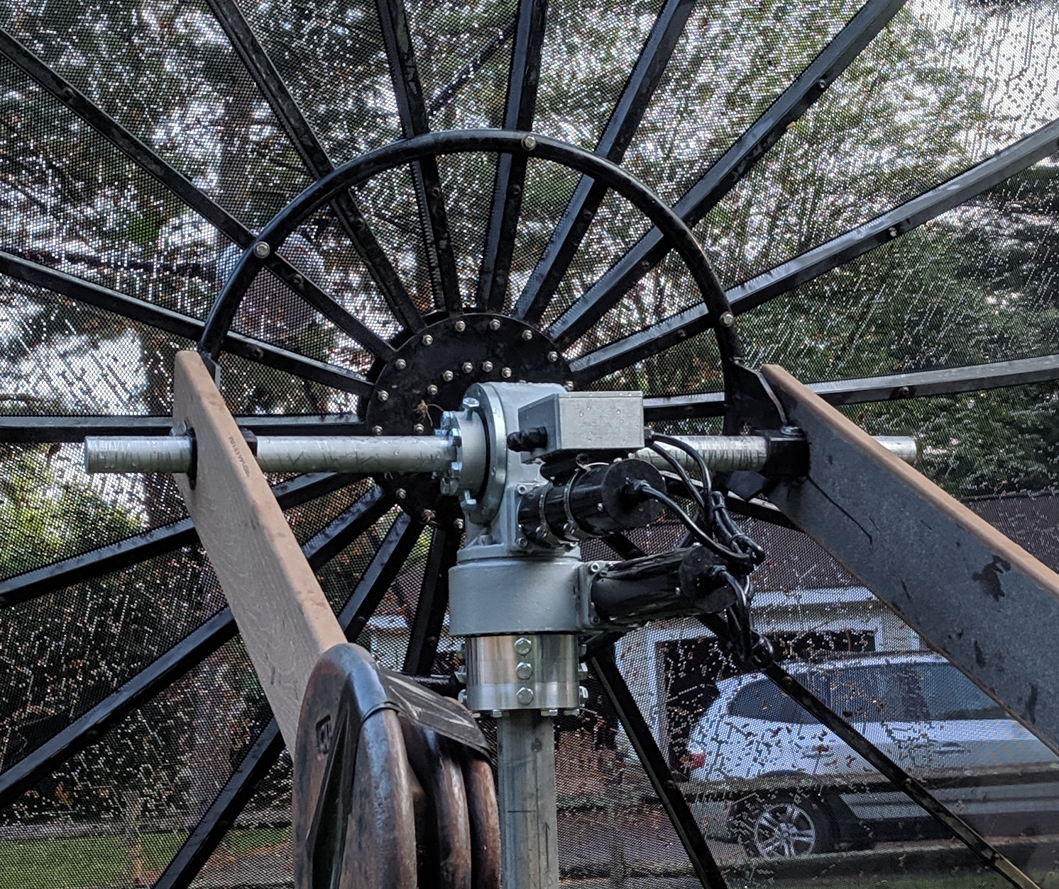
W2HRO’s Sunslew slew drive rotor for his 4 m dish

XE1XA: Max general.manager(x)corix.us was successful in his reception of EME SSTV from the Dwingeloo dish during Apollo event and writes -- The amazing thing for a newcomer to SSTV was to see my first SSTV image off of the Moon! I'm pretty sure that I will be able to improve the image quality with more practice in a future test. Many TNX for the wonderful experience!

OK1TEH: Matej ok1teh(x)seznam.cz writes -- I and OK1VPZ have finished up the new 2.4 m mesh dish (f/d = 0,42 and weight of 22 kilos). Pixs of the dish’s construction are at https://ok1teh.rajce.idnes.cz/240cm_dish, which we tested on tropo during OK Field day Contest at OK2A on 1296 (185 QSOs and 63,873 points). The ribs were drawn with AutoCAD and sent to local machine shop for bending. The resulting ribs made out of 3 mm thick Aluminum were then welded to maintain their shape. The dish can be split into 2 parts for easier transportation. I expect to use this dish for 23 cm and up EME later during this year. Now that I have completed WAS on 2 m, I plan to focus on the higher bands.

K2UYH: Al alkatz(x)tcnj.edu – I do not have a lot of QSOs to report this month mainly because of missing 2 weekends while away on vacation. During the Apollo Landing Celebration, I had my 6 cm feed in place on 20 July, but did not find any 6 cm activity. The next day on 21 July, I switched to 1296 and QSO’d using JT65C at 0440 SP6ITF (7DB/3DB) and 0654 WA6HTP (12DB/11DB) for mixed initial #611*. Between 0445 and 0530 I participated in SSTV tests with PI9CAM. Chris (K2QFA) came over to help with the SSTV setup. We exchanged pictures both ways, but were frustrated at not having the right adapters to connect audio to and from Chris’s laptop. We ended acoustically coupling the audio by microphone and speaker for both RX and TX. I feel certain we could have done better with a direct audio connection. I was unable to operate during the 9 cm MWAW because I had to leave for a vacation trip on 27 July. My trip also limited me to only working the K6MG dxpedition in NE. Fortunately on 1296, I already had QSLs from all of the States visited by Gary and Jim. I QSO’d on 23 cm, on 26 July at 1301 K6MG (5DB/7DB) using JT65C #612*, and on 27 July on 2304 at 1250 K6MG (9DB/7DB) using JT65C for mixed initial #112* and a new State. I would have liked to have worked more stations during the MWAW on 13 cm, and especially later in the week for more new States on 2304, but I had to leave for my flight after our QSO. I plan to be QRV for the Aug MWAW on 6/3 cm, and in Sept for the ARRL MW Contest.

NET/REFLECTOR NEWS: DL4DTU reports that QSLs for all LY/DL4DTU, LY/DL2NUD and LY1EME QSOs should be sent to Norbert Rüdiger, Gompitzer Hang 5, 01156 Dresden, Germany. Also please include a SASE and funds for postage. K7ULS worked K5QE on 222 EME for a new state in Aug. SM2CEW wishes to thank the ARI for the beautiful plaque received for his CW results in the 2018 ARI EME Trophy, Autumn Session. F1HQM is coming on 70 cm EME with QRO SSPA and 4xLY - see https://f1hqm.pagesperso-orange.fr/crbst_47.html. G4FRE is slowly returning to ham radio after his wife’s passing. His first finishing up his 3 cm EME system. YO2NAA (KN05) is trying 70 cm EME with 50 W and 2xLY. OK8HAK (UA4HAK) is QRV on 23 cm with a 4 m dish.

FOR SALE: G4FRE has for sale a VE1ALQ made 23 cm dish feed for £200 collected or you arrange collection. Still has original shipping carton. If interested contact Dave at g4fre_eme(x)g4fre.com. DB6NT has released new version (G4) of his very popular 23 cm transverter. See Kuhne web page. SA1BUN is looking for a WR42 termination, preferably with only a short WG run. If somebody is willing to part with one for a reasonable price, please contact Michael at sa6bun(x)gmail.com. G4NNS knows of a 2.4 m prime focus dish that is available. f/D is ~ 0.4, and some mounting hardware is available. A photo of it lying face down is available. The price is a donation to a charitable trust that had intended to use it for RA, but no longer requires it. I reckon it's a 4 person lift, and close vehicle access may be difficult to arrange; so a 100 m carry could be required. Location Devizes Southern England. Serious enquiries only please to brian(x)brcg4nns.org.

TECHNICAL CORNER: US4ICI brings new cheap high quality components like MMIC SKY67151 LNAs for 23 cm and 70 cm, or 300 W SSPA for 23 cm, see
https://vhfdesign.com/lna/lna-23cm-sky67151.html and
https://vhfdesign.com/pa/pa-23cm-300-watt-pallet-with-controller.html, and see youtube.com/watch?v=AnDr2ki8-ug. There is a new cheap Russian cheap VNA – Arinst 23-6200 MHz. See https://www.ebay.com/itm/New-portable-VNA-SWR-vector-network-analyzer-reflectometer-Arinst-23-6200-MHz/233172634485?hash=item364a2c0b75:g:qCEAAOSwhWFckR3c and http://arinst.net/arinst_vr-23-6200.php.

Radioastronomy Corner: While the EME2018 Conference website is closed, you may miss the OE5JFL/I0NAA/I1NDP presentation about pulsars. Therefore a visit to https://www.youtube.com/watch?v= teJg26rJ7Sk or and http://www.ok2kkw.com/00003016/ eme2018/oe5jfl-i0naa-i1ndp-hunting-for-pulsars-rev-71518.pdf is recommended. Some interesting news from NASA about the Voyager probes can be found at https://www.nasa.gov/feature/jpl/a-new-plan-for-keeping-nasas-oldest-explorers-going,
https://descanso.jpl.nasa.gov/DPSummary/Descanso4--Voyager_new.pdf, https://www.qsl.net/ct1dmk/dsn.html
http://www.rfspace.com/RFSPACE/BLOG/Entries/2007/3/25_Voyager_1_Received_Using_SDR-IQ_Receiver_files/voyager_amsat07.pdf.

FINAL: DK7LJ writes that the 10 GHz Beacon is now repaired and back in operation -- The repair of the PA was done by G3WDG. After installing it, I tried to switch on the beacon, but the water-cooling system did not work. Opening the cover, I found a bird with 5 very baby birds. I decided, I would have to wait until they have left their nest, which would probably delayed operation for several weeks or even a month. I went back to the dish about an hour later to take a picture to post, but all baby birds (mother
and babies) had gone. I did not see them around and have no explanation. So, I finished the installation of the beacon. It has been up and running ever since.

► DL9KR was doing some historic research and TNX to Vlada and Tonda of the OK1KIR group found that The first (intercontinental) 2.3 GHz EME QSO took place on 5 April 1981 between PA0SSB and W6YFK using CW/SSB.

► We are sorry to report that OK1AXH has become a SK. Peter was a well known VHFer and an important member and contributor to the OK1KIR Club – see their report in this NL.

► If you have any info you want to share on your 70 cm & Up Sun noise or sky sources measurements, please send them to ok1teh(x)seznam.cz. Matej has been maintaining a directory of this information.

► PSE keep the tech reports and news coming. We will be looking for you off the Moon. 73, Al – K2UYH and Matej – OK1TEH.

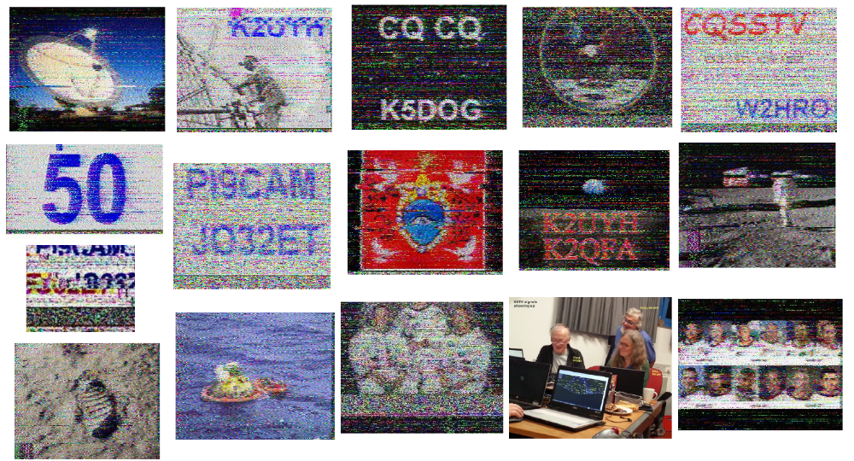
Pictures received by PI9CAM and sent by PI9CAM (received by others).

