432 AND ABOVE EME NEWS
DECEMBER 2014 VOL 42 #11

EDITOR: AL KATZ, K2UYH; DEPT. ELECTRICAL/COMPUTER ENGINEERING, THE COLLEGE OF NEW JERSEY, PO BOX 7718 EWING, NJ 08628, TEL (W 609-584-8424) OR (H 609-443-3184), FAX (609-631-0177), E-MAIL alkatz(x)tcnj.edu
NETNEWS EDITOR (based Reflector News) REIN, W6SZ pa0zn(x)arrl.net WITH HELP OF N4PZ AND WB2BYP
INITIAL LIST G4RGK, DAVID DIBLEY, E-MAIL zen70432(x)zen.co.uk, AT: http://www.zen70432.zen.co.uk/Initials/index.html
EME INFORMAL NETS: 14.345, ~1500 SATURDAY AND SUNDAY, NET COORDINATOR: Steve Gross, N4PZ n4pz(x)live.com
ON0EME EME BEACON, 1296.000 IS QRV WHEN MOON >10°, SEND RX REPORTS TO WALTER (ON4BCB) on4bcb(x)gmail.com
DL0SHF 3 CM EME BEACON, 10368.025, SEND INFO & QUESTIONS TO Per (DK7LJ) per(x)per-dudek.de.
NL EMAIL DISTRIBUTION and EMAIL LIST CORD: WARREN, W2WD wbutler(x)ieee.org [TXT OR PDF OR "ON WEB" NOTICE]
THE NL WEB VERSION IS PRODUCED BY REIN, W6SZ AND AVAILABLE AT http://www.nitehawk.com/rasmit/em70cm.html

CONDITIONS: This month the first 1296 DXCC has been announced. Congratulations to the OK1KIR team for this monumental accomplishment, which would not have been thought possible only a few years – see their report. [I checked with the ARRL and there will not be a problem receiving DXCC certificates for the bands above 432.] OK1KIR still needs to be awarded the certificate]. There are others at or very near 23 cm DXCC. HB9Q may also be there. I [K2UYH], OK1DFC and possibly others are near. There were also several very successful dxpeditions, which make DXCC possible. See the reports on HB0/DL8YHR, PZ5EME/PZ5UD and Z21EME dxpeditions in the newsletter (NL) – TNX! DL8YHR is promising another dxpedition that will including 432 starting on 31 Dec, but there are no other details available. JW/DF8DX is coming up in Feb. The results of the Nov part of the ARRL EME Contest are reported on and highlighted in this NL. The highest reported score on 432 is from DL7APV with 57 QSOs. On 1296 NC1I has the top score with 65x37 – very unusual for a NA station. OK1CA is not far behind with more QSOs but less multipliers and 67x30. The main event, the final leg of the contest, is coming right up on 6/7 Dec. Because of the contest the next 70 cm CW activity time period is not until 4 Jan from 0030-0230 and1600-1800. Sadly there is also heart breaking news. Two more well known EMEers are silent keys. This month Valery, RA3LE (x-UA3LBO) at age 74, and Ken, K6HCP at age 75, passed away this month. Both were active on EME on the 432 and Up bands. They will be greatly missed.

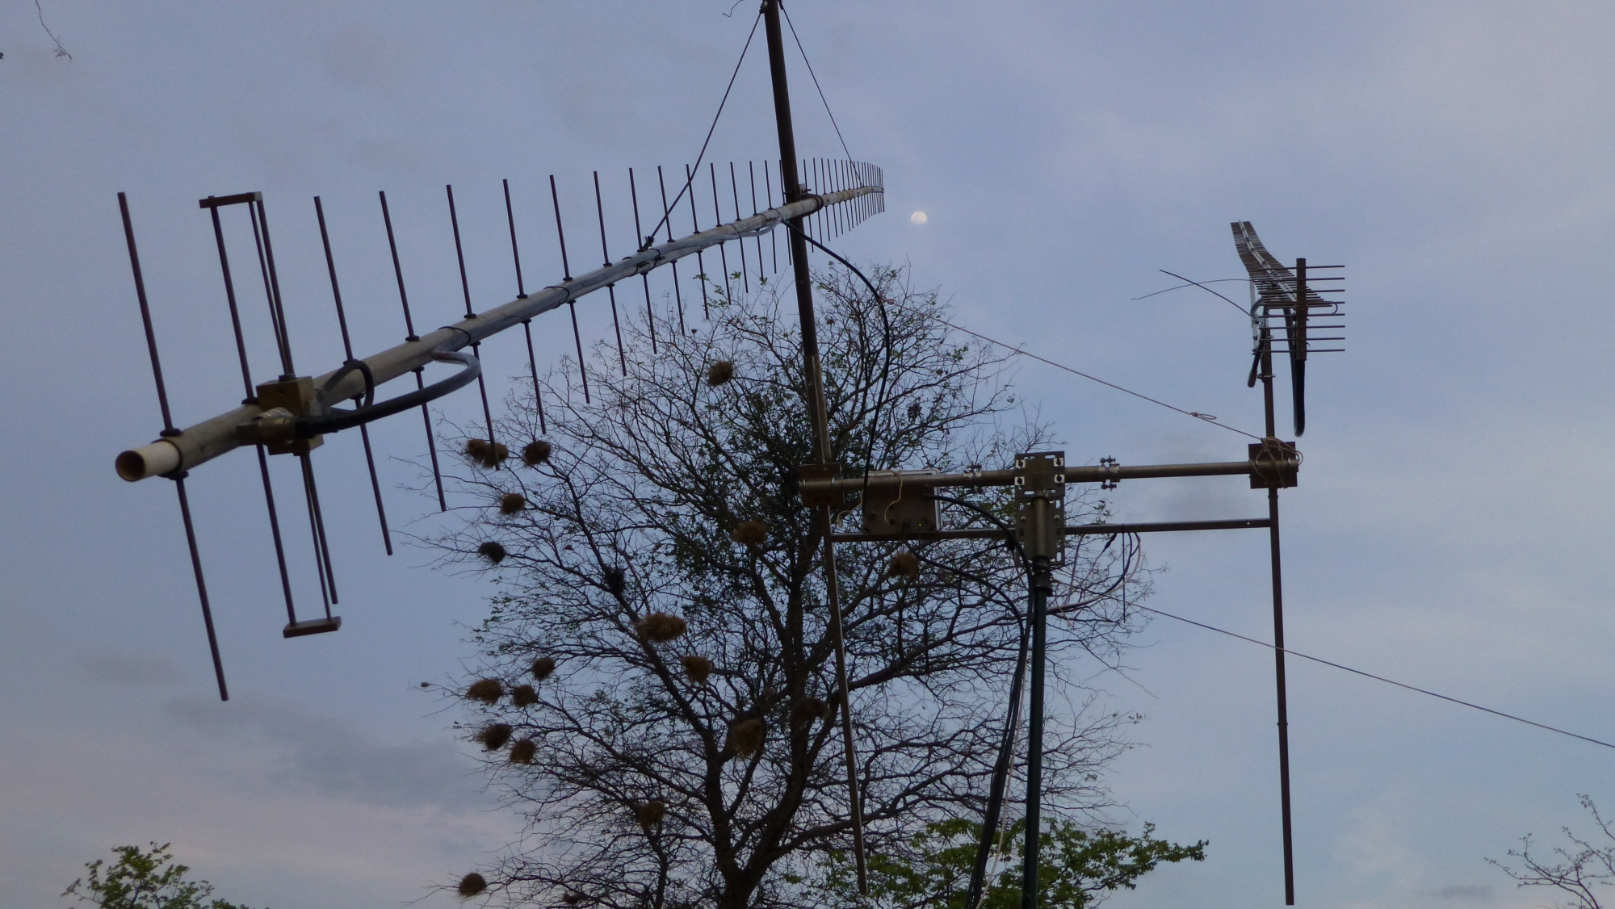
Z21EME 432 (38 el/400 W) & 1296 (67 el/150 W) yagis

DK3WG: Jurg dk3wg(x)ok.de is now QRV on 1296 as well as 144 and 432 EME -- I have for the moment only a single 55 el yagi and 100 W on 1296. By Dec I will have 2 yagis. I added on 70 cm in Oct using JT65B digital initials with W1AW/4, UA0ALA and PA7JB, and in Nov HB0/ DM1CG, Z21EME (DXCC #114), TF3CY and PZ5EME (DXCC #115), and F6HLC on CW. On 23 cm I worked on JT65C I1NDP for my first QSO {#1}, UA3PTW, G4CCH, DG5CST, OE5JFL, K2UYH (DXCC #28), DF3RU, NC1I, JA6AHB (DXCC #29), OK1KIR, HB9Q, UA4HTS, PI9CAM, RA3AUB and DL6SH.

DK7LJ: Per per(x)per-dudek.de sends news on the 10 GHz EME beacon -- The beacon is now repaired with 50 W out in normal mode 740 W out in the high power (by request only and on for not longer than 1 hour). I also found a problem with my motorized polarization control. It was out of align by about 90 degs! I am not sure how long this condition existed, but with the pol this far out the becon signal could have been down by as much as 15 dB! It is now fixed. I would appreciate reports if you notice the difference.
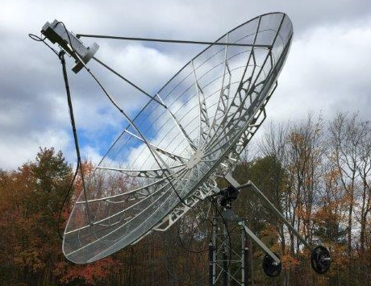
NC1I ‘s 4.5 m dish used to score 65x37 from NA on 1296 in Nov

DL6SH: Slawek dl6sh-eme(x)online.de was active during the Nov EME contest weekend on 1296 -- I worked 39 CW stations as well as 32 stations on JT65C. Most of them were speaker copy with very loud signals this weekend. There was high activity from Japan, especially on Sunday evening. I also had a high speed CW QSO with SM4IVE in spite of my bad CW skills. I added 12 initials. Missed were HB9BBD/HB9CW, DL0SHF, PY2BS and others. I will be back again trying in Dec.

DL7APV: Bernd Wilde dl7apv(x)gmx.de sends his part I EME contest report -- I made some noise on 432 and accumulated 57 QSOs (no dupes), which is much better my last year’s 48. The number of real EME (CW) QSOs was only 9. I missed some US stations on CW including VE6AT, N4GJV, WA6PY and W8TXT and of course the CW is king stations SM2CEW, SM4IVE and SV1BTR. Hope to catch them next part. Due to using loggers (shame on me) I will not send in a log, but I made some activity, which is more important on 432! New stations were were TF3CY, MX0CNS (23 el yagi and 40 W) and HA0HO. I am looking for QSLs from 5B/OK1DFC, PY1UNU, EB5GP, RZ1AWT and UA0ALA.

DL9KR: Jan Bruinier(x)t-online.de updates us on his recent activity -- Family activities blocked my participation in ARRL contest part 1. However, I'm obliged to those primary WSJT users who are willing to change to CW to try a QSO. There seems to grow a friendly coexistence that of course, enhances the fun. Since the end of June following initials were worked: UX0FF, G3LGR (random QRP), SP1JNY, VK5APN/8 (first VK8), W6YX, HB9XAR, VK5APN (from his home QTH), PA7JB, HB0/DL8YHR (unexpectedly loud), W2PU, Z21EME (easy) and PZ5EME (549) CW DXCC 128 and initial #957. The passing of Valera (UA3LBO, RA3LE) fills me with sadness. He was my first Russians via EME in 1982 and continued to be a good friend.

EA3HMJ: Jose ea3hmj(x)gmail.com has some very impressive 1296 EME results -- My station is primary experimental with a focus on testing different antenna ideas. I am currently testing a circular pol feedhorn built from common chimney pipe material with a small 1.2 m dish. I also have been using two 35 turn (1.75 m long) helix antennas. I use one (LHCP) for TX and the other (RHCP) on RX with a 250 W PA. Normally I TX with one helix and list with the other helix or the dish. The dish seems to work about 6 dB better than the helix. I worked with just the helices using JT65C on 9 Aug at 2022 G4CCH (22DB/20DB), 2036 UA3PTW (25DB/19DB) and 2120 DL6SH (26DB/20DB), on 12 Sept at 2132 K1JT: Joe’s (K1JT) k1jt(x)arrl.net contest group operated from 3 locations this year. A 4 yagi station was at Princeton University, W2PU, on 432. At K2UYH’s QTH operation was primarily on 1296, but also there was some activity on 432 when the W2PU operators were off the air. It was a fun weekend. The preliminary count on 432 is 32x23 and 1296 is 56x35. All went well on 432 at both locations, but on 1296 the second day, we had a failure of our 1296 system. The transfer relay that switches TX lines in the shack between PAs internally shorted on 1296. Fortunately the 432 path was still working. We were able to get things fixed, but after the end of our EU window. We were in the middle of a run when it happened and should have broken 60 if the failure had not occurred. On the bad side, the 23 cm SSPA was damaged. We lost about 2 dB of power. We also had problems with libration on 1296. When we got back on 1296 during the JA/VK window, we were greeted by a pile up. Multiple stations calling on top of each other, but we could not identify anyone. It was very frustrating. We finally figured out one call, but by that time everyone else gave up on us. Well there is Dec! After the contest we did some testing of the 1296 preamp. Even though the gain had not changed, we found that the NF was 1.2 dB!

K4EME: Cowles candrus(x)mgwnet.com was QRV on 70 cm during the Nov contest weekend -- This year's first leg went very well. I worked 30 stations and decoded or heard several others. It seems that the activity on 70 cm is up a little from last couple of years. I worked many more stations this year the less time! I had a great time and really enjoyed working the stations this year with no equipment failures. I did have one slight problem, my computer locked up not allowing my mouse to work and I needed to rebooted it before getting control back. I just purchased a TR-1300 transverter from SG Labs for 23 cm and now I am working on two 150 W (W6PQL) boards and a driver board for a total of 300 W on 1296. Right now, with only 2 W of drive from the transverter and one board finished, I have about 50 W output. If any of you are assembling the 150 W boards and are installing the copper spreaders to the XRF-286, do yourself a favor and check that your transistor is not shorted before installing it to the PCB. I somehow managed to get a micro solder ball between one lead of the XRF-286 to ground, while installing the spreader. I did not find this out until trying to power it up! I had the current limit on the power supply set very low, so no damage was done to the PCB or existing circuit. I had to, however remove the transistor from the PCB and spreader before I could clear the short. At first I thought I had purchased a bad transistor. I was successful in clearing the short, but I now know to check for shorts before installing the transistors on the other boards, it may save you much time and trouble! I am still a long way from having an actual 23 cm station operational, but am making good progress. I am still need to get my 10’ dish set up to track the Moon. My HB 1296 preamp seems to be operational. Hopefully when the weather permits, I will finish the preliminary phase of my 23 cm station and have something on the air sometime next year. Please note that I am only planning to be on 70 cm in Dec.

K6JEY: Doug’s drzarkof56(x)yahoo.com group (W6SZ, N6MN and KI6LQV) were on for the contest on 8 Nov (his local Friday) on 23 cm -- We Used a 10' dish and 275 W. We worked 4 stations. By far the loudest signal was G4CCH at S7 on the meter. K1JT was probably second. We expect to be on again next month.

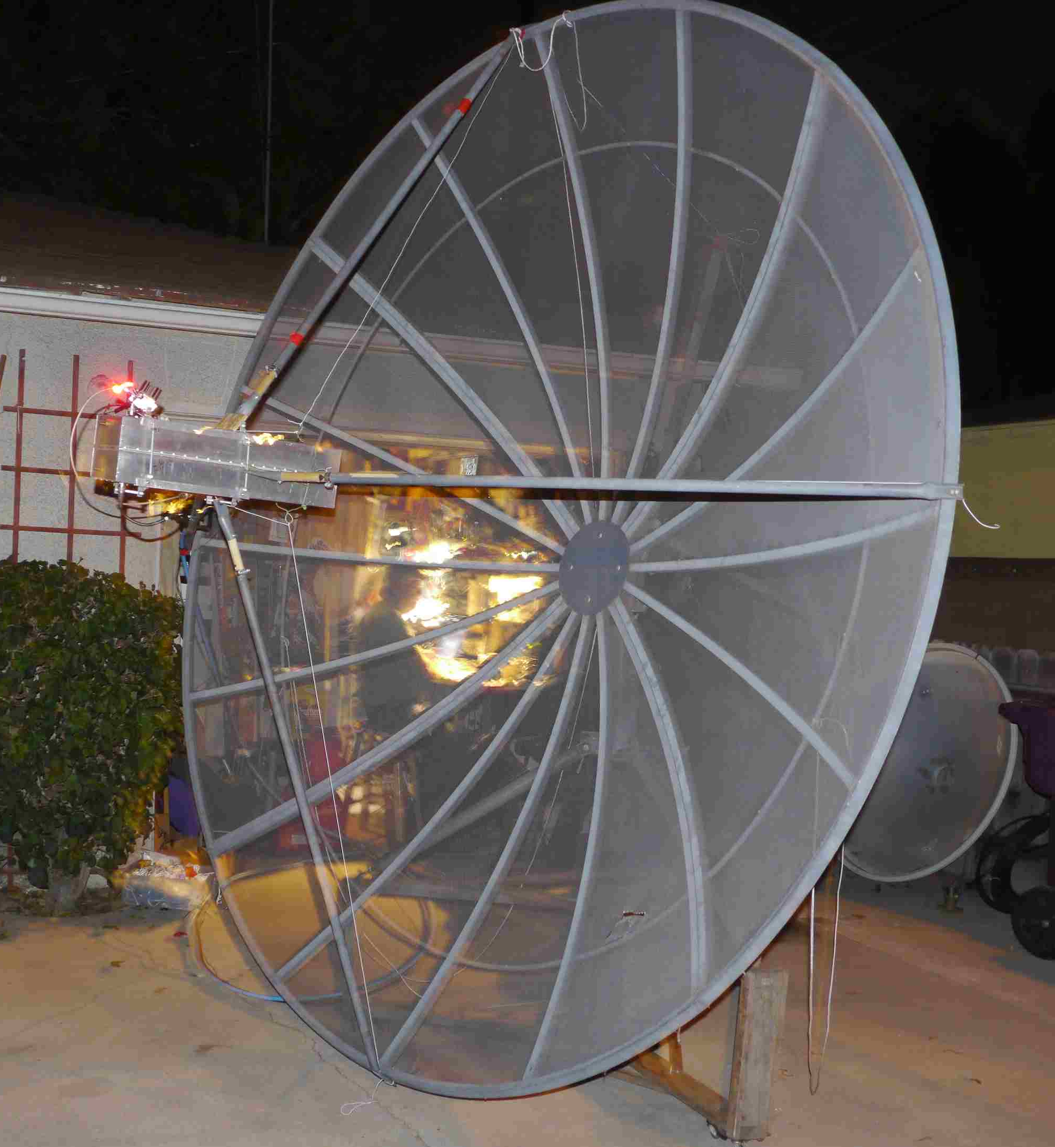
K6JEY’s 10’ dish used in the contest on 23 cm
LX1DB: Willi wbauer(x)pt.lu was active 432 EME during the contest – I was on the first day and made 16 QSOs on CW. It was the first time that I had not to play with polarity. I was operating for the first time on 432 with circular polarization (CP). Reports were reasonable (559 to 589). I did notice the theoretical 3 dB loss when working linear pol station, but the RX signals where more stable. I am using 4 dipoles connected in 0° - 90° -180° - 270° phase by a quadrature hybrid. Phase was checked with a HP Vector Voltmeter 8405A ( +/- 2°) and also tested via Moon with G3LTF by turning the RX antenna pol. On Peter’s side, he recorded the signal to verify the CP pol. I do use the same pol sens for TX and RX as usual on 23 cm and up. I plan to be more active during the 70 cm ATPs.
N4GJV: Ron ronb66390(x)gmail.com was active on CW during the Nov ARRL contest weekend -- I was unable to be QRV for my first moon pass, but I was QRV during a portion of my second moon pass (9 Nov) -- Conditions seemed to be poor on 70 cm (the reverse of what I observed on 144). I initially suspected that my receive system had been degraded by the rain water that had entered my LNA/TR relay box. However, I did hear WA6PY's single yagi station rather well, so perhaps there were other reasons for the sub par number of stations heard and the generally sub par strength of the signals that were heard. I contacted I2FHW, UA3PTW, OH2PO, G3LTF and K1JT for 5 QSOs. Heard and CWNR were WA6PY and W8TXT. On 70 cm I used 4 x 6.8 WL horiz pol yagis and a 2 x 4CX250 PA.

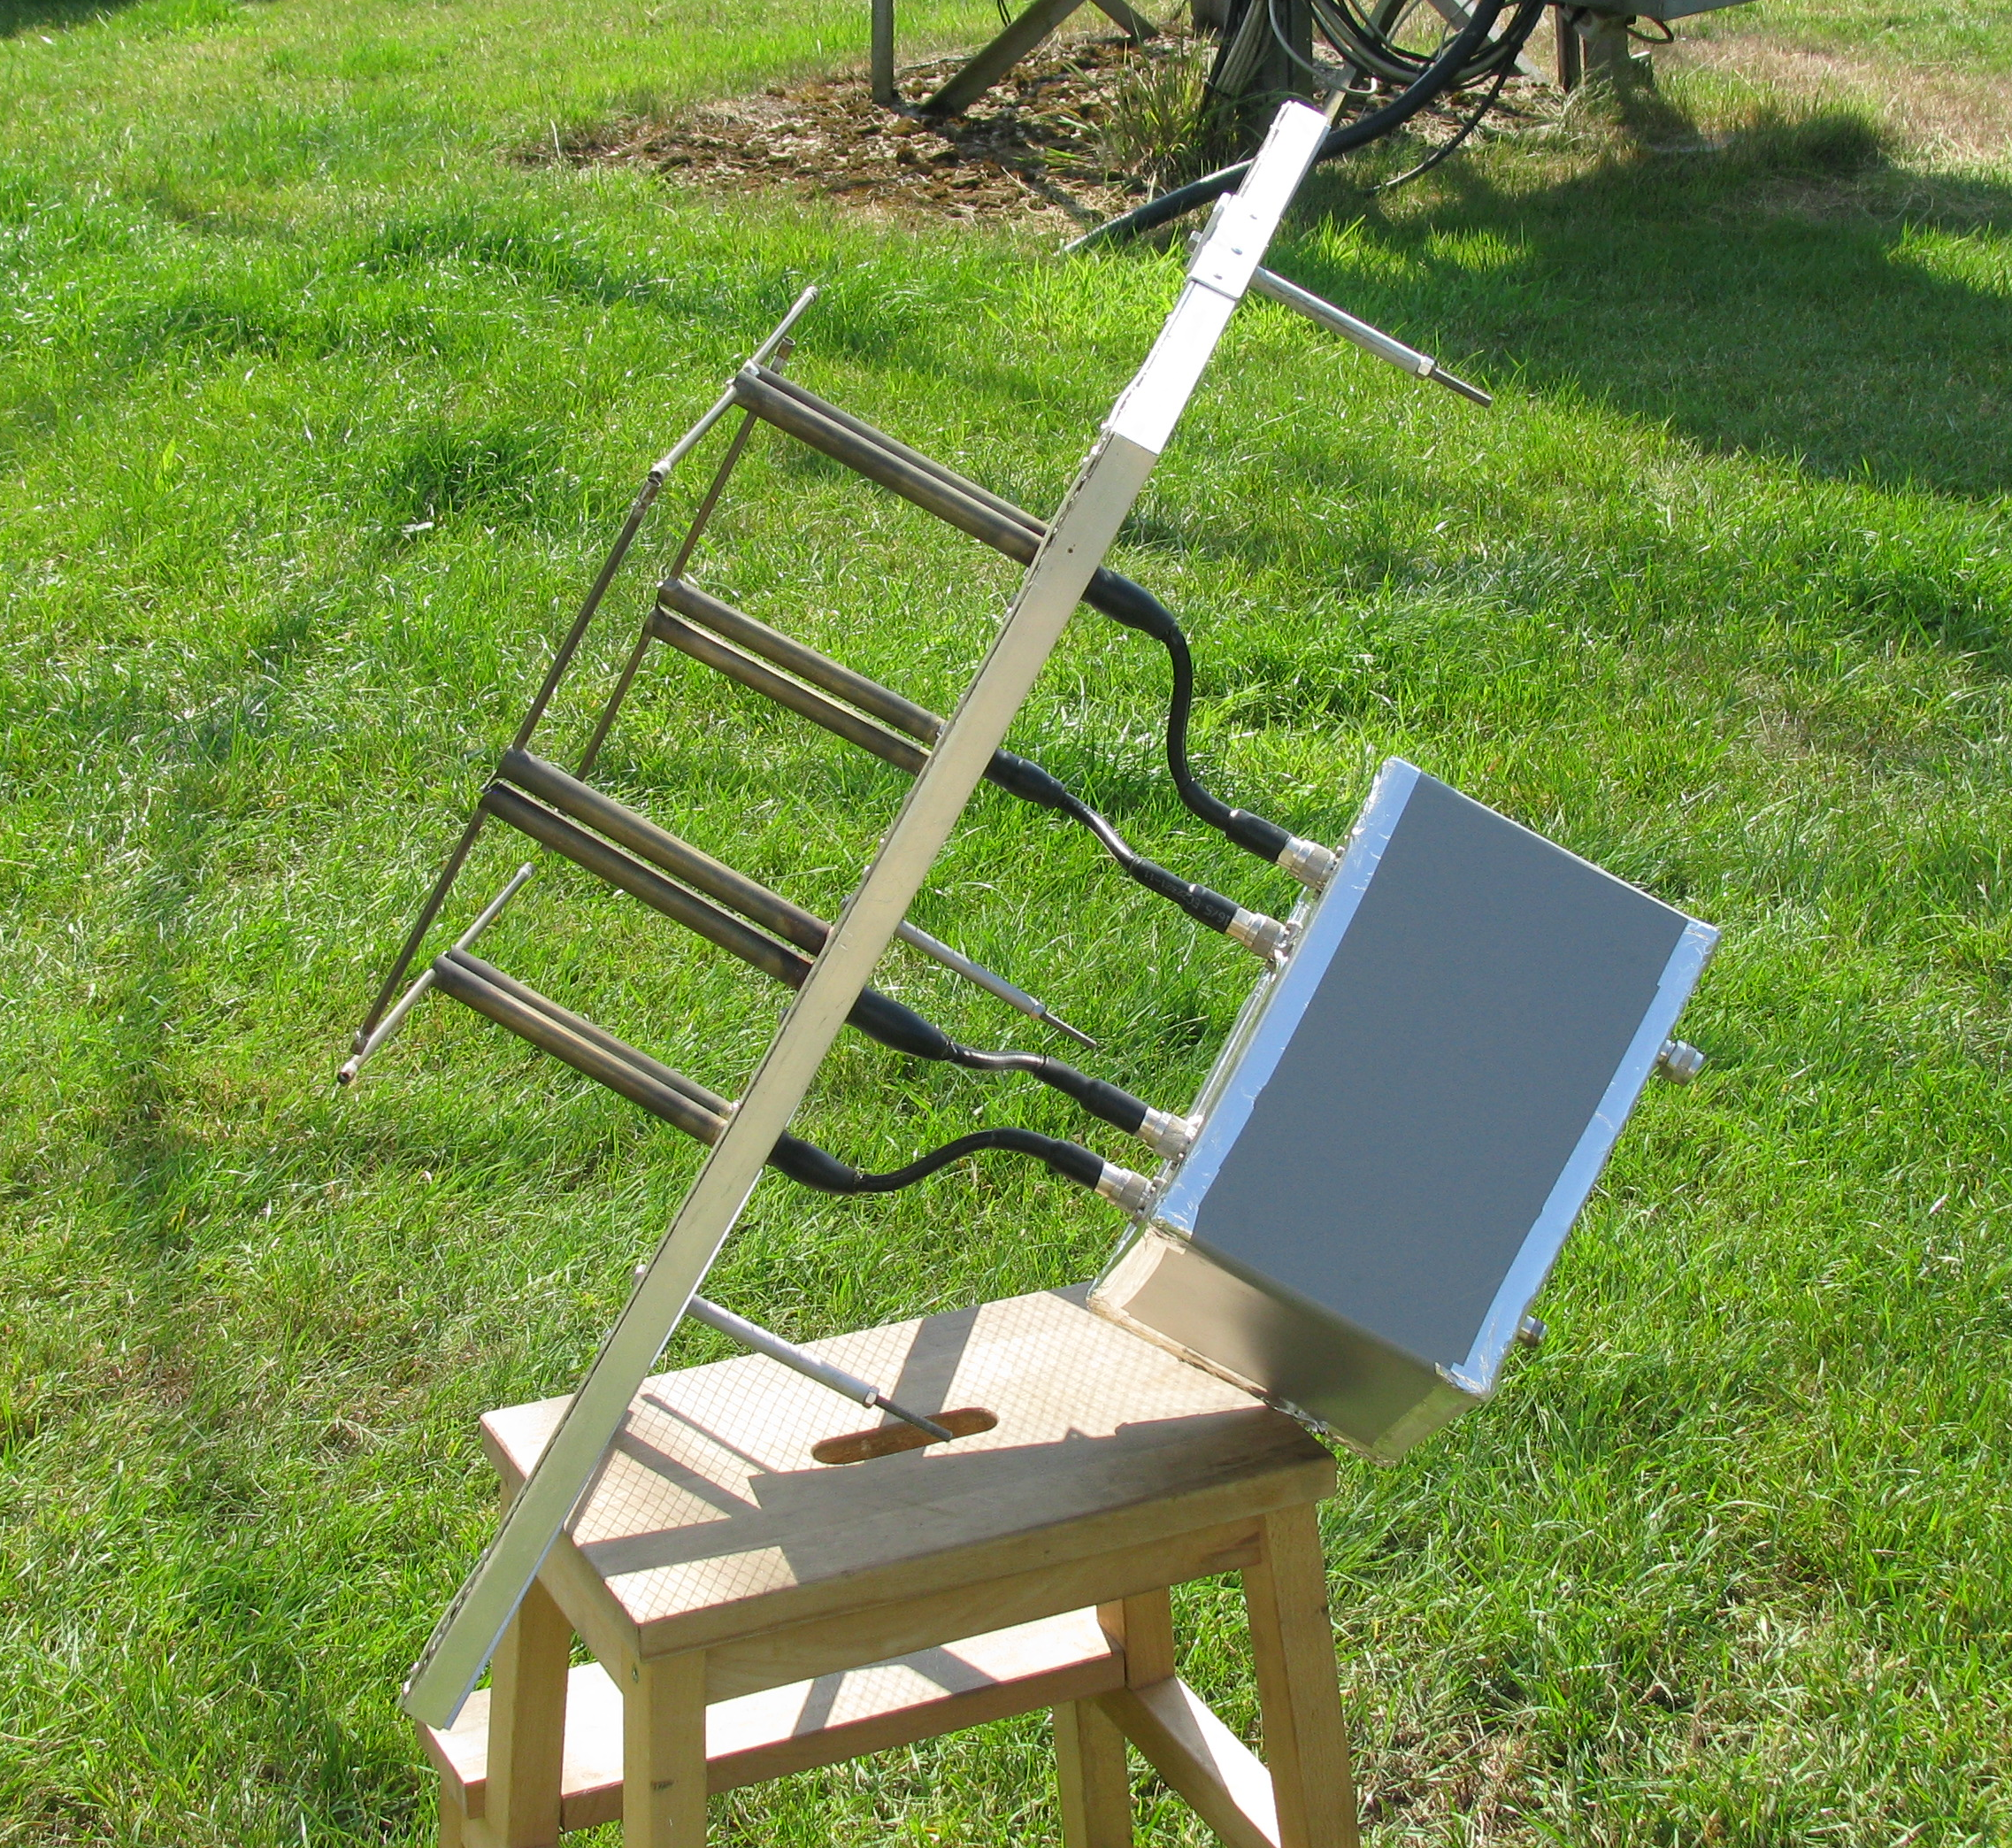
LX1DB’s new circular 432 feed

NC1I: Frank frank(x)NC1I.COM reports on his Nov EME activity -- I started the contest without any specific plans. Actually I had no intentions of submitting my score to the ARRL. I just looked at the contests as an intensive activity weekend. W1QA was unavailable so this was a single operator effort. I started out on 23 cm CW and just stayed there throughout the weekend. The 70 cm station was on all weekend and the array was tracking the moon, but I was enjoying the 23 cm activity too much to change bands. 23 cm activity was excellent and conditions seemed very good. Recent improvements in our receive system seemed quite noticeable. I know there is still room for further improvements, but the difference from when we first became QRV on 23 cm exactly a year ago are pretty significant. All contacts were random and without the use of any loggers. Stations worked over the contest weekend were on 8 Nov at 0017 OK1DFC, 0023 G3LTF, 0035 SP6ITF, 0038 I1NDP, 0042 WA9FWD, 0049 SP6JLW, 0055 EA3UM, 0100 I5MPK, 0105 DL3EBJ, 0115 OK1CS, 0121 9A5AA, 0133 DF3RU, 0143 OE5JFL, 0159 OK2DL, 0207 G4CCH, 0214 YL2GD, 0235 W4OP, 0251 SM3AKW, 0258 RA3AUB, 0315 I5YDI, 0322 VE4SA, 0334 N0OY, 0341 K9KFR, 0351 F5SE/P, 0355 RA3EC, 0411 W7JM, 0415 WA6PY, 0420 VA7MM, 0436 DL6SH, 0449 SV3AAF, 0501 SP3XPO, 0510 CT1DMK, 0515 IK3COJ, 0543 VE6BGT, 0602 W6YX, 0722 Kl6M, 1031 JA8ERE, 1045 JA8IAD, 1106 N6OVP, 1113 VK5MC and at 1131 JA4BLC, and on 9 Nov at 0036 ON5TA, 0044 OZ6OL, 0050 SP7DCS, 0100 OK2ULQ, 0119 IK5VLS, 0125 IK2RTI, 0159 ON5GS, 0229 K1JT, 0245 TI2AEB, 0254 S53MM, 0311 PI9CM, 0352 DG5CST, 0405 WA8RJF, 0413 SM4IVE, 0420 W1AIM, 0432 K1DS, 0516 OK1KIR, 0541 PA2DW, 0658 LU1C, 1127 JA6XED, 1140 JR4AEP, 1149 JA6AHB, 1202 VK4CDI and at 1226 JA1WQF for a total of 65 QSO's and 37 multipliers. I1NDP had the loudest signal heard all weekend (at least as loud as I hear DL9KR on 70 cm) followed closely by SM4IVE. I believe the smallest station worked was PA2DW (2-m dish and 250 W), although it's possible a couple of the stations worked had similar or smaller systems. I was amazed at how many stations worked were using 10-12’ dishes and relatively low power. I would like to thank WA8RJF for his patience! I believe Tony called me for about 30 minutes at three different times over the weekend, but it was not until his third attempt that I finally copied his call 100%. That was my only difficult QSO of the weekend, so I would be very curious to find out was his power level was. The weather here was very good and I did not experience any equipment failures or problems. The 23 cm station consists of 4.5 m RF Hamdesign dish and 1.5 kW PA (combined Kuhne amps). The following stations were worked on 1296 during post contest weekends on JT65C. I QSO’d on 15 Nov at 1029 W2LPL (21DB/15DB), 1040 PA3FXB (13DB/06DB), 1048 DJ2DY (23DB/18DB), and at 1102 G4BRK (20DB/16DB), on 16 November at 0705 YL3AEV (22DB/11DB), 0726 G4BRK (21DB/18DB), 0738 DK0ZAB (O/O), 0830 IK5VLS (13DB/9DB), 0837 PE1CHQ (14DB/10DB), 0843 DJ5BV (O/O) and 0909 DC9UP (12DB/7DB), and on 1 Dec at 2212 PA3FXB (12DB/06DB) and 2224 W2LPL (24DB/14DB). For the last weekend of the ARRL contest, I will be on 23 cm CW only. If the weather cooperates I will be on both nights. My station is also working extremely well on 432. In fact I have had several recent JT QSO's with G3LGR on 70 cm. Mike is running a single 11 el yagi and 75 W. I have also made many QSO's on both 23 and 70 cm over the summer and early fall, but have not taken the time to send in my reports. I believe I have been active every month during 2014. Hopefully we can continue to find the time to get on each month.

OK1CA: Franta strihavka(x)upcmail.cz sends his
EME contest report -- I was QRV during the second part of ARRL EME Contest on 70 cm and 23 cm CW. I was QRV on 70 cm in the first path for only 6 hours and my score is 18x16. Initials were I2FHW, W7MEM, K4EME, PA2V, K3MF, WA2GFK and SV3AAF #173. I think the activity on 70 cm was good, special from NA, and growing. I was QRV on 23 cm during my second and third moon passes. My 1296 score is 67x30. Initials were only RN3DKE and W1AIM to bring me to #308. I plan to be QRV again in Dec on 70 cm and 23 cm again, but weather could affect my operation.

OK1KIR: Vlada andTonda vladimir.masek(x)volny.cz send their latest EME news – On 70 cm, we worked on 1 Nov at 1902 HB0/DM1CG (26DB/24DB) on JT65B for digital initial {#116} and 1955 RU1AA (28DB/22DB) {#117}, on 3 Nov at 1654 Z21EME (24DB/24DB) {#118}, and on 30 Nov at 1856 PZ5EME (19DB/17DB) {#119} and GJ field. On 24 GHz, we QSO’d on 3 Nov in sked at 1604 JA4BLC (O/O) #20 and 1518 JA6CZD (559/559) on random. On 5 Nov we investigated with G3WDG the potential benefit of JT4F at almost real time post-decoding on second computer. OK1KIR was gradually decreasing TX signal power to became marginal at G3WDG. Charlie did not find any difference in decoding between both computers. Further at full TX power we rotated polarity to find a “null” at both sides. Unfortunately the test was not repeated and Charlie’s signal level was not enough to seriously evaluate the level the “null” in dB. However, it would be very interesting to repeat the test with better conditions. Testing was finished at 1734 by a CW QSO (559/559). On 23 cm in the Nov part of ARRL contest, we looked for new stations. On 8 Nov, we worked with CW SP4MPB (O/539) for initial #371, and on digi (JT65C) we collected another 13 initials and 11 QSOs with RN3DKE (11DB/9DB) digital initial {#192}, DK3WG (27DB/O), G4BRK (16DB/O), W2LPL (22DB/O), W7MEM (18DB/12DB), VE4MA/K7 (15DB/15DB), RN4AT (18DB/O), EI2FG (20DB/17DB), ON5TA (7DB/6DB), YL3AEV (14DB/O), PE1CHQ (8DB/5DB), on 9 Nov PE2TV (24DB/O) and W7SZ (17DB/O) {#204}, and on 29 Nov at 1705 DG5CST (9DB/6DB) {#204} and 1753 PZ5UD (15DB/O) {#206}, 1st PZ-OK 23 cm QSO and GJ field. With PZ we achieved 100th country for DXCC on 23 cm and probably the second after HB9Q. On 13 cm, we worked on 1 Dec at 1818 G3LTF (579/589) and 2111 PZ5EME (14DB/O) {#22}, 1st PZ-OK on 13 cm, GJ field and our DXCC 50 via EME on 13 cm. Strange WX around 0 deg C covered the dish by 1 cm of ice. [Congradulations to the OK1KIR group for achieving the first announced 1296 DXCC. Details can be found at http://www.ok1kir.cz/document/ documents/miscelaneous/DXCC_23_cm_en.pdf showing the history of their DXCC QSOs.

OK1TEH: Matej ok1teh(x)seznam.cz sends news of working the Z21EME dxpedition on 432 with one yagi (he also did the same on 2 m) -- Absolutely incredible for me, I worked Z21EME on 432! It is my first ever 1Y to 1Y EME QSO on this band. I remember DL7APV article in Dubus that something like that should be possible based on VK3UM's calculations, but I've never thought that it's possible for me because the high noise here. When I first logged at HB9Q, I saw that Z21EME was spotted by OK1DFC (12DB) and better than (22DB) by PA2V with his 4x23 el LFA yagis. I knew Peter had similar RX capabilities as me and realized that it could be possible to decode Z21EME at some 5 dB worse, or around (27DB). Later Z21EME was decoded by NC1I at (12DB) and I saw Frank NC1I during his QSO (15DB). After that I decoded OH6UW (27DB) and later even G4EZP (29DB). What conditions! While I was watching in both periods, I realized that there was a weak trace in Z21EME’s period. During a QSO I saw ST messages. Yes, it was Z21EME, WOW! And after that, I decoded them (29DB). I started calling but nothing further was decoded, so I wrote Z21EME sri missed you in the noise, TNX for test. They wrote sri, we saw you (27DB)! I continued watching their frequency and started calling them again when they got stronger. Then a 2 period break for PA cooling, and suddenly I decoded both callsigns with OOO. Signals then disappeared again, but after 12 min, I finally decoded the RRR. After the QSO Z21EME wrote that they saw me (25DB) peek, truly amazing! I can't believe that they used only a 38 el M2 and 400 W. Conclusion: don't be too shy to try to work small stations as you may be surprised. A big TNX goes to the Z21EME team.

OZ4MM: Stig vestergaard(x)os.dk sends his EME info – I have not been too active this fall due technical problems and other projects. I missed the 5B dxpedition back in Sept because of a tracking error. The EPROM in my F1EHN got corrupted just when I was setting up for the 5B. F1EHN was so very kind, and programmed and tested my broken tracking board (incredible service), which he returned just in time for me to be ready for a planned sked to finish off 144 WAS (all on CW). I had waited more than 22 years. K1MEA was first interested in 432, but build up a 4 yagi portable system for 144. Now Jim is looking for new projects and soon will be on either 432 or 1296. In late Sept, we visited IK5QLO, IW5BBH and IW5CFN in Lucca. We also met in July IK5VLS and IK5AMB. Indeed, there is much EME activity in the Lucca area. In the ARRL MW contest, I only worked 6 stations on 13 cm because of limited time, but did notice that activity seemed less than normal. In the second part of the EME contest, I QSO’d 34 stations on 1296 and 4 on 432. Again my operating time was very limited. This situation will be the same in last part too, but I will be on for a couple of hours, if WX permits. New stations worked recently on 1296 are Z21EME (JT), LU8ENU (JT), KL7UW (JT), SP6ITF, DC9UP and PA2CHR (JT), and on 432 K2GAB, Z21EME (JT), HB0/DM1CG (JT) and XE2AT (JT).

PA0EHG: Hans reports on his experiments receiving the DL0SHF 3 cm beacon -- After the EME conference I received many questions on my 10 GHz experiments, and decided to build a low cost setup to receive DL0SHF to demonstrate how easy and low cost an receive system can be. Following the example of others, I obtained 2 Avenger PLL LNB's. When they arrived, I measured their frequency stability to see if they were useable. The first LNB was about 35 kHz low in frequency and the second one was about 100 kHz high in frequency. The stability was acceptable and was comparable to my first 10 GHz narrow band system, build about 30 years ago. Although the NF is much better than the equipment from 30 years ago. I measured Cs/G noise to get an impression of the NF. I found about a 2 dB NF at 10368 and about 0.8 dB at 10750 MHz. I also tried to measure the NF using my HP8970b, but there I had the problem of the LNB integrated feedhorn not matching my waveguide transition. I measured at best 1.9 dB at 10368 MHz. So the NF was acceptable. I decided to start using an offset dish with a bit more gain than my 48 cm Procom dish. I choose a 64 cm offset dish, which gives me about 2 dB more gain. After mounting the dish and the LNB to my gearbox, I measured solar noise. On the output off the LNB, I use a short coax cable and a Funcube dongle for receiver. During solar noise measurements, I did find that the Funcube was already in compression caused by the wide band noise from the LNB. I added 20 dB attenuation in front of the Funcube, and then I could make a reliable Sun noise measurement. I measured 3.9 dB of Sun noise - a very good value and good enough to try and test receiving DL0SHF on low power. My first try to find DL0SHF was on 24 Nov. This failed and I could not understand why. I made a phone call to DK7LJ, and he confirmed it was operating. I continued trying to find the beacon with no success. I asked Per to put on high power, but also failed. I continued to try to find the solution. At some point I turned my polarization and all off a sudden I saw a small signal. I turned the pol some more and found that I was 90 degs offset. This was strange as I was almost sure that I had my LNB correct in the vertical position. Anyhow, I found the signal and was happy with this first result. Then Per switched back to low power and the signal was still clearly visible on my Spectravue screen. The next day the WX was still fine, so I tried to find the beacon in low power mode. After setup I almost instantly found the signal and performed some further measurements. The problem with polarization was a puzzle. I even tested on a local beacon to check my pol. It looked as if the pol from DL0SHF was horizontal instead of the normally used vertical. I did some extra checks, but always came to the same result. After that I informed Per of my finding and asked if he would check his pol. A few hours later he confirmed that pol of the beacon was wrong and switched it back to vertical. The Avenger LNB and dish together are an investment of about $55 and the gearbox about $200. The gearbox is by far the most expensive part; it could be done without, but it will be much more difficult. The biggest problem to solve is finding the frequency offset of the Avenger LNB. It might be up to 300 kHz. Further information on this experiment is on my website at http://www.pa0ehg.com/dl0shf2.htm. It includes an audio recording of the CW signal in high power. I want to try and measure tmoonnoise. At the time of my experiments, the Moon elevation was only 17 degs at max and I could not perform a good clear measurement. I also want to try to modify the Avenger to improve the NF on 10368. This would result in about 2 dB improvement of the received signal.

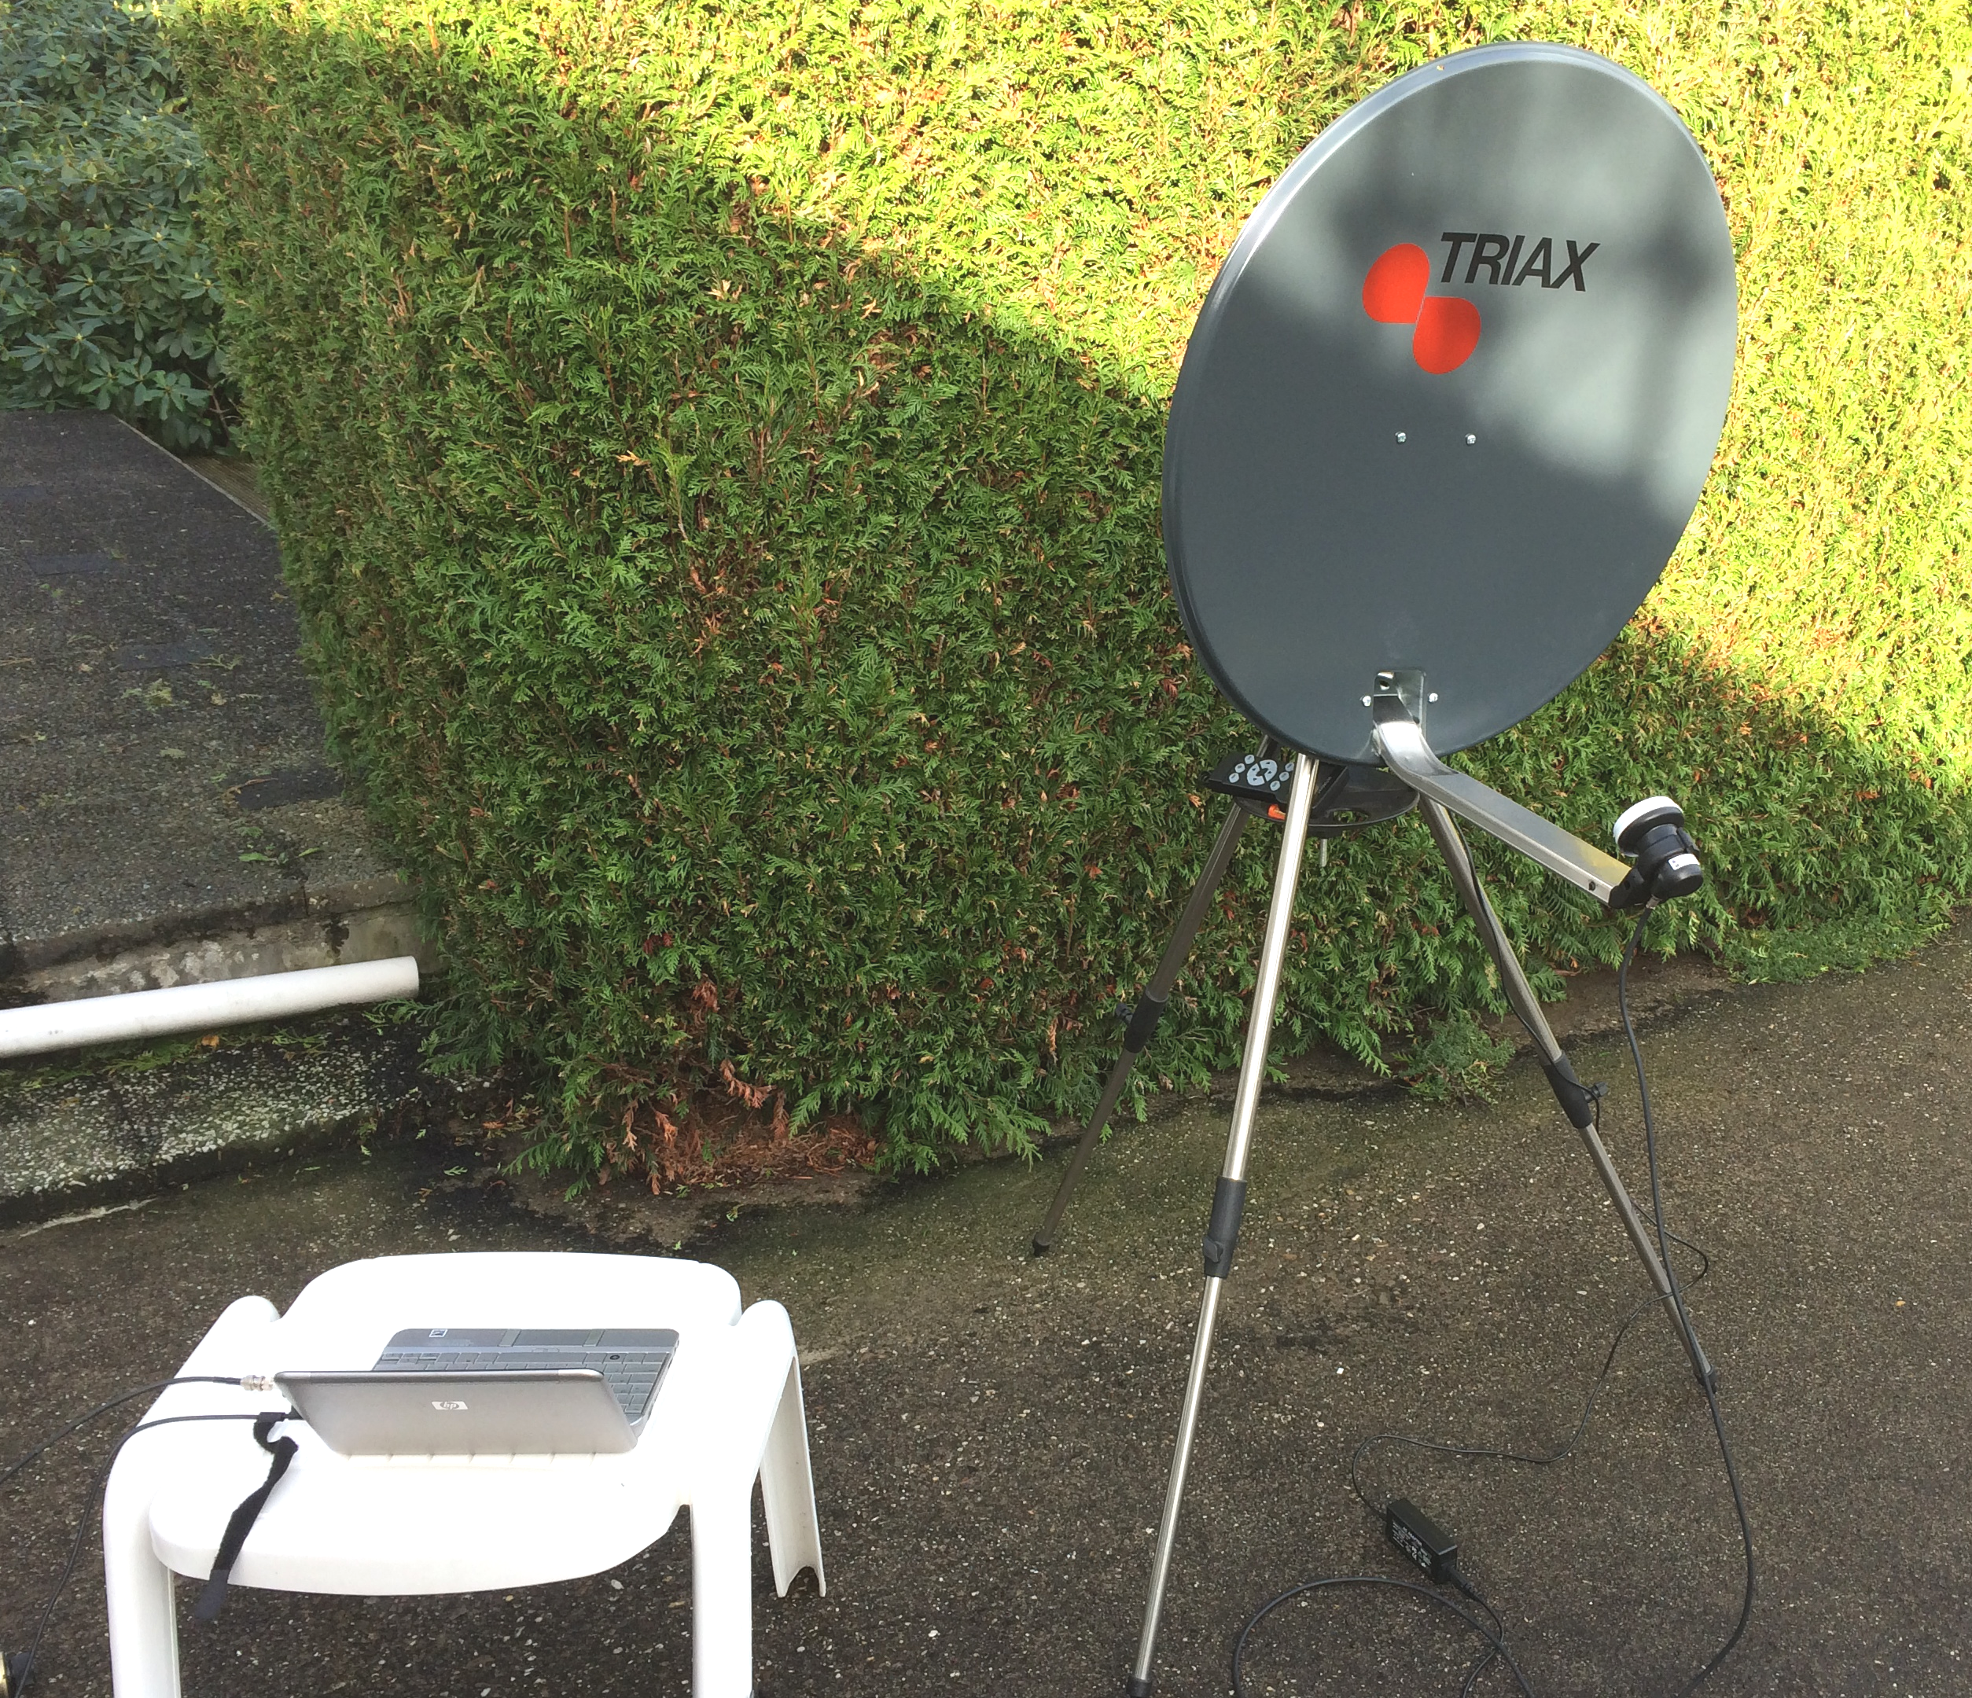
PA0EHG’s $55 3 cm EME RX (with auto tracking)

PA2DW: Dick qtc(x)kpnmail.nl reports on his 1296 activity in the contest -- In total, I made 5 QSOs with one on JT, HB9Q with booming sig, and the rest CW, SM4IVE, I1NDP, NC1I, OZ4MM and F5SE/P who was an initial. I heard W6YX (called them hopelessly), OE5JFL and SP4MPB very weak. The loudest signal by far was SM4IVE with real (579), but I found the signals overall marginal so suspected conditions not that super. I seemed to be missing 3 dB. At daylight I saw that my feed was not pointing perfectly toward the dish and that moment my XYL said ‘oh yes, sorry I hit the feed with the ladder when gardening - hi!

PZ5EME/PZ5UD: Hermann (DL2NUD) and Wolf (DL4WO) are still QRV from Suriname. They have had an extremely successful dxpedition with a truly outstanding signal on 1296. They have thus far QSO’d using the call PZ5EME on 432 DF3RU, DJ4TC, DK3WG, DL5FN, DL7APV, DL8GP, DL9KR, G4RGK, HB9Q, I1NDP, K2UYH, LZ1DX, OH6UW, OK1DFC, OK1KIR, OZ4MM, PE1ITR, PY2BS, S51ZO, UA3PTW and UT5DL, using the call PZ5UD on 1296 DF3RU, DG5CST, DJ9YW, ES6FX, ES6RQ, G4CCH, HB9Q, I1NDP, IK3COJ, IK5VLS, K2UYH, LZ1DX, OK1DFC, OK1KIR, OZ4MM, PA0BAT, PA3CQE, PA3DZL, PE1LWT, PI9CAM, RA3AUB, RD3DA, UA3PTW, UA4HTS and YL2GD, using the call PZ5EME ES5PC, HB9Q, IK3COJ, OK1KIR, ON5TA, PA0BAT, PA3CQE, PA3DZL, PE1LWT, UA3PTW and W5LUA, and on 3400 using the PZ5UD HB9Q, PY2BS and W5LUA(3400). For QSLs send an SAE with enough postage for the way back to you to DL4WO, Wolfgang Freitag, Heidestr. 132, 01454 Radeberg, Germany.

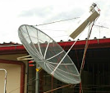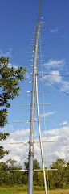
PZ5EME/PZ5UD 1.5 m dish with circular pol feed and 200 W used on 23 cm up and 432 38 el yagi/350 W yagi
SM4IVE: Lars sm4ive(x)telia.com was QRV on 1296 during the contest -- I was not on for a long time. I was QRV for a short period on Saturday evening and went on again around 0400 Sunday morning. I worked some stations, but since I am not participating in the contest, I was looking for raisins out of the cake. I added 10 initials including SP4MBP, VE4MA/7, W1AIM, RA3EC, NC1I, RN3KDE, G4BRK and S53MM. Despite the low activity from my side, I worked 60x25. I was called by 2 stations that I could not pick out the calls. One had a very strange keying that was impossible to read, and one was extremely weak, CA 7 something. I also did some RX on 432 where condx seemed good, but as my PA is not repaired, I only SWLed. I have moved my feed 7 cm away from dish. I think the Sun noise may have increased a bit, but am not sure because of the low Sun elevation.

SP7DCS: Chris sp7dcs(x)wp.pl reports on his EME contest operation -- I had very little time last months for EME and was not able to properly prepare the station for the contest season. I just fired the station up and hoped all would work well. Unfortunately Mr. Murphy was near and caused a lot of problems. Thus my results are not as good as as in recent years. Despite the technical problems, I made lot of CW QSOs and had fun. In the Microwave leg, I had 10 QSOs on 13 cm. I was active for just a single Moon pass on 2320 and had not time to prepare for the other sub-bands. In Nov on 23 cm, I made 58 QSOs (only on for second and third Moon pass). I wanted to be on 70 cm the first night, but my TX was not working properly. Probably water was in my coax or something similar, so no contacts on 70 cm. I did not want to change feed in the night, so switched to 2 m. During rest of weekend, I was mainly on 23 cm and had a lot of fun there. Problems with tracking took me off for some time. I plan to be QRV for the second leg, but I am not sure on which band I will concentrate.

UA3PTW: Dmitry ua3ptw(x)inbox.ru now has a 5.8 m dish and added on 13 cm with 180 W and 6 cm with 50 W. He worked on 432 using JT65B PA7JB, PA6JAM, HB0/DM1CG, Z21EME,TF3CY, PZ5EME and SM3KPX, on 1296 using JT65C K2BLA, DK3WG, W2LPL, Z21EME, SQ7D, G4BRK, YL3AEV, PE1CHQ and PZ5UD, on 2300 using CW S53MM, DF3RU, PI9CM, PE1LWT, SM3BYA, OZ4MM, ON5TA and KL6M, and on 6 cm with CW OK1CA, JA4BLC, ES5PC, OK1KIR, SM6CKU, PA0BAT, G3WDG, OH0/DL1YMK, SQ6OPQ, SM6FHZ, SV3AAF, DL7YC and JA1WQF.

VA7MM: Mark (VE7CMK) and Toby (VE7CNF) va7mm(x)rac.ca report on their 1296 EME activity in the Nov leg of the ARRL EME contest on 8/9 Nov – We were multi-operator, all mode. This was our 12th year participating in the event. In thirteen hours of operation, we have in our log 41 contacts (21 CW, 20 digital) and 22 multipliers. We added 8 initials (2 CW, 6 Digital) updating our initial count to mixed #176* (#123 on CW and {53} on JT). We’re running a recently overhauled OZ9CR cavity amplifier, which produces about 200 W at the feed of our 3 m dish. On receive we have 0.33 dB NF preamp with about 35 dB total gain in three stages. We’re planning to on again in Dec and our otherwise available for scheduled contacts by email.

VE3KRP: Fast Eddie eddie(x)tbaytel.net writes -- I was on during the contest on 1296 only. I worked 24 stations (21 on JT and 3 on CW). I missed my Pacific window due to an azimuth indicator issue, but that has since been repaired. I hope to be on for the next segment and catch those I missed on JT and CW. Hopefully the weather will cooperate as winter is upon us here. My tropo tower rotor was frozen solid for three days due to freezing rain, sleet and ice pellets. I do have a question regarding PI9CM and RA4A. Are these initials? [I think so, but am not sure.]

VE4MA/K7: Barry ve4ma(x)shaw.ca operated the EME contest in Nov from DM43 AZ USA on 23 cm -- I was on from AZ but did not sign the /K7. So if you did not work me before in DM43, it will be a new initial. My station equipment was the same as last winter, a 5’ (1.5 m) offset dish with ~150 W at the antenna. I could see a lot of CW signals on the SDR screen, but I had difficulty pulling out the calls from the many signals whom were operating with strong signals and in contest mode, i.e. short calls. On CW I completed with I1NDP, OE5JFL and SM4IVE. I also identified G4CCH, OK2DL (CWNR), I5MPK, NC1I and JH1KRC (CWNR but I did not look in JT window, I noticed after the contest closed on HB9Q the high JA activity on JT on the second night. I need more power and hope to add 3 dB for Dec! On JT65C, I completed with DF3RU, OK2DL, OK1KIR, DL6SH, K1JT, HB9Q, RA3AUB, SQ7D, IK3COJ and UA3PTW. I also copied PA3CQE, IK5VLS, YL2GD, W6YX (CWNR - busy!) and PA3FXB (lost pilot error). My QSO total was 13 with 3 on CW
and 10 on JT. For the first time, I tried to receive the DL0SHF 10 GHz EME beacon. I used my 5’ offset dish with ~ 0.8 NF. I copy it FB with a report level of about -11 on JT4G, but at the time it was not yet totally clear of local buildings. I am manually pointing with audible feedback so it may not have been in optimum position as I cannot see Moon noise at the same time. I see about 7 dB of Sun noise, but this is probably ~ 1 dB below optimum. I have been adjusting the feed position for max but may not be there yet. My moon noise is about 0.2 dB. I am happy! I see the 2 different modes that can be observed on the Spec JT screen. On one transmission there are 2 tones, and the next there are 4 tones with a frequency shift of one being FSK CW and the other the JT4F.

VK4CDI: Phil vk4cdi(x)gmail.com reports that he has added PA0BAT his list of stations worked on 9 cm EME. [Phil was active during the Nov contest for both Moon passes on 432 and 23 any mode.]

W1AIM: Paul (W1GHZ) w1ghz.q(x)gmail.com reports that VT was on 1296 for the EME contest – We were only on during the second pass and worked 11 stations on CW. Weather permitting, we will be on again in Dec, on CW only.

W2LPL: Les llistwa(x)gmail.com is QRV on 1296 from NJ – I only had limited time in the contest due to family obligations, but I did work 6 stations all on JT65C in one 3 hour pass and heard many more with some being easy speaker copy. As a newbie, I wasted too much time on understanding where to look and xmit due to Doppler. Since then, I have worked out that problem and I am now at initial #24. In addition, after the contest, I played some more with optimizing the feed focus, and picked up another 1 dB of Sun noise and now hear the ON0EME beacon peaking at -17 dB. So I look forward to working many more stations in Dec.

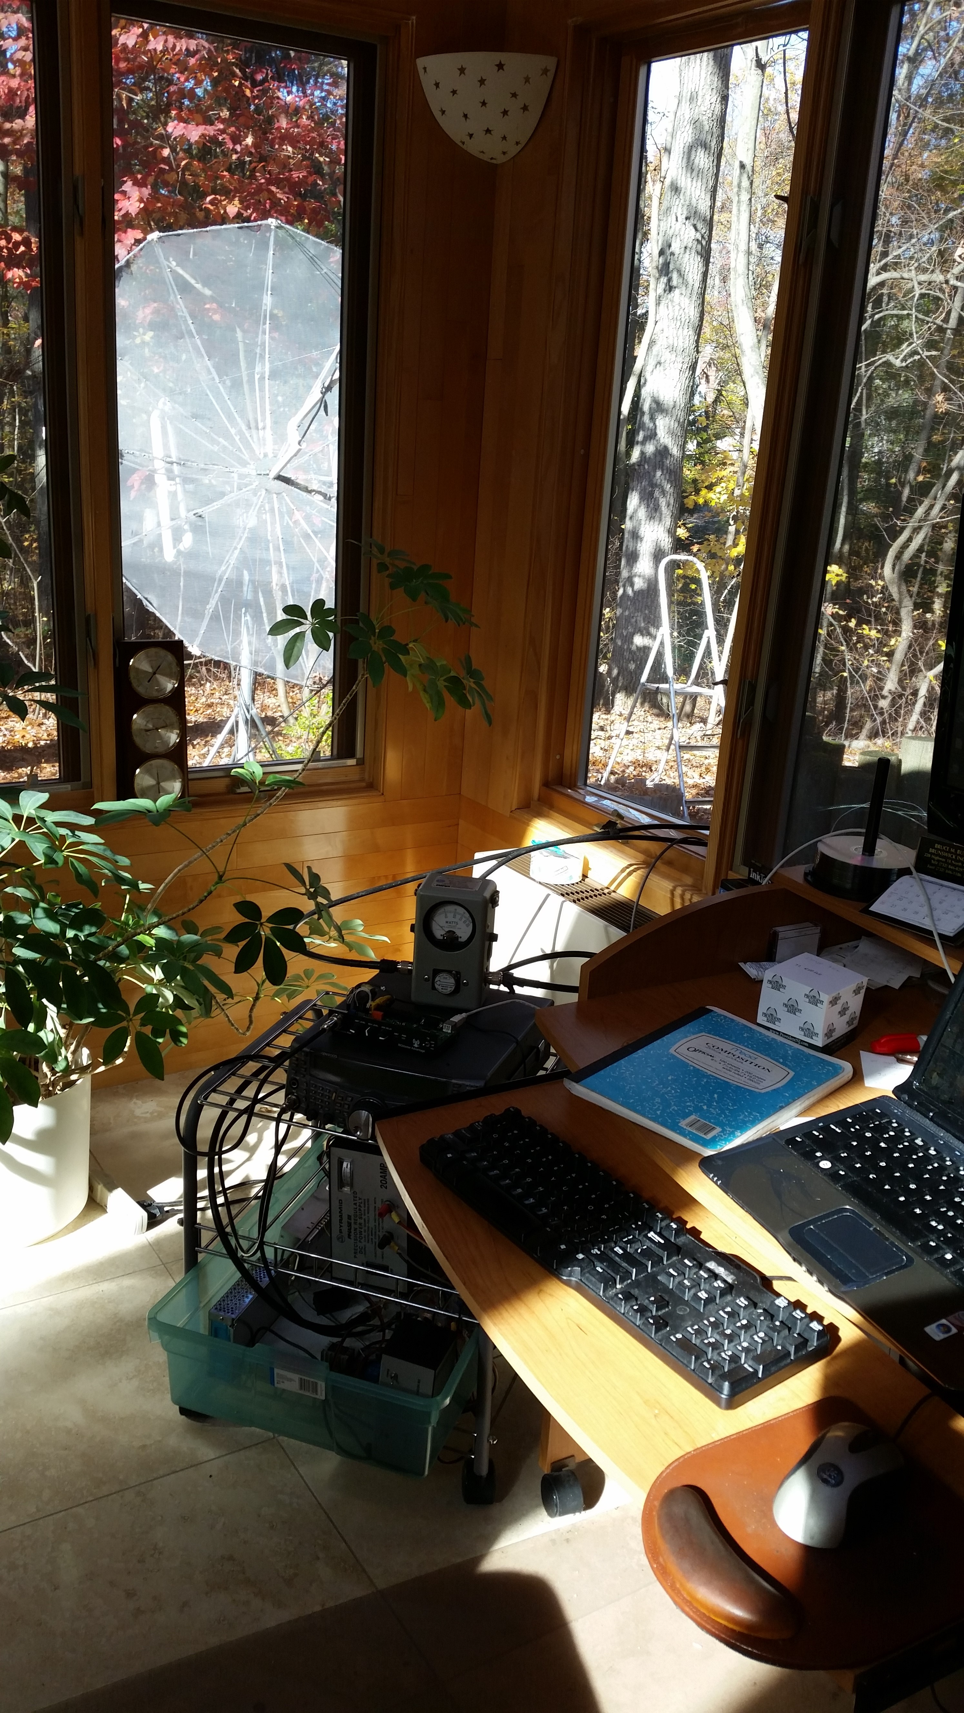
W2LPL’s 10’ dish viewed from his temporary shack

W3HMS: John w3hms(x)aol.com was on 1296 Friday and Saturday nights (local time) during the EME contest -- The signal reports were great on Friday night. I received 4 stations with single digit level on JT. The best was (6DB). I need a better receiver on CW as I missed about 3 who answered my CQs. I will try the KX-3 for CW RCV only. Rig is 450 w to a 3m dish. I made on the first Moon pass 12 QSOs (3 on CW and 9 on JT65C) and on the second pass 5 QSOs (1 on CW and 4 on JT65C) for a total of 17. I plan to be QRV both Dec days.
WA3LIB: Jim wa3lbi(x)me.com writes about his experience copying the 3 cm beacon -- One of the best thrills in my ham life was hearing the DL0SHF beacon on 3 cm! Both its CW and JT4 were copied. I have a new sense of continuing the "challenge" to be QRV and not just an SWL on this band. It gave me practice in tracking, tuning, and tweaking my system. Even my wife spent 30 minutes listening to the first signals at 6 AM one Sunday morning!

WA6PY: Paul pchominski(x)maxlinear.com was QRV for the contest on 432 and 1296 – On 432, I QSOed G3LTF, OH2PO and OZ4MM and heard K1JT, but Joe disappeared. I was jumping to 70 cm only for short periods of time spending most of the time on 1296. I heard my echoes usually with the same polarization as transmitted. On 1296, I worked 9A5AA, CT1DMK, DL3EBJ, DL6SH, F5SE/P, G3LTF, G4CCH, I1NDP, I5MPK, IK3COJ, IK5VLS, JA1WQF, JA4BLC, JA6AHB, JA8ERE, JR4AEP, K1JT, K9KFR, KL6M, N0OY, NC1I, OE5JFL, OK1CA, OK1CS, OK1KIR, OK2DL, ON5TA, OZ4MM, PA0BAT, PA3DZL, RA3EC, S53MM, SM3AKW, SM4IVE, SP6ITF, SP6JLW, SP7DCS, UA3PTW, VA7MM, VE4SA, W4OP, W6YX and W7JM for 44 CW QSOs. I heard SP4MBP and WA8RJF. I was called by some stations in HF style. For example, my call once his call twice or three times. The signals are weak but good enough for QSO. Unfortunately libration fading chopped signals into the pieces. In such situations, I prefer to be called for a longer time.

WA9FWD: John jstefl(x)wi.rr.com is back on 23 cm EME -- I was able to complete and install my KL6M style septum feed in time for the contest. The Sun is too low in the sky right now to get an accurate Sun noise measurement, as my dish is partially shielded by my house. But even with the dish partially in the shade, I still get 12.7 dB of Sun noise, the same as I was seeing with my old VE4MA feed and hybrid combiner. Echoes are definitely improved with the new feed. During the contest I worked 27 stations including 10 initials. I QSO’d NC1I, OE5JFL, OK1DFC, F5SE/p, SP6JLW, OZ6OL, I1NDP, YL2GD for initial #72, G3LTF, K1JT, DG5CST #73, DL3EBJ #74, I5MPK #75 W4OP, W7JM #76, IK3COJ #77, DL6SH #78, ON5TA # 79, OK1CS, G4CCH, CT1DMK, K9KFR, OK1CA, SP7DCS, K5GW, RA3EC #80, PA3FXB #81 were worked. After the contest, I worked KL6M for initial # 82. The station here is the same 3.7 m dish and 4 by W6PQL amplifier running about 500 W. I plan to be operational again on 1296 for the last weekend.

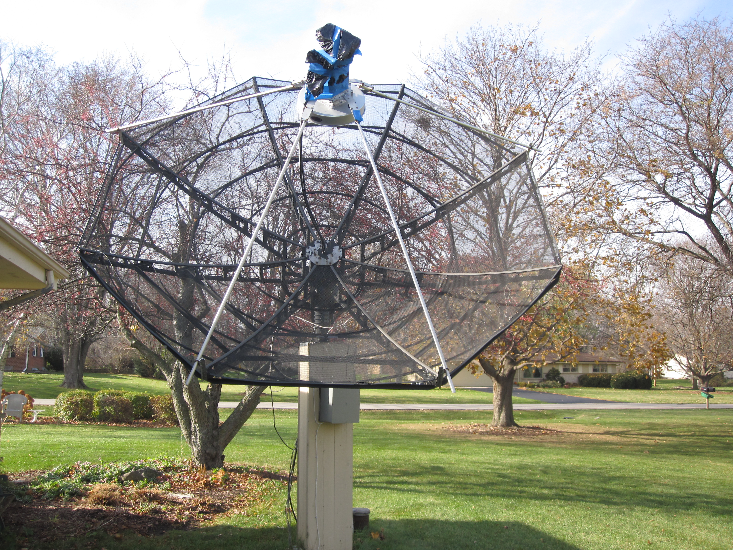
WA9FWD’s 3.4 m dish with new 1296 feed

Z21EME: Chris (PA2CHR) post(x)pa2chr.nl sends news about Zimbabwe EME dxpedition activity on 70 and 23 cm -- While PA3CMC and ZS6JON concentrated on 2 m, I enjoyed very much the higher frequencies. For the first time I was active on 23 cm during a dxpedition and used a single 67 el yagi (SHF design with 19.9 dBd) and a 150 W SSPA by PE1RKI. Saturday 1 Nov was the first day on 23 cm and I was able to work OK2DL (19DB), UA3PTW (22DB), OZ4MM (25DB), DJ9YW (24DB), G4CCH (20DB), OK1KIR (19DB), OK1DFC (23DB), ES6RQ (24DB), RA3AUB (25DB), OE5JFL (19DB), I1NDP (22DB), PA3CSG (26DB), IK3COJ (26DB), HB9Q (20DB), DF3RU (24DB), K2UYH (19DB), PY2BS (20DB), PA0BAT (24DB), DL6SH (21DB), ON5TA (28DB) and DK0SF (20DB) for a total of 21 stations. The next day was a very strange experience because nothing worked at all! I tried for hours, checked


