432 AND ABOVE EME NEWS
DECEMBER 2020 VOL 50 #11

EDITOR: AL KATZ, K2UYH; DEPT. ELECTRICAL/COMPUTER ENGINEERING, THE COLLEGE OF NEW JERSEY, PO BOX 7718 EWING, NJ 08628, TEL (W 609-584-8424), (C 609-947-3889), E-MAIL alkatz(x)tcnj.edu
ASSOCIATE EDITOR AND Reflector/NETNEWS Matej Petrzilka, OK1TEH, Simunkova 1609/21, 18200, Praha 8, Czech Republic, TEL (+420 603 489 490), E-MAIL ok1teh(x)seznam.cz
CW INITIAL LIST G4RGK, DAVID DIBLEY, E-MAIL zen70432(x)zen.co.uk, AT: http://www.zen70432.zen.co.uk/Initials/index.html
SUN & EXTRATERRESTRIAL NOISE LIST MANAGED BY OK1TEH: http://www.ok2kkw.com/next/nl_k2uyh/sun_table.xls
EME INFORMAL NETS: 14.345, ~1500 SATURDAY AND SUNDAY, NET COORDINATOR: OPEN
ON0EME EME BEACON, 1296.000 IS QRV WHEN MOON >10°, SEND RX REPORTS TO WALTER (ON4BCB) on4bcb(x)gmail.com
DL0SHF 3 & 1.2 CM EME BEACONs, 10368.025, 24 TBD, SEND INFO & QUESTIONS TO Per (DK7LJ) per(x)per-dudek.de.
NL EMAIL DISTRIBUTION and EMAIL LIST CORD: WARREN, W2WD wbutler(x)ieee.org
THE NL WEB VERSION IS PRODUCED BY REIN, W6SZ rein0zn(x)gmail.com, AT: http://www.nitehawk.com/rasmit/em70cm.html

VERY BEST SEASONS GREETINGS FOR A WONDERFUL NEW YEAR FROM ALL ON 70 CM & UP EME TO ALL

CONDITIONS: We want you to know this newsletter (NL) is filled with Holiday Greetings that we have not printed in the reports to save space, but we our expressing here for everyone! Because of COVID this has been a difficult year with many silent keys. Let’s hope and pray for a better year in 2021.
This Nov activity was again dominated by the final leg of ARRL’s EME Contest. This part of the contest was affected by Apogee when the Moon is furthest from the Earth and has 2 dB more loss compared to Oct. On other hand, activity stayed at very high level and gave much fun. On 432 DL7APV with his super array almost doubled his 2019 score with an incredible mixed mode total of 219x60! Bernd shows that 432 EME is very much alive.

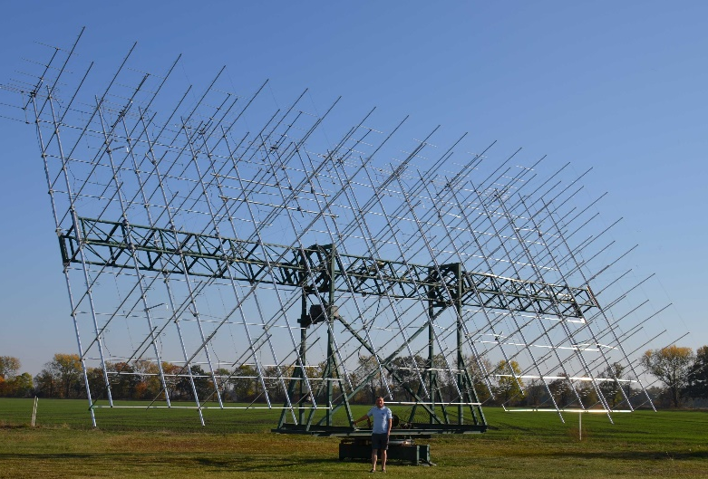
DL7APV scores 219x60 mixed mode on 432!

However, much of the action was on 1296 where CW was a major factor. The ARRL EME Contest is actually two contests: One for CW (and SSB – any non-digital mode), and one for mixed mode (any mode including digital). In the CW only class on 23 cm OZ4MM leads with 96 QSOs and in the mixed mode class. OK2DL reported 169x58 points. PA3FXB also did very well with a mixed class score of 131x50.
Although there are not many dxpeditions this Jan because of COVID, HS0ZOP is QRV from Thailand on 432 and will soon add 1296. Alex (HB9DRI) made his first QSOs in Dec – see his report in this NL. There are also some rare DX stations running from their homes such as HI8DL, HS0ZOP, FR5DN, BD9BU, 9Y4D and 4O6AH.
Coming up on 23/24 Jan is the DUBUS 13 cm CW Contest, and on the following weekend of 30/31 Jan is the SSB Funtest on 23 and 13 cm – see following rules. The next 432 CW Activity Time Period (ATP) is on 24 Jan is 1300-1500 and 2130-2330.

SSB CONTEST: The 23 cm SSB Funtest will be on 30 Jan (0000 to 2359), and the 13 cm SSB Funtest on 31 Jan (0000 to 2359). These events are intended to be fun. You do not need to transmit on SSB to participate. CW to SSB and vice-verse exchanges are encouraged and count for points. (Only one QSO between stations is allowed, i.e., you cannot work a station SSB to SSB and SSB to CW for extra points). Scoring is contact points x number of two letter Grid Sectors (IO, JM, FN, EM ...) worked. SSB to SSB contacts count as 2 points. SSB to CW (or CW to SSB) count as 1 point. The exchange is your Sector (IO, JM, etc.). Only the 2 sector letters need to be sent and copied by EME. The exchange of signal reports and/or 4 character grids is optional and not required. Operation may be by single or multiple operators from one location. No distinction for scoring will be made. This is a Funtest and meant to be similar to an activity event – the goal is to have fun. Communication on Loggers (HB9Q) is OK - [“TU FB QSO”, “GM..”, “73”, etc. is OK]. Logs should be sent to the 432 and Up EME NL by email to alkatz(x)tcnj.edu ASAP after the end of the contests. (All logs for contest awards should have been received within the month following the contest). The top scoring station on each band will receive an attractively framed certificate that will be presented at the next International EME Conference (Prague 2021?). Last year activity on 13 cm was quite low. If you have equipment for 13 cm, please come on for the Funtest. 2300 is an ideal band for SSB EME.

DL0SHF’s 3 cm Beacon: We have both good and very bad news. The beacon is basically repaired, but while making the repair Per (DK7LJ) injured himself when removing the broken (very heavy) azimuth gearbox assembly. He was in hospital at the time of this writing for an operation on his back. The gearbox has been replaced and the antenna tracking checked by monitoring Sun noise for several days. All worked perfectly. However, there is still a small problem with a flow sensor in the water-cooling system for the SSPA that has not yet be repaired. As Per has been unable to work on the system since a few days after his injury. Per hopes to have the beacon operational again within a few weeks. He has the wishes of all of us that his operation is successful and that he has a speedy recovery. [TNX to DF9CY submitting this info].

REPORTS:

9A5AA: Dragan dragan9a5aa(x)gmail.com reports on ARRL EME Contest on 1296 -- In the 28/29 Nov weekend, I made 45 CW QSOs with SM5GDX, OK1KKD, G3LTF, G4CCH, WA6PY, K2UYH, K4OP, LZ2US, I5MPK, SP7DCS, DG5CST, SP5JLW, IK3MAC, OE5JFL, DL6SH, F6CGJ, DL3EBJ, SM4IVE, OK2DL, OZ4MM, DF3RU, I1NDP, DL0SHF, DL7UDA, K0GRT, OH1LY, OK1CS, UA3PTW, LA3EQ, N4PZ, F2CT, IW2FZR, RA3AUB, OH2DG, LX1DB, SP3XBO, ON5GS, IK2MMB, IK1FJ, IK1COJ, PA3FXB, SM6CKU, KA1GT, RA4HL and N8CQ.

4O6AH: Djuro montena(x)montena.me is new to 23 cm EME -- In the ARRL Contest on 28/29 Nov, I made 27 JT65C QSOs on 1296 with W6YX, RD4D, RA3EME, HB9Q, LZ1DX, SP5GDM, DL7UDA, PA0PLY, PA3FXB, RA4HL, DL3EBJ, IK5VLS, ON5GS, OK1DCF, ON4QQ, DF3RU, OK2DL, UA3PTW, ES3RF, GM0PJD, KA1GT, UA4AAV, OH2DG, SM5DGX, DL8FBD, RA3AUB and SM4GGC. My equipment is a 3 m prime focus dish and only a 20 W SSPA. I also provided my equipment for the 1296 special events station celebrating the 70th anniversary of the Radio Amateurs Association of Montenegro, 4O0MNE. The first EME QSO was made on 28 Oct with OK1DFC followed by QSOs with KD5FZX, KA1GT and K5DOG. [TNX to 9A5AA for forwarding this report].

4O6AH 3 m dish used on 1296 with 20 W

DJ3JJ: Andreas dj3jj(x)gmx.net reports on his QSO with OK1DFC and conditions during the Nov Contest weekend -- I was really impressed OK1DFC’s great 23 cm signal from 2.6 m offset dish (with 500 W) as received on my 2.5 m dish. The test QSOs on JT and CW show what can be done with small stations. Conditions were very tricky the time. Saturday night we had thick fog plus 2 dB extra loss because the Moon was 405,000 km away. Many big guns could not pick up my CW signal; but on Sunday conditions became much better when we had a clear cold night. I am curious about what will be possible with my station on SSB; and am looking forward to the SSB Funtest that is coming up in Jan. Ultra noisy SSB with my small dish is super exciting and every QSO is big fun. Last year I made 3 x SSB and 6 x SSB- CW QSOs. I can recommend that everybody should give it a try! You will be surprised what is possible if you optimize your station for DX modulation and optimize compression to give every dB to your partner to copy you. It is a completely different way to optimize your station and there is a lot of room for improvement. My new self-designed sequencer is working perfectly. I am now working on some other ideas to further improve my station.

DK3WG: Jurg dk3wg(x)web.de had a good month in Nov – I added initials on 432 using JT65B with RU4AN, NY2NY, IZ2DJP, PA3HDG, VE3MIS and SP9KDA; and on 1296 using CW with WK9P, and using JT65C with 4O6AH (new DXCC), KB7Q, RD9SAC, RD4D and DG8NCO. [Jurg celebrated 40 years of EME on 29 Nov. He started using the callsign Y22ME].

DL0SHF: Chris (DF9CY) df9cy(x)web.de report of his operation of DL0SHF on 23 cm -- I am still recovering after my heart surgery in July. All is well. I took the chance to operate DL0SHF in the ARRL contest this year. Not full time but for quite a number of hours. Working remote is not easy as I often suffer from Internet dropouts. This time, I had a harddisk crash during the contest. I was lucky as I had made a diskclone a few days before. I operated only on CW again this year. In the Nov part of the contest on 10/11 Oct I worked F5KUG, SM4IVE, I5MPK, F6ETI, IW2FZR, SP6JLW, UA3PTW, OK1KKD, AA4MD, OH1LRY, SP6ITF, SP7DCS, OK1CS, FR5DN, DL3EBJ, OK2ULQ, IK3COJ, RA3EME, G3LTF, S53MM, IK3MAC, OZ4MM, K0PRT, SM6PGP, PA3FXB, DL4DTU, VE4SA, DL6SH, OK2DL, SP3XBO, VA7MM, OE5JFL, WA6PY, DG5CST, VE6TA, W5LUA, IK2MMB, EI2FG, VE6BGT, UA6AH, DF2GB, W6YX, IK5VLS, PA0PLY, WK9P, UA9FAD, DF3RU, PE1LWT, RA4HL, OK1CA, IK3UVC, I1NDP, SP2BMR, W4OP, LZ1DX, LA3EQ, DL7UDA, IK1FJI, OE3JPC, G4CCH, G4ALH, K5DN, K8ZR, F2CT and UA4AAV. Between contest parts, I was QRV using JT65C and worked on 30 Oct LY3DE, GM0PJD, G7TZZ, OH3MCK, 4O6AH and ON4BCV; on 31 Oct RD9SAC, RX6AIA, EW7CC, I5MPK and JH0TOG; on 7 Nov ON4QQ, GM0PJD, KB7Q (with a really good signal), 4O6AH, SP5GDM and AK4WQ; and on 27 Nov LY3DE and ON4BCV. In the final part of the contest, I added IW3HVB, IQ5QLO, DL4DTU (DUP), I5YDI, G4RGK, IK2RTI, DF3RU (DUP), SP7DCS (DUP), ES3RF, K2UYH, PA0PLY (DUP), RA2FGG, LZ1DX (DUP), 9A5AA, ON5GS, CT1FGW, KA1GT, LA1TN, WK9P (DUP), K7CA, I5MPK (DUP), LU1GCB, DJ3JJ, OK1KKD (DUP), KL6M, LZ2US, OK1DFC, OH2DG, F2CT (DUP), DJ3JJ (DUP), DF2GB (DUP), PA3DZL, IK3GHY, DL8FBD and F6CGJ. I ended up with 100 QSOs using CW with 89 stations (11 were DUPs) and 37 mults for a score of 329,300 points. We at DL0SHF are very pleased that we are able to give many small stations a chance for a QSO. You will find me on the HB9Q logger during activity periods. Do not hesitate to ask for a test. The newest member of the DL0SHF group is G3WDG/DL3WDG.

DL7APV: Bernd dl7apv(x)gmx.de had a great time in the ARRL EME Contest on 70 cm. -- In final leg, the number of QSOs is usually much less; but not this time! From moonrise on, I had very nice pile ups, which kept me busy till Sunday afternoon. On Saturday, the condx were mixed with lots of deep QSB and Faraday. Sunday was better for EU to EU, but EU to NA was much of the time one way. In Nov, I only added 4 CW QSOs, but ended up with another 130 QSOs (mixed). The number of DUPs was high, so I "only" added 106 valid contest QSOs. There were several gotaways, so there was plenty activity on the band. In Nov, I also added 10 initials and one new grid square, JN4JGK in rare PM83. The others were IZ3QFG (#), F1IOZ (#), G0JCC (#), DB2AN (#), F5OAU (CW) (#), IK7EOT (#), W2MMD (#), IU3CQP (#) and SM3LBN (#). Many more were seen, but not able to be completed. In total I made 246 QSOs and without DUPs 219 valid contest QSOs!! When I counted correctly, I have 60 multis. It should be my best ever and I believe the all time record on 432 in the ARRL Contest! It was a real fun even after nearly 40 years on 432 EME. It is still not boring.

DL9KR: Jan bruinier(x)t-online.de reports on his 2020 CW activity on 432 – The year began with a QSO to RA2FGG for initial #1080. During the year the following initials were added S51WX, IW2MJQ, F4VTP, IZ5TEP, PJ2T (great job by Gene), PA4VHF, DG5CST, ZL3AAD (at new loc), KD2LGX, KC0V, KB7Q (DN55), IW4ARD, SV8CS, YO2NAA, GW3TKH, DL4ZAG, RA3EME, GW4LDG, DM9EE and RK3T to bring me to #1100, of course all on CW. I made 14 leisurely contacts in the Oct part of the ARRL EME Contest and 9 in the Nov part. It was great fun to work several old acquaintances and friends.

F2CT: Guy f2ct(x)wanadoo.fr enjoyed the ARRL Contest on 1296 – I found high activity level even on CW! Due to troubles with my PC - radio interface, I couldn’t be QRV on JT65. Overall, I scored 68x30 on 23 cm and 12x7 on 13 cm for and overall score of 80x37 all on CW. Worked in Nov in the contest were F6CGJ, W4OP, VE6BGT, IK1FJI, WK9P, N5BF, KW7MM, PA3CSG, DL4DTU, IK3COJ and SM6CKU.

G3LTF: Peter pkb100(x)btinternet.com in Nov focused on using CW in the ARRL Contest on 23 and 70 cm – I worked using CW on 23 cm, on 4 Nov I5MPK, on 6 Nov DL6SH, and on 7 Nov HB9Q (on SSB) and KB7Q for initial #499. I QSO’d in the final leg of the EME Contest, on 28 Nov on 23 cm 9A5AA, LZ2US, SM5DGX, F6CGJ, OK1DFC, WB2BYP, VF6BGT and I5MPK, on the next moonpass changed to 70 cm for G4RGK, OE5JFL, S51LN and PA2V. From then until VE6TAs moonrise at 0100 there was nothing to work on CW, so I relieved the boredom by working 160 m CW in the CQ WWW Contest. Back on 432, I worked VE6TA and then W5LUA to end a rather disappointing (in terms of numbers) contest session on 70 cm. At moonrise on 29 Nov, I was back on 23 cm to work KL6M, SP3XBO, PA3DZL, IK3MAC, I5YDI, PA0PLY, ON5GS, RA3EME, G4RGK, IK1FJI, SM6CKU, LX1DB (on SSB), GMOPJD #500, ES3RF, IW3HVB and N8CQ. My final score on 23 cm was 80x35 and on 70 cm 17x13 for a CW total of 97x48, which was better than 2019 on 23 cm but a lot lower on 70 cm. [We learned that Peter had a fall (on 17 Dec resulting in a broken femur and was in the hospital awaiting an operation to fix the break). Fortunately, the operation was a success and Peter is slowly getting better. We wish him speedy recovery!]

G4RGK: Dave zen70432(x)zen.co.uk writes about the CW Initials List, Arecibo and his ARRL Contest activity -- First, can you ask anyone who takes part in the Initials lists to get me any updates as soon as possible as I will be doing the last update of the year in the next couple of weeks. It was so sad to see Arecibo fall into such a state of disrepair that it collapsed. My first entirely random CW QSO was with KP4I, who came on 432 EME with the dish unexpectedly during the ARRL EME Contest in 1987. Up until then I had only managed to work the big guns on skeds, so to make such a random QSO is something I will never forget. In those days I only had 4 small home built yagis and 80 W from a 2C39 amp. My report for the last couple of months follows; in the Oct leg of the ARRL Contest, I was still busy with moving my company and did not have much time to spend operating, but I did work on 432 I2FHW, SM2CEW, PA2V, KG5GCI, YL2GD, 4Z5CP, KL6M, WP4G, UT5DL, PA4VHF, DL7APV, SM5EPO and HB9Q. On the Sunday I moved to 23 cm and worked SM4IVE, OZ4MM, I1NDP, OK1CA, DF3RU, OE5JFL, DG5CST, SP6JLW, G4CCH, OK2DL, OK1CS and DL6SH. The final leg at the end of Nov was a disaster on 70 cm, I only worked G3LTF before my elevator screw jack gave up. This QRT’d me on 70 cm for the weekend. Sunday I was busy most of the day, but was able to come on 23 cm during the last 4 hours on Sunday evening. I worked RA3EME, PA3FXB, UA3PTW, RA4HL, OK1DFC, I5YDI, UA4AAV, IK5VLS, RD4D, IK3MMB, DL7UDA, GM0PJD, DL3EBJ, G3LTF, SM6CKU, KA1GT, DF3RU, UA4LCF, YO2LEL and ON5GS. I ended with a total on 70 cm of 14x12, 23 cm 22x13, and a overall total of 36x25. I have since stripped the 70 cm elevator, which it turns out was full of water.

HI8DL is QRV on 432 with a single 9 WL M² yagi in the middle of 4 x 2 m yagis and 75 W from the Dominican Republic – (see OK1KIR’s report)
HS0ZOP: Alex (HB9DRI) hb9dri(x)emeham.com updates us on his efforts to put Thailand (OK03gr) on 70 and 23 cm EME – With Great pleasure I announce the first EME QSO on 432 with HB9Q on 17 Dec at 1131 using JT65B. This contact is a milestone in the history of Thailand Radio Amateur and South East Asia. It is the first time the 432 band was experimentally allowed by the NBTC (National Broadcasting and Telecommunication Commission of the Kingdom of Thailand) to be used for EME. The initial QSO was followed by QSOs with DL7APV and UA3PTW; and later with OK1KIR. Signal were good considering the Moon is in south and the excess noise resulting from my center of Bangkok location. As the Moon moves to north more stations should be workable. Expect more operation around Christmas and New Year at any time. I am using an array of 4 x 15 el LFA-JT yagis with about 500 W at the feed point. I am using a Dual Channel IQ+revC with the new UADC4 for RX, which should give me very good performance if not for the high local noise. 23 cm operation will need to wait for the extension of my permit that will expire on 9 Feb. The 23 cm station consisting of a 3 m dish and 600 W SSPA should soon be on the air. I have two upcoming trips that will consume almost the entire month of Jan plus a 16 day required quarantine when I return to Thailand. I have received many requests for skeds in JT and CW. JT will be the easier and the preferable. I would like to express my gratitude to RAST (Radio amateur Society of Thailand) and HS1FVL, who supported me with the contacts and a special request to the Thai authorities. Stay tune and watch the HB9Q logger for the latest news.

IK1FJI: Valter valter_dls(x)yahoo.it reports on his Nov operation – I was QRV in the ARRL Contest on CW/SSB on 1296. I had lots of fun, but unfortunately Saturday evening the wind picked up and forced me to QRT. I was QRV again on Sunday evening to try to increase my score. I finished with 61 CW/SSB QSO's with some DUPs. Sorry for the QRZs, just not enough signal for my dish. My systems consist of 3.2 m dish, TH327 HPA, 0.3 dB NF LNA, EA4TX tracking system and TS2000X.

IK1FJI’s 3.2 m HB dish

JH1KRC: Mike jh1krc(x)syd.odn.ne.jp as usual took part in the ARRL Contest for both legs on 23 cm CW only -- I think my TX/RX coax cables are somewhat deteriorated and may have lost a few more dB. Sorry, but I had no time to test and replace them before the contest. I ended with a score of 40x23 for 92,000 points. Initials were DL4DTU, K0RPT, F5KUG, PY2BS, KA1GT, WK9P and OK1KKD. Heard were XE1XA, DL0SHF and JA6AHB.

KB7Q: Gene geneshea(x)gmail.com is now QRV on 1296 from his MT QTH and was QRV during the final ARRL Contest weekend -- I went out to the barn both evenings of the contest, fired up the 23 cm station, the propane heater, and had an absolute blast. For a small 1.6 m dish with 250 W at the feed, and being at apogee, I still managed a great result with 29 contacts. I felt like the little engine that could! After EU moonset the second evening, I ran out of "dance partners" and called it good night. I discovered when aiming elevated to the south that had some pre-amp overload/hash from a cell tower 1/2 mile away. WSJT-X 2.3 rc2 was flawless. All in all a fun weekend and very rewarding to have the station work so well. Stations worked were DL3EBJ, SP5GDM, OK1DFC, KN0WS (twice), KA1GT, RA3AUB, PA3FXB, OK1IL, PA0PLY, DL7YC, W6YX, VA7MM, K7CA, WA3RGQ, N5BF, KD5FZX, K2UYH, WA3GFZ, OK1KIR, ON5GS, DL7UDA, UA4AAV, K5DN, SM5DGX, OK2DL, IK5VLS, DF3RU, NC1I and IK2MMB.

KL6M: Mike melum(x)alaska.net reports on his Nov Contest weekend -- The first day of the final segment I had very little mutual window with EU because the declination was too low. The Moon barely cleared the trees and mountains. I worked only 4 stations on the first pass, and only one EU. At this low declination, I only had about 4 to 5 hours total mutual Moon window with EU for the entire weekend! It was a very unfortunate choice of contest weekend for me. For the first time on 1296, I had strange RFI (satellite?) so terrible that I could not bore sight on moon noise, which I normally do as a first step to prepare for operation. I also had 1/4 m of snow in the dish. It has never seemed to degrade performance; but just in case, I took a 8 m roof rake and 2.5 m step ladder and removed a ton of snow. There was still about 1/3 of the dish covered at the top. The second pass was better, but relatively poor at moonrise with only 13 more QSOs. So, I got up the next morning and reluctantly decided to swing the dish around to moonset. Surprise! Big signals, and folks piled up on me. I worked 20 more in rapid succession in my short window. I ended up with a 37 total, about half my normal results, but way better than I expected. A very challenging but always fun contest.

KN0WS: Carl carlhasbargen(x)q.com writes on his adventures from his north MN EME QTH during the Nov ARRL Contest weekend -- After seeing nothing on 2 m in Oct, I made another trip up north in early Nov to check out my 2 m array. I planned to give 2 m another try; unfortunately when I arrived for the contest, the 2 m yagis were on the ground. I tried to remount them but the mast I selected had a hidden defect and failed. So, I only had to concentrate on 23 cm. Since I think of Nov Contest weekends as providing “bonus QSOs”, I did have high hopes for adding lots of QSOs. During the 90 mins before the contest using JT65C, I worked VE3NXK (24DB), IK1FJI (14DB), OK1IL (12DB), DL6SH (10DB) and WA2FGK (15DB). The first two were initials and I hoped to see them all again during the contest. I did try to work one later, but I think he mis-interpreted another operator’s shorthand signals as coming from me since he sent a “TU Carl” even though I had not seen my call from him. During the first moon-pass of the actual contest, I worked a few DUPs, but also OH1LRY (15DB), LU1CGB (21DB), DL3EBJ (11DB), WA2FGK (17DB), XE1XA (13DB), VE4SA (17DB) and BD4SY (16DB). For mixed initials I worked RD4D (10DB), KB7Q (22DB), SM5DGX (9DB), DJ3JJ (22DB), W3CJK (27DB), CE3VRT (27DB) with only 50 W into a 1.8 m dish! and JA4LJB (12DB). In the second moonpass, I worked 4 stations using CW G4CCH, OK1KIR, DG5CST and DL6SH to bring me to initial #10 (CW). I then worked using JT65C UA4AAV (15DB), RA4HL (15DB), GM4PMK (18DB), DL7YC (8DB), and had mixed initials with ON4BCV (25DB), W3HMS (18DB) and IK2MMB (14DB). So my “bonus weekend” produced 25 contest QSOs and 13 of my weekend QSO's were initials for me. My final ARRL totals are (2x2) on 9 cm, (1x1) on 13 cm and (76x37) on 23 cm for a total of (79 x 40). Even though I was off 70 cm this year’s score tops my 2019 score by a little bit. This weekend in addition to my 29 dB preamplifier at the feed, I added an inexpensive 14 dB broad-band preamplifier near the radio and heard CW MUCH better than I have ever heard it before. My CW ability is improving. In the future I hope to make even more CW QSOs. During my 12 days on the Moon this year, I did my first 11 QSO’s on 9 cm, my first 9 QSO’s on 6 cm, increased my 3 cm mixed initial count by 4 to #12*, one QSO on 13 cm, zero on 70 cm, and thanks to the ARRL Contest weekends did 88 QSO’s on 23 cm. Hopefully, I am on the Moon more in 2021. I still hope to work G3LTF using CW soon. I also hope to finally to meet another EMEer in person in Prague in ’21!

N5BF: Courtney courtney.duncan.n5bf(x)gmail.com sends his 23 cm report for Nov -- Between the Oct and Nov contest weekends I added four mixed initials 4O6AH (26DB/19DB) #204* and new DXCC 44 in Montenegro - also possibly my most QRP QSO with Djuro running only 20 W to a 3 m. dish, W3HMS (19DB/20DB) #205*, KB7Q (23DB/20DB) #206*, and KW7MM (15DB/12DB) #207*. In the Nov Contest weekend, I added 25 QSOs to the 62 from Oct for a total of 87 with multipliers and final score yet to be tabulated. As always it was frustrating to be so far west that we only have a chance with the hard core operators in EU and Asia on the east end of our Moon pass. I did have an exciting near-horizon to near-horizon QSO with RD4D in LO32 (16DB/12DB) #212*. Other initials for the weekend were WK9P (569/539) #208* on CW, CE3VRT (25DB/O) #209* and DXCC 45 in Chile, JA4LJB (22DB/23DB) #210*, and BD4SY (25DB/15DB) #211* and DXCC 46 in China. On the principle that 'you don't know who you can't work unless you try,' I did manage to work several stations through the nearby pine trees on JT, but no new (or old ones) on CW except when operating in the clear. (The oak trees are still perfect absorber walls.) Near maximum degradation and spreading were notable in Nov and seemed to depress results but conditions were poor for all stations so, in that respect, at least it was 'fair.' In the coming months, between contest seasons, I plan to work individually with stations who aren't so active in contests and work on "in shack" upgrade projects.

NC1I: Frank frank(x)NC1I.COM has his big 432 array back in operation and was active during Nov on both 70 and 23 cm -- I have been very active the last month testing out my rebuilt 432 array. At first, I wasn’t sure if it was working as well as it should but after much activity I am satisfied with the performance. Measured sun noise is around 19.5 dB, which is probably approaching what it should be. I am able to easily work stations that are using 10 elements and 50 W. I am dealing with far more noise than in the past, but I will likely just need to learn to live with it. Since my last report I have added the following QSO’s on 432 using JT65B unless noted: on 13 Nov DK3WG, OK2AQ, F1IOZ, EA5CJ, and RU4AN; on 14 Nov DL8DAU, PA2V and N8AM; on 24 Nov VE3MIS, W1PV, IZ2DJP, SM5EPO, GM4FVM and W7TZ; on 25 Nov K5DOG, VE6TA, W2HRO, PA4VHF, EA5CJ, PA3HDG, OZ1SKY, CT1XC and OE5JFL; on 26 Nov VE3MIS; on 27 Nov VE6TA, W2HRO, VE3MIS, DL5FN, DK1KW, OK2AQ, M0ABA, PA9R, G6HKS, PA3HDG, YO2NAA, CT1XC, DK5SO, and YO2LSP; during the ARRL Contest on 28 Nov DK1KW, W1PV, K4EME, YO2LSP, M0ABA, W7MEM, W5RZ, IK7EOT, DK7ME, UT5DL, N8AM, DK4RC, CT1XC, DG7YBN, UA4AQL, N0AKC, F5VTP, KD2LGX, IK0ZYH, UA3PTW, SM5EPO, K9PW, W4ZST, VE3MIS, LU1CGB, DJ3AK, XE2AT, KJ7OG, K2QFA, N1QG, VE6TA, IK4PMB, PA2V, AE6EQ, ZL3AAD, VK2CMP, JJ3JHP, VK4EME, JA6AHB, JE2UFF, F6APE, DL1RPL, UB4UAA, UA0ALA, DL9LBH, DL4ZAG, G6HKS, OH4LA, F1DUZ, 2M0ETJ, OK2AQ, UT2EG, IZ2DJP, PA4VHF, DG0KW, DB2AN, K0DSP, DM9EE, RK3T, and PA3HDG. On 29 November AI1K, K9MRI, OZ1SKY, W7TZ, RD3FD, HI8DL, K1DS, ES3RF, F1IOZ, K3GNC, LZ1DX, IK0IXO, KD2LGX, PA2CHR, PA3FXB, DN5HR, VE3MIS, JH7IHV, JH7PAV, 7M2PDT, JH7BAY, JR0WFY, ZL3AAD, ZL4DK, JA4UMN, K3WHC, JG7PEF, EA5CJ, DK4RC, DF7VX, DL8DAU, OZ2ND, SM4GGC, CT1XC, and F5OAU. After removing DUPs and including the 12 QSO’s from the first contest weekend, my 432 total was 101x46. I am very happy with that total after operating just one hour during the first weekend. I added post contest on 30 Nov WP4G; on 1 Dec AC4TO; on 2 Dec W1PV, PA3HDG, UT6UG, SV8CS, IK7EOT, DL8DAU and JA4UMN; on 3 Dec AC4TO, HI8DL, WQ5S, W2HRO, JA6AHB, JH7IHV, JH7BAY, and BD9BU; on 4 Dec AC4TO, AK4WQ, UA3PTW, PA4VHF, YL2FZ, DL8DAU, GW4LWD, OE3FVU, JH7OPT, JH7LOC, JH7IHV, JA6AHB, and JH7PAV, on 5 Dec RK3T (JT65B and CW), AK4WQ, VE6TA, WD6Y, and K3GNC, PA4VHF, PA2V (peaked at 1DB), RM5P (first 432 EME QSO), PA3HDG, OK2AQ and G4HGI; and on 6 Dec UB4UAA, RK3T, LZ5GM, OH2BYJ, PA4VHF, IZ2DJP, YL2FZ, PA2V, OK2AQ, S56P, DJ3AK, F6HTJ, DL/HB9HBK, DF2VJ, and GM0HBK. More than 30 initials have been added on 432 since putting the array back up. On 1296 using JT65C, we worked on 26 Nov WA3GFZ, KW7MM, KC2HFQ and W2HRO; and during the ARRL Contest weekend on 28 Nov CE3VRT, HB9Q, F1RJ, RX6AIA, DF2GB, ON4BCV, UA6AH, VE4SA, SP5GDM, LZ1DX, ES3RF, and G7TZZ; and on 29 Nov LA2IMA, ON5GS, KD3UY, PA0PLY, OK2DL, RA3AUB, OK1DFC, KD5FZX, VA7MM, KB7Q, K7CA, W3CJK, I5YDI, W6YX, K2UYH, WA3GFZ, AA6I and N5BF. After including the first weekend and dropping DUPs the 1296 contest total was 55x32 in about six hours of operation. Overall, we had a grand total of 156x78. W1QA was the 1296 op for the few hours the station was active the second weekend. We have finally switched over to using WSJT-X on 1296 and will likely migrate to WSJT-X on 432 in the coming weeks.

OK1DFC: Zdenek ok1dfc(x)seznam.cz writes on his Nov Moon results – I accumulated 52 QSOs in the Oct round of the ARRL EME Contest. For the final round in Nov, I made a few minor adjustments to the septum feed. I extended the flare with a square-circle transition and used the circular output to generate the second mode as calculated for W2IMU. This put me at a Sun Noise value of 11dB/CSN. As I'm running late with the construction of my 8 m offset dish, I also used my 2.6 m offset dish for the Nov round. Thus, my system was the 2.6 m offset dish with 500 W at the feed and a 0.2 dB N/F G4DDK VLNA. Right at the start of the contest, I managed to connect with CE3VRTfor a new country, DXCC 116 and also a new digital initial. Alejandro uses 1.8 m dish and 50 W at the feed. Conditions seemed good during the contest. However, there was signal degradation due to the Moon’s perigee location as well as its libration (50-70 Hz spread at 23 cm). I added another 84 QSOs and ended up with a total of 136 QSOs for the entire contest. I was very surprised by the activity from NA this year, and worked many new stations. KB7Q with his new 1.8 m dish and 300 W was a multiplier from MT, a rare WAS state. The contest brought me a total of 24 new digital initials and 2 new CW initials. I QSO’d LX1DBon SSB (57/59). By next year, I'll hopefully be a QRV with a new antenna. On 24 GHz, I caught DL0SHF checking out his beacon station. We QSO’d using QRA64D (7DB/18DB) for my digital initial {#13}. At the morning time. The skies were overcast, Moon noise at 1.6 dB/CS. The outside temperature was 3°C and the el was 25°. My own echoes were 10 dB. Later I worked using CW WA6PY (O/O) for initial #4 and CA for WAS. Paul was heard at peak (449). I am interested in skeds and checking the HB9Q - 24 GHz room.

OK1KIR: Vlada vlada.masek(x)volny.cz and Tonda send info on their Nov EME activity – We worked on 23 cm using JT65B on 8 Nov at 0827 4O6AH (17DB/O) for digital initial {#391} and 0854 AK4WQ (23DB/27DB) {#392}; then during the last part of ARRL EME Contest on 28 Nov at 1506 R6CS (13DB/O), 1516 RD6D (12DB/O) {#393}, 1536 VK6KCC (12DB/O) {#394} and OF field, 1725 JA4LJB (8DB/1DB) {#395}, 1925 0K1USW (10DB/11DB) {#396}, 2007 PA3FXB (2DB/10DB), 2011 IK3UVC (7DB/12DB) {#397}, 2027 SP2CSQ (22DB/11DB) {#398}, 2033 OK2DL (1DB/1DB), 2037 OK1DFC (1DB/1DB), 2041 ON5GS (1DB/21DB), 2045 DF2GB (1DB/1DB), 2049 OH1LRY (1DB/3DB), 2055 OK2ULQ (2DB/3DB), 2119 RA3AUB (1DB/4DB), 2125 IK2MBB (2DB/2DB), 2133 I5YDI (8DB/10DB), 2244 KF2T (24DB/O), 2249 PH0V (7DB/O) {#399}, 2303 KC2HFQ (15DB/22DB) {#400} and 2359 K7CA (2DB/1DB); and on 29 Nov at 0032 GM0PJD (9DB/3DB), 0036 WA3FGZ (15DB/O), 0040 LU1CGB (9DB/14DB), 0046 G4CCH (2DB/4DB), 0054 VE4SA (11DB/2DB), 0101 KB7Q (9DB/O) {#401}, 0116 W6TOD (16DB/O) {#402}, 0215 KW7MM (2DB/8DB) {#403}, 0245 KD3UY (18DB/4DB), 0254 VA7MM (8DB/11DB), 0258 W2LPL (11DB/10DB) and 0320 N5BF (3DB/9DB); and using CW on 28 Nov at 2148 DG2CST (589/589), 2323 KN0WS (559/559) for initial #474, 2331 DL6SH (589/579), 2337 IK3COJ (579/579), 2344 W4OP (569/589); and on 29 Nov at 0112 G4CCH (589/589), 0116 OK1CS (569/579), 0410 K0PRT (569/559) #475 and finally at only 4 deg el 0446 K2UYH (579/579). [Vlada and Tonda were not operating the contest as much as looking for initials, but still worked on 23 cm using JT65C 20x13 and on CW 9x8]. After the contest on 23 cm we worked on 5 Dec using CW at 0733 KB7Q (529/529) #476 and with JT65C (8DB/10DB) {#403}, and also using JT65C 0901 LY2R (20DB/21DB) {#404}. We then switched to 432. The activity was excellent and we collected 21 digital initials in 27 JT65B QSOs. We QSO’d on 5 Dec at 2041 ZL3AAD (17DB/O) for digital initial {#259} and our new JT ODX of 18094 km (RE68LV), 2102 SV8CS (20DB/17DB) {#260}, 2123 DL8DAU (14DB/22DB), 2133 G4HGI (17DB/O) {#261}, 2213 JJ3JHP (27DB/23DB) {#262}, 2229 VK2CMP (24DB/17DB), 2239 OK2AQ (26DB/22DB), 2259 IZ2DJP (25DB/13DB) {#263}, 2309 JH7OPT (18DB/21DB), 2315 DL2HWA (15DB/15DB) {#264}, 2324 PA3HDG (16DB/14DB) {#265}, 2332 GW4LWD (10DB/20DB) {#266}, 2340 2M0EJT (29DB/17DB) {#267}, 2349 S57M (26DB/22DB) {#268} and 2357 JR0WFY (26DB/O) {#269}; on 6 Dec at 0015 BD9BU (20DB/O), 0435 RK3T (7DB/11DB) {#270}, 0634 VE6TA (10DB/O) {#271}, 0658 OE3FVU (30DB/16DB) {#272}, 0720 PA4VHF (15DB/11DB) {#273}, 0742 N1QG (17DB/17DB) {#274}, 0750 OE5JFL (11DB/7DB) {#275}, 0905 HI8DL (26DB/O) {#276} for 1st HI-OK 70 cm QSO, 0949 S56P (16DB/15DB) {#277}, 0958 IZ2DJP (18DB/20DB) {#278}, 1038 YL2FZ (23DB/20DB) {#279} and 1044 PA2V (9DB/16DB). To QSO HI8DL’s pol was received best at -50 degs (from his horz reference), which corresponded to the spatial offset; but we needed to TX at 90 degs from where we received him. [Why?] BTW, our last CW QSO on 70 cm was nearly 2 years ago on 25 Nov 2018!

OK1TEH: Matej’s ok1teh(x)seznam.cz EME report for the Nov ARRL Contest weekend – 2 m and 23 cm are now unusable for EME from my home QTH due to extremely bad QRM. Due to the COVID situation, I couldn't go to another QTH. I, thus decided to run the contest on 70 cm with my old single 23 el DK7ZB yagi and 1 HP SSPA with 8x SD56120M. Due to the massive birdies below 432.080, I preferred ran the whole contest call CQ in a clear spot (with my TX period always set to be opposite to DL7APV, so Bernd could report me automatically at his LiveCQ). My goal was to beat my personal past best of 32 contacts in an ARRL Contest. This huge effort paid off by adding 8 new stations: VE6TA, JA6AHB, ES3RF, SP9KDA, PA2V (DUP), K4EME, LZ1DX, PA3CSG and RK3T to bring me to mixed initial #144*. My total is 34x24 for 81,600 points. The propagation was not as good as during first part in Oct. The Moon distance degradation was 2 dB worse (which is quite critical for single yagi station!) and I suffered from long time 1-way Faraday pol lockout. On CW I heard SM4IVE (559), but Lars had his EL rotator stuck at 40 degs. I also heard OE5JFL quite well, but could not get Hannes’ attention on random CW. On JT65B, I decoded DL8DAU, 7M2PDT, VE3MIS, PA0BAT, W7MEM and W1PV but could QSO. I also missed DL6SH who was very strong. I thought we had already QSO’d in Oct. I had hoped for more, but made my goal... and where was the beer? For next year, I have to definitely change something as life is too short for single yagi EME… [Unless it is really long]. After the contest, I tried 70 cm EME once again and worked for OE5JFL #144* - he had only 100 W at that time!), S56P (24DB) and SV8CS. I also heard ZL3AAD. He heard me (24DB); however, his signal was quite weak due to my noise problems at low elevation. I also he has blockage at moonset from hills and no possibility of ground gain. Hopefully we’ll can try again during the next Perigee.

OK1YK: Mira ok1yk(x)volny.cz was QRV in ARRL EME Contest in Nov -- I started the contest on Saturday at 1700. I had been in active for a long time and wanted to see if the station still worked. The weather was very foggy and the dish was completely frozen. I had a solid dish from the ice covered mesh dish. Surprisingly, I received reports like never before. According to reports received, my signals were very strong. Unfortunately on the RX side, it was not so good. However, I worked OK2DL (5DB/2DB), JA4LJB (8DB/2DB), OK1DFC (10DB/5DB), OK2ULQ (10DB/5DB), UA4AAV (14DB/4DB), OH1LRY (15DB/7DB), HB9Q (1DB/1DB), GM0PLD (17DB/7DB) and more for a total of 30 QSOs. I finished at 2100. As can be seen from the received reports, it will be necessary to improve my RX. I was pleased with to add a new OK station, OK1USW with a nice signal. On Sunday the weather was fog-free and the dish was also frost-free, but my reports were significantly worse, Hi. I started at 1730 and worked to 1729 adding IK5VLS (14DB/12DB), 1739 ON5GS (14DB/12DB), 1745 YO2LEL (15DB/12DB), 1750 OK1IL (11DB/14DB) and 1816 UA4LCF (19DB/14DB). All QSOs on my CQ. Then there was QRM throughout the band, which unfortunately made me quit. I made a total of 35 contacts. On Monday I rechecked the QRM and while it continued, but because we had good weather, I decided to switch feeds from 23 to 13 cm for the Jan SSB Funtest. So far there isn't interference on this band (yet). [TNX for translation by OK1TEH].

OK2DL: Marek ok2dl(x)seznam.cz was QRV again on 23 cm with his big signal in the Nov part of the ARRL EME Contest -- The temperature did not rise above zero for a whole week before the contest. By contest time the icing on dish had increased to about 1 to 2 cm. Due to icing, I didn't even try to park the antenna between Moon passes. On Saturday morning I was not sure I would be able to operate at all. While decorating our Christmas tree, the Sun suddenly appeared and everything began to thaw. Except for the antenna. A few pieces of ice fell off but it was not enough. I gathered my courage, made a temporary rebalancing and turned the antenna toward the Sun, which then unfortunately began to hide behind clouds. Out of desperation, I pulled out a garden hose and began to sprinkle the antenna, thinking that the ice might fall. After an hour of alternating sprinkling and beating, the antenna was clear enough for operation. Before the moonrise, I was ready and waiting for the first signals to bounced off the Moon. The signals were there and as time passed, the number of contacts slowly grew. There were many stations calling at the same time; many of which I had already QSO’d. A new OK station that did not know was worked, OK1USW (13DB/9DB). I stayed at the radio all night into the early morning when the Moon was down to 20 degs. My last QSO was KL6M on the CW. Sunday, a half-day, was marked by many CQ calls. I ended with a total of 169x58. I missed JA4LJB, R1MVZ, SM6CKU and many others. There were 11 OK stations active in the contest. Activity was relatively low from JA and VK; on the contrary, the stations from NA were 34 this time. [TNX for translation by OK1TEH].

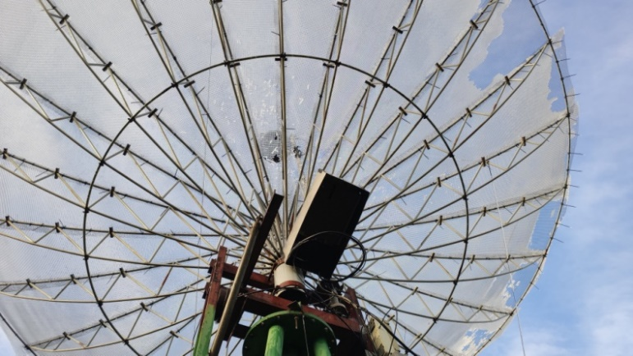
OK2DL’s dish was ice covered for the Nov leg of the Contest but had 1296 top mixed score of 169x58

OK2ULQ: Peter ok2ulq(x)seznam.cz was QRV on 1296 in the Nov leg of ARRL Contest -- On Saturday at moonrise, the Moon was hid behind the roof of a building. I was only able to copy signals at an elevation of 16 degs. Signals seemed weaker than in Oct, but the activity was again excellent. I made 3 CW and 14 JT65C contacts for a mixed total of 17. Initials were LA3EQ, RD4D, F5RD, RA4HL, ES3RF and G7TZZ. My total score in the contest is 69 QSOs. I finished my operation an hour after midnight. When I was leaving my QTH it started to snow. This was probably my last activity at EME this year. [TNX for translation by OK1TEH].

ON0EME: Walter (ON4BCB) on4bcb(x)gmail.com and Eddy (ON7UN) send news on the 1296 EME Beacon -- We have been doing some maintenance on the 23 cm EME beacon the last 2 weeks. The beacon was not QRV during the Nov Contest weekend. It is now back up and running. We had an exciter failure, which needed to be repaired. We took the occasion to install a new monitor and control system to monitor the beacon’s main parameters. Also, after almost 10 years 24h/24h service, the OE5JFL tracker had an LCD that needed to be replaced. Reports are very welcome.

OZ4MM: Stig gsvestergaard(x)gmail.com was only active on 1296 during the final ARRL Contest weekend – My contest weekend plans did not work out. I did not have time to place my 432 feed in the dish. Instead, I focused my available time (too little) on 1296 and operated only CW. Here I added 20 more stations to my log and ended with a total of 96 stations – all on CW. I worked LA1TN for an initial – it was great to meet Ottar again this time on 1296. Many years ago, he was a regular on 144, as was I. I just worked for fun on CW; but saw many stations on the EME logger, who could be easily be worked on CW. I am still using my 10 m dish with 950 W.

PA0PLY: Jan pa0ply(x)pa0ply.nl sends his results for the Nov part of the ARRL 23 cm Contest – The station here is 3 m dish wih a Septum feed and 450 W with on RX a 0.3 dB NF VHFdesign preamp. I started on Saturday morning near moonset. A lot of US based stations with good signals were found active, which was nice compensation for the 2 dB of additional path loss. KB7Q was a smaller station with 1.6 m dish and 300 W on JT65C was (23DB/O), N4PZ on CW was (O/549), Zdenek with his 2.4 m offset dish was extremely strong at (11DB/9DB). The next moonpass started in the afternoon with a lot of EU stations. I enjoyed working using CW G4CCH, IK3MAC, DL6SH, F6CGJ, SM4IVE, DG5CST, DL0SHF and LZ2US; and at the end on JT65C W3CJK (27DB/30DB) with a 1.8 m dish and 400 W. During this moonpass Mr. Murphy gave me a glitch by lowering my RF output to approx 300 W. After a while it restored itself to the expected 450 W. So far I have found no reason for this behaviour. On the last moonpass on Sunday afternoon, I located more new stations, and added using JT65C RD9SAC (12DB/18DB), DL1SUZ (24DB/23DB) and PE1LWT (18DB/17DB). I tried with KL6M but he was at 1 deg EL when we started and was lost. His signal sound like Aurora. Also QSO’d on CW were G3LTF, OZ4MM, LX1DB and IK1FJI. It was wonderful to see how well 4O6AH performed with just 20 W to his 3 m dish. All in all an amazing contest with a total of 63 QSOs, 13 on CW and a 15 initials. After the contest, I dismantled my 23 cm stuff to reinstall 10 GHz. I also have access to a 24 GHz setup to try with about 18 W at the feed. I will be updating the EME Directories on my website very soon.

PA2DW: Dick qtc(x)kpnmail.nl sends what he calls his “non-activity” report -- I was not able to be QRV very much during the final ARRL Contest weekend, but on Saturday had a nice CW QSO with OE5JFL. I came back from a party, so was not too clear in the head. The result was that my tracking was 20 degs off and I forgot Doppler correction. I was 1 kHz off, but Hannes somehow found me. It was a miracle! I was disappointed with the signal strength (no wonder with 20 degs off). I then found a nice strong JT signal, which was W6YX. I managed to setup the Doppler correction this time and we had a smooth QSO. On Sunday, my window was very limited. The contest stopped at 0000 and my window started just 15 minutes prior, but I was able to add DL3EBJ. My score was just 3 QSOs.

PA2V: Peter pa2v(x)advipe.nl found conditions perfect during the first weekend of Dec on 432 – There were very strong signals from EU and NA. It is a pity that so few NA stations were on. [The hour was not ideal]. It seems that the 432 population is growing in the EU and even with low power having a lot of fun. I wish I could get more NA stations on. But it seems that NA activity is something from the past. I worked quite some initials with OE3FVU - one of the smaller stations, ZL3AAD - hopefully some more ZLs will be attracted to 432. During the Nov ARRL Contest weekend, I worked using JT65B unless noted on 28 Nov N1QG for mixed initial #247*, VE6TA, VE3MIS #248*, K5QE, NC1I, JJ3JHP #249*, JA6AHB, UA4AQL, SV8CS, SM5EPO, UT2EG #250*, OK2AQ, OZ1SKY #251*, ES3RF, DF7VX, PA4VHF, IZ2DJP, OH4LA, OK1TEH, DL1RPL #252*, SP9KDA #253*, K4EME, W4ZST, G3LTF (559/569) CW, WP4G, 7M2PDT and VK2CMP; and on 29 Nov DL6SH (549/569) CW, SM7THS, VK4EME, ZS6JON, JH7BAY, DL8DAU, OE5JFL (559/569) CW, SM3KPX, RK3T and F6APE for a total of 37, which when added to 49 from the Oct weekend gives a QSO total of 86.

PA3DZL: Jac pa3dzl(x)icloud.com was finally QRV on 23 cm again from his new QTH – I had good fun during the final part of the ARRL EME Contest. I made 69 QSOs with 21 on CW and 48 on Digi. Initials worked on 1296 since my return were on 6 Nov 4O6AH for mixed initial #368* and DXCC 79, on 7 Nov RX6AIA #369*, KB7Q #370*, on 11 Nov RD9SAC #371*, on 22 Nov CT1FGW #372*, on 26 Nov IZ3VTH #373* and RD4D #374*, on 28 UA4AAV #375*, JH7OPT #376* and WA3RGQ #377*, 29 Nov VK6KCC #378*, DK0ZAB #379*, DL1SUZ #380*, OK1USW #381* and UB4UAA # 382*, and 3 Dec LA2IMA #383* and DL7YC #384* - surprised that I had not worked Manfred on 1296.

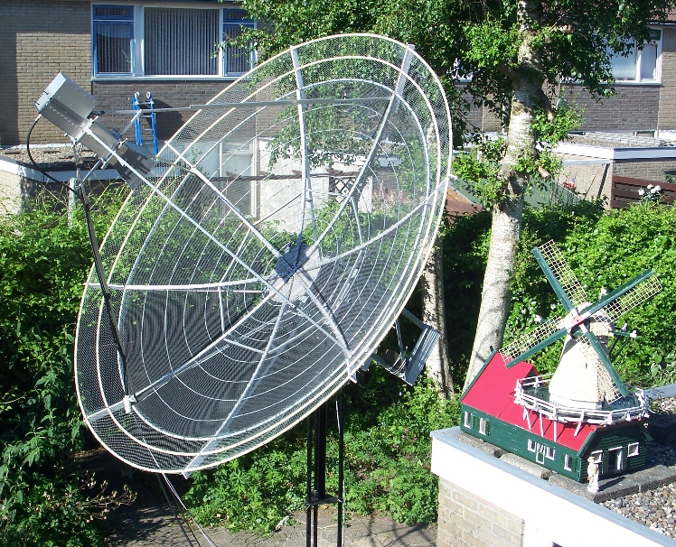
PA3FXB 3 m dish used for 1296 mixed total of 131x50

PA3FXB: Jan jvm(x)netvisit.nl was QRV from his home QTH in the whole ARRL Contest because of the COVID, the PI9CAM dish is closed and writes -- What an amazing activity! I ended with a total of 131x50. 2020 was a good year for EME activity on 23 cm with many new stations appearing off the Moon this year. I am now up to mixed initial #470 and DXCC 88. I hope we can all meet in Prague next year!

PA4VHF: Dick pa4vhf(x)gmail.com sends his latest activity report – I am now running on 432 EME 4x27 el YU1CF yagis and about 250 W at the feed. Initials added in Nov using JT65B were NC1I (3DB/9DB), WP4G (22DB/24DB), SM4GGC (28DB/28DB), UA4AQL (22DB/28DB), OE5JFL (DB/19DB), DG4KLK (22DB/O), DL1RPL (17DB/22DB), SP9KDA (16DB/O), VE6TA (9DB/O), F6APE (25DB/O), 7M2PDT (21DB/O), VK2CMP (23DB/25DB), PA3CSG (5DB/O), IZ2DJP (18DB/O), PA3HDG (16DB/24DB), RK3T (16DB/21DB), SM5EPO (17DB/25DB), PA0BAT (14DB/18DB), ZL3AAD (26DB/22DB) and OH2DG (7DB/12DB). I am now up to mixed initial #73*. Activity on 70 cm from PA seems to be very high. I wish activity in general would go up the same way, HI!

S51LF: Leon leon.fajc(x)gmail.com sends his report for the ARRL EME Contest -- This year, I operated the contest on 70 cm with the help of 4 x 30 el DJ9BV yagis, a 1 kW Soviet vintage GS35b PA and 0.3 dB NF LNA. Before the contest we heard our echoes nicely and the WSJT-X echo test indicated -14 dB. The Moon degradation -0,6 dB. After a few weeks of QRX, the first night came and I had problems with SWR. Water had gotten into divider. What looks like an easy fix, was much worse. I mounted a replacement, but the center of gravity changed and I had to rearrange the counterweights to get the elevation to work. We also discovered a new source of noise from moonrise to an EL of about 20 degs. It turned out to be the switched power supplies for new LED street lighting. Nevertheless, we made a god number of QSOs. In Nov, the conditions were worse with -2.7 dB of Moon degradation. Our WSJT echoes were down to -18 dB but still easily heard on the station speaker. Compared to previous years, the activity at 70 cm EME was about a third higher; maybe because of the virus. They were mostly small stations using JT65B. Unfortunately, 70 cm CW was almost dead. Only about a tenth of the stations were QRV on CW. CW CQs were rare. My total score is 71x36. I added 22 mixed initials (#*), 60 of my QSOs were on JT65B and 11 on CW. Despite the assistance of S51YL with some JT65B QSOs, between Saturday and Sunday, I fell asleep in a comfortable armchair. [TNX for translation by OK1TEH].

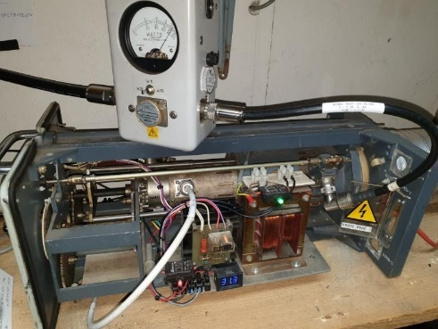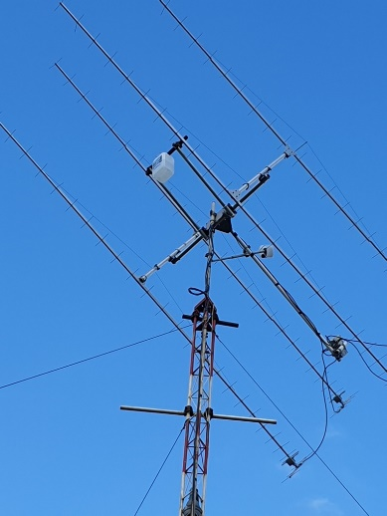
S51LF’s 70 cm GS35b 1 kW PA and 4 x BV yagis

SM5DGX: Anders jatk(x)live.se is QRV on 23 cm with a QRO signal -- After a 30-year absence, it was not quite as I had imagined when I finished my big dish (8 m dia and 350 W). My ambition was to run the ARRL EME Contest on 1296 using CW and SSB. Since I have some health problems right now, I chose to use digital. I was only QRV for the last weekend and able to work only when Moon is between 8 and 30 degs EL. QSO’d using JT65C unless noted were OK1KKD, W4OP, 9A5AA, G3LTF (579/579) CW, PA3FXB, AA4MD, KW7MM, RA3AUB, GM0PJD, W6TOD, DL7YC, KA1GT, UA3PTW, KD5FZX, LU1CGB, VA7MM, KD5DN, W3HMS, KW0WS, WA3RGQ, SM5DGX, W6YX, WA3GFZ, DL3EBJ, N5BF, K4EME, AA6I, K2YUH, K7CA, RD4D, RA4HL, DL7UDA, RX6AIA, OK2DL, RA3EME, OK1DFC, DL4DTU, DF3RU, IK5VLS, JH7OPT, UA4AAV, ON5GS, OK1YK, VK6KCC, LZ1DX, JA4LJB, IN0NAA, OH1LRY, I5YDI, KD3UY, IK2MMB, PA0PLY, ES3RF, SP5GDM, W2LPL, VE4SA, W1PV, KB7Q, DJ3JJ, SM4GCC, YO2LEL, RD9SAC, RA3EM, UA1CCU, UA6AH, JA4UMN, PA3DZL, UA4LCF, SM6CKU and 4O6AH for a total of 68x28 in one weekend.

SM6CKU: Ben’s ben(x)sm6cku.se ARRL Contest report on 23 cm in Nov follows – The activity seemed to be very good, but I spent only 7 hours, no night or early morning operating. I did not seriously participate in the contest and this report is meant mainly as a check log. Pre-contest I worked using CW SM5DGX and RA4HL, and using JT65C IK3COJ, 4O6AH for a mixed initial (#*), ON4QQ, RD4D (#*), IZ3VTH (#*), I7FNW and RX6AIA (#*). Saturday evening, I worked using CW LZ2US, SM4IVE and SM6FHZ, and using JT65C PA3FXB, RX6AIA, OH1LRY, OK1DFC, YO2LEL, IK5VLS; and on Sunday evening using JT65C, F1RJ, DL7UDA, ON5GS, SM5DGX, G4FQI, IK2MMB, GM0PJD, RD4D, PA0PLY, RA4HL, RA3AUB, LA3EQ, DL3EBJ, OK1USW (#*), SP5GDM, UA3PTW, DF2GB, DL7AIG, DJ3JJ, PA3DZL, DK0ZAB, I5YDI, JA4LJB (#*), G7TZZ (#), G4CCH, KA1GT, UA4LCF (#*), and using CW G4CCH, IK3COJ, RA3EME, OK1CS, SP7DSC, DL7YC, SP3XBO, OE5JFL, G3RGK, G3LTF and 9A5AA. During the contest I QSO’d a total of 47x18 with 14 CW contacts. My new feedhorn (N2UO design) has certainly improved both RX and TX performances - thanks to SM6PGP. I have 200 W at the feed of my 8 m dish.

SP6JLW: Andrzej sp6jlw(x)wp.pl and Jacek (SP6OPN) discuss their strategy and summarize their results in the ARRL EME Contest -- This year we planned to operate the competition in the multi-operator, CW only, multi band category. We operated under the callsign SP6JLW on 23, 6 and 3 cm, and under SP6OPN on 13 and 9 cm. We observed that in the CW only category a continuation of the downward trend found in the previous seasons. (Possibly the effect of the aging of telegraphists – Hi). The new generation of operators, brought up in a "digitized" World, do not see the need for direct operator-operator contact. During the Nov weekend on 1296 we added only 10 QSOs. We ended with a score on 23 cm of 78x33, on 13 cm of 15x10, on 9 cm of 6x6, on 6 cm of 13x9 and 10 cm of 14x10 for an overall total of 126x68 for 856,800 points.

UA3PTW: Dmitry ua3ptw(x)inbox.ru was QRV in Nov on EME – I added initials on 432 using JT65B with GM4FVM, G0JCC, PA3HDG, N8AM, SM4GGC, W7TZ, IK7EOT, SP9KDA, YO2LSP and VE3MIS; and on 1296 using CW CT1FGW, and using JT65C KB7Q, LA2IMA, RD4D, IZ3VTH, CE3VRT, KW7MM, KC2HFQ, RW4HW, KD2LGX, OK1USW, W6TOD, AA6I and SP2SCQ. [Thanks to DK3WG for forwarding this report].

UA6AH: Nickolay [email?] was QRV again on 1296 EME in Nov – I worked on CW IK3MAC and SM4IVE; and using JT65C K7CA, OK2DL, RD4D, OK1DFC, PA0PLY, W6YX, KD5FZX, K5DN, DL7YC, IK2MMB, KA1GT and ON5GS. [Thanks to DK3WG for forwarding this report].

VA7MM: Mark (VE7CMK) and Toby (VE7CNF) va7mm(x)rac.ca, the Project Moonbounce Team, report on their results in the final weekend of the ARRL Contest, multi-operator, mixed mode -- We completed the event's two weekends with a total of 80 QSOs of which 24 were CW and 56 were digital and with 40 multipliers for a contest score of 320,000 points. In the final leg of the event we added seven initial digital contacts to our log: KB7Q, DJ3JJ, KW7MM, JA4LJB, RD4D, I5YDI and W2HRO. These initials bring our mixed mode initial total to #276*. In the final weekend we again used a networked operation with one operator at the station controls and another operator remote spotting using a networked SDR receiver on the station’s antenna. This approach worked well with the second receiver spotting many contacts that contributed to our score. We’re running a vintage water cooled OZ9CR cavity amplifier that produces about 200 W at the feed of our 3 m dish. On RX we have a 0.33 dB NF preamp with about 35 dB gain in three stages. The 1296 SSB contest early in the new year is our next planned operation. Otherwise we are available for scheduled contacts anytime, contact us by e-mail.

VE3KRP: Fast Eddie eddie(x)tbaytel.net sends his Nov report -- The second wave of COVID is taking its toll. The amount of cases has significantly increased here; almost all caused by out of town people coming in and not self-isolating for 14 days. I was on for the final leg of the ARRL Contest but had issues with my EL readout and then some high winds, which limited operation. I got it fixed with frozen fingers - Hi. On 23 cm using JT65C, I worked on 28 Nov UA3PTW, RD4D for a mixed initial (#*), SP5DGM, DF3RU, UA4AAV, LZ1DX, ES3RF, RA4HL and PA3DZL, and on 29 Nov DJ3JJ (mixed #), RA3AUB, DL7UDA, PA0PLY, I5YDI, RA3EME, GM0PJD (dupe), KD5FZX (#*) and K5DOG DUP for a weekend total of 18 QSOs.

VK2CMP: Mick vk2cmp(x)me.com had much better success in the 2nd leg of the ARRL Contest -- On 70 cm, I added 13 QSOs compared to only 7 in the 1st leg. It seemed every station was transmitting on a strong birdie in the 1st leg, which due to work deadlines I could not be prepared. So for the 2nd weekend, I re-installed and commissioned the noise blankers in Linrad on my new PC as well as installing 434 SAW filters in-between the 1st Cavity WD5AGO LNAs and 2nd Kuhne LNAs up on the mast. I forget how capable the Linrad noise blankers are and operating a contest without them is a sure fire way to appreciate Lief’s work! My first impression with the SAW filters that have 4 MHz BW are that there were less birdies in the band. I plan to place the 2nd Kuhne LNA in the shack over Xmas and measure the difference over a few days that the SAW filters make. I also have a quote request with Golledge for a 1 MHz 3 dB BW filter and am waiting for the quote. So if you are interested drop me a note and I can send over the spec sheet. [PSE send the info, if it improves things]. My other ’next’ project will be redesigning the airflow for my SSPA. The two days of the contest coincided with our 1st heat wave of the summer with 2 days at 41 degs (105 degs F). I had to run lower power, which cost some time and QSOs. Even with the heat I had a great time in the Contest.

W2HRO: Paul w2hro.fn20(x)gmail.com send for the NL – On 11 Dec I worked KB7Q in MT on 1296 EME using JT65. This was a new grid and WAS #40 for me. More interesting, this was the first QSO between two of my folding fabric dishes. KB7Q is using a 1.6 m folding dish and 300 W; I was using a 1.8 m folding dish and 200 W. KB7Q was using an IC9700 and W6PQL amp. W2HRO was using a Elad FDM-DUO/TR1296 and PE1RKI amp. Both stations were using patch feeds configured for circular pol. The Moon was at perigee - so that helps. It's good to know that a portable 1.8 m dish with 200 W can work a similar station via the Moon.

W4OP: Dale parinc1(x)frontier.com was QRV during the Nov Contest weekend on 1296 using his new extended dish -- I ended up with a total of 67 QSOs using CW/SSB only- upping my initial count by 61 QSOs over 2019. I have no JA/VK window, so am very pleased with this number. The new 15’ dish and 1 kW SSPA mounted at the dish are really playing well. I still need to optimize the focal position of my SM6FHZ feed when the Sun comes north in the spring.

WA6PY: Paul pchominski(x)maxlinear.com reports on his Nov Contest and 24 GHz activity – I QSO’d in the ARRL Contest on 1296 using CW LZ2US, 9A5AA, VE6BGT, F6CGJ, K2UYH, WK9P, NQ7B, ON5GS, VA7MM, K5DN, K7CA, SP2HMR, KA1GT and KL6M for a total of 14x13. I also heard XE1XA and OK1KIR. I was switching to 432 for short periods, calling CQ on CW, but heard only my echoes. On both bands libration was quite high; on 1296 even strong stations were difficult to copy. On 432, I had bad QSB on my echoes. Low declination, apogee and high libration were not the best combination for receiving weak stations during this contest weekend. After the contest, on 7 Dec I QSO’d on 24 GHz OH2DG for initial #7. Libration was 130 Hz. At the end of the QSO, my echoes were quite good and moonnoise (MN) 2.2 dB even though surface of my dish has a lot of small dents. The day before when libration was higher, about 220 Hz, we couldn’t complete a QSO. During high humidity and low elevations MN can be as low as 0.9 dB. On 8 Dec spreading was lower and conditions were better. I QSO’d OH2DG again and OK1DFC #8. I’ve had problems with clouds and wind, which force me quite often to switch off my auto tracking to stop my AZ tracking from oscillating. Due to this oscillation, I can have QSB on my signal. The DEC was 8 -7 deg, when I started with OH2DG. My EL was 11 degs, MN 1.6 dB; at the end of the QSO EL went up and MN was 2.1 dB.

WK9P: Tim tcherrone(x)yahoo.com reports on his Nov activity -- I was happy to be QRV on 23 cm during the 28/29 Nov portion of the ARRL Contest on CW. Weather was good during both weekends. I had a clear sky for viewing the full Moon. I had a lot of fun and heard many good stations. Signals were stronger on the 29th. Looking over my log, I found some DUPs, but still did better in Oct. Between the Oct and Nov weekends without DUPs, I worked 35 stations and had a great time.

K2UYH: I (Al) alkatz(x)tcnj.edu again had a great time operating the ARRL Contest in Nov despite some Murphy – I operated only 1296 (plus the microwave bands) in the contest as part of my teaming arrangement with K2TXB operating 2 m and W2HRO operating 432. K2TXB had one of the pulleys in the tower that holds his array fail and was not able operate at all in Nov. Russ ended with 64x37. W2HRO had only limited time to operate and was not able to do as well on 432 as we hoped. Paul scored 27x20. I again had a problem with preamps randomly blowing despite changing the TR relay and control circuit. Between Saturday and Sunday, I changed the cable that carries the relay control voltage from my shack to the feed and still lost another preamp. I lost a total of 3 preamps during weekend! At the start of the contest while moving my dish to the Moon, I received a telephone, which distracted me. As a result, I drove my dish to its mechanical stops and had my drive chain come off of the main gear. I lost almost an hour of prime Moon time while I fixed the AZ drive. Despite these mishaps and that I had no additional ops present because of Covid, I had my best 1296 score. I QSO’d on 28 Nov using JT65C at 0052 WA2FGK (4DB/10DB); using CW at 0102 LZ2US (569/589), 0130 9A5AA (569/569), 0158 WA6PY (569/569) and 0224 XE1XA (569/569) DUP; using JT65C at 0240 DL7YC (7DB/5DB), 0310 SM5DGX (1DB/3DB), 0335 F6CT (569/559) DUP, 0354 CX3CS (7DB/10DB), 0402 AA4MD (5DB/7DB) DUP, 0409 KB7Q (19DB/O), 0413 CE3VTR (18DB/20DB) for mixed initial #656* and 0421 VE4SA (8DB/7DB); using CW at 0849 KL6M (559/559) and 0853 VK5MC (569/569); using CW at 2303 DL0SHF (699/599); and using JT65C at 2328 PA3DZL (6DB/4DB), 2345 DJ3JJ (17DB/9DB), 2349 PA0PLY (5DB/7DB) and 2353 YO2LET (13DB/14DB) #657*; and on 29 Nov using CW at 0120 I5YDI (559/559), 0124 F6CGJ (569/569), 0132 F2CT (569/569) DUP, 0138 VE6BGT (569/569), 0148 SM6FHZ (559/569) and 0200 N4PZ (569/599); using JT65C 0245 KW7MM (5DB/7DB)#658*; using CW at 0255 ON5GS (559/579); using JT65C at 0307 G7TZZ (12DB/12DB) DUP, 0324 W6TOD (22DB/19DB) #659*, 0335 W3HMS (10DB/O) and 0409 NC1I (3DB/3DB); using CW at 0445 OK1KIR (579/579); and using JT65C 0458 CE3VTR (20DB/19DB) DUP, 0611 W2HRO (17DB/13DB), 0631 K0PRT (1DB/O) DUP, 0920 JH7OPT (17DB/20DB) #660*, 1007 KD2LGX (20DB/O) #661* and 1024 BD4SY (10DB/7DB) for a contest total of 129x48 of which 43 were on CW. Overall our team scored 236x116. I plan to be QRV for both the DUBUS 13 cm CW EME Contest and the SSB Funtest in Jan.

NET/CHAT/LOGGER NEWS: UA4AQL was active in the ARRL Contest on 432 using JT65B and worked OE5JFL and UX5UL. K1DS was QRV in the ARRL Contest in Nov from FL with single yagis on 23 and 70 cm. Rick had problems on 1296 but QSO’d DL7APV and NC1I on 432. UT5DL reports 101 QSOs in the ARRL Contest on 70 cm. W6TOD experienced his first ARRL EME Contest on 1296. He upgraded his power to 150 W at 4 x 35 el yagis and seem to be hearing okay. Todd is available for skeds at w6tod(x)yahoo.com. SP9VFD is very active on 70 cm EME with HB 8x23 yagis; and is currently finishing 6.4 m dish. Raf to use this dish on 1296 and microwave EME too. OK1USW is new OK station active on 23 cm EME with a 1.8 m dish, septum feed, 150 W PA and 0.6 dB NF LNA (part of OK2M's club TR contest rig). Lada has made 15 EME contacts using JT65C and is working on a bigger PA. OK2PE is finishing his new 3.2 m dish that will replace his present 1.8 m dish for 23 cm EME. Karel, prefers on CW. Snow and ice kept him from operation in the ARRL Contest.

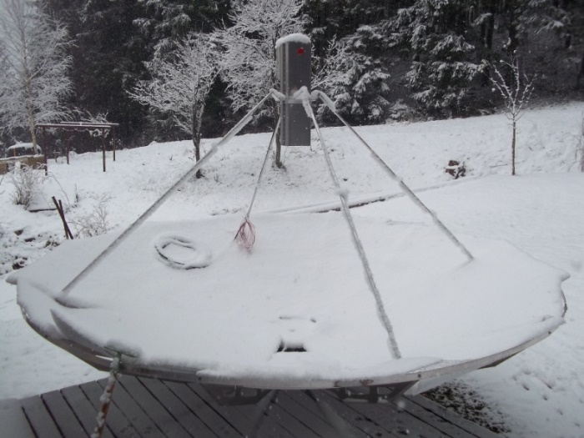
OK2PE’s 3.2 m dish covered in snow during Nov

FOR SALE: JH1KRC is looking for a OM6ATI/OM6AA round septum feed for 1296. If have one available contact Mike at jh1krc(x)syd.odn.ne.jp. N2IQ has for sale his 28’ Kennedy dish in amazing condition. It is almost turn key and comes with precision (Lockheed Martin) AZ/EL mount with encoders, back frame, counter weights, 20’ Rhon 80 tower, original feed poles and feed ring. Also, VE4MA feed horn and VE1ALQ tracking package. Mark will see to all crane work and dismantling and possibly transport to new owner. Price open but not cheap! He also has a KB2AH 23 cm Thompson 328 amp for sale with HV supply. If interested
contact Mark at marknationalaudio(x)gmail.com or tel 315-491-0678. DJ5BV Gerd has for sale his Commercial Plisch TV Linear SSPA ULE 1012A with 0.1 W in for >> 1 kW out, including the PS 32V/80A, liquit-cooling unit, optional air-cooler, technical documentation. NO shipment pick-up only in JO30KI! - eBay #174478891842 and a 432 hi-power 4-way splitter - eBay #174478886293. W2HRO has for sale 1.8 m fabric dishes that folds into a very compact package that is great for portable EME on 1296 and higher bands. Paul also has 3D printed patch feeds for use with his dishes and other light dishes. If interested contact him at w2hro.fn20(x)gmail.com. OM4CW at vh(x)kenwood.sk should be contacted if you need more power on 70 cm. Also see http://vhelectronics.sk/index.php/en/special-offer/big-tajfun-1000-432-mhz-detail. Vlado also sells 1 kW pallets.
An alternative solution from a UK company can be seen at
https://thedxshop.com/product/gemini-70-1k-900w-432mhz-solid-state-linear-amplifier/. OK1TEH: has still for sale a 3 m solid dish with massive ribs that is usable for EME on 24 GHz. Any offer will be considered. For more info see ok1tehlist(x)seznam.cz.

RADIOASTRONOMY CORNER BY OK1TEH:

EME at Green Bank: W4DZC reports that folks in Green Bank have installed a 13.9 GHz radar transmitter on the Green Bank Telescope (GBT) and ran some EME CW tests. If anyone has the capability to receive signals at 13.9 GHz, Contact Rich (W4DZC). They are interested signal reports.

NASA reports contacts Voyager 2 at 11.6 Billion miles from Earth using its upgraded deep space station! For details see https://scitechdaily.com/nasa-contacts-voyager-2-11-6-billion-miles-from-earth-using-upgraded-deep-space-station/.

SETI: Alberto (no call) albertocaballerodiez(x)gmail.com writes: I have been recently coordinating more than 30 observatories to look for exoplanets – see https://exoplanetschannel.wixsite.com/home/project, and we were able to find some new exoplanet candidates: https://www.universetoday.com/147231/saturn-sized-planet-found-in-the-habitable-zone-of-another-star-the-first-planet-completely-discovered-by-amateur astronomers/. Now I have the intention to do the same, but looking for radio signals of possible extraterrestrial origin. I'm aware that the SETI League has over 100 stations, but I believe most of them aren't being coordinated or even active at the moment. [See www.setileague.org]. The project I propose, which I have to write first, would be to conduct a search on very specific stars. Basically, all the observatories would 'listen' to one a star at a time, 24/7. Of course, several observatories would be needed, so each one only observes a few hours per week. I am looking for radio amateurs willing to join us?

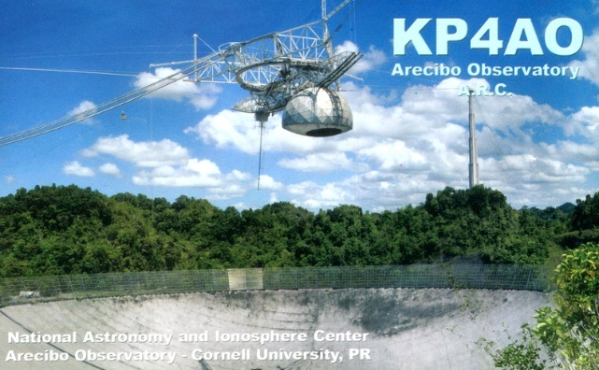

FAREWELL ARECIBO! On 1 Dec the Arecibo Observatory collapsed following its decommissioning by the National Science Foundation the previous month. No injuries were reported. While Arecibo was the most famous and iconic radio telescope in the world, I believe it deserves a small necrology at our astro-section too.
The Arecibo history: In Puerto Rico near Arecibo, until recently, stood the second largest radio telescope on Earth, which was called "El Radar" by the locals and was built in 1960-63. The Arecibo Observatory was part of the National Astronomy and Ionosphere Center (NAIC), and the National Research Center operated with Cornell University in collaboration with and under contract with the National Science Foundation (NSF). It was a spherical (not parabolic) reflector with a diameter of 305 m, built about 20 km south of Arecibo in a natural depression in the mountains. The mirror was spherical, similar to the popular Schmidt-Cassegrain optical telescopes. At such a type of telescopes is often used a "corrector plate”. The corrector plate is a sheet of plastic whose thickness is varied to compensate for the error in path lengths caused by the spherical curve and make the total path length of all rays identical. As the Arecibo radiotelescope had a spherical reflector 305 m in diameter, making a long focal length was impractical. The focus of a spherical reflector is an axial line rather than a point, so special feeds are required; depending on frequency, either a line feed or a specially-shaped subreflector. I mention this because not everyone realizes that it is not easy to irradiate such a mirror properly, and therefore signals from the past transmitted from Arecibo to 144 via EME have been relatively weak compared to the ideal 432 antenna feed, which has been optimized for use in planetary radar.
The earthworks had a volume of about 230,000 m³ of soil. The location of the antenna in Puerto Rico was also affected by other causes. The temperature there fluctuates little. It was therefore not necessary to place great demands on the thermal expansion of the materials used. Furthermore, there was a natural valley of suitable shape, hidden between the hills, and thus protected from the winds. The location is far from industrial centers - radio interference is minimal.
The surface of the reflector was made of 40,000 pieces of perforated aluminum panels and steel mesh (mesh size 12 x 12 mm), hung on a rope and switched off to the surface almost exactly a spherical canopy. During the construction, great attention was paid to the quality of the spherical surface of the reflector. In 1973, the mesh surface was improved by added solid panels.

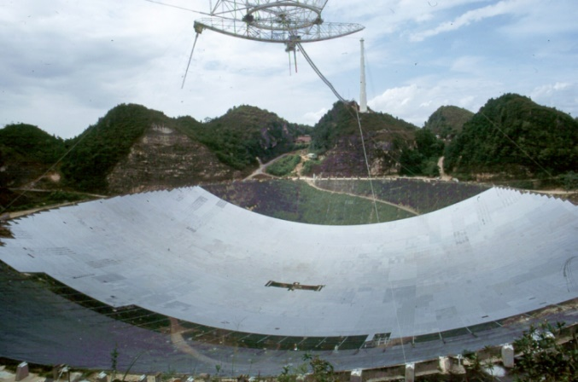
The upgrade of Arecibo surface - 1973
A cable grid was placed on the basic steel frame, which is permanently tensioned every 1.5 m with weights, so that the spherical shape is guaranteed on an area of ​​18.5 acres with an accuracy of ± 2.5 cm. The spherical shape of the reflector was also chosen because with the given method of aiming by the movement of the primary emitter, the largest field of view can be achieved. The diameter of the mirror was 305 m, the radius of curvature 265 m, the mirror occupied an area of 7.5 ha, the gain of the antenna in the 432 band was an incredible 60.2 dBi (58 dBd) and the main lobe had a width of about 0.3 angular degs.
The transmitted RF energy was fed to the reflector and the captured signals were removed from it using a special device located on a 700 tonne platform, suspended at a height of 150 m above the reflector on ropes, which were connected to 3 reinforced concrete towers built in a triangle around the reflector. Each of the towers was located 200 m from the center of the 50 m reflector depression, and its top was 140 m above its upper edge. The aiming was performed by moving the so-called primary radiator on a platform suspended above the reflector. In this way, it was possible to focus on any place in the sky, up to 20˚ from the zenith. In practice, this means that it was possible to communicate by reflection only from those objects that were in the field of view ± 20˚ from the zenith. The radio telescope could thus acquire data from the sky region between about 0 and 38 degrees of declination.
The main purpose of this radio telescope, which was designed as a radar, was to conduct an in-depth survey of the ionosphere and to measure changes in temperature and electron density at altitudes above 50 km. In the early 1960s, radars could only probe the lower layers of the Earth's ionosphere. The study of the ionosphere was therefore the number one task, also because the observation program, especially in the field of ionosphere research, closely touched on the problems associated with the use of intercontinental ballistic missiles and defense against them. Therefore, the entire construction was largely financed by a number of military institutions in the United States, and the actual construction was carried out by engineering units of the US Army. However, it was also planned to capture echoes from the Moon and solar system planets and objects that enter the radar's field of view. Attention was also paid to the research of the Sun's hot gases. Already at that time, the observatory was equipped with a transmitter, which operated on the frequency of 430 MHz and which, during continuous keying, supplied 150 kW to the antenna, in pulse operation up to 2.5 MW. In the early 1970s, a new planetary radar in the 2380 MHz band with the power to produce 1 MW pulses also began to be used.
In 1974, this radar also sent a message to potential alien civilizations in the globular cluster M13, and the radiated power was a fantastic 3 terawatts at 13 cm!
Since the start of operations on 1 Nov 1963, the Arecibo radio telescope has made many important discoveries. As early as 7 Apri 1964, shortly after the observatory opened, Gordon Pettengill's team (who were involved in activating KP4BPZ) determined the exact time of Mercury's rotation, which was not, as previously thought, 88 days, but only 59 days. In 1968, Lovelac discovered the pulsar periodicity in the Crab Nebula (33 ms), the first solid evidence of the existence of neutron stars in space. In the 70's, thanks to the radar in Arecibo (at 420 MHz), the first radar map of the surface of Venus was compiled. In 1974, Russel Hulse and Joe Taylor (K1JT) discovered the first two-star PSR B1913+16 pulsar at Arecibo. These two pulsars are at a distance of 16,000 light-years from Earth and orbit each other once every 7 hours and 45 minutes. K1JT and Hulse found that the two stars approached by three millimeters each other’s orbit. This is a very small distance, but it will increase to meters during the year. Such a reduction in the size of the orbit could already be measured by Arecibo. Their pioneering work showed that the trajectory decreases by exactly the value predicted by Einstein's general theory of relativity when considering the energy carried by gravitational waves. For this result, Joe K1JT and Holse received the 1993 Nobel Prize in Physics.
In addition to the discovery of super-fast-rotating pulsars and even a system of 3 rotating neutron stars in 1990, Arecibo also provided the first radar images of an asteroid in history: 4789 Castalia [1989], and in Jan 2008 spectroscopic detection discovered prebiotic molecules in the Arp 200 galaxy.

Arecibo and ham radio: From the point of view of amateur radio, the decisive historical date was 13 June 1964. This was the first time that EME was attempted with large professional radio telescope, in which amateur radio was primarily involved. Under the KP4BPZ callsign, the 305 m radio telescope in Arecibo was used on 144 and 432. The event had a huge response, as dozens of contacts around the world were successfully made, especially at 70 cm. In 1964 and 1965, Arecibo worked at 70 cm with 4 W at the feed by telegraphy and SSB.

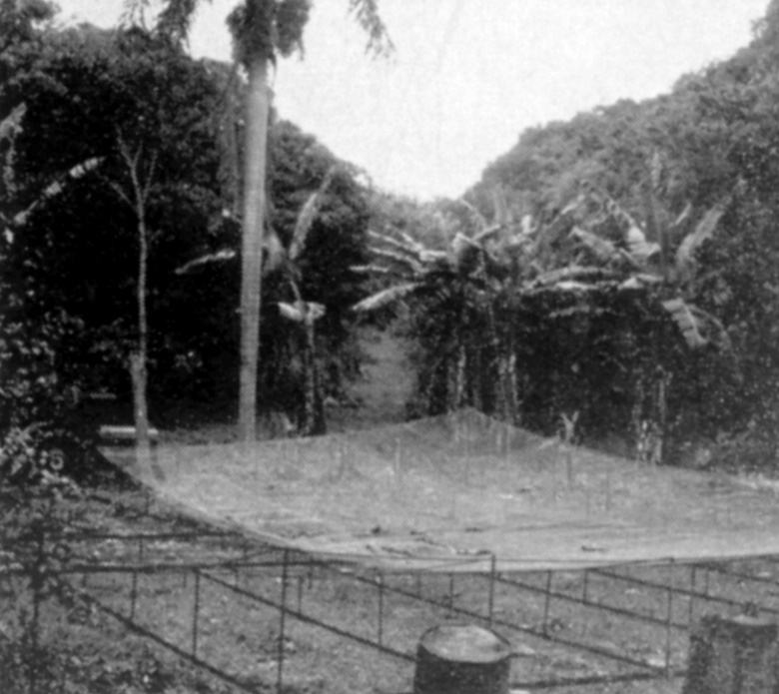
In 1968 W1FZJ/KP4 made a 50’ [15.2 m] square dish for 432 EME tests. The dish was later planned to be expanded to 150’ for use on 144. A movable feed was to be mounted atop a 60’ tower in the center of the dish. Unfortunately, Sam never finished the bigger version due to his illness and passing.
We must remember Sam Harris, W1FZJ. It was no accident that Sam was tapped for an important role in the operation of KP4BZP. Characteristically, it was not long before “a smaller 45,7 m version” of this great array began to take shape over the garden that Helen, W1HOY, had started in their backyard in Arecibo. That it never quite reached the heights of many previous Harris giant EME antenna ventures was due to long illness, which resulted in his death in 1978. However, it was probably the most daring EME project of all times for a single person, hats off!
After Sam’s passing, the Arecibo radio telescope was then activated only three times. The first time after 1965, was on 7 Nov 1982, when during the ARRL EME contest without prior announcement; NP4B went on 432 and then established a total of 13 QSOs with 3 W. Then Arecibo was activated again during the ARRL EME Contest in 1987 under the call KP4I and was again worked on 70 cm, power 10 W. Many heard KP4I so loudly at the time that they considered it a local tropo station. At that time, DK5AI even heard KP4I for 35 minutes after his moonset. In total, KP4I managed to establish 82 QSOs without prior notification of activity.
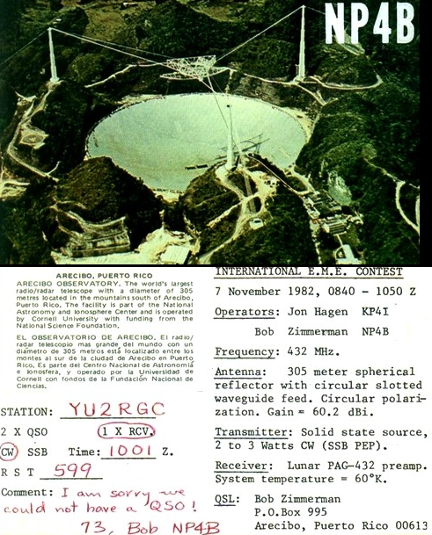

Arecibo was next activated in 2010 under the leadership K1JT. This activity was the most successful event and the KP4AO team made over 240 QSOs. This excellent event is well described at https://physics.princeton.edu/pulsar/ K1JT/Moonbounce_at_Arecibo.pdf and http://www.ntms. org/eme/presentations/VE4MA/EME_2010_Dallas_K1JT_2.pdf
In the following years, other planned EME expeditions were announced, but unfortunately these plans came to an end with the collapse of the poorly maintained rope structure and the subsequent fall of the feed platform to the surface of the mirror.

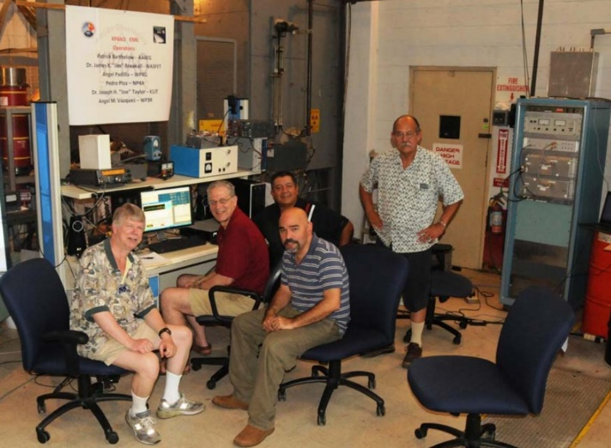
KP4AO 2010: The tired but happy operators are (left to right) WA3FET, K1JT, WP4G in front of WP3R, and NP4A. AA6EG was behind the camera.

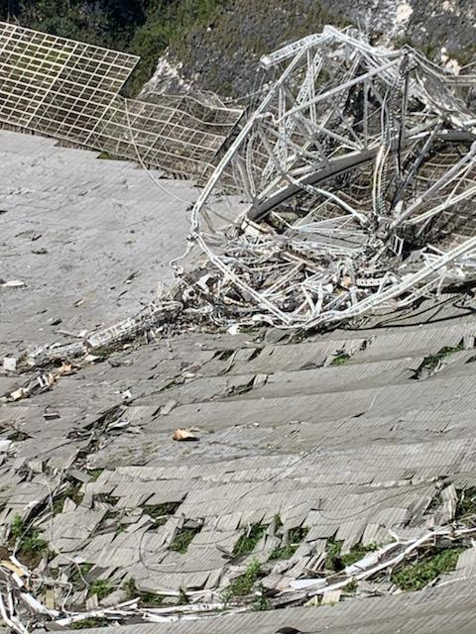
Collapsed Arecibo - credits: https://www.nsf.gov

The king is dead, long live the king(?)
Let us hope that in the future politicians will find the courage to finance the construction of a new telescope at the same place. Arecibo was irreplaceable, especially for planetary radiolocation for mapping of dangerous Earth near asteroids, and this function cannot be replaced even by the larger Chinese radio telescope FAST, which is used only for reception. RIP dear “El Radar!

See also https://petitions.whitehouse.gov/petition/rebuild-arecibo-observatory.
TECH: W2LPL asks have you tried calibrating your rig with WSJT-X? I ran the WSJT calibration option using WWV at 20 MHz and sure enough, it showed I was off 32.07 Hz ( 1.6 ppm). This correction works out to 2,078 Hz at 1296, which is about what I have been having to set my RIT to find anyone. I added the 1.6 ppm to the slope in the Settings and now of course WSJT-X automatically compensates.

FINAL: This month we have DL7APV’s Moon Calendar at the end of this NL. Much TNX Bernd.

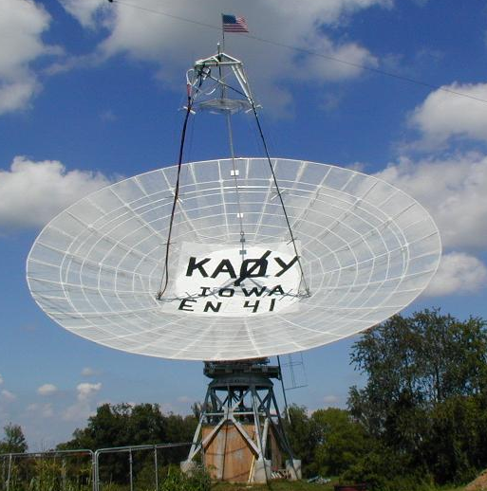
KA0Y’s 50’ dish
► We regret to have to inform you that another EME pioneer, KA0Y has recently become a SK. Ken is probably best known for his 50’ dish, which he operated from his Iowa QTH. He had WAC on 2, 432 and 1296 and WAS on 6, 2, 222 and 432 among numerous other ham radio awards. Ken was not very active in recent years, but will be greatly missed my many of us

► Please, please, please--send K1DS a holiday gift of your ARRL EME Contest log. It would be terrific to have everyone submit. I know there are a few QRO stations that are not yet in and hope they will make their submissions soon. Even if you have a small log, participation counts. [Check logs are appreciated too]. I have even helped an op with just 1 QSO to submit. For all of you who have already submitted, you have my thanks. I have assisted quite a few stations in converting their logs to Cabrillo format and submitting, so if there is any problem, I can assist.

► G4RGK asks everyone who operates CW/SSB to get their updated standings for his CW/SSB Initials lists to him as soon as possible. Dave zen70432(x)zen.co.uk will be doing the last update of 2020 in the next few weeks – see Dave’s report.

► We wish to all NL readers and their families and friends Merry Christmas, Happy Holidays (Hanukkah or whatever you celebrate) and all the best of DX for the New year; may 2021 be a better one! 73, Al – K2UYH and Matej – OK1TEH

PS: Don’t forget on 23/24 Jan the DUBUS 13 cm CW Contest, and on the following weekend of 30/31 Jan the SSB Funtest on 23 and 13 cm respectively.
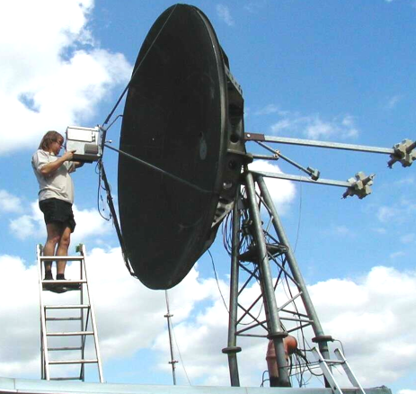
OK1UWA setting up for 24 GHz EME

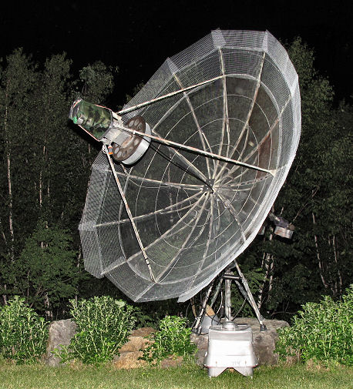
KA1GT’s 3.15 m dish (expanded from 2.4 m) with around 240 W at the feed used in the EME contest

Lunar weekend calendar 2021
Compiled by DL7APV

2400_Sat/ 0000 Sun | Decl/° | Loss/  dB | Sun offset/° | Temp  432/K | contest dates & meetings | Comments
Jan 02/03 | +15,7 | -0,9 | 130 | 20 |  | Night
Jan 09/10 | -21,1 | -0,2 | 44 | 50 |  | Day AM
Jan 16/17 | -11,8 | -1,3 | -50 | 25 |  | Day PM
Jan 23/24 | +20,1 | -1,7 | -123 | 40 | DUBUS/REF CW 13cm  ATP 13-15 & 21:30-23:30 | Day PM
Jan 30/31 | +12,1 | -0,5 | 148 | 20 | SSB FUN contest Sat 23cm/Sun 13cm | Night
Feb 06/07 | -23,5 | -0,4 | 61 | 120 |  | Day AM
Feb 13/14 | -8,6 | -1,4 | -30 | 25 |  | Sun close
Feb 20/21 | +21,9 | -1,7 | -103 | 40 | DUBUS/REF CW 2m/70cm | Day PM
Feb 27/28 | +8,5 | -0,3 | 167 | 20 |  | Night
Mar 06/07 | -25,3 | -0,6 | 76 | 240 | Eu VHF/UHF Tropo | Day AM
Mar 13/14 | -5,0 | -1,6 | -10 | 25 |  | Sun close
Mar 20/21 | +23,5 | -1,7 | -84 | 40 | DUBUS/REF CW 9cm  ATP 10-12& 19:30-21:30 | Day PM
Mar 27/28 | +5,1 | -0,1 | -173 | 25 |  | Night
Apr 03/04 | -26,2 | -0,5 | 92 | 140 |  | Day AM
Apr 10/11 | -1,3 | -1,7 | 9 | 25 |  | Sun noise
Apr 17/18 | +24,5 | -1,7 | -66 | 40 | DUBUS/REF CW 3cm  ATP 8:30-10:30 & 18:30-20:30 | Day PM
Apr 24/25 | +1,7 | -0,0 | -153 | 30 | ARI spring contest | Night
May 01/02 | -26,1 | -0,5 | 109 | 50 | Eu VHF/UHF Tropo | Day AM
May 08/09 | +2,5 | -1,8 | 29 | 30 |  | Sun close
May 15/16 | +24,8 | -1,7 | -49 | 35 | DUBUS/REF CW 23cm  ATP 8-10 & 17-19 | Day PM
May 22/23 | -2,0 | -0,1 | -133 | 30 | Dayton (Xenia) HAMvention | Day PM
May 29/30 | -25,3 | -0,4 | 127 | 35 |  | Day AM
June 05/06 | +6,3 | -1,9 | 48 | 30 | EU 23&up Tropo | Day AM
June 12/13 | +24,3 | -1,6 | -31 | 30 | DUBUS/REF CW 6cm  ARRL VHF Tropo  ATP 6:30-8:30 & 15:30-17:30 | Day PM
June 19/20 | -6,0 | -0,3 | -114 | 25 |  | Day PM
June 26/27 | -23,9 | -0,3 | 146 | 30 | HAM Radio | Night
July 03/04 | +9,9 | -1,9 | 68 | 30 | Eu VHF/UHF Tropo | Day AM
July 10/11 | +23,1 | -1,4 | -14 | 20 | ATP 5:30-7:30 & 14:30-16:30 | Sun close
July 17/18 | -10,4 | -0,4 | -96 | 30 | CQ WW VHF  ES-Tropo | Day PM
July 24/25 | -22,0 | -0,5 | 165 | 30 |  | Night
Aug 00/01 | +13,3 | -1,8 | 88 | 35 | ARRL UHF Tropo  ATP 3:30-5:30 & 23:00-1:00 | Day AM
Aug 07/08 | +21,4 | -1,2 | 4 | 20 |  | Sun noise
Aug 14/15 | -14,8 | -0,4 | -79 | 35 |  | Day PM
Aug 21/22 | -19,4 | -0,7 | -176 | 25 | 19th EME Conference Praha | Night
Aug 28/29 | +16,4 | -1,8 | 108 | 35 |  | Day AM
Sept 04/05 | +19,4 | -1,1 | 23 | 15 | Eu VHF Tropo | Sun close
Sept 11/12 | -18,8 | -0,3 | -62 | 40 | ARRL VHF Tropo | Day PM
Sept 18/19 | -16,3 | -0,9 | -158 | 25 |  | Night
Sept 25/26 | +19,2 | -1,9 | 127 | 35 | ARI Autumn contest | Day AM
Oct 02/03 | +17,0 | -1,0 | 43 | 20 | Eu UHF Tropo | Day AM
Oct 09/10 | -22,0 | -0,1 | -44 | 45 |  | Day PM
Oct 16/17 | -12,7 | -1,2 | -139 | 25 |  | Night
Oct 23/24 | +21,7 | -1,9 | 147 | 35 | ARRL 1st leg | Night
Oct 30/31 | +14,5 | -1,0 | 62 | 20 |  | Day AM
Nov 06/07 | -24,2 | +0,2 | -27 | 100 | Eu VHF CW Tropo | Sun close
Nov 13/14 | -8,6 | -1,3 | -121 | 25 |  | Day PM
Nov 20/21 | +23,7 | -2,0 | 165 | 45 | ARRL 2nd leg | Night
Nov 27/28 | +11,3 | -1,1 | 82 | 20 |  | Day AM
Dec 04/05 | -25,6 | +0,3 | -8 | 180 |  | Sun noise
Dec 11/12 | -4,5 | -1,3 | -102 | 25 |  | Day PM
Dec 18/19 | +25,0 | -1,9 | -177 | 45 | ARRL 3rd leg | Night
Dec 25/26 | +7,4 | -1,1 | 101 | 20 | Xmas & HNY | Day AM

