432 AND ABOVE EME NEWS
FEBRUARY 2015 VOL 43 #2

EDITOR: AL KATZ, K2UYH; DEPT. ELECTRICAL/COMPUTER ENGINEERING, THE COLLEGE OF NEW JERSEY, PO BOX 7718 EWING, NJ 08628, TEL (W 609-584-8424) OR (H 609-443-3184), FAX (609-631-0177), E-MAIL alkatz(x)tcnj.edu
NETNEWS EDITOR (based Reflector News) REIN, W6SZ pa0zn(x)arrl.net WITH HELP OF N4PZ AND WB2BYP
INITIAL LIST G4RGK, DAVID DIBLEY, E-MAIL zen70432(x)zen.co.uk, AT: http://www.zen70432.zen.co.uk/Initials/index.html
EME INFORMAL NETS: 14.345, ~1500 SATURDAY AND SUNDAY, NET COORDINATOR: Steve Gross, N4PZ n4pz(x)live.com
ON0EME EME BEACON, 1296.000 IS QRV WHEN MOON >10°, SEND RX REPORTS TO WALTER (ON4BCB) on4bcb(x)gmail.com
DL0SHF 3 CM EME BEACON, 10368.025, SEND INFO & QUESTIONS TO Per (DK7LJ) per(x)per-dudek.de.
NL EMAIL DISTRIBUTION and EMAIL LIST CORD: WARREN, W2WD wbutler(x)ieee.org [TXT OR PDF OR "ON WEB" NOTICE]
THE NL WEB VERSION IS PRODUCED BY REIN, W6SZ AND AVAILABLE AT http://www.nitehawk.com/rasmit/em70cm.html

CONDITIONS: The pace has slowed a bit this month. On 70 cm, there was the IA0C dxpedition and A65B coming on from UAR to generate some excitement. Coming up is the DUBUS 70 cm EME CW/SSB Contest on 31 Jan/1 Feb, and the 432 EME SSB Funtest intentionally overlapping on Sunday 1 Feb - see the SSB Funtest rules in the last newsletter (NL). A little further out is the 1296 EME SSB Funtest on 22 Feb. This same weekend is Svalbard Island (JW) dxpedition on 22 to 24 Feb. Bodo is now being joined by DL2NUD to expand the scope of this dxpedition to include 23, 13 and 9 cm EME. The dxpedition details are in this NL. The next 70 cm CW activity time period (ATP) is not until 28 Feb 2300-0100 and 1 March 1400-1600. This same weekend is the DUBUS 13 cm CW EME Contest. There should also be some EME activity during the ARRL’s VHF Tropo Contest on 24/25 Jan – see K5QE’s report. Plans for a dxpedition to 7Q7EME in May have also been announced.

1A0C: Rene (PE1L) hasperrene(x)gmail.com and DL8YHR were QRV on 432 from the Sovran Military Order Malta (JN61) on 31 Dec with a 12 el xpol DF7KF yagi with a good signal. They QSO’d on 432 DK3WG, DL7APV, DL9KR, HB9Q, K2UYH, NC1I, OK1DFC, OK1KIR, OZ4MM, UA3PTW, UT5DL, UX0FF and WA4NJP. More info can be found at http://emelogger.com/1a/ index.html.

DK7JL: Per per(x)per-dudek.de reports that the 3 cm EME Beacon was off the air for a day or 2 around 10 Jan because of heavy snow. Despite the winter, WX the beacon has remain operational most days.

DK3WG: Jurg dk3wg(x)web.de reports on his recent EME activity – During Dec, I added on 432 CW I2FHW and DL6KAI and on SSB PA8A (from PI9CAM). I was also on JT65B and worked KJ7OG, EA1PVC, W5LUA, A65BR for DXCC* 116 and 1A0C for DXCC 117. On 1296 with my modest station, I QSO’d on JT65C OH2CG for DXCC* 30 [I thought this might be a typo for OH2DG, but to my knowledge Eino has not been on 23 cm JT], OK2DL, YL2GD, LZ1DX DXCC 31 and OZ4MM.

G3LTF: Peter’s pkb100(x)btinternet.com Jan EME report – There is very little to report this month as the weather has not been good with strong winds on many days, and thus little Moon time. I worked on 1296, on 30 Dec ES6RQ and G4IDR to bring me to CW initial #400, followed by SP6ITF, G4CCH on SSB and VE6TA, and on 2 Jan ON5GS, LZ1DX, I5YDI, and SP6ITF. I came on 432, 4 Jan for the CW ATP at about 1600 but found I had water in my TX feeder junction, so I could not transmit, but I did copy OH2DG with good signals. I plan to be active for the 70 cm DUBUS CW EME Contest and the SSB Funtest. Let’s hope for calm weather.

G4RGK: Dave zen70432(x)zen.co.uk sends news on his activity over the last few months -- I was on for both legs of the ARRL EME Contest as usual and worked a total of 96 stations. In the first leg, I stayed on 70 cm and finishing up with 38 QSOs, mainly on JT. There seemed to be little chance of finding the few CW stations that are left. I called CQ on CW for a couple of hours with few replies. During the 2nd weekend I was on 23 cm, mainly on CW. The activity there was good and a number of new stations were worked. For once everything worked OK and both weekends were relatively trouble free.

IK5QLO: Andrea ik5qlo(x)gmail.com sends some notes for the bulletin -- I was able to be QRV for only 3 hours in the 2nd leg of the ARRL contest and worked 22 stations with 17 on JT and 5 on CW. I finally have switched to SDR with a brand new Italian made FDM-DUO Rtx by ELAD plus my DB6NT 13G2-28 kit (with external OXCO) transverter. SDR really opens new horizons to the activity. On the first day I had to solve a strange problem, which puzzled me. The transverter worked flawlessly on the bench, but, when I mounted it at the dish, it showed a strange drift
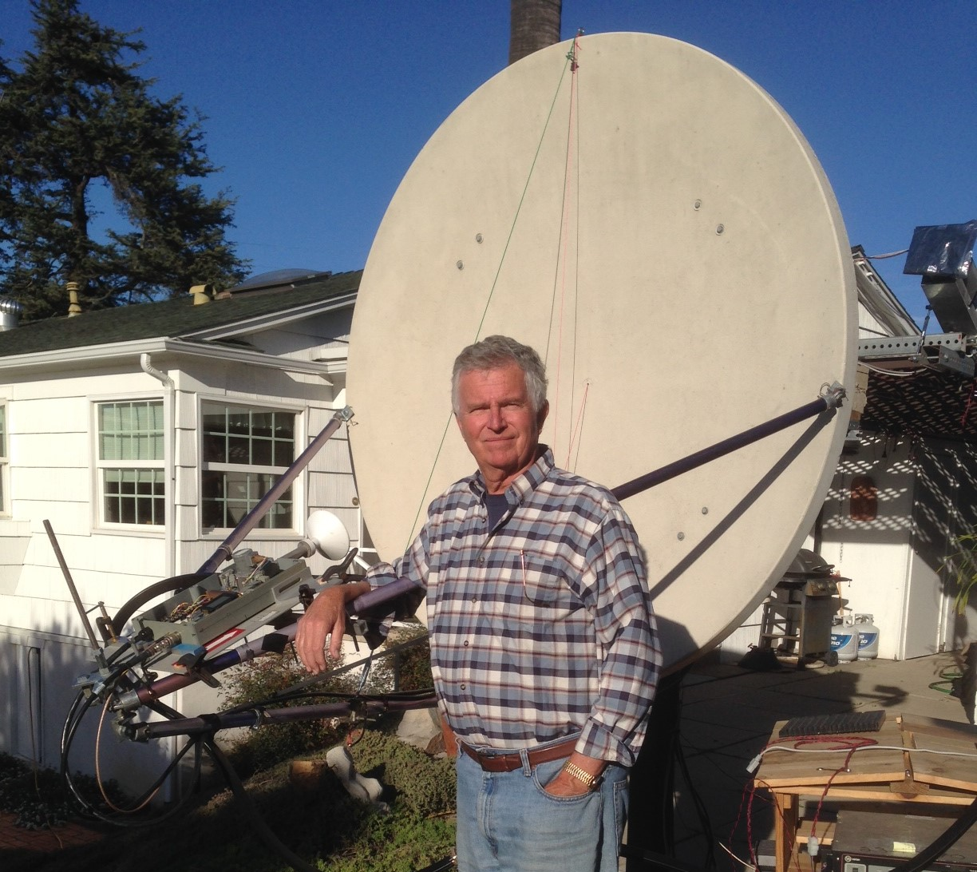
K6QVP is new station on 3 cm – see report on page 2

when TXing. The amount of drift was proportional to the power output, so I thought of RF feedback to the OCXO or the TRV itself. I brought the transverter back to the shack leaving the Interdigital filter on the input of the driver inside the box, and I still had this drift plus the PA/driver was producing a certain amount of RF without driving! It trned out that the problem was the Interdigital filter, an unusual type made with a square tube with its sides open. I bought it some years ago from a German firm. The filter was picking up RF from it’s open ends that was being amplified by the following two stage driver and PA to produce an oscillator! I moved the filter back to the shack, far from the dish, and the drift disappeared.

JA4BLC: Yoshiro ja4blc(x)web-sanin.co.jp sends news on the first QSO in the new JA EME sub-band – Shortly after the new 13 cm frequency assignment from 2400 to 2405 was released on 5 Jan, I tuned my PA to 2400 and was pleased to get 250 W. On 8 Jan, JA6CZD and I finished an easy QSO (549/559) on 2400.1. JA6CZD used his 2.4 m offset dish and 200 W. The Wifi QRM was very small. We hope that 13 cm operators who suffered from QRM on 2424 will now listen us on 2400.

JW/DF8DX: Bodo (DF8DX) df8dx(x)gmx.de has now teamed up with Herman (DL2NUD) to put Svalbard Island on 13 and 9 cm as well as 23 cm -- On 1296 we will use the call JW/DF8DX, and on 13 and 9 cm we will use JW/DL2NUD. Our locator is JQ78QF. We will call with JT65C first and ALWAYS listen on our own echo frequency. If we have speaker copy, you may also work us on CW. Priority will be given to working new stations. So, as long as we are still working new stations in JT65, we will not QSY to CW. If we call CQ and nobody answers, you may call us on CW and we will be more than happy to work you again. Our equipment will be pretty much the same as Herman used from PZ; a 1.5 m dish with 175 W on 23 cm, 300 W on 13 cm and 60 W on 9 cm. We will have Internet to check mail from time to time, but will most probably not be online all the time while operating. Our schedule will be 21 Feb 1100-1400 on 1296.090, 22 Feb 1100-1300 on 2320.100 and 1500-1700 on 2320.100 but with RX on 2304.100, 23 Feb 1130-1300 and 1700-1800 on 3400.100, and 24 Feb 1200-1400 and 1700-1900 1296.090. If you have questions, email me. [SM2BYA put the big radio astronomy dish on Svalbard Island on 432 EME back in Oct 2003. See the Dec 2003 NL for more details].
K5QE: Marshall k5qe(x)k5qe.com reminds us to check the Moon during the weekend of 24/25 Jan for stations looking EME QSOs during the ARRL’s Jan VHF Contest -- Hello to everyone on 432 EME. Once again the K5QE contest station will be looking for 432 EME contacts in the ARRL Jan contest. Our moonrise is 1700 on Sunday 25 Jan. We will operate on 432.070 second sequence. I know that EU tropo contests don't allow EME contacts in their contests, but in the ARRL VHF/UHF contests, they work just fine. Please help us with our contest totals by working us on 432. We run 16 x 28 el yagis all H-pol with about 600 W output.

K6QPV: Greg gbailey(x)mail.sdsu.edu is a new 3 cm EME station from San Diego (DM12mq) – I recently made my first 10 GHz EME QSO with W5LUA. I have a 1.8 m offset dish and a Varian TWTA with 40 W at the horn, and a Nova tracking system. I am not new to the microwaves, only to EME. The majority of my amateur interest has been above 23 cm. I operate the beacons on Mt Miguel that serve the Los Angeles and San Diego area on 23, 9, 6, and 3 cm and a member of the SBMS for many years. Please email me for 3 cm EME schedules.

NC1I: Frank frank(x)NC1I.COM had WX problems but affected his antennas, but remains QRV on 432 and 1296 -- My 23 cm azimuth is now working again, so I am back on that band. Unfortunately we were not able to repair the 70 cm polarity and now expect it will be late spring at the earliest before it's repaired. The 70 cm station is otherwise working fine, but I do not have any polarity rotation. There will be little activity from my station for the next several months due to schedule conflicts. Unfortunately the station will not be active during the upcoming Dubus 432 event. That is very disappointing. W1QA had follow up surgery on his broken leg (a plate and screws put in) and more recently has been back in the hospital with blood clots in the leg. Based on these health issues, it will probably be a couple of months before he can travel to my QTH to activate the station. Stations worked on 70 cm since my last report are on 28 Dec at 1725 PA2V (7DB/24DB), 1935 OK1TEH (13DB/18DB) and 1944 LU8ENU (12DB/10DB), on 29 Dec at 2200 VA3ELE (21DB/14DB) and 2207 OK1DFC (0DB/3DB!), on 30 Dec at 0329 KB7F (11DB/O) and 0335 W1AW/3 (9DB/7DB), on 31 Dec at 2047 A65BR (23DB/22DB) and 2058 1A0C (23DB/17DB) – these 2 QSOs made my New Year's Eve!!, on 1 Jan at 2004 G6HKS (29DB/14DB) and 2129 A65BR (22DB/21DB), and on 3 Jan at 0311 W7AMI (7DB/11DB), 0332 K2GAB (569/559) on CW, 0447 DL8DAU (12DB/16DB), 0538 KB7F (13DB/O), 0625 VA3ELE (O/O) on CW, 0708 VK4EME (10DB/8DB) and 0728 VK4EME (559/559) on CW. All QSOs were on JT65B unless noted as CW. After getting the 23 cm azimuth working again on 6 Jan, I worked at 0152 UA4HTS (559/589) on CW. It was a nice surprise to find Toly active at that time.

OE5JFL: Hannes’ oe5jfl(x)aon.at ARRL Contest report follows [It arrived late due to problems with my email address] -- In the ARRL EME Contest I was again lucky with good weather and no equipment failures in both parts. I was QRV on 23 cm CW and worked (106x44) of 466,400 - [Third highest reported score!]. I did not use JT65 or any logger. In the Nov part I worked 77, DL3EBJ, OK1CS, SP6ITF, DL6SH, PA3FXB, DG5CST, I1NDP, WA9FWD, G3LTF, EA3UM, OK1DFC, OK1YK for initial #368, K9KFR #369, OZ6OL, NC1I, K1JT, 9A5AA, SP6JLW, SP3XBO, W7JM #370, I5YDI, G4CCH, YL2GD, VE4SA, I5MPK, F5SE/p, SM3AKW, RA3EC, W6YX, WA6PY, OK2DL, SV3AAF, N0OY, W4OP, VA7MM, TI2AEB, WA8RJF, CT1DMK, KL6M, ON5TA, IK3COJ, JA1WQF, UA3PTW, IK6EIW, S53MM, VK2JDS, RN3DKE #371, VK5MC, PA3DZL, OK2ULQ, SM4IVE, DF3RU, VK4CDI #372, DL4DTU, PA3CQE, OK1CA, IZ1BPN, UA4AAV, IW2FZR, HB9Q, JA8IAD, SP7DCS, DJ8FR, PA0BAT, IK5VLS, PI9CM, G4BRK #373, W1AIM, K1DS, OZ4MM, ON5GS, VE3KRP, VE4MA/K7, JA8ERE, JA6AHB, IZ2DJP and JR4AEP. In Dec I worked G4RGK, OK1KIR, WA2FGK, N4PZ, VE6TA, LU1C, UA4HTS, W5LUA, VE6BGT, K6JEY, RA3AUB, N8CQ, SM2CEW, JH3EAO, SP4MPB, SM3JQU, PI9CAM, YO2BCT, JA4LJB, ES5PC, ON5RR, JA4BLC, IK3GHY, DK0ZAB, LX1DB, W3HMS, WD5AGO, PA2DW and IK5QLO. Heard were JA6XED, UA9YLU, K7XQ and HB9BCD. The station was my HB 7.3 m offset dish and 500 W SSPA.

OK1DFC: Zdenek ok1dfc(x)seznam.cz continues to close in on 432 WAS -- I would like thank KF8MY for giving me state 38 (Michigan) on 432. I am now trying to get someone on from Missouri. Unfortunately many hams who were QRV on 432 EME before have lost their antennas due to storms or are not active now on 432. Any help is appreciated.

OK1KIR: Vlada and Tonda report on their club’s early Jan QSOs – On 70 cm, we were QRV on 2 Jan for a postponed sked with VK5APN. Unfortunately, he did not appear as there was a terrible bush fire in the southern Australia that was approaching his home and he had to evacuate. We have had no news about him since then. We did QSO with JT65B at 1419 DL8DAU (15DB/O) for digital initial {#121} and 1610 ZS6JON (15DB/O) {#122}, 1624 A65BR (28DB/24DB) {#123} LL field and a new DXCC - pol TX vert/RX hor, 1845 UT5DL (14DB/15DB), 2100 GW3XYW (16DB/O), 2128 LU8ENU (23DB/23DB), 2245 G6KSH (21DB/21DB) {#124} and 2317 VA3ELE (23DB/15DB) {#125). On 9 cm, we worked on 3 Jan in a CW sked at 0048 VE4MA/W7 (O/O) for initial #57 and AZ state, followed by an easy JT65C QSO at 0059 VE4MA/W7 (18DB/14DB) for digital initial {# 6}. Barry used 95 W into only 1.5 m offset dish and was observing 11.8 dB of Sun noise. We are looking for QSL cards for our first 9 cm QSOs RW1AW, LA8LF and KL6M.

OK1TEH: Matej’s xpetrzilka(x)fd.cvut.cz end of year contest report follows [also arrived late because of my email problems] -- I'm still QRV on 432 with a single 23 el DK7ZB yagi, about 600 W at the dipole and a masthead LNA. During 2014 I made 38 QSOs and added 8 initials to bring my mixed total to #95*. New ones were I5CTE (24DB), OK1CA CW, UT5DL (26DB), YL2GD (29DB), DL8GP (25DB), Z21EME (28DB) (1Y-1Y), W5LUA (28DB) and PA2V (26DB). In ARRL contest I was QRV during both legs and I worked 18 QSOs for 25,200 points in the 432 All mode Category. My last QSO of 2014 was W1AW/3 (20DB) - K3MF has a much better signal from his new QTH. On 23 cm, my new station with a bigger dish is still not ready. I was QRV only during last days in Dec. but added initials with OZ4MM (26DB/17DB), DL6SH (28DB/19DB) and I1NDP (25DB/17DB). I have the LNA in my hamshack with about 2 dB loss between LNA and my small dish (~1 m) feed with about 400 W at the linear ringfeed, which is mainly used for tropo. DL6SH was my mixed initial #15*. I have already been decoded by several 3 m dish stations, so after improving of my RX, more contacts are expected.

OK1YK: Mirek ok1yk(x)VOLNY.cz is a new 23 cm EME station. He has been active since Sept with a 4.5 m HB dish (f/d 0.41) and 140 W at feed. Tracking is controlled by OK2TPQ hardware/software. Mirek reports 2 dB less Sun noise than calculated by the VK3UM calculator. In the ARRL EME Contest he worked 35 stations on CW and JT65C. Mirek has new blog at http://ok1yk.blogspot.cz where you can see photos of his EME station. [TNX OK1TEH for forwarding this report].

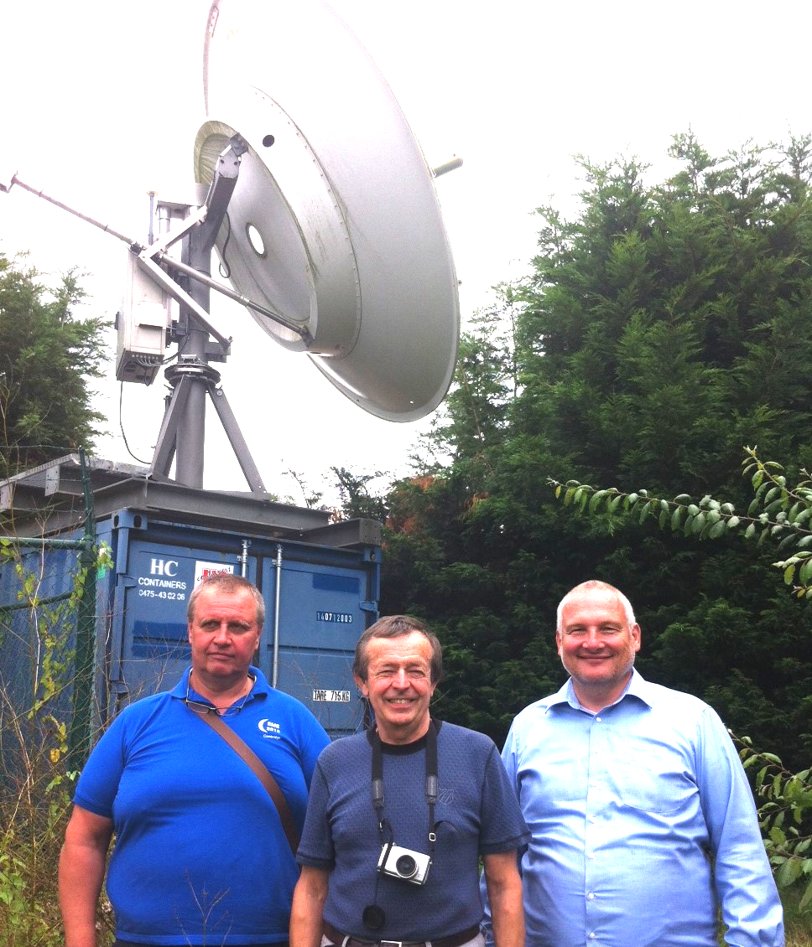
DL6SH, OK1CA and OK1CS visit ON0EME beacon

ON0EME: Eddy ON7UN ejespers(x)telenet.be reports that the 1296 Moon beacon was be out of service for maintenance on 9 Jan at 0600 but was back in service by the next moonpass. The beacon was sown because the electric power company needed to upgrade the electric power connection. They need about 4 hours for the upgrade.
OZ4MM: Stig vestergaard(x)os.dk has a short report this month -- On 432, I added initials with PZ5EME (JT), PA2V (CW), A65BR (JT), DL6KAI (CW), KT1J (JT) and 1A0C (JT). On 1296 I added PZ5UD (JT), DJ2DY (CW) using just 300 W, YL3AEV (JT), ES6FX (JT), EA3HMJ (JT), UA4LCF (JT), PE1CHQ (JT), DK3WG (JT) and OK1TEH (JT). I did not have much EME operating time here. I have to split my time between EME and MTB bicycling racing, which is taking more and more of my days. I am now using too many hours on the road and track, but it keeps me going – Hi. But, I can’t live without moonbounce either; so you do not need to worry about me giving up.

PA2V: Peter peter(x)pa2v.com sends the following copy on recent activities – I was away on holiday at the end of Dec, but before I left on 28 Dec had an easy QSO with NC1I, but then worked OK1TEH in 23 minutes. He was calling me for a long time, and suddenly the rotation went well and I start to see him. His best was (29DB). Matej is my third single yagi station and brings me to mixed initial 61*. Soon after, I worked SP1JNY (27DB) #62* and finally LU8ENU (27DB) #63*. In previous attempts, we were seeing each other many times, but the conditions never made it both ways. LU8ENU (2 Yagi) was also a new DXCC to me. During Jan we have had some awful storms with strong wind, but the array has survived. These have been the first bad weather tests since I put up this 4 stacked array.

PA3FXB: Jan jvm(x)netvisit.nl sends some end of year info -- 2014 was an excellent EME year! I was only QRV 23 cm this year. Changing my system to 13 cm takes a lot of time. Hopefully I will be QRV on 13 cm in 2015. On 23 cm there was a lot going on. Activity on 23 cm is increasing all the time. I added 5 DXCC’s to bring me to DXCC 61. I added 38 initials. My count now stands at [mixed initial] #265*. In the ARRL contest, I had 85 QSOs (mixed mode). This is the best result I have ever had! This year ARI’s JT Marathon was the best I ever had too. I made more than 500 JT QSOs on 23 cm EME - this year Glimlach. My system is still a 3 m dish that I extended to 3.5 m during contests and for dxpeditions with 375 W at an N2UO feed.

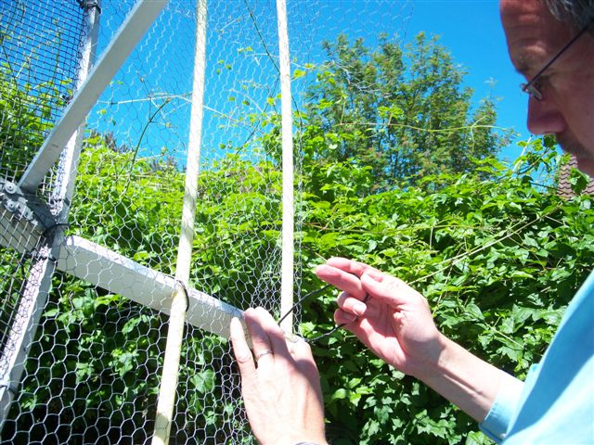
PA3FXB adding 0.5 m extension to his 3 m dish. They are simple to make from wood, PVC electric tubing and mesh, light in weight and effective (~1.4 dB), but fragile so they can only be used when the WX is nice.

RW0LDF: Serge rw0ldf(x)mail.ru is active on 23 cm from one of the most eastern parts of Russia and interested in skeds – Thus far I have worked with JT65C UA4HTS, UA3PTW, JA1WQF. RD3DA, JA6AHB, IK3COJ, G4CCH, DF6RU, ES6FX, DL6SH, PA3FXB, HB9Q, W6YX, VA7MM, PA0BAT, PA3DZL, OK1KIR, DF3RU, OK1DFC, UA4LCF, YL2GD, I5YDI, LZ1DX and G5WQ, on CW G4CCH and on SSB HB9Q. I am the only one working EME on 1296 in the Russian Far East. I use a 1.8 m dish with an RW3AQ feed, HB 6 x RA18H1213G PA with water cooling, DDK LNA (RW3BP modify for 0.145 dB NF), US4ICI ver.1 transverter with TR-751. I use a TV camera for tracking. My EME QTH is in the country about 35 km from my home, so I am pretty much limited to skeds during the weekend.

UA3PTW: Dmitry ua3ptw(x)inbox.ru send word about new stations he QSO’d in Dec. He participated in PA8A’s 432 SSB tests and also added on 432 JT65B KJ7OG, A65BR and 1A0C, and on CW VE6SA. On 1296 he had initials on JT65C with PE2TV, PI9CM and VK2MER. [TNX DK3WG for forwarding this report].
VK7MO: Rex rmoncur(x)bigpond.net.au reports on his side of the 24 GHz EME World Record [see OK1KIR’s report in the last NL] -- On 30 Dec, I operated portable in the south east of Tasmania to work G3WDG and extend the 24 GHz distance record to 17,464 km. We used the JT4f mode. During our previous World Record QSO, we had taken advantage of my operating at height of 1270 m from Mt. Wellington to reduce atmospheric losses. For the new QSO, I operated at only 200 m, and thus we incurred around 2 dB of extra loss. This extra loss was made up by both stations running higher power. We both combined 2 PAs with Magic Tee coupling to produce a near 3 dB increase in power and bring our outputs to abouts 20 W. Just prior to our QSO, I worked OK1KIR to achieve a new ODX for OK of 16,438 km. A more detailed report can be found at http://www.ok2kkw.com/next/vk7mo/24ghz_tests_vk7mo_ok1kir _g3wdg.pdf.

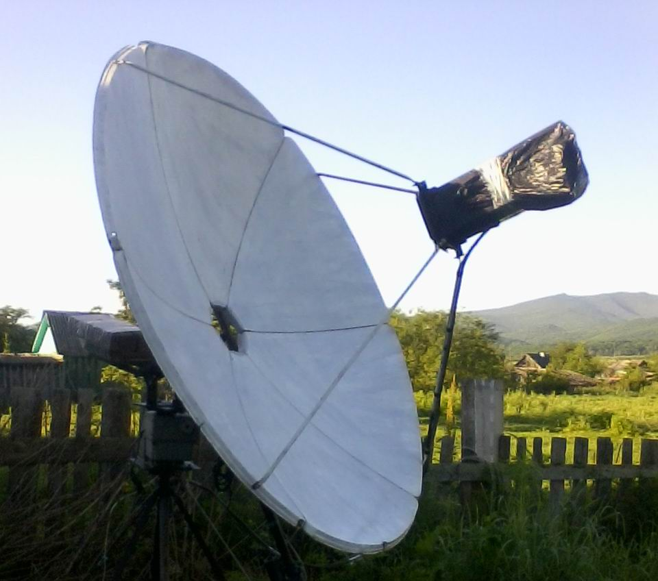
RW0LDF’s 1.8 m dish – onl 23 cm EME in Eastern Russia

W6YX: [John (K2YY) johnhill5000(x)gmail.com is our normally contact, but this report comes by another route] -- We entered the ARRL EME Contest as a multi-operator, multi-band, all mode team. We were QRV on 10368, 1296, 432 and 144. Designing, building and operating 4 EME stations has been a very rewarding challenge. Team participation was the highest ever and included K2YY, KG4UHM, AD6FP, KJ6SDF, W6TCP, K6KLY, KG6NUB, AA6XV, W6LD, KJ6JEX and DL6DR. Non operating contributors were AG6MZ, KJ4QKA, and AA6IW. We thoroughly utilized software defined radios on all bands, using Linrad as our prime software of choice and MAP65 as our wideband JT65 decoder. We always ran WSJT in parallel to MAP65. Our extensive tests have shown WSJT to be the superior decoder, perhaps due to sub optimal phase noise in the 5 different SDR receivers we've tested. Compared to most other entrants, we have limited mutual Moon time with EU, where the bulk of EME stations are located. Relative to a station on the Eastern USA shore, we have 3 hours less Moon time with EU per pass. This 18 hours deficit across all 3 contest weekends, which is a challenge to overcome, even though we don't feel we have the right to complain compared to our friends in the Southern hemisphere, far to the north, and over the Pacific. Time is of the essence for us. We welcome the challenge, as it forces us to work harder, innovate, and stay awake longer to score competitively. Effective software defined radio use was critical to make the most of our EU window, whether we operated a large or small station on the band. On 3 cm, we had 10 contacts. We operated with our new 4.6 m dish. This was its first full contest weekend. VK7MO's tiny 70 cm dish was the fish that got away on this band - mostly due to operator error on our end. It was great to hear that such a small station copied our signal at -12 dB SNR in a 2.5 kHz bandwidth. This was especially exciting considering that our 3 cm station is still far from optimized. Initial draft calculations show a substantial ~5 dB improvement could be obtainable. We were glad to get this station contest ready in time. We're continuing to optimize this station and hope to add receive capability for the Japanese 3 cm band for the DUBUS EME contest in the spring. On 23 cm, 96 contacts were made with our 8 m dish. We were glad to make nearly 100 contacts, being a non-EU 1296 station. We ran Linrad on CW, while it simultaneously fed MAP65 for JT65 decoding. The DIY amplifier we built earlier this year worked great. Linrad proved to be very popular, especially with our Morse code operators. Virtually all of our contacts, regardless of band were made using a software defined radio as the receiver. Linrad v4.03 added a very useful feature, where the user can click on a signal in the baseband waterfall and the software will automatically center it in the CW filter. This is much more intuitive than having to click on the high resolution spectrum for this task as in prior versions. This new feature, plus using the mouse scroll wheel as the VFO knob to fine tune and adjust for Doppler greatly accelerated our search and pounce capability, as well as being able to quickly work through pile ups, especially when stations reply notably far outside of our CW filter's bandwidth. After matter of minutes, CW operators that had never used SDR before were running a pile up, pleased at the features and performance Linrad was providing over our IC-970. The poor IC-970's receiver was likely never used for a QSO. The friendly folks on the Linrad mailing list, https://groups.google. com/forum/?pli=1#!forum/linrad, are a great resource for those wishing to significantly upgrade their station's capability with a software defined radio. It was good to see some of the smaller stations call CQ. A 3 m/150 W class station sticks out like a sore thumb on Linrad's waterfall. It's just a matter of clicking on their trace, pressing the "Q" key to QSY the transmit radio to the proper QRG and make the QSO. The days of laboriously tuning up and down the band have been permanently replaced with point and click efficiency, regardless of mode. The final weekend of the contest resulted in major setbacks. Several times and of course in the middle of a QSO the IC-970 refused to transmit. After some loving taps on the case, it would start functioning properly again. This repair technique did not last long. Around midnight, with the Moon rising in Japan and Australia, we had to stop activity on two bands to cure the intermittent transmit issue. After disassembling and reassembling the IC-970, it started operating again. We were relieved, but noticed in the interim our azimuth drive motor stopped working. Given the time of night and stormy conditions, most would have given up for the night, but giving up is inconsistent with W6YX's reputation in radio contesting. A valiant effort by AD6FP, K2YY and KG6NUB resulted in the heavy azimuth motor being removed, temporarily repaired and reassembled. By 2 PT we were on the air again with our soggy operators making contacts! DK3WG's small yagi setup was the fish that got away on this band, mostly due to operator error on our end. On several instances we had small CW stations calling that were operating HF style and only sending their call sign a few times and seeming to not realize our difficulty copying them. They should send their call for 60-120 seconds nonstop. Stations can even get creative with us in these situations, sending QRSS to 'draw' dots and dashes on our waterfall, or send JT65 on our QRG in reply to a CW CQ, since we're always running MAP65 on all bands. Stations heard on JT65C calling CQ on 1296 were DC9UP, DF3RU, DL6SH, EA1RJ, G4BRK, HB9Q,IK3COJ, JA1WQF, JA6AHB, K1JT, K2UYH [?], K6JEY, LU1C, LU8ENU, OK1DFC, OK2DL, OK2ULQ, ON5TA, PA3DZL, PA3FXB, PY2BS, RA3AUB, RD3DA, RN3DKE, RW0LDF, SQ7D, SV1CAL, UA4HTS, VA7MM, VE3KRP, VE4MA, VK2CBD, VK4CDI, W2LPL, W3HMS, W7UPF, WA2FGK and WA3GFZ. On 70 cm, 15 contacts were made. This exceeded our expectations for a temporarily and far from optimized 4 x M^2 12 el yagi station with a 2 dB NF RX. Unfortunately we were not able to make any CW contacts on this band. In our metropolitan area, there are excessive carriers near the bottom of the band. From our perspective, it would be greatly beneficial if CW activity on 432 was shifted up 25-50 kHz. W5LUA was the fish that got away. We must have called him for 40 mins. Stations heard on JT65B calling CQ on 432 were DF2VJ, DF3RU, DK3WG, DL7APV, G4RGK, HB9Q, JA6AHB, K1JT, K3MF, K4EME, OH2PO, PA2V, SM2A, UA3PTW, UT5DL, VK4EME, W5LUA, W7MEM and YL2GD. This contest is the most fun for us, it's 100% random, mixed mode, and all bands! It's good to see the current ARRL EME contest rules support and promote innovation. We are grateful that the Internet is not allowed for DUBUS CW EME and ARRL EME contests. Moral objections aside, parallel communication channels take away from the joy and skill of making radio contacts, not to mention promote poor operating practices. Like others, we've done comparisons and confirm what folks have discovered: Internet use actually results in less contacts than what can be obtained by purely relying on signals coming from your antenna. We've found the secret to success is not a secret after all. Yes, we not a unique multiplier, have limited EU Moon time, a high noise floor and far from having the largest antenna or lowest NF LNA on any band. Regardless, observers have noted we regularly score quite well, especially compared to stations with antenna, noise floor and/or geographical advantages. Nothing has been more helpful to achieve this than carefully (re)reading the free manuals for all of our software and hardware, plus the effective use of Linrad+MAP65. For us, regardless of the station size, to operate CW or JT65 EME without Linrad or MAP65 would be like making fire by rubbing two sticks together. Yes, it can be done, and man did so for many years, but other inventions and upgrades have come along in the interim. See you in 2015, as we've already started gearing up to enter in both the DUBUS and ARRL EME contest series.

WA6PY: Paul pchominski(x)maxlinear.com fills us in on his Dec ARRL Contest activity and future plans -- WA6PY was QRV in the ARRL EME contest and QSO’d on 432 I2FHW and on 1296 W7JM, DF3RU, DG5CST, RA3AUB, OZ6OL, VE4MA/W7, N4PZ, OK1DFC, PA3FXB, N0OY, SM2CEW, W1AIM, W5LUA and WA9FWD for a total of 14 QSOs. I’m preparing my 10 GHz setup for JA band. The down converter 10.45 to 10.368 GHz is ready, but I need to calibrate the tracking of my 3 m dish to the west. I am experimenting with an RW284 TWT on 6 cm. I am getting 40+ W and I hope to mount this tube close to the feed horn. I have to retune my 2424 MHz converter to 2400 MHz. I plan to check QRM level at this frequency and will report back.

K2UYH: I alkatz(x)tcnj.edu do not have a lot to report since the last NL. New Years eve was a time to celebrate and I did with a 70 cm QSO on 31 Dec at 2236 1A0C (24DB/O) on JT65B for my mixed #883* and DXCC 120*, followed on 1 Jan at 2146 A65BR (28DB/21DB) JT65B #884* and DX 121* for my first QSO of 2015. On 1296, I worked using my linear feed on 3 Jan at 0011 PE2TV (18DB/14DB) JT65B for mixed initial #488*, 0028 ON5GS (559/559) CW and 0045 W3HMS (12DB/8DB) JT65C. I was back on 432 on 4 Jan for the CW ATP, but was disappointed by the activity. I only QSO’d at 0041 OH2DG (569/569), 0113 partial W7MEM (559/-) but disappeared, 0123 DL6KAI - sent QRZ, 0153 LU8ENU (O/O) and 0210 K3MF (559/559).

NETNEWS: JA6XED is active on 23 cm with JA6CZD’s old 5 m dish. KD3UY is getting close to being QRV on 1296 EME from Del. Bob’s email is kd3uy(x)comcast.net.

FOR SALE: UR4LL has for sale coaxial resonators for GS35b triodes and GS23b tetrodes from Russian military stations. See www.ur4ll.net or contact Alex directly drgavva(x)gmail.com for more details. You can’t beat the prices. PA0PLY in conjunction with DU3BC is offering 3 cm LNAs with a 0.65 dB NF and a gain of 27 dB (WR90 in to SMA out with dimensions of 112 x 41 x 21 mm) for EU185. Send email with quantity, details including postal address to info(x)pa0ply.nl. K4EME has very low noise 70 cm VLNAs, ELNA70CM-22N for sale. Contact Cowles at candrus(x)mgwnet.com. G4BAO has 2.5 W 23 cm driver amplifier board kits available for £21 in the UK and €27 in EU (other countries please email him for a quote). Details at http://www.g4bao.com. John can be contacted at john(x)g4bao.com. PA2CHR has have for sale an LT 23 S transverter made by SSB Electronics, 144 to 1296 with QH 40 xtal heater, output ~ 8 W. Contact Chris at post(x)pa2chr.nl.

TECHNICAL: Jose (EA3HMJ) has a 1296 horn feed that can be constructed from standard stove pipes available at many hardware supply houses. He uses 2 probes mounted 90° apart with an external quadrature hybrid to get circular pol. The dimensions of the pipes and the locations of the connectors can be seen from the following figures.

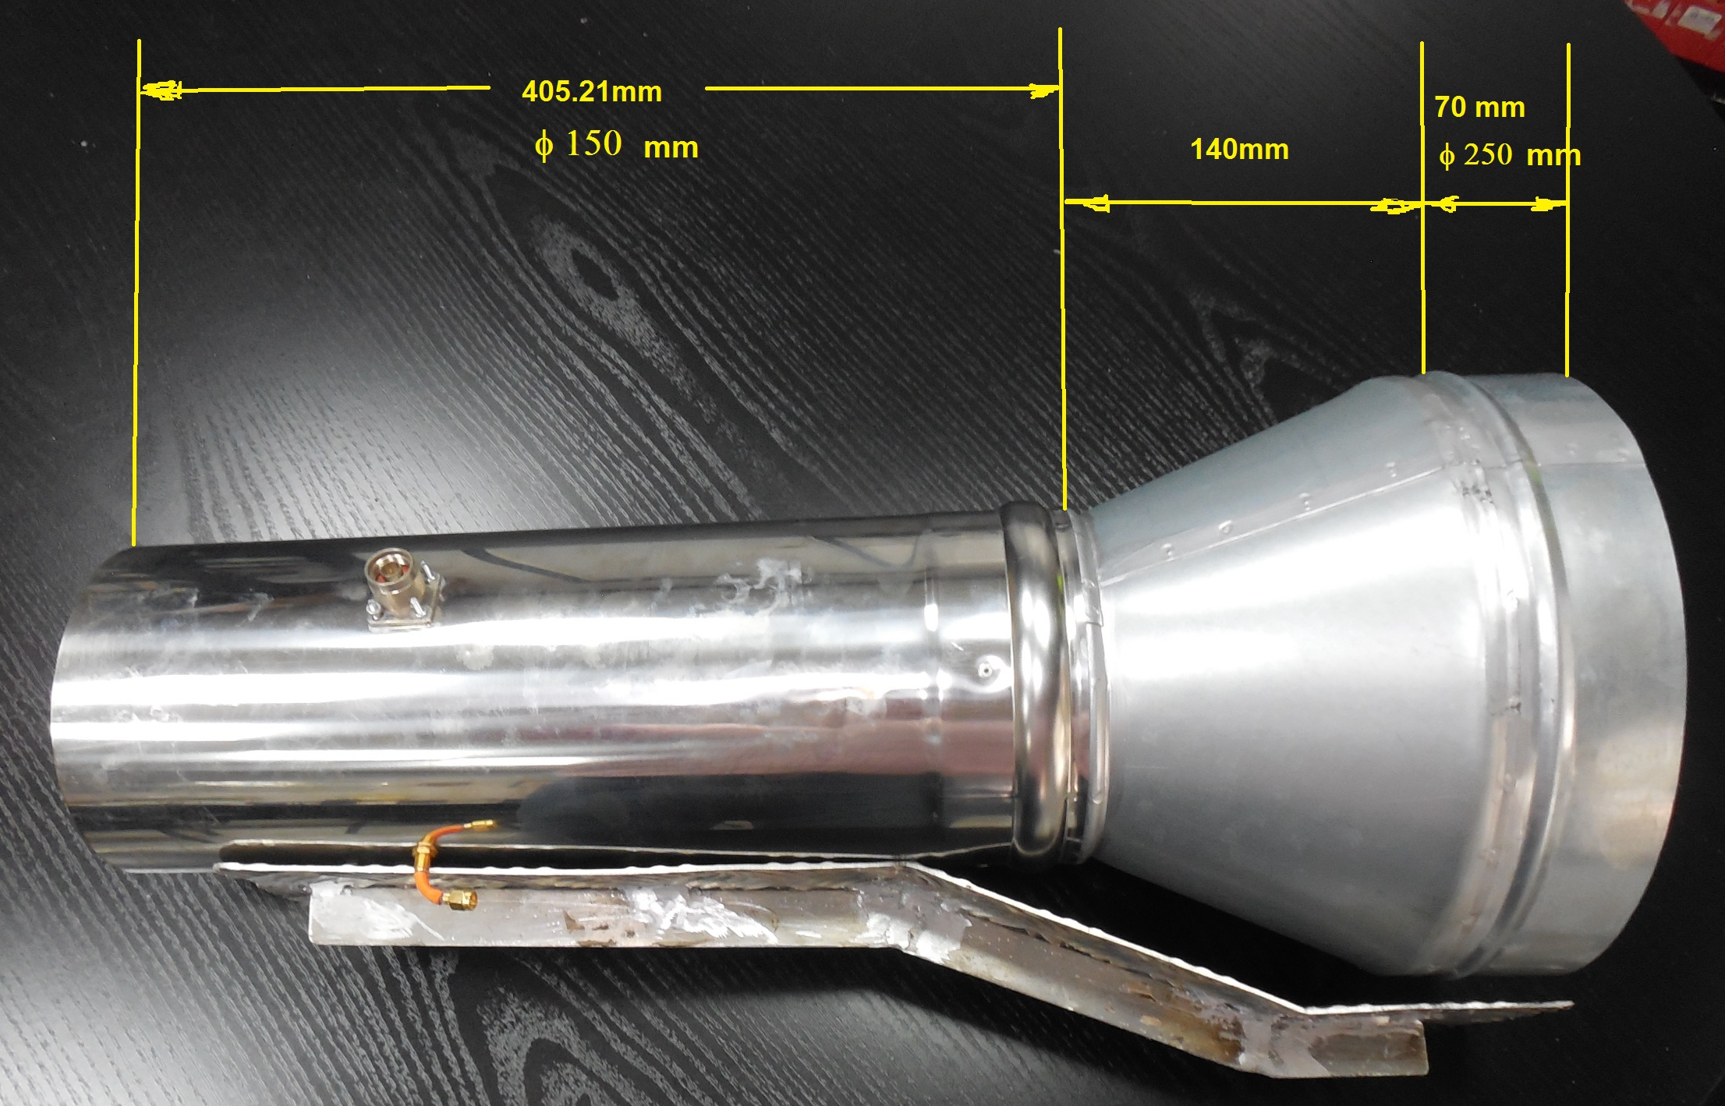
EA3HMJ’s stove pipe feed: Probe lenght (1/4 Î») = 57.83 mm, Probe position (1/4 Î»g)Â = 135.07 mm, Tube diameter (D) =150mm, Tube length (3/4 Î»g) =405.21 mm
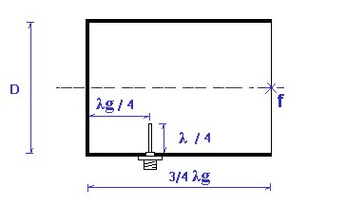

ISCAT echoes on 10 GHz: Charlie (G3WDG) has had good success using ISCAT-B on 3 cm. He conducted tests using his own echoes. He writes that after discussions with VK7MO, it appeared ISCAT-B would have the capability because of its shorter message length than ISCAT-A. I am not proposing that this should ever be used for EME, although it would have the capability to make a very quick digital QSO with strong enough signals! It is interesting that decodes are still possible even though the received signal widths at times were some 2-3x the tone spacing of ISCAT-B (43.1 Hz). We have seen by experiment the same with JT4 modes where even if signals merge into one another, WSJT can often still decode them. I have put a few .wav files and a summary of the tests at http://www.sucklingfamily.free-online.co.uk/ISCATB.zip.

FINAL: I am still having troubles with my a.katz(x)IEEE.org email address. It seems to Google’s management of the IEEE’s email. Certain stations seem to be black listed, their emails never arrive and the stations involved receive no notice that their emails were blocked. Sending email to alkatz(x)tcnj.edu seems to solve this problem. I thus suggest that you use this email address.

This month we have at the end of the NL G4RGK’s Top Ten lists for CW initials for 70 to 3 cm. For the complete list or to update your totals see http://www.zen70432.zen.co.uk/Initials/70cm.htm.

For a truly outstanding report on the EME2015 Conference in Britney see http://www.ok2kkw.com/00003016/eme2014/eme2014bodou_eng.htm! It is worth taking the time to look at it.

EME2016 will be in Venice, but the Dwingeloo PI9CIM group are already thinking about hosting the EME conference in 2018, but they are concerned that this would make a 4th consecutive conference in EU. They want to know if there are groups in other parts of the globe seriously considering hosting 2018? In which case they will focus on 2020.

SM4IVE has posted an updated agenda for the 2015 Swedish EME Conference at http://sm4ive.com/agenda.html. Lars says that the NF measurements and calibrations will be done by HB9BBD this year. He is looking for more technical/EME related topics for presentation. Let Lars know what you have and the time needed for your presentation. If you plan to attend now is the time to start planning. Registrations are already being received. The conference hotel, The Scandic West, is newly renovated and will be a very nice place to stay. If you have any questions email Lars at sm4ive(x)telia.com.

According to G4BAO UK stations can now operate on 13 cm at 2300 (similar to the VK band). There are also some areas of the UK where operation at 2324 is restricted. None of the active 13 cm UK EME stations are known to be affected this restriction. It is likely that we will see 13 cm activity on 2300 soon.

VK3UM EME Planner Ver. 1.94 is now available for download. Doug has added several new options under a new Month Data selection that provides the user a monthly summary of Declination, Path Loss, Distance, Libration, Illumination in a graphical format, and a display of the closest Sun to Moon separation for the month selected. This will allow you to choose the optimum time of operation for your location
at a glance. Work is still progressing with the EME Calculator refining the dish feed options and should be released shortly.

This year’s Heelweg Microwave meeting in Holland is reported to have attracted many EMEers from the Netherlands, France, Germany, England, Sweden and Belgium.

Talking about local conferences, Ray (WA4NJP) asked me to note that the SVHFS will have its annual Conference at Morehead, KY on 24/25 April and is looking for papers. Please see their web site at SVHF.org or contact Ray at wa4njp(x)bellsouth.net.

Please keep the news and technical reports coming. I will be away on business travel, but will be back in time for the DUBUS 432 EME Contest. Hope to CU off the Moon soon & 73, Al – K2UYH



