432 AND ABOVE EME NEWS
FEBRUARY 2019 VOL 48 #2

EDITOR: AL KATZ, K2UYH; DEPT. ELECTRICAL/COMPUTER ENGINEERING, THE COLLEGE OF NEW JERSEY, PO BOX 7718 EWING, NJ 08628, TEL (W 609-584-8424), (C 609-047-3889), E-MAIL alkatz(x)tcnj.edu
ASSOCIATE EDITOR AND Reflector/NETNEWS Matej Petrzilka, Simunkova 1609/21, 18200, Praha 8, Czech Republic, TEL (+420 603 489 490), E-MAIL ok1teh(x)seznam.cz
CW INITIAL LIST G4RGK, DAVID DIBLEY, E-MAIL zen70432(x)zen.co.uk, AT: http://www.zen70432.zen.co.uk/Initials/index.html
SUN & EXTRATERRESTRIAL NOISE LIST MANAGED BY OK1TEH: http://www.ok2kkw.com/next/nl_k2uyh/sun_table.xls
EME INFORMAL NETS: 14.345, ~1500 SATURDAY AND SUNDAY, NET COORDINATOR: OPEN
ON0EME EME BEACON, 1296.000 IS QRV WHEN MOON >10°, SEND RX REPORTS TO WALTER (ON4BCB) on4bcb(x)gmail.com
DL0SHF 3 CM EME BEACON, 10368.025, SEND INFO & QUESTIONS TO Per (DK7LJ) per(x)per-dudek.de.
NL EMAIL DISTRIBUTION and EMAIL LIST CORD: WARREN, W2WD wbutler(x)ieee.org [PDF]
THE NL WEB VERSION IS PRODUCED BY REIN, W6SZ rein0zn(x)gmail.com, AT http://www.nitehawk.com/rasmit/em70cm.html

CONDITIONS: Jan is normally not the best month for EME. At least in the northern hemisphere the weather (WX) can get pretty terrible. This year was no exception. Despite the WX, the 1296 EME SSB Funtest was a great success. OK2DL achieved a phenomenal score of 1,328 points and worked 45 stations! The 13 cm EME SSB contest did not do as well. The top fun maker was SP6OPN (SP6JLW team) with 40 points. The results of the 9 cm Microwave Activity Weekend (MAW) on 18/19 Jan are also reported in this newsletter (NL). The first DUBUS EME Contest of 2019 for 70 cm (and 2 m) is on 16/17 Feb. It will be followed on 16/17 March by the 13 cm contest. There is no 70 cm CW Activity Time Period (ATP) in Feb because of the 70 cm DUBUS Contest. There is very little dxpedition news for this month. The T46MB dxpedition to Cuba was delay again. We are not sure when they will try again. 9K2YM showed up on 70 cm from Kuwait and is expected to be regularly QRV – see Yaser’s report in this NL. EA9LZ (Ceuta) is expected to be QRV on 70 cm between 15 and 19 March. TO2MB (Martiniqua) is expected to be active between 15 and 24 March on 432 and 1296 – see dxpedition info in the last NL. SV9 is planned to be QRV around 10 - 17 May on 23 to 3 cm.

Flash: The OZ 13 cm band has been moved from 2300 - 2400 to 2400 – 2450 – see FINAL section of this NL.

2018 ARRL EME CONTEST RESULTS have already been posted – Thanks to the absolutely superb work of K1DS. The top overall score was again achieved by UA3PTW with 6.75 mil points for all modes and bands. What is most impressive is that Dmitry’s result was achieved single op and is nearly doubles next highest (multi-op) score of 3.4 mil by [my] K2UYH team (NE2U, K2TXB, K2YY and W2HRO), closely followed by the NC1I team (N1DPM, W1QA and W9JJ) with 3.36 mil. The top overall CW score (single op) was by G3LTF 983 k; the overall multi-op CW score was by the SP6JLW team with 562 k. The top 70 cm score was by DL7APV with 916 k all mode. The top 70 cm CW score was by I2FHW (single op) with 49 k. S59DGO made 90 k all mode multi-op. On 23 cm the top score all mode was 705 k by OK1DFC (single op). SM4IVE achieve the top CW score of 447 k (single op). IK5VLS had the top all mode multi op score of 313 k. On 13 cm the top single band entry was the OK1KIR group (multi-op) with 70.4 k. On 3 cm OZ1LRP was the top scorer all mode (single op) with 37.8 k. The N9JIM (Stanford club) submitted the top multi-op score of 9.9 k. The were no other 432 up single band entries. For the full story see URL-link at the end of this NL.

9K2YM: Yaser 9k2ym(x)9k2ym.co is now QRV from Kuwait on 432 with 4 yagis and 30 W at the feed from an FT847, but is preparing a new higher power PA. He has already QSO’d DK3WG, DL7APV, OK1KIR and others.

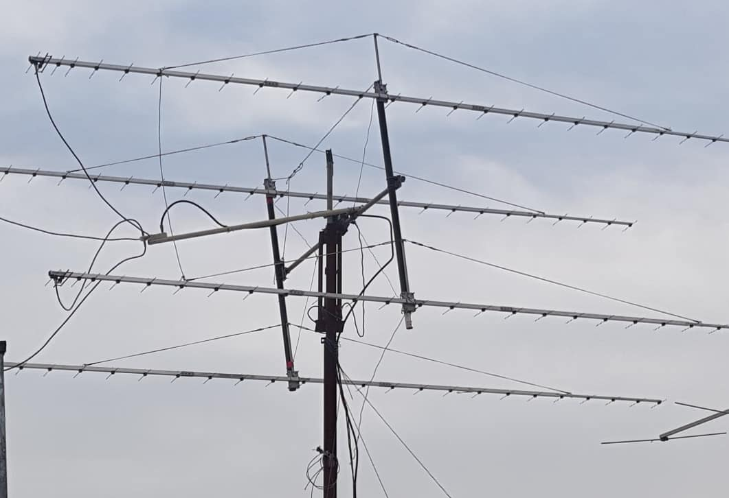
9K2YM 4 yagi 70 cm array

DK3WG: Jurg dk3wg(x)web.de reports on his recent activity – I worked on 70 cm using JT65B BD9BU for grid square 600, R6CS, 9K2YM for DXCC 137 and 4X1AJ; and on 23 cm using JT65C HB0/HB9DBM, ES3RF, ON4QQ, VK2FLR and W1XM, and using CW VK4AFL.

DL0SHF: Christoph (DF9CY) df9cy(x)web.de writes on recent his EME activity from DL0SHF -- We managed to install a remote control to the Flex Radio driving the 23 cm system just before the SSB Funtest weekend. I was thus able to make some QSOs; however, for the time being, it is only possible to operate CW. Hopefully, we get things going on SSB and JT65 soon. The problem are long latency times, which additionally seem to be changing rapidly. This may be a major task to overcome. For the first time by remote, I worked on 1296, on 18 Jan using CW RA2FGG, SP6ITF, IK1FJI, RN6MA, K5DN, SP6ITF (again), DF2GB, IK1FJI (again) and on 19 Jan ON5GS, DL3EBJ (CW/SSB), SP7VC (CW/SSB), OK2DL (CW/SSB), SM4GGC (CW/SSB) and DL6SH. The ON0EME beacon was very strong from time to time peaking up to 25 dB out of the noise. I saw a lot of JT65C signals over a 30 kHz bandwidth, but my computer constantly resisted accept the AF signal for to be fed into WSJT-X.

DL3EBJ: Chris dl3ebj(x)t-online.de was QRV for the 1296 SSB Funtest on 20 Jan -- I worked 29 2-way SSB stations: OK2DL, G3LTF, I1NDP, DL6SH, OK2ULQ, HB9Q, SP7VC, ON5GS, M0DTS, PA3CSG, LX1DB, SV3AAF, IK1FJI, DF3RU, IK3COJ, SM6CKU, SP5GDM, I0NAA, RA3EC, XE1XA, OZ4MM, VE6TA, VE6BGT, OK1KIR, PI9CAM, OH2DG, OK1CS, OZ6OL and VK5MC; and 2 stations in SSB/CW mode: SM4GGC and DL0SHF from 9 sectors (JO, JN, IO, KM, KO, EK, DO, KP and QF) for a total of (30x2+2)x 9 = 540 points. Most QSOs were worked after CQs. Condition were good with most signals easy to copy. My station consisted of a 4.8 m dish and 500 W on TX.

DL7APV: Bernd dl7apv(x)gmx.de fills us in on his Jan 432 activity -- The new array still works excellent; I have around 22 dB Sun noise all the time. I will try some more pulsar receiving soon. During the Christmas holidays there were just too many important distractions - Hi. I worked in Jan about 40 stations. 8 were initials: DM3CK with 1 yagi and 50 W, NT0V, 9K2YM, TM66BL, BH4PVP (OM95) using a 10 turn helical and 20 W, 4X1AJ, F6KBF and UA0ZGX (QO93) with an 18 el (V pol) yagi and 20 W. I again worked MX0CNS with his dipole (27DB/23DB)!

G3LTF: Peter g3ltf(x)btinternet.com reports that EME in Jan slowed a bit and that he operated mainly on 3400 except for the Funtest – I QSO’d on 2320 on 18 Jan during the 13 cm SSB competition SP6OPN JO, OH2DG KP, HB9Q JN and LX1DB JN; all on 2-way SSB for a score of (4x2) x 3 = 24 points. I also heard SP3XBO, and worked on 19 Jan KL6M on 2-way CW as Mike had no SSB transceiver available. Conditions were good but activity was very low. I suspect due to the bad WX in both EU and NA. On 19 Jan on 1296, I worked on CW RN6MA; then in the Funtest on 2-way SSB I1NDP JN, DL6SH JN, DL3EBJ JN, PA3CSG JO, OK2DL JN, OK2ULQ JN, IK1FJI JN, M0DTS IO for initial #467, ON5GS JO, DF3RU JN, I0NAA JN #468, RA3EC KO, SP7VC JO #469, SM6CKU JO, HB9Q JN, SM4GGC JO CW/SSB, DF2GB JN, WX4F EM #470, XE1XA EK, and on 20 Jan but just after the Funtest ended OZ4MM JO. I also copied SV3AAF (57) but he could not hear me. My score was (18x2 + 1) x 6 = 222 points. There were again good conditions but activity was low for the same reasons as on 13 cm. The weather was once more poor with wind and rain for the 9 cm AW. I was also suffering from a cold, and so was only on for a short time. On 23 Jan I worked OZ6OL and SM6PGP and heard SA6BUN and KL6M. I tested with G4BAO. John heard me, but I could not resolve his CW. We were close. My only other 1296 QSO was on 14 Jan with SM6CKU, who had a big signal.

HB9BBD: Dominique dfaessler(x)bluewin.ch sends information on his current EME plans and why he left 23 for 3 cm – My 10 m dish was not lost in a storm. It was dismantled on my decision. For 20 years it did a nice job on 1296. I probably worked everyone there was to work on CW/SSB. When digital took over on 23 cm, I lost interest because computer work is not my EME hobby. The station was 20 min away from my QTH by car, and on rented ground. The annual cost of approx $6000 did not seem worth my 100 or so QSOs per year. On top of the cost, I had to perform many weeks of maintenance, and replace failed components. I just did not want my kids to get the burden of removing all the stuff once I am gone. Nobody was interested either in the dish site including the rig and amplifiers, nor the dish. The amplifiers went to a young and enthusiastic German amateur for free; the tower to Dan and the dish to the scrapyard. I had a tremendous time on 23 cm. Now it is good to have it come to an end. 10 GHz offers me more fun. I can operate from home. This is new situation and a very comfortable one.

I0NAA: Mario mario.natali(x)gmail.com writes about his Funtest activity on 1296 and Pulsars -- I was able to be active only during the first Moon pass on 19 Jan. Rain and winds made operation impossible during my later window. Anyway, it was a lot of fun. I had to find and use my old headset from the 70’s, which brought back memories of the pioneering spirit of that time. SSB on EME is definitely not easy. After the contest, I started thinking of ways to move my PA closer to the antenna to make better use of my 250 W PA. I QSO’d, all on 2-way SSB, starting at 1927 I1NDP (59/57), HB9Q (59/55), DL6SH (57/56), DF3RU (55/56), OK2DL (58/55), LX1DB (58/56), SM6CKU (57/55), DL3EBJ (55/54), G3LTF (57/55) and at 2230 RA3EC (54/55) for a total score of (10x2)x4 = 80 points. My Pulsar activity is progressing well. My count is now up to #9; and my plan is to reach #20. This may require moving to 1400 MHz. I am struggling to defeat RFI that has increased dramatically due to military activity (radars). It is very difficult to use the full bandwidth of Ettus B200. I released the version 9.1.0 of Murmur that includes several tools for observation planning. I am working to include a radiometer in the program to allow fine tuning of antenna pointing, which seems to be on the right track.

I1NDP: Nando i1ndp.nando(x)gmail.com reports on his 1296 SSB Funtest results – I found very good conditions, but not many stations on the band. It would have been nice to have more US stations, but it was fun anyway. I worked all on 2-way SSB unless noted starting on 19 June at 1902 G3LTF (57/58) IO, OK2DL (59/59) JN, DL3EBJ (56/58) JO, SM4GGC (55/56) JO, DL6SH (59/59) JN, PA3CSG (57/57) JO, SP7VC (57/59) JO, HB9Q (59/59) JN, OK2ULQ (57/59) JN, I0NAA (57/59) JN, DF3RU (58/58) JN, M0DTS (57/54) IO, RN6MA (55/56) LN, SV3AAF (58/59) KM, IK3COJ (57/58) JN, IK1FJI (57/57) JN, IK5VLS (55/59) JN, G4RGK (55/55) IO, SP5GDM (56/57) KO, SM6CKU (58/58) JO, OK1KIR (59/58) JN, ON5GS (56/57) JO, ON7FLY (43/57) JO, RA3EC (57/58) KO, SM6PGP (55/55) JO, DF2GB (55/56) JN, DJ2DY (54/54) JN, WX4F (55/57) EM, XE1XA (57/54) EK, WA9FWD (57/44) EN, VE4SA (55/53) EN, OZ4MM (58/57) JO, VA7MM (559/55) CN SSB-CW, PA2DW (54/54) JO, VE6BGT (57/57) DO, VE6TA (57/57) DO, EI2FG (54/33) IO, and ending on 20 Jan at 0217 LU1CGB (569/55) GF SSB-CW for a total score of (36x2+2) x 12 = 888 points.

IK1FJI: Valter valter_dls(x)yahoo.it had fun on 23 cm SSB in Jan – Before the contest, I worked on 23 cm using CW or SSB as noted on 13 Jan SM6CKU (579/579), SM4GGC (549/559) and I1NDP (589/589), and on 17 Jan SM6CKU (56/55) on SSB, on 18 Jan DL0SHF (579/569), RN6MA (569/449) for an initial (#113), DL0SHF (589/579), WA9FWD (569/559) and NC1I (579/579), and on 19 Jan IK5QLO (559/539) and PA3CSG (559/569). I was QRV for the Funtest some hours and worked on SSB OK2DL (55/56) JN, G3LTF (55/55) IO, HB9Q (57/56) JN, ON5GS (54/44), I1NDP (57/57) JN, DL3EBJ (55/55) JO, LX1DB (57/57) JN, OK1KIR (56/55), PI9CAM (56/57) JO and DL6SH (56/58) JO for a total of 10x2x3 = 54 points. Last year I think I worked 21 stations, so I missed some or there was less activity this time. I heard OZ4MM and SV3AAF on SSB. I also worked on CW on 20 Jan WX4F (569/559) (#113), VA7MM (539/549) (#114), PI9CAM (579/579) and RA2FGG (439/559) (#115), on 21 Jan G4CCH (579/579), and on 22 Jan PA3FXB (549/559) and SP6ITF (579/579). I also QSO’d some stations using JT65C. Now after repair, I have full power (850 W) from my PA and used my 3.2 m dish.

IW2FZR: Dario dario.fzr(x)gmail.com sends for the NL the story of his 3 cm operation -- Last year I started to build a "small" system for 3 cm with which I expected to have to operate using the new digital modes. It is a 1.8 m prime focus (old TV sat antenna) and a 20 W TWT. I had many problems to solve such as tracking, RF switching at the feed and LO stability – very important for digital operation. In Dec, I made my first QSOs on 3 cm with UR5LX followed by S57RA, [both on QRA64D?]. I have more work to do. I need a better NF. My EME station is 25 km from my house and not easy to get to in the evening; so much of my work is done at home. I want to thank ON4BCB, OZ1LPR and OZ1FF for their help getting me started on 3 cm. And to Sergey and Pavel for my first QSOs on Christmas' eve - a much appreciated gift!

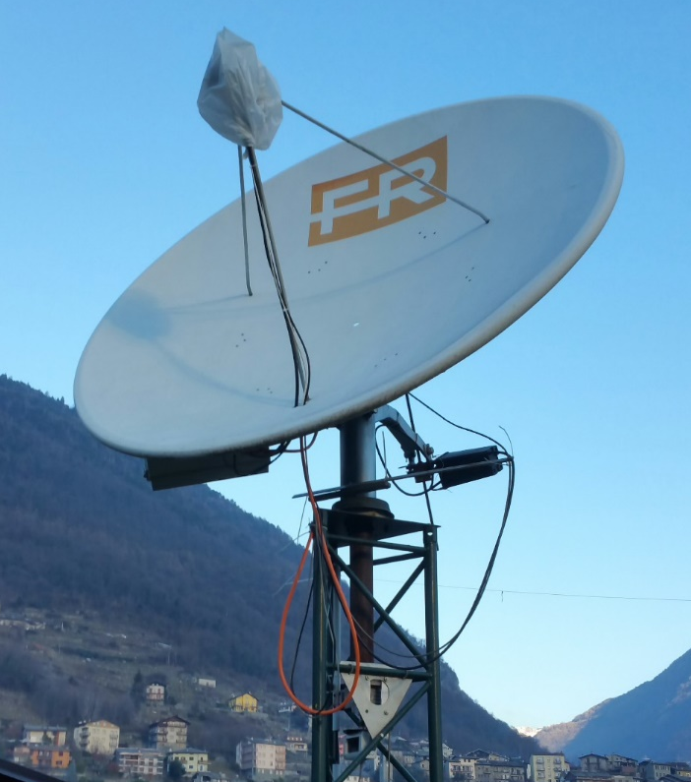
IW2FZR’s 1.8 m dish used on 3 cm with 20 W TWT

JA4BLC: Yoshiro ja4blc(x)web-sanin.co.jp reports on 3 cm in JA – In Dec, I repaired my 10 GHz transverter for use with 2.4 m offset dish, and worked JA6XED and JA1WQF successfully. My 2.4 m offset dish has a good window toward east. I am expecting to work more NA stations having RX on 10450. PSE email if you are interested in skeds.

K5QE: Marshall k5qe(x)k5qe.com was again active in a big way (16 yagis and 1 kW) on 432 EME during the ARRL Jan Tropo Contest that occurred the same weekend as the SSB Funtests, on 19/20 Jan. Unfortunately, Marshall’s announcement missed the Jan NL. I have not received a report on his results, but I have heard that he did quite well this year.

N4PZ: Steve n4pz(x)live.com has his 13 cm 300 W SSPA working again -- I have successfully replaced the original MRF19125 mosfets with 3 MRF 21125s in my 13 cm amp. With a bit of luck and warm WX, I should be back on 13 cm soon.

N5BF: Courtney’s courtney.duncan.n5bf(x)gmail.com Jan EME report – I was QRV again on 23 cm EME on 14 Dec with a DEMW LNA. It works fine but is lower gain than the system was set up for, so adjustments were needed. I made some test QSOs using JT65C, including an initial with RN6MA for mixed #142 in a short window; and was successful despite some computer configuration problems on my end. However, on 3 Jan, I blew out this LNA trying to check into a local 23 cm net. Ultimately, I discovered a flaw in my T/R switching. I neglected to put in both insulating washers, so the FET was intermittently shorting 28 V to chassis resulting in chassis pits. Eventually it burned out, welding itself to the 28 V supply lug in the process. This, again, left the LNA protection relay switched in and the LNA powered during transmit. I repaired this error; this time with fuses so that the next failure will be a blown fuse, not the LNA. Meanwhile the new Kuhne LNA arrived, so it is now installed. Everything is working properly and I plan to be on for the Funtest this weekend. I also plan to use this opportunity to learn more about LNAs by repairing some of the broken ones, so my to do list is, as always, longer than before.

NC1I: Frank frank(x)NC1I.COM sends news of his Dec activity -- Due to conflicts, I do not expect to be active much in Jan or Feb. What little time I have, will likely be spent on 1296. As of the time of this report (on 17 Jan), we are expecting a severe winter storm over the upcoming weekend. Forecasters are predicting 12” of heavy wet snow followed by significant icing, followed by near gale force winds. That is obviously the worst possible combination of conditions for antenna survival. I am most worried about my dish, but if the weather forecast holds up I will also be concerned about my 432 array and HF antennas. Hopefully the forecasts are inaccurate! [MA got hit pretty hard, but I have not heard of any significant damage from Frank]. My activity in Dec was limited and with the best conditions aligning with the holidays activity and was thus way down. I worked on 1296 using JT65C on 19 Dec K7CA, on 20 Dec DJ2DY and RN6MA, and on 22 Dec W1PV. I QSO’d on 432 using JT65B on 20 Dec PA2V and DK1KW, on 22 Dec KF8MY, and on 23 December G3HKS.

OK1KIR: Vlada’s and Tonna’s vlada.masek(x)volny.cz group report on Jan EME -- During SSB Funtest weekend, we were first active on 70 cm and worked with JT65B on 19 Jan at 1456 UB4UAA (21DB/O) for digital initial {#229}, 1541 BD9BU (22DB/21DB) {#230}, 1605 ON4CGX (24DB/17DB) {#231}, 1617 PA3DOL (19DB/19DB), {#232}, 1631 OK2AQ (30DB/22DB), 4X1AJ (27DB/23DB) {#233}, 1714 9K2YM (25DB/O) {#234} for first 9K-OK 70 cm QSO and 1740 again 9K2YM (25DB/O). We then switched to 23 cm to work using JT65C on 19 Jan at 1947 RT6DH (21DB/O) for digital initial {#323}, 1959 ON4QQ (5DB/O), DL1RPL (10DB/18DB) {#324} and 2339 R4HCZ (7DB/10DB), and on 20 Jan at 0055 VA7MM (1DB/9DB) and 0105 ON5GS (1DB/O). We worked using SSB unless noted on 19 Jan at 2048 OK2DL (59/59), 2051 OK2ULQ (55/57), 2054 I1NDP (58/59) and 2339 RA2FGG (549/579) on CW for initial #440, on 20 Jan at 0035 WX4F (569/559) on CW #441, 0110 ON5GS (54/57), 0114 IK1FJI( 55/56), 0121 RA3EC (54/57), 1728 PI9CAM (58/58), 1808 SM6CKU (58/57), 1821 DL6SH (589/589) on CW and 1836 DL6SH (58/57) for a Funtest total of (9x2) x 3 = 54 points. We had no success using JT65C during our 20 Jan, 23 cm sked with ZL2MQ.

OK1TEH: Matej ok1tehlist(x)seznam.cz was QRV on 70 cm EME with his 1 yagi in Jan -- I worked S51LF (29D/29DB), PY2BS (28DB/28DB) and PI9CAM (20DB/11DB). I am looking for skeds with new stations and will be QRV around Perigee in Feb and March – especially during the 432 DUBUS Contest.

OK2DL: Marek ok2dl(x)seznam.cz sends his log for the 1296 SSB Funtest – In the competition, I worked 45 station in 16 sectors. 38 were worked on SSB and 7 were on SSB-CW for a contest score of (38x2+7) x 16 = 1,328. I QSO’d on SSB unless noted on 19 Jan 1902 DL3EBJ (59/59) JO, 1903, I1NDP (59/59) JN, 1907 SP7VC (55/59) JO, 1908 DL6SH (58/59) JN, 1909 OK2ULQ (57/59) JN, 1915 ON5GS (57/59) JO, 1916 G3LTF (59/59) IO, 1918 IK1FJI 57/56) JN, 1920 PA3CSG (58/58) JO, 1925 SM4GGC (559/55) JO SSB-CW, 1930 RN6MA (55/57) LO, 1935 DJ2DY (53/55) JN, 1937 DF3RU (59/59) JN, 1940, SV3AAF (59/59) KM, 1945 M0DTS (55/54) IO, 1955 HB9Q (59/58) JN, 2001 I0NAA (55/58) JN, 2017 RA2FGG (559/55) KO SSB-CW, 2019 LX1DB (59/59) JN, 2021 IK3COJ 58/58) JN, 2028 SP5GDM (53/57) KO, 2031 IK5VLS (55/53) JN, 2048 OK1KIR (59/59) JN, 2107 SM6CKU (58/58) JO, 2123 DF2GB (55/55) JN, 2201 RA3EC (57/58) KO, 2238 DL0SHF (59/599) JO SSB-CW and 2302 WX4F (55/53) EM, on 20 Jan at 0003 VE4SA (55/55) EO, 0015 XE1XA (53/56) EK, 0021 OZ4MM (57/57) JO, 0031 WA9FWD (58/54) EN, 0401 VA7MM (559/57) CN SSB-CW, 0405 VE6TA (57/57) DO, 0408 VE6BGT (58/57) DO, 0447 K5DN (57/57) EL, 1604 OH2DG (58/58) KP, 1628 VK4AFL (559/56) QG SSB-CW, 1702 PI9CAM (59/59)JO, 1706 OZ6OL (58/57) JO, 1708 OK1CS (58/59) JO, 1722 G4FQI (54/42) IO, 1755 PA0PLY (559/55) JO SSB-CW, 1800 VK5MC (55/55) QF and 1836 DF2VJ (559/55) JN SSB-CW. My station consists of a 6 m dish, an 800 W at the feed SSPA, 0.1 dB LNA, DB6NT TRV and K3.

OK2ULQ: Peter ok2ulq(x)seznam.cz wrote on his blog http://ok2ulq.blogspot.com -- I started the New Year with participation in the 1296 SSB Funtest and made 10 SSB Contacts on 23 cm in only 3 hours. It was big pleasure to say hello in Czech to OK2DL, OK1KIR and DL6SH followed by HB9Q, LX1DB, G3LTF, I1NDP, SM6CKU, DL3EBJ and DF3RU all on 2-way SSB. My score was (10x2) x 3 for 60 points. [TNX to OK1TEH for the translation].

ON5GS: Dirk dirk.reyners(x)telenet.be was QRV in the 1296 SSB Funtest – I used a 6 m dish with 200 W, G4DDK LNA to an FT736R from (JO21sc). All QSOs were 2-way SSB. I contacted on 19 Jan at 1914 OK2DL (57/59) JO, 1921 DL6SH (56/58) JN, 1929 HB9Q (55/59) JN, 1937 PA3CSG (44/55) JO, 1941 DF3RU (55/55) JN, 1946 DL3EBJ (55/55) JO, 1955 IK1FJI (54/55) JN,2013 LX1DB (57/59) JN, 2031 SM6CKU (55/57) JO, 2110 I1NDP (56/57) JN, 2124 G3LTF (55/56) IO and 2340 RA3EC (55/55) KO, and 20 Jan at 0033 OZ4MM (55/55) JO, 0058 XE1XA (41/54) EK, 0113 OK1KIR (54/57) JN, 0142 PA2DW (52/55) JO and 1811 PI9CAM (57/57) JO for a total score of (17x2) x 5 = 170 points.

PA2DW: Dick qtc(x)kpnmail.nl reports that in the ARRL EME Contest he ended up with 27 CW QSOs on 1296 -- I feel sorry I did not submit my log. It was an all-time record for my small setup, probably due to the good conditions and most definitely to the superb CW activity. I also made 5 JT QSOs. My rig was a 2.4 m dish, 500 W SSPA, G4DDK LNA and K3 with TR1296H.

PI9CAM: Dick (PA2DW) qtc(x)kpnmail.nl has sent in the 1296 Funtest logs from the Dwingeloo 25 m dish -– We were only QRV limited time toward the end of the event, but many some nice EME SSB QSOs. All contest QSOs were 2-way SSB, although we did make contacts on other modes outside of the contest. We worked on 20 Jan at 1648 OZ4MM (59/59) JO, 1651 RN6MA (55/55) LN, 1659 DL6SH (59/59) JN, 1701 OK2DL (59/59) JN, 1703 OK1CS (58/58) JO, 1705 OH2DG (59/55) KP, 1708 SM4GGC (55/56) JO, 1711 SM6CKU (57/58) JO, 1719 DL3EBJ (58/57) JO, 1731 OK1KIR (58/58) JN, 1736 PA0PLY (51/55) JO, 1740 DF3RU (59/56) JN, 1759 OZ6OL (57/56) JO, 1805 VK5MC (56/57) QF, 1808 ON5GS (57/57) JO, 1836 IK1FJI (56/57) JN, 1839 IK3COJ (58/58) JN and 1852 LA3EQ (55/55) JO for a total of 18x2x5 = 180 points. We were running our normal 120 W at the big dish’s feed.

SM4GGC: Stig sm4ggc(x)gmail.com operated the 1296 SSB Funtest -- I wanted to see what it was possible to work with a QRP station on SSB. I have a 3 m dish and 250 W at feed. I worked 5 stations on 2-way SSB: I1NDP, HB9Q, OZ4MM, PI9CAM and SM6CKU. I also QSO’d on CW/SSB6 stations: OK2DL, DL6SH, DL3EBJ, G3LTF, DL0SHF and LX1DB for a total of 11 stations (2x5+6)1 in 3 fields = 48 points. The smallest station worked DL3EBJ with 4.8 m dish and 500 W. I was QRV about 4 hours on Saturday evening and 3 hours on Sunday to the end of the contest. Most of my time was spent listing for stations.

SM7THS: Sverker sm7ths(x)live.se writes that not much of EME interest had happened since Christmas until the weekend of 19/20 Jan when there was some very excellent Moon propagation -- I worked BD9BU for the first BY-SM 70 cm QSO. I also added 7 initials. Several of them were with single long yagi stations. All contacts were using JT65B. My best QSO was with MM0GYX. Ian was using a single 15 el yagi and 100 W, and amazingly was quite easy to work. I hrd him (26DB). [TNX to OK1TEH for forwarding Sverker’s report from his blog: http://sm7ths.blogspot.com].
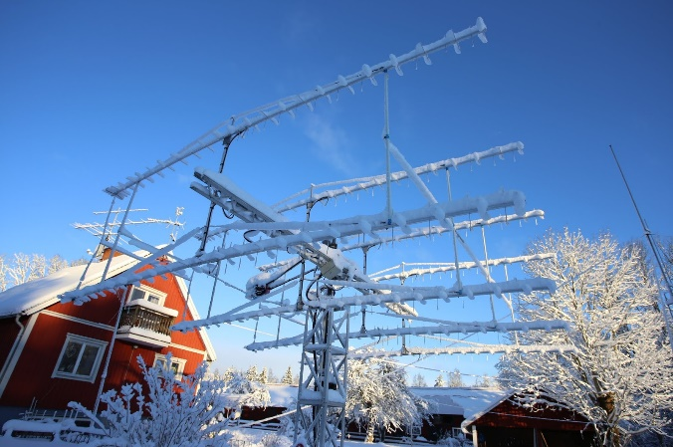
SM7THS’s 8 x 14 el (vert) yagis in the snow

SP5GDM: Jan sp5gdm(x)wp.eu has submitted his log for the 1296 SSB Funtest. He uses a 3.7 m dish with DFC septum feed, 500 W SSPA and 0.25 dB DDK VLNA. He worked all on 2-way SSB on 19 Jan at 2020 I1NDP (57/56) JN, 2027 OK2DL (57/53) JN, 2101 DL3EBJ (56/54) JO, 2106 DL3RU (56/54) JN and 2140 HB9Q (57/52) JN for a score of (5x2) x 2 = 20 points.

SP5GDM 3.7 m dish used in 1296 Funtest

SP7VC: Mek sp7vc(x)wp.pl was QRV in the SSB Funtest on 1296 – I worked using SSB unless noted on 20 Jan at 1906 OK2DL (59/55) JN, 1920 I1NDP (59/59) JN, 1926 DL6SH (55/55) JN, 1931 HB9Q (59/55) JN, 1938 DL3EBJ (55/55) JO, 1959 DF3RU (55/55) JN, 2043 LX1DB (59/56) JN, 2140 G3LTF (55/54) IO and 2232 DL0SHF (599/43) JO CW-SSB. My score was (8x2+1) x 3 sectors = 51 points. My station is a 4.5 m dish, 350 W PA and TS2000X.
SP6OPN: Jacek (SP6OPN) reports on activity by the SP6JLW group (SP6OPN, SP6JLW and SQ6OPG) during the 13 cm SSB Funtest – We decided to operate only on 13 cm this year because of the very cold temperatures during the contest weekend. Despite the WX, the EME conditions on 13 cm were excellent. Our echoes were (59) on SSB. However, there were only a few stations QRV. We believe that we worked everyone on, which was only 5 stations. We QSO’d on 18 Jan at 1808 OH2DG (55/58) KP, 1809 G3LTF (57/58) IO, 1953 HB9Q (59/58) JN, 1958 LX1DB (58/57) JN and 2004 SP3XBO (54/55) JO. All QSOs were 2-way SSB for a score of (5x2) x 4 = 40 points. We used our 6.5 m dish, 1.5 kW SSPA (16 X MRF21125) and DG0VE LNA.

UA0ZGX: Nikolay ua0zgx(x)mail.ru made his first 70 cm EME QSO using JT65B with DL7APV (18DB/25DB). He is using a single 18 el yagi on vert pol V with only 20 W. [TNX to DK3WG for forwarding this report].

UA3PTW: Dmitry ua3ptw(x)inbox.ru is to be congratulated for achieving the top score in the ARRL EME Contest; his report on recent initials follows – I added on 432 using JT65B 4X1AJ, DM3MS, IK3VZO and GM0HBK; and on 1296 using JT65C HB0/HB9DBM, ON4QQ, UD2F, DL1RME, DL7AIG, ZL3DXT, SK0CT, 0DM3MS and UA6AJS. [TNX to DK3WG for forwarding this report].

UR3EE: Arthur ur3ee(x)i.ua in Jan added on 432 QSOs using JT65B with UB4UAA, SM7THS, PA3DOL, PA2V, JA6AHB and DL2HWA. He is using a single 70 cm long yagi inside a 2 m 4 yagi array. [TNX to DK3WG for forwarding this report].

VA7MM: Mark (VE7CMK) and Toby (VE7CNF) va7mm(x)rac.ca were active during the 1296 SSB EME Funtest -- We made two contest contacts counting on 20 Jan at 0250 I1NDP (54/55) JN on SSB and 0358 OK2DL (559/57) JN CW-SSB for a score of only (2+1) x 1 = 3 points. We made other random CW and digital QSOs with OK1KIR, K7CA for a mixed initial, DL3EBJ, ON5GS, IK1FJI, PA2DW, VE6TA, LU1CGB and K5DOG. We’re planning to operate next in the DUBUS 1296 EME contest in April and are otherwise available for scheduled contacts via email.

VE3KRP: Fast Eddie eddie(x)tbaytel.net had WX problems in Jan -- I spoke too soon about lending out my snowblower. We had over 50 cm of snow with freezing rain and ice forming all over. So, activity has been nil here. I need to snow blow a path to the dish to untie it and see if it is still operational. I hear a cold snap is on the way. Sorry but so far, it has not been a winter for EME fun!

VE6BGT: Skip macaulay.skip(x)gmail.com reports on his Nov, Dec and Jan activity: I had a great time during the last part of the ARRL EME Contest on 1296. I made a few more contacts including some initials. QSO’d were LZ1DX, SP6ITF, W4OP, IK1FJL, OK2DL, K2UYH, SM4IVE, W4AF, DF3RU, SP7DCS, RA3AUB, F5KUM, PA3FXB, LZ2US, K6MG, SK0UX, G3LTF, OK1CS, SM6PGP, G4CCH, SM2CEW, NC1I, VA7MM, KA1GT, N6OVP and WA9FWD. I also made it on for the 9 cm AW on 23/24 Dec. I could not be QRV for the first night due to bad weather, high winds, but the following night was perfect. The turnout was a bit low mainly due to the Moon position and middle of night/early morning timing. It was still good to work K2UYH, SM6PGP, PA0BAT, W5LUA, SA6BUN and G4CCH. I am working on a 6 cm SSPA and feed assembly, and am looking forward to hearing my echoes on this new band very soon.

W2HRO: Paul w2hro.fn20(x)gmail.com finished off 432 WAC in Jan -- I worked PY2BS to complete 432 WAC with my extended 4 m dish, loop feed and 150 W at the feed. I was very lucky to 5 great stations/ops to work - thanks. I will now concentrate on WAC on 1296. I did some testing of my 1296 feed with my relatively deep 4 m dish (extended from 3 m). I wanted to see how much the 90 deg hybrid splitter used to get circular pol with my patch feed degraded my RX. The results were interesting for me but just as you would expect. Test #1 - Dual Pol Patch Feed & cables to hybrid & hybrid & preamp protection switch. With this setup - cold sky to Sun delta was 11.5 dB. Test #2 - Dual Pol Patch Feed with preamp connected directly to V-pol. With this setup - cold sky to sun delta was 12.5 dB. The good news is that my 4 m extension is effective and working as expected. The bad news is the patch and hybrid is also working as expected. I'm still happy that with the small footprint (and weight) patch feed, but to try a septum feed at some point.

WX4F: Gray grayfulk(x)embarqmail.com is QRV on 1296 EME and writes -- I am having FUN, and a lifelong dream fulfilled since I first read about EME in the 1976 in the ARRL Handbook at age 14. On 1296 I am now up to mixed initial #33* (8 on CW, 3 on SSB and 22 JT65C) as follows: AA4MD, DF2GB, DF2VJ, DJ2DY, ES6FX, F1RJ, G3LTF, G4CCH, G4FQI, HB9Q, I1NDP, IK1FJI, IK3COJ, K5DN, K5DOG, K7CA, KA1GT, KD3UY, OK1L, OK2DL, ON4QQ, PA3FXB, PE1LWT, RA3EC, RN6MA, SM4IVE, SM6CKU, SP5GDM, SP6JLW, VA6EME, W1PV, W2HRO, and W4OP (my first contact), with 14 countries and 8 US states. I worked the 3 SSB QSOs during the 23 cm SSB FUNTEST. They were I1NDP, OK2DL, and G3LTF. The SSB contacts were quite FUN for sure; and Good copy! On CW during FUNTEST, I contacted SM6CKU, RA3EC, and IK1FJI. I used a 4.5 m dish and about 400 W at the feed.

K2UYH: Al alkatz(x)tcnj.edu – Jan was not a good month for EME. It yielded no QSOs because of a combination of poor WX and travel. I have hoped to fit in a few hours on 13 cm at the very start of SSB Funtest, but it was not to be. I ran out of time. The end of Dec was a little better. On 21/22 Dec I ran some test on 10368 EME with KN0WS. Carl copied me, but I could not find him despite the fact that I was hearing good echoes. I was on 9 cm for the AW and QSO’d on 23 Dec at 0158 VE6BGT (569/569) and 0532 SM6PGP (559/569) both on CW, and on 24 Dec at 0451 G4CCH (579/579) for initial #51 on CW, 0505 WA3RQG (2DB/16DB) on JT65C for mixed initial #58* - Don does not work CW, 0610 SA6BUN (569/559) and 0546 VE6BGT (569/569) again on CW. On 25 Dec I worked using JT65B on 432 at 1248 JA6AHB (4DB/16DB) and 1342 BD9BU (19DB/26DB) for mixed initial #983*. On 29 Dec I was back on 10368 using QRA65D for sked at 0800 with S57RA, but Pavel lost AC power, but did QSO at 0908 DL6ABC (12DB/17DB) for mixed initial #39*, and on 30 Dec at 0938 S57RA (10DB/14DB) #40* and DXCC 23. I was very disappointed to miss the SSB Funtests and the related EME generated for the ARRL’s Jan tropo contest. I do plan to be QRV for the 432 DUBUS EME Contest in Feb and if WX permits some more 3 cm skeds.
NET/REFLECTOR NEWS: DL2NUD is planning to go to 4S7 in the spring. F2CT will be QRV in 2019 with on 432 8 x 27 el yagis and 1 kW, on 1296 4 m dish and 1 kW; and 10368 4 m dish and 60 W. Contact Guy for skeds (CW) at f2ct(x)wanadoo.fr. G4BAO is working on 100 W SSPA for his 9 cm system. Should be done soon. On 13 cm he has 200 W to his 1.9 m dish. KN0WS has been working on a calorimetric power meter to accurately measure the power of his 3 cm SSPA. He is QRV on 3 cm over the winter from his home QTH with a small 1.2 m dish and available for skeds. ON5RR has a new email address moonbouncer.on(x)gmail.com. Marc asks us to start using his new one. PA3DZL on 15 Dec moved to his new QTH (Almkerk, NL) and is working on the permit for antennas. In the interim, Jac expects to be QRV with portable yagi setup. VE1KG is setting up for 3 cm RX using an offset 77 cm dish and a SDR. VK4EME is working on new 70 cm SSPA. Alan expect some new VK2’s on 70 cm EME. ZL3AAD is also working on a 70 cm SSPA and preparing to return to EME on both CW and JT65.

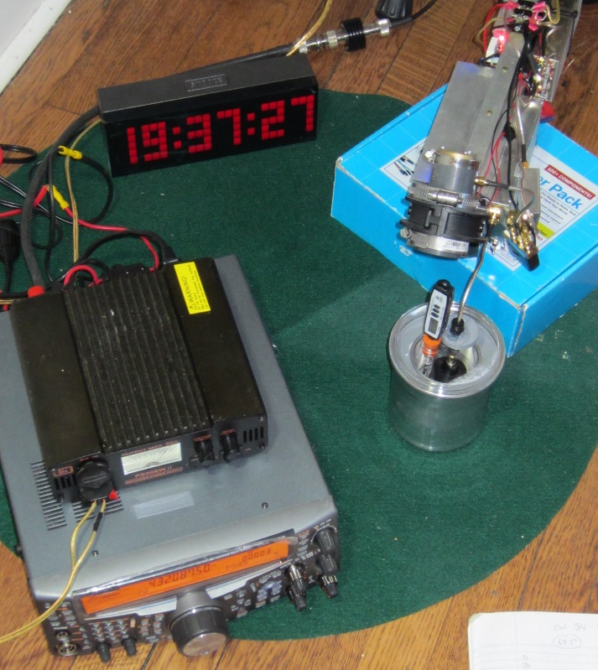
KN0WS calorimetric power testing on 3 cm

FOR SALE: N4PZ has about 12 MRF19125s available for free to anyone who needs them. He also has some MRF21125s available for a reasonable price. If interested contact Steve at n4pz@live.com. OK1TEH found that there are 4 abandoned 28’ Kennedy dishes, similar to those used by VK3UM and others. They are in PA - Hoek van Holland and may be available for a very reasonable price. See http://tchorski.morkitu.org/18/lessive-01.htm. [See info on Kennedy dishes at:
http://www.storyavenue.com/dskpages.htm]. KD2XN has for sale: DEMI LTRS 4-step squencer kit for $55 (incl. shipping); DEMI 30 W 23 cm linear amp kit for $180 (incl. shipping); VHFdesign.com 23 cm LNA with 34 dB gain and 0.3 dB NF with RF relay, 50-ohm load + enclosure for $130 (incl. shipping); VHFdesign.com 23 cm 300 W SSPA with heatsink + fans + 28 V PS for $550; Kuhne 23 cm transverter (1296-1298/146-148) for $450 (incl. shipping), RFHamDesign Dual Mode Septum Feed 1296 p/n CIR-1296/Opt1 with CLX-05 dish feed bracket for $300; and DAIWA CN-801 SII .9-2.5 GHz cross needle SWR/PWR meter for $220 (incl. shipping). If interested contact Phil by email.

TECHNICAL: KA1GT was not too active in Jan but has written a small Windows App that takes the AZ-EL file data from WSJT(-X) and calculates doppler shifts for the various WSJT-X doppler modes as well as displaying some other information useful to EMEers. Anyone can download it from -- http://bobatkins.com/radio/dopplercalc.html.
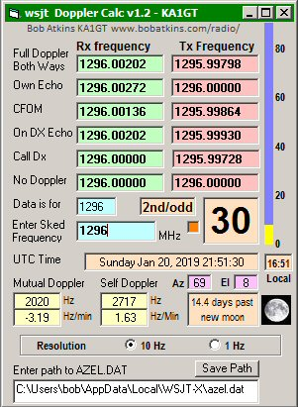

SDR to 3 cm -- The limesdr can cover 10 GHz -- see https://www.crowdsupply.com/lime-micro/limesdr-mini/updates/lms8001-companion-extends-coverage-to-10-ghz.

W2HRO has installed US Digital encoder (other similar encodes will work too) on his SPID Rotor use for AZ of his 4 m dish. It required sprockets and a chain, but worked nicely -- I mount a sprocket on the bottom of the SPID. It drives a 2nd sprocket by a chain with a 1:1 gearing ratio. I get a nice smooth read out on the DRZ control box. It improved my readout resolution from 1 deg to 0.1 deg - see following picture.

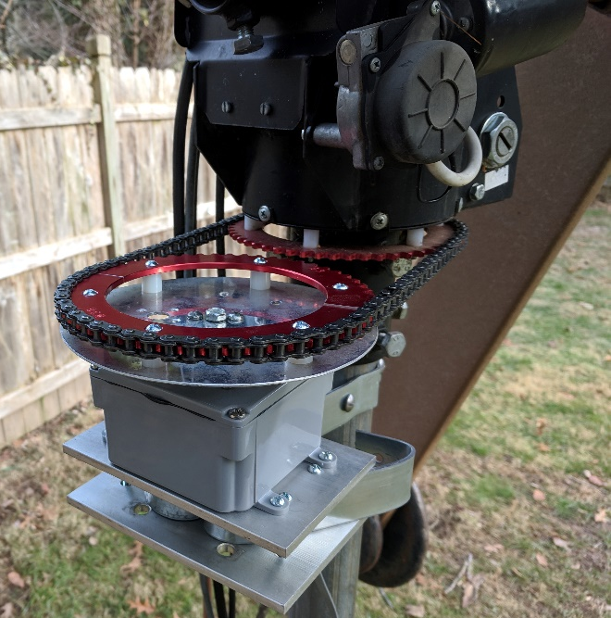
Readout in gray box at bottom left; SPID at upper right

RADIO ASTRONOMY CORNER: See IONAA’s report for more information on Pulsar hunting.

Scientists close to the first sighting of black hole's shadow:
Radio-astronomers from the project Event Horizon Telescope (ETH) have almost finished the processing of 230 GHz interferometry image of Sagittarius A* in the center of Milky Way. In Jan a senior scientist on the project said that “spectacular” data was gathered during observations of two black holes, including Sagittarius A* at the center of our own galaxy and a supermassive black hole called M87 in the Virgo cluster of galaxies. Peter Galison, who is based at the the History of Science dept at Harvard University and is also involved in the project, said that if successful the EHT’s first image would become one of the most significant in the past 50 years of astronomy! All fingers are crossed. See more at:
https://www.theguardian.com/science/2019/jan/11/scientists-close-to-capturing-first-image-of-black-hole-at-the-centre-of-the-milky-way

News from NRAO announced that the VLA (“ng” very large array) Science Book is available online via “Open Access” on the ASP webpage:
http://aspbooks.org/a/volumes/table_of_contents/?book_id=592.
SETI and Fast Radio Bursts: The discovery of a repeating fast radio burst (FRB) source FRB 121102 eliminated models involving cataclysmic events for this source. Avi Loeb from the Harvard-Smithsonian center for astrophysics has posited some outlandish theories suggesting FRB could be evidence of incredibly advanced alien technology.
More info see:
https://www.theguardian.com/science/2019/jan/09/repeating-fast-radio-bursts-from-deep-space-could-be-liens. A full article can be read at:
https://www.nature. com/articles/s41586-018-0864-x.epdf.

FINAL: Our thanks to Rick, K1DS for getting the 2018 ARRL EME Contest scores posted so early – tremendous job! See all 17 pages at:
https://contests.arrl.org/ContestResults/2018/EME-2018-FinalFullResults.pdf.

► Concerns about power restrictions on ON0EME, the 1296 EME Beacon have evaporated. As Eddy (ON7UN) writes: It seems it was a storm in a glass of water. The AirPort radars were having interference from wide band signals such as DATV, but not for narrow band modes. Most likely there will be no change for the beacon, EME or tropo.

► We have received a new worrying report – As of 1 Jan The OZ 13 cm band has been moved from 2300 - 2400 to 2400 – 2450; see https://vushf.dk/transverter-ombygning-til-2400-mhz/. Is this the time to try and move all 13 cm EME to 2400 as many of us have an allocation to TX at this subband?

► The Swedish 432 & UP EME Conference are moving into high gear with the conference little more than 3 months to go. The agenda have been updated with more speaker info - see http://www.sm4ive.com/agenda.htm. New in 2019, all participants will do a short 5-10 min presentation about their station, why you are into EME, and how you became interested in EME. These presentations will be in between the regular program. HB9BBD will do the NF measurements. Dominique would like to know the frequency of LNAs and Noise sources, and how many you may bring. Please send this info ASAP.

► The ARI’s EME Trophy Contest will take place on 16/17 May. The complete rules plus the results of past contests can be found at http://www.eme2008.org/ari-eme/contest.html. Contact I5WBE for questions. Enrico also announces that ARI annual EME Meeting will be on13/14 April at the Marina di Pietrasanta (LU) – Hotel Joseph. For further info please write to I5WBE i5wbe(x)i5wbe.it.

► Ben (SM6CKU) in 1994 organized with his Swedish EME friends organized the 6th EME Conference in Gothenburg (actually in Gotemskar about 40 km south of Gothenburg). SM6KJX spent many hours with his big camera making a video of the event and then editing it. This video now can be watched on YouTube – see https://youtu.be/_ZcCzTlLyGA. For those who were there you can see how you looked 25 years ago. If you were not there, it still should be interesting. Take a look and find out how fun we had! The film is 50 minutes long and is not very technical.

► You can view a video showing the 2018 TD9CHR/ TD9FYC EME dxpedition to Guatemala. See:
https://www.youtube.com/watch?v=xnxVaHpQ8_g.
► This is old news that was missed last month -- WSJT-X version 2.0.0. has been officially released. There is very little that affects EME and microwave operation, but It's still important to upgrade as many of the bugs in earlier versions have been fixed.

► We are very sorry to report that EME and VHF/UHF DXer OK1RK (ex OL1BRA, OK1AUT, 5N0AUT.) has become a silent key at the age of 47. Right before his death, David was working on new 70 cm antenna for EME. See for more details http://www.ok2kkw.com/rip/board.php. May he rest in peace.

► Please keep the reports and tech info coming. We hope the increase in 432 logs submitted to the ARRL EME Contest bods well for a good turnout in the DUBUS 432 CW EME Contest. We will looking for you off the Moon (even with one yagi!) on 16/17 Feb. 73, Al - K2UYH and Matej – OK1TEH

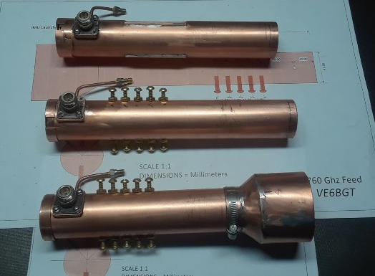
VE6BGT has feeds ready for EME on 6 cm

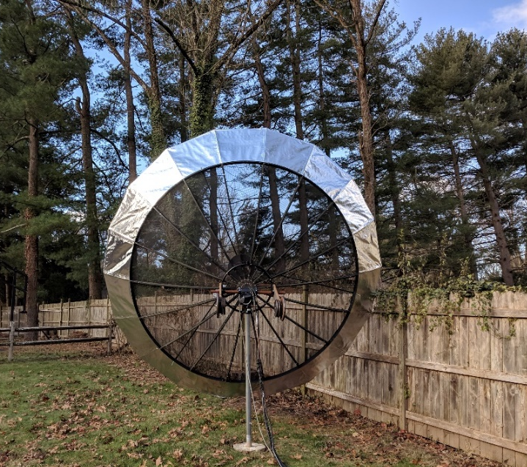
W2HRO’s Moon window for Asia and VK to complete WAC – quite an accomplishment.

