432 AND ABOVE EME NEWS
FEBRUARY/MARCH 2020 VOL 49 #2

EDITOR: AL KATZ, K2UYH; DEPT. ELECTRICAL/COMPUTER ENGINEERING, THE COLLEGE OF NEW JERSEY, PO BOX 7718 EWING, NJ 08628, TEL (W 609-584-8424), (C 609-947-3889), E-MAIL alkatz(x)tcnj.edu
ASSOCIATE EDITOR AND Reflector/NETNEWS Matej Petrzilka, OK1TEH, Simunkova 1609/21, 18200, Praha 8, Czech Republic, TEL (+420 603 489 490), E-MAIL ok1teh(x)seznam.cz
CW INITIAL LIST G4RGK, DAVID DIBLEY, E-MAIL zen70432(x)zen.co.uk, AT: http://www.zen70432.zen.co.uk/Initials/index.html
SUN & EXTRATERRESTRIAL NOISE LIST MANAGED BY OK1TEH: http://www.ok2kkw.com/next/nl_k2uyh/sun_table.xls
EME INFORMAL NETS: 14.345, ~1500 SATURDAY AND SUNDAY, NET COORDINATOR: OPEN
ON0EME EME BEACON, 1296.000 IS QRV WHEN MOON >10°, SEND RX REPORTS TO WALTER (ON4BCB) on4bcb(x)gmail.com
DL0SHF 3 CM EME BEACON, 10368.025, SEND INFO & QUESTIONS TO Per (DK7LJ) per(x)per-dudek.de.
NL EMAIL DISTRIBUTION and EMAIL LIST CORD: WARREN, W2WD wbutler(x)ieee.org
THE NL WEB VERSION IS PRODUCED BY REIN, W6SZ rein0zn(x)gmail.com, AT: http://www.nitehawk.com/rasmit/em70cm.html

CONDITIONS: The big news this month is not the SSB and 432 Dubus contests, but the reception of W5LUA’s EME signals at 47 GHz using QRA64D – see W5LUA’s report and Tech details of JA1WQF 47 GHz system along with comments from RW3BP at the end of the newsletter (NL). This surprising result could be a game changer for EME at 47 GHz and above. The previous QSOs were made by long time integration that took 10 minutes per transmission.

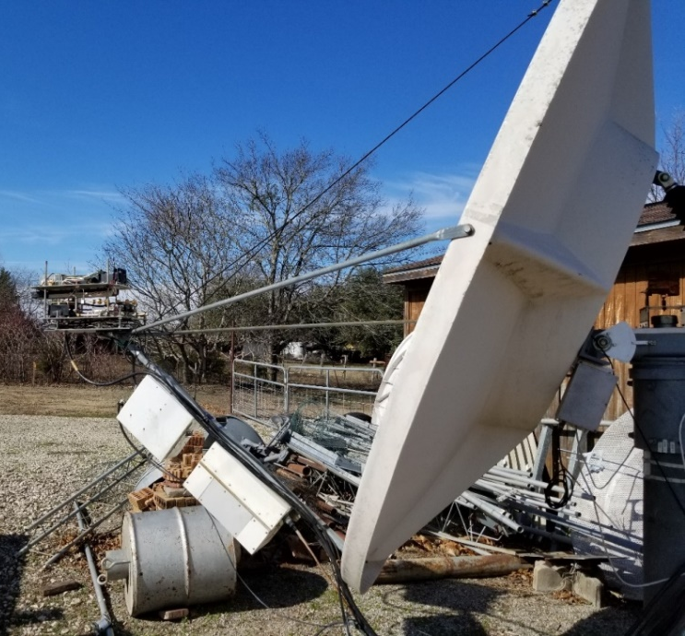
W5LUA’s 47 GHz system at feed of his 2.4 m dish

Activity during the SSB Funtest was significantly down from the past. On 23 cm, OK2DL is the top fun maker with a score of (32x2+1) x 10 = 650 points. Marek was also the top fun maker last year, but with 1,328 points. This year’s score was the lowest since 2014. 13 cm was even worse. SP6OPN is the top fun maker with 21 points. They also won last year with 40 points. These scores are lower than on 70 cm before we moved the Funtest to 13 cm. 13 cm is a great band for SSB, as good and possibly better than 23 cm. Are we giving up on 13 cm because of the politics? We need to make an especially good showing for the 13 cm Dubus Contest. The 70 cm CW was also a bit disappointing after last year’s excellent scores. Weather (WX) appears to be definitely a factor. The top reported score is from SP7DCS with a total of 17x17. Last year, it was over 40 QSOs.

Coming up is the Dubus 9 cm CW EME Contest on 7/8 March. We want to encourage everyone to turn out on 3400 and try CW. If you are having trouble with CW, use JT65C; people will work you and we will recognize high score by any mode in the newsletter (NL). The next 432 CW Activity Time Period (ATP) is on 29 Mar 0900-1100 and 1830-2030. On 4/5 April is the Trophy ARI EME Contest and on 25/26 April the Dubus 6 cm CW EME Contest.

Dxpeditions have increased since Jan’s low. In the beginning of Feb was the very successful OE6V microwave EME dxpedition by the HB9Q team that is reported on in this NL. On location but to our knowledge not yet transmitting is PJ2T, KB7Q’s 70 cm dxpedition to Curacao. Gene will be on the island to 31 March – see his report in this NL. There is also a chance of 432 EME activity from MJ/DH7FB on the Island of Jersey (IN89xf) between 11 and 15 March. The HB9Q team will next be on the Island of Rhodes – see the SV5/HB9COG report later in this NL.

W7CI is a Silent Key: There is more sad news this month. Long time EMEer W7CI has joined the Silent Keys. Steve was a regular on 432 and 1296 EME for many years, and active off the Moon until the end. He will be greatly missed. Steve RIP.

REPORTS:

CX2SC: Ric cx2sc.base(x)gmail.com is setting up for 23 and 3 cm EME -- I will be QRV on 1296 starting the week of 24 Feb. After three years of work and lots of help from LU1CGB, I am ready for operation. I hope to spend the whole week QRV off the Moon form GF25. My station is a 3 m dish with OK1DFC septum feed, 50 to 100 W PA, LNA, GPS locked transverter and FT857 with only a few meters of 7/8” Heliax to the feed. Although in the past CX9BT was QRV on 23 cm in 1994 and there was a dxpedition to Uruguay by DL1YMK that operated on 23 and 13 cm back in 2008, this will be the first that hopefully remain active over an extended period of time. I hope very soon to also put Uruguay for the first time on 3 cm EME. I have a 1.5 m offset dish with a DC5GY feed, a HB transverter with GPS lock based on a W1GHZ design, an LNA made from a surplus Ku LNB, but presently only 1 W of output power. This power was enough for a successful 300 km tropo QSO, but I believe insufficient for EME. I am looking for at least a 10 W SSPA at a reasonable price. I would like to hear from anyone who might be able to help us. [Ric also ask about the status of DL0SHF 3 cm EME Beacon? It is still off air.]

DF8DX: Bodo df8dx(x)gmx.de writes that although he has not been activity on EME during the past year that he hopes to be QRV on 1296 again in the near future -- I am still interested in EME, but changes at work and the purchase of a house in HB9 have temporarily diverted my attention. At my new home, I am planning a bit activity with my old portable EME equipment. I will use just an antenna set up on terrace, but hope to QSO a few of you.

DJ3JJ: Andreas dj3jj(x)gmx.net reports on working stations in 23 cm SSB Funtest -- With my 2.5 m dish and 250 W (x) feed, I QSO’d 7 stations in the Funtest. Worked on SSB unless noted were HB9Q (57/52), DK0SF (53/42), DF3RU (53/43), OK2DL (53/559) CW to SSB (RX), SP6JLW (52/559) CW to SSB, DL3EBJ (52/559) CW to SSB and IK1FJI (51/549) for a score (3x2+4)x2 = 20. I also worked on CW DL0SHF (589/549) and heard LX1DB in a pileup and OZ4MM in QSO with G3LTF, with a lot of QSB. It was great fun with my small dish and good training for digging SSB signals out of the noise.

DK0SF: Slawek (DL6SH) dl6sh(x)online.de operated the 1296 SSB Funtest using my club callsign – I was joined by DG5CST. We made 15 SSB QSOs with SP6JLW, SP6ITF, DF3RU, OK2DL, DL3EBJ, SM5DGX, DK4RC, IK1FJI, OK2ULQ, SP3XBO, SM4GGC, DL7UDA, F1RJ, DJ3JJ and LX1DB for a total of 15x2x2 = 60. Outside of the Funtest, I worked on CW I5YDI, DL0SHF and OK2PE. I would highly prefer the time slot for 23 cm to be from Saturday to Sunday night in 2021. We missed a lot of stations, because we could not be QRV early for the Saturday Moon pass. [11 Jan was chosen for 1296 because of the higher DEC – more Moon time. Next year, we will be more sensitive to the operating times].

DK3WG: Jurg dk3wg(x)web.de reports on his Moon activity in Jan – I added initials on 432 using JT65B with F4VTP, W2P and KD2LGX; and on 1296 using CW with SM5DGX and using JT65C with UA6LCN, N1AV and WA7XX.

DL3EBJ: Chris dl3ebj(x)t-online.de had fun on 23 cm in the SSB Funtest - I was QRV Saturday for booth passes. The Moon and weather conditions were excellent; signals were mostly good copy. I worked 20 SSB/SSB QSO's and a SSB/CW QSO. Contacted were G3LTF, OH2DG, SP6ITF, SM4GGC, IK1FJI, WK9P, SP6JLW, W4OP, OK2DL, VE6TA, K2UYH, SM5DGX, DF3RU, DK0SF, PA3DZL, OK2ULQ, DK4RC, SP3XBO, F1RJ, HB9Q and DJ3JJ (CW/SSB) for a score of (20x2+1)x8 = 328. In 2019, I worked 26 Stations.

DL7APV: Bernd dl7apv(x)gmx.de reports excellent condx on 432 during the DUBUS 432 CW EME Contest -- Echoes were booming and good reports received from other stations. I made a few CW QSOs for DUBUS Contest, but was surprised by the many new stations and good activity on JT. Unfortunately, my time was limited by conflicting family activities. If my memory is correct; after a solar storm condx are usually good. Has anyone else seen this phenomena as well? In the CW DUBUS Contest I made 7 CW and 2 SSB QSOs for total of 9; including IW2MJQ with 2x9 el yagis and 100 W for an initial. Using JT65B I added mixed initials with IK8XLD (JN70) with a single 21 el yagi and 50 W, and on Sunday (during 90 km/h gale) UA4FKD (LO13) with 20 el yagi and 50 W, IK0ZYH (JN62) and F5VKV (JN33). Back in Jan using JT65B, I added VE2PN (FN46), F1IOZ/p (JN07), PA4VHF (JO32) with a 21 el yagi and 100 W with no el, YO2LSP (KN05) 50 W with a 16 el yagi, R9CQ (MO17), NY2NY (FN30) with a 9 wl yagi and 225 W, and F4VTP (JN14) with a 15 wl yagi and 450 W (X-ON4KNG). All my antennas survived the storm OK, but another one is presently on the way.

DL7YC: Manfred dl7yc(x)snafu.de has good news for millimeter-wave (MMW) moonbouncers: On 11 Feb, I received my first time MMW signals at 47 GHz off the Moon. The transmission was made by W5LUA with a 2.4 m dish and 25 W at the feed. His signal was received in Berlin in between 0344 and 0410 at 47,088.100 MHz with my 2.4 m precision prime focus dish, a 2.0 dB NF LNA (at 5 deg outside temp) using auto-tracking. WSJT-X, 1000 Hz and 1500 Hz tones could be easily seen, and both calls and Al`s locator were decoded in three different time periods. QRA64D signal strength was (21DB) best at optimum libration and squint angle conditions for this month. This was only one=way - (not a QSO yet). I estimate that I will need at least 10 W to make a QSO. Even this maybe too small and 20 W a better estimate. Hopefully these results will attract others to jump into MMW EME.

F8DO: Marius f8do(x)orange.fr sends some news on 432 EME -- Conditions were good around second weekend in Feb [70 cm CW DUBUS Contest weekend]. I QSO’d using JT65B DK3WG, PA2V, DL6SH, and UB4UAA for mixed initial #39*, LZ1DX, DF3RU, W2HRO #40* and VK4EME. I ended with a score of 8x8. Conditions were always QRP with my modest 2 x 21 el yagis and 120 W.

G0JLO: Keith's keith(x)analog.co.uk 432 CW DUBUS contest report -- In the first hour after midnight at the contest start (8 Feb), the conditions seemed to be excellent. I worked UA3PTW (579/579), SP7DCS (559/559), OH2DG (569/569) and G3LTF (569/569). I have a couple of hours of tree and house blockage at moonrise so I couldn't start again until 1849 when I worked DL6SH (449/449) for initial #30, followed by SM2CEW (569/569) and SP6JLW (559/559) #31. By this time storm Ciara was starting its first serious attempt to destroy my 8x20 el array. I chickened out, and decided to lowered the antennas. Consequently, there were several getaways, including ES5PC, who had a very nice signal and was called several times but I could only raise QRZs. I think the Faraday may have been the problem there. Also, DL8UCC was heard but not worked. So sadly, Ciara meant this year’s DUBUS 432 CW contest was nothing like as successful as last years with a score of 7x7. Roll on 2021, or maybe there could be another contest before the ARRL all mode event at the end of the year. The Pulsar hunting continues to move ever onwards with 17 now identified, including the fast spin period (1.5 ms) B1937+21 at 11,413 light years distance. This required sampling at 8K/s, which produced a 6.0 dB S/N with 8 hours tracking in a nominal 20 MHz RF bandwidth, although the antenna’s 1dB gain bandwidth only measures 13 MHz on Sun noise.
G3LTF: Peter g3ltf(x)btinternet.com sends news on his Jan/Feb EME -- I was active on 1296 and worked on 4 Jan on CW DG5CST, OH2DG, ON5GS, IK1FJI, G4YTL, I5YDI, SM5DGX for initial #487 and DJ3JJ, on 5 Jan SP6ITF, LA3EQ and AA4MD #488, on 10 Jan, will getting ready for the Funtest, on SSB DL3EBJ, SM4GGC and DL4DTU. Then the weather broke and due to the high winds, and their effects, I only got to operate one moon pass in the Funtest weekend. On 23 cm, I QSO’d using SSB, on 11 Jan between 0000 and 0400 DL3EBJ, OH2DG, SM4GGC, IK1FJI, SP6ITF, WK9P, WA7XX (2-way CW) #489, OK2DL, VE6TA, SP6JLW, W4OP, KA1GT, WA7XX, K2UYH and SM5DGX. I left the feed in hoping to get on for the MR window later in the day, but the wind got really strong in the morning and I had great difficulty stowing the dish. I thus ended with 14x2x9 for 252 points. Although I had everything ready for 13 cm something had gone wrong in the gear train of the hour angle drive and even though the wind had dropped, I couldn’t operate. The drive was then stripped down in the workshop and is now rebuilt and operating again. Conditions on 1296 were excellent with really loud echoes on SSB, but activity was disappointing and I was really sorry to miss 13 cm. However, thanks to all for the nice QSOs, hearing familiar voices on phone via EME is for me very special. And a well done to VE4MA for waking up EME again in AZ! Unfortunately, operation in the DUBUS/REF 432 CW Contest was again badly curtailed by the weather. I was on at 0000 hours on 8 Feb, but activity was low. I worked on CW P7DCS, UA3PTW, OH2DG, ES5PC, VE6TA, G0JLO, WA6PY and DL8UCC. I shut down at 0200. Later on Saturday, at MR, the first winds of a big storm started and I worked DL6SH, LZ1DX, SM2CEW, DL9KR and YL2GD before I had to shut down at 2130 with a total of 14x14. I heard (once only) SP9VFD and CWNR OE3JPC. The QSO with SM2CEW and DL9KR was a 3-way chat for about 10 minutes; very enjoyable and for me a first via EME. The main topic was our 160 m CW systems! Conditions on 432 were excellent, big echoes and low Faraday. If a single yagi station, WA6PY can be worked on random CW, why was Paul the only US station around in the NA window? On Sunday, the storm blew in big time with 70 mph gusts. All my antennas survived, but we lost mains power when a falling tree took down the cable.

G4BAO: John john(x)g4bao.com (JO02cg) is trying to complete WAC on 13 and 9 cm -- While I have no leaves on the trees, I'm looking for skeds with VK and Asian stations on 13 and 9 cm. (I also still need Africa on 9 cm). I have limited low elevation visibility at Moonrise. I have had a winter JT65C QSO with VK2JDS on 23 cm, so It is possible! On 13 cm, I have a permit for operation on 2300-2302 as well as 2320 and and can RX outside these ranges (2304). I have a 1.9 m dish, 250 W and a 0.4 dB NF. Currently, I have no 2400 RX capability; but can probably rig something up, if there was interest in a sked. On 9 cm I've 75 W to my 1.9 m dish and a 0.8 dB NF. I can receive below 3400. Please email me with your sked proposals. I have a 9 cm sked with VK3NX coming up. I am available for skeds with both my call and with a new prefix, GX3EEZ, to make things even more interesting. GX3EEZ is the call of the UKuG club. I will also be checking the HB9Q logger for skeds.
IK1FJI: Valter valter_dls(x)yahoo.it sends his 23 cm Jan report – I was QRV in the SSB Funtest on 11 Jan and worked on SSB DL3EBJ JO, G3LTF IO, OH2DG KP, WK9P EN, SP6JLW JN, VE6TA DO, OK2DL JN, DF3RU JN, DK0SF JN, HB9Q JN and SM4GGC JO, and mixed mode TX SSB to RX CW DJ3JJ JN for a total of (11x2+1) x 6 = 138 points. I found good conditions, always could hear my SSB echoes, but missed lot of big guns worked last year. I also worked using CW on 1 Jan SM5DGX (559/569), DF3RU (579/579), I5YDI (559/569), G3LTF (579/579) and ON5GS (549/569), on 5 Jan OH2DG (579/579), SM5DGX (579/579), DJ3JJ (O/O), NC1I (579/569) and OE5JFL (559/569), on 6 Jan DG5CST on SSB (57/56), PA2DW (O/O), K2UYH (579/579) and N4PZ (589/589), on 10 Jan VK4AFL for initial #131 (559/539), on 11 Jan WA7XX #132 (549/539), DK0SF #133 (579/579) and DL0SHF (589/589), on 12 Jan SM5DGX (579/579), F2CT #134 (569/569) and PA3DZL (569/569), and on 13 Jan VK2JDS #135 (559/559) and F2CT (559/569). I also worked some new stations using JT65C. My new TH327 PA seems to be working great. I am using a 3.2 m dish and the TH327 at ~ 1300 W at feed.

K5QE: Marshall k5qe(x)k5qe.com (EM31cj )was QRV on 432 EME during the ARRL Jan VHF Contest (19 Jan from 0830 to moonset) looking for additional grids and contacts using primarily JT65B but also CW. His station was 16x28 el M2 yagi array on H-pol and 650 W with a tower mounted cavity preamp. He operated mainly on 432.080. Unfortunately, Marshall never followed up his announcement with a report of his results. It is very likely he will be doing the same during future ARRL tropo contests.

K7ULS: Mike k7uls(x)yahoo.com is focusing on 222 EME, but is also active on 432 EME from Utah -- I have only been on 222 since June 2019, and have already worked 18 states and 1 Canadian Provence with a single 17 el LFA yagi with elevation from a Yaesu G-550 rotator and the Armstrong method for azimuth. Of the 18 States, 6 are via EME. The smallest was K1OR who used a single yagi with no elevation on his moonset with 1100 W. So, if you have worked everyone within meteor scatter range, the only other way is by the Moon; and one station needs elevation. It would be nice if both stations were running a KW, but it's not a necessity. For my first 222 EME contact was with N9HF, I only had 220 W from a TE brick. He was running 4 x 16 el yagis and 600 W. I now run a Beko at 700 W, which makes things easier. The hardest part is finding stations in each state to run with that have a long boom yagi and high power. There are a lot of stations out there with 222 gear, but they won't try long enough or think it's impossible. I hope to work other close in States via meteor scatter as they come online, but who knows when this will be. I have also been active on 432 EME with a single yagi and this month added UA3PTW and K5DOG.

N1AV: Jay whereisjay(x)gmail.com (DM43) is now on 23 cm – I am having a lot of fun on 1296 EME, and am close to 50 mixed initials* now. The SSB event was a hoot! It was an experience to see and hear the signals off the Moon. I managed to work one station on SSB, and then had to run to an evening appointment. It was a thrill to work SSB off the Moon. I also enjoyed working stations during the Jan ARRL VHF Contest for major points and multipliers on 1296. Thanks to everyone!

N5BF: Courtney courtney.duncan.n5bf(x)gmail.com writes on his Jan 23 cm EME -- Travel and family events took up much of my Jan; and prevented me from participating in the SSB Funtest weekend. Nonetheless, I still add three new mixed initials using JT65C this month with N1AV #175*, WA7XX #176* and N2QG #177*. It's good to see new stations coming up on 1296 EME.

OE6V: Dan (HB9Q) dan(x)hb9q.ch sends on his very successful microwave dxpedition Austria -- Many thanks to OE6FNG (Werner) and his XYL, Linde, and the OE6V-Team for a great and unforgettable week in southeast Steiermark, Austria! Werner offered us (Dan, HB9CRQ, YL Sue, Sam, HB9COG) to use their contest QTH in Künegg (JN76VT), located on a hilltop in the middle of the Reichmann-Family wine yards. From there we had an amazing 360° view from the Austrian Alps into the Slovenian Alps. After a 840 km drive, we arrived Sunday evening at Werner’s home. On Monday morning, we drove the 15 km to our radio location. There we immediately started building our station. At 10 LT a TV crew from the Steiermark TV Station came to interview us. The same evening a 2.5 minute video was shown on ORF TV. On Monday 3 Feb, we started operation at 1200 on 1296 and worked a total of 37 QSOs (35 on JT65C and on 2 CW) with 35 mixed initials in 16 DXCC and 4 continents. We went QRT at 0000 after more than an 1 hour without any calls. Although we had some gusty winds throughout our operation, we had no antenna problems. On Tuesday, 4 Feb, we started operation just before 1200 on 2320 and worked a total of 13 QSOs (12 on JT65C and 1 on CW) with 11 mixed initials in 8 DXCC and 2 continents. We went QRT at 2100 after more than 2 hours without calls. We had some rain and again gusty winds. On Wednesday, 5 Feb, we had very strong winds gusting up to more than 70 km/h and some snowfall. The wind speed was too high wind to be QRV all the time. So, we had to QRX for several hours and we went QRT at 2120 due to still very strong wind. Never the less, we worked on 3400 11 QSOs (10 JT65C and 1 on CW) with 8 initials in 6 DXCC on 1 continent. On Thursday, 6 Feb, we had a very nice sunny day with only little wind. At our moonrise (2° elevation) we started operation on 5760 and we worked 21 QSOs (13 QRA64D, 1 JT65C and 7 CW) with 15 initials in 11 DXCC on 3 continents. We went QRT at 2400 due to no activity. On Friday, 7 Feb, we had another very nice sunny day with only little wind. We started again to operate on 10368 at 2° elevation. We worked 26 QSOs (23 QRA64D, 3 CW) with 24 initials in 20 DXCC on 4 continents. At 0030 we went QRT due to no activity. On Saturday, 8 Feb, in the morning we dismantled and packed our station. At noon we enjoyed a very nice Farewell-Lunch with Werner and Linde. On Sunday, 9 Feb, in the morning we drove back home where we arrived in the late afternoon. Although we could have worked many more stations, we are very happy with our results: 108 QSOs (94 digital, 14 CW) and 93 mixed initials. QSLs will only be accepted by direct and must including SAE to: HB9Q, PO Box 133, CH-5737 Menziken. The full story with a full log can be found at https://hb9q.ch/2018/?page_id=1999. Last but not least, after a dxpedition is before a dxpedition… stay tuned for the next announcement! [In this NL].

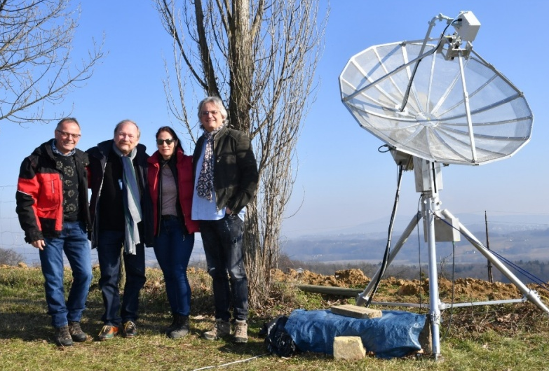
OE6V team (Sam HB9COG, Werner OE6FNG and YL Sue, Dan HB9CRQ,

OK1DFC: Zdenek ok1dfc(x)seznam.cz was mainly QRV during the OE6V EME dxpedition; his report follows – I QSO’d on 5 Feb using JT65C on 9 cm at 1436 OE6V (O/O) for digital initial {#13} and DXCC 10 and 1447 PA3DZL (10DB/23DB); on 6 Feb on 6 cm using QRA64D at 1501 OE6V (16DB/17DB) for digital initial {#17} and DXCC 22, 1512 PA0BAT (10DB/11DB) {#31}, 1522 PA3DZL (11DB/10DB), 1528 JA6AHB (14DB/14DB), 1522 UR5LX (15DB/10DB) {#32} and 1540 OZ1LPR (11DB/10DB); on 7 Feb on 3 cm using QRA64D unless noted at 1745 OE6V (12DB/13DB) for digital initial {#46}, 1756 DF1SR (11DB/11DB) {#47}, 1804 CT1BYM (14DB/15DB) {#48} and DXCC 31, 1811 OK1KIR (8DB/14DB), 1828 PA0BAT (11DB/9DB), 1921 PA3DZL (9DB/9DB), 1921 UA3TCF (17DB/11DB) and 1946 IK0HWJ (9DB/13DB) {#49}; and continuing on 8 Feb at 0008 W5LUA (7DB/11DB), 1810 HB9DUK (17DB/17DB) {#50}, 1830 IK6CAK (22DB/13DB) {#51}, 2123 LX1DB (579/579) on CW and 2134 IW2FZR (19DB/14DB). During the Feb activity days, I found relatively low activity. This was a pity as the WX was great with low temperature and low humidity. Conditions were really good! On 3 cm I measured Moon noise at 1.9 dB. I was ready also for 24 GHz, but did not find anybody who was able to test. I hope for some 24 GHz activity in next EME window.

OK1KIR: Vlada and Tonna vlada.masek(x)volny.cz write on their Jan/Feb EME – Our only activity in Jan was on the 13th from 0500 tol 060 on 24 GHz in long sked with CT1BYM. Miguel was using a 1.8 m dish and 5 W. He received us all the time at (15DB) using JT4F and (16DB) with QRA64D, while we were not able to find a trace from him. Moonnoise was 2.7 dB and it decreased to 2.4 dB when the sked was ending at lower elevation (25 degs) with clouds present. Mutual predicted spread decreased from 170 to 90 Hz during the sked time. On Sunday 2 Feb after installation of our 23 cm feed in preparation for the OE6V dxpedition, we made JT65C QSOs at 1751 F2CT (8DB/9DB) for digital initial {#352},1804 UA6LCN (12DB/9DB) {#353}, 1903 AA4MD (10DB/1DB), 1945 N1AV (12DB/O) {#354}, 1959 OZ1CTZ (26DB/O) {#355} using 2 x 37 el yagis and 60 W and 20:9 DK3SE (20DB/16DB) {#356}. In between with CW at 1915 AA4MD (559/569) for initial #460 and 1934 GM0PJD (O/539) #461. On Monday 3 Feb we worked on 23 cm using JT65C at 1216 OE6V (9DB/7DB) {#357} - unfortunately they were unable to operate CW at this time. On Tuesday, 4 Feb on 2320 with JT65C we QSO’d at 1216 OE6V (11DB/15DB) for digital initial {#73} and with CW at 0228 OE6V (O/O) for initial #176. Later we had a partial with EA8DBM (-/5DB). We could find nothing wrong with our RX. On Wednesday, 5 Feb on 9 cm we worked with JT65C at 1346 PA3DZL (8DB/13DB) from his new QTH and 1403 OE6V (11DB/13DB) for digital initial {#36} and a new DXCC, and 1925 OE6V (O/O) on CW for initial #83 - due to strong wind in OE, our CW QSO was delayed. We measured G/CS noise of 6 dB. On Thursday, 6 Feb on 6 cm using QRA64D we worked at 1322 OE6V (13DB/13DB) for digital initial {#45} and with CW at 1515 OE6V (539/529) for initial #111 and 1543 with QRA64D UR5LX (10DB/10DB) {#46}. On Friday, 7 Feb on 3 cm using QRA64D we worked at 1512 OE6V (13DB/14DB) for digital initial {#201}, 1602 IK6CAK (21DB/12DB) {#202} - his first 3 cm QSO with only 7 W into a 1.2 m dish, 1621 IW2FZR (17DB/16DB), 1631 PA3DZL (10DB/7DB), 1713 F6BKB (14DB/10DB), 1750 CT1BYM (12DB/10DB), 1808 OK1DFC (9DB/8DB), 1852 UA3TCF (19DB/15DB) and 1935 IK0HWJ (11DB/10DB) {#203}. We also copied decodes from HB9DUK (11DB) and F/DD3VY (10DB). Using CW, we worked at 1536 OE6V (449/529) for initial #132 and 2045 LX1DB (579/579). Moonnoise was 3 dB. On 8 Feb, we were again on 3 cm using QRA64D and QSO’d at 1746 HB9DUK (11DB/8DB) for digital initial {#204} and after a swap of feeds to 13 cm worked with JT65C at 1923 DK3SE (15DB/18DB) for digital {#74}. These QSOs were followed by a long night of tests on 24 GHz with CT1BYM. Still on 8 Feb, with high mutual spreading of over 250 Hz, Miguel easily decoded us (15DB) using JT4F, but we could not find his signal. The sked continued with some long breaks, and on 9 Feb during the best time, between 0300 and 0400, Miguel again easily able decoded us (15DB) with both JT4F and QRA64D. Unfortunately, we were only able to occasionally find a weak trace when he was transmitting with a single 1000 Hz tone. However, his JT4F (four tones) could not be decoded by us. Even when the mutual spreading dropped down to 60 Hz did not help. Our moonnoise was 2.6 dB at -4°C with a totally clear sky.

OK1IL: Ivan ivaknn(x)gmail.com has sent -- Since the end of Oct I have tried to pick up initials on 23 cm. New calls in my log are OH1LRY, OZ9KY, SK0UX, DG5CST, W2T and W2P [special callsigns to commemorate the historic battles of Trenton and Princeton], UA6LCN, DK4RC, N1AV, DJ3JJ, G4DDK, IZ4VVS, W7SZ in WA for WAS 24 and OE6V all using JT65C, and SM5DXG using CW to bring me to mixed initial #214*.

OK2DL: Marek sochor(x)kwradio.cz reports on the 1296 SSB Funtest – I had excellent results in the SSB contest and ended with 33 QSOs (32 on SSB and 1 on CW-SSB) for a score of (32x2+1) x 10 = 650 points. Stations logged were on 11Jan at 0216 SP6ITF (57/57) JO81, 0218 IK1FJI (57/56) JN44, 0222 DL3EBJ (58/58) JO31, 0224 G3LTF (58/58) IO91, 0230 WK9P (58/57) EN61, 0232 W4OP (58/57) EM85, 0235 VE6TA (58/57) DO33, 0237 SP6JLW (58/58) JO80, 0240 SM4GGC (57/57) JO69, 0259 WA7XX (56/57) DM, 0304 KA1GT (56/55) FN54, 0320 DJ3JJ (559/53) JN48 CW-SSB, 0349 SM5DGX (57/57) JO89, 0408 K2UYH (58/57) FN20, 0512 N1AV (55/52) DM42, 0528 WB2BYP (52/54) FN, 1717 DL7UDA (55/54) JO62, 1805 DF3RU (58/58) JN59, 1809 DK0SF (55/55) JN48, 1821 VK5MC (58/56) QF02, 1849 VK4AFL (55/55) QG62, 1900 SP3XBO (58/57) JO81, 1905 I5YDI (55/55) JN54, 1912 PA3DZL (57/57) JO21HM, 1919 F1RJ (57/53) JN18, 1927 DK4RC (57/55) JO60, 2009 HB9Q (59/57) JN47, 2106 G4FQI (57/55) IO and 2219 LX1DB (59/59) JN. This year, some less contacts were achieved than last year. Maybe it was because the contest was in two parts; the first from 0000 to around 0700 and the second part from 1900 to 0000 on Sunday. Since I was sleepy, I skipped the first two hours and set my alarm for 0200. Within 10 minutes, the dish was in position and I started to calling CQ. The meteorologists threatened freezing rain, so I kept an eye on the outside temperature. It was slightly above zero, so fortunately nothing freezed. Most of my contacts were made on CQs, as searching for stations was difficult because of the few number calling CQ. For the first time, I used SW SDR Console in live operation. While listening, I used the NR3 function, which is experimental. Compared to the radio, it was really a difference, and listening was more readable. Six new initials were added: WA7XX, SM5DGX, N1AV and DK4RC during the Funtest, and OK1TEH and DK2AN out of contest using JT65C. A total of 29 contacts (last year was 45). From OK, I worked only OK2ULQ. [OK1TEH translated the last part of this report from OK2DL’s blog at http://www.ok2dl.eu - TNX].

OK2ULQ: Peter ok2ulq(x)seznam.cz wrote on his EME blog on his EME SSB Funtest activity -- The beginning of the year brought windy weather that bent the center tube of my antenna mount. Despite the damage, I decided to try to operate contest. I started on Saturday evening, and by the few stations present. I made SSB contacts with OK2DL, DF3RU, DL3EBJ, SP6JLW, DK0SF, HB9Q and a new station for me was DK4RC for a score of (6x2)x2. Another new station was SM5DGX, who was on CW. I could not QSO any other stations, so I tried WSJT and made 8 additional QSOs. Initials were ES3RF, EA5DOM, DL7AIG and GX3EEZ [same as G4BAO]. [Translated by OK1TEH from OK2ULQ’s blog http://ok2ulq.blogspot.com/2020/01/ eme-ssb-fun-contest-2020.html.

ON0EME: Eddy (ON7UN) ejespers(x)telenet.be reports the 23 cm EME Beacon is down -- I checked the ON0EME Moon Beacon and found a burned out output board in the W6PQL. The MRF13750H seems to have survived. Tomorrow (13 Feb) I will attempt to remove the output board (the board has been glued to the copper spreader with Silver Epoxy). I have some spare boards available. I hope to get the repair done before next week Tuesday - (weather forecast is not very promising and I plan to attend the GHZ meeting in Dorsten, DL this weekend; and then will be traveling to EA5 on Tuesday. If it is not possible to get the repairs done, it will be early March before I can get the beacon online again. If weather permits, I will try to install a lower power amp, but we have a new storm coming this weekend. It is most likely that I will not be able to work on the beacon until after 27 Feb.

OZ1FF: Kjeld kjeld(x)oz1ff.dk send news on his Jan/Feb 3 and 1.25 cm efforts -- On 10 GHz using QRA64D I worked CT1BYM, HB9DUK, IK0HWJ, ZS1LS for DXCC 39, OE6V and W3SZ to bring me to digital initial {#68}. My rig on 3 cm is 2.4 m offset dish with 50 W at feed. On 11 Feb, I was heard by CT1BYM on 24 GHz using QRA64D at (21DB). On 1.25 cm, I am using the same dish as on 3 cm, with 10 W at feed.

OZ4MM: Stig gsvestergaard(x)gmail.com writes that he has nothing special to report – I have not been able to be QRV since Nov as every time I plan to operate, we have had high winds. As a result, I missed the 23 cm SSB Funtest. I will try to be QRV for the Dubus 432 CW Contest because of family social events. I am working on a new SSPA to replace my old tube TV transmitter, as flashover has become quite common. I need more time to complete the redesign and modifications, but I am making progress.

PA0PLY: Jan pa0ply(x)pa0ply.nl sends news his recent Moon activity – In Jan I was on 23 cm and worked using JT65C unless noted on 2 Jan RA4HL (14DB/13DB), IK1FJI (13DB/17DB), G4FQI (9DB/14DB), ES3RF (23DB/20DB) and W2P (24DB/20DB) for mixed initial #146*, on 3 Jan AA4MD (9DB/15DB) #147* and G4DDK (23DB/19DB )#148*, and on 4 Jan BD4SY (15DB/14DB) #149*, DG5CST (559/559) on CW #150*, SM5DGX (559/539) on CW #151* and I0NAA (15DB/15DB) #152*. While preparing to increase my RF power on 23 cm, I lost one of the FET’s in my DF9IC SSPA. Thanks to PA0BAT, I now have 2 modules, which will provide me 500 W. I expect to be QRV again on 23 cm by end of Feb. I was active during the 13 cm SSB Funtest on 12 Jan and QSO’d using SSB to CW SP6OPN (59/559) for mixed initial #15* and K2UYH (53/559) #16* for a score of only 2x2 = 4. There was dramatically low activity on 13 cm during this event. I set up 13 cm in anticipation of more activity – very disappointing. I did add initial using JT65C on 17 Jan with ON4AOI (21DB/22DB) #17*, and on 4 Feb (during the activity generated by the OE6V dxpedition) OH2DG (14DB/11DB) #18*, UA3TCF (19DB/21DB) #19*, DF3RU (10DB/O) #20*, OE6V (30DB/16DB) #21* and PA3DZL (10DB/16DB) #22*. I was surprised that OE6V was really on the edge and barely visible on the JT waterfall screen. I expected a stronger signal from Dan compared to his signal on 23 cm during earlier expeditions. My 2320 system is 3 m dish, 70 W SSPA and G4DDK LNA. [For info on the KLNA 24 GHz LNAs see For Sale section of this NL].

PA3DZL: Jac is QRV off the moon again after a QRX of almost 20 months because of his move to a new QTH -- I made my first QSO on 23 cm on 28 of Dec - my goal was to be QRV before the end of 2019! It was a lot of work, but “no pain no gain”. I am using my 3.7 m Andrew solid dish, which I used at my old QTH. I made improvements to the AZ and EL gears… No backlash anymore due to a nice slewing drive for AZ and bigger actuator for EL. My tower is also new and tiltable. Thus far I have made 53 QSOs on 23 cm in modes of SSB, CW and JT65C. I had great fun during the SSB FUN contest on 23 cm. I am happy with my results, but have room for some improvements such as a lower loss TX feedline (potential for 1.5 dB more power). I also have a new feed for 1296 ready. I should be QRV again on 70, 13, 9, 6 and 3 cm soon. During the summer, I will also work on my 2 m EME setup. Some pictures can be seen on my QRZ.COM page. The OE6V dxpedition was a trigger to become QRV again on 13, 9, 6 and 3 cm from my new QTH. It was hard work but I made it. On Wednesday and Friday, I had a day off from QRL, which gave me time to prepare the station to operate on the different bands. Was very happy to QSO OE6V on all 5 bands. Beside OE6V, I was very pleased to work some other nice QSOs, initials and DXCCs. I worked on 2/3 Feb on 1296 GMØPJD for an initial (#*), N1AV (#*), SM6CKU, N4PZ, SM5DGX and OE6V (*#); on 4 Feb on 2320 OE6V (#*), UA3TCF (#*), OE6V Dup, PAØBAT, DF3RU and PAØPLY (#*); on 5 Feb on 3400 OK1KIR, OE6V (#*) and a new DXCC and OK1DFC; on 6 Feb on 5760 OE6V (#*) and DXCC, JA6AHB (#*), OE6V dup and OK1DFC (#*); and on 7 Feb on 10368 OE6V (#*) and DXCC, OK1KIR, OK1DFC, UA3TCF (#*), CT1BYM (#*) and DXCC, IKØHWJ (#*), IW2FZR, W3SZ (#*), OZ1LPR and ZS1LS (#*).

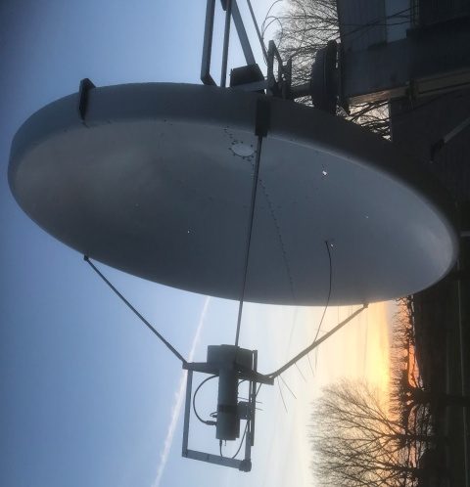
PA3DZL’s 3.7 m dish mounted at his new QTH

PI9CAM: Jan (PA3FXB) jvm(x)netvisit.nl writes the team was sorry to miss the EME SSB Funtests this year – One reason was the error in date that initially appeared in the NL. It is not possible for us to get TX permission on a short notice. Also, the contest conflicted with the annual Heelweg Microwave meeting. When we realized the correct date, it was too late to make a change.

PJ2T: Gene (KB7Q) geneshea(x)gmail.com is currently QRV from Curacao on 70 cm EME – I will be on the island from 13 Feb to 31 March at (FK52kg) Santa Marta Bay, Curacao. I plan to operate on 432.090 first using JT65B with a 1 x 9 wl yagi, 500 W, WD5AGO preamp, IC9700 w/GPSDO. I will have Internet and will come up on the HB9Q Logger. I am care-taking of the PJ2T HF contest station again this winter. As time permits I will be able to operate 70 cm EME. This will be mostly a JT65B mode operation given my QRP status, but if called on CW I will reply on CW. I'll try and get on and debug the gear sometime around February 13/14, but the main operating window that works best with my schedule appears to be 1 to 13 March. Donations are greatly appreciated, as it takes two checked bags to move the EME gear to Curacao and back. I am also planning 70 cm EME operation from TX7MB, Marquesas in Nov. 144 will be the main focus, but it sure would be nice to get this rare DXCC country up on 70 cm as well.

SM4GGC: Stig stig.ake.larsson(x)gmail.com reports on his Jan/Feb 1296 EME operation -- I was active in the 23 cm SSB Funtest a couple hours early on Saturday and on Saturday evening. I manage to work 10 SSB/SSB QSO and 1 CW/SSB QSO. In the mode CW, I also work WA7XX (549/549). Before the contest started I made a mistake by trying another mic with a PPT button. I forgot that protection relay at the feed is only switched by my PTT foot switch. So, I had to put my spare LNA in the feed in the dark just before the contest started. [Sounds so familiar]! I did record some of the SSB QSOs that I made – listen on https://www.youtube.com/playlist?list=PLtz98w8uKEGJhkexZxrBqdR9o5d_h8843. I QSO’d on SSB unless noted in the 23 cm Funtest on 11 Jan at 0034 OH2DG KP (56/44), 0051 DL3EBJ JO (55/55), 0058 G3LTF IO (54/54), 0240 OK2DL JN (57/57), 1715 SP6JLW JO(55/54), 1738 SM5DGX JO (55/529) CW/SSB, 1753 DF3RU JN (55/55), 2026 DK0SF JN (54/54), 2030 HB9Q JN (58/57), 2036 DF3RU JN (55/55), 2122 DK4RC JO (55/52) and 2128 IK1FJI JN (54/54) for at total of (10x2+1)x4 = 84 points. After the contest, I made the following QSO’s on 19 Jan using JT65C UA6LCN (14DB/15DB) and W1XM (17DB/12DB), on 30 Jan using CW SM5DGX (559/559), 1 Feb using CW VK4AFL (549/549) and OH2DG (569/569), 2 Feb using CW SM5DGX (569/569), G4CCH (559/569) and SP6ITF (539/539), on 2 Feb using JT65C L3EQ (13DB/18DB), N1AV (9DB/10DB), GM0PJD (18DB/16DB) and K7EME (O/O), 3 Feb JT65C OE6V (20DB/14DB), F1RJ (9DB/6DB) and G4DDK (16DB/10DB), and 3 Feb using CW W2BYP (569/559) and N4PZ (569/579). My Rig is a 3.9 m dish with a 600 W SSPA at the feed.

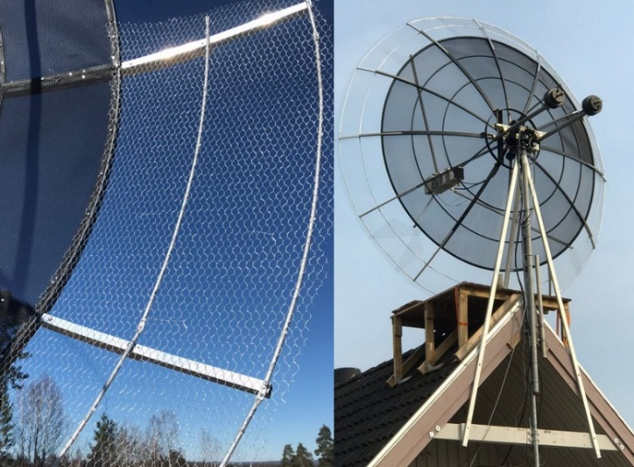
Details of SM4GGC’s extension of his dish to 3.9 m

SP6JLW/SP6OPN: Andy (SP6JLW) sp6jlw(x)wp.pl writes about his contest groups activity in Jan/Feb -- The 2020 contest season has begun. We started on two bands in the SSB Funtests. We used the calls SP6JLW on 23 cm and SP6OPN on 13 cm. We found very little activity on 13 cm and wonder why? SSB signals should be better there than on 23 cm. On 1296 we made 20 SSB/SSB QSOs and 2 CW/SSB QSOs with DL3EBJ, OK2DL, VE6TA, G3LTF, W4OP, IK1FJI, DJ3JJ (CW-SSB), K2UYH, SM5DGX, WB2BYP (CW-SSB), SM4GGC, DK0SF, DF3RU, DL7UDA, SP3XBO, SP6ITF, PA3DZL, OK2ULQ, F1RJ, DK4RC, HB9Q and LX1DB for a score of (20x2+2)x6 = 252 points. On 13 cm we made only 3 SSB/SSB QSOs and 1 CW/SSB QSO with PA0PLY (CW-SSB), K2UYH, OH2DG, SP3XBO for a score of (3x2+1)x3 = 21 points. We were also QRV for the 432 DUBUS/REF EME Contest under the callsign SP6JLW. This time we suffered from bad (windy) weather. We could only operate for one moonpass from Saturday to Sunday. In the late evening the wind increased hour by hour. There gusts threatened our antenna system. Near our moonset, the band was quiet; no NA stations appeared, so we went QRT. QSO’d were OH2DG, UA3PTW, SP7DCS, G3LTF, SP9VFD, DL6SH, DF3RU, SM2CEW, G0JLO, DL8UCC, DK3WG, DL7APV, YL2GD, ES5PC, PA2V and DL9KR for a total of 16x16. Thanks to all for keeping the band alive and the great contacts.

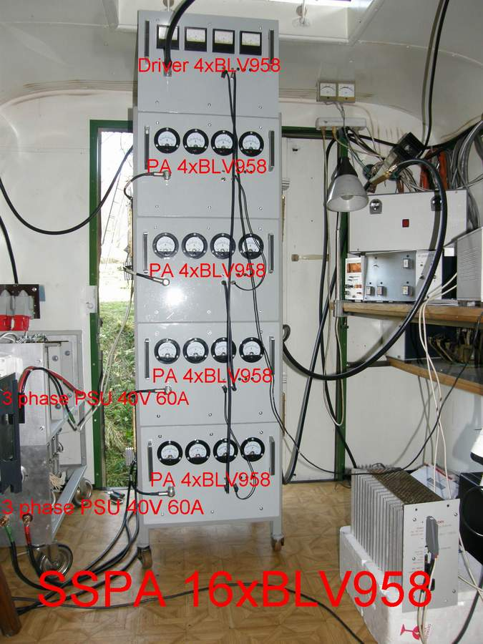
SP6JLW’s “small” 1.2 kW SSPA for 23 cm

SP7DCS: Chris sp7dcs(x)wp.pl operated in the 432 Dubus/REF CW EME Contest -- I was QRV only Saturday (8 Feb) and I worked OH2DG, WA6PY, VE6PY, DL6SH, UA3PTW, SP6JLW, SM2CEW, G3LTF, G0JLO, DK3WG, ES5PC, DL8UCC for an initial (#), SP9VFD (#), DL7APV, PA2V (#), DL9KR and DF3RU for a total of 17x17.

SP9VFD: Rafal sp9vfd(x)protonmail.com sends info on his participation in the Dubus 432 CW EME Contest – I was QRV from on 8 Feb 0000 to 2200 using 8 x 23 (8 wl) yagis and a new HB GS35B tube PA that was put into operation just before the contest. In the first moonpass, I had very poor weather conditions with a lot of snow on my yagis. Mr. Faraday was also not cooperating and disturbed my reception of weak signals. I heard some weak stations who called from VE, but never copied all the letters. In the second moonpass weather conditions were much better and the snow disappeared from my antennas. Received signals levels were much improved, but around 2200 my TR relay failed at splitter near antennas about 14 m over the ground. At the time, in middle of the night, it wasn’t possible to fix the relay. I was disappointed as it ended my contest operation. I had hoped to make some QSOs with North American stations. The reason for the relay failure appears to be problem with my TR sequencer. Despite the problems, I worked in the contest UA3PTW, ES5PC, OH2DG, WA6PY, SP6JLW, DL6SH, SM2CEW, SP7DCS, DK3WG and DL7APV for a total of 10x10. I also called DL9KR just when my relay failed and was not able to complete a QSO. I am looking forward to more 432 EME – Thanks all.

SP9VFD’s 8 x 23 (8 wl) yagi array

SV5/HB9COG: Dan (HB9Q) and the Q-team announce their next dxpedition to Rhodes on 23 thru 3 cm from 23 to 31 May – We will fly to Rhodes, the mayor island of the Dodecanes. We will be on the island for 18 days, doing some sightseeing/vacationing and of course EME on 23, 13, 9, 6 and 3 cm with capability for all sub-bands. The house on the southeast side of the island is already booked, so are the flights from Zurich to Rhodes and back. Team members this time are Sam HB9COG, Dan HB9CRQ and Sue (Dan’s YL). Our QTH is in KM36xa, directly at the beach. So MR should be perfect! For MS we expect some 10 to max 15° elevation due to the mountains and some trees. We will only know exactly once we are there. We should have good enough MS to work the US-Westcoast. We decided to be QRV during 2 weekends, hoping that this will help more stations to be QRV. Operation will begin on 23 May on 1296.100 using JT65C (1st with RX on own echo on all bands) from 0330 until 1630; then on 24 May on 2320.100 JT65C from 0415 until 1730 (2301.990 and 2400.100 on request only, please send e-mail to dan(x)hb9q.ch), 2304.100 (QSY will be announced on HB9Q logger); on 25 May on 3400.100 JT65C from 0500 until 1800 (3399.990 1st on request only); on 29 May on 5760.100 QRA64D CFOM from 0900 until 2130; on 30 May 10368.100 QRA64D CFOM from1010 until 2200, (10450.100 on request only); and on 31 May on 1296.100 JT65C from 1115 until 2245. CW, although near our limit, we will work CW on all bands. However, only with big-guns and after the pile-up on JT/QRA are over.

UA3PTW: Dmitry ua3ptw(x)inbox.ru was QRV in Jan – I worked initials, on 432 using JT65B with R9CQ; and on 1296 using JT65C N1AV and WA7XX. [TNX DK3WG for forwarding this report].

UA3TCF: Alex ua3tcf(x)mail.ru reports on his EME operation from the beginning of 2020 -- In Jan, I QSO’d on 10 GHz using QRA64D UR5LX (14DB/16DB), and on 14 Jan using CW OK1DFC (O/O). On 13 cm using JT65C, I worked ON4AOI (O/20DB), PA0PLY (O/19DB), OE6V (O/O) and PA3DZL (O/O). On 3 cm, I added using QRA64D unless noted on 5 Feb HB9DUK (14DB/20DB), on 6 Feb HB9DUK (15DB/20DB), on 7 Feb OE6V (18DB/19DB), OK1KIR (18DB/19DB), UR5LX (14DB/17DB), OK1DFC (11DB/17DB), PA3DZL (13DB/19DB) and PA0BAT (14DB/ 18DB), and on 8 Feb using CW UR5LX (O/M) and LX1DB (559/559).

UR5LX: Sergey ur5lx(x)ukr.net send a report on his 3 cm EME in Dec – I QSO’d with QRA64D on 6 Dec HB9DUK (15DB/19DB) - first EME QSO for HB9DUK who used 1.8 m dish and 80 W, on 12 Dec F4VTA (13DB/12DB) and on 13 Dec CT1BYM (16DB/19DB) for mixed initial #105* and new DXCC. I am using on 3 cm EME a 2.4 m offset dish and a 20 W SSPA.

VK4AFL: Trevor tbenton(x)bigpond.net.au has been active on both 23 and 9 cm in the last few months – I am always looking for contacts. Recent I add new ones on 9 cm with VE6BGT and SM3BYA, and on 23 cm with I5YDI, DJ3JJ, IK1FJI and WA7XX. During the 23 cm SSB Funtest day last month I worked a few on CW and heard four stations on SSB all good copy, but with my power level I was only able to complete with OK2DL. I will change back to 9 cm for the March contest; and will be working split when required with TX on 3399.800.

W2ZQ: Paul (W2HRO) w2hro.fn20(x)gmail.com bring us up to date on 1296 EME from the DVRA club station -- Our 23 cm EME (10’ dish) setup performed well during the holidays. We also operated on EME used the calls W2T and W2P as part of the club’s Special Event activity celebrating the Washington’s Crossing of the Delaware and the battle of Trenton, which occurred during the US Revolution. Their location can be literally seen from the club station. The following 1296 EME stations worked both W2T and W2P and quality for the special Lieutenant certificate: AA4MD, OKL1IL, PA0PLY, PA3DZL, DJ2DY, and IK1FSI. We also work I5YDI, G4CCH, K5DOG, ON5GS, DF3RU, G4FQI, SP5GDM, ES3RF, ES6FX, DF3RU, and VE3KRP. (The EME ADI files have been added to LoTW). We received our 1st EME QSL card from PA3FXB, who was also our 1st QSO. We have upgraded our preamp to a VHFDesign LNA with an integrated interdigital bandpass filter to suppress some of the RFI seen when the dish is pointed toward a cellphone base station. The new preamp is making a huge improvement. Our next upgrade is to move the 250 W SSPA out to the dish to reduce cable loss. Currently, we lose 6 dB of our TX power in a 100’ LMR600 cable. Please email if you would like a sked.

W5LUA: Al w5lua(x)sbcglobal.net has been working on 47 GHz EME – I am very pleased to report that JA1WQF was able to successfully decode my 47088.1 MHz QRA-64D signal on 10 Feb. These were one-way tests with only me transmitting. At the moment Mitsuo has only 1 W, but is working on a 10 W PA. I am running a 30 W TWTA which produces about 25 W at the feed. The tube is a Hughes 932H driven by a Varian VPW2931 power supply modified for a second suppressed collector of the Hughes TWT. Both of us are using 2.4 m offset fed dishes. My system NF is 4 dB; JA1WQF has a NF of about 2.5 dB. We are using the “Constant Frequency on Moon” (CFOM) technique of frequency control, which allows you to hear/see the other station and your echoes on the same frequency. I started out by sending single tones to Mitsuo, which he copied well and then sent several sequences of calls and grids. Mitsuo was able to decode calls and my grid at 1146Z and 1234Z on 10 Feb. Signal levels were (23DB and (25DB). DTs were spot on and frequency was within 13 Hz. On 11 Feb, I had similar successful 1 way tests with DL7YC. Between 0348 and 0352, Manfred copied my QRA-64D signal with (21DB to 23DB) reports. We chose times that were at perigee and minimum libration. As a side note, the first EME on 47 GHz took place back in early 2005, with RW3BP working AD6FP (now K6MG), W5LUA, and VE4MA. VE4MA also went on to work AD6FP. It is nice to see a resurgence of EME activity on this band. The first EME QSOs that took place on 47 GHz utilized a program called MMCW, which was a program written by a friend of RW3BP’s. The MMCW program required 10 minute transmissions in order to enhance the signal to noise ratio for optimum decode. It is very encouraging to see a WSJT mode provide similar decodes with less than 1 minute transmissions. I am looking forward to making several QSOs on 47 GHz EME this year.

WA6PY: Paul pchominski(x)maxlinear.com was QRV in the Dubus 432 CW EME Contest -- I QSO’d using a single yagi DL8UCC, ES5PC, G3LTF, OH2DG, SP7DCS, SP9VFD, UA3PTW and VE6TA for a total of 8x8. All signals were heard with vertical polarization, however my echoes in average were stronger using horizontal polarization. I plan to be in the 9 cm contest on 7/8 March.

WB2BYP: John storyavenue(x)hotmail.com was on for the 23 cm Funtest for a short time -- I had QSOs with OK2DL SSB/SSB, SP6JLW SSB/CW and K2UYH SSB/SSB for a score of (2x2+1)x3 = 15 points. Heard but not worked were SM5DGX and KA1GT. I was also QRV on 1296 and QSO’d on 31 Jan N4PZ on CW. I installed a 300 W SSPA in the shelter below my dish and worked 1 Feb WK9P, DF3RU, SM5DGX and N4PZ all CW, and DF3RU on SSB, and on 4 Feb RA4HL, RN6MA, DF3RU, DL8FBD, SM5DGX and SM6PGP all on CW. I am planning to put my 3400 feed in for the March DUBUS Contest.

WK9P: Tim tcherrone(x)yahoo.com reports on his recent 23 cm activity – In Jan, prior to the Funtest, while testing for my 23 cm SSB echoes, I was surprised by how well I copied them. On 7 Jan, I worked DG5CST on SSB, which was exciting. During the Funtest, due to winter weather here, I was QRV for less than 2 hours. On 23 cm SSB both ways, I worked OH2DG, DL3EBJ, IK1FJL, G3LTF and OK2DL for a total of 5x2x4 = 40 points. I heard W4OP as I was going QRT due to the heavy Ice. After the Funtest, I had a large tree trimmed, which gives me a new lower declination window.

XE1XA: Max general.manager(x)corix.us writes -- I have not been very active on EME in the past months, due mainly to trips, family issues and minor health problems. I was very sorry to miss the SSB Funtest this Jan. With my dish and 250 W, I can copy Q5 my SSB echoes. There should be a lot more stations capable and interested in trying SSB QSOs more often during random operation. What about having an SSB call frequency? Lets say 030, for any time the moon is close to perigee? I was very pleased to successfully participate in the last PI9CAM SSTV test, and even if PI9CAM will be not able to repeat such tests more often, I think that there would be probably more EME stations capable to put a decent SSTV signal off the moon. Those additional modes of operation will eventually enhance the interest in experimenting between the EME community.

OK1TEH: I (Matej) ok1tehlist(x)seznam.cz focused my EME time on perigee, around 8/9 Feb on 70 cm; and I enjoyed great EME condx. I worked using CW DL9KR and DL6SH with very nice signal for two CW initials, and using JT65B DL6SH (15DB/17DB), LZ1DX (23DB/25DB), W2HRO (26DB/20DB) for mixed initial #135*, LU8ENU (28DB/27DB) #136* and DXCC 54 (1 yagi to 2 yagi QSO), JA4UMN (27DB/23DB) #137*, DF3RU (18DB/28DB), ES3RF (25DB/26DB) and S51LF (27DB/25DB). I was especially happy with my 432 QSOs with LU8ENU and JA4UMN. I had tried for LU many times beginning with LU7DZ some 13 years ago. At the time I heard and saw Eduardo quite well, but unfortunately he had problems with decoding me because of signal drift and then became an SK. During the last 8 years I spent a lot of time skedding LU8ENU; however his signal was always too weak. Then during the last ARRL EME Contest, I put my single yagi 40 cm further out on the H-frame from the mast. My system preformed about 1 to 2 dB better. Finally, I was able to copy LU8ENU (29DB)!. Since then, it was just a matter of time. Juan TNX for your patience! I'm the smallest station he has ever worked on 70 cm. New target is to work are 4Z5CP, XE2AT or BD9BU. Perhaps it's impossible, but impossible contacts challenge me. In the meanwhile I’m preparing some new antennas, but have not had much free time for ham radio. CU at HB9Q chat around next Perigee.

K2UYH: I (Al) alkatz(x)tcnj.edu put my 1296 feed back in my dish on 6 Jan to check out my system in preparation for the upcoming SSB activity. I worked at 2350 IK1FJI (569/579) on CW and on 7 Jan at 0010 N1AV (2DB/7DB) using JT65C for mixed initial #629*. All seem to be working well. Two days later, just before the start of the 1296 SSB Funtest, I put the dish on the Moon and promptly blew 2 LNAs, one after the other. It turned out one of the wires to my protection relay at the feed horn was making an intermittent connection. By the time I had located and replaced the bad connection at the feed in the dark and cold, nearly 4 hours had passed. And I only had a few mediocre preamps left. (I had not repaired several bad preamps that I previously blown; probably from the same cause). I could tell that my RX was degraded by the drop in moonnoise. I then on 11 Jan QSO’d in the Funtest at 0355 SP6JLW (55/56) SSB JO, 0400 G3LTF (56/57) SSB IO, 0407 OK2DL (57/47) SSB JN, 0426 VE6TA (56/56) SSB DO, 0439 DL3EBJ (56/56) SSB JO, 0457 SM5DMX (55/56) SSB JO, 0540 I5?? (24/55) SSB – no QSO, 0550 WB2BYP (44/55) SSB FN and 0600 KA1GT (559/52) FN CW-SSB for a total of (7x2+1) x 5 = 75 points. Not one of my best Funtests. The next day, I set up for the 13 cm Funtest. The WX was beautiful and I was anticipating a great contest. K2QFA come over with his YL to show her EME. The only problem was that there were (almost) no stations. I worked on 12 Jan at 0231 PA0PLY (559/53) JO CW-SSB - Jan had no SSB and 0240 SP6OPN (58/57) JO for a disappointing score of (2+1) x 1 = 3 points. We heard no other stations. SP6OPN had a huge signal to impress K2QFA’s YL! I was so discouraged that I did not get up for the VK/JA window. I was QRV again for the ARRL’s Tropo VHF Contest to give out some points on 19 Jan. I worked on 1296 using JT65C at 1024 N1AV (5DB/0) DM43, 1039 HB9Q (1DB/1DB) JN47, 1045 LU1CGB (11DB/O) GF05, 1053 G4CCH (9DB/11DB) IO93 and 1102 WA7XX (12DB/O) DM42 #630*; then switched to 432 using JT65B at 1255 K5QE (14DB/O) DM43, but had the driver amp to my tube PA fail; I did not have enough power to work KD2LGX and K7ULS, who were copied. I went back to 1296 to add at 1409 W2ZQ (O/O) FN20 #631*, 1414 K5DOG (10DB/5DB) EM00, 1430 VE6TA (4DB/1DB), 1436 W1MX (20DB/4DB) FN42 #632* and 1609 VK4CDI (12DB/12DB) QG52. I had wanted to work the OE6V dxpedition, but an old Sciatic nerve problem returned at many years that limited my mobility near the end of Feb. At times I could not walk and I was unable to change feeds without assistance. On 5 Feb, K2QFA was able help me put in place my 9 cm feed; but the dxpedition had bad WX and was not able to be QRV during my Moon window. Chris was again available to help on 6 Feb; and I worked on 5760 using QRA64D at 2320 OE6V (15DB/15DB) for mixed initial #64* and DXCC 31. The next day, it was my turn to have high winds and I did not try to change to my 3 cm feed. I was also tried to QRV for the 432 Dubus CW Contest with a replacement driver amp. Unfortunately, it would not work with my PA due to a VSWR problem. It kept turning off and I only contacted on 9 Feb at 0535 VE6TA (559/559) before I lost power. I also tried it on JT65B at 0553 R1NW (18DB/-) but did not have any better luck keeping it on. I plan to be QRV for the 9 cm Dubus Contest in March and hope to do better.

NET/CHAT/LOGGER NEWS: W4OP was QRV during SSB Funtest on 1296, but could not operate the next day due to very bad WX. G4NNS plans if WX permits to be QRV on 24 GHz on 8 March for the 24 GHz APT proposed by OK1DFC. OZ1LPR will try to be on 24 GHz on 8 March. PA5Y is build a 5 m dish for 1296 EME and looking for a feed. SM5GDX was active on 23 cm during the SSB Funtest with a good signal. WA3QPX has a 12’ dish mounted with a DFK Septum feed in place for 1296 EME.

FOR SALE: PA0PLY reports the KLNA (24 GHz LNAs) are making progress. The pilot units are all modified now and have a general performance of 1.1 dB NF and 32 dB gain. I expect the new rev B production units to be on schedule for the end of April. See www.pa0ply.nl. K1DS is interested in an elevation rotor to use for EME from his FL QTH. If have something contact Rick at k1ds(x)hotmail.com. N1DPM has for sale 1) a 902/903 -144/145 DEMI transverter NF<1dB with 250 to 300 W MRFE6VP5600 LDMOS SSPA and RX. TR antenna switching relay included on an aluminum plate, ready to run. Needs 12 and 50 V PS - not included; 2) 1296-144 DEMI transverter with external < 1 dB NF LNA, 3 W DEMI driver and Infineon PTF 14150E ~100 W SSPA. TR antenna switching relay included on an aluminum plate, ready to run. Requires 12 VDC and 28 VDC PS – not included. A spare PTF 14150E FET is included; 3) 2304-144 DEMI transverter packaged in a milled aluminum enclosure with external <1 dB NF LNA, with 3 W driver and a SSPA consisting of a pair of base station modules hybrid combined to make ~225 W. Output antenna T/R switching is included and ready to run. The system is packaged on a chassis with PS. And lots more stuff. 4) 3456-144 DEMI transverter packaged in a milled aluminum enclosure with ~ 0.7 dB NF LNA and a Toshiba ~45 W SSPA. All built on a chassis with power supply included and T/R antenna relay - ready to run. Plus lots of more stuff of interest. Contact Fred at n1dpmfred(x)gmail.com for more information and pricing. SM4IVE has new DB6NT 9 cm transverter kits and assembled units for sale. Contact Lars at sm4ive(x)telia. com for details and http://www.sm4ive.com/forsale.htm. PA5Y is looking for a SM6FHZ 5 step 1296 septum feed or someone who while fabricate one for him. If you can help contact Conrad at g0ruz(x)g0ruz.com.

OK1EM MMW EME STORY: Matej (OK1TEH) writes that not well known are the other stations who are working to be QRV EME whose efforts have sadly been foiled because of local restrictions. One of such ham is OK1EM. Eda is well known from his operation on the 47/76/122/134 GHz EHF bands. Details of how he tried to setup for microwave EME with a 3 m dish before he had to stop work can be found at https://ok1em.blogspot.com/2019/03/me-eme-zacatky-konce.html.

TECH DETAILS OF JA1WQF's 47 GHz EME SYSTEM:
Antenna - Mitsuo used a Prodelin 2.4 m Prime focus Ku dish (f/D=0.37) in a Cassegrain configuration. To improve the dish surface, he used aluminum tape (5 mm wide) with 0.05 mm thickness and 0.008 mm acrylic coating bought in China. The result was a Sun noise to 8.4 dB and Moon noise to 1.0 dB.

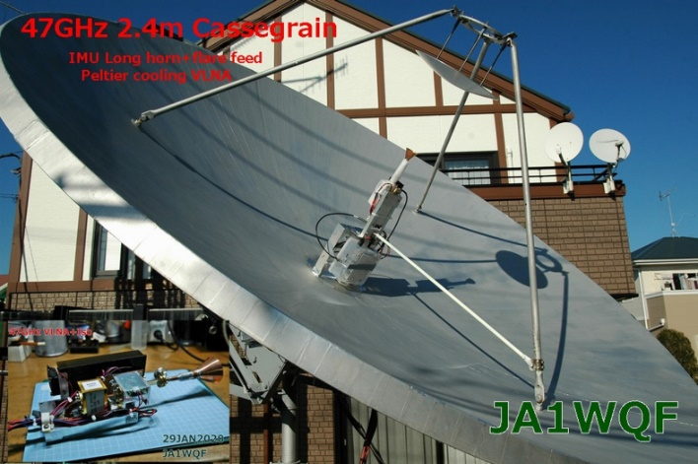
JA1WQF’s 2.4 m dish with Cassegrain feed

Feed - When Mitsuo started work on 24 GHz, he had to solve the problem of how to locate a heavy TWT at the focus. The solution was to use Cassegrain feed made from a 32 mm dia reflector. The Cassegrain system is based on W2IMU dual mode feed scaled to 47 GHz.0 So far he uses linear polarization but he is going to make septum feed in the same way how he did for 10 and 24 GHz EME.

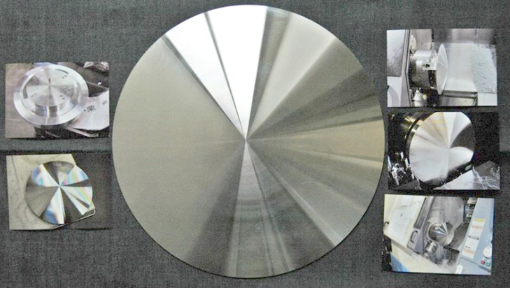
Details of the Cassegrain reflector fabrication

LNA - Right after the horn is a short WR-22 waveguide adapter he use to connect to a home-made 1.9 dB NF LNA (common project with JA8CMY) using a CGY2260UHFC1 and including a Peltier's cooler (max -20°C). The idea was to improve the NF a little but not use the complex liquid Nitrogen system or dry ice. Right after the LNA, he uses an isolator to avoid oscillations. He is planning to add a membrane air dryer to solve the problem of condensation.

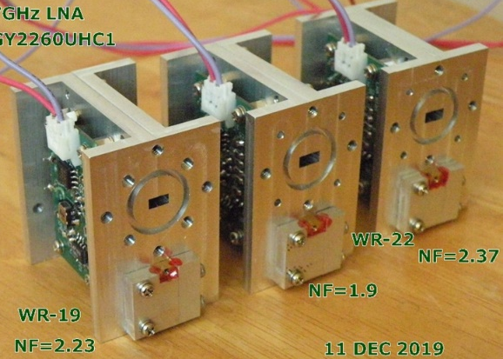
Three 47 GHz 1.9 dB NF LNAs
PA - It's not a secret that Mitsuo together with JA8CMY are preparing a 10 W+ SSPA for 47 GHz. The PA was completed on 12 Jan and it consists of 8 x 2 W PAs with TGA4046X8. The main problem, which must be solved before he can attempt a 47 GHz QSO with Al is to tune all8 phase shifters for max power. He is up to was 9 W output!

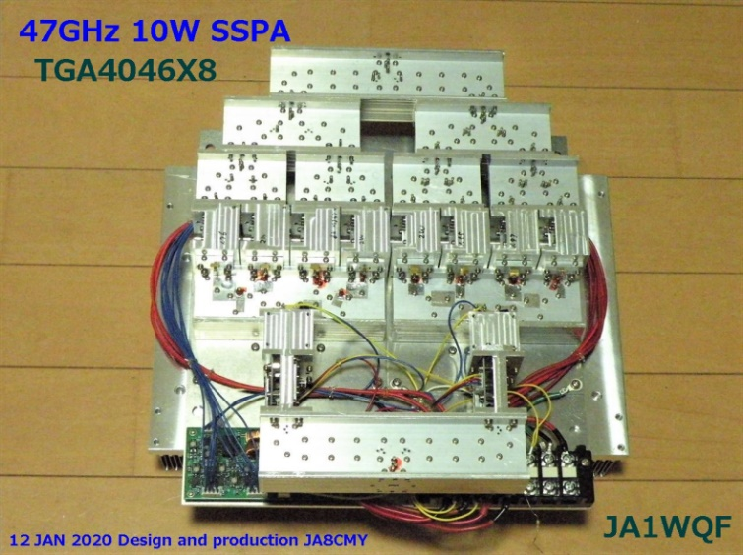
47 GHz 10 W SSPA made from 8 TGA4046 2 W MMICs

Other info - It's not clear yet what Mitsuo is using for the AZ/EL control, but at 47 GHz the dish’s main lobe just 0.19° wide for -3 dB. By the way on 47 GHz, it's hard to use the Moon noise as a beacon because the Moon noise is depended on the Moon phase. During testing, the elevation angle and weather condx (hum. and temp.) greatly affect the attenuation of the atmosphere. Data on JA8CMZ’s 47 GHz WG coupler is at http://millimeterwave.free.fr/2%20COMB.pdf

RW3BP Comments - Sergei wrote -- Congratulations to Al and Mitsuo! Wery nice to see EME activity on 47 GHz band! A few words about the MWCW program: Al and Barry could copy my CW signal in 2004 simply with their ears. But the power of my transmitter at that time was 240 W at 47 GHz. Gary, Al and Barry had only 30 W. It was necessary to somehow compensate for the 9 dB difference in the power level. I described in detail the necessary algorithms for processing the CW signal and asked my friend Vladimir to code a program. MWCW provides the copy of a weak CW signal by averaging a repeatedly repeated message. The final CW decoding is performed by the operator's ears. The program can work with wide signals. It is not as comfortable as WSJT or QRA64, but it is quite effective. The difference of 10 min and 1 min is due to the fact that in 2005, we did not know that there was an optimal time for the minimum libration smearing of the signal. Our QSOs were made at 600 Hz smearing. Today's tests were performed at the optimal time at 50 - 60 Hz smearing. Therefore, a difference of 10 dB in the receiver band width required more processing time. Now at the optimal time, I use MWCW to receive my echo at 76 GHz with a transmitter power of 2.6 W. I don't need 10 minutes of processing to do this.
Conclusion - It should be noted that the main result of the JA1WQF's and now DL7YC’s test with W5LUA is the conclusion that 47 GHz EME QSO in QRA64 mode should be possible with 2.4 m dish with at last 8 W at the feed. Several groups of hams are working to make QSOs on 47 GHz. The EA3HMJ team has 2.4 W on 47 GHz - see https://www.youtube.com/watch?v=rKq-rkziwzA

Recommended literature for 47 GHz EME:
http://www.pnwvhfs.org/conference/2005/presentations2005/GN-slides-PNWVHFS-2005-09.ppt
http://www.ok2kkw.com/next/47g/47g_ad6fp_2004.pdf
http://www.pa0ehg.com/what47ghz.htm
http://www.pa0ehg.com/47ghzeme.htm
http://www.pa0ehg.com/47ghzfeed.htm
http://www.ok2kkw.com/00003016/eme2014/pdf/w5lua_analyzing_path_loss_to_the_moon_and_back_for_eme_communications.pdf

List of 47 GHz EME stations interested in tests:
http://www.pa0ehg.com/47ghzperformance.htm

Station | Antenna | NF | Pwr | Sunnoise | Moonnoise
AD6FP | 1.8 m offset | 1.5 dB cooled |  | 9.2 dB
DC7KY | 2.4 m offset | 2.3 (x)17C | 1 | 11 dB @ 15 ? | 0.69 dB ??
DL7YC | 2.4 m 0.4 pf | 2 dB | 1 | 8.8 dB @ 16 el | 0.85 dB (x) 33 el
EA3HMJ | 1.2 m offset | 5 dB | 2,4 | 5.8 dB @ 24 el | 0.31 dB (x) 36 el
JA1WQF | 2.4 m pf Cassegrain | 2,3 | 9 | 8.4 dB | 1 dB
PA0EHG | 1.8 m 0.4 pf | 5 dB | 4
RW3BP | 2.4 m offset | 0.8 dB? | ? | 4.9 dB | 0.6 dB
VE4MA | 2‘ offset | 4 dB |  | 5.5 dB | 0.3 dB
W5LUA | 2.4 m offset | 4 dB | 25 | 6 dB | 0.4 dB

RADIOASTRONOMICAL CORNER BY OK1TEH:

Powerful Strange Radio Signal From Deep Space Appears to Be Repeating in a 16-Day Cycle: Perhaps you have ever heard that during last few years astronomers have been fascinated by fast radio bursts (FRB). See https://www.youtube.com/watch?v=vjy-nNF2KTM. During the start of Feb, it was announced that a really mysterious well-known source of FRB flashes (FRB 180916.J0158+65) was discovered to scream at us in an approximately 16 day cycle! Briefly, fast radio flashes are very short and very powerful screams on radio waves flying at us from various places in space. They usually appear random, so it is quite difficult to find them, let alone study them. The first such scream was only detected in 2007. We have not yet heard that much about the FRB screams. So far, we have known only one source that shows up repeatedly, but irregularly - the legendary FRB 121102. A large team of researchers initially studied radio telescope data in British Columbia, which is running the Canadian Hydrogen Intensity Mapping Experiment (CHIME). They found the source of FRB flashes in their data. They located over 400 previous observations. It turned out that this source, which was designated FRB 180916.J0158+65, emits fast radio flashes in a regular cycle. It has a really strange regular cycle. The duration of this cycle is about 16.35 Earth Day. The first four days of this cycle, the FRB source 180916.J0158+65 roars about once per hour. Then suddenly there is silence. Twelve Earth days pass and then this source starts again in the same way. Can anyone at least imagine a natural object that could do something like this? This is not to say that this is impossible. Although the cycle is really weird, it is probably something that orbits something. Or at least it rotates around itself. But such a characteristic fits most objects in the universe. The discoverers of this new mystery has succeeded at least in tracing this source of FRB flashes into a spiral galaxy about 500 million light-years away. New technologies might give us more insight, see https://www.youtube.com/watch?v=iaqUl3I3y_Q.

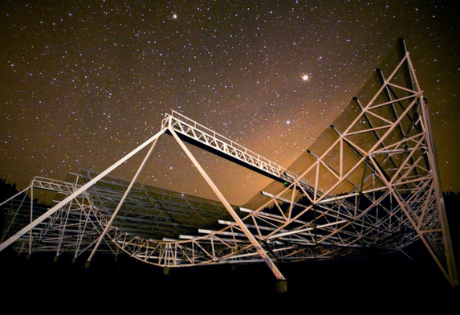
Canadian radio telescope boosts the search for FRB (https://commons.wikimedia.org/wiki/Category:Canadian_Hydrogen_Intensity_Mapping_Experiment).

FINAL: We should not forget that two years ago we agreed to name the 1296 SSB Contest as “F5SE Memorial 1296 SSB Funtest“. Also, the Dubus 1296 Contest is the “VK3UM Memorial 1296 CW EME Contest“.
► Now is the time to make your plans for EME2020 in Prague. Registration is going well. They already have 121 participants and have received my proposals for lectures. Already 16 lectures are booked. See https://www.eme2020.cz/ for more details.
► K6MG has compiled the W6YX EME story, a history of the Stanford Club’s EME activities that should be of interest to NL readers. See https://w6yx.stanford.edu/index.php/news/37-2018-2019-moon-bounce-adventures.
► The OK VHF club is holding a local EME and MW seminar in hotel Medlov on 17/19 April. More details and program can be found at http://www.vhf.cz/seminar-2020/. The webpage is in the CZ language, but if anybody interesting to join, let me know at ok1dfc(x)seznam.cz.
► The Polish VHF club PK-UKF will make traditional 59th SHF meeting at well-known hotel at Zielenec near to OK/SP border, loc: JO80EI60WJ on 15-17TH May 2020. This time the meeting will be dedicated mostly to microwave contesting. Photos from the last meeting at Zielenec can be seen at https://ok1teh.rajce.idnes.cz/17th_Technical_VHF_Meeting_Zieleniec_15-16.08.2015/ Are you looking for any UHF/microwave components or visit near SP6JLW’s EME station? Try think about it ;) More information will be announced at next NL issue.
► A 24 GHz AW has been proposed by OK1DFC for 8 March (second day of the DUBUS 3.4 GHz EME Contest).
► XE1XA is proposing a 1296 SSB calling frequency (030?) – see Max’s report. What do you think?
► HB9CRQ, announces that all QSLs due for the microwave part of the A21EME EME dxpedition have been mailed. Dan apologizes for the delay. If would like a QSL for your A21EME QSO please send your QSL plus SAE for 1296 – 10368 QSOs to HB9Q, PO Box 133, CH-5737 Menziken; and for 50 – 432 to OQ-100: Lins Berben, Simonshoek 2, 5768 CS Meijel, Netherlands.
► The 54th Central States VHF Society Conference is in La Crosse, WI on 24/25 July this year. This conference regularly attracts many EMEers from around North America and the world. It is being held at the Radisson Hotel located on the beautiful riverfront of the Mississippi River, and will include VHF/UHF and microwave technical presentations, antenna range, NF lab, rover row and dish bowl, Thursday evening social activity, Friday evening trade-fest, dealer room, hospitality suite for evening socializing, fun family activities, and a closing banquet with and prize table. See the conference website at http://2020.csvhfs.org/ for details.
► Lets show that there is great interest in the 9 cm by having a big turnout for the Dubus Contest. We had some complications this month the delayed completion of NL. We decide it would be best to combine the Feb and March issues, and hope that you enjoyed it. Please keep sending in your reports, news and tech info in 2020. 73, Al – K2UYH and Matej – OK1TEH

