432 AND ABOVE EME NEWS
July 2021 VOL 51 #6

EDITOR: AL KATZ, K2UYH; DEPT. ELECTRICAL/COMPUTER ENGINEERING, THE COLLEGE OF NEW JERSEY, PO BOX 7718 EWING, NJ 08628, TEL (W 609-584-8424), (C 609-947-3889), E-MAIL alkatz(x)tcnj.edu
ASSOCIATE EDITOR AND Reflector/NETNEWS Matej Petrzilka, OK1TEH, Simunkova 1609/21, 18200, Praha 8, Czech Republic, TEL (+420 603 489 490), E-MAIL ok1teh(x)seznam.cz
CW INITIAL LIST G4RGK, DAVID DIBLEY, E-MAIL zen70432(x)zen.co.uk, AT: http://www.zen70432.zen.co.uk/Initials/index.html
SUN & EXTRATERRESTRIAL NOISE LIST MANAGED BY OK1TEH: http://www.ok2kkw.com/next/nl_k2uyh/sun_table.xls
EME INFORMAL NETS: 14.345, ~1500 SATURDAY AND SUNDAY, NET COORDINATOR: OPEN
EME DIRECTORY BY JAN, PA0PLY AT www.pa0ply.nl/directory.htm
ON0EME EME BEACON, 1296.000 IS QRV WHEN MOON >10°, SEND RX REPORTS TO WALTER (ON4BCB) on4bcb(x))gmail.com
DL0SHF 3 & 1.2 CM EME BEACONs, 10368.025, 24 TBD, SEND INFO & QUESTIONS TO Per (DK7LJ) per(x)per-dudek.de.
NL EMAIL DISTRIBUTION and EMAIL LIST CORD: WARREN, W2WD wbutler(x)ieee.org
THE NL WEB VERSION IS PRODUCED BY REIN, W6SZ rein0zn(x)gmail.com, AT: http://www.nitehawk.com/rasmit/em70cm.html

CONDITIONS: There is less to report this month with no EME contests or major dxpeditions. There was the 9 cm Microwave Activity Weekend (MWAW) on 3-4 July. The activity was not spectacular but enough to generate a reasonable turnout with a good mix of CW and digital activity. The presence of GM4PMK who provided Scotland on 3400 for the first time facilitated the fun. Also, big signals as those from the OK1KIR group helped. KA6U traveling up the east cost of the US provided some new grids on 432. Otherwise, there was no dxpedition activity. Aug does not offer anything better. The 13 cm MWAW on 31 July- 1 Aug and the 6 cm MWAW on 28-29 Aug for 5.7 GHz should offer some good diversion. The next 432 CW Activity Time Period (ATP) is Sunday 1 Aug 0330-0530 & 2300-0100. The SP Microwave and EME meeting “Zielenec” will be held on 20-22 Aug – see FINAL section for details.

DL7APV: Bernd dl7apv(x)gmx.de was QRV on 70 cm but had only limited time to operate since the last NL -- I did add initials mainly using JT65B with MI0ILE in IO64 with only a single 7 el yagi and 50 W, KA6U during his single yagi grids/States dxpedition in FM26 and FM25, KB0Z in EN11 with 4 x 14 el yagis and 100 W and WC8VOA in EM79 with 4 x 14 el yagis and 500 W. I received my VP8EME QSL to confirm my DXCC 150 and the next day from HS0ZOP for DXCC 151. I am still struggling in my pulsar search with my Airspy SDR as I have too much QRM within its 10 MHz BW. Does anyone have a (beginners) manual for RFIfind and Presto.

G3LTF: Peter g3ltf(x)btinternet.com was QRV for the 3.4 GHz MWAW – I was disappointed to find that activity was low. We were competing with a US holiday weekend and a contest in Europe. I worked on 3 July using CW DL4DTU, OK1KIR and K2UYH and on 4 July OK1KIR, G4NNS, OH2DG, W5LUA and K2UYH. I could just see GM4PMK with my SDR; I had expected him to be an easy CW QSO. My Sun noise was 17.4 dB and Moon noise 1.0 dB. I was on 23 cm and worked on 14 July using CW N0CTR for initial #503 and on 15 July I5MPK and KB2SA #504.

I received Sun noise measurements from 5 stations (including myself) obtained during the 9 cm MWAW. – See the following graph. Notes are as follows: G/T is calculated from the reported Y factor and dish diameter. The 3.4 GHz solar flux is taken as 98. The calculation takes account of the lower level of flux intercepted by larger dishes (Boven correction).

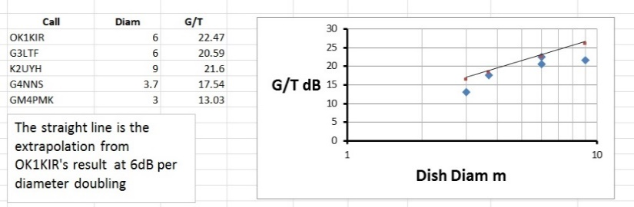

G4BAO: John john(x)g4bao.com is spending his Moon time on 3 cm – I was QRV on 3 cm on the weekend of 3/4 July and to spend the rest of the lunar month there. I was limited to morning operation due to a min AZ of 190 degs and a min EL of 24 degs due to trees. I am totally blocked by a tree to VK. I am using a 1.1 m offset dish with 25 W; and can work a well setup 1.8 m dish using the digi modes. I am happy to try skeds with anyone big or small, CW or digi. My goal is to make my first CW 3 cm EME QSO. It could be you! Email me for skeds.

GM4PMK’s 3.2 m dish used to put GM on 9 cm

GM4PMK: Roger gm4pmk(x)marsport.org.uk is putting Scotland on 9 cm EME for what I believe is the first time – I was QRV during the 9 cm activity weekend and worked on Saturday 3 July OK1KIR using JT65C for mixed initial #2*, and on Sunday 4 July K2UYH using JT65C #3* and W5LUA using Q65-60C #4*. Previously, I had QSO’d HB9Q for #1*. [These QSOs should be new DXCCs for all]. My station consists of a 3.2 m dish, an RFHD circular pol feed with 22 W at the feed and G4DDK preamp. I am available for skeds in July and possibly in Aug. [This is a correction from the June NL].

N5BF: Courtney courtney.duncan.n5bf(x)gmail.com sends a post 23 cm DUBUS Contest report – I had an excellent CW QSO with VK4AFL (439) for my CW initial #66 and mixed initial #234*. This was an unusual QSO for me in that it was the first time I have tried legacy "2 minute period" sequencing. This would have been a difficult QSO using the standard "call for a while on the echo frequency" approach. The 2 minutes TX, 2 minutes RX gave plenty of structure and opportunity to piece together and verify each part of the QSO. It's also possibly the first time, I've worked non-echo. Both of us had announced 1296.025 and tuned for each other independently. Of course, I did check my own echoes before beginning just to verify pointing and calibration. Many thanks to Trevor for the QSO and a demonstration of how it was done in the golden era.

OK1KIR: Vlada vlada.masek(x)volny.cz and Tonda report on EME in July – The 9 cm EME AW was held during weekend of 3-4 July at a time when the Moon was close to apogee. During a time when the band was quiet on Saturday morning, we measured a Sun noise = 17.5 dB and a Moon noise = 1 dB. Noise background was slightly influenced by mild local QRM. Mobile operator who gained the band above 3400 fortunately have not yet installed technology close to our neighborhood. We must take care as any interference from signal to its operation is strictly prohibited. Finally, after 0600 the first EME signals appeared. We worked on 3 July using JT65C unless noted at 0630 OZ5G (4DB/4DB), 0646 DL4DTU (2DB/3DB) for digital initial {#43}, 0731 GM4PMK (15DB/25DB) {#44} and a new digi DXCC, 0842 G4NNS (569/579) CW, 0903 KN0WS (18DB/14DB), 0916 G3LTF (569/569) CW, 0930 KD3UY (15DB/13DB), 1017 K2UYH (2DB/3DB), 1104 KD3UY (17DB/18DB) Q65-60C and last 1206 K2UYH (569/579) CW; and on 4 July we heard on otherwise dead band DL2LAC (559) CW - but Guenther did not respond to our calls, at 0832 DL4DTU (14DB/5DB) who was weaker than on Saturday, 0722 G3LTF (569/579), 0859 OH2DG (579/579) and last 0947 W5LUA (579/569). We just hope that some future disturbing, coexistence with the mobile service on 3.4 GHz band will be possible.

OZ4MM: Stig gsvestergaard(x)gmail.com was QRV for the 70 cm CW ATP on 11 July ATP. The ATP really wasn't a great success; only DL7APV answered my calls at the low end of the band. I tried to generate some interest on the HB9Q logger with no success. I was QRV in both passes; going in and out of the shack as we had great WX during the weekend. I did add HZ0ZOP using JT65B for a new 432 DXCC! I have now relocated my rebuild 70 cm R&S SSPA in the amplifier house below the dish. All test indicate it is working well. Back in May I ended the 1296 DUBUS CW contest with 57 stations in the log. It is great to be on the Moon!

PA5Y: Conrad g0ruz(x)g0ruz.com in the future will be QRV on 432 in bigger way -- After playing about on 432 with a single 26 el yagi horizon only system, I decided it was time to make a more serious attempt and so I have started to build a “real” 70 cm EME system. The mast and H frame is ready, as is the AZ EL system. With my horizon only station, I was up to digital initial {#41} and WAC with a single yagi; including several 1 yagi – 1 yagi QSOs. I heard a good number of CW stations but could never get their attention. My new system will consist of 4 x 23 el yagis (PA-432-23-6) horz pol, < 0.3 dB NF LNA at feed point (1.6 m of ½” hardline to splitter), G4DDK Iceni transverter to a K3S or TS-890S. The PA will be to start a TH327 PA, but I am working on a water-cooled R&S SSPA. I have a quiet rural location. I hope to make a nuisance of myself soon; and am looking forward to some CW EME.

UN6PD: Nikolai un6pd(x)inbox.ru has been QRV on EME from Kazakhstan for some years – I am QRV on 23 cm (3 m dish + 800 W), 6 cm and 3 cm (1.6 m dish + 25 W). I hope to also be active on 24 GHz. [Need a preamp]. I ran skeds in July with K2UYH and W5LUA with Q65-D60. Although signals were copied both ways, we did not complete any QSOs due to decoding problems.

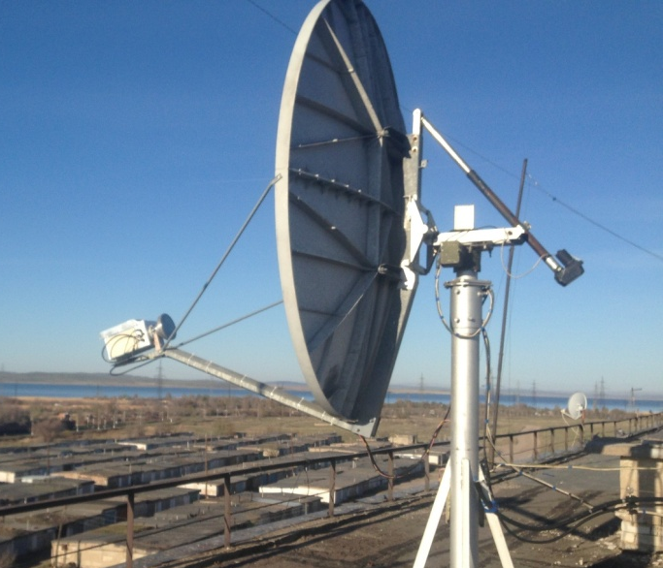
UN6PD’s 1.6 m offset dish with 6 cm feed

W5LUA: Al w5lua(x)sbcglobal.net reports on the 9 cm AW and his other MW activity in July -- On 4 July on 3400, I worked G3LTF and OK1KIR on CW. I then switched to the Q65-60C and worked KD3UY, DL4DTU, KN0WS and K2UYH. I was on 5760 and worked on 9 July K2UYH using Q65-60D and on 10 July IK0HWJ on both Q65-60D and CW. The rest of the month has been spent working sporadic E on 6 and 2 m. I plan to get back to working on my 47 GHz TWT power supply during the next month.

WC8VOA: Richard (WC8RK) gkreute(x)gmail.com and Joe (WA8OGS) have set up a portable EME station to used primarily at Voice of America (VOA) Museum – We made our first 432 EME contacts on 14 July with DL7APV and UA3PTW. The VOA Museum is in West Chester, OH (EM79ti). We operated from a grassy field in front of the museum building, and used the VOA radio club call sign WC8VOA. We experienced strong RFI noise on the rising Moon, and waited for the noise to decrease when the Moon elevation was above 25 degs for these two initial contacts. We made several calls after completing with UA3PTW, but nothing was else was heard. Our portable station consisted of 4 home-brew 15 el yagis (15LFA-JT), horiz pol, 600 W Tajfun SSPA, an AGO 0.29 dB NF preamp, az-el G-5500 rotor and Icom 9700.

WC8RK under the shelter during WC8VOA 432 EME demonstration

WK9P: Tim tcherrone(x)yahoo.com is adding 10 GHZ EME as a second EME band – I am picking up a 1.8 m dish while on vacation in FL. I have a DB6NT MKU 10 G3 Transverter, LNA and 102 B 2 W PA. I still need to find a higher power SSPA. I also have a feed, WG switch and mount. My Rig is tied into a SDR, HDSDR and cat control too. With luck I could be on 3 cm by the end of the year.

K2UYH: I (Al) alkatz(x)tcnj.edu was QRV on 70, 9 and 6 cm in July – I was active during the 9 cm MWAW and worked on 3 July at 1014 OK1KIR (3DB/2DB) using JT65C, 1020 DL4DTU (18DB/5DB) JT65C for mixed initial #67*, 1107 KN0WS (17DB/10DB) JT65C, 1130 G3LTF (569/569) CW and 1140 OK1KIR (579/569) CW; and on 4 July 0949 K3UDY (18DB/16DB) Q65-60C, 1000 GM4PMK (15DB/24DB) #68* and DXCC 33*, 1028 G4NNS (559/579) CW, 1044 G3LTF (569 569) and 1050 W5LUA (579/679). The next weekend I switched back to 5760 to work 9 July at 1312 W5LUA (3DB/4DB) using Q65-60D for my first Q65 QSO on 6 cm; 10 July 1340 W5LUA (3DB/6DB) Q65-60D, 1414 IK0HWJ (7DB/12DB) Q65-60D for mixed initial #69* and 1442 IK0HWJ (569/539) CW for initial #60; and 11 July at 1500 partial UN6PD (16DB/-) Q65-60D - Nikolai could not decode me. I also contacted on 432 using JT65B unless noted on 10 July at 1650 ES3RF (14DB/15DB) Q65-60B for mixed initial 1036* and 1702 RU4AN (20DB/20DB) #1037*; and on 11 July at 1625 PA3FWV (22DB/17DB) 1038*, 1811 EA5CJ (11DB/18DB), 1822 UT6UG (13DB/8DB), 1830 PA2V (12DB/11DB) and 1850 partial WD6Y (12DB/-) - Kal never decoded me. I plan to be active for the 13 cm MWAW on 31 July – 1 Aug.

NET/CHAT/LOGGER NEWS: KB7Q’s 70 cm operation from TX7 (Marquesas) is cancelled as reported last month because the Covid risk from variant D, but Gene will be multi-band (including 222) QRV from WY/SD/NE this fall. VP8EME is presently in the UK, but should be back at the end of July and is expected to be QRV on 432 EME again when he returns.

FOR SALE: W2HRO has 1.8 m folding dishes (10 lbs) with 1296 circular pol feeds for sale. Larger dishes are also available along with LNAs, isolation relays and terminations. More info can be found at www.Sub-Lunar.com. Paul’s goal is to offer specialized EME equipment and ultimately a turnkey station for 1296 EME. A video showing his folding dish and patch feed can be seen at https://youtu.be/p66s1jF7760. SM6CKU has a 2.4m offset dish made by Vertex in good condition. Comes complete with ground post, manual az/el mount and Gregorian feed system. It should be good on 10 and very likely 24 GHz with another feedhorn. Must be picked up at my QTH. Weighs > 200 kg. Contact Ben for more details at ben(x)sm6cku.se. OK1TEH Matej ok1tehlist(x)seznam.cz still offers for pick-up his 3 m solid center dish (f/D 0.35) with massive ribs and good surface up to 24 GHz. The same kind of dish was already used by OK1UWA for his successful 24 GHz EME operation. If there is serious interest, even more pieces of such a dish could be found via my friend OK1TP. ON4AOI offers for sale a big part of his 70/23/13 cm gear and measuring equipment. If interested contact Guy at on4aoi_pda(x)skynet.be, or see https://1url.cz/XKByD. WA2ODO asks if there is any interest in custom made power dividers? He has made them for many people. These are low loss, good RL, 1/4 or 1/2 wave, high power (DIN or N), ruggard, and most important cheap. Contact Pete at pmanfre(x)gmail.com, if interested.

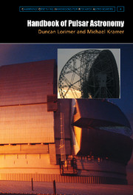
RADIOASTRONOMICAL CORNER by OK1TEH: Hi friends, I’m often asked about good tips for radio astronomical books. I can recommend the famous “Amateur Radio Astronomy” 2nd edition by ZS5JF and “Radio Auroras” by G2FKZ, which can be bought from RSGB online shop. Another special book that is very well written is the “Handbook of Pulsar Astronomy” from M. Kramer. Although this book is from 2004, it contains lot of very detailed and usable information. I bought it and found it good reading for my summer holiday. It can be bought at https://www.cambridge.org/cz/academic/subjects/physics/astrophysics/handbook-pulsar-astronomy?format=HB&isbn=9780521828239 or Amazon. It is also on sale from Cambridge University Press, which also sells several other books for professional radio astronomers such as a “Pulsar Astrophysics (IAU S337)".

Can Amateur Radio Astronomers Detect Quasars? The
answer is yes, although the instrumentation needs to be pretty sophisticated. It’s not well known that first Quasar 3C298 was captured by RA on 29 April 1986. A very interesting article on this event can be found at:
http://adsabs.harvard.edu/full/1986JRASC..80L..51R.
I remind you of CT1DMK’s well known table:

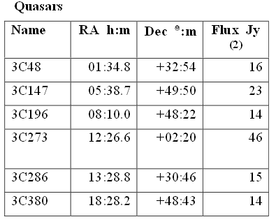

While not every ham has an EME dish that is big enough for positive detection. You can also try to captured one with your small optical telescope or DSLR too. The brightest quasar is 3C 273 in the constellation of Virgo. Position -> RA: 12 h 29 m 06.7 s, DEC: +02° 03′ 09″. It was the first quasar ever to be identified (in 1963). It has +12.8 magnitude; and its distance is about 2.4 billion light-years, and receding from us at 14.6 % of the speed of light. Amazingly, you can easily see this quasar in a 15-cm (6-inch) aperture optical telescope or make photo with DSLR with a modest telephoto lens and 10 min exposure; however, you’d need to travel out of a city, as you’d need dark sky with minimal light pollution. By the way - What is the furthest object, which can be observed by an amateur’s optical telescope? The answer is APM 08279+5255 – Quasar in Lynx, a tiny red 15.2 magnitude ‘star’, which is an incredible 12 billion light years away; 87% of the way back towards the birth of the Universe itself! To put it in perspective, the Universe is estimated to be 13.8 billion years old and the light from this object has been traveling for 12 billion of those years. The Sun is young by comparison, only 4.6 billion years old. When the Sun was born the light from this quasar had already been traveling for 7.4 billion years, give or take. The black hole at the core of this quasar is one of the largest known with an estimated mass of 20 billion Suns. On the Internet you may find photos of this far object made by Meade SN-8" Schmidt-Newton OTA Telescope. See
https://www.cloudynights.com/topic/593158-what-is-the-furthest-object-you-have-imaged-please-post-photos/?p=8134363. Can you imagine any bigger DX? :-)

FINAL: The EME Beacon situation is not good. ON0EME, the 1296 Beacon, is still not QRV. The 24 GHz beacon reported on last month is OK; however, the 3 cm Beacon is in trouble again. The new SSPA has failed for a second time. G3WDG is working on a repair. Charlie has found black residue and a conductive path to ground at the output. He feels it is important to understand the cause of the failure to ensure long term reliability; and is looking for help in doing an analysis of the chemical composition of the deposits around the charred area – [can anyone help?]. In the meantime, the DL0SHF 10 GHz Beacon is off the air.

► EME 2022 Prague: Please note EME2021 is postponed to Aug 2022. Let’s start making plans to attend Prague 2022. It a little more than a year away!

► Not canceled is the announce that annual SP Microwave and EME meeting “Zielenec” to be held on 20-22 Aug thanks to the SP6GWB & SP6JLW EME groups. See more at: ok2kkw.com/sp6/zieleniec2021en.htm. This event is a great opportunity to meet old friends from SP/OK/OM/DL & 9A, and buy hard to find microwave components at the flea-market.

► We are doing better this month and will send out the July NL earlier in the month. The earlier mailing does make for a shorter NL with less reports. Coming up are the 13 cm MWAW at the very end of July/beginning of Aug and the 6 cm MWAW at the end of Aug. Let’s keep the Moon alive during the dog days of summer. 73 and be QRV, Al – K2UYH and Matej – OK1TEH.

Many hams are taking advantage of 3D Printing to make feeds. Two examples of 3 cm feeds are shown below:

KN0WS 3 cm IMU horn made by 3D printing. Carl used copper tape to make inner part of horn conductive

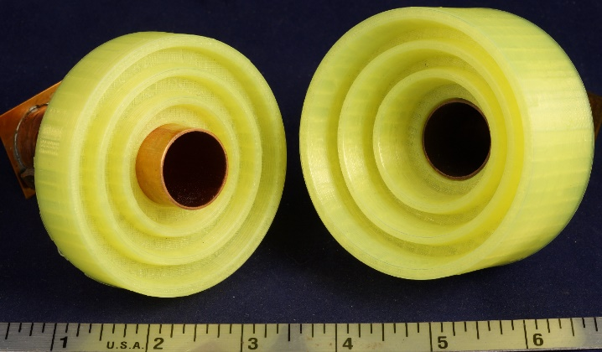
Scalar rings made by W1GHZ using 3D Printing

