432 AND ABOVE EME NEWS
JUNE 2016 VOL 44 #5

EDITOR: AL KATZ, K2UYH; DEPT. ELECTRICAL/COMPUTER ENGINEERING, THE COLLEGE OF NEW JERSEY, PO BOX 7718 EWING, NJ 08628, TEL (W 609-584-8424) OR (H 609-443-3184), FAX (609-631-0177), E-MAIL alkatz(x)tcnj.edu
NETNEWS EDITOR (based Reflector News) REIN, W6SZ pa0zn(x)arrl.net WITH HELP OF N4PZ AND WB2BYP
INITIAL LIST G4RGK, DAVID DIBLEY, E-MAIL zen70432(x)zen.co.uk, AT: http://www.zen70432.zen.co.uk/Initials/index.html
EME INFORMAL NETS: 14.345, ~1500 SATURDAY AND SUNDAY, NET COORDINATOR: Steve Gross, N4PZ n4pz(x)live.com
ON0EME EME BEACON, 1296.000 IS QRV WHEN MOON >10°, SEND RX REPORTS TO WALTER (ON4BCB) on4bcb(x)gmail.com
DL0SHF 3 CM EME BEACON, 10368.025, SEND INFO & QUESTIONS TO Per (DK7LJ) per(x)per-dudek.de.
NL EMAIL DISTRIBUTION and EMAIL LIST CORD: WARREN, W2WD wbutler(x)ieee.org [TXT OR PDF OR "ON WEB" NOTICE]
THE NL WEB VERSION IS PRODUCED BY REIN, W6SZ AND AVAILABLE AT http://www.nitehawk.com/rasmit/em70cm.html

CONDITIONs: Although summer was not far off, there was still plenty in May to keep EME interests high. The main event was the 3 cm leg of the EU/DUBUS EME Contest. Activity and conditions during the contest were good. OK1KIR appears to be the leading scorer with a total of 35x33. Dxpedition wise, D44TVD provide many new DXCCs on 23, 13 and 6 cm, but did not have as strong a signal as expected - see Hermann’s report later in this newsletter (NL). P40MB was QRV on 432 from Aruba on 7 May with a good signal and provided many JT65B QSOs. I do not yet have their report. Some 70 cm contacts were also reported with 9A8DXG in Croatia - not a new DXCC. Other successful 432 May dxpeditions were KB7Q/7 to WY – see Gene’s report and EA6/PA2CHR (Baleric Is). KB7Q/O will be QRV again from SD on 9 and 12 June. I know of no other June dxpeditions, but the summer’s first microwave activity weekend (MWAW) for 9 cm EME is scheduled for 11/12 June. The final DUBUS EME Contest for 6 cm EME will be 2/3 July. I received no reports of activity during the May 70 cm CW activity time period (ATP). The June ATP has already passed (on 5 June). The July periods are on 3 July from 0400-0600 and 1300-1500, but conflict the 6 cm contest – see FINAL section of this NL for additional comment.

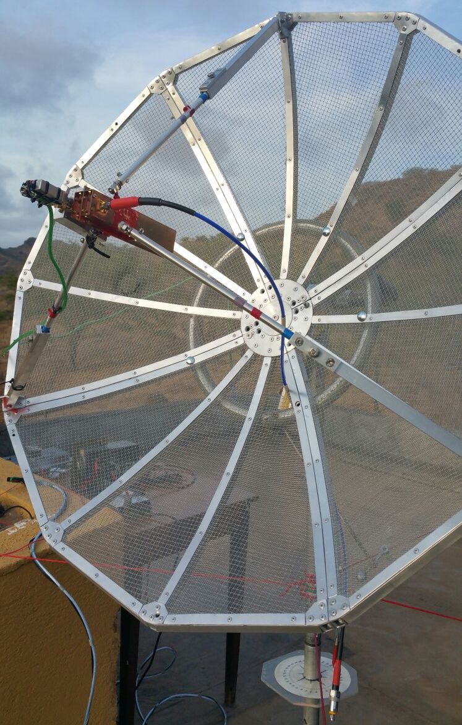
1 m dish at D44TVD with 6 cm feed

D44TVD: Dan (HB9Q) hb9q(x)hb9q.ch reports on DL2NUD’s microwave dxpedition to Cape Verde Island – Hermann and his equipment (56 kg) made it back home safely. He had problems with his moon window. He had blockage at moonrise and could not operate when the moon was near over head. He also had power problems, particularly after dark that limited his moon time with NA. He worked on 1296 HB9Q, UA3PTW, I1NDP, G4CCH, ES5PC, OK2DL, OK1KIR, K2UYH, OK1DFC, DF3RU, OZ4MM, OH2DG, PY2BS, LX1DB and LZ1DX for a total of 15 stations. He did RX several others but could not work them. His antenna did not perform as expected. His RX and TX was 3-5 dBs down from what it was when testing from home. He could not find the reason. He probably had his best performance on 13 cm where he QSO’d HB9Q, OK1KIR, OH2DG, UA3PTW, OK1DFC, ES5PC, PY2BS, PA3DZL, DF3RU, PA0BAT and IK3COJ for a total of 11. As on 1296, several additional stations were decoded but not worked. On 6 cm, he ended with 4 QSOs with HB9Q, OK1KIR, DF3RU and OZ1LPR. A few others were also decoded but not worked. Conditions were generally bad, which made it even more difficult to QSO. Over all Hermann is disappointed with the number of stations worked. At the same time he has learned a couple things, and he received a lot of feedback and help. He will try to implement all of this knowledge to improve his station for the next dxpedition. Stay tuned!

DB6NT: Michael michael.6nt(x)kuhne-electronic.de is now QRV on 3 cm EME and active in the DUBUS Contest – I am using a 3.7 m dish with 50 W. In the contest, I QSO’d SP6JLW, OK1CA, OK1KIR, DF1SR, F1PYR, G4NNS, OZ1LPR, UA4HTS, PA0BAT, YO2BCT, LA8LF, IW3FZR, HB9Q, PA3DZL, VK3NX, ES5PC, LX1DB on SSB, SP6JLW on SSB, OK1KIR on SSB, DL0EF on SSB, DL7YC, VE4MA, K2UYH and W5LUA for a total of 22x21. It was a lot of fun. I plan to be QRV on 6 cm next.

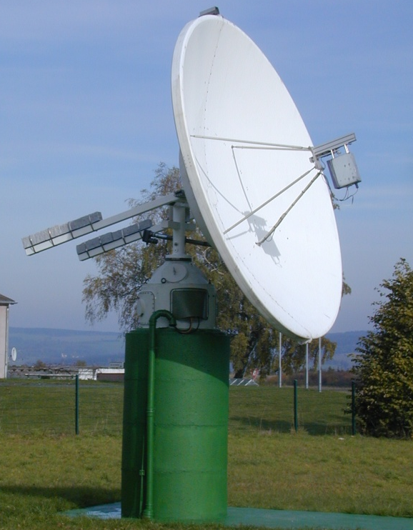
DB6NT’s 3.4 m dish with 3 cm feed

DF1SR: Georg df1sr(x)arcor.de was QRV for the first time on 3 cm during the recent DUBUS Contest – I was using a 2.4 m offset dish with only 15 W and worked SP6JLW, OK1KIR, DB6NT, PA0BAT, LA8LF, OZ1LPR, F1PYR, PA3DZL, UA4HTS and ES5PC for a total of 10x10. Heard were OH2DG, OK1CA, W7CJO, LX1DB, G4NNS, YO2BCT, IK2RTI, HB9Q, HB9SV, UA4AAV and WA3LBI. I plan to be on again next time.
DK3WG: Jurg dk3wg(x)web.de was active on 432 and 1296 in May – On 70 cm, I added QSOs using JT65B with BG6LQV a new station from China with 2 x 13 el yagis and 100 W, P40MB dxpedition for my DXCC #125, DL8FBD, EA6/PA2CHR, KB7Q in WY (DN44), EI8JK, BH4PVP with 4 x 13 el yagis and 100 W for his first QSO and 9A8DXG dxpedition. On 1296, I worked using CW F1PYR, IW2FZR and KL6M, andon JT65C LA3EQ and GW3XYW.

F1PYR: André andre_f1pyr(x)yahoo.fr has added 1296 to his EME capability and is interested in skeds – I am QRV on CW only with a 3.5 m dish and 400 W. My window is also limited to the Moon at < 175° AZ.

FR5DN: Phil fr5dn(x)izi.re after several years absence is back on 70 cm EME and making QSOs from Reunion Island -- Thanks to all who helped and gave me energy and support. My array of 4 x 21 el yagis is low to the ground compared to before (3 m instead of 7 m and 8 yagis). I also have some TVI troubles now - the digital TV is on 482 MHz! The neighbors’ antennas are some 30 m from my array. I need a filter to be connected to the TV system. I have tried several solutions from notch to highpass + notch, but i get too much attenuation on 482, and when OK on 482, not enough attenuation on 432. I am looking for effective design with standard components or affordable commercial solution.

G3LTF: Peter g3ltf(x)btinternet.com had an unusual month no EME contacts on any band – The main reason is that I was concentrating my time on getting a 3 cm system to work on receive during the DUBUS Contest. I have a 2.4 m fiberglass offset dish in two halves. It had no back frame or feed support. I had to start from scratch to get the two halves aligned and to find the focus. The f/d is 0.71. The day before the contest, I built a dual mode horn using the W1GHZ software at http://www.w1ghz.org/antbook/ch6_5-1.pdf. This worked reasonably well, but I could not get more than 8 dB of sunnoise and about 0.4 dB of moonnoise. I made a lot of checks to eliminate any surface dish problems and set about listening during my very short window. I copied the following on CW OZ1LPR, SP6JLW, LA8LF, UA4HTS, HB9SV, OH2DG, PA0BAT, DB6NT, YO2BCT, OK1KIR and G4NNS. The next day I added OK1CA and HB9Q. After the contest, I make a much more accurate set of profile measurements of the dish, and used these to find a more accurate focus. I got the sun noise up to 11.7 dB with 0.8 dB moon noise at 380,000 km and a noticeably sharper pattern. The next job is to build a better version of the feedhorn. The dish is on a polar mount, and so very simple to steer and keep on the Moon. I just give the HA motor a little burst to keep the moon noise peaked. Lots to do, but I was pleased to copy signals. This time of the year I am very busy with the garden, but in June I hope to return to the 3 cm project. (The picture below shows the dish rear frame with the two extra arms that I added to adjust the relative position of the halves to get perfect alignment).

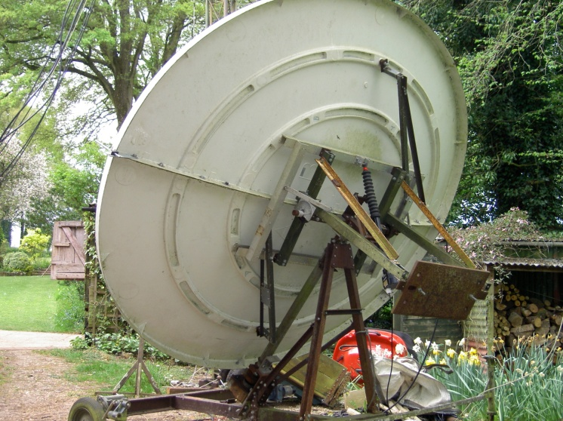
G3lTF’s 2.4 m offset dish for 10 GHz

G3WDG: Charlie charlie(x)sucklingfamily.free-online.co.uk activity over the last month has been mostly on 10 GHz – I made a brief test of my repaired 5.7 GHz system with a new driver amplifier using a TGA2576-FL, which will serve on 13 and 9 as well as 6 cm. Otherwise, I was on 10 GHz. I have been experimenting with JT65C (recently implemented with excellent performance in WSJT-X 1.7) and comparing it to JT4. Using JT4, I was able to QSO OZ7Z who had 10 W to 90 cm dish. It just worked! However, when libration spreading is very low (maybe < 30-50 Hz) JT65C is better, but above that it rapidly declines, as expected since the tones then overlap. In one JT65C test with VK7MO with spreading down to a few Hz, I decoded him running only 5 W and replaying the wave files with the signal degradation feature of WSJT-X, showed that we had a least 3 dB margin. Decodes ought to have been possible with only 2.5 W on his end (to his 77 cm dish)!

G4DDK: Sam jewell(x)btinternet.com was on 13 cm looking for the D44TVD dxpedition -- It was a pleasure to work HB9Q, UA3PTW and IK3COJ on 2320. I am now at mixed initial #20*. Unfortunately I did not see any sign of a trace from Hermann (D44TVD) with my 2.3 m dish. While setting up, I heard (decoded) PY2BS, OK1DFC, ES5PC and PA3DZL. I think most of these stations would have been workable on CW, although I have a marginal preference for digital because of my poor CW. On 5.7 GHz, I am now suffering from not preparing the dish mount properly. The pallet mount is now beginning to 'list' a bit in level. When I set up east, there is a significant elevation error to the west. I can get away with this on 23 and 13 cm, but on 6 cm it makes a significant difference. I can see about 0.4 dB moonnoise and 9.5 dB sunnoise on 6 cm, so the system is working.

G4NNS: Brian brian-coleman(x)tiscali.co.uk can now receive on the JA 10 GHz band -- I have built 10450 RX into my 3 cm system and would be pleased to test with anyone. I will TX on 10368 with RX on both 10368 and 10450. For skeds, please email me direct. I am running a 3.7 m dish with 20 W. My sunnoise is 17 dB and moonnoise 2.7 dB.

HB9Q: Dan to dan(x)hb9q.ch sends his group’s DUBUS 10 GHz EME Contest report – We were QRV for several hours on both days of the contest and worked 20 different stations including 6 initials. Initials were ES5PC (449/559), SP6JLW (559/579), LA8LF (559/569), HB9SV (559/589), PA3DZL (559/559) and VE4MA (259/449) for a total mixed initials of #50* and 23 DXCC (since early Sept 2015). Unfortunately, we had a power problem that we could not resolve during the contest. So, we were reduced to about 25 W (normal is 55 W). We found conditions to be at times very difficult with very strong libration fading and a lot of spreading. Never the less, it was great fun to operate! We heard several stations working others, which we did not work. We hope to find them again some other day. We plan to be QRV again during the 6 cm DUBUS contest in July. As always we are available for skeds if there is any station that needs or wants to work us, just email or look for us on one of our MW-loggers.

JA1WQF: Mitsuo ja1wqf(x)d5.dion.ne.jp was among the 5 JA stations that were active in the DUBUS 3 cm EME Contest – [see JA4BLC report below]. He was visited by Murphy a week before the contest and lost his SSPA. He replaced it with a TWTA. Mitsuo had to work many hours on the waveguide connections needed to get the tube in operation, and in the end could not operate the contest full time. He QSO’d OK1KIR, JA6CZD, W5LUA, JA4BLC, JA8ERE, IK2RTI and PA3DZL for a total of 7x7. He used circular polarization in the contest with his 2.4 m Cassegrain dish and a 100 W TWTA. [TNX JA4BLC for forwarding this report].

JA4BLC: Yoshiro ja4blc(x)web-sanin.co.jp writes that the JA 3 cm gang planned to be QRV on 3 cm simultaneously in the DUBUS CW/SSB 3 cm Contest for one hour on each NA, VK and EU window listening 10368/10450. To avoid QRM between the five JA stations we agreed the transmitting frequency 10 kHz separation (JA8ERE on 10450.130, JA1WQF on 140, JF3HUC on150, JA4BLC on160 and JA6CZD on 170. Operation was similar to attempted on 6 cm during the ARI Spring Trophy that was quite successful. We thank all for the cross segment operation with us. It seemed to have worked quite well. I have not before experienced so high a level of activity on 3 cm in Japan. I worked on 7 May JA8ERE, JA6CZD, OZ1LPR, F1PYR, PA3DZL, ES5PC and OK1KIR, and on 8 May JF3HUC for initial #33, VK3NX, JA1WQF, OK1KIR (dupe), HB9Q (partial - wrong callsign) and OH2DG for a score of 11x11. I used circular polarization on both days with my 3 m Cassegrain dish and 70 W TWTA. I also heard very strong signals on 10368 from SP6JLW (589). I also worked on 10 May on 1296 in a sked F1PYR for an initial (#).

JA6CZD: Shichirou ja6czd(x)mx35.tiki.ne.jp used circular polarization and a 2.4 m offset dish with a 50 W SSPA in the 3 cm DUBUS EME Contest. He worked 10x10 stations: JA4BLC, JA1WQF, JA8ERE, PA3DZL, OK1KIR, F1PYR, ES5PC, JF3HUC, OH2DG and OK1KIR. [TNX JA4BLC for forwarding this report].
JA8ERE: Mikio sgl01011(x)nifty.ne.jp suffered from strong wind during the full weekend of the 3 cm DUBUS EME Contest, but managed to work JA4BLC, JA6CZD, IK2RTI, OZ1LPR, HB9SV, ES5PC, OK1CA, OK1KIR and JA1WQF for a total of 9x8. Mikio is using 4 m solid dish (f/D = 0.32) and linear H polarization with a 25 W SSPA. [TNX JA4BLC for forwarding this report].

JF3HUC: Yoshitaka jf3huc(x)mbox.kyoto-inet.or.jp during the 3 cm DUBUS Contest experienced 3 cm EME for the first time. He used his 6 m dish covered by a 2.5 mm mesh, circular polarization and a 50 W SSPA. Yoshitaka needed some time to set up and could not be QRV on Saturday. On Sunday he worked JA4BLC, OK1KIR, JA6CZD, OZ1LPR, UA4HTS and ES5PC for a total of 6x6. [TNX JA4BLC for forwarding this report].

K5QE: Marshallk5qe(x)k5qe.com reminds everyone that his group will
be active on 432 EME in the ARRL June VHF contest. We have found a bad cable in the 432 RX chain that was seriously degrading the signal as it came through. Maybe we will finally be able to hear as we should. Please give us a try this year. Our moonrise and the start of the contest is 1800 on 11June. We will monitor 432 as long as we have moon. On 12 June, we have a second moonpass beginning at 1845. So we have a rare two pass contest this time. Sunday afternoon is a great time to work us via EME as that is normally a very slack time. I am looking forward to working everyone possible this time. Thank you in advance.

KB7Q/0: Gene geneshea(x)gmail.com reports on his plans for operation from SD in June and the results of his WY mini-dxpedition in May -- I'll be active from South Dakota (DN85gu) on 70 cm (and 2 m) EME in June. The call will be KB7Q/0 and always the first period on 432.088. I will normally TX JT65B, but I will be looking for CW as well. If I hear CW callers, I’ll respond using JT CW mode for keying (1 minute sequence) as soon as I finish the current JT65B QSO. I will have no Internet available, so let folks know on the loggers if you hear me. This time I will have 2 x 9 wl yagis, 500 W and a new 0.24 NF LNA. 432 operation will be on 9 June from 1630 onwards and 12 June after 1930. Please let me know if you need South Dakota for WAS. See www.kb7qgrid.blogspot. com for updates. Regarding my activity in May, I found a place just 80 miles from my house in Montana where Route 191 dips into Wyoming; there is even a quiet trailhead with ample parking a 1/4 mile back off the road. As a bonus this is Yellowstone Park. I suspect this was the first EME operation from Yellowstone Park! Joyce and I took the RV and camped nearby to give 70 cm EME a shot. Using a single 9 wl yagi, 500 W and a Honda generator, I worked the following folks during a single moon pass: WA4NJP (18DB), OK1KIR (17DB), HB9Q (14DB), DK3WG (16DB), DL7APV (16DB), UA3PTW (19DB), OK1DFC (20DB), UT6UG (20DB), LZ1DX (16DB), G4RGK (21DB), DL9KR (CW 559), UT5DL (24DB), DL8GP (29DB), UX5UL (22DB), OH6UW (27DB), K2UYH (18DB) and DF3RU (18DB) for a total of 17 stations. Despite some SWR issues at the start, it was definitely a success. I initially started testing on .089 and discovered the EA6/PA2CHR’s pile-up on .090 - [Gene had no Internet] and decided to stay there. It was convenient for checking RX to look at the EA6 pileup. The driven element of my yagi had been damaged and my SWR was awful until I realized how I had smashed it and shorted out the folded dipole. I’m just glad I was able to recover and deliver the goods. I’m pretty sure I worked all I saw. I CQ’d for two hours after things quieted down with nil from Stateside.

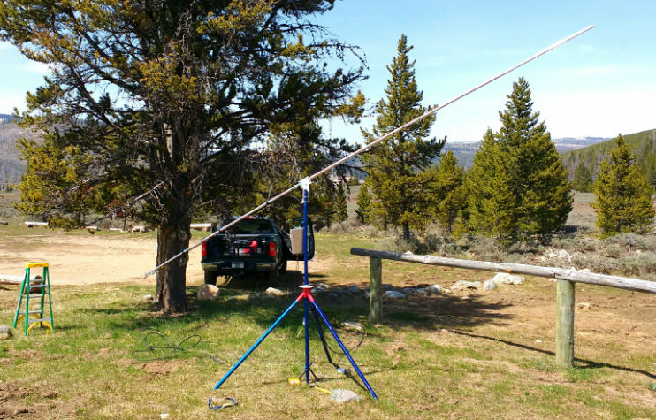
KB7Q/7 9 WL yagi in Yellowstone Park in Wyoming

LA8LF: Anders anders(x)la8lf.com reports on his 3 cm activity in the DUBUS contest -- My score was 22x21 QSOs. All QSO were on Saturday and all initials. Unfortunately there were no QSOs on Sunday as my TWTA PSU failed soon after moonrise. I heard an additional 7 stations that day. A highlight was working PA3DZL as we have now worked each other on 7 bands on CW EME. Others were the (589) report from W7CJO and OZ7Z hearing my CW signals on a 90 cm dish! Friday, the day before the contest, I measured 3.2 dB of moonnoise and 20.3 dB sunnoise. I hear very well, but was disappointed with the reports received considering the power I was running. I am using the original NEC Cassegrain feed. My EL tracking works extremely well, but my AZ tracking is somewhat sloppy on 3 cm due to backlash. I was using moon noise tracking by help of my SDR-IQ RX. The property where my EME site is located has been sold and I have to remove the dish before the end September. If somebody is interested, it is available for very little money, otherwise it will go to scrap. Hopefully I will be QRV with my 3.8 m offset dish from my summer home in the spring of next year. Worked during the contest were HB9Q (569/559), YO2BCT (579/569), UA4AAV (569/569), OK1CA (569/569), PA3DZL (569/559), F1PYR (569/569), HB9SV (569/579), SP6JLW (589/569), OK1KIR (579/569), ES5PC (569/569), G4NNS (559/569), DF1SR (449/569, PA0BAT 569-569, IK2RTI 589-579, IW2FZR 559-559, OZ1LPR 599-579, UA4HTS (579/569), SP2HMR (O/O), VE4MA (559/559), DB6NT (569/559), K2UYH (559/559) and W7CJO (599/589). I hope to be QRV during the 6 cm DUBUS contest in July.

OK1CA: Franta strihavka(x)upcmail.cz sends May report for the NL -- I was QRV in the EU EME Contest on 3 cm on the 7/8 May weekend. I had trouble with my signal on Saturday morning due to a bad connect between two ports of my 10 MHz reference. I ended up working 19 QSOs at Saturday; initials were JA8ERE, DB6NT and LA8LF to bring me to #78. This last QSO is the first between OK – LA on 3 cm. I finished on Sunday with 25 QSOs, all on CW. Out of the contest, I made 2 QSOs on JT4F. The weather was very good during the both days.

OK1DFC: Zdenek ok1dfc(x)seznam.cz writes that thanks to KB7Q he is only missing 5 states to complete 432 WAS – I am missing only NV, IA, LA, MS and AL. I will be happy to try with any single yagi station with 50 W or greater.

OK1KIR: Vlada and Tonda vlada.masek(x)volny.cz send their club’s May report – We QSO’d on 70 cm on 7 May with JT65B at 1328 P40MB (24DB/22DB) for digital initial {#165} and a new DXCC, on 14 May with JT65B at 1852 EA6/PA2CHR (24DB/21DB) {#166}, 1941 UX4IJ (19DB/8DB) {#167}, 1949 WA4NJP (10DB/10DB) and 2142 KB7Q (20DB/17DB) {#168} in WY; on 23 cm on 5 May with JT65C when testing a new 70 W driver at 1236 K5DOG (13DB/7DB), and on 14 May with JT65C at 1442 LA3EQ (23DB/18DB) for digital initial {#243} and later 2214 D44TVD (26DB/23DB) {#244} and a new DXCC and 2345 WA3RGQ (21DB/O) {#245}; on 13 cm on 13 May at 1532 D44TBD (21DB/24DB) for digital initial {#39}, 1st D4-OK on 13 cm and a new DXCC; on 6 cm, we devoted two moon passes to the D44TVD dxpedition without success, on 12 May we suffered from terrible WiFi interference that made copy impossible, and on 18 May after re-aligning filters for better suppression of WiFi interference, signals were even weaker - we think Hermann underestimated requirements for pointing his 1 m dish on 6 cm and dxpedition took place during time of worst conditions (Moon in apogee and high spread); and on 3 cm in DUBUS EME Contest on Saturday 7 May using CW at 0534 OH2DG (559/559), 0541 SP6JLW (579/569), 0548 HB9Q (569/579), 0602 VK3NX (569/569), 0612 PA3DZL (559/559), 0624 OK1CA (569/579), 0641 OK2AQ (O/O), 0717 JA6CZD (569/559) (RX/TX 10450), 0740 JA4BLC (559/569) (RX/TX 10450), 0802 JA1WQF (559/559) (RX/TX 10450), 0856 JA8ERE (559/569) (10368/10450), 0915 YO2BCT (559/559), 0919 DB6NT (569/559), 0925 DF1SR (549/559) for initial #105, 0937 F1PYR (559/569), 0942 G4NNS (559/569), 0948 UA4AAV (559/559), 0958 LA8LF (569/579) #106 and new DXCC, 1011 ES5PC (559/579), 1447 VE4MA (559/559), 1605 UA4HTS (579/589), 1614 K2UYH (559/559) and 1810 G3WDG (579/569), on Sunday 8 May at 0711 JA4BLC (559/559) (RX/TX on 10450), 0731 JF3HUC (549/549) #107 (RX/TX on 10450), 0747 PA0BAT (569/569), 0800 IK2RTI (569/569), 0827 DL0EF (569/559), 0841 HB9SV (569/569), 1110 OZ1LPR (579/579), 1214 SP2HMR (O/O) #108,1250 DB6NT (44/54) (SSB), 1324 IW5BHY (O/O), 1540 DL7YC (569/569), 1647 IW2FZR (559/559), 1710 W5LUA (579/579) and 1737 LX1DB (44/55) (SSB), W7CJO was heard but disappeared before we called him and were heard by VK4CDI (539), G3LTF and HB9BBD for a total score of 35x33, and out of the contest using JT4F on Sunday 8 May at 0542 VK7MO (13DB/8DB) at 50 W, 0552 VK7MO (16DB/8DB) at 10 W, 0558 VK7MO (18DB/8DB) at 5 W into a 77 cm dish for our JT QRP record, 0911 OZ7Z (18DB/16DB) for digital initial {#74}, 1442 WA3LBI (17DB/9DB), 1632 OK1DFC (18DB/15DB), 1809 K2UYH (14DB/21DB) {#75} and at 1838 EA3HMJ (15DB/7DB). The high activity on 3 cm and unpleasant WX on Sunday in EU eliminated a changeover to 24 GHz. It seems that a separate weekend for 24 GHz should be considered as it might initiate greater participation as during the last 24 GHz AW. For most stations it is complicated to change back and forth between 10 and 24 GHz. However, sudden rainy weather would be a threat for such an arrangement for many stations.

OK2AQ: Mirek mirek(x)kasals.com wrote -- I was looking forward the week around the DUBUS EME 3 cm and Up Contest as high activity was expected and therefore an opportunity to experiment. The conditions for EME on the microwaves were also excellent. I had few things to test including a new, more robust tripod with the dish mounted higher above the ground. However, primarily I needed to try out the new system of Doppler shift compensation - see the article in the Jan 2016 issue of DUBUS. With my QRP setup consisting of a 1.8 m dish and a power around 20 W, it is very hard to take part in the CW contest. However, the opportunity to hear big signals make participation very attractive. I succeeded in repeating QSOs with VK7MO, who has 77 cm dish and 50 W, using this time the JT65c mode. Signal width was 3 Hz only and we use no averaging. A QSO on JT65c with G3WDG followed. There was a bigger spread among EU stations, but signals were stronger. The next day when the minimal signal width was 20 Hz, a QSO with VK7MO on JT65c could not be established anymore. My total number of QSOs was 12 with two initials to EA3HMJ digital initial {#15} and PA3DZL {#16} using JT4f. In the contest, I worked only OK1KIR on CW.

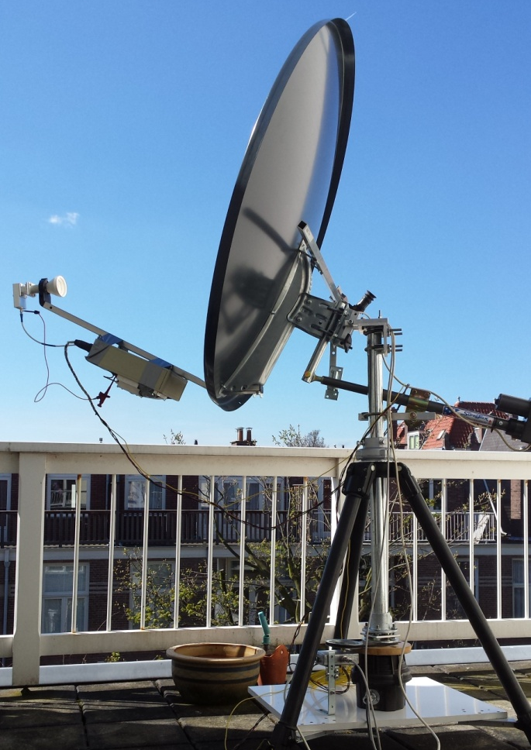
PA0HRK’s 3 cm station using 1 m offset dish

PA0HRK: Harke harke.smits(x)hccnet.nl writes about his first real experience with 3 cm EME during the DUBUS Contest – I have a 1 m dish on my balcony and at first experimented with a PLL LNB. I quickly abandoned that after getting annoyed by the frequency offset of about 90 kHz and drift depending on if the Sun was shining or not. So, I mounted a DB6NT LNA (NF = 0.67 dB) and my good old transverter. The Funcube at the IF output of my transverter and Spectravue software did a good job! And voila, more than 8 dB of sunnoise and 0.4 dB noise from the Moon. Stability was good enough, but could be improved. On Saturday, I heard SP6JLW, OZ1LPR and UA4HTS with good signals on CW from the speaker of my FT817. Spectravue was used as a panoramic receiver. Many more signals could be seen on it. I also heard the characteristic sound of JT4F. The next day, I heard OK1KIR when my antenna was half blocked. SP6JLW was constantly calling CQ with a loud signal. I am not very sure about signal strength as the signal per division is not so clear in Spectravue (1 or 2 dB in waterfall mode, 4-5 divisions). Anyway, they were loud and clear. Many more stations were heard and seen, but most of them were not identified. After so many years of neglecting my CW, I have become quite rusty! Then I started WSJT and quickly decoded three QSO's in JT4F: WA3LBI with OZ1LPR, OK1DFC with OK1KIR and OK1DFC with OZ1LPR. A very exciting experience! I am now desperately looking for an affordable PA of about 30-50 W!

PA3DZL: Jac pa3dzl(x)ziggo.nl had a very nice time on 3 cm off the moon in the contest – I made 25 QSOs X 23 mult, 13 initials and added 6 new DXCCs. I copied SP6JLW (57) on SSB. The strongest signals were from SP6JLW, LA8LF, YO2BCT, UA4HTS, OZ1LPR, W7CJO and DB6NT. The was also nice X-band activity on 10450 from JA. I heard all 5 JA stations but could only work 3 of them. The weather was also very nice, although there was some wind that made it difficult to keep my dish on the moon. Very often I had to track by hand using moonnoise. During the weekend I measured close to 17 dB of sunnoise and 2.4 dB moonnoise. QSO’d on Saturday were OK1KIR, VK3NX initial #20, SP6JLW, ES5PC, JA4BLC, JA6CZD #21, LA8LF #22, YO2BCT #23,
OK1CA, HB9SV #24, PAØBAT, HB9Q #25, OH2AXH, IK2RTI #26, UA4HTS, OZ1LPR, OH2DG, G4NNS, DF1SR #27, VE4MA #28, W7CJO #29, IW2FZR #30 and F1PYR. Heard were UA4AAV and JA8ERE. On Sunday, I was only QRV for a few hours because of Mothers Day and only added DB6NT #31 and JA1WQF #32. Heard was JF3HUC. My station is 3.7 m solid Andrew dish, f/d 0.34, vertical pol with 65 W (x) the feed and a 0.65 dB preamp.

RD3DA: Yuri rd3da(x)list.ru sends some disappointing news -- I have been told by city authorities that parabolic antennas are not allowed on residential house roofs. [I know some stations have received special permission to have antenna because they were performing scientific experiments… using their dishes for radio astronomy, etc.]. There is no opportunity to work EME portable near my home. My village is circled by woods and for VHF is not suitable.

SP/OK5EME: Zdenek (OK1DFC) ok1dfc(x)seznam.cz is again planning a mini dxpedition for 3,4 - 5,6 and 10 GHz at MW and EME seminar in Poland on 11-15 Aug. More details http://www.ok1dfc.com/peditions/ sp_2016_MW/sp_2016_mw.htm.

UA3PTW: Dmitry ua3ptw(x)inbox.ru reports QSO on 70, 23, 13 and 6 cm in May – I QSO’d on 432 using JT65B P40MB, DL1KDA, EA6/PA2CHR, BH4PVP and 9A8DXG, on 1296 using JT65C D44TVD and F5EJZ, on 2320 with JT65C D44TVD and G4DDK, and on 6 cm with JT4F UR7DWW and on CW DF3RU. [TNX DK3WG for forwarding this report].

VE3KRP: Fast Eddie eddie(x)tbaytel.net had a pretty quiet month activity wise – I did manage to work on 15 May using JT65C G4BAO, K5DOG and KD3UY all on 23 cm. I am getting ready to operate the June VHF contest (11/12 June) from N0EO (EN37) and will be looking for EME QSOs.

VE6BGT: Skip macaulay.skip(x)gmail.com reports his 21.5’ dish is taking shape -- I am working on the inner rings right now and hopefully within the next month will begin to mesh in the dish surface. Lots to do before all that and then I have to get the four footings cemented into the ground to hold the stand for this project. I hope to have it up and QRV by the fall.

ZS6EME: Alex zs6eme(x)linkrf.ch sends an update on his progress -- Last week I was able to place my 3.6 m dish in place and test the AZ/EL system with great success. I was forced to engage a company to rise up the dish due the fact it was impossible for me to do it without help. The antenna mechanics are working perfectly and now I'm concentrating on the SSPA and RX part. One delay is the fiberglass pipes needed to support the feed. Because I decide not to use a tripod configuration for support, the fiberglass pipes are a must. The pipes were delayed two weeks; they now promise deliver next week. The RX part is finished and just needs to be placed inside a waterproof box. I'm now working on the SSPA. I have two Erickson PAs and will install both combined. The first problem I had was my driver. I mechanically destroyed the FETs (MRF21030s) due an error in milling the aluminum. The EME community’s response was great. G4BAO is sending me 3 FETs to replace the damaged ones. ES5PC has already sent me several FETs and parts. I modified one of the output combiners; I removed the SMA connector and replaced it with an N. I also replaced the small 50 ohm terminations (just 10 W) with 150 W loads. The result is impressive. The PA now delivers almost 300 W without overdriving it. I am proceeding with modifying the second PA and expect to have 500 W after they are combined. Never the less, I will run only 400 W (my legal limit). This will give plenty of magin in the RF budget to run the overall SSPA very comfortably. For the modifications, I followed a guide from N1JEZ and KT1J - TNX. I will try to finish everything before 8 June. I will be holiday for 10 days, but if all goes as expected, I hope to make my first QSO the 3rd or 4th week of June. The first EME contact on 13 cm with South Africa was between ZS6AXT and VE4MA on 17 Jan 1997. Only a few QSOs were made and many stations never had the chance to add South Africa to their DXCC list. I have already been receiving requests for skeds. My CW skills are not the greatest, but I will try my best - just be patient with me. I would be pleased to give out many first ZS to XXX QSOs on 13 cm. Let me know if you want a sked.

K2UYH: I alkatz(x)tcnj.edu was away for almost two weeks in May, but managed to catch on 432 on 7 May at 1407 P40MB (23DB/23DB) JT65B from Aruba for my DXCC* 126 and mixed initial #913*. I had put Aruba on 23 and 70 cm EME back in 2007, but did not have time to work my own station on 432. I then switched to 3 cm for the DUBUS Contest. I worked using CW on 7 May at 1530 SP6JLW (579/559), 1537 LA8LF (559/559) for initial #15 and DXCC 11, 1546 OK1CA (559/569), 1553 UA4HTS (559/559) #16 and DXCC 12, 1614 OK1KIR (559/559), 1740 F1PYR (O/O) #17, 1802 VE4MA (O/O) and 2356 W5LUA (559/559) XB with Al TXing on 10450, and on 8 May at 1525 partial HB9Q (559/-) – I had problems with wind gusts blowing my dish off the Moon on Sunday and never completed and 1632 DB6NT (559/559) #18 and DXCC 13 for a score of only 9x8. I was on for the JA-NA window, but by its start at 0000, the Moon was already quite low, and by 0030 at 5 degs. The good news is my 10450 received system worked well. Although I copied no JA stations (I copied what appeared echo testing before I lost the moon), I did copy W5LUA calling on 10450 and I was able to easily QSO him crossband. [See the Technical section of this NL for a discussion on what I did]. On 3 cm outside of the contest, I made my first JT4F QSOs on 7 May at 1654 G3WDG (9DB/20DB) mixed initial #19* and DXCC* 14, 1730 OZ1LPR (18DB/10DB), 1738 EA3HMJ (24DB/10DB) #20* and DXCC* 15, and 1751 OK1KIR (21DB/14DB). I was QRV on 5760 on 12 May to QSO with JT4F at 1924 W5LUA (5DB/12DB) and 1934 OK1KIR (18DB/14DB), and on 13 May at 0330 KL6M (559/559) CW for my initial #47 and DXCC 23. I worked on 14 May on 432 at 2145 EA6/PA2CHR (19DB/17DB) JT65B #914*, then on 1296 at 2220 D44TVD (29DB/29DB) JT65C for mixed initial #536* and DXCC* 109, back on 432 at 2300 KB7Q (16DB/O) JT65B #915*, and finally on 1296 at 2345 WA3RQG (15DB/O) JT65B #537* - worked before but now from a new grid (EL98). I was unable to be QRV on 15 May because of travel and thus missed the May 70 cm ATP.

NET/REFLECTOR NEWS: KL6M reports making the first 6 cm EME QSOs from Alaska with 10 W and his 30 m dish. UA4AQL was active on 432 with JT65B in May and added initials with JS3CTQ, FR5DN and DL6SH – [TNX DK3WG for forwarding this information]. EA3HMJ is now QRV on 3 cm EME using a 1.8 m offset dish and 100 W at the feed. You can reach Jose for skeds at ea3hmj(x)gmail.com. SQ7D/SN7D has limited his EME activity due familly affairs but hope to be 23 cm with JT. W1PV is making progress on adding 23 cm EME and trying to get some RF out of his 4 x 7289 cavity on 23 cm. Skip is in CT and can be emailed at flathood(x)rcn.com.

FOR SALE: JA4BLC can supply several 82 MHz crystal oscillators for 10450/10368 converters. See Jan 2014 DUBUS Magazine pp. 76-85. The price is 5 USD or Euro each including shipping! Email Yoshiro at ja4blc(x)web-sanin.co.jp. LA8LF has a dish and mount available for a very good price. Contact Anders at anders(x)la8lf.com. K6PF has for sale a number of items that may be interest: RF Concepts RFC 4-110 for 430-450 MHz with 10 W Pin for 100 W Pout with built-in preamp. Includes manual & schematics for $US200. SSB LT23S xvtr. 1296-1298 MHz to 144-146 MHz IF. 9 W Pout for $375. New 23 cm PA & PS built by K6KWQ using water cooled GS-15B in cavity built by KD5FZX. Pout at 1296 350-400 W. Free-standing or rack mount. 19" W x 7" H x 17" D. Never used. Includes all pwr supplies & variac includes 3 extra GS-15Bs with water jackets, water pump & heat exchanger & uA meter for measuring current in water supply, 220 VAC pwr for $1,250… and lots more. Contact Bob at k6pf(x)sbcglobal.net if interested. u have my DL9EBL 23 cm TH-327 cavity for sale. It works fine as Steve’s signal will attest. Included are two TH-327s. They are used but produce 1500 W. The price is $US1300 plus shipping. He also has the original power supply, which needs some work and is negotiable. Contact Steve at n4pz(x)live.com.

TECHNICAL: An easy way to receive the JA 10,450 MHz band by K2UYH -- What I did was use my DB6NT transverter with a DSP dongle tuned to 226 MHz. I measured my transverter and found it only lost 9.8 dB of gain at 226 MHz. I am sure others may want to try the same approach to copy the JAs on 10450.

EME 35 & 25 Years Ago BY PETER, G3LTF: In the April/May 1981 NL, the new skeds coordinator, G3WDG stated that skeds should be kept to a minimum during contest weekends. (The ARRL Contest was then in the spring and one weekend corresponded with the “sked weekend”). The G3WDG group also reported on high speed AFSK data tests, 2.5 second bursts with echoes decoded and error corrected giving error free data rate of “several letters/minute”. In May, the big news was the first NA/EU contact on 2300 between PA0SSB and W6YFK. Jan had his 100 W tube final at the feedpoint and 10 dB of sunnoise. He used the ALSAP moon beacons for tracking. W6YFK had a 1 kW klystron and Jan copied his SSB. HB9BPQ (now G0JLO) completed the first 4 yagi WAC on 432, and TI2NA made his first EME QSO (with TI2AEB assisting). The issue also included a detailed description of G3WDG’s GAT6 cavity preamp for 1296 with the gate bias choke inside the cavity inner; the first time this technique was used. Also featured was a nice picture of WB5LUA’s 24’ stress dish and dual band feed with H and V for 432.
The May 1991 NL was 8 pages despite a prep clash with the Trenton Computer Fest! 40 stations reported from 5 continents. OK1KIR reported on his REF contest weekend results with 30 on 432, 24 on 1296 and 4 on 2300. N4GJV worked 65 on 432, VS6BI suddenly appeared and was worked by 16 stations on 432 with his 4 yagis and 3CX800. 2300 activity was high with 10 stations active and many initial QSOs and several others preparing gear. The I6QGA group reported copying SM4DHN and WA7CJO on 10 GHz with their 4 m dish. WB0GGM was up to initial #18 on 432 with only 100 W (solid state) on CW to 4 x 5.5 m long yagis. OH2DG was then up and running on 1296 and up to #8.

EME and MW Seminar in OK Reported by OK1DFC: On 22/24 April 2016 was held the 25th Mikrovlnný a EME seminá. This year we celebrated 25th year of OK VHF club. On Friday evening, we had a celebration dinner sponsored by ALCOMA, GES-ELECTRONICS, PPC Belden and M&M Reality. On Saturday morning, we started by presenting awards to winners of IARU Region 1 UHF and Microwave Contests and the Czech Championships. Our ham friends from the Polish VHF club also presented a special award to the OK VHF club for their 25th of anniversary. OK1VBN, 93 years of age received the OK Hall of Fame Award for his pioneering work from the beginnings VHF – UHF activity in OK to the present.

Group at the Czeck EME and Microwave Seminar

FINAL: 17th International EME Conference Update: We have now broken the 100 participant barrier, but we can accommodate more. Please get you registration in as time is running out. The registration deadline is 10 June. After this date we will not be able to guarantee the availability of rooms at the conference hotel. I am trying to stretch the deadline with the management, but this is not certain. PSE register at: http://www.eme2016.org/index.php/registration/. I remind you that you can send even a partially compiled form, if you don't have all the requested data at the moment. There is no obligation to book the room at the conference hotel, but you will not have to deal with transportation if you are at the hotel. (If you have a vehicle available, it should not be a problem). You can use the last field of "Your message" for any inquiry. Many have asked to extend their stay to enjoy a vacation here, and we are happy to help! If you need any information just ask and we'll try to accommodate you. Remember that we can also host table-top presentations, or you can simply send a paper just to be published in the proceedings. The II3EME station will be active for most of Aug on 144, and we are working to activate the call also on 1296, 2304 and 5760. The presentation schedule follows: Saturday - Welcome and conference briefing, IW3HVB, - Chapter II – Signal polarity in V/UHF bands, IK1UWL & IK3XTV, - Failure levels in LNAs, G4DDK, - On the Theoretical and Practical Limits of Digital QSOs, DJ5HG, - Q-ary Repeat-Accumulate Codes for Weak Signals Communications, IV3NWV, - Stress Offset Dish for 1296 MHz, K2UYH, - Portable EME MW Setups, OK1DFC, - High Power Switching Class E and F amplifiers, AD6IW, - PB8 13 m Cassegrain Dish Adventure with ORPB society, F2CT, - Experiences with Circular Polarization on 10 GHz, G3WDG, - Techniques used in construction of a home brew 10 m parabolic antenna, VK5MC, and - Azimuth Drive for Small Dishes, G4HUP; and Sunday - Let’s Bounce, PA3FXB, - New Codes, Modes, and Tools for EME, K1JT, - Optimized EME reception with Linrad and WSJT under multi-polarization configuration, ZS6EME, - The Stealth Dish, I0NAA, - Please Don’t Throw Tomatoes – ARRL EME Rules, K1DS, and - Roundtable and Conclusion. We are also close to the deadline for the receipt of papers (5 June). It is critical that you send all material to be published promptly - the sooner the better! If you have your material in editable format (e.g. Word, Power Point, …) with separate image files that would be appreciated. A pdf with the preferred layout is also welcome.

It is pretty clear that the 70 cm CW ATPs are not working. Part of the problem is that there are too many conflicting activities. Many of the 70 cm CW operators also operate CW on the microwave bands. Possibly the solution is better scheduling with less conflicts. The CW ATPs should definitely be discussed at the EME Conference in Venice!

K1RS is looking for your feedback on the ARRL EME Contests can be improved and asks that EME operators fill out the survey at https://www.surveymonkey.com/r/PR5SMB2. Information from the survey will be presented and discussed at the International EME meeting in Venice in August.

There is now a Russian language EME NL: "EME vestnik" being produced by Alexey, RA4SD ra4sd(x)yandex.ru. He will be translating parts of this NL for inclusion in this NL and is being helped by Toly, UA4HTS and Dima, UA3PTW. The NL can be loaded from the Russian VHFDX site http://forum.vhfdx.ru/eme-b7/eme-etk/msg254038/?topic seen#new.

Some possible good news: there are possibilities of future 9 cm allocations in France, Spain and Italy – info TNX DJ3JJ.

I5WBE reports the results of ARI EME Trophy Spring 2016 can be found at site http://www.eme2008.org/ari-eme/Results%20Trophy%20Spring% 202016.pdf.

DK7LJ had problems with the 10 GHz EME beacon this month. It appears to be with the new HB tracking software. Before he can leave the beacon unattended, he needs to put in more time testing.

The OK1KIR recently celebrated the 40th anniversary of the first ever EME contact from OK on 23 May 1976. Operators from that time with XYLs and some other OKs visited the astronomic observatory near Prague where radio-telescope used back then for EME is still in use for sunnoise measurements. More info can be found at www.vhf.cz.

With modern communications my job of compiling the NL should be easier, but I am again running out of time. There is much more I’d like to include, but I need to stop. Please keep the reports and tech info coming. I hope to find you off the Moon and see you in Venice in Aug. 73, Al – K2UYH

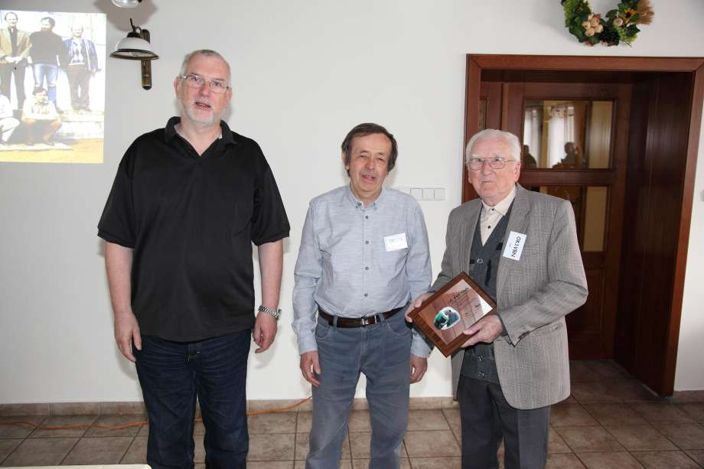

OK1DFC, OK1CA and Hall of Fame Award winner OK1VBN at Czeck Conference

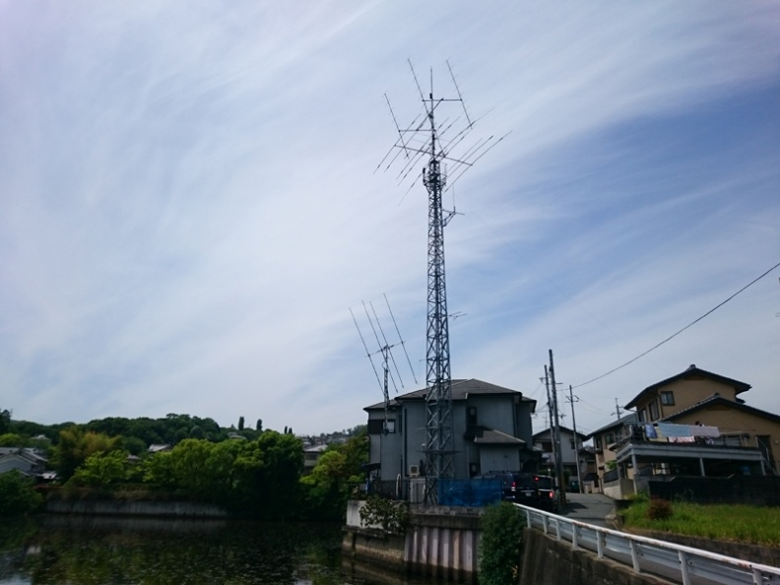
JS6CQT arrays: 70 cm EME array is left of main tower

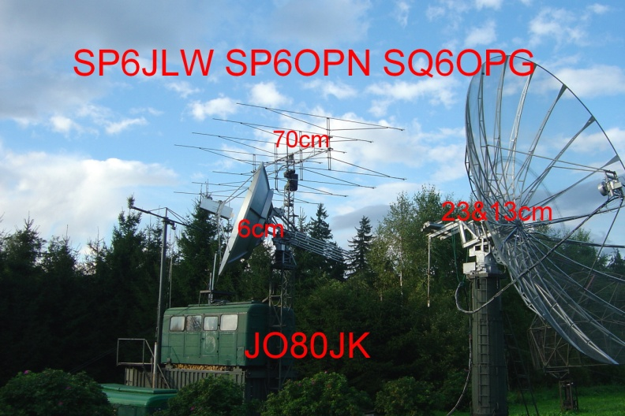
SP6JLW had one of the strongest and most consistent signals in the 3 cm DUBUS Contest.

