432 AND ABOVE EME NEWS
June 2017 VOL 46 #5

EDITOR: AL KATZ, K2UYH; DEPT. ELECTRICAL/COMPUTER ENGINEERING, THE COLLEGE OF NEW JERSEY, PO BOX 7718 EWING, NJ 08628, TEL (W 609-584-8424) OR (H 609-443-3184), FAX (609-631-0177), E-MAIL alkatz(x)tcnj.edu
ASSOCIATE EDITOR AND NETNEWS (based Reflector News) Matej Petrzilka, Simunkova 1609/21, 18200, Praha 8, Czech Republic, TEL (+420 603 489 490), E-MAIL ok1teh(x)seznam.cz
CW INITIAL LIST G4RGK, DAVID DIBLEY, E-MAIL zen70432(x)zen.co.uk, AT: http://www.zen70432.zen.co.uk/Initials/index.html
EME INFORMAL NETS: 14.345, ~1500 SATURDAY AND SUNDAY, NET COORDINATOR: OPEN
ON0EME EME BEACON, 1296.000 IS QRV WHEN MOON >10°, SEND RX REPORTS TO WALTER (ON4BCB) on4bcb(x)gmail.com
DL0SHF 3 CM EME BEACON, 10368.025, SEND INFO & QUESTIONS TO Per (DK7LJ) per(x)per-dudek.de.
NL EMAIL DISTRIBUTION and EMAIL LIST CORD: WARREN, W2WD wbutler(x)ieee.org [PDF OR "ON WEB" NOTICE]
THE NL WEB VERSION IS PRODUCED BY REIN, W6SZ rein0zn(x)gmail.com AND AT http://www.nitehawk.com/rasmit/em70cm.html\

CONDITIONS: Activity in April/May was dominated by the 9 cm Dubus Contest. Conditions and activity were reasonable good during this contest. The top scorer was OK1KIR with 32x30, and the second place scorer was ES5PC with 31x27. This newsletter (NL) will arrive too late to announce the 6 cm Dubus CW Contest and the ARI’s EME Contest, both on the weekend of 27-28 May. The May 432 CW Activity Time Period (ATP) was also on this weekend. These events will be reported on in the next NL. D44TU was to be on 432 in May, but never made it on. Look for extra EME activity on the 10-11 June moonpass, which is the ARRL’s June tropo contest (EME is allowed). A number of clubs are planning a serious effort off the moon - see the W3CCX report. The 3 cm Dubus EME CW Contest is on 24-25 June. There is also a 6 cm microwave activity weekend (MWAW) on 17-18 June and the June 70 cm ATV on 18 Jun 0200-0400 and 0830-1030. We know of no dxpeditions scheduled for the next month. The SM EME Conference at Orebro was another great success - see the end of this NL. EME’s own G3LTF has been selected as Honorary Vice President of the RSGB! Congratulations to Peter; all agree that the RSGB could not have made a better choice. Details can be found at http://rsgb.org/main/blog/news/ gb2rs/headlines/2017/04/22/new-rsgb-honorary-vice-president/.

G3LTF new RSGB Honorary Vice President
A leader the fight to preserve the 23 cm band

3DA0MB: Lins (PA3CMC) info(x)pa3cmc.nl sends news that Swaziland will be on 23, 70 and 200 cm EME between 13 and 18 Oct in KG53mn. They will use both JT and CW. The team is 3DA0VV, PA3CMC, ZS6JON, PA2CHR and ZS6AVH. On 1296 they will have a single 67 el yagi and on 432 a single 38 el m2 yagi. Donations are welcome to Paypal info(x)pa3cmc.nl, Bank IBAN NL58INGB0006770934 or BIC INGBNL2A. More information will follow.

BV3CE: Tom tom33638998(x)yahoo.com.tw is QRV on 432 EME -- I am using 2 x 20 el vertically pol yagis with a HB 800 W PA. On 30 April I completed my 1st QSO on JT65B with DK3WG (O/19DB) followed by UA3PTW (O/19DB) and DL7APV (O/21DB). I look forward to QSOing more stations. I am moving to a new house, but will be QRV again before the end of May.

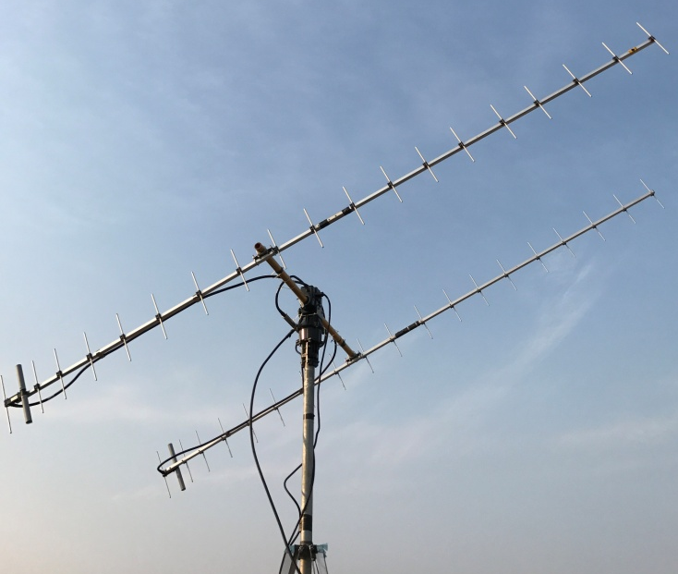
BV3CE’s 2 yagi array for 432 EME

D44TU: Dan (HB9Q) shack(x)hb9q.ch reports that the X-Team tried to QRV on 70 cm EME on 3 May with 2 x 17 el yagis and 50 W, but apparently had troubles and never made a QSO.

DL0FHA: Thorsten (DL1DBT) benkner(x)gmx.net is building up a club station at FH-Aachen University to demonstrate EME to his students -- We are just at the beginning with our station. The antenna is a 2 m dish on a 9 m tower on the roof of our building in Aachen (JO30bs). Up to now, we have used the dish to receive various L-band satellites. We are working on a circular feed and LNA for 23 cm. We hope to copy the ON0EME beacon.

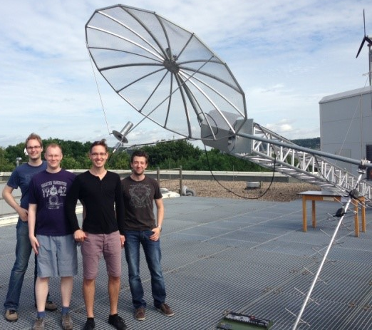
FH-Aachen University ham club setting up for 23 cm EME
ES5PC: Viljo viljo.allik(x)estcube.eu sends news on his Dubus 9 cm contest operation -- There was good activity on 9 cm during the contest weekend. I worked KL6M for an initial (#), SP6OPN, DF3RU, LZ1DX, OF2DG, G3LTF, G4CCH, OK1CS, HB9Q, OK1KIR, OK1KKD (#), PA3DZL, OH1LRY, DL1YMK, OK1CA, S53MM, S59DCD, 9A5AA, PA0BAT, OZ6OL, K2UYH, WA9FWD, VE4MA, VE6TA, WA6PY, WB2BYP (#), SM6PGP, SP3XBO (#), OZ5G, PA7JB and LX1DB for a total of 31x27. I worked 7 more stations than last year! So it seems that more stations were actually QRV this time. I use a 4.5 m dish and SSPA designed by SM6PGP. The output power was about 150 W to the feed. During Saturday it was sometimes too windy to keep the antenna pointing stable, so there was probably quite a lot of QSB on my signal. Sunday was much better. I had also some problems with my PA or possibly transverter oscillation. It turned out to be caused by too much RF leaking into the RX input of my DB6NT transverter. I fixed it by adding a 4 dB attenuator at transverter RX port.

G3LTF: Peter g3ltf(x)btinternet.com sends his April-May EME report -- We had visitors over the 9 cm EME contest weekend, and so I was only able to be active for the first 5 hours of the contest on Saturday. I found activity and conditions both good. I worked 19x16. Stations QSO’d were KL6M, DF3RU, ES5PC, PA3DZL, OF2DG, HB9Q, OK1KIR, SP6OPN, OK1CS for initial #58, S59DCD, OH1LRY, G4CCH, DL1YMK, OK1CA, LZ1DX, OK1KKD #59, OZ6OL, SP3XBO #60 and S53MM. I’m sorry I had to miss the main NA window. My thanks for all the nice QSOs and especially for the very kind congratulations messages on CW. There is an amazing level of EME activity and interest in OK now. It is really good to see. I very much enjoyed SM EME meeting. It was a great stimulus to get back to working on my 3 cm system.

G3WDG: Charlie charlie(x)sucklingfamily.free-online.co.uk was QRV for the 10 GHz activity weekend (AW) in May -- I was able to listen again on 10450 with a second down converter (that I had mislaid for a couple of years). Stations worked were JA1WQF, JA4BLC, OK1CA, OH2DG, HB9Q, OZ1LPR, PA3DZL, WA3LBI, LX1DB, PY2BS, VE4MA and UN6PD. All were on CW except for WA3LBI on JT4F, and LX1DB on SSB. I was using my new linear rotatable pol feed. Most of the time V pol was about optimum, but the feed did enable a QSO to be made with UN6PD, where the polarization offset was about 40 degs, and his CW was too weak to copy with V pol at my end. I have also been experimenting with some small horn antennas, and have been able to get good decodes from DL0SHF (running QRA64-D) using both 25 dB and 20 dB horns!

G4BAO: John john(x)g4bao.com has added 6 cm EME to his station - I have been testing on 6 cm my QRP system consisting of a 1.9 m dish and 20 W, and a RA3AQ feed. On 25 May I worked at 1019 SM6CKU.

HB9Q: Dan dan(x)hb9q.ch writes about the 1296 WAS challenge -- We would like to continue to work on our WAS for 1296. After working N4QWZ in Tennessee (it was his 1st 23 cm EME QSO), we ‘only’ need 13 states to complete WAS. With our 10 m (33’) solid dish and 1 kW at feed (see for more info www.hb9q.c), we are capable of working stations using single-yagi with 30 el running 50 W or 1.5 m dish with 10 W on JT56c. For CW we need some 6 dBs more. We are very interested in skeds. If you have 1296 equipment (also if it is QRPP and you never have worked EME before) and you are willing to try please let us know. Please email or look for us on the HB9Q 1296 EME logger (we are always stand-by when QRV).

JA4BLC: Yoshiro ja4blc(x)web-sanin.co.jp writes on his activity in April -- I was on 10450, on 25 April and worked JA1WQF and JA8ERE several times during testing of circular and linear polarization. Setting the polarization linear horizontal, I worked JA6BLS (O/O) for initial #35 and his first ever EME QSO. JA6BLS has 2.4 m dish and 20 W TWTA. The next day I worked JA8IAD (O/539) #36 and his first ever 10 GHz EME. Michinori is using 3 m TVRO dish and 50 W GaN SSPA made by JA8CMY. On 30 April, I worked DL6ABC (569/539) #37 crossband (10368/10450). My GPS-RX Z3801A was broken last week and I replaced my 10 MHz reference with a Rubidium oscillator, but my own echoes were weak than normal. I solved this problem by inserting a single 10 MHz xtal at the output of the Rubidium osc in series as an filter. This filter worked well. On 5 May I worked JA8ERE (559/549). Conditions on 6/7 May during the 3 cm AW were bad. The Moon was too low in declination and there were storms in northern Japan. I worked on 7 May G3WDG (559/559) cross band, JA6BLS (O/M) and JA1WQF (559/559). The annual EME meeting in JAPAN was held on 20/21 May at the Inn at Tsuyama city GL.
KL6M: Mike melum(x)alaska.net had a great time in the 9 cm Dubus Contest -- My whole system was working flawlessly, and the WX was great too. My output power was 112 W, thanks to DL7YC’s modification to the Toshiba UM2683B SSPA, and to N8CQ's PCB design. I managed to work a total score of 28x25. QSO’d on 29 April were at 0050 VE6TA (569/579), 0634 OK1KIR (569/569), 0639 OF2DG (569/569), 0713 SP6OPN (559/559), 0740 HB9Q (579/579), 0747 ES5PC (569/569), 0751 DF3RU (569/559), 0808 LZ1DX (559/569), 0808 G3LTF (569/569), 0808 G4CCH (579/579), 0808 PA3DZL (569/569), 0831 OK1KKD (559/559), 1828 OZ6OL (559/569), 1846 WA9FWD (559/559), 1854 VE4MA (559/569), 1902 OK1CS (549/569), 1912 OH1LRY (559/559), 1925 DL1YMK (579/569), 1940 WA6PY (569/579), 1944 WB2BYP (559/559), 2000 9A5AA (559/579) and 2011 SM6PGP (569/569), and on 30 April at 0736 OK1CA (569/569), 0837 OZ5G (569/559), 0950 PA0BAT (559/559), 1007 VK3NX (O/O), 1919 K2UYH (579/569) and 1952 LX1DB (579/579). I had some great RSTs, but one of my best QSOs was VK3NX (O/O) on 3398.1 with less than one deg of elevation. I auto tracked from moonrise to moonset without a glitch, which really thrills me, after all the trouble I have had. WA9FWD's suggestion that I put more capacitance on my 5 V regulator at the encoder did the job. I experienced a very strange thing the first day. My tracking was spot on, and I can rotate AZ from moonrise (65 degrees) to moonset (305 degrees) and not lose even a 1/10th of a deg. Yet when I was close to the horizon on moonset, the closer I get to the horizon, I seemed to have to re-boresight as much as a degree. I concluded that I am seeing 'REFRACTION' of the signal due to passing through more atmosphere. Thanks to all 9 cm folks for a great contest.

KL6M’s 9 cm feed with cake plate scalar ring - see Technical

LU8ENU: Jaun lu8enu(x)gmail.com sends news of the first SA-SA 3 cm EME QSO -- On 6 May PY2BS and I completed a contact on 10368. The actual QSO using JT4F was quite fast despite that my SDR receiver was not working properly. I found Bruce’s trace very easily given that he used CFON. Another great help is that we are both using GPS frequency references. Signal level was very good and Bruce's signals were audible. I was using a 2.3 m dish with V4MA stile linear feed horn set to H pol and a 25 W TWTA.

N4PZ: Steve n4pz(x)live.com has returned from Orebro (Sweden) EME Conference and reports it was terrific -- It was the "crem de la crem." I am putting the new 300 W, 13 cm SSPA that I acquired at Orebro at the feed. I will completely avoid cable loss.

N5BF: Courtney courtney.duncan.n5bf(x)gmail.com write about his 23 cm activity -- Somehow I missed turning in a report last month with my 23 cm DUBUS results. I completed 18 random CW QSOs with 17 multipliers over the Dubus 23 cm weekend (1-2 April); and as a result I have a much better understanding of how 23 cm CW EME works, given libration fading and other propagation issues. Throughout the Dubus weekend, I was seeing my own echoes around -16 dB; meaning I would have given myself a (559). I was working stations down to -18 dB. ôArmchairö QSOs were on Saturday with VE6TA, K2UYH, SP6JLW for a new mixed initial (#*), OK2DL, DL6SH, HB9Q, OK1KIR, ES5PC, G3LTF, G4CCH, VE6BGT and KL6M, and on Sunday with SM4IVE (#*), OK1DFC, NC1I, OK1CS (#*), UA3PTW and OE5JFL. Overall I accumulated 3* additional mixed initials and 7 CW initials. The moon was so low for UA3PTW and OE5JFL that when I worked them (6 degs) that I think it had to be their last contest QSOs. SM4IVE was the loudest. As others have noted, there was a good showing from OK-land! Sadly, I had no luck to my west. I called for a while late Saturday during my VK/JA window with no responses. I determined that my pine trees to the west were worth 12 dB loss by comparing between K2UYH in the clear and through these trees. The oak trees lower down are absorbers (infinite dB). There was one station late Friday evening that tried to answer my CQ repeatedly, but I was unable to pull out a complete callsign in half an hour. Two other stations on Sunday were, similarly, not quite clear enough for me to answer their CQs. Receive improvements are planned. I was able to work stations smaller than my own size (3 m dish with 300 W SSPA and 0.45 dB NF LNA). I also tried an EME contact across town to K6JEY with K5PV operating and did make a direct tropo QSO, but nothing heard off the Moon. WA9JIB came by and witnessed some of this attempt. I missed some others (DK3WG, N4PZ, PA2DW, PA3DZL) by not being at the right place at the right time. Tuning for stations across the band (1296.005 to 1296.050) during the DUBUS event while Europe was in view reminded me of 40 m on Sunday afternoon when I was a teenager in the 1970s. 23 cm EME continues to be the most challenging and fun I’ve had in a long time! Four weeks later, by pre-arranged schedule, I worked several more new stations. I added on 28 April PE1CHQ (#*), IK5EHI (#*), G4CDN (#*), LA4ANA (#*) and a new DXCC, LA3EQ (#*), DJ5AR (#*), and PA3DZL (#*) - who rushed home from a restaurant to make the QSO! All contacts were on JT65C. I failed on CW with F5KUG and N6OVP, but plan to try again after planned improvements have been made by all stations.

NC1I: Frank frank(x)NC1I.COM sends his late April/early May report -- On Saturday morning 29 April, we were able to make repairs and get the 432 array back in service. However, we were not able to get the polarity rotation working. I have help lined up for Friday afternoon, 26 May, and expect to have the polarity repaired before sunset that day if the weather cooperates. We hope to have the array back to full capabilities for the weekend of 27/28 May. I will try to be active much of that weekend (although this is a holiday weekend here in the States and we are celebrating my son’s graduation from University, so time will be somewhat limited). I will also make it a point to be on for the CW ATP. As of the last weekend of April, we are back to full power (1400-1500 W). From 29 April through 8 May we made 52 QSO’s on 432. Several initials were added including working BH4PVP and BG6LQZ consecutively on my moonrise of 30 April. That was certainly the highlight of our recent activities. Stations worked on 29 April included N7NW, UR3EE, OK2AQ, KF8MY, DL5FN and F6APE, on 30 April JS3CTQ, BH4PVP, BG6LQZ, PA0BAT, K3GNC, G4YTL, UA0AET, G3LGR, DL8DAU, OK2AQ, F8DO, RA9CHL, G6HKS, GW3XYW, PI9CAM, PA2V, PD7RKZ (2 x 24 el yagis and 20 W) and DL7APV, on 1 May WA2FGK and JA6AHB, on 3 May OK1DFC and K5DOG (nice to see Steve back on), on 4 May DF3RU, 4Z5CP (1 x 15 el yagi and 400 W), US8IGT, DL8DAU, DK5SO, DD0NM and DK3SE, on 5 May DD0NM, FR5DN, GW3XYW, UT6UG, DL6SH, DL7APV, DL6SH, PE1RDP, I1NDP and DL8DAU, on 6 May UR3EE and GW3XYW, on 7 May K5DOG, KF8MY and KJ7OG, and on 8 May K5DOG and N4BH. W9IIX was heard calling K5DOG, but Doug was dead on my frequency, so I suspect he thought he was calling me, but he had Steve’s call in his text line. 1296 did not get much attention as we were focusing on 432, but we did log on 28 April F5EJZ, IK5EHI, SP5GDM, G4CDN and N5BF, on 30 April K5DOG, JA8SZW (bad drift), IK2MMB, VE4MO, DF2VJ, LA8ANA, UA9FA, DF2GB, LA3EQ, II0IAAR/5 and VE3KRP, on 1 May F6EJZ, and on 5 May LA3EQ. W1QA and I have a lead on a possible location for a NH EME dxpedition. We hope to check it out by the second week of June. The window on rising and setting moon may be limited to about +7-10 degs, but that should be acceptable. If all looks good we hope to put NH on 1296 EME this summer or early fall. We could also consider 432 at some point.

OK1CA: Franta strihavka(x)upcmail.cz had a very good time on microwave EME in April/May -- On 27 April, the distance from the Earth to the Moon was only 359,327 km. I planned a 24 GHz sked with VK7MO for this date. The WX was not optimal; it was cloudy and the humidity was high - 85%. I measured moonnoise after my moonrise at only 1.6 dB. My usual value is 2 dB. I saw Rex’s signal from the very start. Its level varied from -25 to -19 dB. I worked VK7MO (19DB/21DB) on JT4F for my ODX on 24 GHz of 16,373 km. I was also QRV in the 9 cm Dubus EME Contest on 29/30 April. I was active Saturday for only 3 hours and made 18 QSOs. I continued on Sunday and added 10 more QSOs. My overall score was 28x26. Initials were with OK1KKD, SP3XBO, OZ5G and WB2BYP to bring me to initial #58. The conditions were very good, but with strong winds on Sunday. I measured sunnoise at 18.9 dB (SFU 78.2) and moonnoise as 1.9 dB. I also participated in the 3 cm AW on 6/7 May weekend. I worked on Friday evening using CW PA3DZL and F1PYR. I was QRV again on Saturday from my moonrise and worked crossband JA1WQF and called many times JF3HUC, but without success. I heard very well JA4BLC. I continued on CW to work OF2DG, HB9Q, G3WDG and on JT4F UN6PD (17DB/18DB) for a digital initial {#}. I worked in the NA window OZ1LPR, PY2BS and LX1DB. I heard the DL0SHF beacon in the QRA64D mode. The condition were not optimal for the wide spread of the signals. I was not QRV at Sunday.

OK1DFC: Zdenek ok1dfc(x)seznam.cz was expecting to be QRV during the DUBUS 3.4 GHz contest from a portable location - My plans had to change after an accident on the stairs at home. I broke leg and could not travel. I hoped to be QRV from my home QTH with the help of volunteers to build my portable dish on terrace. But the WX and my leg did not cooperate. However, plans are on for my EME dxpedition to Morocco in Oct. More details can be found at http://www.ok1dfc.com/peditions/ morocco/cn_2017.htm.

OK1KIR: Vlada vlada.masek(x)volny.cz sends his group’s report of recent activity (April/May) -- We were QRV on 6 cm and worked on 26 April at 0637 YO2BCT (559/559) for initial #95 using CW. We were active in the 9 cm part of Dubus Contest and worked on Saturday 29 April at 0633 KL6M (569/569), 0642 OF2DG (569/569), 0730 SP6OPN (559/579), 0738 OK1KKD (549/559) for initial #65, 0738 DF3RU (559/539), 0824 HB9Q (589/579), 0830 G4CCH (579/579), 0836 OK1CS (559/579) # 66, 0844 LZ1DX (559/559), 0855 SP3XBO (559/569), 0905 G3LTF (569/569), 0915 ES5PC (579/579), 0920 PA3DZL (579/579), 1003 OH1LRY (559/579), 1121 OK1CA (579/579), 1227 OZ6OL (559/559), 1342 S53MM (559/549), 1400 PA0BAT (569/579), 1445 9A5AA (559/559), 1531 WA9FWD (559/549), 1545 K2UYH (569/559), 1601 PY2BS (569/559), 1648 WB2BYP (569/559) #67 and State of NY, 1713 VE4MA (549/569), 1743 VE6TA (569/579) and 2016 SM6PGP (559/569), and on Sunday 30 April at 1003 VK3NX (559/579), 1245 PA7JB (549/569), 1320 LX1DB (589/579) and 1338 S59DCD (549/559). Heard was OZ5G but disappeared. Our total score was 32x30. Sunnoise was measured as 16 dB (at SF77) and moonnoise 1.2 dB. We were on 70 cm during the time we were waiting for a signal from the D44TU dxpedition on 3 May. We worked with JT65B at 1343 F8DO (27DB/23DB) for digital initial {#205}, 1613 DK0TE (22DB/O) {#206}, 1625 US8IGT (24DB/13DB), 1641 PA2V (18DB/17DB) and 1711 DK5SO (30DB/18DB) {#207}. UA0ALA (22DB/QRZ) in NO66 unfortunately only responded to our calls with QRZ. We did not participate in the 3 cm AW on 5-7 May due to other duties.

ON5RR: Marc moonbouncer(x)skynet.be was QRV in the 13 and 23 cm Dubus Contests -- We were only on each time for a couple of hours, but with good results. I was able to work a little more than 30 stations on both bands. On 13 cm I added 3 initials, on 23 I was able to log 7 new ones. Unfortunately, I will not be able to be QRV in the 6 cm contest due to some other engagements.

PA3DZL: Jac pa3dzl(x)ziggo.nl reports on his recent moon operation -- I found very nice activity and great signals on 3400 during the Dubus Contest! 9 cm is a great EME band to operate on, it is a shame that we cannot use it worldwide. The strongest and BIG signals this weekend were from: HB9Q, KL6M, OK1KIR, OF2DG, ES5PC, OK1CA and K2UYH. I worked 26 stations x 23 mult and 6 initials, which made me very happy! I worked VE4MA for our 6th band EME QSO (70, 23, 13, 9, 6 and 3 cm). Last year, I only had 16 stations and 1 initial, so a good improvement. My operating time on Sunday was very short because of high winds. I worked on Saturday KL6M, HB9Q, G3LTF, G4CCH, OK1CS for initial #47, SP6OPN, LZ1DX, DF3RU, OK1KIR, SP3XBO #48, OK1KKD #49, OH1LRY, OF2DG, DL1YMK, ES5PC, OK1CA and OZ6OL. I QSY’d to 23 cm to work UA9FA (JT65C) and XE1XA (559) on CW for 2 initials. Max was also a new DXCC. Back to 9 cm again, I worked VE6TA, WA6PY, PA0BAT, VE4MA #50, K2UYH, 9A5AA #51 and WB2BYP #52. I worked on Sunday VK3NX XB (3400.1 to 3398.1) and SM6PGP. My Rig was a 3.7 m Andrew solid dish, RA3AQ feed, 0.5 dB NF LNA and 150 W (x) feed. I was on briefly during the 10 GHz AW and worked F1FYR (559/559) and OK1CA (569/569). G3WDG heard me Q5 but could not TX at the time. The DL0SHF beacon is very strong all the time. On 3 cm I run the same dish with V-pol linear feed, 60 W (x) feed and 0.6 dB NF LNA. After a long period, I am also QRV again on 70 cm EME. I am using my small dish on 432 with a PY2BS patch feed with H & V pol and 0.35 dB NF preamp. I have made 2 contact using JT65B in one day of operation. I worked DK3WG (20DB) and PA2V (22DB) both with vert pol. I heard KF8MY (28DB) on horz pol - Mike has 2 x 33 el yagis. Being able to switch between H and V is really fantastic! I will be looking forward to make some nice CW QSOs as well.
PI9CAM: Jan (PA3FXB) jvm(x)netvisit.nl reports CAMRAS was active on 30 April and 27 May on 23 and 70 cm. He notes visitors are welcome. On 30 April they ran a EME SSTV show for Astronomers Without Borders in cooperation with their artist in residence Daniela de Paulis. It was streamed via Facebook Live. See the AWB website at https://www.facebook.com/astronomerswithoutborders/videos/1643857088976647/. See also www.camras.nl.

VE3KRP: Fast Eddie eddie(x)tbaytel.net reports on his recent 23 cm EME -- The snow is finally gone but did see a few snowflakes this week! I made 1296 contacts during the Dubus 23 cm contest weekend on 1 April, all using JT65C with IK5EHI, W3HMS, G4CDN (JT) for a new mixed initial (#*), EW1AA (#*) and LU1CGB, and on 2 April PI9CAM on CW, UA3PTW on CW), SM7SJR on JT and OK2DL on CW. I was also QRV and worked on 29 April DF2VJ on JT, G4YTL on JT, F1PYR on CW, OK1IL on JT (#*), K5DOG on JT, N4PZ on CW, I5YDI on JT and NC1I on JT.

W3CCX: Rick (K1DS) rick1ds(x)hotmail.com sends news that during the ARRL June tropo contest (10-11 June) his club will be operating both 10 GHz and 1296 EME during the Sunday (Z) moonpass from FN21hb in PA. They will be using on 3 cm WA3LBI portable station and on 23 cm K1DS portable station -- We will try to use both CW and JT modes. The June VHF contest exchange includes call sign and 4 digit grid. We hope that conditions will be good and look forward to many contacts.

WB2BYP: John storyavenue(x)hotmail.com enjoyed the 9 cm Dubus Contest -- I worked OK1KIR, OK1CS, DL1YMK, K2UYH, VE6TA, ES5PC, SP6OPT, PA3DZL, KL6M, VE4MA, G4CCH, OK1CA, DF3RU, OF2DG, PA0BAT, OK1KKD, LX1DB and OZ6OL for a total of 18x15. I was sorry to miss SM6PGP. I could not get his call complete at the time. I have only CW and do not use assist in contests. Thanks to all participants and organizers for the event. All contacts were initials. Apparently I have much work to do on improving tracking. I found using moonnoise on a GR1236 to be the best way to keep peaked. Gusty winds made that a challenge. The PA was making 80 W at the base of the tower in a shelter that also contained the transverter and IF radio, remotely operated over the home network. My LNA is a 36077 that I fried and repaired the previous night testing the sequencer timing! My antenna is an 8.4 m DS Kennedy dish. Images are at www.storyavenue.com. I also had a wonderful time at Orebro EME Conference in Sweden.

ZS6EME: Alex hb9dri(x)emeham.com writes that he is a bit disappointed by his results on 13 cm as a result of WiFi noise and his southern location -- Most of the stations are located in the northern hemisphere and they like to operate when moon conditions are good for them. But, what is good f in the north is usually "bad " for those of us located in the south. It seems that I always must operate under bad conditions. Even so, I have completed 40 QSO and 21 DXCC with most on CW and SSB. I'm now seriously considering giving up my on 13 cm, building a better feed for 23 cm (more suitable for my dish) and moving to 1296. The 23 cm activity is amazing, even with the most terrible conditions. My projects on 9, 6 and 3 cm now are under re-consideration.

K2UYH: I alkatz(x)tcnj.edu was mainly active during the 9 cm Dubus Contest this past month. NE2U joined me for part of the contest. Conditions seemed good, but my xverter failed. I tried to get on with another one, but realized it was for 3456, not the EME band at 3400 - hi. Despite the hardware problems, we worked on 29 April at 1548 OK1KIR (559/579), 1556 ES5PC (569/579), 1604 DF3RU (559/559), 1614 SP6ONP (559/579), 1636 OK1CS (559/579), 1701 DL1YMK (559/559), 1712 WA9FWD (549/559), 1752 WB2BYP (559/559) and Initial #44, 1809 PA0BAT (559/569), 1817 VE6TA (559/559), 1823 G4CCH (569/579), 1835 PA3DZL (569/569), 1854 HB9Q (559/589) and 1910 VE6TA (559/569) when we lost signals. I did not get the problem fixed until the next moonpass. We added on 29 April 1750 OH2AXH? (559/559) - lost, 1754 OK1CA (579/579), 1804 SM6PGP (559/559), 1810 OF2DG (569/579), 1814 SP3XBO (559/569) #45, 1828 WA6PY (559/569), 1847 OZ6OL (559/559), 1910 LZ1DX (569/579), 1919 KL6M (569/579), 1926 9A5AA (559/579) and 1943 VE4MA (559/559). I had to stop early, but because of another conflicting event. We ended with a score of 23x21. I was on 2304 to QSO at 1116 ON4AOI (15DB/13DB) on JT65C for mixed initial #94*. I also tried with Guy on CW and DL5AR but WiFi interference came on before I could complete these QSOs.

NET-REFLECTOR NEWS: SM6CKU has resumed 6 cm activity with a 4 m dish and 45 W. JA6BLS has now made his first 3 cm EME QSO with JA4BLC and then JA1WQF. JA1WQF during the 3 cm AW worked OK1CA, G3WDG, JA6BLS, JA4BLC and UN6PD (JT?). JA1GKX [CORRECTION] - was incorrectly listed as JA1GXK last month]. He has 250 W on 10450 and expects his license very soon. [TNX JA4BLC for forwarding these last 3 reports]. N4EME will be operating 3 cm from FM25ce on 29 May. He has already worked JA1WQF from this location. ON4AOI is now active on 13 cm (both 2320 and 2304). He has WAC on 14 bands and needs only Oceania to add 2300 to his list. DJ5AR is QRV on 23 and 13 cm EME. Andreas is looking for skeds. SM2CEW has applied for an extension of his permit to operate with high power on 13 cm and says things are looking promising and expects to return to 13 cm EME again soon. WA2FGK worked JA6AHD this past month on 432 and now needs only Africa for WAC. Contact Herb wa2fgk(x)yahoo.com for skeds.

FOR SALE: N4PZ has a new KD5FXZ 23 cm GS15b cavity for sale. It will make 300-400 W. Make any reasonable offer. It's from an estate. Steve n4pz(x)live.com will ship it anywhere in the world. JA4BLC is looking for an X-band waveguide motorized switch. WR75 or WR90 are OK. Anybody who can supply, PSE contact Yoshiro at ja4blc(x)web-sanin.co.jp. N1BUG has 2 six tube OZ9CR cavities. He is interested in info on putting them on 1296 EME. If you have info, contact Paul at paul(x)n1bug.com. OK1DFC has available for sale five 432 cup loop feeds and ten 23 cm septum feeds. If interested contact Zdenek at ok1dfc(x)seznam.cz. He is not making 144 loop feeds [see picture in the last month’s NL]. These feeds can be obtained from DL6SH. Email Slawek at dl6sh(x)online.de. Details about the 144 feed can be found at http://www.ok1dfc.com/eme/technic/144feed/loop_feed_for_144_mhz.htm. W3CMP has some 7650 or 7561 tubes available. Contact Chris at w3cmp(x)comcast.net if interested. DJ3FI has circular 3 cm septum feeds for sale. If interested contact Hubert at htdj3fi(x)t-online.de. G8MBI/F5VHX has a TS480HX and a TS2000X with extras for sale. Contact Graham at graham.d(x)orange.fr if interested. SM4IVE is selling a FunCube Pro V2.0 for 120 EU plus postage. Contact Lars at sm4ive(x)telia.com if interested. WD5AGO has a 13 cm 275 W amp for sale. It needs 26 V at 66 A. Tommy is interest in a > 50W SSPA for 5760. Contact Tommy at wd5ago(x)hotmail.com.

DJ3FI circular 3 cm septum feed

TECHNICAL: Cake Pan Ring for 1296 and Other Septum Horn Feeds by KL6M -- The scalar I am presently using is not a cake pan - see the Dec 2016 NL. However, quite a few folks are using a cake pan ('Fat Daddio' cake pan, 18” x 3" available from Amazon) based on my recommendation. I have been meaning to make a careful comparison, maybe this summer. As carefully as I could measure, I'm getting an extra 1.1 dB from the scalar ring. I need to do similar measurements for cake pan vs. the fabricated (slightly different size) ring. The cake pan is 18" x 3" and my fabricated scalar is 19" x 3.1". For a long time I ran with the ring flush with the mouth of the horn. I was told (I think by W1GHZ) that was best for a 0.45 f/D. When I came up with my remote focus actuator, I spent hours optimizing focus and also scalar position and ended up with the scalar back 1/2" from the mouth. But my calculated f/D is 0.45, so it seems that my effective f/D is more like 0.43. Interestingly, the absolute sun measurement is the same with or without; the Y-factor increases due to less noise at the noise floor. See for more info http://kl6m.com/23cm/ cakepan/cakepan.html. On 9 cm I do have a cake pan scalar on my feed. I have since found a commercial scalar that fits perfectly, and plan to do some comparison testing. Details of my remote focus apparatus can be found at http://kl6m.com/feed/Focus.pdf .

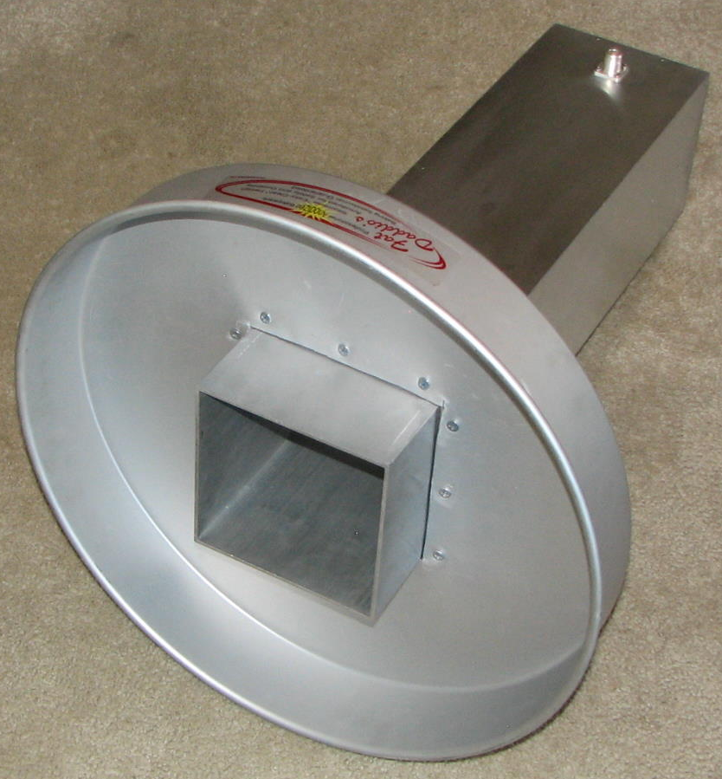
KL6M’s cake pan scalar ring for 1296

FINAL: The SM EME Conference at Orebro deservers an A+ based on the many comments received as the following from HB9BBD – “Thank you very much for this superb conference! Very interesting program, presentations and discussions. The gathering was also very inter- national. I certainly plan to participate in 2019 again.” SM2CEW have made up a nice update on the conference at www.moonbouncers. org with all the info including the technical papers.

Moon needs help! The “Free Talk Moon Reflector” is not running free of charge. Our host DF6NA is paying more than 500 EU/year on maintenance and updates to the ISP. Some years ago a few EMEers sponsored Rainer’s initiative and contributed to the yearly recurring cost of this service - see http://lists.moonbounce.info/listinfo/moon. This topic was discussed at the EME meeting in Orebro Sweden, and it was decided to ask for help again. It is time to send a contribution to Rainer to support the Free Talk Reflector. You can send a contribution by Paypal to dk0wz(x)vhf-dx.net. Please contribute to keep Moon running!

HB9Q report in this month’s NL is a request for stations to help finish 1296 WAS. WAS is a goal of many stations on 23 cm. Thus far there are only 2 stations that have completed WAS on 23 cm: W5LUA and K5JL. If you find new states that become QRV on 1296, please share the news as there are many interested stations.

JH1KRC warns that the JA 23 cm band is at risk do to the GPS satellite MICHIBIKI No.2 that is scheduled to be launched next June. This positioning system uses the full 1260-1299 MHz amateur band, which is a secondary band allocation for JA amateurs - see http://global.jaxa.jp/. A JARL 23 cm repeater near-by the experimental range was requested to go QRP to 1 W because of malfunctioning of the satellite’s receiving system during testing. Similar problems during actual operation could close down 23 cm operation in Japan. Unfortunately, the JARL has shown no interest in defending JA 23 cm amateur band.

W2PU will be used for EME with the 60’ dish at NJ Info Age site (in place of N2MO) in the future.

This year the 13 cm MWAW was missed; partly because it is a difficult year to find good moon weekends. G3lTF is suggesting 22-23 July (on the 23rd the Sun and Moon are very close) or 19-20 Aug (holiday season). Which do you prefer? Let Peter know.

Please keep the news coming. We will catch up on reports on the 9 cm Dubus Contest and the ARI EME Contest in the July NL. There are lots of activities coming up including the 10 cm Dubus Contest, 6 cm AW and the 70 cm ATP. We hope to CU off the Moon. 73, Al - K2UYH and Matej - OK1TEH

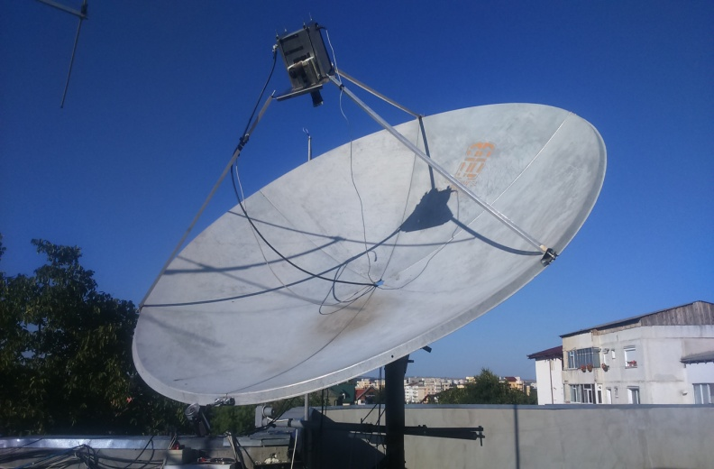
YO8RHI’s dish

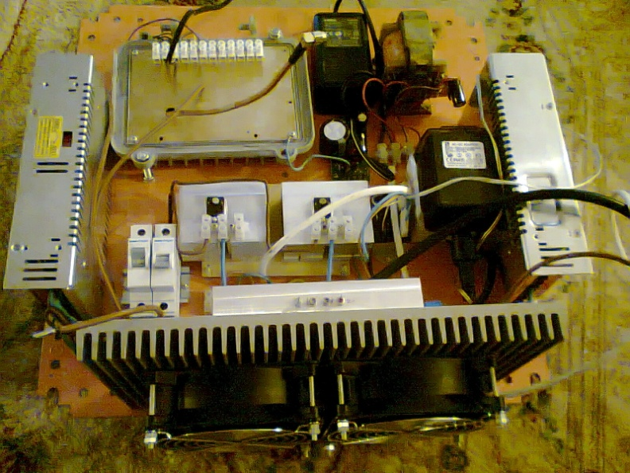
YO8RHI’s SSPA

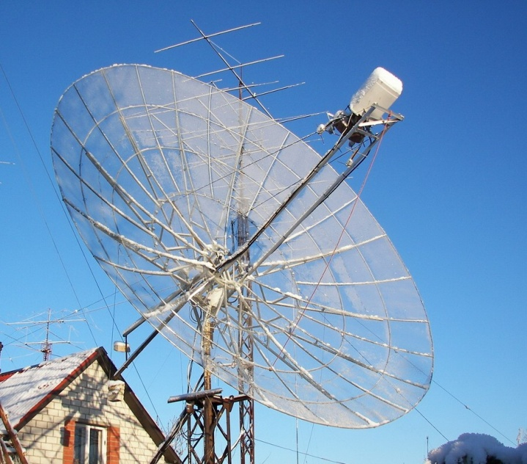
YL2GD 6 m dish

