**432 AND ABOVE EME NEWS**

**JUNE 2019 VOL 48 #6**

EDITOR: AL KATZ, K2UYH; DEPT. ELECTRICAL/COMPUTER ENGINEERING, THE COLLEGE OF NEW JERSEY, PO BOX 7718 EWING, NJ 08628, TEL (W 609-584-8424), (C 609-947-3889), E-MAIL [alkatz((x))tcnj.edu](mailto:alkatz@tcnj.edu)

ASSOCIATE EDITOR AND Reflector/NETNEWS Matej Petrzilka, Simunkova 1609/21, 18200, Praha 8, Czech Republic, TEL (+420 603 489 490), E-MAIL [ok1teh((x))seznam.cz](mailto:ok1teh@seznam.cz)

CW INITIAL LIST G4RGK, DAVID DIBLEY, E-MAIL [zen70432((x))zen.co.uk](mailto:zen70432@zen.co.uk), AT: <http://www.zen70432.zen.co.uk/Initials/index.html>

SUN & EXTRATERRESTRIAL NOISE LIST MANAGED BY OK1TEH: <http://www.ok2kkw.com/next/nl_k2uyh/sun_table.xls>

EME INFORMAL NETS: 14.345, ~1500 SATURDAY AND SUNDAY, NET COORDINATOR: OPEN

ON0EME EME BEACON, 1296.000 IS QRV WHEN MOON >10°, SEND RX REPORTS TO WALTER (ON4BCB) [on4bcb((x))gmail.com](mailto:on4bcb@gmail.com)

DL0SHF 3 CM EME BEACON, 10368.025, SEND INFO & QUESTIONS TO Per (DK7LJ) [per((x))per-dudek.de](mailto:per@per-dudek.de).

NL EMAIL DISTRIBUTION and EMAIL LIST CORD: WARREN, W2WD [wbutler((x))ieee.org](mailto:wbutler@ieee.org) [PDF]

THE NL WEB VERSION IS PRODUCED BY REIN, W6SZ [rein0zn((x))gmail.com](mailto:rein0zn@gmail.com), AT <http://www.nitehawk.com/rasmit/em70cm.html>

**CONDITIONS:** Activity is supposed to slow down about this time of year. If May is any indication we are going to have a very busy summer. This month we had two contests taking place on the weekend of 11/12 May. The Europe (EU)/Dubus 3 cm and up EME CW Contest had a good turnout but did seem a little down from previous years; possibly do to everything that was taking place. SP6JLW has reported the top score of 30x29. In the ARI Spring Trophy EME Contest SM4GGC reports the leading QSO count with 57 QSOs on JT and CW on 1296. **Coming up on 8/9 June is 6 cm Dubus Contest and on 29/30 June 9 cm Contest.** The ARRL’s June VHF (Tropo) Contest that includes and encourages EME is also on 8/9 July. [The exchange is your grid]. There are no 70 cm CW Activity Periods in June. The SV9/HB9CRQ dxpeditions was also QRV during the contest weekend as well as before and after. This dxpedition was hugely successful with 154 initials on 70 to 3 cm. See Dan’s preliminary report later in this newsletter (NL). Coming up is the VE2TWO Zone 2 dxpedition, QRV on 70 and 23 cm from 28 June to 8 July – see report in this NL. FG/DL2AAZ (FK96ch) is to be QRV 432 from 29 May to 13 June with 4x 11 el yagis and 600 W. XV9DF (OK42) is to be QRV on 432 + lower bands between 02 and15 June. The Swedish 432 & UP EME Conference at Orebro all took place on 22/23 May and from the many report was truly extraordinary event! See SM4IVE’s reports and others comments.

[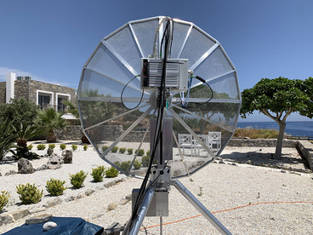](http://www.google.com/url?sa=i&rct=j&q=&esrc=s&source=images&cd=&ved=2ahUKEwiD2sut4MTiAhVFvFkKHSo0CHoQjRx6BAgBEAU&url=http%3A%2F%2Fwww.urel.feec.vutbr.cz%2Fesl%2Ffiles%2FEME%2FEME10368.htm&psig=AOvVaw3RBUbhp7_rQqhAJbf46OR6&ust=1559357191276454)

**SV9/HB9CRQ’s 1.5 m dish at Crete dxpedition site**

**JR4BRS has joined the silent-keys:** I am sad to report that on 16 April Toshi passed away. He was the first to make a 1296 EME QSO from Japan. He worked OE9XXI in June 1984 with 3 m portable dish and enjoyed many EME QSOs. He was also active on satellite communications. Toshi was 78 and struggled ALS for several years. May he RIP.

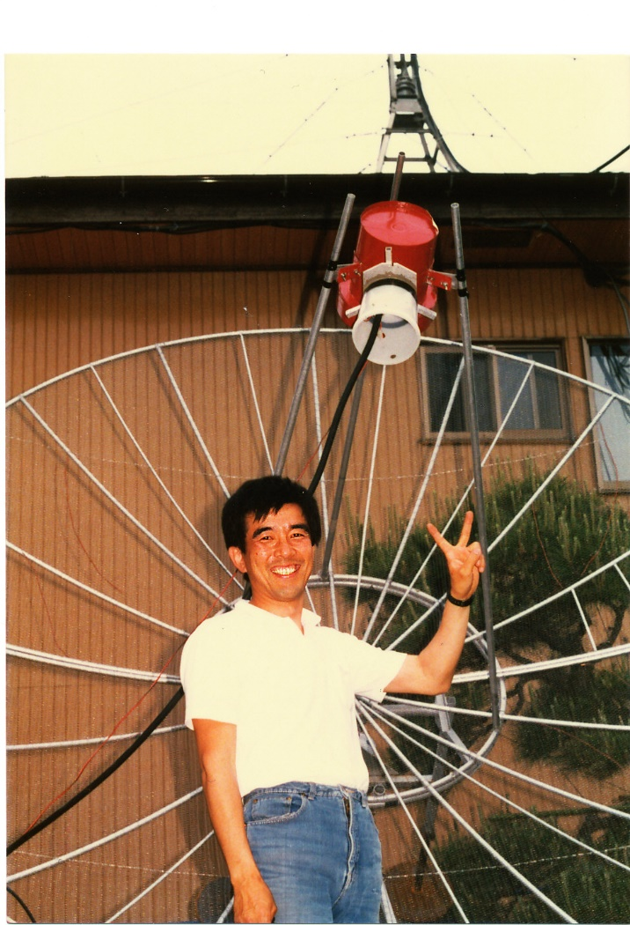

**Toshi (JR4BRS) after completing first JA 1296 EME QSO with HB9XXI in June 1984 with a 3 m portable dish**

**Troubling news from Denmark:** In OZ amateur use of the 13 cm 2304 and 2320 sub-bands were on 1 Jan. They still have access to the 2400. As of 1 July use of the 3400 band will be lost.

**Microwave Activity Weekend (MWAW) for 2019** -- At the Swedish EME Meeting, it was decided because the 6 cm and 9 cm EU/Dubus CW EME Contests are coming up shortly and because it is highly likely that more of the Scandinavian countries (SM/OZ) may lose access to 13 and 9 cm this summer, it was agreed that the remaining “good” weekends should be used to maximize the possibility of working them. Thus, a MWAW will be on 27/28 July for both 13 and 9 cm. 13 cm will be on 27 July and 9 cm on 28 July. For newcomers: An AW is when we attempt to get all those with capability on a specific band to come on and make QSOs, run tests for those needing signals, test new feeds, preamps etc. No pressure, no scoring, use the reflector, use any mode, just activate the band.

**BV3CE:** Tom [tom33638998(x)yahoo.com.tw](mailto:tom33638998@yahoo.com.tw) was not as active as he would have liked to be during the past month -- In April, I only had 3 EME QSOs on 23 cm with JA6AHB, K2UYH and VK4CDI. All were initials and using JT65C. I am still seeking SA stations to complete 1296 band WAC. If any station is interested, please email me for a sked.

**DB6NT:** Michael [db6nt(x)gmx.de](mailto:db6nt@gmx.de) was active in the EU/Dubus 3 cm EME Contest – During the weekend of 11/12 May, I was only able to be on for short time but appreciated the QSOs. I worked on 10368 CW DL0EF, OH2DG, OZ1LPR, SA6BUN, F1PYR, RA3EME for initial #49, SP6JLW and ES5PC. All stations had great signals! I ended with a total of 8x8.

**DL0SHF:** Chris (DF9CY) [df9cy(x)web.de](mailto:df9cy@web.de) reports on his April/May activity from DL0SHF by remote -- I only had a little time for radio, but nevertheless made a few contacts. On 4 April I worked on 23 cm using JT65C 4X1AJ and F1RJ, on 16 April VP2EMB - good signal and easy copy, G4EZP, EA5DOM, UD2F, UA1CCU and FR5DN, on 11 May SV9/HB9CRQ (7DB) shortly after moonrise, later ON5GS, UD2F, R4HCZ, AA4MD, FR5DN, IK3COJ, PA3FXB, DL3EBJ, 4X1AJ, RN6MA, IW8RRF and ES6FX. CW is hard to do with my VPN arrangement because of dropouts, but I managed to work F2CT and SM4GGC with CW. Both had good signals. On 11 May, I had some problems with the antenna control and was forced to stop earlier than planned. During my activity, I am usually on the HB9Q logger. I recently acquired a 1.3 m solid dish including some mechanics at no cost. I got hold of horn feed for 13 cm with a 90° coupling device, which allows RH or LH operation. If I can get a good preamp, I will try to receive EME signals from my home later in the summer. I already have a working RX converter.

**F2CT:** Guy [f2ct(x)wanadoo.fr](mailto:f2ct@wanadoo.fr) follows up on his report in the last NL with results for both April and May – On 23 cm I worked using CW in April DJ9YW, DK3WG, DL3EBJ, DL6SH, DL7YC, DL7UDA, EA8DBM, ES5PC, F5KUG, FR5DN, G3LTF, G4CCH, HB9Q, I1NDP, IK3COJ, IK5VLS, K2UYH, KL6M, OE5JFL, OH2DG, OK1CA, OK1CS, OK1DFC, OK2DL, OZ4MM, PA0BAT, PA0PLY, PA3FXB, PA7JB, PI9CAM, PY2BS,  RA3LE, RA3EME, SM6CKU, SP6ITF, SP6JLW, SP7DCS, UA3PTW, UA3TCF, VE6TA, W4OP, WA6PY and 9A5AA; and in MayDK3WG, DL0SHF, DL3EBJ, DL7UDA, EA8DBM, ES6RQ, F6KRK, G3LTF, G4CCH, G4FUF, IK5VLS, I1NDP, JA4BLC, K7CA, LX1DB (55/56) on SSB, N4PZ, OK2ULQ, ON5GS, PA2DW, PA3FXB, RA3EC, RN6MA, SM4GGC, SP6ITF, SP7DCS, SV9/HB9CRQ, UA3TCF, VE6TA, W4OP, XE1XA and 4X1AJ. My station is a 4 m solid dish with 0.35 f/d, 700 W SSPA at feed and 0.3 dB NF G4DDK VLNA. I plan to work on my RX system.

**G3LTF:** Peter’s [g3ltf(x)btinternet.com](mailto:g3ltf@btinternet.com) May EME report -- Not a great number of QSOs this month, but some very interesting ones, on 4 bands. All QSOs were on CW. I worked on 11 May on 1296 SV9/HB9CRQ for initial #474 and DXCC 74. They were using a 1.5 m dish and 50 W. I think this is the smallest station I have yet worked on 23 cm. I then worked on 1296 in the ARI contest DL3EBJ, SP7DCS, ON5GS, RA3EC, IK3COJ, PA3FXB, DF3RU, ES6FX and FR5DN for 9 QSOs in 37 min. After dinner, I came back and worked IK5VLS, K7CA, WB2BYP, N5BF, F2CT, SP6ITF, PA2DW and XE1XA for a total of 17 QSOs all on CW. I worked on 12 May on 2320 SV9/HB9CRQ for initial #144 and DXCC 47, on 13 May on 3400 SV9/HB9CRQ for initial #73 and DXCC 29, and finally on 14 May on 5760 SV9/HB9CRQ for initial #85 and DXCC 37. I was lucky on 6 cm to work them while the signal was still T9 and libration was low, but on all bands the CW QSOs were fairly easy. They were helped by HB9CRQ’s ability as a good weak signal op. The dxpedition was able to very quickly to swap from JT to CW, which I much appreciated. I attended the 6th Swedish EME meeting, which was a great experience with interesting papers and lots of good discussion. Thanks to Lars for his efforts in organizing this event.

**IW2FZR:** Dario [dario.fzr(x)gmail.com](mailto:dario.fzr@gmail.com) was QRV for the Dubus 3 cm Contest – I only QSO’d WA6PY in the contest. I operated from my country location in JN56be, where I have my 4 m dish and 50 W on 10368. I normally only operate CW from this station and via Internet control from my home QTH. At my home, JN46we, I have for 3 cm a 1.8 m dish and 15 W. From my home I'm active with the digital modes and am on the HB9Q chat.

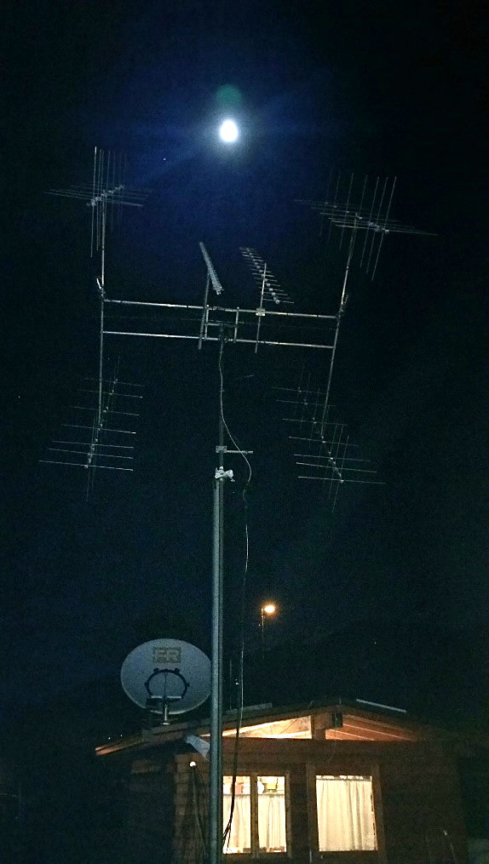

**IW2FZR’s EME antennas at home QTH with 1.8 m dish**

**JA4BLC:** Yoshiro [ja4blc(x)web-sanin.co.jp](mailto:ja4blc@web-sanin.co.jp) reports on his May EME -- I joined the fun on 3 cm during the Dubus Contest and worked XB (10450 to 10368) on 11/12 May WA6PY, JA8ERE, SA6BUN, OK1CA, OH2DG, SP6JLW, UR5LX, OZ1LPR, JA6XED, DL0EF for initial #50, F1PYR, IW2FZR and DF1OI for a total of 13 x13. Before the contest, I worked on 8 May JA1WQF also on 3 cm. On 12 May, I QSO’d on 1296 F2CT for initial #232. All QSOs were CW.

**JA6XED:** Hisao [ja6xed(x)kumin.ne.jp](mailto:ja6xed@kumin.ne.jp) was QRV on 3 cm for the Dubus 3 cm in May -- I worked using CW SA6BUN, OK1CA, SP6JLW, JA4BLC and OH2DG for a score of 5x5. [TNX JA4BLC for forwarding this report].

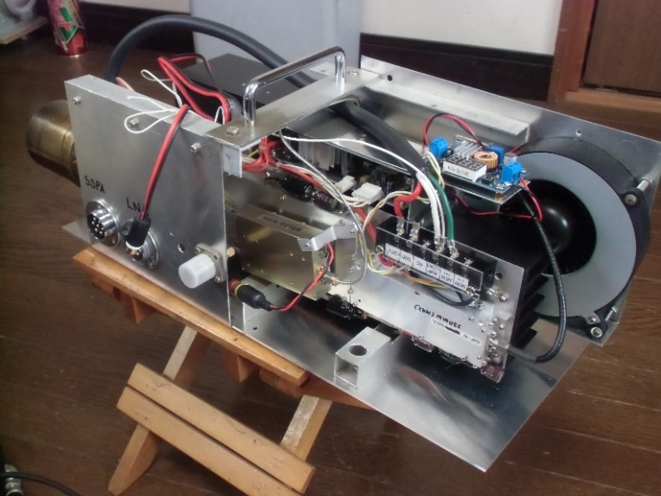

**JA6XED’s 3 cm feed system**

**JA8ERE:** Mikio [sg01011(x)niftyserve.or.jp](mailto:sg01011@niftyserve.or.jp) was also active in the Dubus CW Contest on 3 cm – I QSO’d OH2DG, IW2FZR, OK1CA, SP6JLW, SA6BUN and JA4BLC for a total of 6x6. [TNX JA4BLC for forwarding this report].

**KA1GT:** Bob [ka1gt(x)hotmail.com](mailto:ka1gt@hotmail.com) write about his recent activity -- I was in the UK during April, so no EME. On 11/12 May, I worked on 1296 using JT65C SV9/HB9CRQ (18DB) – an easy contact and around 20 other stations. On 13 May I added EA5DOM who had a very nice signal from his 1.8 m offset dish and 150 W. I'm currently working on feed modifications for 1296 and a small (~ 1 m) dish installation for 10 GHz RX to start.

**KB7Q:** Gene [geneshea(x)gmail.com](mailto:geneshea@gmail.com) is planning to put Curacao on 70 cm EME – I should be on for some sustained activity from PJ2T on 432 from 6 to 12 March 2020. I’ll probably have the station on also in mid Feb, but for sure in March. I’ll do primarily JT65B, but will be happy to try CW with some of the “big guns” as I did in Hawaii. I’ll have at least 500 W, an excellent preamp and a 13 wl Yagi (maybe 2). My moonrise isn’t great for ground gain, but moonset over salt water is outstanding.

**KN0WS:** Carl [carlhasbargen(x)q.com](mailto:carlhasbargen@q.com) was on from his EME location for the ARI Contest -- When I arrived at my property early on Friday 10 May, there was still some snow on the ground. The mesh I had placed on my 6 m dish several weeks earlier was OK. It was extremely muddy, and I could not drive my pickup truck up to the dish area. I had to use my tractor to haul 3 loads of gear over the 300 yards back to my dishes. Each trip left 4” deep ruts in the mud. It took me 5 hours to set up for 23 cm – longer than ever before! It turned out that the mechanical indicator used to point my 4.8 m dish was off by 5 degs. This is probably why I had such weak signals at the end of my 2018 EME season during the last ARRL Contest weekend. Before the ARI contest even started, I worked I7FNW, PA3FXB, W2HRO, DL7YC, VE3KRP, N5BF and XE1XA; and initials with SM6CKU, UA1CCU, K7CA and SV9/HB9CRQ - all using JT65C. At the start of the ARI, the Moon was down in EU, but I worked N5BF, K7CA, AA4MD, W1PV and JA8SZW and had an initial with VE6TA. I slept soundly in my tent, and then was up for moonrise to work IK5VLS, DL7UDA, GM4PMK, SV9/HB9CRQ, ES6FX, I7FNW, RA3EC, VE3KRP, SM4GGC, PA3FXB, DF2VJ and IW8RRF; and initials with FR5DN, RN6MA, PE1LWT, WX4F and RA2FGG. I need to make a better position encoder for this dish because my current arrangement drifts off by several degs over time. I also need to get MAP65 working. Soon after moonrise, my DSP waterfall display showed 10 stations TXing on even minutes and 10 on odd. Long before I worked my way through these 20 stations, most were off the air. I would spend 3~5 minutes with WSJT watching signal reports and 73s go back and forth before I knew the calls of the stations that were working each other. Then I might discover it was someone I had already worked or they would stop TXing altogether! I miss out on a lot of QSOs. When the EU stations, who had already spent all day working each other, went to bed (3 hours before their moonset) it was quiet. I had not planned to try any CW, but when G3LTF announced his CQ, I thought I would try using the JT CW software. I ended up demonstrating why it is dangerous for me to try CW. Usually my biggest problem is hearing. Between my loud generators, my lack of experience and my poor skills, it usually feels that I am trying to pick out a melody from someone whistling in a hurricane. This time I heard Peter better than I have in the past, but my TX was a problem. Between hardware delays and a struggling generator, the start of each character was clipped. My “- . –“ became “. . –“, my “- .” became “. .”, and so on …, so Peter heard “UI1MI”. I have some work to do. As I only saw one signal from JA and none from VK, I took down my 23 cm gear and set up for 70 cm before going to bed. I awoke to find that although my 70 cm PA put out 600 W last fall, it now had only 400 W. A few hours later my generator coughed a few times and I lost RX. It seems that my TX/RX relay was now stuck in the default TX position. I just used the TX line into a relay and an ARR preamplifier on the ground, 25’ from the feed, which made it harder to hear. I did work DL7APV, PA2V and DL5FN, and initials with ES3RF, PA3DOL, PA2CHR, XE2AT, SM5EPO and F6HLC. After failing to get OK1TEH to hear me, I discovered I needed to run outside my tent, climb a ladder and change polarity 90 degs between TX and RX every minute to maximize EU hearing me. All in all, I think activity was less than I had hoped for, but I suspect the 3 cm Dubus contest, the Crete dxpedition on 13 cm, and Mother’s Day (in USA) may have had an impact. Everything now has a new layer of mud on it. I fed my first northern Minnesota tick in 2019, and I can say I had 43 QSO’s, including 16 initials. EME season has begun! From my home, I am working on 6 and 3 cm operation. Recently, I literally picked up a 6’ solid offset dish for free at a BP gas station. It was laying against a fence. It had a damaged edge but otherwise looks OK. It will be limited in AZ and won’t be portable, but it will have twice the area of my present 1.2 m dish.

**OK1CA:** Franta [strihavka(x)upcmail.cz](mailto:strihavka@upcmail.cz) sends his report for May -- I worked the SV9/HB9CRQ dxpedition on 23 cm using JT65C on 10 May. Then in the EU Dubus EME Contest on 3 cm, I QSO’d on 11 May JA8ERE, JA4BLC, JA6XED, DL0EF, SA6BUN, OH2DG, SP6JLW, OZ1LPR, UR5LX, IW2FZR, YO2BCT, F1PYR, SM6CKU, G4NNS, F5JWF, RA3EME, VE4MA, SM2CEW for initial #92, 9A5AA, F5IGK, SP3XBO, OK2AQ, WA6PY and K2UYH, and on 12 May ES5PC, IZ2DJP and LX1DB. I called HB9BBD many times with no reply. My total score is 27x26. The conditions were good; measured moonnoise of 3.2 dB.

**OK1KIR:** Vlada [vlada.masek(x)volny.cz](mailto:vlada.masek@volny.cz) and Tonna report on their group’s May EME activity -- Our first task in May was to replace a damaged 17 m cable – it was broken and twisted at the bent just behind our dish. It interconnected the feed compartment and the rig in the shelter below the dish. After this difficult and risky job was completed, we found huge decline in local QRM. On 4 May we worked on 23 cm using JT65C at 1549 LU8ENU (14DB/10DB). On 11 May in 10/24 GHz part of the Dubus contest, we were only active for a short time on 24 GHz. Right at the start of activity we responded at 1127 to JA1WQF’s CQ and made a nice random QSO (O/O), and then tried with S57NML on CW. Andrej heard us very weak almost all the time. Unfortunately, we were not able to locate his signal, which was scattered by terrible spreading of about 300 Hz. Later we realized that Andrej was about 6 kHz lower in frequency than expected but even that did not help. This effort was closed down on our side by a windstorm and rain. Actually, only WSJT(X) had a chance to succeed in such conditions. Being limited in time by other duties, we then focused on the SV9/HB9CRQ dxpedition. Dan and Sam again provided an excellent operation on 23 thru 3 cm with only a 1.5 m dish. This dish is the same as used in their previous dxpeditions (3DA0, EA6, HB0 and ZS6). At the last minute they added a small 70 cm QRP rig (11 el yagi and 50 W). This was a big challenge with “only” 6 m dish on our side. However, in a row day by day, we worked the Q-team on the all 6 bands. We QSO’d on 23 cm with JT65C on 10 May at 0900 SV9/HB9CRQ (14DB/13DB) for digital initial {#331}; on 11 May with CW at 1101 SV9/HB9CRQ (O/539) for initial #443; on 13 cm on 12 May with JT65C at 1108 SV9/HB9CRQ (16DB/19DB) digital initial {#63} and 1st SV9-OK and with CW at 1321 (0/539) for initial #170; on 9 cm on 13 May with JT65C at 1308 SV9/HB9CRQ (15DB/12DB) for digital initial {#33} and 1st SV9-OK on 9 cm and with CW at 1717 (O/O) for initial #77; on 6 cm on 14 May with QRA64D at 1356 SV9/HB9CRQ (18DB/16DB) for digital initial {#43} and 1st SV9-OK on 6 cm and with CW at 1724 (O/O) for initial #108; and on 3 cm on 15 May with QRA64D at 1512 SV9/HB9CRQ (16DB/14DB) {#187} and 1st SV9-OK on 3 cm and with CW at 1530 (0/539) for initial #125. We also QSO’d on 3 cm using QRA64D at 1723 F5VKQ (10DB/9DB) {#188} and with CW at 1808 G4RFR (O/O) # 26. The last day on 70 cm on 16 May we spent almost 3 hrs to finally decode with JT65B at 2328 SV9/HB9CRQ (26DB/21DB) for digital initial {#236} and 1st SV9-OK on 70 cm QSO. Sincere thanks to the Q-team for their perfect activation of this rare DXCC.

**OK2AQ:** [Mirek(x)kasals.com](mailto:Mirek@kasals.com) sends his 10 GHz May report -- Of course, taking part in a CW/SSB contest with a 1.2 m dish is a boldness, but also a challenge. Fortunately, in addition to the Dubus 3 cm Contest, the ARI EME Contest took place same weekend in which the digi QSOs are also included. Mainly, it was a period of increased activity on the 3 cm band, when it is definitely worthwhile to be QRV. The 1.2 m offset dish was setup and the radio and computers put into operation on Friday. I then calibrated the antenna and measured S/N to CS = 9.8 dB and a moonnoise = 0.6 dB followed by copy of my own echoes. In this contest I made 7 CW QSOs with SP6JLW (O/O), OZ1LPR (559/529), SA6BUN (O/O) for an initial (#), DL0EF (559/539), OK1CA (O/O), UR5LX (O/O) and F1PYR (O/519). I also added for the ARI Contest 5 QRA64D QSOs with DC7KY (11DB/11DB), DL7YC (17DB/16DB), OK1CA (14DB/15DB), EA3HMJ (21dB/18DB) and UR5LX (16DB/15DB). Although I have a solid power of 42 W, I still hear better than I call. I called crossband JA8ERE and some other stations with no success. My score for Dubus Contest is 7x100x7=4900 points and for ARI Trophy Spring 7x4+5x1=33 points. On the following Wednesday, there was a heavy rain all day. We waited for SV9/HB9CRQ dxpedition on 10 GHz. Fortunately, the QSO between the two small antennas went smoothly (20 DB/20 DB) {#} and moreover, thanks to the activity that the dxpedition triggered, three more initials were added with OH2DG (15DB/16DB) {#}, G4RFR (18DB/15DB) {#} and PA7JB (18DB/15DB) using JT4F with the others with QRA64D.

**OK2ULQ**: Petr [ok2ulq(x)seznam.cz](mailto:ok2ulq@seznam.cz) was QRV in the ARI Spring EME Contest and added SV9/HB9CRQ -- On Saturday 11 May, I planned to work on my antennas and to give out a few points in ARI contest. The beginning was slow as I expected and there were not many stations at the CW, but JT was quite alive. I also searched for SV9/HB9CRQ who was to be on. It didn't take long before I had logged some nice QSOs. The result for my modest effort was 8 CW and 18 WSJT contacts for a QSO total of 36. I added 9 initials with IW8RRF, SV9/HB9CRQ, BD4SY, DJ2DY, GM4PMK, AA4MD, PE1LWT, K7CA and W2HRO.

**ON0EME:** Eddy (ON7UN) [ejespers(x)telenet.be](mailto:ejespers@telenet.be) writes -- Unfortunately the new PA failed [around 6 May]. I will be at the beacon side on 8 May to change back to a backup PA. [I am pretty certain it is now QRV again].

**ON5GS:** Dirk [dirk.reyners(x)telenet.be](mailto:dirk.reyners@telenet.be) writes about his recent 1296 EME -- I had a nice weekend on 23 cm working new and old moon friends with a new G4DDK preamp, which proved to work very fine. The old one had become very rusty and had a degraded NF. I worked the following stations in May with my 6 m dish: SV9/HB9CRQ, IW8RRF, PA3FXB, RA3EC, SP7DCS, IK5VLS, LZ2US, OK2ULQ, DL3EBJ, BD4SY, I0NAA, F2CT, EA8DBM, IK3COJ, G3LTF, DF3RU, ES6FX, G4FQI, IK5EHI, R4HCZ, GM4PMK, FR5DN, RN6MA, PE1LWT, DL7UDA, SP6ITF, VE3KRP, SM4GCC, G4FUF, DL0SHF, K7CA, N5BF, XE1XA, VE6TA ,OK1YK, ON4QQ, RA2FGG, DL3EBJ, LA3EQ, PA0BAT, SM4GCC, G0LBK, I7FNW, UA1CCU, DK0ZAB, DG0FE, DF2VJ, RA3EC, AA4MD, W1PV, G4CCH, G4CCH, NC1I, OZ6OL and W4OP.

**OZ4MM:** Stig [vestergaard(x)os.dk](mailto:vestergaard@os.dk) updates us on his participation in the Dubus 23 cm Contest and recent dxpedition contacts – I was pleased to work the great Q-team (SV9/HB9CRQ) dxpedition to Crete on 432 (JT) and on 1296 (CW & JT) in May. Back in April, I worked 45 stations in the 1296 CW Dubus EME Contest in few hours of QRV. Initials were RA2FGG, I0NAA, RA3EME, OK2PE, F2CT and LA1K. I also worked the VP2EMB dxpedition on 432 and 1296; both QSOs were on JT. Lately I find it very difficult to find time for EME, as most of my time is used on my favorite cycling training. I am going to a cycling race in the French Tour Alps in middle of June. Also, I has joined a group of EMEers who are on 160 m CW; I have fun experimenting and building antennas for this challenging band.

**PA2DW:** Dick [qtc(x)kpnmail.nl](mailto:qtc@kpnmail.nl) reports on his 1296 operation in May – I was on 23 cm to work SV9/HB9CRQ for a new DXCC with solid signals! I worked also PA3FXB, KA1GT, K7CA, RA3EC, N5BF, DL3EBJ and IW8RRF - all on JT65C. I also had excellent CW QSOs with G3LTF and F2CT on CW. Guy had a super signal. I spent 15 minutes calling N4PZ, but Steve did not copy me due to his local QRM at his end. My 23 cm system consists of 2.4 m dish with 500 W SSPA and DDK LNA. The rest of my time was spent on trying to get on 3 cm. My elevation-tracking is still not yet operational, so had to point by hand. I waited until the Moon was at relative stable elevation and had about 15 mins without running to move the dish. Tuning the band, I found SP6JLW (549) on CW! I also saw QRA64 traces from OZ1LPR. I am now busy fixing the elevation tracking and connecting my PA to the waveguide. I am awaiting a flexible section of waveguide to arrive. My system is a 90 cm dish with about 15-18 W at the feed from an SSPA and DU3BC 0.7 dB NF LNA. But, I have manual waveguide switch. So, lots of running to keep me fit - HI!

**PY2BS:** Bruce [py2bs(x)me.com](mailto:py2bs@me.com) is very happy to have worked SV9/HB9CRQ on 5 bands from 23 to 3 cm. All QSOs were on digital with JT65C thru 3 cm and QRA64D above. He sends his thanks to Dan and his team for another very successful dxpedition!

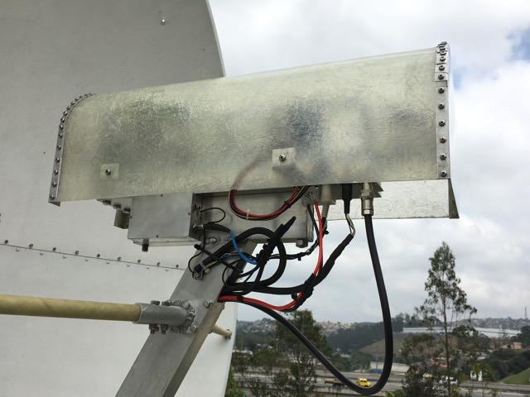

**PY2BS 10 GHz feed arrangement**

**SM4GGC:** Stig [stig.ake.larsson(x)gmail.com](mailto:stig.ake.larsson@gmail.com) reports on my activity on 23 cm the past month -- With JT65C I worked on 5 May ZS4A, on 6 May W1PV and on 10 May SV9/HB9CRQ. In the ARI Spring Contest I worked on 11/12 May using CW ES6FX, RA3EC, DL0SHF, DL3EBJ, LZ2US, VK5MC, SM6CKU, SP7DCS, IK5VLS, OK2ULQ, DF3RU, SP6ITF, IK3COJ, F2CT, EA8DBM, RN6MA, F6KRK, I1NDP, LX1DB, ON5GS, W4OP, NC1I, OZ6OL and N4PZ for 24 CW QSOs; and with JT65C IW8RRF, PA3FXB, I0NAA, IK5VLS, DL7UDA, FR5DN, VE3KRP, AA4MD, GM4PMK, ON5GS, I7FNW, RA3EC, SP5GDM, KN0WS, K7CA, JA8SZW, ES6FX, LZ4OC, RU4HU, DL3EBJ, ZS6JON, DK3WG, OK1YK, R4HCZ, RN6MA, G4FUF, G4CCH, PA0BAT, G0LBK, KA1GT, ON5GS, W1PV and DG0FE for 33 JT QSOs and a total QSO count of 57. There was great activity in ARI contest on 23 cm! I have now been QRV on 23 cm since June 2018 and it will soon be a year. I looked at my statistics and now have worked 382 QSOs, 41 DXCC and 137 grids. My rig is a 3.8 m dish, 500 W and G4DDK LNA.

**SM4IVE:** Lars writes on the very successful Swedish 432 & UP EME Conference -- Thanks to all the speakers and all participants that made this conference so special! Even though its not so much work [?], I was very tired Sunday night after it ended. I will uppload the presentations that I have on my laptop to SM2CEW. Peter will publish most talks and measurement results (LNAs and noise sources) on <http://www.moonbouncers.org/>. I want to give a special thank you to HB9BBD for doing and making the measurements possible - BIG Thanks Dom. I hope everyone enjoyed the conference and that we will see you again next time.

**SM6CKU:** Ben [ben(x)sm6cku.se](mailto:ben@sm6cku.se) send his May Moon report -- I spent some time on 4/5 May on 23 cm and worked initials with ZS4A, EA3HMJ, SV9/HB9CRQ, KN0WS and IW8RRF - all were on JT65C. I also made CW QSOs with SM4GGC and OK2ULQ. The SV9 dxpedition was good copy and could have been worked on CW, but I forgot they were also operating CW. The next weekend 11/12 May I was on 10 GHz for the Dubus Contest. On Saturday I worked SA6BUN, OZ1LPR, OK1CA, DL0EF, SP6JLW, OH2DG, IW2FZR, VE4MA and HB9BBD, and on Sunday F1PYR, ES5PC, IZ2DJP for an initial (#), G4NNS, F5JWF (#), RA3EME (#), UR5LX, LX1DB, SP3XBO (#) and finally WA6PY. All QSOs were on CW and I ended with a score 19x19. Propagations were strange on Saturday and much more "normal" on Sunday. After the contest I worked WA9FWD for a new one on 3 cm. It was nice to meet with John in Orebro a couple of weeks later. I am running an 8 m dish and 400 W on 23 cm, and a 4 m dish and 15 W with a CP feed on 3 cm.

**SM7FWZ:** Ronny [sm7fwz(x)arlembke.se](mailto:sm7fwz@arlembke.se) listened on 10 GHz EME during the Dubus Contest -- I copied in the order received on Saturday evening DL0SHF, SP6JLW, RA3EME, OZ1LPR, VE6TA, SA6BUN, IW2FZR, OH2DG, DL0EF and W7CJO, and on Sunday DL0SHF, SA6BUN, DL0EF, IW2FZR, ES5PC, RA3EME, YO2BCT, SP6JLW, OZ1LPR, F5JWF, G4NNS, F1PYR, OK1CA, IZ2DJP, SM6CKU, HB9BBD, LX1DB and DB6NT, and Sunday on 10450 OH2DG, JA6XED, JA8ERE, SP6JLW, JA4BLC and DF1OI. I was using a 4 m solid dish. Octagon Green LNB adapted for Chaparral feeder and SDR Play RSP2pro. I was receiving 15.5 dB of Sun noise and 2 dB of Moon noise measured with a FCD and Spectravue. I am still repairing my station from a lightning hit last year, and am testing my new OE5JFL/BCB tracking. It is working very well so far.

**SP0VHF:** Zdenek (OK1DFC) [ok1dfc(x)seznam.cz](mailto:ok1dfc@seznam.cz) will be operating portable from EME & Microwave meeting in Gajow, Poland (JO80em) – I plan to be QRV on 6 cm as SP0VHF on 6 to 9 June, particularly during the 5760 Dubus EME Contest. I will also have my 24 GHz EME equipment with me. If conditions look promising with low spreading, I can quickly change between bands and try 1.25 cm, if anybody wants to try. On 24 GHz the setup will be a 180 cm dish, 23 W SSPA and 1.8 dB NF LNA. On 5.6 GHz setup will be the same 180 cm dish, 100 W SSPA and 0.9 dB NF LNA. I hope to have everything ready for test on 7 June. I will be on HB9Q chat for 24 GHz tests. If anybody is interested in 24 GHz test, please let me know by email. See also [http://ww.ukf-te.iq24.pl/default.asp?grupa=250986& temat=492691](http://ww.ukf-te.iq24.pl/default.asp?grupa=250986&%20temat=492691).

**SP6JLW:** Andrzej (SP6JLW) and Pawel (SP6OPN) [sp6jlw(x)wp.pl](mailto:sp6jlw@wp.pl) report on the Klodza group’s active during the Dubus 3 cm Contest -- Our equipment worked flawlessly, although there were concerns that there will be problems with the high voltage cable (13.5 kV) for the TWT. Throughout the weekend, we had rain and it was 100% humid. After modernization, we are also QRV on the 10450 band, which greatly improves the comfort of working with JA stations. In the log are QSOs using CW with JA8ERE, JA4BLC, OH2DG, SA6BUN, RA3EME, YO2BCT, OK1CA, OK2AQ, JA6XED for an initial (#), OZ1LPR, F1PYR, UR5LX, DL0EF, HB9BBD, IW2FZR, SM6CKU, F5IGK, DL0EF(DUPE), F5JWF, G4NNS, DL7YC, SP3XBO, SM2CEW (#), VE4MA, 9A5AA, WA6PY, W7CJO, ES5PC, DF1OI, IZ2DJP and DB6NT for a total of 30x29.

**SV9/HB9CRQ:** Dan (HB9CRQ) [dan(x)hb9q.ch](mailto:dan@hb9q.ch) and Sam produced a text book 6 band (70 cm thru 3 cm) EME dxpedition to Crete. We do not yet have the full story; a summary follows, but Dan has promised to send pictures and more details for the next NL. On 70 cm they used JT6B to make 8 QSOs and 8 initials in 7 DXCCs; on 23 cm they used JT65C and CW to make 104 QSOs and 85 initials, 7 were on CW in 24 DXCCs; on 13 cm they used JT65C and CW to make 19 QSOs and 14 initials, 5 were on CW in 10 DXCCs; on 9 cm they used JT65C and CW to make 15 QSOs and 10 initials, 5 were on CW, in 8 DXCCs; on 6 cm the used QRA64D to make 20 QSOs and 15 initials, 7 were on CW in 12 DXCCs; and on 3 cm they used QRA64D and CW to make 28 QSOs and 22 initials, 9 were on CW in 13 DXCCs; for a total on 194 QSOs and 154 initials, 33 were on CW in 30 DXCCs. Please send your QSLs with an SAE to HB9Q, P.O. Box 133, CH-5737 Menziken. They will be on again from A21EME in Oct.

[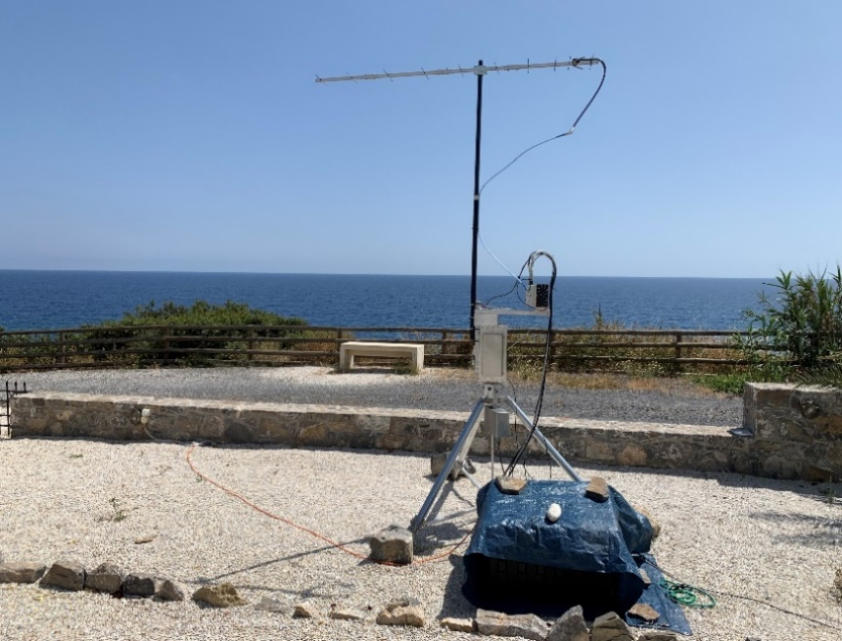](https://www.google.com/url?sa=i&rct=j&q=&esrc=s&source=images&cd=&cad=rja&uact=8&ved=2ahUKEwir8M2-5MTiAhUFxVkKHYV1BRMQjRx6BAgBEAU&url=https%3A%2F%2Fhb9q.ch%2F2018%2F&psig=AOvVaw3RBUbhp7_rQqhAJbf46OR6&ust=1559357191276454)

**SV9/HB9CRQ 11 el yagi used on 432 EME**

**UA3TCF:** Alex [ua3tcf(x)mail.ru](mailto:ua3tcf@mail.ru) sends news on his recent 13 and 23 cm EME -- I added several new DXCC and initials (#) in April and May. I worked using JT65C on 13 cm

on 8 April HB9Q (11DB), OK1KIR (15DB), PA0BAT (19DB), DF3RU (26DB) and IK3COJ (20DB). I QSO’d on 1296, on 14 April in the Dubus EME Contest using CW HB9Q, UA3PTW, G3LTF, SM6CKU and OZ4MM; (and heard JA4LJB, DL3EBJ, OE5JFL, DL6SH, OK2ULQ, OK2DL, OH2DG, RA3EME, G4CCH and K2UYH); on 15 April using JT65C RA2FGG (23DB) for a new DXCC, FR5DN (24DB) new DXCC,  DL8FBD (20DB) and EA5DOM (24DB) new DXCC; on 18 April using JT65C 4X1AJ (28DB) new DXCC and UA9FA (26DB); on 19 April using CW F2CT (O/O), and over the next few days using JT65C RN6MA (22DB) and  DL7YC (12DB). I was back on 13 cm on 15 May to work using JT65C SV9/HB9CRQ (29DB) new DXCC, DL7YC (14DB), PA7JB (19DB), PY2BS (17DB) new DXCC and ODX 12260 km, followed using CW DL7YC (O/O); (and heard on CW G3LTF (559), PA0BAT (539) and JJ1NNJ (M), and copied on JT65C ON4OAI (25DB), PA0BAT (16DB), DF3RU (18DB), WA3RGQ (25DB) and K2UYH (21DB)).

**VE2TWO:** Peter (VA3ELE) [va3ele(x)gmail.com](mailto:va3ele@gmail.com) (and VE2UG) report on this summer’s Zone 2 EME dxpedition – We are disappointed to inform everyone that the Zone 2 expedition will only be on 432 (from a new grid FO60tf) and 1296. There is a chance we will also be QRV on 13 cm, but the system has not yet been tested. We have lost one of the members of our team, which has forced us to rollback our plans for the microwave EME. Perhaps we can try to include them next year. The dxpedition is from 28 June to 8 July at Sept Iles, Quebec, Canada. See Facebook at <https://www.facebook.com/groups/998896550301418/>.

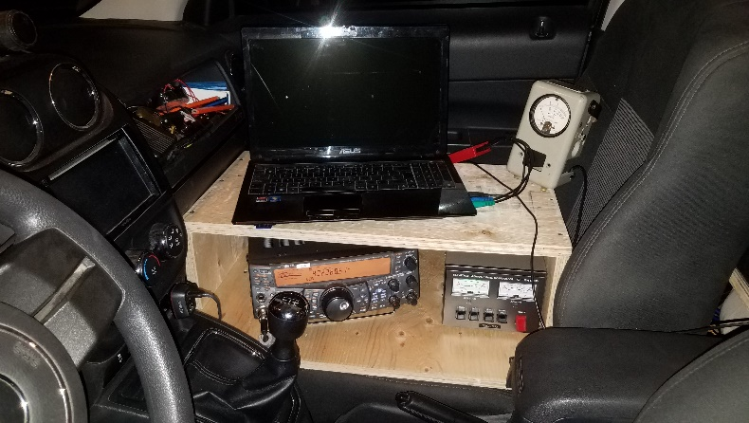

**VA2ELE dxpedition operating position**

**VE3KRP:** Fast Eddie [eddie(x)tbaytel.net](mailto:eddie@tbaytel.net) writes on his May 1296 EME activity – The WX here has been cool, but otherwise OK. I worked on 23 cm using JT65C on 8 May SM6CKU, DK3WG, G4YTL, LA1K for a mixed initial (#*) and 4X1AJ (#*) and a new DXCC, on 10 May KN0WS and AA4MD, and on 11 May SV9/HB9CRQ (#*) and a new DXCC, SM4GGC, DF3RU, RA3EC, DL3EBJ, KA1GT, PA2FXB, OK2ULQ, K7CA, ON4GS, ES6FX, G4FQI, KN0WS, DV2VJ and N5BF.

**W4OP:** Dale [parinc1(x)frontier.com](mailto:parinc1@frontier.com) was active in the Italian Trophy Contest – I was only QRV on 23 cm on Sunday 12 May. Bad storms and lightning kept me off for the first two passes. I worked OZ6OL, LZ2US, SM4GGC, SP6ITF, RA3EC, PA3FXB, DL8FBD, DL3EBS, ON5GS, N4PZ, F2CT and K7CA for a total of 12 QSOs. XE1XA got away despite my best efforts. I am still running a DB6NT 1 kW amp at 850 W until the new feed with 716 connectors is finished.

**WA9FWD:** John [WA9FWD(x)outlook.com](mailto:WA9FWD@outlook.com) writes about Orebro and 3 cm EME -- I have just returned from SM4IVE’s Conference in Orebro, and had a fantastic time. It was an event that was definitely worth attending. I have received much good advice on improving my 3 cm operation, which hasn’t been too successful up to now. I made an attempt to be operational for the DUBUS  3 cm Contest. A rainy spring and household chores limited my preparation time, but I thought I was ready. I had listened last year, and knew that I was capable of hearing the stronger stations. My equipment now consists of PE1RKI CP feed, A DB6NT preamp, transverter and 30 W SSPA. This is in my very old 3.7 m 4 GHz TVRO dish. The sun noise was 10.2 dB and moonnoise 0.8 dB, not very good, but I had heard stations in the past, so I knew I should be able to work the stronger ones. I tried to operate on Saturday and called several stations without results. I checked the equipment later and found that the FET switch for the DC to the SSPA wasn’t working and that I wasn’t getting any power output. I repaired the problem and was ready for Sunday. I decided to try a CQ and immediately heard several stations come back to me on exactly the same frequency. All were about the same strength, and none was very loud. I then decided to try calling the stronger stations. I called four different stations and never got as much as a QRZ in response. On Monday after the contest I tried again, with the aid of the HB9Q reflector. I was able to work OZ1LPR, easily on my end and SM6CKU with some difficulty. Ben is using CP also so that may have been a factor in our QSO. I am installing a linear feed in my dish and should be ready for a test when the moon gets back north again. I am hoping that the removal of the losses due to polarization mismatch will help me with my receive. An additional 2 to 3 dB should make many more signals readable here. A long talk with VE4M has convinced me that the poor results are mostly due to the mesh in my dish. I will be performing some tests suggested by Barry to verify this, and will do the best that I can to improve my ability to work others. I am able to detect my echoes very weakly, but the CP definitely makes it more difficult for others to copy. Once the Moon gets back above 5 degrees north latitude, I will be able to operate, and will do my best to honor all requests. I will be operational for the 6 cm segment of the contest. I can change between the bands fairly quickly and will be available on both before and after the contest.

**K2UYH:** Al [alkatz(x)tcnj.edu](mailto:alkatz@tcnj.eduJ) – I had great hopes for the 3 cm Dubus Contest weekend. I decided to use my TWTA at the feed rather than my 30 W HB SSPA. The TWTA should give me more than a 3 dB stronger signal than the SSPA, but is considerably heavier and takes more effort to mount at the feed. I rearranged my 3 cm equipment to allow the TWTA to be lugged up to the feed separately from the rest of the system. This change made the of mounting the TWTA easier, but I still had to connect and disconnect waveguide and various cables. I had everything working well before my JA window and the echoes did seem a little stronger, but not as loud as I had remembered. On 11 May, I was set up for operation on 10450 and looking for JAs. I copied JA4BLC (559) around 0300, but he never heard me and no other stations were copied. I tried again the next moonpass on 10368 and was able to QSO at 2050 VE4MA (O/O), 2105 OZ1LPR (579/559), 2142 W7CJO (559/559), 2217 DL0SHF (559/559) for initial #33, 2226 OK1CA (559/559), 2240 OH2DG (559/559) and 2306 DL0EF (559/559) #34 and a total of 7x7. Before the contest I worked on 10 May on 1296 at 1905 SV9/HB9CRQ (16DB/11DB) using JT65C for mixed initial #609*; after the contest on 12 May on 2304 at 2050 SV9/HB9CRQ (13DB/16DB) using JT65C for mixed initial #112* and DXCC 32; on 13 May on 3400 at 2122 SV9/HB9CRQ (23DB/9DB) using JT65C for mixed initial #60* and DXCC 31; and on 14 May on 5760 at 2256 SV9/HB9CRQ (17DB/15DB) using QRA64D for mixed initial #63* and DXCC 30. We tried on 16 May to work SV9/HB9CRQ on 3 cm but just as the Moon began clear our trees the T/R control synchronizer failed and I lost my best 3 cm preamp and the QSO! I plan to be QRV for the 6 cm contest, but will be away most of the earlier week.

**OK1TEH:** Matej [ok1teh(x)seznam.cz](mailto:ok1teh@seznam.cz) -- In the ARI EME Contest, I was QRV with my single yagi antenna on 70 cm. Activity wasn't high, but by the end I logged 8 contacts and 5 multipliers for a total 4000 points. QSOs were ZS4TX (29DB), DK3WG (24DB), DL7APV (11DB), PA2V (24DB), PA2CHR (25DB), UT5DL (25DB), DL5FN (22DB) and F6HLC (26dB), and all using JT65B. I saw few more stations and after contest I got an email that KN0WS saw me too. TNX to all who called me.

**NET/REFLECTOR NEWS: JA8IAD** and **JA1WQF** had equipment trouble and could not be QRV in the 3 cm Dubus Contest. **VK5ABN** is setting up for 3 cm EME from PH57. Berndt has already run some TX tests and is interested in sked. **W5AK** (x-N4EL) is coming back on EME after more than 30 years. He was active on 432 in the 1980’s. He is concerned about activity. Dick’s is at [rbeersr(x)att.net](mailto:rbeersr@att.net).

**FOR SALE:** **PA3CMC** has for sale a 70 cm R&S PA completely modified, includes full protection and PTT. 10 W in for 1 kW out. PSU is also available if needed, 30 V (x) 80 A. Excludes coax relay and fan. Coax relay also available if needed. Also available is a second 70 cm PA that is water cooled and complete modified, includes full protection and PTT, built in 3 phase power supply (if single phase is needed a PSU 30 V is available. Exclude coax relay and water pump (easy to do). 15 W in for 2 kW out. Price and pictures on request. (Possibility to bring PA to Friedrichshafen). If interested in either PA, contact Lins at [pa3cmc(x)martensmilieu.nl](mailto:pa3cmc@martensmilieu.nl). **9A5AA** is looking for a TWT power supply for an RVN 322p PSU. If you have something contact Dragan at [dragan9a5aa(x)gmail.com](mailto:dragan9a5aa@gmail.com). **G4FRE** (x-WW2R) has dor sale a VE1ALQ made 23 cm dish feed originally used in the WW2R EME station. Photos of it in use are at <http://g4fre.com/1296eme.htm>. The support frame is not unavailable. Price is £200. Buyer to collect or arrange shipping. If interested contact Dave at [g4fre(x)g4fre.com](mailto:g4fre@g4fre.com).

**EME HISTORIC NOTE:** 40 years ago, the first EME QSO between the USA and the USSR (now Lithuania) took place, on 11 May, 1979 on 70 cm. YL5VO [ly2vo(x)qrz.lt](mailto:ly2vo@qrz.lt), Mino wrote with information on this event. The QSO was between the Siauliai, Lithuania club Station, UK2BAS and USA station, K2UYH. UP2BBC (now LY2VA) Aloyzas, UP2BEA (now LY4EA) Rimas, UP2BDZ (now LY2BDZ) Jonas, UP2BIG (now LY1A) Victoras and UP2PAJ (now LY5A) Jonas built a huge antenna system consisting of 72 x 4 el yagis (4.2 m X 7 m) with a measured gain of about 27 dB. They also built the PA and LNA for the 432 band. This QSO was the achievement of their goal.

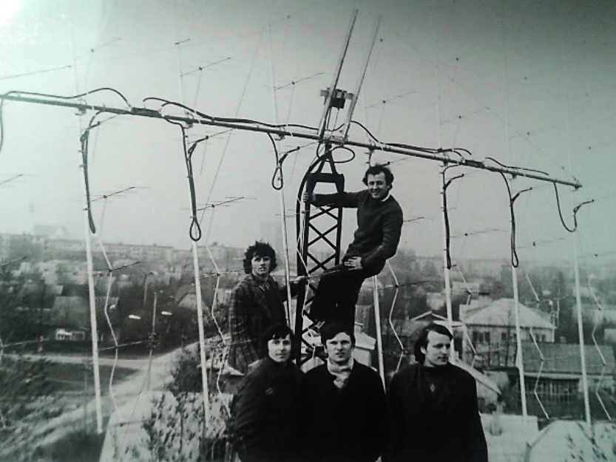

**UK2BAS team 1979**

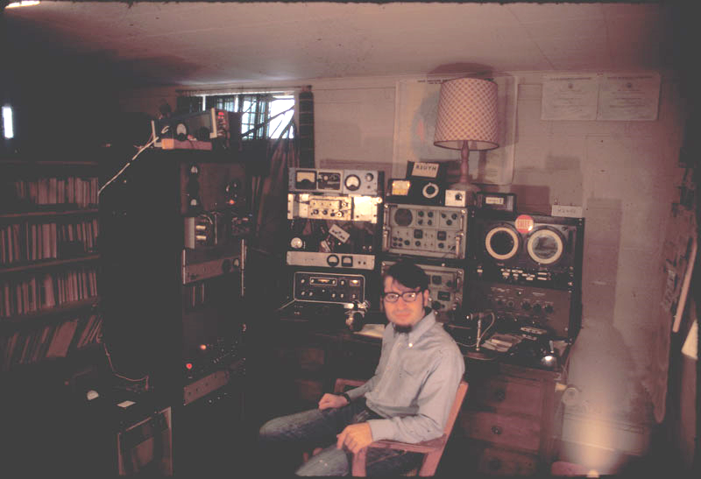

**K2UYH (1976)**

The operators recently met after 40 years to reminisce and discuss new challenges.

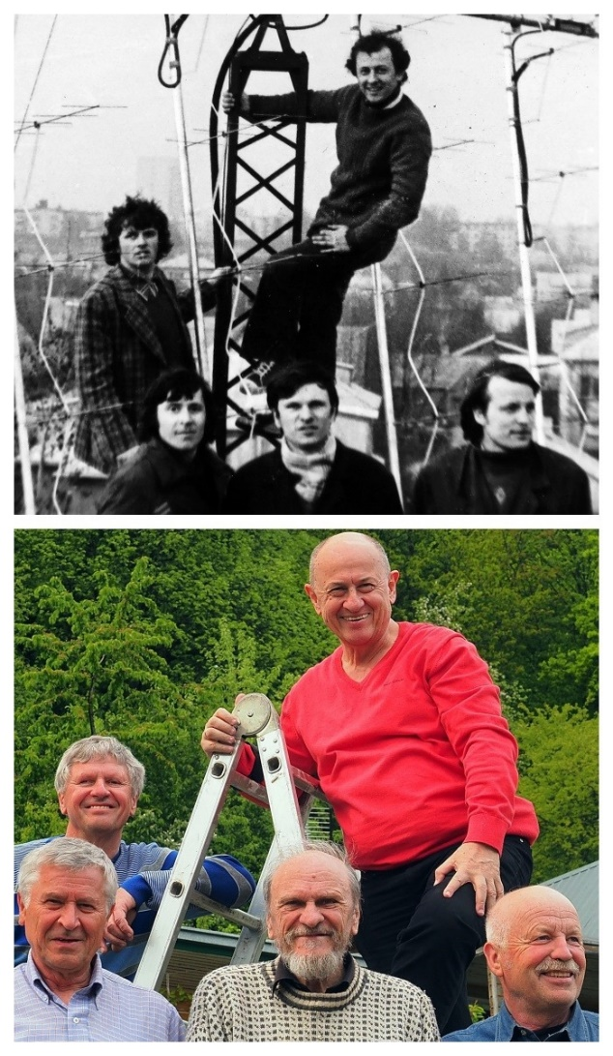

**UK2BAS team 1979**

At my end [K2UYH], I was amazed to receive a call on 20 m, right after the 432 EME Net, from UK2BAS. I had a very modest 20 m station, just enough to work the net control (K1RQG). I had never worked a DX station on 20 m. I thought at first the call was K2BAS. It became clear that they wanted to set up a 432 EME sked. We made it for the following week. I thought it might be a hoax, but they were there and we had an easy QSO. I was still skeptical until I received the QSL. Mino mentions that there will be a VHF-UHF-SHF conference during Lithuanian Hamfest on 27 July – see <http://lrmd.lt/en/hamfest2019>.

**TECHNICAL:** VE1KG sends the following comments on selecting a TV camera for seeing and tracking the Moon -- Here I use a $16 camera from China bought on

Epay color. It should be black & white if you want to see the moon during the day. I have a wide angle shot and see the Moon from a 10 cents piece to a 25 cent piece in

the center of my 6" monitor. Try to get a black & white camera if you can find one. Also make sure it is waterproof mine is not and I put it inside of a camper's flash lite. It runs on 12 Vdc, which I have up the tower already. [The same or similar camera can be used to view a compass rose or other dish marked off in degs for a very inexpensive and highly reliable AZ readout – as has previously been discussed in this NL].

**RADIO ASTRONOMY CORNER:** At the Örebro meeting on 24-26 May were 2 nice resentations; one about Pulsars by OE5JFL – see [http://moonbouncers.org/Orebro2019/ jfl_sweden_2019.pdf](http://moonbouncers.org/Orebro2019/%20jfl_sweden_2019.pdf), and a second by UA3AVR on Using the cosmic microwave background for noise figure measurements – see [http://moonbouncers.org/ Orebro2019/UA3AVR_NF%20measurements&Radio%20Astronomy_Orebro2019.pdf](http://moonbouncers.org/%20Orebro2019/UA3AVR_NF%20measurements&Radio%20Astronomy_Orebro2019.pdf).

**Dwingeloo's VLBI project -** Jan (PA3FXB) reports that a few months ago our volunteer, PE1NUT (who happens to work at JIVE) did a test using the Dwingeloo dish for VLBI observation for the first time. He succeeded in getting fringes with the Jodrell Bank Observatory. He used Rubidium time synchronization, which is not accurate enough for 'real' VLBI work. In Westerbork, there is a Hydrogen maser available. It appears that the signal of this maser is routed to Dwingeloo (ASTRON building). We only need to add 100 m or so of optical fiber to get the maser signal to the PI9CAM dish. So, there has been some digging going on the last few weeks. For now, we have the maser signal available at the dish! Paul did another test and once again got great fringes with Jodrell Bank. It's very likely that PI9CAM will cooperate in professional VLBI observations in the future! [The differences between reference clocks: 87Rb is 10^-12, 133Cs is 10^-13 and 1H is 10^-15. While the rubidium clock isn't good for VLBI and a hydrogen maser is too expensive for individuals; at Ebay it is possible to buy a Cesium atomic clock, which should be good enough, more at is https://www.haystack. mit.edu/workshop/TOW2017/files/Seminars/tow-time2017. pdf and [https://tycho.usno.navy.mil/ptti/1976papers/Vol% 2008_43.pdf](https://tycho.usno.navy.mil/ptti/1976papers/Vol%25%202008_43.pdf). Thus, if you have a big accurate dish and a cesium atomic clock, even amateurs should be able to join VLBI collaboration].

**FINAL:** We still more to say, but we have run out of time. We will pick up on the discussion of the 432 and 1296 Up WAC Clubs. Hopefully next month.

► Do not forget to submit your logs for ARI.EME-Trophy All Modes Contest to [**i5wbe(x)i5wbe.it**](mailto:i5wbe@i5wbe.it)**.** The contest ules are at [http://www.eme2008.org/ari-eme/Trophy% 202019%20rules.pdf](http://www.eme2008.org/ari-eme/Trophy%25%20202019%20rules.pdf).

► There were some problems with the 10 GHz (10368.025) EME beacon in April and May. It should be up now, but DK7LJ is not sure if he has really fixed the problem. Per asks if there is no signal for you to look at <http://moonbeacon.dl0shf.de/>.

► If you are QRV on 6 cm and/or 9 cm don’t missed the Dubus weekends. We both plan to be QRV on EME. 73, Al - K2UYH and Matej – OK1TEH

[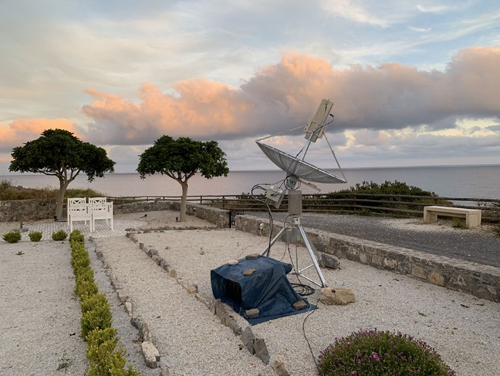](http://www.google.com/url?sa=i&rct=j&q=&esrc=s&source=images&cd=&ved=2ahUKEwjYl5SJ78TiAhXhmuAKHZizCaoQjRx6BAgBEAU&url=http%3A%2F%2Fwww.vhf.cz%2Ftext-kreta-na-9cm%2F&psig=AOvVaw3RBUbhp7_rQqhAJbf46OR6&ust=1559357191276454)

**SV9/HB9CRQ on 1296 EME**

