**432 AND ABOVE EME NEWS**

**JUNE 2020 VOL 49 #6**

EDITOR: AL KATZ, K2UYH; DEPT. ELECTRICAL/COMPUTER ENGINEERING, THE COLLEGE OF NEW JERSEY, PO BOX 7718 EWING, NJ 08628, TEL (W 609-584-8424), (C 609-947-3889), E-MAIL [alkatz(x)tcnj.edu](mailto:alkatz@tcnj.edu)

ASSOCIATE EDITOR AND Reflector/NETNEWS Matej Petrzilka, OK1TEH, Simunkova 1609/21, 18200, Praha 8, Czech Republic, TEL (+420 603 489 490), E-MAIL [ok1teh(x)seznam.cz](mailto:ok1teh@seznam.cz)

CW INITIAL LIST G4RGK, DAVID DIBLEY, E-MAIL [zen70432(x)zen.co.uk](mailto:zen70432@zen.co.uk), AT: <http://www.zen70432.zen.co.uk/Initials/index.html>

SUN & EXTRATERRESTRIAL NOISE LIST MANAGED BY OK1TEH: <http://www.ok2kkw.com/next/nl_k2uyh/sun_table.xls>

EME INFORMAL NETS: 14.345, ~1500 SATURDAY AND SUNDAY, NET COORDINATOR: OPEN

ON0EME EME BEACON, 1296.000 IS QRV WHEN MOON >10°, SEND RX REPORTS TO WALTER (ON4BCB) [on4bcb(x)gmail.com](mailto:on4bcb@gmail.com)

DL0SHF 3 CM EME BEACON, 10368.025, SEND INFO & QUESTIONS TO Per (DK7LJ) [per(x)per-dudek.de](mailto:per@per-dudek.de).

NL EMAIL DISTRIBUTION and EMAIL LIST CORD: WARREN, W2WD [wbutler(x)ieee.org](mailto:wbutler@ieee.org)

THE NL WEB VERSION IS PRODUCED BY REIN, W6SZ [rein0zn(x)gmail.com](mailto:rein0zn@gmail.com), AT: <http://www.nitehawk.com/rasmit/em70cm.html>

**CONDITIONS:** Despite problems with weather (WX) the 13 cm DUBUS Contest turned out to be an excellent event with many high scores reported. The top was from the OK1KIR group with a score of 41x34; a nearly 30% increase over last year’s reported high score. There is no contest activity in June due to a close Sun and Moon. **The Big One, the 23 cm VK3UM Memorial/DUBUS CW EME Contest is on 18/19 July -** see rules at [marsport.org.uk/dubus/eme.htm](http://www.marsport.org.uk/dubus/eme.htm). Although dxpedition activity is at a low due to COVID-19 travel restrictions, the HB9CRQ grid dxpedition (JN46) on the microwave bands (23 cm thru 3 cm) by the Q-team generated lots of interest – see HB9Q’s report in this newsletter (NL). KB7Q’s 432 grid dxpedition in MT was cut short by a balun failure, but still provide a few QSOs – see Gene’s report. The 70 cm CW activity time period (ATP) is 28 Jun 1300-1500 and 2000-2200 for once has no competition and hopefully attract a good turnout. There are some reports in this NL on experimentation with FT8 on 70 and 3 cm EME. No one is suggesting using FT8 for regular EME. The intention of these tests was to see what can be done with a difficult form of modulation. It is similar to QSOs made in the early days of EME using FM modulation. If you have a big enough system, it can be done as shown by W2HRO and PA2V on 432.

**REPORTS:**

**DB6NT:** Michael [db6nt(x)gmx.de](mailto:db6nt@gmx.de) has now added 13 cm to the list of microwave bands that he is QRV -- I have assembled a station for 2.3 GHz and was QRV for the first time on this band on 23/24 May for the DUBUS Contest. I am limited to TX on 2320, but can listen and work crossband (XB) with the other sub-bands. I worked using CW (and SSB where noted) ES5PC, OH2DG, SP6OPN, SA6BUN, UA3PTW, OK1CA, G3LTF on SSB, DF3RU on SSB, PA0BAT on SSB, OK1KKD, OK2ULQ, OH1LRY, OK1KIR, F5JWF, LX1DB on SSB, VE6TA, PA3DZL, SM2CEW, W5LUA, F2CT, SP3XBO, IZ2DJP, G4RGK and IK3COJ for a total of 24x22. I also heard WA9FWD. My station is a 3.7 m Andrew dish with OK1DFC feed and > 75 W at it, and a 0.35 dB NF LNA.

**DK3WG:** Jurg [dk3wg(x)web.de](mailto:dk3wg@web.de) was quite active in May/June – I added initials on 432 using JT65B with G4IDR, HI8DL with a single 9 wl yagi and 75 W for DXCC 140, UA4CC, DG4KLK, WP4G with a single 25 el yagi and 50 W, 2M0ETJ with 2 x 14 el yagis and 50 W, RP75TT and

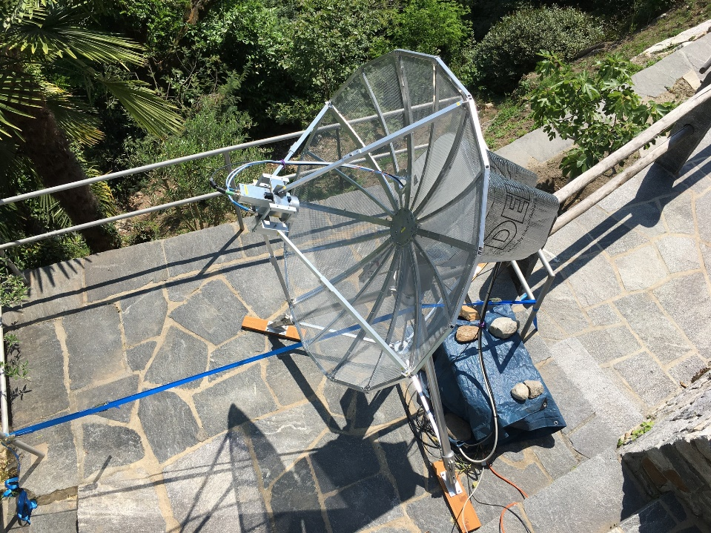

**HB9CRQ grid dxpedition 6 cm feed in 1.8 m dish**

GW3TKH using a single 20 el LFA yagi and 200 W, and on 1296 using JT65C CT1BYM, DK5AI, HB9Q in (JN46) and LY3DE for mixed initial #300*.

**DK5AI:** Wolfgang [DK5AI(x)darc.de](mailto:DK5AI@darc.de) is back on the Moon; now on 23 cm -- I am QRV since 25 May with a 1.8 m solid dish, Septum feed and about 150 W into it. During my first week, I worked 32 initials!

**DU3T:** Ron [ronald.schiltmans(x)freenet.de](mailto:ronald.schiltmans@freenet.de) is basically QRV on 1296 -- One of the few advantages of the lockdown is that I finally had time to work on my 23 cm EME station here in the **Philippines**. The antenna size is 4.5 m dish. I am copying stations FB, but am still trying to get my HPA to work. [Ron should be QRV by the time you read this].

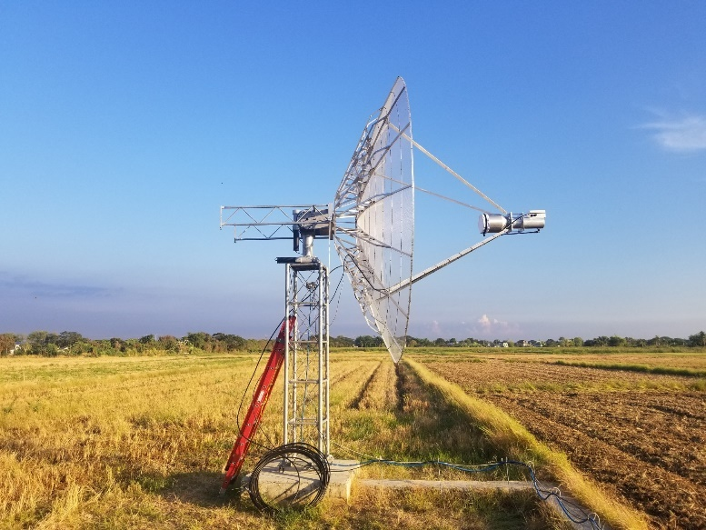

**DU3T’s 4.5 m dish on 23 cm**

**F2CT:** Guy [f2ct(x)wanadoo.fr](mailto:f2ct@wanadoo.fr) reports on his operation in the 13 cm contest – I was only QRV on 24 May and QSO’d OH2DG (559/559), UA3PTW (559/559), OK1CA (559/559), ES5PC (559/559), G3LTF (559/559), DF3RU (559/559), SA6BUN (559/539), K2UYH (559/559), OK1KKD (559/449), OH1LRY (559/539), OK1KIR (559/559), DB6NT (569/549), SP6OPN (569/559), PA3DZL (559/559), PA0BAT (559/559), LX1DB (579/579), WB2BYP (559/559), HB9Q (559/559), PY2BS (559/549), JJ1NNJ (559/539) and SM3BYA (559/539) for a total of 21x19. I am looking for Africa and Oceania to complete 13 cm WAC.

**G3LTF:** Peter [g3ltf(x)btinternet.com](mailto:g3ltf@btinternet.com) writes on his May EME -- The 13 cm DUBUS/REF Contest did not start well here. The weather on Saturday was gale force winds and I lost 10 hours of moon time, but Sunday was much better. Activity seemed good with some really big signals. I worked 32 stations x 28 on random CW + 1 SSB DUP and added 3 initials. I worked on 23 May SP6OPN, UA3PTW, SA6BUN, PA3DZL, SP3XBO, ES5PC, JA6AHB XB, OH2DG, DF3RU, SM3BYA, OK1CA, OH1LRY, DB6NT for initial #147, OK1KKD, OK2ULQ, UA3TCF and DG5CST, and on 24 May OK1KIR, F2CT #148, JA6XED XB #149, SP7DCS, G4RGK, WA9FWD XB, WB2BYP XB, IZ2DJP, IK3COJ, W5LUA XB, WA6PY XB, K2UYH XB, VE6TA, VE6BGT, KL6M XB. DB6NT was also worked on SSB. CWNR XB was WD5AGO, and heard on 2304 only were WA5AFY, LX1DB and SP2HMR. I listened on the VK frequency on Sunday, but nil heard, apart from OH1LRY. I was on 23 cm using CW and worked on 27 May NC1I, then saw a small signal on 020 and added NQ7B for initial #492 in AZ - it is always nice to work a new one completely random; on 29 May SM5DGX and NQ7B again; and on 30 May another random initial, SV1CAL #493 followed by a nice chat with IK1FJI. The declination axis potentiometer failed this month. It’s probably been there for 20 years, so that’s been replaced and recalibrated, and I now have a failed 3CX100A5 to replace in the 6 tube ring, then will be ready for the big 23 cm DUBUS/REF Contest in July.

**G4BAO:** John [john(x)g4bao.com](mailto:john@g4bao.com) is currently not QRV and when he returns will be only on 10 and 24 GHz only -- I have at least temporarily taken down my 1.9 m mesh dish and replaced it with a 1.1 m solid dish. This smaller dish out performs my old mesh one on 3 cm. With my 3 cm and 25 W PA, I was able to make CW contacts. I had a problem with the 12 V DC supply that I was using due to cable volt drop. I'm building a new pair of switching supplies to mount next to the PAs. I now have a 24 GHz TWT (ex G4EAT, SK). 24 GHz will be my focus once 10 GHz is stable. I am also thinking about RX on 47 GHz EME!

**G4RGK:** Dave [zen70432(x)zen.co.uk](mailto:zen70432@zen.co.uk) was QRV for the 13 cm DUBUS Contest but had problems with WX – I have not been very active on EME but did manage to get my 13 cm station together and running for the CW contest; however the WX did not cooperate. A severe thunder storm was forecast for the early part of the weekend, and it arrived as forecast. It proved impossible to untie the dish on Saturday, so I used the time to remount the feed and make some changes to stabilize the mount. As Sunday dawned it was still blowing hard, but by midday it had calmed down and I was able to get the dish on the Moon for the first time. I was able to work OK1CA, OK1KIR, UA3PTW, OH2DG, G3LTF, ES5PC, PA0BAT, DB6NT for an initial (#), SP6OPN, and DF3RU all on 2320 with great signals for a total of 10x9. Heard and called with no response were SM3BYA, SP3XBO, PA3DZL, OK1KKD and IK3COJ, and XB on 2304 WB2BYP and K2UYH. My station is a 4.6 m stressed dish, 300 W PA, RA3AQ feed and DDK preamp.

**HB9CRQ:** Dan (HB9Q) [dan(x)hb9q.ch](mailto:dan@hb9q.ch) reports on the Q-Team’s microwave grid dxpedition to (JN46je) -- We worked a total of 108 QSOs and 89 initials on 5 bands in 5 moon-passes of 5-6 h each. We also made 23 CW QSOs on the 5 bands. On 23 cm we had 39 QSOs (4 CW and 35 JT65C), 34 initials, 16 DXCC and 4 continents. The smallest station was DF2VJ (29DB/26DB) with a 2.6 m dish and 140 W. On 13 cm we had 12 QSOs (1 CW, 11 JT65C), 11 initials, 7 DXCC and 2 continents. On 9 cm we had 13 QSOs (3 CW, 10 JT65C), 8 initials, 5 DXCC and 2 continents. The smallest station was OK1DFC (22DB/24DB) with a 2.5 m offset dish and 45 W. On 6 cm we had 22 QSOs (10 CW, 22 QRA64D), 14 initials, 10 DXCC and 3 continents. The smallest station was KN0WS (22DB/21DB) with a 1.8 m mesh dish and 50 W. On 3 cm we had 26 QSOs (5 CW, 21 QRA64D), 22 initials, 14 DXCC and 3 continents. The smallest station worked was G4CBW (18DB/15DB) with a 1.5 m offset dish and 55 W. Our station was a 1.5 m dish with on 1296 100 W, on 2300 90 W, on 3400 80 W, on 5760 80 W and on 10368 50 W. A circular pol feed was used on all band except 3 cm were a vertical linear feed was used. The story behind the story: In summer 2019 we booked flights to Rhodes (SV5) and a house on the beach. But then Covid-19 hit the world! In April our flight to Rhodes was canceled. Switzerland and Greece were still in lockdown and it became obvious that there was no chance this year to activate SV5. So, we decided to postpone the dxpedition to May 2021. In HB the lockdown started to ease up in early May. So, we decided to do a grid dxpedition to JN46 where Dan and Sue own a house in Brione sM. The QTH is at 400 m asl; this is 200 m above the lake Lago Maggiore, located on the south slope of the Swiss Alps, close to the Italian border. Unfortunately, although the house has a spectacular view, moonrise and moonset are obstructed by large trees and bushes. So our usable EME window was restricted to only about 5-6 h. Never the less we felt it might be of interest for the microwave EME community to add a new initial and a new grid to their logs. We apologize to our JA and VK friends, for not being QRV for them. 2320/2304 and 3400 MHz are not part of the HB9 license. To operate on these frequencies you need a special permit, which we got just in time to operate. It is a 2.5 h drive from home to Brione sM, crossing the Swiss Alps through a 16 km long highway-tunnel. We arrived a few days early to enjoy touring the region. On Friday 22 May we built and tested the station. On Saturday and Sunday the weather was perfect with only a very little wind. Despite our limited window, we had a great time and worked a good number of stations. Monday through Thursday we again spent a lot of time hiking the nice valleys of the area. On Friday 29 May, the weather was still perfect. We were QRV 5760. Everything was working perfectly. The same on Saturday on 10368, and also on our last day, Sunday on 1296. We had a great time! Many thanks for working us! On 4. June we drove back home. This is the first time we only operated on weekend days; we hope this made it easier for our *customers* to be QRV and work us. We feel it was worthwhile and will do this again in our next dxpeditions. QSL information: please QSL direct with SAE to HB9Q, P.O.Box 133, CH-5737 Menziken, Switzerland.

**HB9EHJ:** Bodo [df8dx(x)gmx.de](mailto:df8dx@gmx.de) (also DF8DX) writes that is now using his HB call to operate from his home QTH -- After being too busy with work, travelling and moving, I finally had some time to set up my old EME equipment that I used on so many dxpeditions [and make possible 1296 DXCC for so many]. The station consists of a 55 el long yagi and about 80 W at the dipole. I was happy to log OE5JFL, UA3PTW, DF3RU, PA3DZL, OK1KIR, NC1I, SM5DGX and KA1GT. The antenna is not permanently set up, but it is mounted in a way that I can be quickly QRV. I plan to show up every now and then to catch some more stations.

**IK1FJI:** Valter [valter_dls(x)yahoo.it](mailto:valter_dls@yahoo.it) sends his May EME CW report – On 23 cm I worked using CW unless noted on 2 May DL0SHF (589/589) and FR5DN (549/559), on 3 May OK2DL (56/55) SSB, IK3MAC (559/569) and IK3MAC (54/55) SSB, on 29 May NC1I (579/569), OE3JPC (O/O) for an initial (#) using 2 x 55 el yagi and 400 W, SV1CAL (549/559) (#) and G3LTF (579/569), and on 31 May PY2BS (579/579), SM5DGX (579/569) and HB9CRQ (24DB/17DB) JT65C grid dxpedition in JN46.

**JA4BLC:** Yoshiro [ja4blc(x)web-sanin.co.jp](mailto:ja4blc@web-sanin.co.jp) writes he could not be QRV for the 13 cm DUBUS Contest – I lost last Nov the 6 m dish that I used for 2400 EME; and thus sadly could not be QRV for the contest. The following stations were QRV on 2400 for the contest weekend: JJ1NNJ, JA8ERE, JA6AHB and JA6XED. [Yoshiro also notes that the COVID situation is becoming better in Japan].

**JJ1NNJ:** Koichi [jj1nnj(x)extra.ocn.ne.jp](mailto:jj1nnj@extra.ocn.ne.jp) reports on his DUBUS 13 cm Contest result -- I had some trouble, but was able to started operation at the beginning of the contest. The Sun was close to the Moon, but it wasn't a problem. I had heavy rain on the first day, which stopped on the second day, but then there were high winds! I QSO'd 6 stations. All were on CW and most XB. They were OH2DG, ES5PC XB, W5LUA XB, VE6TA XB for initial #16, OK1KIR and OK1CA for a score of 6x4. Heard were KL6M, PA3PXB, SP6OPN, UA3PTW, OK1KIR, SA6BUN, JA6AHB, JA6XED, SM3BYA, G3LTF, PA3DZL, SP3XBO, DF3RU, K2UYH, SP2HMR and PA0BAT. My equipment consists of a 3 m solid dish with f/d of 0.25, 3 ring VE4MA feed and 100 W. My sunnoise is 9.4 dB (x) 2400 MHz SF70. As far as I know, only three stations, JA6AHB, JA6XEC and JJ1NNJ, participated from Japan. I heard a lot of EU stations on 2320, but no answers. I hope more stations TXing on 2320 will listen on 2400 next time.

**KB7Q:** Gene [geneshea(x)gmail.com](mailto:geneshea@gmail.com) reports on his 70 cm mini grid dxpedition to DN55 (Absarokee, MT) -- Joyce and I drove down to our friends ranch on 29 May with our camper and got my single yagi EME station set up a day early. Conditions were quite good, so I got on and worked DL9KR (CW 549), DL7APV (13DB), UA3PTW (17DB) and PA2V (17DB). It rained hard overnight and I found my SWR had gone to 7:1. After an hour of trouble-shooting, it appeared that water had infiltrated the aluminum housing on the driven element. So, it was QRT! Still we had a great camping trip; it was good to escape the house! After returning home, I discovered it wasn't water infiltration after all; rather the internal balun connection inside the aluminum housing on the driven element had failed. A replacement part is on the way.

**KL6M:** Mike [melum(x)alaska.net](mailto:melum@alaska.net) writes about his XB experiences during EME DUBUS 13 cm weekend -- I heard MANY on 2320, but NOBODY seemed to be listening on 2304. All were on 2320 except VK3NX, and Charlie apparently wasn't listening on 2304 either. On my moonrise today, I worked only one XB QSO with SM2CEW. Thus far I have a total of 13 QSOs. My system appears to be seriously degraded and I don't have time to try to figure out what's going on now. [We never received a follow up report from Mike].

**KN0WS:** Carl [carlhasbargen(x)q.com](mailto:carlhasbargen@q.com) attempted to be on 13 cm and then was successful on 6 cm at the end of May – Despite a discouraging weather report, I decided to head north to operate during the DUBUS 13 cm on 23/24 May. I first used my 16’ dish for 13 cm in 2017, which is also the LAST time I successfully used the dish for 13 cm. I spent more time setting up than I ever have before - 7 hours! Back in 2017, I struggled to point my dish. I manually set the declination of my polar mount and then use an analog timer to drive my DC motor for 5 seconds out of every 100. It usually tracks well enough on 1296. This time I used my 23 cm feed to receive ON0EME; then adjusted the rotation of my polar shaft by 3 degs (feed offset correction) to use my 13 cm feed without having to touch the declination. I was able to see HB9CRQ’s signal easily. I assumed, if I could copy Dan’s small dish this well, I would be able to see LOTS of folks! But, once I tried to TX, I lost everything! The rest of the day was wasted. I changed my sequencer, my preamp, the relay… nothing seemed to work. The only signal I copied was from OK1CA. I finally packed up my gear and headed home. I considered trying on 9 cm with HB9CRQ from home the next day, but I only had 2.5 hours sleep. Instead, I spent the next few days working out the wrinkles in my 6 cm system. I am using my 1.8 m back yard dish; and it basically boiled down to a new preamp that happened to have lower gain, but at least it worked! Using QRA64D on 29 May I had successful initials with HB9CRQ (21DB), OK1KIR (15DB), W5LUA (14DB), PA3DZL (16DB), PA0BAT (16DB), OZ1LPR (16DB), K2UYH (19DB) and HB9Q (13DB). G4CCH and I used JT4F for a successful QSO (16DB). I decoded PY2BS (18DB), but Bruce did not see me. I switched to 3 cm gear for the next day, but did not have much luck. I decoded OK1DFC (15DB) and PY2BS (17DB), but neither one saw my 20 W. I did work using QRA64D PA3DZL (18DB) for an initial and quit while on a high note. Since then I have adjusted my dish pointing a bit. All 24 of my QSOs this year have been from my small back yard dish at 9, 6 and 3 cm.

**NC1I:** Frank [frank(x)NC1I.COM](mailto:frank@NC1I.COM) brings us up to date on his plans and status -- We have made significant progress on the rebuild of my 432 array. The array is nearly ready to go back up. All coaxial phasing lines have been replaced and power dividers rebuilt. We have replaced the UT250 and N connectors on the copper sleeve baluns at the 12 open wire junctions at each of the four bays. The 2-way power divider at the input to the array had a broken N connector on one side. Both of the outer 6-way dividers had broken solder joints between a couple of the N connectors and the center conductor of the dividers. These issues are not surprising after more than 25 years of New England weather, but it is surprising how well the array continued to work up until last summer. I suspect the fatal blow was the broken N connector on the center 2-way power divider. Thanks to W1QA and N1DPM for their assistance working on many of these components remotely (due to COVID-19). The mount was delivered to a local machine shop to have all bearings replaced and a complete rebuild. They have recently advised me that everything should be complete and ready to ship to the powder coaters by mid to late July. Based on the progress of the array and mount, I hope to be back on 432 this fall; however, it will take a small crew (and crane) to reinstall everything on the tower so there is a chance that COVID-19 could delay the reinstallation. After several months of very limited EME activity, I was able to spend some time on 1296 EME in May. I put 48 QSO’s in the log during May including many initials and at least two new countries. I will try and to be active in June, but the current heat wave will likely lead to thunderstorm activity, so any activity could be sporadic. We desperately need some rain so the thunderstorms will be welcomed! All of our dxpedition plans are still on hold due to the COVID-19 pandemic; and my focus is on getting the 432 array back up in operation. At this point it will likely be 2021 before we attempt any dxpeditions. We hope to activate one State on 432 and another State on 1296 in 2021.

**N5BF:** Courtney [courtney.duncan.n5bf(x)gmail.com](mailto:courtney.duncan.n5bf@gmail.com) sends news of his May 23 cm results – I added this month several initials using JT65C unless noted with 4X1AJ (27DB/20DB) mixed #182* and DXCC #41, DG5CST (11DB/9DB) #183*, SM5DGX (569/539) CW initial #50, VE3NXK (25DB/18DB) #185*, SV1CAL (19DB/19DB) #186* and DXCC 42 and CT1BYM (26DB/25DB) #187* and DXCC 43. I was still not able to complete with IU0BTM, but hope to do so later in the year. I am currently preparing materials for an upgrade from a 3 to a 3.8 m dish. This should improve performance, and perhaps allow regular single yagi digital QSOs and cleaner CW copy. The plan is for the tower to come down right after the DUBUS 23 cm weekend and be down for about a month in preparation for the fall EME season.

**OK1CA:** Franta [fr.strihavka(x)seznam.cz](mailto:fr.strihavka@seznam.cz) reports on his May EME -- In the 13 cm DUBUS CW EME Contest, I was QRV on Saturday in the second part of the my EME window, and on Sunday in the first part of the my window. Basically, I was QRV on Saturday local time. I worked 32 QSOs Saturday and another 7 QSOs on Sunday for a final result of 39x37. I added initials with SA6BUN, DB6NT, DG2CST and F2CT to bring me to initial #157. Outside of the contest, I worked using JT65C HB9CRQ - grid dxpedition and DL1EMA to bring me to digital initial {# 19}. DL1EMA used an Adam Pluto SDR transceiver and had a good stable signal. On Saturday it practically rained all day and on Sunday before noon, I had a bad storm with hail falling on my QTH.

**OK1DFC:** Zdenek [ok1dfc(x)seznam.cz](mailto:ok1dfc@seznam.cz) at the end of May move down in freq and planned to active in the DUBUS 13 cm EME Contest -- I built a new SSPA especially for the 13 cm contest. It is designed to be installed directly in the focus point of my offset dish. However, on the Thursday before the DUBUS contest, my fourth grandson was born and so I was with my family on the weekend. I hope now to test the new SSPA during the ARRL EME contest. I missed the connecting with HB9CRQgrid dxpedition on 2320. I was QRV just for Dan's EME dxpedition on 25 May on 9 cm for a new grid square and initial. I worked on 29 May on 6 cm HB9CRQ again, and as a bonus PY2BS with a FB signal to fulfill 5760 CW WAC; and on 30 May on 3 cm HB9CRQ using QRA64D and (559/559) CW for initial #48, S57RA (7DB/12DB) QRA64D for digital initial {61}, PY2BS (7DB/12DB) QRA64D, OK2AQ (10DB/14DB) QRA64D and DL4DTU (7DB/17DB); then switched to 1296 on 31 May – (I have not been 23 cm for a long time because my 2.4 m dish is marginal on this band) to catch using JT65C HB9CRQ (24DB/21DB) for mixed initial #369*, AA4MD (12DB/12DB), DK5AI (24DB/O) #370*, GM4PDJ (23DB/O) #371, KA1GT (14DB/6DB), W1PV (21DB/18DB), SM5DGX (7DB/4DB) #372, K2UYH (10DB/8DB), WA3QPX (10DB/12DB) who is the only one QRV in Delaware for #373 and WAS 42, and very pleasantly surprised by OM4XA (22DB/O) in Slovakia who is regularly QRV with a 3 m dish and 50 W. The *cucumber* EME season is starting; COVID19 has canceled all dxpeditions; and we have had to move the International EME Conference 2020 to Aug 2021. [More information is at [www.eme2020.cz](http://www.eme2020.cz) and the end of this NL].

**OK1KIR:** Vlada [vlada.masek(x)volny.cz](mailto:vlada.masek@volny.cz) and Tonda report on the 13 cm part of the DUBUS Contest and HB9CRQ’s dxpedition -- We worked prior to the contest, on Friday 22 May on 13 cm using CW at 1511 DK4RC (559/559) for initial #177, 1520 DF3RU (559/559), 1541 SA6BUN (569/569) #178 and 1549 DB6NT (569/569) #179; and in the beginning of the contest on 23 May using CW at 0509 VK3NX (559/549); then SSPA failed while calling JJ1NNJ XB. We spent hours trying to fix the SSPA without success. Finally, after losing 6 hours, we came back on with an old SSPA. We QSO’d at 1148 OH2DG (569/569), 1155 HB9CRQ (O/O) #180, 1226 OK1KKD (569/579), 1232 OK2ULQ (559/589), 1313 UA3PTW (579/589), 1328 OK1CA (579/579), 1332 ES5PC (579/579), 1337 OH1RLY (569/579), 1406 SA6BUN (569/569), 1430 SP3XBO (569/579), 1438 PA3DZL (569/579), 1454 DB6NT (56/55) on SSB, 1459 WD5AGO (559/559), 1517 WA9FWD (559/579), 1532 WB2BYP (559/559), 1544 WA6PY (569/569), 1552 SP2HMR (559/569), 1559 K2UYH (569/569), 1615 LX1DB (589/579), 1631 SP7DCS (549/579), 1646 KL6M (559/579), 1657 SM2CEW (569/579), 1711 W5LUA 569/569, 1721 VE6TA (559/569), 1727 SP6OPN (579/579), 1742 IK3COJ (569/579) and 1858 VE6BGT (559/579); and on Sunday 24 May at 0522 JJ1NNJ (559/559), 0533 JA6XED (569/569), 0605 DF3RU (569/559), 0656 JA6AHB (559/559), 0719 G3LTF (569/569), 0759 UA3TCF (549/559), 0943 F2CT (559/559) #181, 1246 PA0BAT (569/569), 1305 G4RGK (O/O), 1332 SM3BYA (559/579), 1357 IZ2DJP (559/579), 1516 WA3RGQ (559/549) and 1612 W5AFY (569/579) for a score of 41x36. Off the contest, we worked on 23 May using JT65C at 1040 HB9CRQ (12DB/19DB) for digital initial {#75} and 1247 DL1EMA (14DB/10DB) {#76}. On 24 May switched to 9 cm to work using JT65C at 1058 HB9CRQ (18DB/23DB) for digital {#37} when they saw Moon hidden in the leaves. Later on their signal improved and we repeated the QSO with better reports at 1124 HB9CRQ (13DB/17DB) and at 1134 using CW HB9CRQ (O/O) for initial #84. When we were switching back to 13 cm, HB9CRQ improved to 9 DB. On Friday 29 May at the time of lowest mutual spread between VK7 and EU we tested with VK7MO using FT8 on 3 cm. At a spreading of less than 40 Hz, we received at 1011 until 1025 good FT8 signal from VK7MO, but no decode. The test continued between VK7MO a HB9Q also without a single decode. The test was finished with QRA64D as a check at 1106 VK7MO (11DB/12DB). We also measured moonnoise as 2.8 dB and Zo/CS as 7 dB. Later we also worked at 1208 OK2AQ (11DB/11DB). On 29 May on 6 cm we worked at 1608 HB9CRQ (14DB/14DB) using QRA64D for digital initial {#47}, 1923 HB9CRQ (O/O) on CW for initial #113, 1943 KN0WS (14DB/15DB) using QRA64D {#48} and a new US state (MN). The next day on 30 May on 3 cm we repeated FT8 tests with VK7MO at 1140 with even a lower spread of only 22 Hz, but still no decodes. Later with QRA64D we worked at 1637 IW2FZR (12DB/11DB) for digital initial {#209} and 1710 HB9CRQ (16DB/15DB) {#210}, and using CW at 1848 HB9CRQ (529/529) for initial #136. Then we installed the 70 cm feed for KB7Q’s grid dxpedition. Unfortunately, Gene was QRT due to water in his feed. Later, on 70 cm, we worked using JT65B at 2039 SQ9CYD (14DB/13DB) {#248}, 2054 WP4G (18DB/16DB) {#249} and a new JT DXCC, 2143 KC0V (23DB/25DB) {#250}, 2204 LU1CGB (22DB/O) {#251} and 2346 partial YO2LSP (22DB/NIL). On Sunday 31 May we were QRV on 23 cm and measured sunnoise as 19.2 dB and a Zo/CS of 8 dB. After moonrise we worked using JT65C at 1322 UA6AH (11DB/8DB) for initial {#358}, 1340 4X1AJ (16DB/3DB), 1409 DK2AN (21DB/13DB) {#359}, 1419 SM5DGX (1DB/1DB) {#360}, 1428 DG0FE (6DB/1DB) {#361}, 1456 DK5AI (19DB/O) {#362}, 1501 JH7OPT (13DB/11DB) {#363}, 1545 CT1BYM  (10DB/8DB) {#364}, 1554 GM0PJD (5DB/1DB), 1635 OM4XA (10DB/O) {#365}, 1654 HB9CRQ (12DB/11DB) {#366}, 1722 ON4LX (27DB/8DB) {#367} using only a 3 m dish and 8 W!, 1738 G4ALH (10DB/12DB) {#368}, 1747 LY3DE (14DB/7DB) {#369}, 1801 IU0BTM (21DB/5DB) {#370}, 1849 IK1FJI (1DB/8DB) {#371} and 1949 HB9EHJ (20DB/O) {#372}. With CW we worked at 1926 HB9CRQ (539/539) for initial #462.

**OK1IL:** Ivan [ivaknn(x)gmail.com](mailto:ivaknn@gmail.com) reports on his 1296 activity in the ARI Contest and since -- I had wanted to collect some more initials during the contest, especially on CW. On my first attempt to TX, no power came from the PA. Fortunately, my first concern that the power FETs had gone was not confirmed. The reason for the failure turned out to be a bad connection of the PTT line between the shack and the PA. It took me a while to get to the remote QTH and then fixed the cause of the failure. By the time I was QRV, it was near the end of the contest. Despite my contest problems, I have added initials on 23 cm with CX2SC for DXCC 61, K7EME, VE2UG, DJ9YW, IU0BTM, WA3QPX in DE for WAS 25, UA6AH, G4ALH, CT1BYM, HB9CRQ dxpedition in JN46 and OM4XA for mixed initial #226* and DXCC 62.

**OK2AQ:** Mirek [mirek(x)kasals.com](mailto:mirek@kasals.com) writes his recent activity on 3 cm -- During the weekend of the Q team’s grid dxpedition, there were good EME conditions and increased EME activity on 10 GHz. I worked on 28 May IW2FZR (15DB/13DB), on 29 May VK7MO (14DB/16dB), OK1KIR (11DB/11DB), JA1WQF (13DB/12DB), F5VKQ (12DB/16DB) and UA3TCF (18DB,14DB), on 30 May HB9CRQ (15DB/19DB) for digital initial {#92}, PA3DZL (16DB/11DB), S57RA (10DB/15DB) {#93}, PY2BS (10DB/11DB), OK1DFC (11DB/8DB) and IW2FZR (16DB/15DB), on 31 May UN6PD (15DB/13DB), F5VKQ (15DB/17DB), on 1 June HB9DUK (12DB/19DB), IZ4BFA (22DB/18DB), on 2 May IW2FZR (16DB/16DB), and on 3 May S57RA (12DB/14DB).

**PA2V:** Peter: [peter(x)pa2v.com](mailto:peter@pa2v.com) had good success on 432 in May/June adding 2 new DXCCs – I worked using JT65B unless noted on 1 May at 1109 ZL3AAD (22DB/7DB) for initial #220 new DXCC, 1258 VK4EME (12DB/4DB0, 1347 DL8GP (24DB/17DB) #221, 1405 G4YTL (24DB/O) and 1411 JE2UFF (27DB/21DB), on 3 May at 1633 DF3RU (13DB/8DB), 1719 G3LGR (28DB/20DB) and 1846 RP7TT (21DB/21DB) #222, on 16 May at 0921 W2HRO (25DB/25DB), on 17 May at 1042 W2HRO (18DB/20DB), on 21 May at 1223 first EME QSO using FT8 demonstrated on 70 cm W2HRO (17DB/18DB), on 29 May at 1903 EA5CJ (28DB/O), 1935 WP4G (25DB/16DB) #223 and new DXCC, 1942 KC0V (29DB/26DB) #224, 2057 and KB7Q (20DB/17DB) grid dxpedition in DN55 MT, on 30 May at 1327 VK4EME (16DB/2DB), 1346 VK4EME (19DB/8DB) using FT8, on

14 June at 0808 K5QE (18DB/O), 23 June at 1441 DK3WG (12DB/6DB), 1835 SQ9CYD (20DB/9DB) #225, on 24 June 1705 RD3FD (24DB/19DB) and 1913 SQ9CYD (21DB/5DB), and on 26 June at 1935 R6CS (24DB/20DB) and 1421 BD9BU (27DB/19DB). I have been experimenting with different filters QRM from a nearby high power transmitter on 431 MHz. PA7JB suggested using commercial SAW filters. I did some tests and was amazed by the performance. I expect that these filters may be of help to others. They easy to use, require no tuning and are cheap. I bought 10 SAW filters for EU19. The one available that worked will was centered on 434 MHz. For RX requirements they are perfect. They are not good for applications that require handling any power handling. The max voltage on the input is 10 V. Their insertion loss is around 2 dB and return loss is >20 dB. The challenge is getting thin coax on the input and output pins as they are intended surface mount on PCB. I used very thin coax placed in a groove on a double-sided PCB. [See additional filter pictures and info later in this NL].

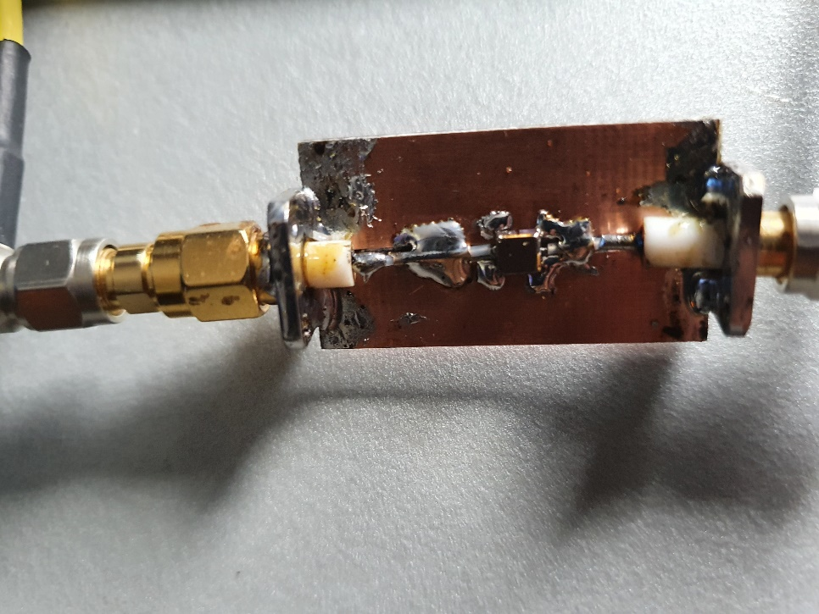

**PA2V’s 432 Saw Filter**

**PA3DZL:** Jac [pa3dzl(x)icloud.com](mailto:pa3dzl@icloud.com) has been busy on EME from his new QTH -- In May, I worked on 17 May on 23 cm using JT65C CT1BYM for a digital initial {#}, on 23 May on 13 cm in the DUBUS Contest using CW SP6OPN, VK3NX XB, SP3XBO, DG5CST, G3LTF, K2UYH XB, VE6TA XB, SM3BYA XB, SA6BUN for initial (#), LX1DB XB, OH2DG, UA3PTW, DF3RU, OK1CA, ES5PC, OK1KIR, PA0BAT, OK1KKD, IK3COJ, SM2CEW, F5JWF, DB6NT (#), OH1LRY, JA6XED (#) XB and F2CT (#), and using JT65C outside of the contest JA6AHB {#} XB and HB9CRQ {#} grid dxpedition; on 24 May on 9 cm using JT65C HB9CRQ dxpedition for digital initial {#}, then back to 13 cm for the contest using CW IZ2DJP (#), WB2BYP (#) XB, WA9FWD (XB), W5LUA XB, WA6PY XB, SP7DCS and KL6M XB for a total of 32x30, and out of the contest using JT65C DL1EMA {#}; on 28 May on 23 cm using SSB DB6NT; on 29 May on 6 cm using QRA64D HB9CRQ dxpedition for digital initial {#}, using CW HB9CRQ for initial (#), using QRA64D KN0WS {#} and using QRA65D PY2BS; on 30 May on 3 cm all using QRA64D DL4DTU for digital {#}, IW2FZR, HB9CRQ dxpedition {#}, DL3DTS {#}, OK2AQ , PY2BS and KN0WS {#}; and on 31 May on 23 cm all using JT65C HB9CRQ dxpedition {#}, DK5AI {#}, G4ALH {#}, LY3DE {#}, UA6AH {#}, PE1LWT, HB9EHJ {#} with a single 55 el yagi and 80 W, ES3RF and PA3FXB. I am also working on a new 432 feed for my 3.7 m dish, so hope to be QRV again on this band. My first feed was a PY2BS patch feed, but plan to change to an OK1DFC ringfeed. PAØBAT has had such good results with this feed, that I want to try it. I am also working on a 24 GHz EME station and hope to be QRV by the end of this year.

**R1NW:** Fedor [r1nw(x)mail.ru](mailto:r1nw@mail.ru) is QRV on EME on 2 m, 70 cm and 23 cm – I have on 432 4 x 26 el yagis and 800 W, and on 1296 4 x 50 el yagis and 200 but presently only on the horizon (no elevation). I am working on for 23 cm a 3.7 m dish with full elevation.

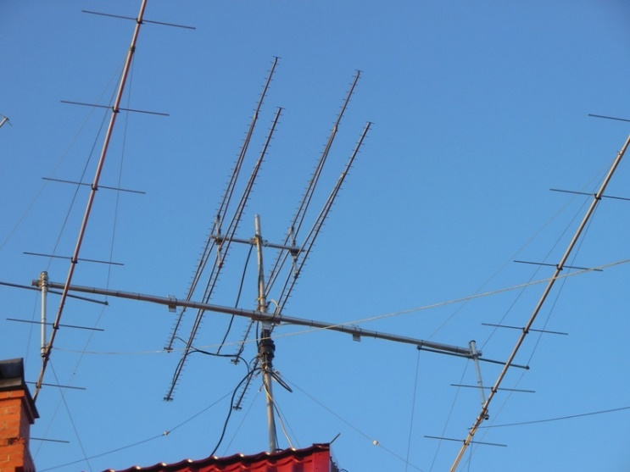

**R1NW’s 1296 4 x 50 el yagi array above 2 m yagis**

**SM2CEW:** Peter [sm2cew(x)telia.com](mailto:sm2cew@telia.com) is back on 13 cm with a time restricted high-power permit -- I felt quite excited about the DUBUS 13 cm Contest. However, due to very strong winds I was not able to come on the band until late on Saturday. I QSO’d PA3DZL, SA6BUN, UA3PTW, OK1CA, OH2DG, VE6TA, SP7DCS, DB6NT, OK1KIR, ES5PC, WB2BYP, K2UYH and KL6M. I struggled a bit with my XB receiver, but eventually I solved the problem and could complete some contacts while transmitting on 2320 and receiving on 2304. My license is for TX only on 2320 and expires at the end of Sept. Just after my QSO with KL6M, a very strong wind gust caught my 8 m dish from the rear side. The dish elevation was just a few degs above the horizon, and the threads on the 1" elevation drive leadscrew were damaged causing the dish to crash down to its mechanical end stop. I was QRT with no chance of operating on Sunday, which was very disappointing. My total score was 13x12. To fix the elevation, I had to order some special parts and do a bit of welding. I am glad to report that everything is now working again. I am looking forward to the VK3UM Memorial/DUBUS 23 cm Contest in July. On 14 June, I was QRV on 23 cm and worked SM5DGX (#) and GM0PJD (#) for CW initials. Paul (GMOPJD) told me after our random QSO that it was his first ever CW EME contact. Welcome to CW EME Paul, UFB signal and excellent CW operating. Apart from activity on 70, 23 and 13 cm, I will also be on 3 cm during the coming weeks looking for stations to work on CW.

**SP2HMR:** Marcel [m(x)e.pl](mailto:m@e.pl) writes about his effort to be QRV in the DUBUS 3 cm Contest – With the contest fast approaching, I started building a 3 cm feed. The first task was the transition from the WR90 to round waveguide. Fortunately, I had one made by DC7YS. The scalar rings came from a satellite feed. I was surprised by how well the feed looked on an analyzer on my first try. I installed the feed with a waveguide relay and 0.84 dB NF LNA on my 3 m dish. The Sun noise was about 15.8 dB and the Moon noise 2.2 dB. When I connected my FT-817, I immediately found the DL0SHF beacon booming in. I then connected my 60 W SSPA to the feed and pointed towards our natural satellite. Beautiful echoes came back from my CW. It was fantastic to be here on Earth and receive signals straight from the silver globe! But, an hour before the start of the contest the PA stopped working. I devoted the day to looking for a fault, but I did not find any clue. It was only with the help of SP6GWN, on Sunday morning that we found the fault. What a joy, I was able to participate in the contest. I started on at 1350 (2 May) and worked OH2DG, SA6BUN, PA3DZL, OZ1LPR, ES5PC, SP3XBO, IW2FZR, PA0BAT, HB9BHU, 9A5AA, OK2AQ and UR5LX by one hour before the end of the contest. I was able to receive a station using only a 1.8 m offset dish and 40 W. My total was 12x12 for my 10 GHz debut.

**SP7DCS:** Chris [*SP7DCS(x)WP.PL*](mailto:SP7DCS@WP.PL)was QRV for the 13 cm DUBUS CW Contest – I am very sorry but I still have a high level of noise on 2304 and 2320 and I had big problems with my RX. I was still able to log on 23 May OK1CA, ES5PC, SP6OPN, UA3PTW, OK2ULQ, OH2DG, SM2CEW for an initial (#) and OK1KIR, and on 24 May G3LTF, OK1KKD, OH1LRY, WB2BYP (#), WA9FWD (#), WA6PY, LX1DB, SM3BYA, SA6BUN (#) and PA3DZL for a total of 18x16.

**UA3PTW:** Dmitry [ua3ptw(x)inbox.ru](mailto:ua3ptw@inbox.ru) was QRV in May/June and added initials on 432 using JT65B with HI8DL, DG4KLK, VK4MIL, G4IDR, R3KK, NY2NY, GM4FIZ and KB7Q during his grid dxpedition in MT (DN55); on 1296 using CW with OE3JPC, and using JT65C with OE3FVU, DK2AN, G4ALH, CT1BYM, OE5VRL/5, DK5AI, ON4LX, LY3DE and HB9EHJ; and on 2320 using CW SA6BUN, DG5CST, DB6NT, WB2BYP and F2CT, and using JT65C with HB9CRQ during grid dxpedition and DL1EMA. [TNX to DK3WG for forwarding this report].

**UR5LX:** Sergey [ur5lx(x)ukr.net](mailto:ur5lx@ukr.net) (KO70wk) brings us up to date on his microwave results in April to June – I was QRV in the DUBUS 6 cm EME Contest at the end of April and worked 19 QSOs using CW including initials with G4NNS #49 and G4CCH #50; and after the contest with VE6TA #51 and SM6PGP #52. On 6 cm I am using a 2.4 m offset dish and 40 W. In the DUBUS 3 cm EME Contest in the beginning of May, I worked using CW OK2AQ, OK1CA, HB9BHU, SA6BUN, IW2FZR, PA3DZL, OZ1LPR, PA0BAT, ES5PC, 9A5AA, OH2DG and SP2HMR for initial #113 and a total of 12x12. I was also on 3 cm for the HB9CRQ (JN46) grid dxpedition and using QRA64D worked them and SP2HMR. On 10368 I am also using my 2.4 m offset dish but with 20 W.

**W2HRO:** Paul [w2hro.fn20(x)gmail.com](mailto:w2hro.fn20@gmail.com) has QSO’d PA2V using FT8 on 432 EME -- We all know that FT8 is a big deal on the HF bands and for VHF tropo contesting but not a good mode for EME. Until today it wasn't successfully used via moonbounce. W2HRO and PA2V completed to our knowledge the first FT8 QSO via 432 EME this morning. You might ask yourself - why?  Well, because it had not been done! JT65B is used on 432 EME because its signals can be decoded down to -30 dB S/N. However, each JT65 transmission runs for 1 minute, which is required to achieve extreme sensitivity. FT8 was developed to be much faster, but at the expense of sensitivity. FT8 can decode signals down to only -20 dB S/N. A typical JT65 QSO via EME will take 6 to 8 minutes. With FT8, a QSO can be completed in a little over 1 minute, but needs 10 dB stronger signals. [See OK1KIR report on FT8 on 3 cm].

**WA9FWD:** John [WA9FWD(x)outlook.com](mailto:WA9FWD@outlook.com) writes about the 13 cm DUBUS CW EME Contest -- I had a total of 23 total QSO’s including 6 XB in the contest. I called CQ a great deal of this time to see if that was a good strategy. I missed both western windows due to family commitments and a lack of frequency flexibility. I have a new Kuhne 13 cm transverter with that flexibility, but haven’t hooked it up yet. I find 13 cm to be a great band; my echoes there are almost as good as on 23 cm with a fraction of the power. I don’t think that I missed any station calling me as I never heard a station too weak to copy, which is very unusual with my small dish. I worked WB5AFY and WB2BYP for initials, both were loud and it is good to have some new stations in the US get on. I also had four EU initials so they are still gaining on NA. The contest hours were not unfavorable this time. Contest time of day should be considered as a factor in selecting a contest date. I am against loosening the rules; contests are supposed to be hard. Copying the other stations call is the most difficult part of a contact, and usage of the Internet takes that away. If you know who is calling you, you can fake the rest. I look at the ARRL contest as an opportunity to look for new stations, but my feeling is that they ruined the contest by counting digital contacts the same as CW and SSB contacts and allowing Internet use.

**WA6PY:** Paul [pchominski(x)maxlinear.com](mailto:pchominski@maxlinear.com) sends his report for the 13 cm DUBUS weekend – I was QRV 23/24 May and QSO'd 26x21 in the contested. Worked were DF3RU, ES5PC, G3LTF, K2UYH, KL6M, LX1DB, OH1LRY, OH2DG, OK1CA, OK1KIR, OK1KKD, OK2ULQ, PA0BAT, PA3DZL, SM3BYA, SP6GWN, SP6OPN, SP7DCS, UA3PTW, VE6BGT, VE6TA, W5AFY, W5LUA, WA9FWD, WB2BYP and WD5AGO. I was on western horizon on 23 May looking for JA/VK, but didn't hear any JA or VK stations. I plan to be on 23 cm during the 18/19 July DUBUS Contest.

**WB2BYP:** John [storyavenue(x)hotmail.com](mailto:storyavenue@hotmail.com) reports on his Moon activity in May -- Over the DUBUS 13 cm event weekend I was able to work 27x25 on random CW. I only have the 2320/2304 band segments going at the moment, but hope to add the others soon. Contacted were WA9FWD, OH2DG, WA6PY, OK1KIR, OK1CA, W5LUA, OH1LRY, ES5PC, OK1KKD, OK2ULQ, SP6OPN, UA3PTW XB, VE6TA, KL6M, K2UYH, SA6BUN XB, SM2CEW XB, VE6BGT, G3LTF XB, PA3DZL XB, SM3BYA, SP7DCS, W5AFY, DF3RU, SP3XBO XB, WD5AGO and LX1DB. I also worked on 30 May F2CT XB on a sked.

**WD5AGO:** Tommy [wd5ago(x)hotmail.com](mailto:wd5ago@hotmail.com) was on for the DUBUS 13 cm contest -- Trees are now taking over my neighbor's yard, which effects my moonrise to 45 degs.  I will need to move the dish sometime. Therefore, signals and echoes were weak most of the time. I logged QSOs on CW with ES5PC, OK1CA, OK1KIR, W5LUA, VE6TA, KL6M, WA6PY, SP6OPN and WB2BYP for initial #105 and a total of 8x7. CWNR were DB6NT, PA3DZL, UA3PTW, SM3BYA, and G3LTF.

**K2UYH:** I (Al) [alkatz(x)tcnj.edu](mailto:alkatz@tcnj.edu) did most of my May operation at the end of the month – I QSO’d using CW unless noted on 13 cm the day before the DUBUS Contest, 22 May, at 1637 SA6BUN (559/559) XB for initial #102 and 1645 DB6NT (569/569) #103 XB, in the contest on 23 May at 1423 SP6OPN (579/579), 1429 OH2DG (579/579), 1427 ES5PC (579/569), 1444 UA3PTW (569/579) XB, 1450 OK1CA (579/579) XB, 1455 OK2ULQ (559/579) XB #104, 1508 out of the contest HB9CRQ (20DB/11DB) grid dxpedition using JT65C for mixed initial #123*, 1556 OK1KIR (569/569), 1603 OH1LRY (559/559), 1623 KL6M (569/559), 1643 WA6PY (569/569), 1657 VE6TA (569/569), 1706 OK1KKD (579/569), 1752 WB2BYP (559/569) #105, 1803 W5LUA (579/569) and 1839 SM2CEW (559/559) XB #106; on 24 May at 1425 outside of the contest WA3RQG (6DB/O) using JT65C, 1509 outside of the contest DL1EMA (23DB/O) using JT65C XB #126*, 1624 SA6BUN (569/569) XB, 1630 SP3XBO (559/559) #107, 1644 G3LTF (569/569) XB, 1650 DF3RU (559/569) XB #108, 1719 F2CT (559/559) XB #109, 1736 SM3BYA (569/589) XB, 1851 VE6BGT (579/579) and 1924 SP2HMR (559/589) for a total of 23x21; on 25 May on 9 cm at 1520 HB9CRQ (12DB/12DB) JT65C dxpedition for mixed initial #66*, 1540 HB9CRQ (559/559) CW for initial #54 and 1602 G4CCH (569/579) CW; on 29 May on 6 cm at 2109 HB9CRQ (13DB/17DB) QRA64D dxpedition mixed initial #66*, 2012 HB9CRQ (O/O) CW initial #58 and 2114 KN0WS (17DB/21DB) QRA64D #67* and MN State; on 30 May on 3 cm at 1912 HB9CRQ (17DB/17DB) QRA64D dxpedition for mixed initial #49* and 2120 IW4FZR (13DB/16DB) QRA64D #50*; on 31 May using JT65C on 23 cm at 2050 HB9CRQ (23DB/18DB) dxpedition for mixed initial #637* in the trees, 2108 GM0PJD (12DB/18DB), 2114 DL5AI (15DB/O) #638*, 2121 G4ALH (25DB/O), 2130 OK1DFC (8DB/10DB), 2138 W1PV (11DB/16DB) and partial 2156 HB9EHJ (24DB/-) – randomly lost preamp for no obvious reason; and on 14 June for ARRL Tropo Contest on 432 at 1101 K5QE (9DB/O) JT65B EM31, and on 1296 at 1210 AA4MD (14DB/17DB) JT65C EL87 and 1215 N1AV (14DB/14DB) JT65C DM43. I am planning to be QRV for the 1296 VK3UM Memorial Contest sponsored by DUBUS in July.

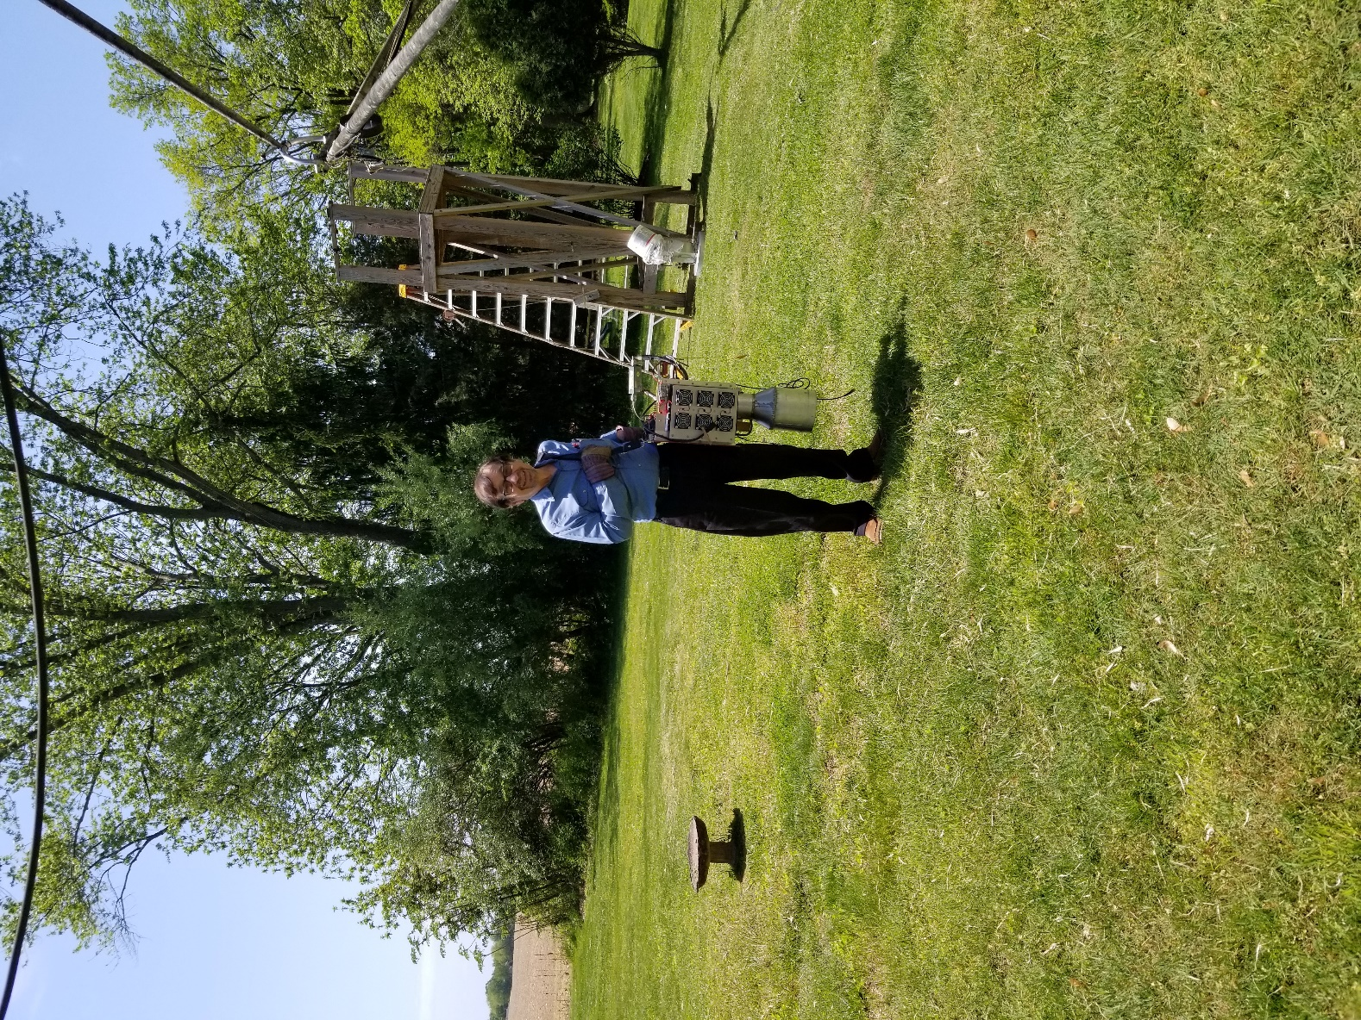

**K2UYH taking his 13 cm SSPA/horn to feed point**

**NET/CHAT/LOGGER NEWS: SA6BUN** was active in the DUBUS 13 cm Contest using his 3 m dish and 500 W. Michael never intended to operate on 2320 with this dish, and had to offset his feed by 8 degs to fit the mounting space. Nevertheless, he was able to provide a good number of initials. **VK4CDI** will be QRT for 6-9 months, as he is relocating to the Sunshine coast. Phil will let us know when and where he will be QRV again once everything has stabilized. **K5QE** was QRV on 432.080 EME during the June ARRL Tropo Contest (which counts EME QSOs) on 13/14 June with 16 x 28 el yagis and 1000 W. [Unfortunately, Marshall’s information arrived too late for the May EME NL]. **KB8JNE** is testing on 10 GHz RX with 1.2 m Channel Master offset dish, a Universal LNB and SDRPlay without much success. He hopes eventually to become QRV on 3 cm. **N4BH** is setting up for 1296 EME from (EM95) with a 10’ dish and 100 W. Pat should be QRV by the time you read this. **PY2BS** is looking for EME skeds on 902. He found the gear used on 33 cm in 2014 to work W5LUA, VE4MA, VE6TA and K2UYH. If anyone is interested in trying on this band, email Bruce at [py2bs(x)me.com](mailto:py2bs@me.com). **VK3BZF** is setting up for 432 EME and is looking for advice, particularly on yagis, from experienced EME operators. He already has an Az-El mount, 150 W SSPA and masthead LNA. Pete can be reached at [peterandrosemarie(x)hotmail.com](mailto:peterandrosemarie@hotmail.com). **W4OP** is working to have his new 15’ dish ready for the VK3UM Memorial 23 cm DUBUS EME Contest on18/19 July. It is on the mount, but there is still a lot to do!

**FOR SALE:** **DK5AI** has for sale a 3.7 m solid dish. It was used for TVRO Uplink and is made of 6 sections. It can be transported with a trailer. If interested contact Wolfgang at [DK5AI(x)darc.de](mailto:DK5AI@darc.de). **WD5AGO** has available in stock 2 m and 70 cm cavity LNAs along with a new 42 dBg, 0.29 dB NF 23 cm LNA. Contact Tommy at [wd5ago(x)hotmail.com](mailto:wd5ago@hotmail.com). **DK7LJ** has 2 modern Nortel DASA 300 W TWTAs that are ready for amateur use at 10368 for sale. If interested see the details at web [http://filmserver.dl0shf.de/MoonEME/ equipment-for-sale/](http://filmserver.dl0shf.de/MoonEME/%20equipment-for-sale/). **OK1DFC** has available 24 GHz feedhorns designed for a 0.8 F/D offset dish. See <http://www.ok1dfc.com/eme/24ghz/pic/20200430_112936.jpg>. In the short future I will also have a 0.6 F/D version, and 47 GHz IMU horns with circular to rectangular transition (WR22) used with these feedhorns. http://www.ok1dfc. com/eme/47ghz/w2imu_feed.htm. Zdenek is looking for a working 47 GHz bandpass filter. If you are interested or have a filter contact him at [ok1dfc(x)seznam.cz](mailto:ok1dfc@seznam.cz). **ON7UN** as reported in the last NL had some of surplus dishes available. Most of these dishes have already been sold, but he had two 2.4 m dishes in 4 panels left for a price around EU500. He also had some 1.8 m Offset dishes complete with AZ/EL mount and feed arms. These would be ideal for 10 or 24 GHz EME. However, these may have been already taken. If interested contact Eddy at [ejespers(x)telenet.be](mailto:ejespers@telenet.be). **PA0PLY** reports COVID-19 seriously has affected the production of our 10 GHz (XLNA) and 24 GHz (KLNA) preamps. Do not expect any to become available until after DU3BC can fly again.

**TECH:** **OK1TEH** has made a major update to info on Sun, Moon and other natural noise source measuring at:

<http://www.ok2kkw.com/next/nl_k2uyh/sun_table.xls>. **K6ML** and VK friends have new **122 GHz** transverters with about 8 dB of NF going and are planning to make the first Sun noise measurement on this band. Matej is very interested in any data from these experiments, and any other above 24 GHz Sun noise measurements to add to the Sun noise table. Please send reportsand note the elevation and weather conditions.

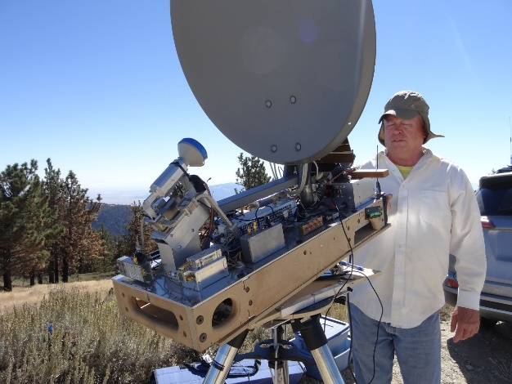

**K6ML with dual 10/24 GHz feed for offset dish**

**TECH:** See **PA2V’s** report that includes info on a 70 cm SAW BP filter. Here is additional info on Peter’s filter.

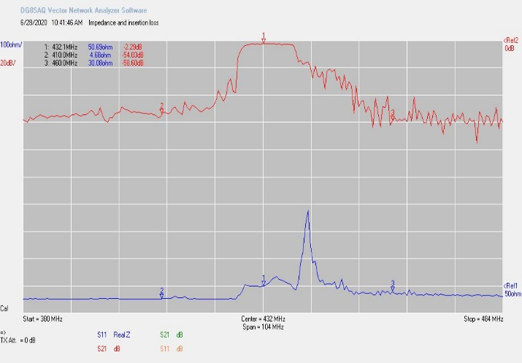

**PA2V’s BPF Frequency response and return loss**



**SAW Filter Specs**

**FINAL:** This NL is a bit later than planned because Matej may have come down with COVID-19. He is still waiting for the results. Hopefully all well be OK and all back to normal in July.

► Because of the pandemic EME2020 is now EME2021: OK1DFC writes – Dear OMs, as promised here is the information on the current status of the EME 2020 Conference in Prague. Due to COVID19 travel has been greatly reduced and many of you may not be able to come. Generally, the COVID-19 situation is good in the Czech Republic. Starting on 15 June, it will be possible to travel freely across the border. Also as of June, up to 300 people are allowed to rally at one place. We have everything ready, including lectures and press proceedings. Nothing prevents us from holding the conference, but as very few of us are expected to be able to attend, the organizing committee decided after considering discussion to postpone the conference until next year. The date will be 19–22 Aug 2021. We have negotiated with the hotel and other companies that help us with the conference. The outcome is: 1. The top hotel will leave your booking in effect and adjust the date. It will leave all prices without change (same as this year). There is also no change in the conference fee.

2. The transport company and the accompanying program companies will change our dates to 2021, but prices are not yet agreed upon. We hope they will not change. In the event of a price change, it will certainly not be a dramatic increase and we would agree on a payment change for already registered participants individually. We have everything carefully registered. 3. Everything else remains as planned in 2020. We will be posting the details on the website [www.eme2020.cz](http://www.eme2020.cz). We hope you understand the reasons for the change, and to see you in 2021. Most of us are already in the 60+ age group, which are the most affected by COVID-19. This fact helped us decide to make the change. We look forward to seeing you in 2021 -- On behalf of the EME Prague 2021 Organizing Committee.

► G3LTF is proposing that microwave activity weekends (MAWs) be schedules for 25/26 July with 3 cm on Saturday and 13 cm on Sunday, 15/16 Aug with 9 cm on Saturday and 6 cm on Sunday. (MAWs are an attempt to get all those with capability on a specific MW band to come on and make QSOs, run tests for those needing signals, test new feeds, preamps etc. No pressure, no scoring, use the reflector, use any mode, just be activate on the band).

► The news on Covid-19 is looking a little more positive, but please be careful and stay well. Keep all the excellent reports and tech info coming. They are very much appreciated. TNX to G3LTF for his getting the message out.

► We try to edit the reports to keep them short and often eliminate the many thanks for the terrific QSOs. We want you to know that you signal off the are greatly appreciated – even if we do not repeat your appreciation. Both of us plan to be active off the Moon on 18/19 July for the VK3UM Memorial CW EME DUBUS Contest. There should be plenty of activity no matter what mode you operate. Thanks for the great signals. We will be looking for you! 73, Al – K2UYH and Matej – OK1TEH.