432 AND ABOVE EME NEWS
MAY 2016 VOL 44 #4

EDITOR: AL KATZ, K2UYH; DEPT. ELECTRICAL/COMPUTER ENGINEERING, THE COLLEGE OF NEW JERSEY, PO BOX 7718 EWING, NJ 08628, TEL (W 609-584-8424) OR (H 609-443-3184), FAX (609-631-0177), E-MAIL alkatz(x)tcnj.edu
NETNEWS EDITOR (based Reflector News) REIN, W6SZ pa0zn(x)arrl.net WITH HELP OF N4PZ AND WB2BYP
INITIAL LIST G4RGK, DAVID DIBLEY, E-MAIL zen70432(x)zen.co.uk, AT: http://www.zen70432.zen.co.uk/Initials/index.html
EME INFORMAL NETS: 14.345, ~1500 SATURDAY AND SUNDAY, NET COORDINATOR: Steve Gross, N4PZ n4pz(x)live.com
ON0EME EME BEACON, 1296.000 IS QRV WHEN MOON >10°, SEND RX REPORTS TO WALTER (ON4BCB) on4bcb(x)gmail.com
DL0SHF 3 CM EME BEACON, 10368.025, SEND INFO & QUESTIONS TO Per (DK7LJ) per(x)per-dudek.de.
NL EMAIL DISTRIBUTION and EMAIL LIST CORD: WARREN, W2WD wbutler(x)ieee.org [TXT OR PDF OR "ON WEB" NOTICE]
THE NL WEB VERSION IS PRODUCED BY REIN, W6SZ AND AVAILABLE AT http://www.nitehawk.com/rasmit/em70cm.html

CONDITIONS: There was plenty of activity this month thanks to the ARI Spring EME Trophy Contest and the 9 cm weekend of the EU/DUBUS EME Contest. Both were on different weekends. A big surprise was the high level of 6 cm EME during the ARI contest. This was sparked by a coordinated effort by JA stations to be on 6 cm during the contest. A similar effort by JAs is planned for this month’s DUBUS 3 cm contest weekend. I also found the ARI’s adding of JT and CW QSOs tended to increase CW activity. There was a good turnout for 9 cm. The top reported score is from OK1KR with a total of 23x22. G3LTF was close with 21x18. Unfortunately the 70 cm CW activity time period (ATP) was lost in all the ARI contest activity. The next ATP will be on 15 May 1330-1530 and 2000-2200. There are no conflicting contests. Let’s all try to make it on this month! The only dxpedition in April was the superbly executed AA1KK dxpedition to RI on 432 – see their report below in this newsletter (NL). However, there are many dxpeditions coming up in May. P40MB is to be QRV on 432 from Aruba on 7/8 May. There has only been two 432 EME QSOs with Aruba in the past. I have little other information and there has been little publicity on their 432 effort. EA6/PA2CHR will be on 432 for the 14 May moonpass. Also on 14 May, KB7Q will be QRV from Wyoming on 70 cm EME. Hermann (DL2NUD) will put D44TVD, Cape Verde Island on 23, 13, 6 and 3 cm between 12 and 22 May. See the reports in this NL for more info on all these dxpeditions. There is also a possibility of operation on 432 by 9A8DXG from the Island of Palagrua at the end of May.

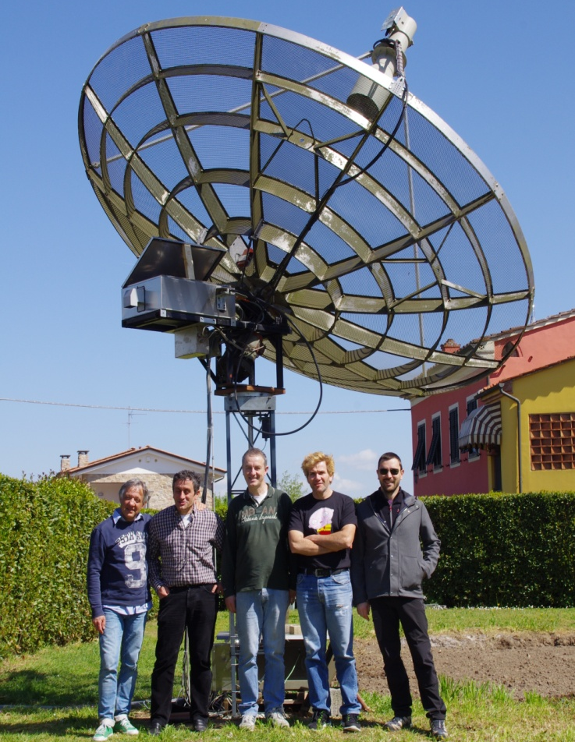
IK5VLS team operated both ARI and 9 cm EME Contests

9A5AA: Dragan dragan9a5aa(x)gmail.com reports on his results in the 9 cm DUBUS EME Contest -- I was only able to be QRV on Sunday. On Saturday the wind was just too strong to allow operation. I had 9 contacts on 17 April at 1552 OH2DG (559/549), 1609 OK1CA (569/559), 1623 OK1KIR (559/549), 1632 G3LTF (559/549), 1722 DF3RU (559/549), 2208 ES5PC (559/559), 2215 G4CCH (559/549), 2255 K2UYH (559/449) and 2327 W5LUA (569/549) for a total score of 9x8.

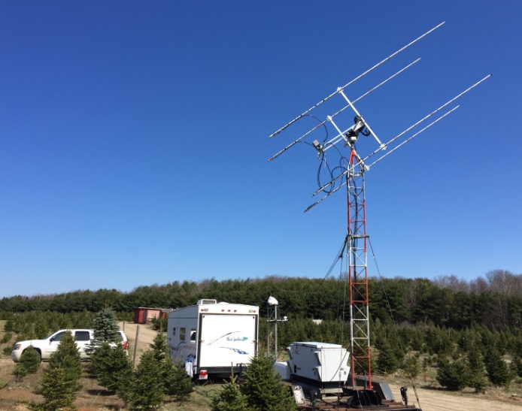
AA1KK RI dxpedition site – doing it right!

AA1KK: Frank (NC1I) frank(x)NC1I.COM tells the story of the recent 432 dxpedition to RI – The dxpedition team consisted of KA1QFE, N1NK, W1QA and me. We were quite pleased with the end results of our dxpedition even though we had our challenges. Conditions seemed good and fortunately polarity was lined up with EU for long periods of time. A total of 56 unique calls made it into the log. We made 12 CW QSO's and WAC was achieved by the second day. Our only disappointment was that we only worked five NA stations. The 4 x FO25 yagis worked extremely well, even though our power was a bit lower than expected. We had only 650-700 W at the feed. The following stations were worked (all JT except where noted): UT6UG, DL5FN, DF3RU (JT & CW), DK3WG (JT & CW), OK1KIR, DL7APV, ES3RF, UX5UL, UA3PTW, G4FUF, OZ4MM, OH6UW, I1NDP, DL8GP, DD0NM, OH2DG, OK1YK, DK4RC, G4EZP, SM3KPX, ZS6JON, DL6SH (JT & CW), S53ZO, OZ4MM (CW), OK1DFC (JT & CW), WA4NJP, LZ1DX (JT & CW), SM7GVF, K5DOG, DK0SF, PA2V, DF2VJ, KL6M (CW), JA6AHB (JT & CW), VK4CDI, YL2GD, UR7D (JT & CW), UT5DL, DL8FBD, OK2AQ, EA5CJ, PI9CAM, HB9Q, OK1TEH, PY2BS, K2UYH, RW4HW, G3LTF (CW), W1PV, FR5DN, G4RGK, DL7FF, UX0FF, F6CPI, UX4IJ, US7GY, DL9KR (CW), & SM2CEW (CW). QSL cards have been printed and we hope to get them in the mail to everyone by the second week of May. All stations noted above will be mailed a QSL card to their QRZ.com address unless they have provided us with a different address. If you would like to send a return card, it can be sent to the NC1I at my QRZ.com address (many have already been received - TNX). W1QA will also be uploading the logs to LOTW soon. One interesting note, this RI dxpedition was almost 29 years after our first RI dxpedition (W1QA & NC1I operating as NC1I/1) in 1987. We do not believe there has been any serious 432 EME operation from Rhode Island between these two operations.

D44TVD: Hermann (DL2NUD) is to be QRV from Cape Verde Island from 12 to 22 May on 23, 13, 6 and 3 cm. This is a microwave only dxpedition. Unfortunately operation on 9 cm is not allowed. 1 m dish will be used on all bands with on 23 cm 200 W at a horizontal dipole, on 13 cm 100 W at circular feed, on 6 cm 55 W at circular feed, and 3 cm 50 W at linear feed (V or H). Operation will be at 100 on each band.

DK3WG: Jurg dk3wg(x)web.de reports on his EME results during the past month – I worked on 432 using JT65B K0TPP, AA1KK in RI on both JT and CW for state 48 - TNX, UR7D, W5RZ using a single 28 el yagi and 50 W, and on 1296 using CW DJ8FR, and using JT65C R4YM, UA9FEM, R1961GP in LO21 and R1566O in KO82. [Jurg also notes that he has stopped providing QSL services for UN6PD as on June 2015].

DK7LJ: Per per(x)per-dudek.de reports that he is still having problems with the 3 cm EME beacon since the lightning strike -- The hardware tracking system and related software have been re-done, but there are still some bugs in the software. I hope to get system debugged before the 3 cm contest, but I am not the writer of the software, so the result is not certain. When it is ready, I will announce it on the reflectors.

EA6/PA2CHR: Chris (PA2CHR) post(x)pa2chr.nl announces that Menorca Island will be QRV again on EME between 6 and 17 May – I will be primarily operating on 144, but plan to run one complete moonpass on 432, on Saturday, 14 May. I will have a 21 el yagi and Italab PA on 70 cm. See http://www.pa2chr.nl/News.html for the latest news.

F5SE: Franck kozton(x)free.fr reports that his portable dish location was hit by thieves -- They stole considerable equipment, but EME-wise the loss of my 2 x 500 W 1296 DB6NT SSPAs is my biggest problem. Fortunately they did not take my test equipment, power supplies and computing equipment. I am presently planning to put steel bars on the windows of the building.

F6ETI: Philippe f6eti(x)wanadoo.fr sends news of his recent EME activity – During the CJ2016 French VHF/UHF/MW meeting on the weekend of the ARI EME Contest, 8 April, I moved my 1296 MHz EME station to the conference (JN07qg) to share the EME experience with the VHF operators there. I QSO’d using CW only IZ1BPN, PI9CAM, DL3EBJ, I1NDP, G3LTF, OE5JFL, G4CCH and OK2DL for a total of 8 contacts. I also heard SP6ITF, SP7DCS, DJ8FR and ES6FX. Thanks to all who worked us for their patience with my frequency drift and for identifying the "portable" call F6ETI/p! I was using a 3 m dish with a 100 W SSPA (2xMRF286) and G4DDK LNA. I am presently not QRV from my home QTH, but hope to do some more portable operation during the summer and fall. Back in March from my home, I found very nice activity with continuously from 15 to 20 stations in the first 40 kHz of the band during the REF-DUBUS contest on 1296. I QSO’d 27 stations on CW and one on SSB with 23 multipliers. In order contacted were HB9Q, OK2DL, OK1KIR, HB9CW, OK1CA, UA3PTW for an initial (*), OE5JFL (*), G4CCH, G3LTF, DL3EBJ, UA4HTS, I1NDP, RA3EC, OH2DG (*), ES5PC (*), OK1CS (*), OK1DFC, PI9CAM on SSB, PI9CAM, OZ4MM, F5SE/p, YL2GD, SP6JLW, DF3RU, DJ8FR, K2UYH, NC1I and VE6TA. After the contest, I worked on 14 March UA3PTW, on 15 March G3LTF and DF3RU, on 16 March OK1DFC, 17 March G4YTL (O/O) - after several tries between us low-power stations, and on 21 March OZ6OL.

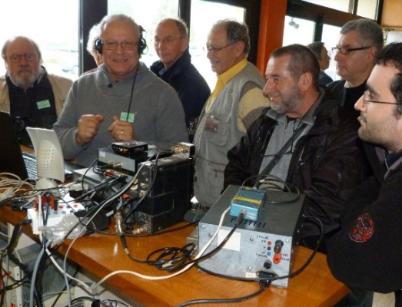
F6ETI demonstrating 23 cm EME at French VHF/UHF/MW meeting

G3LTF: Peter g3ltf(x)btinternet.com report for April follows -- I was active on 4 bands in the ARI contest. I started on 9 April on13 cm with a requested SSB demonstration QSO with HB9Q followed by OK1CA on CW. I then moved to 23 cm and worked on CW JA6AHB, DJ8FR, SP6ITF, PI9CAM, I5YDI and DL3EBJ, on SSB (called CQ on SSB on 1296.050) I1NDP, SP5GDM for initial #422 and IK5VLS, then back on CW SP7DCS, RA3EC, HB9BCD, F6ETI/P #423, RV3DE #424, SP2HMR, SP3XBO, RA3DGP, OE5JFL, PA3CQE, and ES5PC. I heard RA3DRC. I then changed feeds to 70 cm and worked K2UYH and AA1K for initial #463 - a nice signal on CW. On 10 April I was active on 6 cm although the weather was not very kind with gusting winds and worked DF3RU, OK1KIR, SM6FHZ, JA6CZD, JA1WQF, JA8ERE, HB9Q, IK3COJ, IK2RTI, DL7YC, OH2DG, OZ1LPR, ES5PC and VE4MA. CWNR were SP7JSG (559) and UR7DWW, and heard were JA4BLC, JA8IAD and JH3HUC. I measured 1.6 dB moonnoise at 360,000 km range. On 11 April, still on 6 cm, I worked JA8IAD for initial #58 and JA4BLC with a big signal from his new PA. This has been a great month for microwave EME because next, on 16/17 April was the 9 cm DUBUS EME Contest, and the weather here was excellent. I worked on 16 April HB9Q, VK3NX, DF3RU, OK1CA, SP6OPN, OK1DFC, OZ6OL, S59DCD, S57NML, ES5PC, S53MM, OK1KIR, PA3DZL, SM6PGP, G4CCH, OH1LRY for initial #55, PA0BAT, VE4MA, OH2DG, 9A5AA and K2UYH for a total 21x18. With the calmer weather, I was able to make a good set of measurements on both 6 and 9 cm as follows. On 6 cm on 19 April the sunnoise was 15.7 dB at an SF of 109; moonnoise was 1.3 dB (401,000 km); and G/CS was 4.4 dB but the “ground” is bare leaf trees with lots of sky visible. When I remove the isolation relay, the sunnoise rises by 0.4 dB. The values are lower than one would expect for a 6 m dish because of profile errors. It’s equivalent to about 4 m at this frequency. On 9 cm on 18 April sunnoise was 18.4 dB with SF109; moonnoise was 1.3 dB (400,000 km); and G/CS was 5.4 dB with the same conditions noted for 6 cm. I need to work on my 6 cm NF by building a new preamp.

G4RGK: Dave’s zen70432(x)zen.co.uk April NL report -- I was only on 432 this month; no 1296 activity from here. I found no activity in the 432 CW ATP at the time that I was on and echoes were very weak. I went up on to the JT section and worked DL6SH, YL2GD, JS3CTQ, OK2AQ, UR7D, JE1TNL, EA5CJ, FR5DN (nice to work Phil again after being so long QRT), AA1K (RI), and PY2BS over the next few hours.

HB9Q: Dan (HB9CRQ) dan(x)hb9q.ch reports on operation in April – We were only QRV a total of 6 hours during the 9 cm DUBUS Contest and worked 18 different stations including an initial with OK1DFC (549/579) for a total mixed #52*. We plan to be QRV for a couple hours on 7/8 May during the 3 cm DUBUS Contest, but we will not participate in the contest. We will not be on for all of the moon-window. If you would like to work us drop us an e-mail with the date and time you will be QRV. We will be happy to look for you. During our activity we will post our CQ frequency on the 10 GHz logger.

IK3COJ: Aldo ik3coj(x)gmail.com found extremely interesting activity 9/10 April during the ARI EME Trophy on 5760 -- Many stations were on the air with strong and stable signals. I was very happy because I do not have great power (only 20 W with TWT). I contacted 15 stations and had 16 QSOs. I added 7 initials with DF3RU, OK1CA, HB9Q, UR7D, VE4MA, JA1WQF and OZ1LPR. I heard JA6CZD, JF3HUC, JA8ERE, JA8IAD, IK2RTI and K2UYH. I QSO’d on the Tuesday after the contest IK2RTI. I hope to make improvements for DUBUS contest in July.

IK5VLS: Gabriele ik5vls1961(x)gmail.com writes that his team operated in the ARI and in DUBUS contests in April with great satisfaction -- During both weekends, conditions were very good and the fun was not to be missed, which included some good signals on SSB! On the occasion of ARI contest, we organized a barbecue and neglected the EME race a bit, but not the spirit. [I think they mean the vine and beer – hi]. Our team included in addition to me, IK5AMB, IZ5OVP and IZ5DIY. I hope to meet many friends as possible at the EME 2016 in Venice next Aug.

JA4BLC: Yoshiro ja4blc(x)web-sanin.co.jp reports on JA 6 cm operation during the ARI spring contest – The JA 6 cm gang was QRV on 6 cm simultaneously in the ARI contest for one hour on each NA and EU window. To avoid QRM between the 6 active JA stations, we agreed to TX with 5 kHz frequency separation: JA8ERE on 5760.050,
JA1WQF on .055, JF3HUC on .060, JA4BLC on .065, JA6CZD on .70 and JA8IAD on .075. Our operation was quite successful and we thank all for co-operating with us without any confusion. I have never before experienced so high activity on 6 cm in Japan. JA4BLC worked on 9 April OK1KIR, OH2DG, OK1CA, DF3RU for initial #38, JA6CZD, DL7YC, UR7D partial (no R) and SM6FHZ, and on 10 April JA8ERE, JF3HUC, JA1WQF, ES5PC, JA8IAD, PA0BAT, IK2RTI and UR7D #39. JA1WQF worked on 9 April OK1KIR (559/559), OK1CA (569/559), DF3RU (569/559), DL7YC (569/529), OH2DG (569/569), SM6FHZ (569/559) and OK1KIR (8DB/14DB) on JT, and on 10 April JA8IAD (559/559), K2UYH (559/559), JF3HUC (559/559), JA8ERE (579/559), JA4BLC (559/559), ES5PC (559/559), JA6CZD (569/569), JA8IAD (559/559) DUP, OZ1LPR (9DB/9DB) JT4F, IK2COJ (559/559), PA0BAT (569/559), IK2RTI (589/569), G3LTF (569/569), UR7D (559/559), DL7YC (589/549) DUP and DF3RU (52/52) on SSB. JF3HUC worked on 10 April K2UYH (549/559) for initial #6, JA4BLC (559/559), JA1WQF (559/559), OK1KIR (559/559) #7, JA8ERE (569/559), OH2DG (559/559) #8, HB9Q (559/579) #9, SM6FHZ (559/569) #10, DF3RU (559/559) #11, IK2RTI (559/569) #12, DL7YC (559/559) #13 and OZ1LPR 559/549 #14. JA8ERE suffered from high wind on Saturday and could not be QRV. On Sunday he managed to be on and worked K2UYH, JA4BLC, OK1KIR, JA1WQF, JA8IAD, JF3HUC, DF3RU, SM6FHZ, OH2DG, DL7YC, OZ1LPR, PA0BAT, JA6CZD, UR7D, IK2RTI, G3LTF and HB9Q. JA8IAD managed to be QRV on 9 April in very windy condition and worked
OK1KIR, SM6FHZ, DL7YC, OK1CA and OH2DG, and on 10 April K2UYH, JA1WQF, JA6CZD, JA4BLC and JA8ERE. JA6CZD worked on 9 April OK1KIR, OK1CA, OH2DG, DL7YC, JA4BLC, OZ1LPR, SM6FHZ, UR7D and DF3RU, and on 10 April JA1WQF, JA8IAD, PA0BAT, JA8ERE, G3LTF and IK2RTI. JA8ERE used a 4 m solid dish with lin pol and a 50 W SSPA. JA1WQF used a 2.4 m Cassegrain feed dish with cir pol and a 100 W TWTA. JF3HUC ran a 6 m mesh dish with lin pol and a 50 W SSPA. JA4BLC ran a 3 m Cassegrain dish cir pol with a 70 W TWTA. JA6CZD used a 2.4 m offset dish with a 50 W SSPA.

KB7Q: Gene geneshea(x)gmail.com writes that he will make a quick trip to Wyoming on 14 May to put it on 70 cm EME -- I’ve found a spot in WY (DN44) just an hour from my house to try a quick and dirty 70 cm EME outing in Yellowstone Park from a trailhead parking lot. I will not have Internet access. I will use a 9 wl yagi and a 500 W SSPA. Operation will be 2100 onward for several hours on 432.090 using JT65B and will TX first. If you’re interested be sure to let me know.

KD3UY: Bob Robert.F.Baker(x)jhuapl.edu writes that he is doing quite well here -- I have built a new 9’ dish to replace my old 6’ dish, and am now up to initial #60 on 1296. I have now worked somebody smaller than me!

KN0WS: Carl carlhasbargen(x)q.com writes that it is warming and he should be back on the Moon again soon -- This week I made my first excursion of the year to my northern Minnesota property. My 20’ dish for 70 cm it still up, but it may be a few more weeks until I get the mesh back on it for the summer. There was a bit of snow on the ground from the day before. I spent time starting the erection of my new polar mount for use with a 16’ dish for 23 cm. I am glad that others are enjoying the March and April EME contests, but for me here in MN I really do not expect to ever participate in those early events of the year. And with no more 70 cm digital DUBUS events, my contesting just may have to wait for the ARRL weekends. I did not need to know CW for my license and am not confident I will ever learn it well. But there are many folks in the EME world that use it exclusively. I can use my JT65 software to send a CW message and if the other operator were to repeat EACH CHARACTER 5 times in a row, as I have seen posted on an old EME web site, I might just have enough time to figure out what the character is, if I hear it several times in a row. For someone to send the complete message at regular speed 5 consecutive times would be too fast for me to figure out. Anyway, if anyone wants to try to communicate with me this way, I am willing to give it a try. I wonder if there are CW-only folks out there who would be interested in working with a CW invalid like me to make a new contact? This procedure would not do for contest operation, but might work for a sked, if someone is patient.

M0ABA/MX0CNS: Tom m0aba1970(x)gmail.com continues to experiment with just how small an antenna he can make EME QSOs on 70 cm – I did more testing with an even smaller DG7YBN yagi. This time just 3 elements and the results were 2 contacts. One was with PI9CAM and one DL7APV. My power 60 W at the feed or about 340 W EIRP!

N4PZ: Steve n4pz(x)live.com has improved his feed antenna on 13 cm -- I put my VE4MA 13 cm feed with a choke ring at the bore site of my 4.9 m, f/d 0.3 dish and removed the 23 cm feed. My dish is a conversion of an original 12’ dish to 16’. I suspect the design is responsible for the fact that I cannot quite see the sunnoise that I think I should see. It's always about 1 dB low on both 23 and 13 cm. I am now seeing about 14.5 dB of sunnoise, which seems low but is 4 dB better than it was when I had it nested in the 23 cm choke ring. It worked, but not very well. I worked about 12 stations, but never heard an echo with 130 W or so at my feed. I can receive on 2304 and 2320 with more bands coming soon.

NC1I: Frank’s frank(x)NC1I.COM April report -- Due to our RI dxpedition, I was not active from home in April. May will be another busy month, but I do plan on being active on 23 cm as time permits. If the weather cooperates on Saturday, 7 May I will have a crew here to make one last effort to repair the big 432 array, but I am not very optimistic that the proper repairs can be made without getting the antenna and mount down on the ground. Assuming the array will be coming down, the approach will be a total rebuild of the mount and replacement of the coaxial phasing lines on the array. I am hopeful that the open wire phasing lines on the twelve bays of four antennas will not need to be replaced. A crane will be required to take everything down (and to get it back up) and I expect repairs will take a minimum of three months. We will try to get everything down on the ground by the end of May. During the time the array and mount are being rebuilt, we will also be making some station improvements on 432. It is our hope that when the array goes back up the entire 432 station will be working better than ever. It was nice to see many EME folks at the VHF Super Conference in Washington DC last month!

OK1CA: Franta strihavka(x)upcmail.cz sends his report for the NL -- I was QRV during the last weekend in ARI EME Trophy on 23, 13 and 6 cm. On Saturday, I worked on 6 cm 12 QSOs on CW and 2 QSOs on JT4F. Initials were made with JA8IAD, OZ1LPR, DF3RU, UR7D and IK3COJ to bring me to initial #62. I was QRV primarily on 23 cm on Sunday. I worked 25 CW QSOs. Initials were SP9AFS, EA8FF, F6KRK and XE1XA to bring me to #324. I worked 13 QSOs on JT65. I made only 2 QSOs on 13 cm during the both day. In total I had 54 QSOs on the three bands. I was QRV also in EU EME Contest on 9 cm during 16/17 April. I worked 12 QSOs at Saturday without the NA window. I continued at Sunday and finished with 20 QSOs, but no new initials. I worked VK4CDI on JT4F at Sunday. Phil had only 15 W. I think, the date of Contest was not optimal. The signals were poor with greater spreading than on 6 cm during the ARI contest the week before.

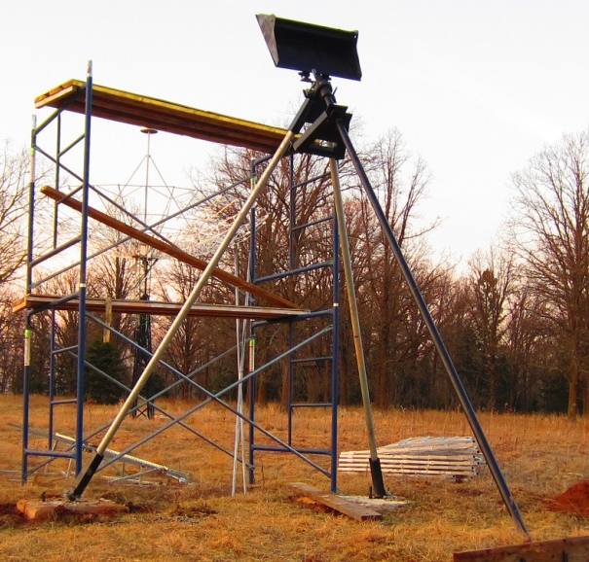
KN0WS’ polar mount construction

OK1DFC: Zdenek ok1dfc(x)seznam.cz was QRV in the 9 cm part of the DUBUS Contest – I was QRV mainly on Saturday but also a bit on Sunday partly. I worked on15 April at1954 ES5PC (559/559) for initial #15 and DXCC 12, on 16 April at 0011 ES5PC (559/559), 0028 W5LUA (559/549), 0035 OK1CA (559/559), 1305 OH2DG (559/559), 1327 HB9Q (579/549) #16 and DXCC 13, 1335 SP6OPN (539/559) #17, 1347 DF3RU (559/559), 1442 VK3NX (559/539), 1532 G3LTF (559/559), 1610 S59DCD (559/559) #18 and DXCC 14, 1821 OK1KIR (579/569), 1829 S53MM (559/549) #19, 1859 SM6PGP (539/559) #20 and DXCC 15, 1904 PA0BAT (569/559) #21, 2023 G4CCH (559/569) #22, 2107 OH1LRY (539/539) #23, 2128 OZ6OL (539/559) #24 and DXCC 16 and 2150 PA3DZL (559/559), and on 17 April at 1402 VK4CDI (25DB/O) JT4F for digital initial {#6}, 1530 OK1KIR (15DB/O) JT4F {#7} and 1903 LX1DB (559/559). I heard and missed VE4MA and VE6TA. My final contest score was 19x18. The strongest station was HB9Q follow by OK1KIR. Nice signals were also produced OH2DG, G3LTF, ES5PC, and OK1CA. All QSOs were on CW unless noted otherwise. My gears for azimuth now has more than 0.5° backslash and thus it was not easy to keep the dish pointed to the Moon in the windy weather here on Sunday. So the rest of my free time during Sunday was spent on finishing my 6 cm TRV. I expect to be QRV on this band soon. I am looking forward to the 3 cm leg in May, and hope to by QRV with my tinny setup there. I have no idea how many CW stations I will be able work, but I can test also with JT4F if any anybody is interested. My setup is 180 cm prime focus dish, 30 W SSPA on the wave guide switch and 0.7 dB NF LNA. I have already worked OK1KIR easily on JT4F (13DB) and on CW and UA4HTS (13DB) on JT4F.

OK1KIR: Vlada" vlada.masek(x)volny.cz writes for his group’s EME in April – We worked on 70 cm on 8 April using JT65B at 1322 AA1KK (9DB/O) for digital initial {#164} and 1451 SM3KPX (18DB/20DB) {#165}, and on 6 cm during ARI EME Trophy Contest using CW on 9 April at 0657 JA8IAD (O/539) for initial #84, 0716 JA4BLC (559/569), 0750 DF3RU (559/559) #85, 0800 JA6CZD (569/569), 0808 JA1WQF (559/559), 0845 OK1CA (569/579), 0855 UR7D (549/559), 0910 DL7YC (569/559), 0921 OH2DG (569/579), 1028 IK3COJ (549/449), 1045 SM6FHZ (569/569), 0253 HB9Q (589/569), OZ1LPR (559/559), SM6PGP (549/559), 1446 PA0BAT (569/569), 1607 VE4MA (549/549) and 1820 K2UYH (559/559), on 10 April at 0709 JA8ERE (569/569), 0731 JF3HUC (559/559) #86, 0813 ES5PC (559/559), 0906 IK2RTI (569/579), 0947 G3LTF (569/579), 1207 PA7JB (559/569), 1358 SM6FHZ (44/44) on SSB, 1824 VE6TA (O/O) and 1836 PA3DZL (569/569), and using JT4F at 0737 DF3RU (16DB/15DB) for digital initial {#18}, 0928 JA1WQF (14DB/8DB), 0946 OK1CA (14DB/14DB), 1120 UR7D (12DB/12DB) {#19}, 1629 VE4MA (15DB/14DB) {#20} and 1231 IK3COJ (13DB/18DB) {#21}. Total in ARI Contest was 25 CW and 6 JT QSOs. We appreciate great participation of 6 JA stations. There was heavy rain during the 9 cm EU/DUBUS EME Contest. We worked using CW on 16 April at 1739 S53MM (559/559), 1750 G3LTF (569/579), 1755 ES5PC (569/569), 1805 S59DCD (559/579), 1810 DF3RU (569/559), 1816 OK1DFC (569/579), 1826 S57NML (O/559), 1842 PA0BAT (569/569), 1859 SM6PGP (559/569), 2017 HB9Q (599/579), 2042 OH1LRY (559/559) # 63, 2053 OZ6OL (559/559), 2131 G4CCH (569/589), 2138 PA3DZL (569/569), 2221 VE4MA (549/569) and 2343 VE6TA (559/559), and on 17 April at 1402 VK3NX (569/569), 1409 OH2DG (569/579), 1426 OK1CA (579/579), 1623 9A5AA (549/559), 1743 LX1DB (589/579), 2225 K2UYH (559/559) and 2251 W5LUA (569/569) for a total in the contest of 23x22. Out of the contest, we worked using JT4F on 17 April at 1525 OK1DFC (12DB/15DB) for digital initial {#21} and 1533 VK4CDI (16DB/14DB). On 3 cm, we ran a long, hard test (4 hours total) with UN6PD on 16 April using JT4F and finally succeeded at 1610 (15DB/12DB) for digital initial {#73} and the first UN-OK 3 cm QSO. Nikolai had trouble with his 25 W SSPA, which moved up and down in power to his 3 m dish. Nikolai has 1.8 dB of moon noise, and is working to fix his SSPA.

OK1TEH: Matj petrzmat(x)fd.cvut.cz sends news on 70 cm -- In Dec I was happy to worked R6CS (25DB/22DB) on JT65B for mixed initial #104* - his Moon was only 0.5 degs above the horizon. In 2016, I haven't been very lucky. With only a single 23 el yagi, it is rather difficult and I suffer from a lack of free time due to work. I tried with SM7BJR, N0IRS and SM5DIC (partial copy) without success. But in March my luck turned. I worked DL6SH (22DB/23DB) #105* with his 8 m dish and 600 W at the feed. We tried CW too, but I had some problems with local interference from a HV line and we didn't complete. In April, I was very happy to work AA1KK (25DB/27DB) from RI for #106* and my WAS 19. They started answering me almost immediately after my first call - many TNX. I am interested in skeds with new stations on both JT65 and CW. I am QRV on 432 with 23 el DK7ZB 5.7 m long yagi, LNA near it's dipole and about 600 W (x) antenna. See http://www.ok2kkw.com/eme/aa1kk_70cm_090416_ antenna_1.png for more info. I am looking forward to meeting all of you in Italy.

OZ4MM: Stig’s vestergaard(x)os.dk April EME news follows -- I made a mistake regarding weekends and completely missed the 432 ATP. I did work on 8 April the AA1KK dxpedition on both CW and JT65B – they had a great signal. Polarization was 90 degs, so yagi stations in EU also had a good opportunity to work RI. On 9 April, I was also on for a few hours, on 1296 and found great activity. It wasn’t until later that I discovered it was the ARI contest. I worked 13 stations in my short time QRV, including initials with EA8FF and F6KRK. I apologize for my bad CW skills during the last few months, but I have had some keying problems, which should be solved soon. I was not QRV on 16-17 April because travel.

PA3DZL: Jac pa3dzl(x)ziggo.nl sends info on his recent EME activity -- For the ARI EME Contest, I could only be QRV for a few hours during my moonset on 6 cm on 10 April. I made 9 QSOs and 3 initials with DF3RU (579/579) for an initial (#), VE4MA (559/569), OK1KIR (569/569), HB9Q (579/579) (#), OZ1LPR (559/569) (#), IK3COJ (559/559), VE6TA (559/559), PAØBAT (569/569) and OH2DG (569/569). My rig is a 3.7 m solid Andrew dish, f/d 0.4 with 100 W (x) the feed and 0.5 dB preamp. There were very nice signals and good activity; I worked all the stations I heard. I was also QRV for the 9 cm DUBUS EME Contest and worked 16 stations. I QSO’d on 16 April HB9Q (579/579), G3LTF (579/569), S53MM (549/559), ES5PC (569/569), OK1KIR (569/569), OK1DFC (559/559), G4CCH (579/579), PAØBAT (569/569), S59DCD (559/559), OH1LRY (549/559) for initial #44, SM6PGP (559/559) and DF3RU (559/569), and on 17 April VK3NX (559/559), OK1CA (569/579), OH2DG (579/579) and LX1DB (579/579). No other stations were heard. Signals were very nice with the strongest from HB9Q. I measured at 1500 a sunnoise of 15 dB and at 1600 a moonnoise of 0.5 dB. My 9 cm rig is the same 3.7 m dish with RA3AQ feed and 150 W (x) feed and 0.6 dB NF LNA. I will be QRV in May for the 3 cm contest with JA RX capability, and on 70 cm EME during the summer.

UA3PTW: Dmitry ua3ptw(x)inbox.ru active in April and QSO’d on 432 using
JT65B the AA1KK dxpedition, K0TPP, UR7D, UR3EE and DL8FBD, and on 1296 using CW N2MO (Diana EME dish), and with JT65C N4CNN and UA6AH. [TNX to DK3WG for forwarding this report].

VE3KRP: Fast Eddie eddie(x)tbaytel.net reports the snow is mostly gone – It is nice to see green grass starting to show up. I hated shoveling a path to the dish... Hi, Hi. Spring fever has limited activity, but I managed to work on 23 cm on 9 April ES6FX, IK5VLS, OE9GLV, K5DOG and VE4SA – all on JT56C. I am planning to be at the 50th anniversary of the Central States VHF conference in Rochester Minnesota in July. Hopefully some of the EME crowd will be in attendance.

VE6BGT: Skip macaulay.skip(x)gmail.com sends an update on his new dish project – The new dish I am working on is 21.5’ in dia. I started working on this project years ago; first building the stand that will winch the dish up into its position. When I was laid off almost a year ago, I figured it would be a good time to weld up the ribs. It’s been a beast of a project, I’m not sure if I will get it up and running before the winter or not, as there is lots to do yet.

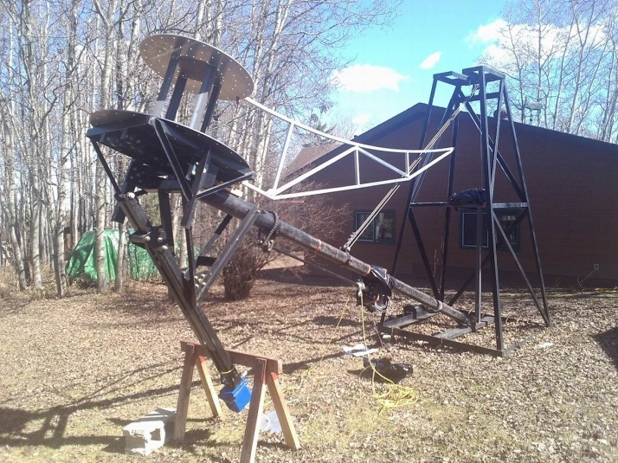
VE6BGT’s new 21’ dish under construction
VE6TA: Grant ve6ta(x)xplornet.com brings us up to date on his 1296 DUBUS Contest activity last month -- I was on for the 23 cm contest. Signals were very strong and there appeared to be higher than normal activity. I worked VK5MC, JA8IAD, JA6AHB, JH1KRC, JA4BLC, VE6BGT, JH5LUZ, HB9Q, UA4HTS, G3LTF, ES5PC, OK1KIR, DL1YMK, UA3PTW, DL3EBJ, OZ4MM, SP7DCS, OK2DL, S53MM, OE5JFL, I1NDP, LX1DB, S59DCD, WA9FWD, G4CCH, OK1CA, 9A5AA, NC1I, N4PZ, SP6ITF, K2UYH, WA6PY, WB2BYP, W4AF, IK3COJ, W6YX, VA7MM, OK1DFC, SP6JLW, OK1CS, ES6FX for an initial (#), HB9BCD (#), G4RGK, OZ6OL, DF3RU, PA3DZL, SM7FWZ, F6ETI (#), IK5VLS (#), RA3EC, F5SE/p, YL2GD, IW2FZR, VE4MA/K7, PY2BS, VE4SA, KL6M and W4AF. There were some incredible signals during the contest, which really sounded like 20 m on moonrise. HB9Q was at times 20/S9 – amazing! Last year, I had improved the mesh surface on my homebrew dish and wanted to try it out on 6 cm. During the ARI contest weekend on 10 April, I quickly placed the feed tray in the dish, and gave it a try to see if I could hear anything. I was unable to optimize on sunnoise, as I made it back to the home QTH quite late from a business trip. I was happy to hear stations quite well and good echoes when the moon came over the trees. Stations worked were OK1KIR, DF3RU for initial #23, DL7YC, VE4MA, HB9Q #24, PA3DZL, OZ1LPR #25 and PA0BAT. All in all, it was a very nice moonpass. I switched feeds back to 3.4 GHz for the following weekend’s DUBUS leg. Activity was very low as was the declination as most of the activity in EU had gone to bed prior to my moon window. In fact I worked only 4 EUs the entire weekend. Stations in the log are W5LUA, OK1CA, ES5PC, VE4MA, VK3NX, OK1KIR, DF3RU for initial #40 and K2UYH. I may push my luck and see if the dish will work on 10 GHz this coming weekend.

WA9FWD: John jstefl(x)wi.rr.comsubmits his April report on his DUBUS EME Contest efforts -- I switched feeds to 9 cm and was ready for the start of the contest. I immediately heard ES5PC calling CQ. I replied many times, but only received QRZs in reply. I finally checked the power out of my PA. I was very disturbed to only find less than 1 W. I traced the problem back to my transverter putting out only a few microwatts. At this point I gave up and went QRT. Hopefully I will do better in July. I have been working toward having 6 cm ready for the July portion of the contest. I have built a 50 W GaN SSPA as designed by SM6PGP, and have a DEMI transverter and WD5AGO septum feed with Kuhne preamp. This will be used with my 3.7 m dish.

WD5AGO: Tommy wd5ago(x)hotmail.com discusses his EME activity during the past few months -- I had a good time at the VHF Super conference in DC with many EME friends in attendance. Back in Feb during the DUBUS' 13 cm leg, we could only be on after Saturday evening and part of Sunday. We worked W5LUA, VE6TA, JA8IAD, PA3DZL, ES5PC, OK1CA, OH2DG, G4CCH, UA4HTS for initial #93, UA3PTW, LX1DB, F1PYR #94, WA9FWD, K5GW, WA8RJF, HB9Q, VE6BGT #95 and W6YX for a total of 18 x 15. Several others were heard, but missed especially cross-band. I am still looking for Africa on 13 cm to complete WAC on this band. Currently I have over 500 CW QSOs and 95 initials on 13 cm with either a 2.7 m or my current 3.2 m dish. All other contest legs and bands have conflicted with work. I hope to have my 6 cm equipment back up and running for the summer.

XE1XA: Max general.manager(x)corix.us reports on stations worked on 1296 in April – I was QRV during the ARI EME Trophy on random CW and worked on 9 April I1NDP, G4CCH, DL3EBJ, SP7DCS for an initial (#), ES5PC, DJ8FR (#), RA3EC, OE5JFL, IK5VLS (#) and PI9CAM (#), and on 10 April OK1CA (#), I1NDP on SSB, I5MPK (#), G4YTL (#) and K2UYH. My total was 15 QSOs. I also worked on 16 April as part of the Yuri Gagarin, first man in space anniversary celebration at 2153 R1566O (same as RA3EC). I note that when the Moon is high over NA, I see very little activity. Most of the time, I'm alone testing and hear only my own echoes!

ZS6EME: Alex zs6eme(x)linkrf.ch writes that for those needing Africa on 13 cm to finish WAC that he will be there very soon -- I'm glad to announce my future EME operation from Pretoria, South Africa in KG44cf. Since Sept 2015 I have been located in SA and will be there for the next 4 years. My station is almost finished. I will start operations at the end of May or at the latest the second week of June (If Murphy is not kindly to me). I have a 3.6 m solid dish with stepped dual mode septum horn feed based on RA3AQ, 300 W at the feed, G4DDK preamp, and modified DEMI transverter for operation on 2304 and 2320 plus IQ+ single channel modified with GPS locked oscillator and full Doppler compensation for digital modes. The tower with AZ/EL DRICAS-G2 (OE5JFL) antenna controller are already in place and the dish is ready to be assembled and mounted on the tower. My Moon path is very clear never the less the minimum elevation to the West will be 20 degs for the moment; I need to do something with some trees. My main activity will be in JT, but I will do some CW - considering my weak skills in CW be patient with me. I will take skeds and random QSO's and I will be present on the HB9Q logger. My homepage http://www.linkrf.ch/zs6eme.html is not yet updated but soon I will upload photos and latest info. Future operation is planned on 70, 9 and 3 cm. The 9 cm band is not yet allocated in SA for Ham radio, but we are working hard to receive a special permit.

K2UYH: I alkatz(x)tcnj.edu was kept busy with contest activity in April. I had only limited time during the ARI contest weekend and S9+ noise on 432 was frustrating. Despite the noise, I was able to QSO on 9 April on 432 at 1639 AA1KK (20DB/O) JT65B for mixed initial #911*, 1650 DL6SH (13DB/3DB) JT65B, 1654 YL2DG (20DB/O) JT65B, 1658 UR7D (23DB/O) JT65B #912*, 1746 G3LTF (O/O) CW and 1750 DK3WG (O/559) – the noise made what should have been easy CW QSOs difficult. I thus decided to switch to 5760 to work using CW on 9 April at 1813 DF3RU (559/559) for initial #43, 1819 OK1KIR (559/569), 1826 VE4MA (559/549) and 1848 OH2DG (O/O), and on 10 April 10 0043 JA8IAD (559/559) #44, 0052 JH3HUC (559/549) #45, 0110 JA8ERE (569/569) #46, 0134 JA1QWF (O/O), 1802 DF3RU (559/559) DUP, 1811 DL7YC (569/529), 1835 HB9Q (579/549) for a total of 10 QSOs. I then switched to 1296 to add1929 OK1CA (589/579) CW, 1932 LZ2US (569/579) CW, 1937 KL6M (569/569) CW, 1940 DL3EBJ (569/569) CW, 1945 XE1XA (569/569) CW, 1954 IK2MMB (569/579) CW, 1958 I1NDP (589/589) CW, 2002 IK5VLS (559/559) CW, 2017 IK5VLS (12DB/O) JT65C, 2022 VE4MO (20DB/17DB) JT65C for mixed initial #533*, 2034 VA7MM (8DB/7DB) JT65C, 2039 VE4SA (11DB/11DB) JT65C, 2052 W3HMS (10DB/8DB) JT65C, 2106 partial SP8WJW (22DB/-) JT65C – lost, 2127 G3YTL (11DB/O) JT65C #534*, 2133 DF2VJ (22DB/O) JT65C #535* - on the horizon and 2147 KD3UY (15DB/13DB) JT65C. I end with scores on 1296 of 1472, 432 of 52 and 5760 of 200. The next weekend I was at the Super VHF Conference were I met many EMEers, but left early to get a little Moon time in during the 9 cm DUBUS Contest. I worked on 17 April at 0618 VK4CDI (559/569), 0618 VE6TA (559/559), 0641 VK3NX (559/559), 2219 G3LTF (559/569), 2225 OK1KIR (559/559), 2229 OH2DG (569/569), 2235 G4CCH (569/569), 2241 DF3RU (559/569) for initial #41, 2245 ES5PC (569/569), 2250 9A5AA (559/559) and 2305 W5LUA (579/569) for a total of 11x11.

NETNEWS: RX3A worked on 432 using JT65B DL7APV in April. G4YTL has only been QRV on 23 for a couple of months and enjoying the experience. He plans to be in Venice in Aug. KL7UW has sent out a large number of EME QSLs and asks if anyone still needs his card to contact him. SP6JLW plans to be QRV in the 3 cm DUBUS EM Contest with 500 W. VE4MA will also be QRV on 3 cm for the contest. G4NNS plan to be QRV for some (but not all) of is Moon window for the 3 cm contest. He is getting good echoes with his 3.7 m dish and 20 W. Sunnoise is 17 dB and moonnoise 2.7 dB, but he has no JA RX.

FOR SALE: WD5AGO has for sale new: 1 9 cm CP Feed with Scalar ring, 1- 1296 MHz CP Feed without ring, 144 and 432 cavity LNAs with extra filtering and 0.15 to 0.25 NF and +10 P1dB CP and higher +14 P1dB CP VHF LNAs available with 0.25 to 0.35 NF, 1296 (0.25 NF (x) 38dBg), 2304 (0.4 NF (x) 28 dBg), 3400 (0.5 n/f (x) 25 dBg) multi stage LNAs, and Cavity filters for 1296 and 2304 MHz. Contact Tommy at wd5ago(x)hotmail.com. WB9SBD reports a 100’ dish [the dia is in question] with 35,000 sq ft building and 103 acresis for sale. See http://www.wvgazettemail.com/news/20160409/perfect-man-cave-awaits-buyer-in-rural-preston-county. N4PZ has a DL9EBL 1296 PA for sale that he has used for years. Steve says that he has never run it above 1.5 kW output but that he thinks it will do 2 kW or more with a good tube. He also writes that it is definitely not plug and play, so anyone interested must have extensive experience with tube amps, cavities and microwave. If you are interested, contact Steve at n4pz(x)live.com. [He is replacing this PA with one from K5SO that will make even more power]. OK1DFC is looking for cavity made by Plish - see http://www.ok1dfc.com/eme/technic/PAs/TH347432/th347-432. htm. Zdenek does not need a rebuild cavity, just a cavity for spare parts. E-mail info to ok1dfc(x)seznam.cz. VE4MA has information on several 3 kW Klystron PAs for 13 cm! Each is in a cabinet which includes a 3 phase 13.8 kV switched PS at 1.8 A. The company that has them is looking for SCRAP value only. If anyone is seriously interested, Barry, ve4ma(x)shaw.ca can put you in contact with the company. He would like to see they go to a good home! Specs can be found at http://www.slac.stanford.edu/econf/C0508141/proc/pres/ ILCAW0214_TALK.PDF. It takes only 31 mW to get over 3kW out!

EME 35 & 25 Years Ago BY PETER, G3LTF: On page 6 of the March #2 1981 NL DL7YCA reported on his new 16 x 21 el DL6WU array giving 16.4 dB sunnoise and Tsys of 80K. WB5LUA was working with his new 24’ stress dish reporting 20 dB sunnoise on 432 and 17-18 dB on 1296. G4WDG and G4KGC took over as sked co-ordinators with a telex link to Al to avoid mail delays. 13 stations were listed in the 1296 skeds list. Growing 432 activity from JA with 4 reports and 14 US stations reporting including several from (now) hard to get states. A late news item noted that MGF1200s, 1.1 dB at 1296, were available at $13 and MGF1412s giving 1 dB at 4 GHz were $61.50!
In the April 1991 NL poor conditions were reported on 432 as the sked weekend coincided with a big Aurora (SF of 250) and high winds were a problem for many. OK1KIR were very active with QSOs on three bands: 432 and 1296 and on 2304 - copied W4HHK on SSB. 2304 activity was picking up fast with 11 stations in the skeds list and several others getting ready. There was a list by K1FO of his assessment of the performance of a number of rigs as EME receivers; the FT-1000 and TS850S came out top.

FINAL: The VHF Super Conference attract many NA 70 cm up EMEers including NC1I, KL6M, NA4N, WD5AGO, K2TXB, N4CQ, W4OP, W2CNS, K1JT, W3SZ, W3HMS, KD3UY, K4QV and many more I apologize for missing in this quick list. The tutorial I organized with W1GHZ and K1RS on getting started on 70 cm and above EME was very well attended. I estimated there were more than 200. Proceedings CD from the conference are available at http://www.newsvhf.com/supercd.html.

17th International EME Conference, Venice – time is starting to get short. If you have not yet registered, please do so soon! Connect to http://www.eme2016.org/index.php/registration/.

PA0EHG has web page showing a table showing stations active on 6 cm EME and their equipment. See http://home.planet.nl/~alphe078/ 6cmemestations.htm. [TNX SM6FHZ for this info]. Send your info to Hans to keep him current.

The summer microwave activity weekends (MWAWs) are coming soon -- The idea of activity weekends is to encourage activity on the higher microwave bands outside contest weekends. There are no restrictions. if you wish then use the logger, telephone, HF....and use any mode. It is not a contest. It enables everyone to make QSOs, test new equipment, feeds, preamps etc. Big stations are normally on to provide Big signals for newcomers to look for. This summer’s MWAWs are 11/12 June for 9 cm, 30/31 July for 3 cm, 27/28 Aug for 6 cm, and 17/18 Sept for 13 cm.

I am afraid I have run out of time again. There is much more I’d like to include in this NL, but I need to stop if is to be received before the 10 GHz contest weekend. Please keep the reports and tech info coming. I hope to find you off the Moon and see you in Venice in Aug. 73, Al – K2UYH

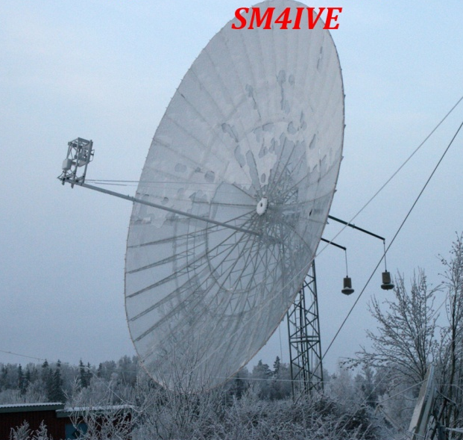
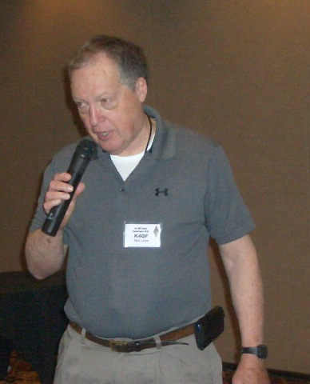
K4QF long time EMEer from Alabama addressing VHF Super Conference – Ben will be QRV on 1296 EME soon

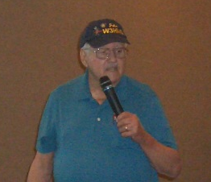
W3HMS discussing his 1296 EME station at SVHFC

W1GHZ discussed dish feeds for EME on 1296 and above at SVHFC

