432 AND ABOVE EME NEWS
MAY 2018 VOL 47 #4

EDITOR: AL KATZ, K2UYH; DEPT. ELECTRICAL/COMPUTER ENGINEERING, THE COLLEGE OF NEW JERSEY, PO BOX 7718 EWING, NJ 08628, TEL (W 609-584-8424), (C 609-047-3889), E-MAIL alkatz(x)tcnj.edu
ASSOCIATE EDITOR AND Reflector/NETNEWS Matej Petrzilka, Simunkova 1609/21, 18200, Praha 8, Czech Republic, TEL (+420 603 489 490), E-MAIL ok1teh(x)seznam.cz
CW INITIAL LIST G4RGK, DAVID DIBLEY, E-MAIL zen70432(x)zen.co.uk, AT: http://www.zen70432.zen.co.uk/Initials/index.html
SUN & EXTRATERRESTRIAL NOISE LIST MANAGED BY OK1TEH: http://www.ok2kkw.com/next/nl_k2uyh/sun_table_2017.xls
EME INFORMAL NETS: 14.345, ~1500 SATURDAY AND SUNDAY, NET COORDINATOR: OPEN
ON0EME EME BEACON, 1296.000 IS QRV WHEN MOON >10°, SEND RX REPORTS TO WALTER (ON4BCB) on4bcb(x)gmail.com
DL0SHF 3 CM EME BEACON, 10368.025, SEND INFO & QUESTIONS TO Per (DK7LJ) per(x)per-dudek.de.
NL EMAIL DISTRIBUTION and EMAIL LIST CORD: WARREN, W2WD wbutler(x)ieee.org [PDF]
THE NL WEB VERSION IS PRODUCED BY REIN, W6SZ rein0zn(x)gmail.com, AT http://www.nitehawk.com/rasmit/em70cm.html

CONDITIONS: The major news this month relates to the EU (REF-DUBUS) 13 cm CW EME Contest. There is some disagreement if this year was better than last, especially if disregard the affect of the higher declination. There is no doubt that those who showed up had a great time. Based on DL7YC’s report there were 43 stations active. The top reported score is shared by ES5PC and the SP6OPN team, both with a total of 40x38. Coming up is the BIG ONE, the 1296 EU CW Contest on 21/22 April. The Mauritius dxpedition, 3B8MB will be active on 23 cm CW during the contest – see their report in the newsletter (NL). Also active on Sunday of the contest weekend will be the Z66EME dxpedition. They are to be at Kosovo from 22 to 28 April, on all bands to 3 cm. They plan to be QRV on 1296 using JT65C on 23 and 24 April. See the reports on their plans in this and the last NL. Coming up on 13 to 24 May is EA6/HB9COG, Ibiza Island to be QRV on 23, 13, 6 and 3 cm; also reported on in the last NL with a full operating/band schedule listed. In March CR2EME provided 20 new 432 Azores QSOs and is reported on in the NL. The next 70 cm CW ATP (activity time period) is coming up on 22 April 1000-1200 and 1900-2100, but is the same weekend as the 1296 CW contest.

3B8MB: Aldo (IK3COJ) ik3coj(x)gmail.com reports that the Mauritius dxpedition (LH80ta) is on schedule and will be QRV on 1296 (and 144) with a 2.3 m dish and 200 W JT and 300 W CW. They plan to be on the island from 20 to 28 April. Team is IW3VHB (Aldo’s son), I3VFJ, IK3YBX and IZ3IBL. Their focus is on 23 cm. They plan to be QRV for the DUBUS 23 cm Contest. For last minute info see www.iw3hvb.it. [Aldo will be at EME2018 in the Netherlands].

9A5AA: Dragan dragan9a5aa(x)gmail.com is setting up for 24 GHz EME – the antenna is Prodelin 1244 dish with a modified W2IMU dual mode feed using a flare (W5LUA version), and RW 1127 TWTA driven with a modified ARCOM 26TX010 TX Module. [See picture at end]. I use the two stage final amplifier and get more than 1 W out. Contact Dragan for details.

BV3CE: Tom tom33638998(x)yahoo.com.tw is QRV on 1296 with 4 x 30 el yagis -- I initially QSOed G4CCH, OK1IL and HB9Q with only 2 yagis. I then added another 2 yagis for a total of 4, and worked PA3DZL, PE1CHQ, DL0SHF (big signal), DK3WG, PA3FXB, SP5GDM, ON4AOI, IK1FJI, IK3COJ and SM7FWZ as of 24 March. I only have a setting Moon window, but may move his array in the future.

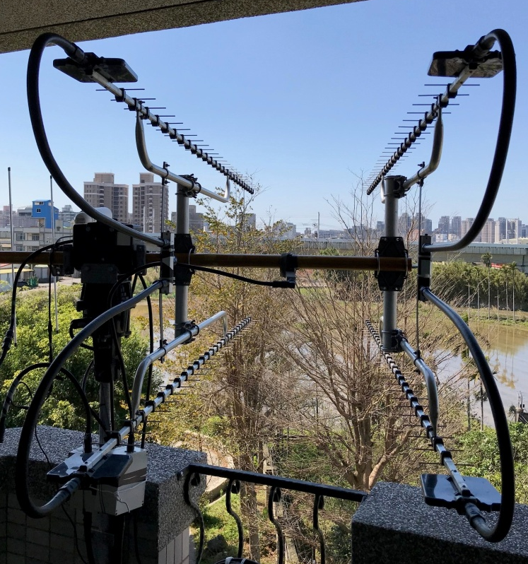

BV3CE 4 x 30 el yagi array for 1296

CR2EME: Frank (DH7FB) and Bernd (DF2ZC) xteamdxp(x)gmail.com report on their highly successful dxpedition to the Azores – We are very happy with our 70 cm results given that we had only 2 x 17 el DK7ZB yagis and 150-200 W. Most of the time, the RX pol was orthogonal to our horz yagis. We were well copied, but saw only an empty display. We decided that one of us (DH7FB lost the draw) had to act as human switch between H and V pol. In the 10 seconds between TX stop and RX start, we manually turned one of the two yagis to V pol and vice versa at the end of the RX period. Signals then popped out of the noise! With this method we made at least 2/3 of all our QSOs. We had some 3 dB less on RX as the other yagi remained in H pol. The time was too short to turn both yagis. We will have a better solution for our next dxpedition. We QSO’d HB9Q, OZ4MM, DK3WG, UA3PTW, DL7APV, DL6SH, OK1KIR, JA6AHB, YL2GD, OH2DG, UT6UG, NC1I, UT5DL, I1NDP, UX5UL, G4RGK, DL9KR (559) CW, ES5PC, DK0SF and LZ1DX. The big CW signal from DL9KR (559) was amazing. Called but not completed were DL8FBD, OZ6OL and W5LUA. Thanks go to OK1DFC for helping make our 432 operation a success. Before the trip, we were searching for a 432 SSPA in the 200 - 300 W range. We found nothing on the market. Luckily Zdenek offered to build an SSPA for us. It is a very professional looking small amp that delivers 250 W with an integrated LNA. We placed it directly below the antenna. (Luckily there was no rain in the Azores). Zdenek himself missed working us because of a business trip but he had already worked the Azores.

DK3WG: Jurg dk3wg(x)web.de reports on his March EME – I was on 432 with JT65B and glad to worked TD9CHR for DXCC135, DL1KDA, N2END and CR2EME and RX9AT. On 1296 I added using JT65C BV3CE for DXCC #58.

DL7APV: Bernd dl7apv(x)gmx.de sends news on the progress on is new super array -- Just before our holidays, I could make some tests with the new antenna. Big TNX to my XYL, Astrid, who helped me finish when the in final day when I partially fractured my finger. The SWR was 1.4 on my first test, and the Sun noise around 20 dB. The beamwidth 2 degs horz and 5 degs el. These measurements were made on the fly on 3 April. I’ll have more details when I am back from holiday at the end of April.

DL7YC: Manfred ran a survey using Moon on activity during the EU/DUBUS 13 cm CW Contest – It looks like 42 participants showing up for shorter or longer times. I had the wrong impression of much lower contest activity than in former years. It was influenced by my late start on Saturday. It seems that some calls heard in the first pass, never returned in the second pass. Countries with multiple band allocations seemed favored in this contest due to their ability to respond direct to calls in different bands. My list of contest participants by area in alphabetical order follows: Japan - JA4BLC, JA6AHB and JA8ERE, [also JA8AID], EU - DF3RU, DL7YC, ES5PC, F1PYR, F5HRY, F5JWF, G3LTF, G4BAO, HB9Q, IK2RTI, IK7UXW, LX1DB, OH1LRY, OH2DG, ON5RR, OZ4MM, OZ5G, PA3DZL, OK1CA, OK1DFC, OK2ULQ, PE1LWT, S53MM, SM3BYA, SP3XBO, SP6OPN, SP7DCS and UA3PTW, Africa - ZS6EME, NA - VE6BGT, VE6TA, K2UYH, KL6M, N4PZ, WA9FWD, WB5AFY, WD5AGO, WA6PY and W7JM. There were no calls from SA and Australia.

ES5PC: Viljo viljo(x)comnet.se reports on his activity in the EU 13 cm CW Contest – I worked total of 40 stations x38 in the weekend, but I still agree that activity was lower than in recent years. In 2017, I worked 47 stations. Possibly there were more stations QRV, which I did not work. I heard VE6BGT and one too weak to identify. Activity from US was not too bad. I worked 8 US stations. My complete list of stations worked is OK1CA, OH2DG, KL6M, UA3PTW, JA8ERE, HB9Q, OK1DFC, G3LTF, F5JWF, SP6OPN, JA4BLC, ZS6EME (both SSB and CW), JA6AHB, OH1LRY, OK2ULQ, F1PYR, DF3RU, S53MM, SP3XBO, PA3DZL, G4BAO, SM3BYA, OZ4MM, ON5RR, IK2RTI, WB5AFY for an initial (#), WA9FWD, PE1LWT, WD5AGO, K2UYH, N4PZ, OZ5G, VE6TA, WA6PY, SP7DCS, DL7YC, F5HRY, IK7UXW (#), W7JM and LX1DB.

G3LTF: Peter g3ltf(x)btinternet.com sends info on his 2320 EU contest activity -- My only EME activity this month was the DUBUS contest. The weather has been cold, wet and windy making it hard to get enthusiasm to undo the dish and put the feed in. We were lucky for the DUBUS CW/SSB contest with good WX. I started off on Saturday with QSOs with OK1CA, UA3PTW, OH2DG, ES5PC, SP6OPN and OK1DFC. I then concentrated on 2400, and worked JA8ERE, JA4BLC and JA6AHB who is now the loudest JA with a really nice signal. Calling on the corresponding frequency (2400.060 = 2320.060) worked well. I then worked ZS6EME on SSB, OH1LRY, SM3BYA, F1PYR, HB9Q, PA3DZL, G4BAO (559) - smallest station worked with a 1.9 m dish, S53MM, F5JWF, OZ5G and F5HRY. I had to quit at 1645 before the NA window. I was back on at 2300 and worked VE6TA, KL6M (who has a huge signal now) and K2UYH, but I know I missed some of the NA stations, who had been on earlier while I was out. I called WD5AGO, but he was apparently not listening cross band. On Sunday I started with PSU problems (as in - it blew up!), but after replacing it I then worked DL7YC, SP7DCS, OK2ULQ, SP3XBO, OZ4MM, DF3RU, LX1DB (CW and SSB), WA9FWD, N4PZ, and WA6PY. CWNR were PE1LWT and I heard W7JM who was loud, but I understand that John has no cross band RX. I also heard IK7UXW (549), but had no opportunity to call him. In total I scored 33x30. I worked 33 calls and heard 37; this was a bit down on the best years, and several well known calls were missing. I worked no Italians this year. My Sun noise with my 6 m dish was 16.6 dB with SF65 and Moon noise 1.0 dB. I am building a polarization rotation system for 3 cm using the ideas described by G3WDG in DUBUS (3/2017) and making good progress. This (and the WX) has been a block to my 3 cm progress. I will be on for the 23 cm DUBUS CW/SSB contest using my 6 m dish and 400 W at the feed. Small stations please call CQ after you have worked all the big guys; my SDR will find you.

G3WGD: Charlie charlie(x)sucklingfamily.free-online.co.uk brings us up to date on his recent 23 cm EME -- I was QRV with the new 1296 feed in CP mode [with 3 m dish] on 17/18 March and worked HB9Q, DL8FBD, LA3EQ, SM7FWZ, G4YTL, EA3HMJ, SP3XBO, W2HRO, F1RJ, NC1I, IK5VLS, DF2GB and K5DN. I also CWNR PA2DW. The QSOs with LA3EQ and EA3HMJ needed QRA64 as my 40 W was not enough for JT65C. LA3EQ struggled to decode me with QRA64C but with QRA64B it worked easily. I was QRV again on 24 March and worked SP6ITF, JA8SZW, ON4AOI, I7FNW, IK3COJ, F1RJ, IK1FJI, VE3KRP, PA2DW and DF2GB. On 25 March I worked DF2VJ and LA3EQ (this time on JT65C as the moon had moved closer to perigee since our last QSO which needed QRA64). On 27 March after some successful one way tests with KA1GT, I worked AA7HC, VA6EME and N5BF. I’m now up to initial {#35} using digital modes. My plans are to increase power in the coming months, but I’m very happy with the results using only 40 W.

G4BAO: John moon(x)moonbounce.info enjoyed the 13 cm EU contest weekend -- I worked the "usual suspects" plus K2UYH and SP6OPN for CW initials #26 and #27. I worked on Saturday OK1CA (579/559), PA3DZL (559/559), OH2DG (569/559), G3LTF (569/559), ES5PC (569/549), UA3PTW (539/569) and K2UYH (O/O). I saw a lot more signals on both 2304 and 2320, but mostly just too weak to make out calls with my little system. Amazingly I missed HB9Q this time. I guess I was lost under the pileup. Interesting to note that the strongest stations I heard on 2304 were from EU. Shame on you USA - Hi. I added on Sunday SP6OPN (579/559), LX1DB (559/ 559) and OK1DFC (539/539) for a total of 10x10. A gotaway was KL6M, who I saw on HB9Q but I never heard. After the contest I worked DL7YC on CW for #28. Please note that I think I'm the only UK station with a 2300-2302 permit that's QRV on EME. I know the TS2000 will RX below 2301.95 using the RIT with a 2404 transverter. Is there anyone (possibly with 2320 QRM problems) that would like to sked down there on CW/JT?

JA4BLC: Yoshiro ja4blc(x)web-sanin.co.jp sends news on his late Feb and March EME activity -- On 18 Feb I worked on 3 cm IW2FZR (O/O) for initial #47 XB, and on 23 Feb successfully copied my echoes on 4 microwave bands with 3 dishes! My 6 m dish was on 1296 and 2400, my 2.4 m offset dish was on 10 GHz and my 3 m Cassegrain dish was on 24 GHz. All 3 dishes were tracking the Moon at the same time. This configuration will enable me to provide more QSOs on multiple microwave bands during contests. I also worked on 25 Feb on 3 cm JF3HUC (549/549) and IW2FZR (579/569). (JA1WQF and JA6XED also worked IW2FZR). On 2400, on 23 March I worked JA8ERE (559/559) with my 6 m mesh dish. Then in the EU 13 cm contest, on 23/24 March, I worked KL6M (559/569), JA8ERE (559/569), JA8IAD (559/559), ES5PC (559/579), SP6OPN (569/559), G3LTF (559/559), OH2DG (559/569), OK1CA (579/579), HB9Q (589/579) and K2UYH (559/569) for a total of 10x9. On the same weekend I QSO’d on 24 GHz, on 24 March OZ1LPR (O/O) for initial #13 with my 3 m Cassegrain dish, and on 26 March OH2DG (O/O) #14 and DL7YC (O/O) our second QSO after 3 years. If anyone wishes to try 24 GHz, please email me.

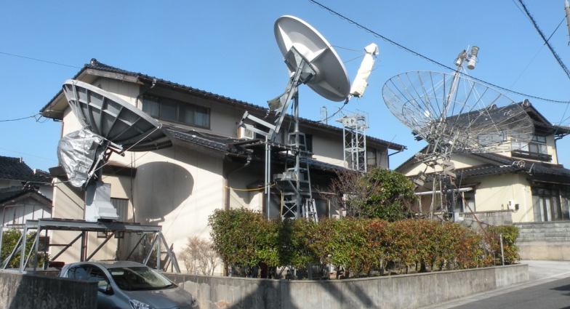

JA4BLC’s 3 dish in simultaneous operation: (R to L) 6 m dish on 1296 and 2400, 2.4 m offset dish on 10 GHz and 3 m Cassegrain dish on 24 GHz.

JA6AHB: Toshio ja6ahb(x)plala.to was QRV during the EU contest on 13 cm – I had a proble with my GPS lock on 24 March, but still worked XB HB9Q, G3LTF, OH2DG, SP6OPN, OK1CA and ES5PC. I was using a 3 m TVRO dish with 200 W. [Toshio was QSO QRV on 25 March, but I have not received his report].

K7ULS: Mike k7uls(x)yahoo.com is now up to initial #3 on 1296 from Utah – I have added a 60 W SSPA in the shack about 30' from antenna. I have now worked HB9Q, OK1DFC and PI9CAM. The PI9CAM QSO almost did not happen because the of tracking problems due to the location. I have also copied NC1I and K2UYH (11DB). Email me for skeds.

KA1GT: Bob ka1gt(x)hotmail.com sends his latest news -- I'm now QRV on 1296 with a 2.4 m dish, G4DDK preamp and around 70 W at a septum feed. As of early April I've worked W2HRO, NC1I, K2UYH, VA6EME and DK3WG on JT65c. I also worked G3WDG using QRA65, but it was a very long session with lots of talkback, so we're not really counting it as a QSO! I am hoping to have at least 100 W and maybe 200 W at the feed within a month or two. This puts Maine back on 1296 EME for the first time (I think) since K1RQG became SK in 2011. I also have 500 W on 432 with a rotatable feed for the dish, and have made quite a few QSO with this system. For now I will be concentrating on 1296.

KL6M: Mike melum(x)alaska.net was QRV for 13 cm contest -- It started very well on the first day with 21 QSOs. I worked K2UYH (569/569), N4PZ (559/569) for an initial (#), VE6TA (569/579), VE6BGT (569/579), JA8IAD (559/559), JA8ERE (559/569), WA6PY (569/579), JA4BLC (569/559), OH2DG (569/569), OK1CA (569/559), ES5PC (569/559), UA3PTW (579/589), PA3DZL (569/569) (#), SP6OPN (589/569), HB9Q (589/579), OH1LRY(559/559) (#), OK1DFC (559/569), DL7YC (559/549) (#), WD5AGO (549/559), OK2ULQ (559/579) (#) and G3LTF (579/589). However, and day two I had very bad interference and only worked two more stations WA9FWD (559/549) and DF3RU (579/579) (#). It was a very good time overall. My overall score was 23x21. I have bad RFI from wide band digital link(s), which I believe are feeder links for cell phone sites. They are much lower in frequency around 2100 MHz, but very strong, one of them is -20 dBm which is desensing my LNA. I'm working on a filter, but did not have it finished in time for the contest. Europeans seem to forget that Alaska is on 2304 on their moonrise. Many were on 2320 and not listening to 2304 wasting a whole hour until finally PA3DZL heard me for a nice initial. I'm planning on being QRV for all the remaining DUBUS weekends, including 10 GHz. I'm working hard to be QRV in time. I'm skipping Dayton Hamvention and my 50th Class Reunion for EME contests!

KL7WU: Ed kl7uw(x)acsalaska.net is getting back in operation on 1296 -- My 1296 system has been out of commission for a long time. It is my own fault for trying to move the VE1ALQ digital encoding display into another enclosure. Since then, the WX has caused some mechanical issues with the dish. The LNA enclosure fell off and dangling from the cables, and the 1/2-inch linear actuator bolt sheared off causing the dish to drop on its lower edge. There was no real damage to the dish, but I have some work to do to get it repaired. The winter is finally receding in the far north, so I will be able to get outside to work on the dish. I have a new G4DDK LNA so that will be replaced. Another change will be the purchase of a W6PQL LDMOS 600 W PA for 1296. It will be a big improvement from the 125 W that I ran before. If I can get all this done, i might make the DUBUS 23 cm contest. It will be nice to be back on 1296. I plan to be attending the CSVHF Conference in Wichita and bringing 10 GHz for testing and show.

N4PZ: Steve n4pz(x)live.com had a great time in the EU 13 cm Contest – I QSO’d VE6TA (579), K2UYH (579), VE6TA (579), VE6BGT (589), ES5PC (569), PA3DZL (569), OK1CA (579), IK2RTI (569), OK1DFC (579), OH2DG (569), WD5AGO (569), OH1LRY (569), OK2ULQ (569), KL6M (569), DF6RU (569), G3LTF (579), SP3XBO (569), SP6OPN (589) and WA6PY (569) for a total of 19x16.

NC1I: Frank frank(x)NC1I.COM reports on his March results – It was not a real active month for me but I did add a couple of initials and one new country on 432 (CR2EME). We QSO’d on 432 starting on 18 March RD3FD, N2END and OK2AQ, on 23 March VA3ELE, SM5EPO and DL1KDA, on 24 March DL6SH, KC0V, OK2AQ, and N2END, on 25 March K5DOG, DL8DAU, SM5EPO, VA3ELE, and KF8MY, on 26 March K4MSG, on 27 March CR2EME for a new country, SM5EPO, F6APE, LU8ENU, SP1JNY, and DL6SH, on 28 March VA3ELE and KF8MY, on 29 March KF8MY and OK1TEH, and finally on 31 March K5DOG. We QSO’d on 1296 starting on 18 March K5DN, LU8ENU, IK5VLS, G3WDG, F1RJ, PA2DW, and VE3KRP, on 22 March PA3DZL and DF2GB, on 24 March AA7HC, DL8FBD, and GM4PMK, on 25 March W2HRO, and finally on 1 April KA1GT. I still don’t have my 432 polarity rotation working and it now appears that it will not be repaired before May. W1QA and I are working on possibly activating another rare State (likely on 1296) and may be able to put something together for June. I hope to have more information for the next NL.

OK1CA: Franta strihavka(x)upcmail.cz was on for the EU DUBUS Contest on 13 cm -- During theI contest I tested a new 2.3 GHz transverter from SG Laboratory It worked very well with stable output power and a simple way to change between the various 23 cm subands. I worked 35 QSOs including initial #148 with IK7UXW during my Saturday window. I was QRV only 4 hours o Sunday and I worked only 2 more QSOs. My total score was 37 QSOs and 36 multipliers. I also worked using JT65C OK1DFC and ZS6EME outside of the contest.

OK1KIR: Vlada (OK1DAK) vlada.masek(x)volny.cz and Tonda (OK1DAI) EME news for March follows – Our report is short this month. On 5760 we worked on 24 March at 1244 BD4SY with a nice JT4F signal (18DB/21DB) for digital initial {#38} and 1st OK-BY QSO. Subsequently on our request to try QRA64D, Zhu by mistake continued with QRA64A and we decoded him easily regardless spreading of 55 Hz. Unfortunately Zhu had trouble with WSJTX, so we tried even CW, we copied Zhu weak “O” but nil on BD4SY side probably due to the fact that Zhu used CW mode of WSJT. On 432 we had difficulty on 27 March digging CR2EME’s signal from the noise. Finally at 1808 succeeded with CR2EME (25DB/O) for digital initial {#220}. Our best copy was near horz pol.

OK2ULQ: Petr ok2ulq(x)seznam.cz wrote at his blog http://ok2ulq.blogspot.cz a short report on the 13 cm contest -- On Saturday, after an hour of AZ/EL control problems, I began to think about giving up on the contest, but finally I was able to get everything working. The reward was my 1st QSO with JA8ERE. It was a pleasure because I had never before heard anyone in the JA segment. I finished the Saturday's window with 20 QSOs including initials with JA8ERE, F5JWF, OH1LRY, SP7DCS, WA6PY, VE6TA, N4PZ and KL6M. Saturday's conditions were excellent. On Sunday, I worked 3 more, including initials with DL7YC and JA6AHB. The conditions were a little worse and there were fewer stations active. I was QRV for only 4 hours, and end with a total of 23 QSOs. I also heard JA4BLC, SP3XBO, IK2RTI and several others, but weren't able to attract them. We'll see next time. [Translated by OK1TEH].

PA3DZL: Jac moon(x)moonbounce.info sends his results in 13 cm EU Contest -- Almost all stations in contest had very nice signals – most reports ranged from (559) to (589) and even (599)! 13 cm is a great band, and the different allocations make it challenging Hi. I worked on 24 March KL6M for initial #115 and DXCC 50 XB, OH1LRY, OK2ULQ, G4BAO - random CW (559/559) from a 1.9 m dish, DF3RU, G3LTF, HB9Q - strongest signal on the band, SP6OPN – big signal too, OH2DG, OK1CA, ES5PC, S53MM, OK1DFC, F5JWF, SM3BYA, SP3XBO, IK7UXW #116, N4PZ #117 XB and K2UYH XB, and on 25 March ZS6EME, PE1LWT #118, UA3PTW, and DL7YC for a total of 23x22. I heard LX1DB and on Sunday again G4BAO calling CQ with (559) signals! Unfortunately I copied no signals during my 45 min window to JA. I had WIFI QRM for the first time on 2400! I also missed OK1KIR - not QRV? My 13 cm rig is a 3.7 m Andrew solid dish, VE4MA feed, G4DDK preamp and SSPA.

PA3DZL’s 70 cm patch feed
SP6OPN: Andrzej (SP6JLW) sp6jlw(x)wp.pl reports on the Klodzko contest team of SP6JLW, SP6OPN and SQ6OPG in recent EU 13 cm EME Contest. – In the contest we operated under the callsign SP6OPN that we normally use in the "Multi-operator" category. We made 40 contacts and 38 multiplies, which gave a much better result than in the previous year (39x32). The list of QSOs is OH2DG, OH1LRY, OK1CA, OK2ULQ, OK1DFC, HB9Q, UA3PTW, JA8ERE, JA4BLC, JA6AHB, G3LTF, G4BAO, KL6M, WB5AFY, WA9FWD, K2UYH, WA6PY, WD5AGO, W7JM, N4PZ, ES5PC, ZS6EME, F5JWF, F1PYR, F5HRY, S53MM, SM3BYA, DF3RU, DL7YC, SP3XBO, SP7DCS, PA3DZL, PE1LWT, OZ4MM, IK3GHY, IK2RTI, IK7UXW, ON5RR, LX1BD and VE6TA. Thank you all for the great QSOs. See http://emejo80jk.cba.pl/aktualnosci.html for more info. [TNX OK1TEH for the translation].

VE3KRP: Fast Eddie eddie(x)tbaytel.net writes about his plans – I am getting ready to retire from my job in May, which I am looking very forward to! I was active on 23 cm EME in March and worked on 17 March DL2VJ (JT), on 18 March G3WDG (JT) for a mixed initial (#*) and NC1I (JT), on 23 March AA7HC (JT), SP6ITF (JT) (#*), OH3LWP (JT) (#*) and DF2GB (JT), on 24 March RU4HU (JT), I7FNW (JT), K5DN (JT), IK1FJI and G3WDG (JT), on 25 March OK1IL (JT) and RA2FGG #(JT), and on 1 April W2HRO (JT).

VE6TA: Grant ve6ta(x)xplornet.com up dates us on his recent 13 cm EME – There was poorer activity on this side of the pond for the 2.3 GHz contest, but I had a better score than last year. I believe this was due to the higher declination. I worked the following: N4PZ - good signal now from Steve after his improvements, K2UYH, KL6M, VE6BGT, JA8ERE, OK1CA, SP6OPN, ES5PC, UA3PTW, OH1LRY, WA6PY, OH2DG, OK2ULQ for initial #95, WD5AGO, G3LTF, DF3RU, SP3XBO #96, DL7YC #97 and WA9FWD for a total score 19x19. I hope to be on for at least one pass of the 1296 contest, as I will be travelling on business around that time.

UA3PTW: Dmitry ua3ptw(x)inbox.ru during the recent past reports working initials on 70 cm using JT65B with TD9CHR and CR2EME. On 23 cm he added with JT65C W2HRO, and on CW WB5AFY and N4PZ. . [TNX DK3WG for forwarding this report].

UA4AAV: Viktor was on 432 and QSO’d using JT65B new ones with JE2UFF, DK4RC, SM7GVF, NC1I, TD9CHR, LZ1DX and SM5EPO. [TNX DK3WG for forwarding this report].

W2HRO: Paul w2hro.fn20(x)gmail.com sends information on his 1296 EME activity – I am now reliably QRV on 23 cm with my 3 m dish with CP - Patch feed (upgraded from LP) and 150 W. The CP is performing nicely and I definitely benefited from the change. My thanks to SM6PGP for the nice patch design and G4DML for his helpful construction tips. With additional adjustments, my Sun noise is now 10 dB. My March 23 cm Initials were KA1GT (Maine), GM4PMK, IK3COJ, I1NDP, VK2JDS, OH3LWP, RA2FG, VE3NXK, I7FNW, SP5GDM, PA3DZL, DC9UP, G4DML (patch to patch), VK4CDI (WAC!), IK5VLS, G3WDG (yagi), SP3XBO, SM7FWZ, EA3HML, DL0SHF, DL8FBD, UA3PTW and OH2DG. I'm still 100% JT65 with 100 QSOs, #70 Initials, 24 DXCC, 11 WAS, and as of this month 23 cm WAC. I'm planning a dxpedition to Delaware sometime this summer with a 1.8 m dish with CP feed and 150 W.

W4OP: Dale writes -- After being QRT for almost a year, I have finally had time to look at my 600 W P.A. Echoes were off by over 7 dB. I discovered a failed solder joint in my 4 port hybrid. That caused the dump port (too small wattage) to also fail. I have not had the opportunity to assess the (2) PE1RKI amplifiers. If they survived, I will be on for 23 cm DUBUS. Meanwhile, I have been listening and copying great CW signal levels with my 14’ dish, VE4MA feed/scalar and W7CNK LNA.

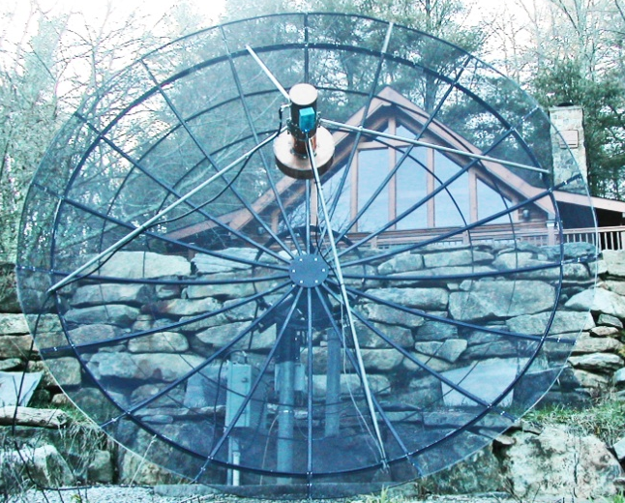

W4OP’s 14’ dish and 1296 feed

W6YX: Gary (AD6FP) ad6fp(x)lbachs.com reports his club was active in the 23 cm SSB Funtest. We combined this event with a shack open house for new students studying to get their radio license. We have since had almost 50 people from the campus community get licensed! Our 1296 station had issues resulting in very poor RX performance and subdued TX performance. We only QSO’d I1NDP, OK2DL, K2UYH, VE6BGT, VE6TA and WB2BYP. None the less, many students were impressed with the contacts and it further motivated them to get licensed. If time permits, we'll trouble shoot and repair our station to leisurely operate the DUBUS 23 cm event next month.

WA6PY: Paul pchominski(x)maxlinear.com found good signals during the EU 13 cm Contest – I was QRV in the 13 cm contest and QSO’d JA8ERE, JA8IAD, KL6M, SP6OPN, OK1DFC, OK1CA, OH2DG, OH1LRY, ES5PC, OK2ULQ, K2UYH, VE6TA, UA3PTW, DL7YC, G3LTF, N4PZ and SP3XBO. My total was 16x14 from my US west coast location. I was only on for my JA/VK window during first night. I heard F5HRY in QSO with WA9FWD, but John moved to another part of the band. I called DF3RU many times, but couldn’t get his attention. Cross band operation is difficult. Next moth I’m planning to be on 1296 contest.
WA9FWD: John wa9fwd(x)outlook.com sends a short report on his activity for the 13 cm DUBUS weekend -- When I installed the 2.3 GHz feed I noticed the noise level was considerably greater than in the past. I ended up working the first day ES5PC, SP6OPN, OK1CA, WD5AGO, K2UYH, and OH1LRY and OH2DG, and the second day OK1DFC, DL7YC, DF3RU, UA3PTW, G3LTF, N4PZ, VE6TA and KL6M for a total of 15x14. I have been making some changes to my station. I now have two of the W6PQL 600 W amplifiers that I am combining and hope to have ready for the 23 cm contest weekend in April. On 9 cm, I have a new 300 W amp; and on 3 cm I have a new 30 W PA.

WB5AFY: Dan’s wb5afy(x)wb5afy.net 13 cm contest report – I was only on 13 cm for a few hours during the EU window Saturday afternoon, but worked (all on random) ES5PC (569/569), OK1CA (579/569), SP6OPN (569/569), OH2DG (569/569), UA3PTW (569/579) (XB) and OH1LRY (579/579) for a score of 6x6 or 3600 points. I heard K2UYH and WD5AGO with good sigs, but had to QRT before I got a chance to work them. I also heard many stations on 2320 and was happy to make my first XB (2304/2320) QSO with UA3PTW. I plan here is to improve my 2320 RX setup and overall G/T performance of the system prior to the fall contest. I am available for skeds; just email me.

Z66EME: Dan (HB9Q) sends some updated news on DG8NCO’s and DL2NUD’s dxpedition to Kosovo (KN02). Activity on all microwave bands will be on .100 with TX the 1st period and RX on their own echo. Operation on 1296 should start on 22 April sometime after moonrise and use JT65C. They will continue on 1296 on 23 April. 13 cm will be on 24 April, on 2320 with 2304 on request using JT65C. 9 cm will be on 25 April using JT65C. 6 cm will be on 26 April also using JT65C. [Dan recommends JT4F]. Finally 3 cm will be on 27 April using JT4F. Sorry, but they will not be on CW. 432 activity is expected at the end of the dxpedition, possibly on 27 April. On 28 April they have to pack-up and depart for the 2000+ km drive back home. See the report in the last NL for more info.

K2UYH: Al alkatz(x)tcnj.edu reports the end of March was not very different than the beginning with low activity because of a combination of bad WX and conflicting activities (TCF2018) -- I was on for the 13 cm EU DUBUS EME CW Contest and was joined by K2YY and NE2U for part of the contest. We QSO’d on 24 March at 0006 N4PZ (569/559), 0012 KL6M (569/569), 0020 VE6TA (569/579), 0045 VE6BGT (56N/569), 0215 JA8ERE (569/559), 0330 JA8IAD (569/559), 1955 OK1CA (579/579), 2003 ES5PC (569-579), 2008 OH2DG (569/569), 2011 OH1LRY (569/579), 2019 UA3PTW (569/589) (XB), 2026 WA9FWD (56N/559), 2034 OK2ULQ (559/579), 2039 IK2RTI (569/569), 2048 SP6OPN (569/559), 2053 OK1DFC (569/569), 2058 F5JWF (569/589), 2116 PA3DZL (579/579) (XB), 2147 WA6PY (569/579), 2208 G4BAO (O/O) (XB) – under a birdie for initial #94, 2227 WD5AGO (559/559) and 2349 G3LTF (579/579) (XB), and 25 March at 0436 JA4BLC (569/559) (XB), 0450 JA6AHB (O/O) (XB) #95 – right under bad WiFi noise at 070, 2137 DF3RU (559/559) (XB), 2200 DL7YC (559/579) (XB) for a total score of 26x24. On 27 March I tried to work CR2EME, but at the time had very high noise on 432 and never heard them. Fortunately I already have the Azores on 70 cm. I was on 1296 on 1 April with my linear pol feed to try to work K7ULS using only 10 W and a single yagi. He copied me up to (12DB); I was never able to decode him even though he peaked several times at (27DB). Next time I will try the latest (X17C) of WSJT. I am told it offers about a 3 dB improvement over the older versions on JT65C. I did QSO at 0301 AA7HC (11DB/11DB) with JT65C for mixed initial #574*, 0317 AA7HC (559/O) on CW for #389 and 0524 KA1GT (O/20DB) on JT65C #575*. I plan to be QRV for the DUBUS 1296 Contest as much as possible, but I have some social conflicts both days.

NET/REFLECTOR NEWS: F2CT plans to have his 4 m solid dish operational by the end of April for the 23 cm DUBUS EME party. He is also working hard on a 16 x 30 el H/V array for 432.

FOR SALE: KL7WU has for sale 2 x 150 W W6PQL SSPAs either as a complete 300 W PA, or separately. They require 28 V and drive with 10 W, each. Anyone interested should contact me for details. One SSPA is still a kit, but I will assemble it for sale (give me 30 days to complete). N4PZ is looking converter from 1296 to 144 or to 28 MHz. If you can help, contact Steve at n4pz(x)live.com.

A SIMPLE MOD FOR GPS LOCKING TS2000X BY KN0WS: I soldered a SMA coaxial cable to the reference output wire from the radio’s crystal oscillator and I moved inductor L429 off the circuit board and in series with a switch that was epoxied to the back of the radio. When the switch is closed, the internal voltage is applied in series with the switch to the crystal oscillator as per usual. To use an external reference, just turn off the switch and apply the external reference to the coaxial cable. I use the wonderful Leo Bodnar GPS clock still available on line. It is programmed to 15.6 MHz with current of 8 mA.

HOW TO MEASURE NOISE WTTH AN SDRPLAY FROM PA5Y VIA OK1DFC: To measure noise in the continuum mode with SDRIQ (limited to 30 MHz) at almost any frequency use an SDRPlay (or equivalent). The SDRPlay is connected to by its sound card output to SpectraVue’s I/Q sound card input. It works very well. I am now able measure Sun noise and Moon noise direct on 1296, 432 and 144 where I have IF for my MW bands.

RADIOASTRONOMICAL CORNER: Radio astronomers captured the first generation of stars in the universe - The EDGES experiment captured hydrogen signals from the time that our universe was only 180 million years old. After the Big Bang, our universe was very dark for about 400,000 years. There were no galaxies, no stars. Virtually the entire universe was filled with a neutral hydrogen gas. Over the next 50 to 100 million years, this gas has been shrinking slowly in some areas of high density due to gravity, collapsing in the form of stars of the oldest generation. As far as the first stars in the universe are concerned, scientists are constantly wondering: What did they look like? When exactly did they occur? After a tedious effort in the last twelve years, scientists led by astronomer Judd Bowman of Arizona State University finally have the first information on the oldest generation of stars. They traced the radio signals of the oldest generation of stars, dating from 180 million years after the Big Bang. This was a big challenge because the sources of noise overlapping this signal could be a 30dB stronger. Their publication appeared in the new issue of the journal Nature https://www.nature.com/articles/nature25792. Bowman's team has done this work with the help of a remarkable ground facility, the so-called radio spectrometer, located in the Murchinson Radio Observatory (MRO) in Western Australia. Within their Experiment to Detect the Global EoR Signature (EDGES), the average radio spectrum of all astronomical signals captured in the southern sky was measured. In the radio spectrum, they were looking for small deviations that revealed weak signals. The first stars of the universe could be not observed directly; they traced them by their surroundings. In this case, these stars caused microwave background (CMB) damping. In the end, the researchers successfully detected the signals most likely to come from the primordial hydrogen that spilled into the universe. According to Bowman, it seemed unlikely that we would have seen in our lives these older stars in space. A great contribution to research has been the exceptional radio silence that surrounds the Murchinson Observatory. Australian legislation restricts the use of radio transmitters within 260 km of the Observatory. The research results confirm the expectations of experts. Signals from the time of the first stars were captured most clearly at a frequency of about 78 MHz. This corresponds to 180 million years after the Big Bang. It's a direct detection of the earliest signal of hydrogen gas in the universe. Surprisingly, however, the universe was probably colder at that time than we thought. Either the astrophysics need to re-calculate or re-think the new physics. It could be the result, for example, of the interaction of baryons, a common matter, with dark matter, in which baryons slowly lost energy in favor of dark matter. This concept was originally proposed by Rennan Barkan of Telaviv University. If it is confirmed, it would be a significant advance in the search for dark matter. For more info see https://phys.org/news/2018-02-secrets-universe.html and www.youtube.com/watch?v=wU6KXoO0NEE.

FINAL: We have given the NL a little bit of a face lift this month. We have increased the font size. There have been many requests for a bigger font. With the electronic format there is no need to conserve space as in the old days when the NL was sent by snail mail. The problem with the large font size is it makes the columns more choppy and less effective. What do you think? We have also received requests for the use of less highlighting and bold in the NL. We started using the highlighting and bold in response to requests to make it easier and faster to find information in the NL, such as contest scores and dxpedition activity. We had previously tried to limit the highlight colors to ones that were easier to see. In this issue we have reduced the amount of highlighter content significantly. Is this any better?

► The EME 2018, the Netherlands, early bird discount period ends on 1 May! In just about 4 months we hope to see many of you in Egmond aan Zee, the Netherlands and in Dwingeloo at the 25 m dish of PI9CAM. On 1 May the basic entrance fee will increase from 110 to 125 EU. So if you are planning to come to the conference, this is a good time to book and save some money. We received a great response to our call for papers. We now have more presentations than we have available ‘slots’. So, we have to see how we can change some presentations to ‘table top’ or poster presentations. I am sure we will sort this out in a good way. On the website, www.eme2018.nl, you can find a small downloadable file under ‘contact’. This area contains information about travelling and public transport in the Netherlands. It should be especially useful for those of you who want to extend their stay and see some more of the country. If you have some any questions about where to go and how to get there, do not hesitate to send us an e-mail. We can help you! Looking forward having the EME family in the Netherlands soon! 73, Jan, PA3FXB and the PI9CAM team.

► Correction - please note that in WB3DZC’s report in the last NL "is" is attached to the ending ".edu" of his email address. It should read <rbradley(x)nrao.edu>. See Rich’s dish to be used from UVA campus below.

► VE7BQH Antenna tables on the design of yagis (includes 432) can be found at http://sm2cew.com/gt.htm.

► We shall be looking for you in the 1296 EU CW EME Contest and off the Moon in general. Good luck with all the dxpeditions. 73 Al – K2UYH and Metej – OK1TEH

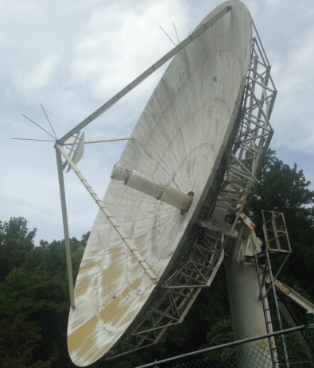

WB3DZC’s 10 m dish to be used from the UVA

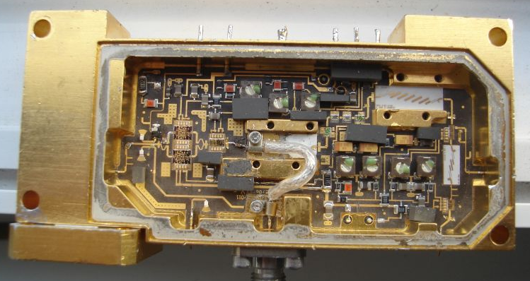

9A5AA’s modified 24 GHz ARCOM TX Module

