432 AND ABOVE EME NEWS
MAY 2019 VOL 48 #5

EDITOR: AL KATZ, K2UYH; DEPT. ELECTRICAL/COMPUTER ENGINEERING, THE COLLEGE OF NEW JERSEY, PO BOX 7718 EWING, NJ 08628, TEL (W 609-584-8424), (C 609-947-3889), E-MAIL alkatz((x))tcnj.edu
ASSOCIATE EDITOR AND Reflector/NETNEWS Matej Petrzilka, Simunkova 1609/21, 18200, Praha 8, Czech Republic, TEL (+420 603 489 490), E-MAIL ok1teh((x))seznam.cz
CW INITIAL LIST G4RGK, DAVID DIBLEY, E-MAIL zen70432((x))zen.co.uk, AT: http://www.zen70432.zen.co.uk/Initials/index.html
SUN & EXTRATERRESTRIAL NOISE LIST MANAGED BY OK1TEH: http://www.ok2kkw.com/next/nl_k2uyh/sun_table.xls
EME INFORMAL NETS: 14.345, ~1500 SATURDAY AND SUNDAY, NET COORDINATOR: OPEN
ON0EME EME BEACON, 1296.000 IS QRV WHEN MOON >10°, SEND RX REPORTS TO WALTER (ON4BCB) on4bcb((x))gmail.com
DL0SHF 3 CM EME BEACON, 10368.025, SEND INFO & QUESTIONS TO Per (DK7LJ) per((x))per-dudek.de.
NL EMAIL DISTRIBUTION and EMAIL LIST CORD: WARREN, W2WD wbutler((x))ieee.org [PDF]
THE NL WEB VERSION IS PRODUCED BY REIN, W6SZ rein0zn((x))gmail.com, AT http://www.nitehawk.com/rasmit/em70cm.html

CONDITIONS: The VK3UM Memorial Contest (VMC) also known as Dubus/REF 1296 EME Contest Weekend, on 13/14 April brought some nice activity to 23 cm. Although the weather (WX) in many parts of the world was terrible, which may have contributed to a slightly lower turnout than last year. I do not think the conditions were as good with libration that at times made CW copy difficult. The top reported contact number comes from SM6CKU with 81 QSOs, but Ben takes himself out of the competition for mistakenly announcing CQs on the HB9Q Logger. The next highest score is from G3LTF with a total of 72x60. Congratulations to Peter.

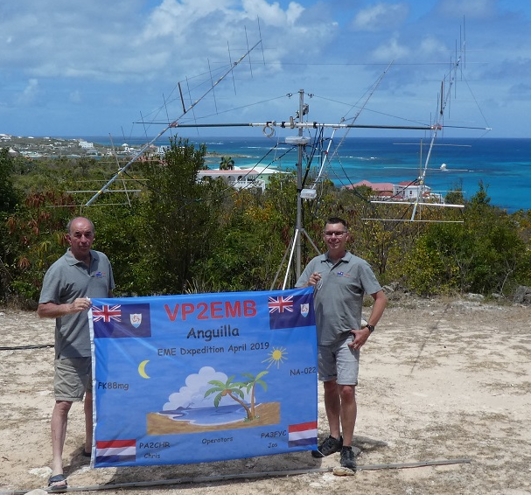
VP2EMB team (PA2CHR and PA3FYC)

There was also dxpedition activity on 1296 from VP2EMB in St. Maarten during the weekend that may have distracted slightly from the contest. They had great success and had on 432 39 QSOs and on 1296 56 QSOs for an overall dxpedition count of 357! Hats off for to them for the great fun. See their detailed report later in this newsletter (NL). The LY/DL2NUD and LY/DL4DTU dxpedition operating from LY2IJ’s Lithuanian country home also did well on 23, 13 and 6 cm, but were not able to complete any QSOs on 3 cm. I do not yet have their report but do know they made 46 initials on 1296 and a good number on 13 and 6 cm. I hope to have more information for the next NL. Thanks to Norbert and Hermann. Coming up very soon is the SV9/HB9CRQ dxpedition to Crete – see below. After that I know of no dxpeditions until VA3ELE puts VE2TWO on from Zone 2 on 23, 13, 9 and 6 cm EME from 28 June to 8 July. See Peter’s report later in this NL. Scheduled for 28 July to 6 Aug is the T46MB dxpedition from Cuba on all band from 6 m thru 3 cm.

The next Dubus CW Contest is 11/12 May on 10 GHz http://www.marsport.org.uk/dubus/EMEContest2019web.pdf. Also, the same weekend is the ARI Spring EME Trophy Contest covering all EME bands and all modes. See www.eme2008.org/ari-eme/contest.html. There is no 70 cm CW Activity Time Period (ATP) in May because of the ARI EME Contest.

UPCOMING EME EXPEDITIONS IN SPRING 2019 >432
SV9/HB9CRQ: Dan (HB9CRQ) dan(x)hb9q.ch and his Qteam will be active from Crete (KM25xa) on 432 thru 3 cm -- We have tested and packed all the equipment and are ready to go! Because SV9 was activated just once on 432 EME, we have built a QRP station, which fits in the existing transport boxes of our microwave dxpedition station. We will be using on 432 a single 11 el yagi by DG7YBN, preamp and 50 W with our fully automated az/el control. Our QTH locator ison the southeast cost of Crete. We should have pretty good MR and MS windows; we expect to have Moon down to 5-10 degs el. On all the microwave bands we will use a 1.5 m dish. On 23 cm we will have 50 W at a circular pol feed with preamp at horn. On 13, 9 and 6 cm we will have exactly the same set up, with the ability to operate all sub-bands on 13 cm. On 3 cm we will also have 50 W and a similar setup, but with a linear vert pol feed, and the ability to operate all 3 cm sub-bands. We fly on 3 May to Heraklion in SV9. From there we drive to our QTH. The first week, before we start our EME activity, we’ll do some sightseeing. On 19 May we’ll fly back home. During our activity, we will be QRV on the HB9Q loggers. We will start operation on 10 May on 1296.100 first from 0830 to 2200, and 11 May again on 1296.100 first from 0930 to 2300, on 12 May on 23xx.100 first from 1030 to 2330. At MR on 2301.990 (on request only), will QSY later to 2400.100 (on request only), later to 2320.100 and finally to 2304.100 (QSY will be announced on HB9Q 13 cm logger). On 13/14 May on 3400.100 first from 1145 to 0015. At MR on 3399.990 first (on request only), QSY will be announced on HB9Q 9 cm logger. On 14/15 May on 5760.100 first from 1300 to 0045, on 15/16 May on 10xxx.100 first from 1400 to 0115. We will be on 10450.100 first (on request only), QSY will be announced on the HB9Q 3 cm logger. On 16/17 May we will be on 432.085 first from 1500 to 0200. On 17/18 May, the frequency open from 1615 to 0230. Now that WSJT-X 2.0.1 is available, we will use JT65B with Doppler control (“Own Echo”, in other words we listen on our own echo) on 70 cm. On 23, 13 and 9 cm, we will use JT65C with Doppler Control (“Own Echo”). On 6 and 3 cm we will use QRA64D (if necessary JT4F) including Doppler Control (“Constant Frequency On Moon” and if necessary “Full Doppler to DX Grid”). Hopefully more people will take advantage of automated Doppler control. Especially on 6 and 3cm it is a MUST for successful QRP operations. Although it is on the limit, we will work CW on all bands (except 432). However, only with big-guns and after the pile-up on JT/QRA is worked. How big a station do you need to work us? On 70 cm at least 8 long yagis and very good power; on 23 cm, a 2 m dish and 150 W at the feed; on 13 cm, a 2 m dish and 100 W at the feed; on 9 cm, a 2 m dish and 50 W at the feed; on 6 cm, a 1.5 m dish and 80 W at the feed; and on 3 cm, a 1.2 m solid dish with 40 W at the feed. QSL policy: QSL are only by direct and must include an SAE to: HB9Q, P.O. Box 133, CH-5737 Menziken. If you wish to sponsor our activity, you are welcome to do so by using PayPal dan(x)hb9q.ch (please mention your call). We are looking forward to our SV9/HB9CRQ dxpedition and hope to work many of you!

EME REPORTS:

BV3CE: Tom tom33638998(x)yahoo.com.tw sends news on his EME results in April -- With new antenna location, I added more 23 cm QSOs including one with K2UYH. [Last month we incorrectly listed Tom’s call as BV5CE. It is, of course, BV3CE as shown this month. Our apology].
DJ3JJ: Andreas dj3jj(x)gmx.net was unable to QRV for the 23 cm Dubus CW EME Contest -- During the winter, I reworked my Egis rotor. It is now able to run a full 360 degs in AZ and 2.5 to 53 degs in EL. On the Friday before the contest, I wanted to install the rotor and dish, but the temperature dropped to 0 degs C and it started to snow! Of course, by Monday the weather (WX) was back to normal, and I could complete my system. It was very frustrating, but I suspect I was not the only one who was not QRV because of the WX. This contest, I believe, generates the most CW EME of any. I have recommended, it be moved to May to insure, we do not have a repeat of this situation next year. I now hope to see you all in the ARRL 2019 EME Contest.

DK3WG: Jurg dk3wg(x)web.de in April QSO’d new DXCC on both 432 and 1296 – I contacted initials on 70 cm using JT65B with VP2EMB for DXCC 139, and on 23 cm using CW F2CT and SP2HMR and using JT65C LY/DL4DTU, LY1EME [both same], LA1K, WA6HTP and VP2EMB for DXCC 65. I also participated in the Dubus CW EME Contest and worked 25 stations.

F2CT: Guy artza.expert(x)orange.fr was on 1296 for the Dubus EME Contest -- Since Saturday 13 April, I have been QRV on 23 cm EME with my 4 m solid dish, 700 W at my septum feed and 0.3 NF LNA. During the EME contest, I worked 50 stations using CW. Especially strong signals were from HB9Q, UA3PTW, OE5JFL, OZ4MM, DL3EBJ, SP6JLW, SM6CKU, KL6M and W4OP (the loudest). I still want to improve my reception by adding DSP filters; as it was very difficult to decode multiple CW signals all calling at the same time and QRG. My apologies to those that called with no reply.

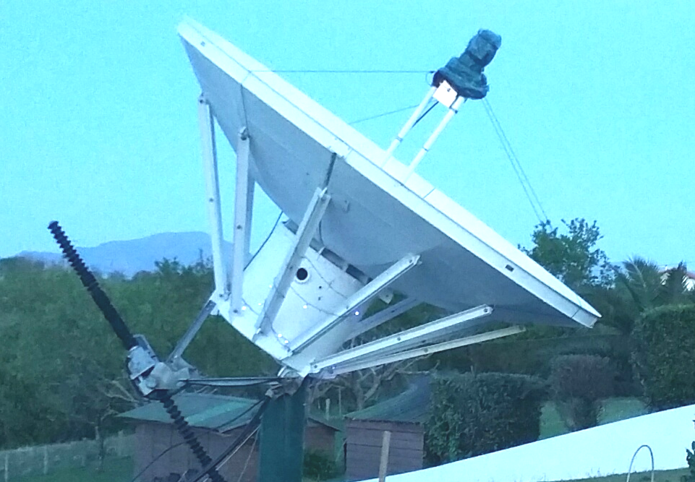
F2CT 4 m dish on 1296

G3LTF: Peter pkb100(x)btinternet.com sends his April EME report -- Following on from the 13 cm Dubus Contest, I worked on 13 cm CW on 9 April WA3RGQ and on 10 April PA0PLY for initial #143 with a very good signal for his first 13 cm QSO. I then switch to 23 cm to QSO on 12 April K7CA and RA3Y for initial #471, on 13 April in the Dubus-REF Contest KL6M, JA4BLC, FR5DN #472 and DXCC 73, OK2DL, IW2FZR, SM4GGC, 9A5AA, ES5PC, JR4AEP, LZ2US, OZ4MM, SP6ITF, UA3PTW, OK1YK, RA3EC, SP6JLW, RA3EME, JA5LJB, OK1CS, SP3XBO, PA0PLY, SP7DCS, F2CT, I0NAA, SP2HMR, SM6CKU, OH2DG, S59DCD, F5KRK, I1NDP, PI9CAM, IK5VLS, DL7UDA, EA8DBM, OK1CA, SM2CEW, OK2ULQ, OE5JFL, F5KUG, DL6SH, PA7JB, F5JWF, SV3AAF, SK0UX, IK3COJ, W4OP, K2UYH, K7CA, RN6MA, WA6PY, DL7YC, VE6TA, W4AF, K5DOG, OH1LRY, OZ6OL, DF2GB, N5BF and SM6PGP, on 14 April HB9Q, DL3EBJ, VK4AFL, UA3TCF, ES6FX, F5HRY, DK3WG, OK1DFC, WA9FWD, G4CCH, NC1I, DF3RU and ZS1LS #473, on 15 April (after end of contest) RA2FFG #474 and SP2HMR, and on 16 April SK0CT (same as SK0UX for a contact in the Nordic Amateur Radio Contest). I ended the Dubus Contest with a total 72x60. For reference on 14 April my moon noise was 0.6 dB and sun noise 19.8 dB. The activity levels in the contest were pleasingly high with many big signals, especially during the EU-JA-VK windows. I enjoyed the random contacts with many old friends. I listened to the LY dxpedition on 23 cm and 13 cm. On both those bands they would have been an easy CW contact, but were not using that mode. The VP2 would have been workable on CW on 70 cm, but I missed the short time when they worked DL9KR.

G4RFR: John (M5AHV) john.g0api(x)gmail.com writes that after a near 25 year break in EME operation, his radio group, FRARS (for the Flight Refueling Amateur Radio Society) has returned and are on 3 cm -- have nearly finished a full makeover of our 10 GHz system in IO90. Our 3.4 m dish is fully auto tracking using in house developed software to interface to NEC Selsyns. It just turns on goes and even works via mobile phone). The frontend is a modified Octagon LNB. The feed is a VE4MA via 90 deg twist onto a 4-port switch. Its position can be remotely adjusted using a small linear jack with a digital readout. On TX we currently have only 10 W, but it is mounted in the feed box with its associated power supply. The backend systems are all HB with GPS locking to the up and down mixer/LO. All narrow band modes are available via CAT controlled IC746 for WSJT and CW/SSB. We tested on 11 April and worked OZ1FF (no final Rs), UR5LX, OK1KIR, PA0BAT (CW), OH2DG (CW), DL6ABC and a partial with SM2CEW (CW). All contacts were on WSJT [mode?] unless indicated as CW. Several were on random and the others arranged on HB9Q. During this one session we worked almost as many stations as we worked during our total activity back in 1994. We have QRO PA nearly ready. The required 50’ of interface cables have now been tested and the system only needs to be integrated for final testing. We hope to deploy on the dish during this summer. The FRARS consists of G0API, G3YGF and M5AHV.

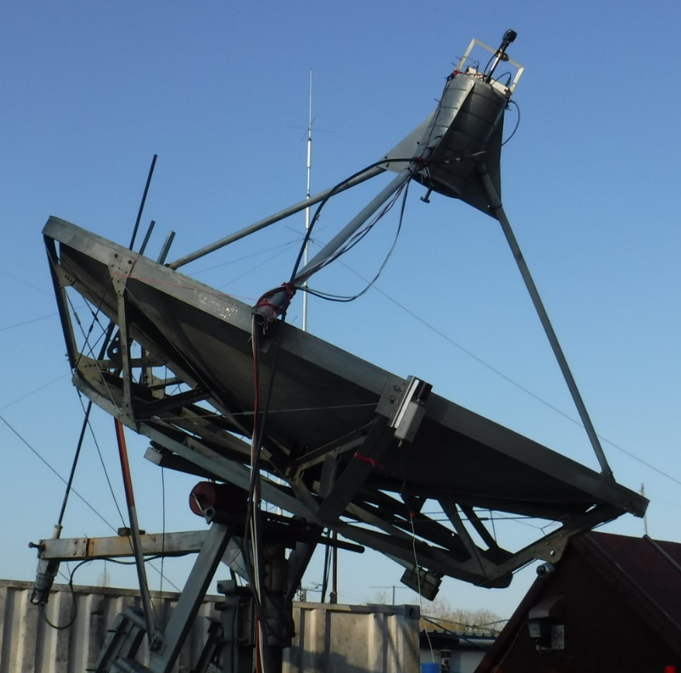
G4RFR 3.4 m with 10 GHz system

HB9Q: Daniel (HB9CRQ) dan(x)hb9q.ch reports on his recent results – My initials worked from mid Dec to the end of April are on 70 cm using JT65B unless noted otherwise 4X1AJ, JH7OHS, GM4FVM, 4X1AJ, JH7OHS, GM4FVM, 9K2YM for DXCC 164 (his first 432 EME QSO), DC2TH, W4HN, DM3CK, UA6AQN, IC8SQS, OE3JPC (CW from new QTH), UA0ZGX, RX6APY, GM0HBK, TO2MB, KO4MA and VP2EMB for DXCC165 for mixed initial #1079*; on 23 cm using JT65C unless noted otherwise UD2F, WX4F, L3DXT, DM3MS (his first EME QSO), SK0CT (SSB), SP7VC (SSB), DL1RPL, IW3HVB (his first EME QSO), G0LBK (his first EME QSO), GM6VXB, OE3JPC (CW from new QTH), DF0BRB, TO2MB for DXCC 123, LY/DL4DTU, WA6HTP, FR5DN, LA1K, F2CT (CW), OK2PE (CW), VP2EMB for DXCC 124, JH7OPT and OK1USW (CW) for mixed initial #685*; on 13 cm using JT65C UA3TCF and LY/DL2NUD for DXCC 65 and using CW PA0PLY for mixed initial 175*; on 6 cm using JT65C LY/DL4DTU for DXCC 39 and mixed initial #39*; and on 3 cm using QRA64D IZ4BFA (his first EME QSO) and I4TZ (his first EME QSO for mixed initial #169* and at DXCC 37. On 1296, we still need the following 9 states to complete WAS: AL, AR, DE, KY, MS, MT, SD, WV and WY. We can work easily stations running 1 yagi (40-70 el) and 15 W or 1.5 m dish and 10 W. Any help is very much welcome!

I1NDP: Nando i1ndp.nando(x)gmail.com had intended to seriously compete in the 1296 Dubus Contest but had bad luck with the WX – I started operating at the beginning of the first moonpass, but had to give up after few hours because of a drastic change in WX. A series of thunder storms with big lightning strikes and very high wind made operation impossible. Despite the limited operating time, I still managed to accumulate 44 CW QSOs, 6 initials and 3 new DXCCs with FR5DN, LY/DL4DTU and VP2EMB. The WX was not any better the second day and was not QRV at all.

JA4BLC: Yoshiro ja4blc(x)web-sanin.co.jp was active in the Dubus CW 23 cm Contest -- I worked KL6M, K2UYH, WA6PY, K7CA for an initial (#), JA8ERE, SM6CKU, OK2ULQ, OK2DL, G3LTF, OH2DG, VK5MC, VE6TA, VA7MM, UA3PTW, OK1CS, RA3EC, SP6JLW, OZ6OL, SK0UX, LZ2US, G4CCH, RA3EME (#), OE5JFL, HB9Q, SP7DCS and ES5PC for a total of 26x24.

KD3UY: Bob kd3uy(x)comcast.net in MD (FM19lg) is now in operation on 3400 EME – I heard on JT65C W5LUA (17DB) and HB9Q (13DB), and on 18/19 April worked K2UYH and later W5LUA on both JT65C and QRA64D. My frequency is well calibrated, my dish is pointing OK, but the bad news is that I only have about 8W at the feed of my 9’ dish. However, I have a 50 W Toshiba SSPA on the way and should have more power by the time you read this report. I am interested and available for skeds at your convenience. I do need about 15 degs elevation due to trees.

KN0WS: Carl carlhasbargen(x)q.com should have his far north EME QTH ready by the time you receive this NL -- I drove the 100 miles to my dishes today for my first trip north this year. Usually when I put the mesh back on my 20’ dish, it is cold, damp and miserable, but today it was beautiful. The SWR for my 70 cm feed was 1.3, so it looks like my season is ready to start. I am a little concerned as I now hear that we could have a couple of inches of snow in the next few days. My plan is to wait until the snow is really done before “mesh day”. I normally take the mesh off after the Oct ARRL Contest weekend. I plan to head north to be QRV for the ARI Contest weekend on 11-12 May. I see that SV9/HB9CRQ will be on from Crete that week. I may try to be on 3 cm from my home QTH on the 14/15 May. I fear my setup (4’ dish) may be too small for their portable station to hear. However, I suspect they will attract bigger stations to the Moon that I could work.

N5BF: Courtney’s courtney.duncan.n5bf(x)gmail.com 23 cm Activity Report for April – I worked 11 stations and 11 prefixes on CW in the DUBUS 23 cm weekend. My station seems to be back up to where it was last year, although libration for this weekend was higher than the last two years. I was also active in April on JT65C and added initials with VA3ELE for mixed initial #143*, WX4F #144* and AA4MD #145*. Two attempts with VP2EMB were unsuccessful, although the moon was near zenith there on one and here on the other. Single yagi stations seem just too small for me to QSO. [Did you consider trying a linear feed with him for an extra 3 dB]. Later I saw the BV3CE RRR trace at (31DB) during his QSO with VK4CDI, but saw no other traces or decodes from BV3CE.

OK1CA: Franta strihavka(x)upcmail.cz was only active in the 1296 Dubus Contest on Saturday – I started immediately after moonrise; the traffic was busy and CW QSOs were made rapidly. The VP2EMB dxpedition was QRV in the evening on 23 cm. I was their 5th QSO (21DB) using JT65C. I then continued on CW in the contest to make a total of 62 QSOs, including 9 initials. These were with LA1K, FR5DN, F2CT, DF2GB, RA2FGG, I0NAA, RN6MA, K5DOG and VA3ELE to bring me up to initial #359. I was very pleased with the activities of OK stations; I contacted OK2DL, OK2ULQ, OK2PE, OK1CS, OK1YK and OK1IL - almost everyone had great signals. On Sunday morning despite some light snow, I changed the feed of 10 m dish to 70 cm for VP2EMB; and worked them on Monday 15 April using JT65B (O/O) for a new DXCC.

OK1DFC: Zdenek ok1dfc(x)seznam.cz writes that he has been very busy at QRL, but still has been able squeeze in some time for EME -- I have not been very active on bands, but instead have spent most of my free time to upgrade of my 24 GHz gear. I wanted to have it ready for my 2019 dxpedition activity. I now have a reasonable amount of power and hope to be more active on 24 GHz. I want to especially thank JA1WQF for his excellent SSPA design. I have now built the same design using 4 x TGA4915CP devices and have 23 W of output power. Detailed information can be found on my webpage http://www.ok1dfc.com/eme/24ghz/TRV3.htm. [See photo at the end of this NL]. I was for a short time in March and April on 70 and 23 cm focusing on the TO2MB dxpedition. I worked on 23 cm on 18 March at 2029 TO2MB (O/O) using JT65C for digital initial {#349} and DXCC 113; and on 70 cm on 22 March at 2313 BD9BU (O/O) using JT65B for digital initial {#465}, on 23 March at 0027 TO2MB (O/O) {#466} and DXCC133, 2134 UB4UAA (O/O) and 2138 JA4UMN (O/O), 2148 DL8DAU (O/O), 2154 JH7OPT (O/O), 2157 JE2UFF (O/O), 2159 VK4CDI (O/O), 2206 JH7IHV {#467}, 2212 PA3DOL (O/O) {#468}, 2219 JG7PEF (O/O) {#469}, 2228 JH7PAV (O/O), 2245 GM0HBK (O/O) {#470}, 2254 GM3SEK (O/O) {#471}, 2301 DK5SO (O/O) and 2333 F8DO (O/O).
I am looking for a sked on 70 cm with anybody in my last zone (29) to complete my 432 WAZ award. I need someone from VK8-VK9. If you have single long yagi and 50 W, please let me know and I would like to arrange sked with you.

OK1IL: Ivan ivaknn((x))gmail.com wrote us -- Since my last report in Jan, I added 4 new DXCC on 23 cm, TO2MB #55, LY1EME #56, VP2EMB #57 all 3 in JT65C and 9A5AA #58 in CW. Still no progress to improve my WAS count of 17 states. Number of mixed initials is at #180*, including stations worked during 23 cm DUBUS contest last weekend. I didn't join it, just concentrated to pick up new initials and refusing to work doodle. Initials were LZ2US #177*, SP6JLW #178* and ES5PC #179*. Just one day after contest, I worked 9A5AA #180*. I trained my ears to copy CW disturbed by noise much better after fine trimming my TRX setup. I am starting to have fun on CW in spite of my bad keying sometimes; I hope my partners excuse me.

OK1KIR: Vlada vlada.masek(x)volny.cz and Tonna send their group’s April EME report -- We worked on 23 cm using JT65C on 6 April at 1340 LY/DL4DTU (16DB/O) for digital initial {#328} – Lithuania dxpedition and 1405 WX4F (5DB/1DB) {#329}; on 13 cm using JT65C on 8 April at 1011 UA3TCF (11DB/O) for digital initial {#61}, 1033 ON4AOI (7DB/10DB) and 1346 LY/DL2NUD (10DB/20DB) {#62}, on 9 April at 1004 LY1EME (14DB/19DB); on 6 cm using JT65C on10 April at 1012 LY/DL4DTU (19DB/25DB) for digital initial {#42} and first LY-OK 6 cm QSO; but on 3 cm using JT4F on 11 April tried many times with LY dxpedition without any visible traces. During breaks between trials, we did QSO on 3 cm using QRA64D on 11 April at 1915 G4RFR (12DB/11DB) for digital initial {#186}. We also had QSOs with the VP2 dxpedition on 23 cm using JT65C on 13 April at 1820 VP2EMB (26DB/23DB) {#330} for the first VP2E-OK 23 cm QSO; and on 70 cm using JT65B on 15 April at 2100 VP2EMB (20DB/O) for digital initial {#235}.

OK1TEH: Matej ok1teh((x))seznam.cz was QRV on 70 cm during the dxpedition activity of VP2EMB -- Because of local noise in Prague I wasn’t able to work VP2EMB on 70 cm. [I did work them 1 yagi to 1 yagi on 2 m]. I did decode stations calling Chris such as NC1I (16DB), UT6UG (25DB), SM7THS (24DB), DL2HWA (24DB), ES3RF (26DB), YL2GD (27), ZS4TX (29DB), OK1CA (23DB), G4RGK (24DB), G4FUF (26DB), DK4RC (28DB), UT5DL (24DB) and a few others. Operating from noisy Prague is getting more and more difficult. It’s even a problem to work 2 x long yagi stations. Anyway, I will be QRV during the next perigee again, and looking for initials with N0AKC, KF8MY, JE1TNL, DF7KB and OE5JFL.

OK1YK: Mira ok1yk(x)volny.cz was QRV in the 23 cm Dubus Contest - I started my participation in the contest with a 1 hour delay because my moonrise was blocked by neighboring houses. My SDR waterfall was full of calling stations with strong signals. So, I started making QSOs pretty fast, mainly with big guns. Later, it became difficult to work anybody. After consultation with OK2ULQ, I realized that I must a problem with my output power. I discovered a broken connection on my 400 W SSPA PCB. After fixing, I had full power back, but my PA was running unstable. I then went QRT at 2000 with only 21 QSOs. I hope to be back on 1296 in May for the ARI Contest. [Translated by OK1TEH from OK1YK’s blog at http://ok1yk. blogspot.com/2019/04/dubus-23-cm.html].

OK2AQ: Mirek mirek(x)kasals.com was active during the VP2EMB dxpedition on 70 cm with single yagi (8 WL XP M2 yagi) but never saw them. On 13 April he did work using JT65B HB9Q (14DB) and DL7APV (13DB). [He has more information on his webpage related to 70 and 3 cm EME http://www.urel.feec.vutbr.cz/esl/files/EME/EME.htm. TNX OK1TEH].

OK2DL: Marek ok2dl(x)seznam.cz wrote about the his activity during Dubus 1296 Contest -- With the outside temperature at 5 degs C, I didn’t have a problem cooling the SSPA. I ended working 72 QSOs and 1 initial with F2CT. I also was pleased to QSO VP2EMB on 23 cm using JT65C (22DB). My full log can be seen at http://www.hrdlog.net/Viewlogbook.aspx?user=OK2DL. [TNX OK1TEH for translation].

OK2PE: Karel ok2pe(x)kbb.cz sends a few insights from his participation in Dubus EME Contest on 23 cm – I have a 1.8 m dish and a 250 W SSPA (4xMRF9060L). The contest wasn't easy for me as I have QTH in valley and my view to Moon is very limited. The contest started at 0200 when the Moon was behind a local forest. I was finally able to see the Moon at about 1400, but I am limited in el to < 50 degs, so I was on the air until 2000. My pre-contest preparation suffered from some small problems but I successfully solved them and was able to log OK2DL, OK1CA, OZ4MM, PI9CAM, HB9Q, SP6JLW, OK2ULQ, OH2DG, RA3EME, SM6CKU, UA3PTW and Sunday just before midnight OE5JFL. I'm quite happy with my total of 12x12 and 6 initials. Many of the QSOs were with guys that I met at the Czech EME meeting 1 week before the contest. By the way, I operated the contest without a PC, only a GPS and white paper - hi.

OK2ULQ: Petr ok2ulq(x)seznam.cz writes that although the WX was bad that he was able to take part in the 23 cm Dubus Contest – I worked 47 stations and 1 initial with F2CT. I was very happy with my results. [TNX translation by OK1TEH from http://ok2ulq.blogspot.com].

ON0EME: Eddy (ON7UN) ejespers(x)telenet.be writes about the 1296 Moon Beacon upgrade – We have been upgrading the ON0EME beacon with a new power amplifier (PA) - W6PQL SSPA with MRF13750Hh. The new PA uses a 48 V device so the power supplies also needed to be changed. ON4BCB is also doing an upgrade to the Monitoring and Control and is adjusting measurement parameters. As a result, the Beacon may have been occasionally Off during the past Month. The new PA is now installed. The beacon is tracking the Sun and so far all looks OK. The temperature is running cooler, which is OK; IDD and efficiency look fine. The output power is back to nominal now. While testing the beacon on the Sun (sunnoise measurement), we found that the antenna was pointing 1.8 degs off in AZ. We have to find out why this happened. We had a similar situation last year after a big storm. We corrected the 1.8 deg error in the controller, since we have no ladder to climb on top of the mount where the absolute encoder is located. Thus, the pointing on the webpage will be off by 1.8 degs. We will correct this later. We will leave the beacon running for 10 days to see if all is stable, before we make any further adjustments. Tomorrow (27 April) at 0330, the Moon will be +10° EL in Belgium and the beacon will start transmitting to the Moon again. Reports are welcome on the Moon reflectors.

PA0PLY: Jan pa0ply(x)pa0ply.nl sends his update on recent activity -- I have been experimenting with my 70 cm antenna system – discussed at EME2018. I found that I am better off with all my yagis mounted one pol (horz) rather than using half vert and the other half horz. I made my first QSOs on 2320. Signals were amazing. I was too late for the LY dxpedition, and first tried a sked with ON4AOI using JT65C. I could not find Guy; nor he me, but I could see FB echoes with only 45 W. He later confirmed that he had a problem. An hour later, I had my first QSO on CW, G3LTF (559/559) followed by HB9Q using JT65C (1dB/4dB) - booming signals! I then switched feeds for the Dubus 23 cm CW EME Contest, and enjoyed a wonderful weekend with really lots of CW stations seen using my MAP-65 screen. Since my skills on CW are still developing, I was pleased to work 10 stations: OK2DL, SM6CKU, OK1CA, OE5JFL, G3LTF, UA3PTW, SL6JLW, SP7DCS, LZ2US and KL6M. I also QSO’d on JT65C digital initials {#} EA5DOM, VA3ELE and ZS1LS. I used WSJT-X and had to disconnect it from the TS2000X every time I wanted to run a CW QSO, otherwise it was not possible to change to CW mode. [Just set RADIO to NONE]. It’s a pity because now I could not take advantage of the Doppler correction. [I have no solution for this limitation].

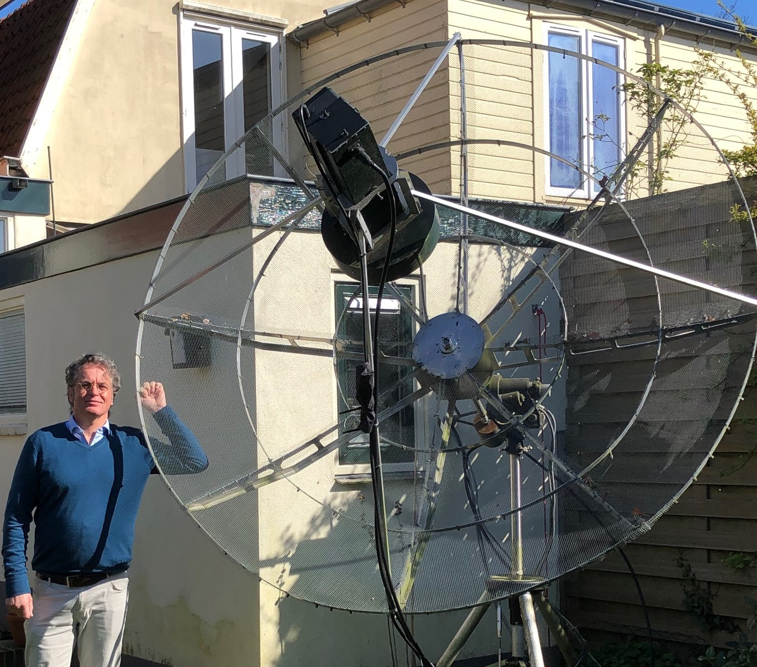
PA2DW and 2.4 m dish on 23 cm

PA2DW: Dick qtc(x)kpnmail.nl has analyzed some of the statistics of his small 23 cm station – I use a 2.4 m dish with OK1DFC feed plus choke, 2 PE1RKI power modules for 500 W at the feed, G4DDK LNA with 0.17 dB NF and a Kühne TR1296H transverter with an Elecraft K3. After many years of DXing on 2 m, including EME, I moved to 23 cm; driven upwards by the intense local noise on 2 m and also inspired by the project I worked on at PI9CAM. I lost the log of my very first app. 80 QSOs. From 2012 to now, I have made 791 QSOs with 107 initials; so many are double, triple or even more QSOs with the same station. In my favorite mode CW, I made 226 QSOs, 546 on JT65C, and 19 on SSB. The smallest station I worked using CW is probably F5KUG and using JT65C G4EZP with one 67 el yagi. My QSO’s in the last three months (from 12 Feb) using JT65C unless noted are 4X1AJ, W1PV, AA4MD, G3LTF CW, K7CA CW, KA1GT, PA0PLY, W1XM, VA6EME, K5DN CW, RA2FGG, DF2VJ, WA6HTP, RN6MA and LU8ENU. I also started activity on 3 cm with a 90 cm dish and a DB6NT G3 transverter plus 0.7 dB NF LNA. My first sunnoise measurements gave me exactly what VK3UM’s program predicted: 4.6 dB (6.1 dB on another day with higher flux). I have 18 W of power, but only a manual waveguide switch. I will give it a try soon as my tracking is working properly.

PA2V: Peter’s peter(x)pa2v.com log for his last two months of 432 EME follows – I worked using JT65B unless noted on 10 March at 1223 UT5DL (24DB/15DB), on 13 March at 2033 R1NW (23DB/17DB) for mixed initial #183*, 2057 DL5FN (15DB/16DB) and 2107 LU8ENU (23DB/15DB), on 14 March at 1827 DL8DAU (20DB/18DB), on 15 March at 1823 R1NW (25DB/15DB) and 2035 NC1I (10DB/7DB), on 17 March at 2019 TO2MB (21DB/23DB) #184* and DXCC, 2139 F8GHE (17DB/13DB) #185, 2201 F8DO (27DB/O) and 2209 US7GY (23DB/13DB), on 18 March at 1510 JA4UMN (25DB/15DB), on 19 March at 1802 YL2GD (17DB/15DB) and 2004 SM7THS (17DB/11DB), on 20 March at 1846 OE5JFL (12DB/7DB), 1900 DL2HWA (22DB/21DB) and 2044 DK0TE (28DB/25DB) #186*, 6 April at 1457 SM2CEW (359/559) CW, 1559 DL7APV (5DB/11DB) and 1633 KF8MY (26DB/27DB), 8 April at 0404 SM5EPO (29DB/17DB) #187*, on 9 April at 1503, DL8DAU (24DB/19DB), on 11 April at 1329 BD9BU (29DB/27DB) #188*, on 12 April at 1919 LU8ENU (22DB/25DB) and 1941 R1NW (24DB/14DB), on 13 April at 1353 JH3BHB (23DB/12DB) #189* - 50 W, and 2016 N0AKC (21DB/20DB), on 14 April at 1427 JS3CTQ (23DB/21DB, 1501 ZS4TX (18DB/14DB) and 1626 DL4ZAG (26DB/18DB) #190*, on 15 April at 2048 VP2EMB (24DB/22DB) #191* and DXCC, and on 17 April at 1747 DF3RU (15DB/12DB) and 1901 SM5EPO (23DB/14DB).

PA3DZL: Jac pa3dzl(x)icloud.com reports on his new QTH -- In Dec we moved to our new home in JO21ls. My old QTH was only 36 km away and also in JO21, so you will not count as a new initial. We are very pleased with the new house and location. It is in the "countryside" and we have only a few neighbors, the closest a 100m. I do not yet have any my EME antennas up. In the beginning of April I received permission from the local government to put up my tower and dish. The antenna regulations in PA are very strict these days! I am making plans for a telescopic tower and the tower for my dish. In March I build equipment for the Qatar Satellite, Oscar 100. The 75 cm offset dish in the shack and works great, and I have met quite a number of EME friends on this transponder. It is not as challenging as EME or Terrestrial DX but still nice to meet EME friends. I hope to be QRV off the Moon in the autumn.

SM4GGC: Stig stig.ake.larsson(x)gmail.com sends news of his new bigger dish and results in the Dubus Contest -- I have extended my 3 m (F/D 0.42) TVRO dish to 3.8 m (F/D 0.32). The improvement is about 2.5 dB in Sun noise. At http://sm4ggc.se/new%20owl%2014%20el%20ant.html you can see how it was done. I have also increased my power to 500 W with a W6PQL PA. The Dubus 23 cm EME Contest was very nice and all seems to work well. I QSO’d on CW OK2DL, UA3PTW, RA3EME, OH2DG, SP7DCS, OK1CS, SM6CKU, G3LTF, RA3EC, KL6M, G4CCH, ES5PC, SP6JLW, OK1CA, OE5JFL, SP2HMR, SP3XBO, OK2ULQ, SK0UX, SP6ITF, OZ6OL, IK3COJ, OH1LRY, I1NDP, DL7UDA, ES6FX, F5KUG, PI9CAM, SV3AAF, W4OP, LZ2US, DL6SH, HB9Q, PA3FXB, SP2HMR, EA8DBM, DL3EBJ, IW2FZR, F2CT, 9A5AA, DK3WG, OZ4MM, OK1DFC, DL7YC, K7CA, K2UYH and WA6PY for a score of 47x42. I also added on 14 April the VP2EMB dxpedition using JT65C.

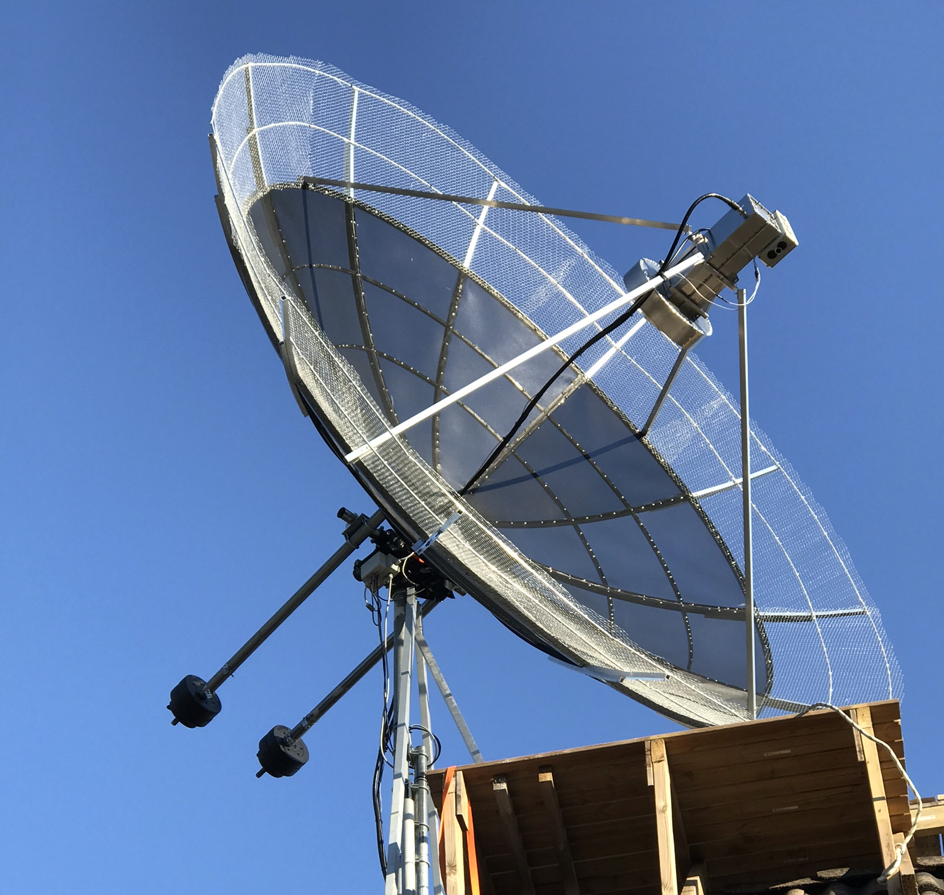
SM4GGC expanded dish (from 3 to 3.8 m)

SM6CKU: Ben ben(x)sm6cku.se had a very enjoyable time in the Dubus 23 cm Contest -- I worked 81 stations using CW and added about ten initials. Activity was great, but nil was heard nil from South America. There were a few "getaways" and if you called me without a QSO, let me know, as I know we can make it. Unfortunately, I did not read the rules until today, so I will not turn in a log. A few times I announced my CQ calling on the HB9Q logger trying to get the JT guys down to the CW portion and this is not permitted. [Submit your log as a “check log.” They want as many logs as possible, even if not contact entrees]. I used my 8 m dish and 400 W. I have installed my 6 cm gear in my 4 m dish and I am available for skeds on this band.

SM6PGP: Hannes sm6pgp(x)illipe.se was active in the 23 cm Dubus EME, but also made his debut on 13 cm -- I worked my first QSOs on 13 cm CW, 2320, with my 2.3 m dish and 350 W (2 x MRF21180) at the feed. I using a patch feed with two feed ports; it is almost a copy of my 23 cm feed. I worked so far SP6OPN, UA3PTW, ES5PC and OK1KIR. In SM we have special permits for 2320 lasting 6 months. We don’t know how long this will continue. In the Dubus Contest on 1296, I worked 20 CW stations and 19 multipliers with my 2.3 m dish and 400 W at a patch feed. QSO’d were PI9CAM, OK2DL, UA3PTW, LZ2US, SP6JLW, SM6CKU, I1NDP, ES5PC, OK1CA, OE5JFL, SP7DCS, KL6M, G3LTF, OZ4MM, HB9Q, OH2DG, RA3EME, DL3EBJ, DL6SH and OK1CS. I hope to CU all at the Swedish EME 432 & Up meeting.

SP6JLW: Andrzej (SP6JLW) and Pawel (SP6OPN) sp6jlw(x)wp.pl report on the Klodza group’s active during the Dubus 1296 Contest -- We operated under the callsign SP6JLW and completed 68 QSOs x 60 multiplies. This result was worse than in previous year because of bad WX. We suffered from a thick layer of wet, sticky snow on the dish’s surface that affected our RX. Snow removal attempts helped temporarily, but the snow kept falling intensely throughout the first moonpass of the contest. QSO’d were SM6CKU, SM4GGC, SM2CEW, SK0UX, SM6PGP, RA3EC, RA4EME, RA2FGG for an initial (#), UA3PTW, RN6MA, OK2DL, OK1CA, OK2ULQ, OK1YK, OK1IL (#), OK1CS, OK2PE, SP2HMR, SP3XBO, SP6ITF, SP7DCS, DL7UDA, DF2GB, DL6SH, DL7YC, DL3EBJ, DK3WG, IK3COJ, IW2FZR, IK5VLS, I1NDP, I0NAA (#), IK5GHY, FR5DN (#) and new DXCC, LZ2US, OZ4MM, OZ6OL, G4CCH, G3LTF, OE5JFL, KL6M, W4OP, K7CA (#), K2UYH, WA6PY, K5DOG, W4AF, OH1LRY, OH2DG, VK5MC, VK4AFL, F6KRK, F2CT (#), F5KUG, F5JWF, VE6TA, LA1K (#), SV3AAF, PI9CAM, PA0PLY, ES5PC, ES6FX, 9A5AA, S59DCD, HB9Q, EA8DBM, JA4BLC and JR4AEP. [TNX to OK1TEH for translating from http:// emejo80jk.cba.pl]

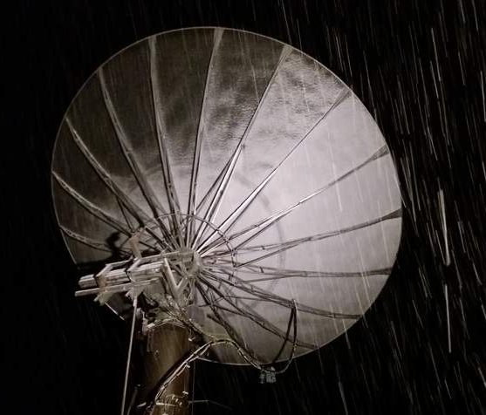
SP6JLW’s 6.5 m dish during 23 cm Dubus Contest covered with snow

UA3PTW: Dmitry ua3ptw(x)inbox.ru was QRV up to 5760 this month and added some dxpeditions QSOs – I worked on 70 cm using JT65B with VP2EMB, on 23 cm using JT65C LY/DL4DTU and VP2EMB, on 13 cm using JT65C LY/DL2NUD, and on 6 cm using JT65C with LY/DL2NUD and LY/DL4DTU – [same stations]. [TNX DK3WG for forwarding this report].

UR3EE: Arthur ur3ee(x)i.ua in Ukraine (KM78ml) added on 432 using JT65B with his single 34 el yagi using JT65B ZS4TX and R1NW. [TNX DK3WG for forwarding this report].

UR5LX: Sergey ur5lx(x)ukr.net was on 6 and 3 cm in April – I worked initials on 5760 using CW DF3RU and using JT65C LY/DL4DTU, and on 10368 using CW SM2CEW and using QRA64D G4RGR. [TNX DK3WG for forwarding this report].

VA3ELE: Peter va3ele(x)gmail.com conducted his initial testing of his new 1 and 7/8 m dish during the Dubus Contest weekend -- I am now using a 1.87 cm dish and 250satt SSPA (150 W at OK1DFC Septum feed) with WA2ODO LNA to SG-Labs transverter and a Kenwood TS2000. This is the setup that we will use for the VE2TWO - ZONE 2 Microwave EME expedition coming up from 28 June to 8 July. I will be in Sept Iles, Quebec, Canada (FO60) on 23, 13, 9 and 6 cm EME. During the Dubus weekend I QSO’d using JT65C KA1GT, K5DOG, K7CA, VA6EME, VK4CDI, W1PV, NC1I, W5LUA, F1RJ, G4CCH, DJ9YW, N5BF, WX4F, JA6AHB, VE3KRP, OK1DFC, DL7YC, PY7BS, W2HRO and HB9Q. I also worked using CW DL7YC, KL6M and OK1CA for a score of 3x3.

VA7MM: Mark (VE7CMK) and Toby (VE7CNF) va7mm(x)rac.ca report of their team’s activity on 1296 CW for the European EME Contest weekend -- Our operation was limited this year due to RF PA failure at the outset of the contest. Installation of a new 7289/ 3CX100A water cooled driver tube got us back on the air, but we missed most of the EU window on 13 April. In 4 hours of operation on 14 April we made 14 CW contacts and 14 multipliers with KL6M, EA8DBM, K2UYH, VE6TA, K7CA, VK5MC, WA6PY, JA4BLC, OK1DFC, UA3PTW, W4OP, S59DCD, DF3RU and ES5PC. We use an OZ9CR water cooled cavity amplifier. Our power at the feed of our 3 m dish is 200 W. On RX, we have a 0.33 dB NF preamp with about 35 dB gain in three stages. We are available for scheduled contacts by e-mail almost anytime.

VE3KRP: Fast Eddie sends his April report -- I worked on 23 cm using JT65C on 7 April LY/DL4DU for a mixed initial (#*) and new DXCC, F1RJ and OK1YK, on 13 April LY1EME and K5DOG, and on 14 April W1PV and VA3ELE (#*). I tried but didn't work VP2EMB. I only saw very weak traces with no decodes from them.

VP2EMB: Chris (PA2CHR) post(x)pa2chr.nl and Jos (PA3FYC) tell the story of their dxpedition -- After a nine hours flight from Amsterdam we arrived in St. Maarten (PJ4) on 10 April. We stayed for one night on St. Maarten to make sure all our luggage had arrived. If something was missing, as happened last year in Guatemala, we had the possibility of picking it up the next day before leaving for Anguilla. The next day the ferry took us in 30 minutes to beautiful Anguilla Island. The ferry is too small for cars, so we had to take all our luggage, 7 suitcases and 2 golf bags on and off the ferry by hand. A taxi brought us to a supermarket, to get food etc. for the coming days, and to our location in the North-east part of the island. As soon as we arrived, we started to assemble an antenna for 2 m and used it with a portable receiver to find out if there was any QRM around. Some QRM was heard from a neighbor’s house, but we were able to find a good location for our antennas. We operated the first and second Moon passes on 2 m, but were also QRV on 23 cm for the second pass. This was a few hours earlier than expected, mainly to work XE1XA who had to go on a business trip for the rest of the week. Some US stations including XE1XA were worked with good signals. On 13 April at 1810 the party started on 23 cm with very nice signals from EU and within 3 hours we worked 30 stations with the 67 el horiz yagi and about 120 W at the feed. In total we made 58 QSOs including 2 dupes. The smallest station worked was probably PE1LWT with a 3 m dish and 180 W. Our 70 cm operation started on 15 April with working UA3PTW (13DB). We had very nice pile-ups on this band during 2 Moon passes on 15/16 and 21 April. We worked 39 stations in total. Conditions were not good on 21 April, but just before moonset in EU they improved a lot and we were able to work PA5Y with his single yagi. I am sure we also could have worked OK1TEH with his single yagi, but he was too tired after being QRV during many nights trying work us and went QRT earlier. On 432 we used a new homemade X-pol antenna with 27 el horiz and 23 el vertical with about 300 W at the feed. This antenna seems to work very well, but we need to get more experience with it to be certain. 39 QSOs is not very much on 70 cm. We called many hours of CQ on the 21 April without any QSOs. Last year from Guatemala (TD9CHR) we had 42 QSOs, and before from Swaziland (3DA0MB) we had 47 QSOs. Is activity really decreasing on 70 cm? There must be more than 4 US stations QRV? We will see in the future. A full list of stations worked on 432 and 1296 follows: 70 cm on 15 April UA3PTW (13DB), OK1DFC (20DB), DK3WG (19DB), DL7APV (10DB), OZ4MM (14DB), PA2V (22DB), HB9Q (10DB), OK1KIR (20DB), LZ1DX (19DB), DF3RU (18DB), SM7THS (21DB), NC1I (15DB), UT6UG (18DB), ES3RF (26DB), YL2GD (23DB), ZS4TX (26DB), DL2HWA (23DB), OK1CA (17DB), UT5DL (12DB), DL9KR (CW), ON4AOI (26DB), ZS6JON (16DB), G4RGK (20DB), UX5UL (23DB), PA0BAT (23DB), DL1RPL (24DB), W5LUA (22DB), UX0FF (24DB), K2UYH (17DB), DJ4TC (25DB), DL8GP (22DB) and DK4RC (24DB); on 16 April KF8MY (27DB), JA6AHB (21DB), VK4EME (29DB) and JE1TNL (27DB), and 21 April UR7DWW (24DB) (UT5DL), DL5FN (19DB) and PA5Y (28DB). 23 cm on 13 April K2UYH (21DB), K5DOG (25DB), W5LUA (19DB), XE1XA (27DB), VA6EME (25DB), UA3PTW (27DB), OK1KIR (23DB), HB9Q (15DB), OZ4MM (21DB), G4CCH (28DB), OK1CA (21DB), OK2DL (20DB), PI9CAM (17DB), SM6CKU (24DB), DL6SH (22DB), PE1CHQ (26DB), IK3COJ (26DB), ES6RQ (23DB), PA3CSG (21DB), I1NDP (19DB), EA8DBM (22DB), DJ9YW (23DB), PA0BAT (24DB), RA3EC (24), ES3RF (21DB), PE1LWT (26DB), YL2GD (23DB), DK3WG (29DB), OK1IL (23DB), PI9CM (27DB), ON4AOI (25DB), DL7UDA (27DB), NC1I (22DB), DL7YC (25DB), DG0FE (27DB) and DK5YA (30DB); 14 April JA6AHB (23DB), VK4CDI (25DB), OK1DFC (18DB), LZ1DX (20DB), PA3FXB (26DB), DK0ZAB (28DB), G4DML (23DB), DF3RU (21DB), G4RGK (27DB), G4YTL (27DB), DK3WG (29DB) (DUP), OK1IL (26DB) (DUP), SM4GGC (28DB), DL8FBD (27DB) and W2HRO (26DB); on 15 April VE6TA (26DB), on 16 April ZS6JON (27DB), DL0SHF (13DB), ZS4TC (28DB), and on 17 April PY2BS (23DB) and K7CA (24DB). Thanks for the QSOs. We hope to CU all in Oct from A21EME on 6 m to 10 GHz.

W4OP: Dale parinc1(x)frontier.com was on for Dubus 23 cm CW Contest with his new PA -- W4SC and I operated the contest together. Our Moon time was shortened due to WX - strong winds, rain and hail. The new dish mounted 1 kW amp, running at 850 W performed perfectly. My next project is finishing a SM6FHZ round septum feed. Libration was strong Saturday and almost non-existent for us on Sunday. Worked were WA6PY, EA8DBM, K2UYH, KL6M, K7CA, N4PZ, K5DOG, SP7DCS, SP6JLW, OH2DG, OE5JFL, S59DCD, SP2HMR, ES5PC, SM2CEW, OK2DL, G3LTF, SM6CKU, IW2FZR, IK5VLS, RA3EC, LZ2US, SP6ITF, OK1CA, RA3EME, OZ6OL, IK3COJ, SM4GGC, PI9CAM, OK2ULQ, F2CT, VE6TA, OH1LRY, DF2GB, OK1CS, DF3RU, F6KRK, UA3PTW, DL7YC, SP3XBO, F5KUG, 9A5AA, OK1DFC and VA7MM for a total of 44x39.

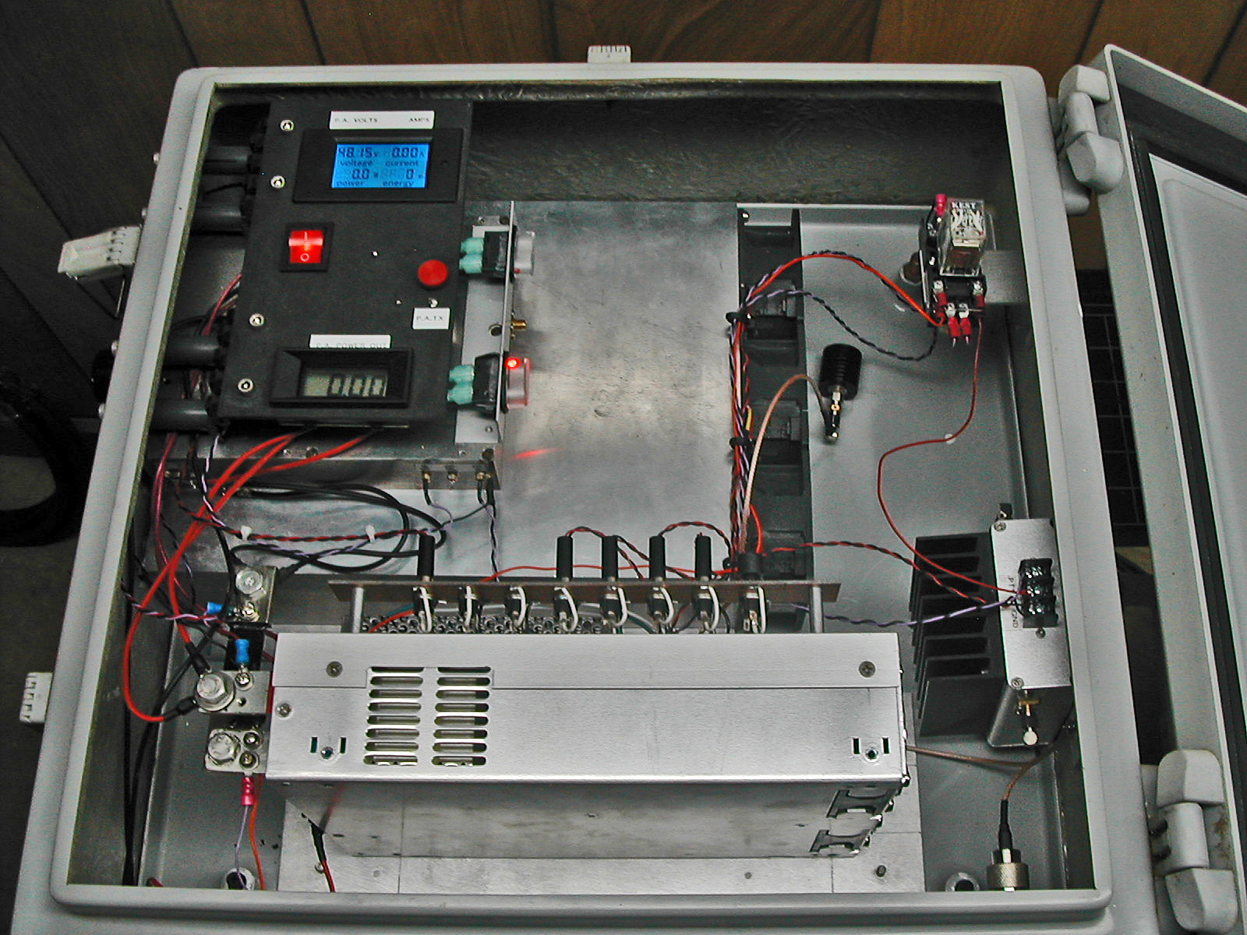
W4OP’s new 1296 1 kW SSPA

WA9FWD: John WA9FWD(x)outlook.com was operational for the 1296 segment of the Dubus Contest -- I worked a total of 26x24 including I1NDP, ES5PC, OK2DL, OE5JFL, OH2DG, OK1CS, SP7DCS, SM6CKU, SP2HMR, K2UYH, UA3PTW, SP6ITF, PI9CAM and SP3XBO on Saturday. Sunday presented its own challenges as we had a blizzard going on. I started calling CQ while the Moon was still in the trees and worked OK1CA, WA6PY, F5KUG, G3LTF, DL7UDA, RA3EME, DL7YC, OZ6OL and LZ2US before I gave up due to WX. My new high power resulted in much better signal reports than in the past and allowed me to get through faster when answering CQs, and it also seemed that when I called CQ, I received multiple callers quite often. I plan to be active in the 3 cm segment of the contest. I also will be attending the SM4IVE conference in May.

K2UYH: Al alkatz(x)tcnj.edu – I had a great time operating the Dubus Contest on 23 cm, although my score was a little down from last year, and at times conditions did not seem the best due to difficult copy from libration. I was again joined by NE2U and K2YY for parts of the contest. We QSO’d on 13 April using CW at 0014 WA6PY (559/579), 0018 W4OP (569/569), 0028 EA8DMB (559/559), 0043 K7CA (579/579), 0050 KL6M (579/579) and 0058 K5DOG (559/559). We then took a break to QSO using JT65C at 0222 VP2EMB (21DB/21DB) JT65C for mixed initial #603* and DXCC* 117. I had my linear feed in place, but it was not needed. I then returned to CW to work at 0445 JA4BLC (559/559) and 0452 VK5MC (559/559). Near moonset I tried with BV3CE using CW without success and ended up working Tom on JT65C at 0523 BV3CE (20DB/21DB) #604*. We had been looking for a high dec weekend that we were both available to sked for a few months. The next day, we switched back to my circular feed (OK1DFC septum feed with a cake pan choke ring). Right at the start (Moon clearing the trees), we had a preamp blow; I have no idea why. I replaced it with another, and had no other problem for the remainder of the contest. We worked at 2021 UA3PTW (559/589), 2029 OH2DG (569/579), 2032 SP6JLW (569/579), 2040 OE5JFL (569/579), 2046 G3LTF (569/579), 2052 SP6ITF (559/579), 2056 OK2DL (589/599), 2058 IK3COJ (559/579), 2106 SP7DCS (569/589), 2110 SV3AAF (569/679), 2115 OH1LRY (569/559), 2120 RA3EME (559/559), 2126 WA9FWD (559/559), 2130 F5KUG (559/569), 2133 OK1CS (559/579), 2139 OK2ULQ (559/579), 2151 IW2FZR (559/579), 2202 RA3EC (559/579), 2209 ES5PC (569/579), 2213 SK0UX (559/559), 2220 F6KRK (559/559) for initial #406, 2230 SM6CKU (589/589), 2236 LZ2US (579/579), 2242 I0NAA (559/559), 2257 S59DCD (559/579), 2315 OK1CA (579/579) and 2346 OZ6OL (559/559), and continuing on 14 April 0012 9A5AA (559/559), 0034 VE6TA (569/579), 0043 F6CT (559/559) #407, 0114 VA7MM (559/579), 0119 SP2HMR (559/559), 0131 VE4SA (559/569), 0150 N5BF (559/559), 0245 W2HRO (O/O), 0440 JR4AEP (559/559), 0500 N6OVP (559/559), 0524 AA4MD (559/559) #408, 2110 SP3XBO (559/569), 2116 G4CCH (569/579), 2124 DL7UDA (559/589), 2132 DF2GB (559/559), 2146 DF3RU (569/579), 2224 SM4GGC (559/569), 2234 RA2FGG (559/559) #409, 2341 DL7YC (559/569), 2315 W4AF (559/569) and 2119 W1PV (559/559) #410 for a total of 56x49. Before and after the contest, I worked on 7 April on 1296 using JT65C at 1558 LY/DL4DTU (19DB/O) with my linear feed even though they were circular pol for #602*, 1622 W1PV (4DB/6DB) and 1633 K7CA (2DB/7DB) our first on digital; on 8 April on 13 cm using JT65C at 1558 LY/DL2NUD (25DB/9DB) for mixed initial #111* and DXCC* 31 – my GPS lock failed just before this QSO and it was amazing we could complete with the drift; on 10 April on 5760 at 1734 LY/DL4DTU (16DB/23DB) using JT65C for mixed initial #61* and DXCC* 29 and 1758 DB6NT (569/559) with CW for initial #56; on 11 April on 10368 we looked for LY/DL2NUD with out any success, and at 0227 JA6XED (O-559/O) CW XB for initial #31; on 15 April on 432 at 2237 VP2EMB (18DB/17DB) using JT65B for mixed initial #989* and DXCC* 137; and on 19 April on 3400 at 0239 KD3UY (25DB/10DB) using JT65C for mixed initial #59* with only 8 W and at 0305 KD3UY (15DB/15DB) using QRA64D. Although I was able to work Bob on both JT65C and QRA64D. I achieved detection much quicker with QRA64D. I plan to be on 10368 CW for the Dubus 3 cm Contest. If time/activity on 3 cm permits, I will try to get on a bit for the ARI EME Contest. It is too bad both these contests are on the same weekend.

NET/REFLECTOR NEWS: F8DO reports copying VP2EMB on 13 April at (25 dB) on JT65B with his 2x21el F9FT. Unfortunately, Marius could not TX at the time. DL9KR reports working SV9/SV1BTR back on 9 Aug,1995 using CW of course. Jimmy was using 2 x 19 el FT yagis and 180 W. F6KRK was QRV during the 1296 Dubus Contest. For sked info contact Bruno (F1MPQ) at f1mpq(x)orange.fr. RA3Y, Vladimir, a well known DX and VHF operator was reported to be QRV during the Dubus 1296 Contest. He can be reached at ra3yf(x)mail.ru. LU8ENU could not participate in the 23 cm Dubus Contest because his 1296 dish is quite low and was blocked by trees. His 432 yagis are higher and were useable during weekend to enable Juan to add several initials. PY2BS’s mail address has changed and is not receiving QSLs sent to his old address. He is getting a new Postal Box, but for the present please use his home address: Bruce Halasz, rua Marcus Pereira 258 apto 241, Sao Paulo, SP, 05642-908 Brazil. If you are missing any of his cards, let him know. W7CJO will be active during the 10 GHz Contest. Jim is also setting up for digital and will have it as an option in the future. VE4MA also plans to be QRV on 3 cm for the Dubus Contest.

TECHNICAL CORNER: Rex (VK7MO) wrote an interesting article about the new IC9700 transceiver. See http://www. ok2kkw.com/next/review_of_the_ic9700.pdf. There is even YouTube video: https://www.youtube. com/watch?v=u0MqtZNyzLE.

RADIOASTRONOMICAL CORNER:

FIRST DIRECT PICTURE OF CLOSE SPACE AROUND BLACK HOLE AT 230 GHz – Virgo M87

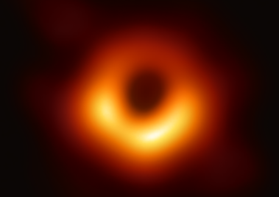

Scientists have obtained the first image of a black hole, using Event Horizon Telescope observations of the center of the galaxy M87. The image shows a bright ring formed as light bends in the intense gravity around a black hole that is 6.5 billion times more massive than the Sun. This long-sought image provides the strongest evidence to date for the existence of supermassive black holes and opens a new window onto the study of black holes, their event horizons, and gravity. Credit: Event Horizon Telescope Collaboration. eventhorizontelescope.org. See more at the following sites:

https://eventhorizontelescope.org/files/eht/files/20190410-78m-4000x2330.png
https://iopscience.iop.org/journal/2041-8205/page/Focus_on_EHT

Note, if you want to detect noise from Virgo M87 at your home and you don't have big dish capabilities, I found nice article on how to build small and cheap interferometer, which is working in 74 cm band:
http://www.britastro.org/radio/projects/temp/Detection_of_Radio_Source_VIRGO_A.pdf Later Joe, K1JT wrote me that he made similar project in 1964:
http://physics.princeton.edu/pulsar/k1jt/Low_Cost_Radio_Telescope.pdf. It’s interesting how little the world seems to have changed since that time.

SUN NOISE: Good news from I0NAA. He is testing a new version of his Total Power software. This program allows the measurement of noise with the RTL-SDR. It is the basis of his project to allow automatic fine adjustment of his antenna’s pointing. The program is also very useful in collecting drift scans of cosmic noise sources. He’ll release the final version during May on his web site: http://i0naa.altervista.org/index.php/downloads. If you want to help with beta-testing, please write Mario via his email mario.i0naa((x))gmail.com. If you are looking for Sun noise measurements, please check out the link at the NL headline.

FOR SALE: PA0PLY’s 24 GHz preamp production has encountered a major delay. After releasing 5 units at the EME2018 Conference, it was found that off-band oscillations made the units unstable. They are working on a solution for the 5 units, and a new PCB design has been produced in the meantime. More info at http://www.pa0ply. nl/sspa_amplifiers.htm. WA9FWD has for sale a number of Toshiba 9 cm SSPAs. These are the UM 2683B versions that have been modified with the DL7YC mods. Contact John at wa9fwd(x)outlook.com for details. WA2ODO has for sale very good working HP 8970b noise figure meter. Battery changed, tested and checked against a calibrated unit. Price is US$290 + shipping. Pete sell the noise heads too. If interested contact him at pmanfre((x))gmail.com .
FINAL: If you are interested in having Microwave Activity Weekends (MWAW) this summer write to G3LTF.
► Örebro 2019 (The 432 & UP Swedish EME Meeting organized by SM4IVE) is only a few weeks away - to be held on 24-26 May. Based on reports, there should be an excellent turnout this year. See more at http://www.sm4ive.com/ememeetingmay.htm.
► Is your grid locator on your QSL card? G4DDK was organizing his QSLs in order to apply for a grid locator related award. He was surprised by how many EMEer’s QSLs did not include their locator.

► Dan (HB9CHQ) asked me to remind everyone that to sign into the HB9Q EME Logger to use https://hb9q.ch.
► There is still more to say. I want to continue the discussion on the 432 WAC and the 1296 Up WAC Clubs. But both of us have run out of time and hopefully will do better next month.

► We both plan to be active off the Moon on the contest weekend of 11/12 May. [OK1TEH in the ARI Contest, and K2UYH primarily on 3 cm]. If you are QRV on 3 cm don’t missed the Dubus event. 73, Al - K2UYH and Matej – OK1TEH

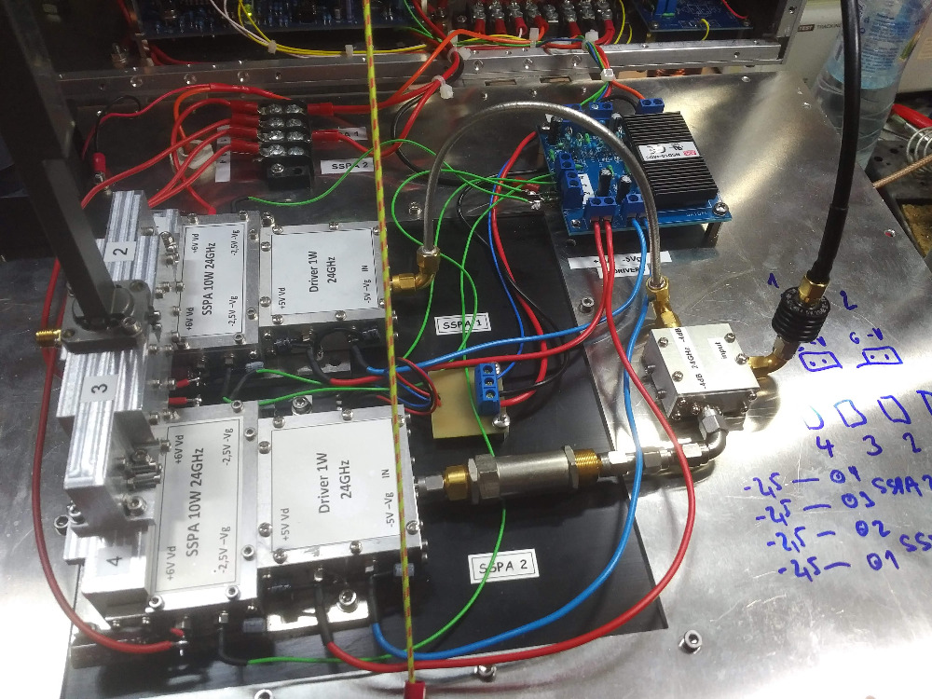

OK1DFC’s new 24 GHz 23 W SSPA based on JA1WQF’s design

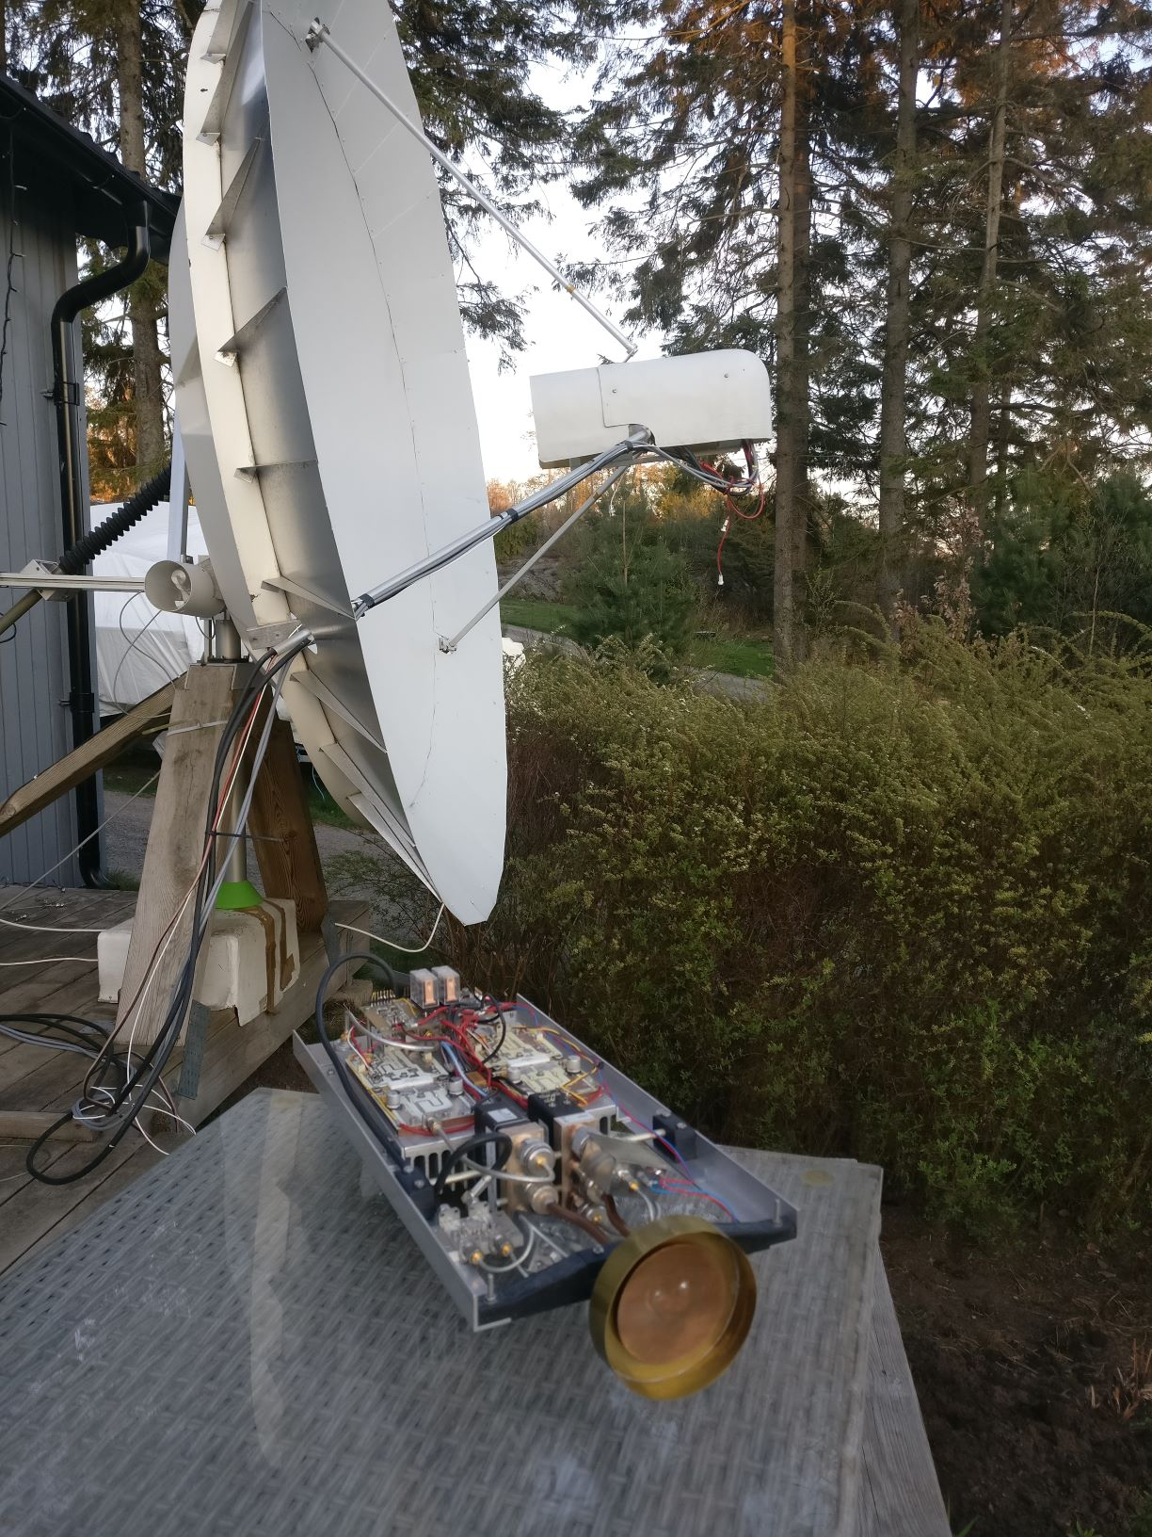
SM6PGP’s 2.3 m dish with patch feed & 350 W SSPA

