432 AND ABOVE EME NEWS
NOVEMBER 2015 VOL 43 #11

EDITOR: AL KATZ, K2UYH; DEPT. ELECTRICAL/COMPUTER ENGINEERING, THE COLLEGE OF NEW JERSEY, PO BOX 7718 EWING, NJ 08628, TEL (W 609-584-8424) OR (H 609-443-3184), FAX (609-631-0177), E-MAIL alkatz(x)tcnj.edu
NETNEWS EDITOR (based Reflector News) REIN, W6SZ pa0zn(x)arrl.net WITH HELP OF N4PZ AND WB2BYP
INITIAL LIST G4RGK, DAVID DIBLEY, E-MAIL zen70432(x)zen.co.uk, AT: http://www.zen70432.zen.co.uk/Initials/index.html
EME INFORMAL NETS: 14.345, ~1500 SATURDAY AND SUNDAY, NET COORDINATOR: Steve Gross, N4PZ n4pz(x)live.com
ON0EME EME BEACON, 1296.000 IS QRV WHEN MOON >10°, SEND RX REPORTS TO WALTER (ON4BCB) on4bcb(x)gmail.com
DL0SHF 3 CM EME BEACON, 10368.025, SEND INFO & QUESTIONS TO Per (DK7LJ) per(x)per-dudek.de.
NL EMAIL DISTRIBUTION and EMAIL LIST CORD: WARREN, W2WD wbutler(x)ieee.org [TXT OR PDF OR "ON WEB" NOTICE]
THE NL WEB VERSION IS PRODUCED BY REIN, W6SZ AND AVAILABLE AT http://www.nitehawk.com/rasmit/em70cm.html

CONDITIONS: No matter how you feel about the rules, there was plenty of fun to be had during the first weekend of the 50 thru 1296 part of the ARRL EME Contest. Conditions and turnout seemed great, especially on 23 cm. I and others did observe non-reciprocal polarization (TX pol was near 90 degs to the best RX pol) on 70 cm much of the time, but reports show some excellent scores. DL7APV made 77 QSOs! Activity was clearly better on 1296 than 432; there W6XY reports the highest score with 85x46. F5SE/p scored 71x33 with all QSOs on CW. I suspect there are others from EU who used JT and CW that may be higher. I ended on 23 cm with 60x55, which is one of my better scores for the first weekend. The final leg of the contest is coming up on 28/29 Nov – don’t miss it! However, the EME contest is far from the whole story. This month’s dxpedition activity was truly exceptional and there was also a very successful 24 GHz EME activity weekend (AW). Thank you to all the great dxpedition teams! The Saint Maarten Island dxpedition, operating both the Dutch (TO2EME) and the French (PJ7/PE1L) sides deserve the highest of honors. Both JT and CW QSOs were provided. TO2EME made 63 initials on 1296 with 13 CW contacts, and PJ7/PE1L was not far behind with 54 initials on 1296. At the same time, the N1VT team did an absolutely superb job putting the state of VT on 432 and 1296 EME. See the reports on both these dxpeditions in this newsletter (NL). And more dxpeditions are on the way. From 19-29 Nov HK0/DL2NUD will be QRV from San Andres Island (EJ94) on 70, 23, 13, 9 and possibly 6 cm. About the same time, on 18-25 Nov FH/DL1RPL will be active on 70 cm from Mayotte Island (LH27). On 25 Nov, he will move to Reunion Island and QRV as FR/DL1RPL between 27 Nov – Dec 3. See details in reports in this NL. The 24 GHz AW proposed by LX1DB on 24/25 Oct was a great success and is reported on in this NL.

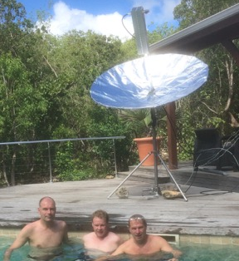
EME PJ7/PE1L style – 1.8 m dish used also at TO2EME

AE7OV: Gary gklust(x)hotmail.com is a new station on 432 EME from AZ -- I am still an EME newbie with only 50 W out of a TS2000 and an array of 4 x14 el homebuilt (HB) DG7YBN yagis. I also have a HB rotor system with an Arduino controller. I am also interested in skeds.

DK3WG: Jurg dk3wg(x)web.de has been very busy off the Moon on 70 and 23 cm –- Since my last report, I added initials on 432 using JT65B W1PV (using 2 x 25 el yagis and 100 W), TO2EME for DXCC 121, G3LGR (QRP), N1VT, PJ7/PE1l for DXCC #122 and YO2BCT, and on 1296 using CW F5SE/p, SP6JLW, DL3EBJ, RA3EC, VE6TA, LZ2US and SP7DCS and using JT65C OK1YK, 5B/DL2NUD for DXCC 46, DJ2DY, I0NAA, KD3UY, TO2EME for DXCC #47, OE9GLV, IK5EHI, IK2MMB, EA1RJ, RW0LDF, PJ7/PE1L for DXCC #48, N1VT, WA2FGK, G4EZP (single yagi), WB7ABP, K6JEY, WA3GFZ, VA7MM, VE4MA and G4BAO.

DL1NAW: Thomas thomas.lauterbach(x)franken-online.de is setting up a small radioastronomy experiment at the Nuremberg Observatory during which they will receive ON0EME signals. Since the antenna gain they will have available will not be sufficient for direct reception, they will see the signal’s spectrum by integrating over multiple transmissions. [TNX to ON4BCB/ON0EME for forwarding this report].

DL7APV: Bern dl7apv(x)gmx.de did very well on 432 in the ARRL contest – I was lucky to work 77 in first weekend on 432; my best ever count for the first leg. There were another 12 getaways that I had on my list. JT65 kept me busy most of the time, so I only made a few CW QSOs. I hope to make more CW contacts in the next leg. Hopefully the WX and condx will as good as in first leg. As usual, I used the HB9Q logger and will only send in a check log. I have no numbers but OH2PO and UA3PTW were also very busy and should have equivalent numbers. Activity was very good and a few new ones found their way into my log. I was especially happy to work N0IRS (MO) for my 49th US state. I received a booming signal from SM7GVF with his single yagi and 800 W.

F6DRO: Dom f6dro(x)wanadoo.fr is QRV on 3 cm EME using CW only. He easily worked PA0BAT and is looking for skeds. He often checks the HB9Q reflector. He has a 1.2 m dish.

F5SE/p: Franck’s kozton(x)free.fr ARRL contest report -- During the Oct/Nov leg of the contest, I tried to be active on 1296 as long as the Moon was available at my location. I ended up with a score of 71x33 with all QSOs on CW. Only two new stations were added this time: UA9YLU (539/559) for initial #185 and LU1CGB (319/559) #186. Just before the contest, I worked my old friend F6ETI (329/529) for #184. We managed to "re-work" ourselves later during the contest. As usual, activity was sustained in Europe, but low in North America. Due to a lot of technical problems involving my tropo equipment, (thank you Murphy!), I spent too much time doing repairs. Therefore, I did not work at all on my EME rig. Nothing has been changed for months. I keep using my 500 W PA, located 2.7 dB from the dish horn. A new septum-feed is ready to go, but still waiting on the work bench for its first "real life" tests on the dish.

FH/DL1RPL & FR/DL1RPL: Peter (DL1RPL) peter(x)dl1rpl.de reports will be active on 70 cm from Mayotte Island (LH27) on 18 Nov to 25 Nov. He will then move to Reunion Island (LG79) where he will be active from 27 Nov to 3 Dec. He has not yet posted his schedule for 432 operation (he will also be QRV on 144) - see www.dl1rpl.de for schedule details. Peter will operate on 432.090 using 2 x EF7017 yagis and a 400 W SSPA. He hopes to have Internet from the beginning and will use HB9Q for 432.

G3LTF: Peter’s g3ltf(x)btinternet.com Oct-Nov EME report – I was activity on three bands this month, all CW/SSB. On 8 Oct, I was on 13 cm looking for 5B/DL2NUD. He was speaker level on JT when he had the dish on the Moon, but I never managed to make a CW QSO. I worked ES5PC on SSB and OK1YK #123 on CW. On 24 Oct on 23 cm I was delighted to work TO2EME on CW for initial #413 and DXCC 65. The new PA7JB designed dish and tracker gives them a very consistent and readable signal. The next day, I worked them on 13 cm for initial #124 and DXCC 41. On 432, I could barely see a trace of them on the SDR. Due to absence and weather, and a touch of Murphy, I missed them in PJ7 on all bands, but it was a great effort by their team. On 27 Oct, I was pleased to work WA3FGK #125 and give Herb his 3rd 13 cm QSO. In the contest, I was not able to be on for the first pass and as my 70 cm feed was faulty, I stayed on 23 cm for the 2nd and 3rd passes. On 31 Oct I worked VK3UM, OH2DG, KL6M, DL3EBJ, JA4BLC, SP6JLW, OK1CS, RD3BA, RA3EC, SM3JQU, UA9YLU, F5JWF, OK1CA, JR4AEP, VK5MC, UA3PTW, I5MPK, F5SE/P, DG5CST, S53MM, OE5JFL and SP7DCS. I quit at 2400 as I was very tired after a busy week and didn’t resume until 0830 on 1 Nov. My SDR then went screwy and I spent quite a time sorting it out, (partly why I missed PJ7). I then worked W6YX, VE6TA, WB2BYP, OK2DL, SM4IVE, K1DS, PI9CAM, WA6PY, WA9FWD, N1VT #414, VA7MM, VE4MA, K9KFR and N4PZ. On the 3rd pass I worked VK3UM and OK1DFC through wet trees and then LZ1DX, IK3COJ, JA1WQF, 9A5AA, SM3AKW, G4CCH, VK4CDI, F6ETI #415, SP3XBO, YL2GD, PA3FXB, SP6ITF, JA6AHB, I5YDI and IK5VLS for a total of 52 QSOs in 7.5 hours operating, a pretty good rate. The next day I repaired the 432 feed. The coax braid had frayed at the back of the Pawsey stub due to the rotation and may have degraded my receive performance. On 3 Nov I went on 70 cm and worked YL2GD for initial #459 and DXCC 74, SM7GVF #460, which was a completely random single yagi QSO! On 3 Nov, I added UX0FF #461 and PA2V #462. Amazing, no new initials on 432 for a year and then 4 in 2 days! Its a great shame that people over-estimate the difficulty of working CW on 432. When one end has full polarization control, a single yagi with 1 kW is easy to work. I hope to be on 23 and 70 cm in the final leg of the contest, weather permitting. Finally, it was only when putting this report together that I realized that YL2GD was a new 70 cm DXCC for me that doesn’t happen very often!

G4BAO: John john(x)g4bao.com was QRV on 23 cm in late Oct and during the ARRL contest -- I worked on 21 Oct at 2112 W3HMS (25DB/27DB) JT65C for digital initial {#19} and 2124 OK1CS (19DB/15DB) JT65C {#20}, on 31 Oct at 2349 RA3AUB (19DB/16DB) JT65C {#21} and new DXCC and 2355 SP5GDM (17DB/20DB) JT65C,
1 Nov at 0001 OK2DL (11DB/O) JT65C {#22}, 0023 PI9CAM (4DB/9DB) JT65C {#23}, 0030 PI9CAM (549/529) CW initial #4, 0053 JA1WQF (19DB/19DB) JT65C {#24} and new DXCC, 0658 IK5VLS (19DB/20DB) JT65C {#25}, 0725 VE4MA (21DB/O) JT65C {#26} and new DXCC, 0737 PA3CSG (13DB/13DB) JT65C {#27}, 0746 N1VT (19DB/24DB) JT65C {#28}, 0753 VA7MM (19DB/21DB) JT65C {#29}, 0805 DF3RU (14DB/O) JT65C {#30}, 0832 DK6WG (20DB/O) JT65C {#31}, 0923 W6YX (15DB/O) JT65C {#32} and 0942 KL7UW (21DB/17DB) JT65C {#33} and new DXCC for a score of 16x13. I am using 1.9 m dish with a SM6FHZ CP patch feed, a 180 W TX and a 0.3 dB LNA. I couldn't hear TO2EME on 23 cm and missed them on 13 cm due to holiday travel! I find that many "big dish" stations have got so used to having easy copy signals. Giving RST reports is becoming the norm rather that the exception. I never know what to expect or how to react to the reports in the excitement of having a rare CW contact! I'd like to make an appeal for everyone to stick to the basic procedures (use 2.5 min sequencing, and M-O reports unless you know the other station is copying you well) when working newbies like me. By all means exchange RST and ragchew with big stations, but remember that in many case small stations may not be hearing you as well as you hear them. Really small dishes tend to be noisy and non-reciprocal (better on TX than on RX if they have reasonable power. With a sub 2 m dish, it is a very different ball game. I feel it more akin to EME in the 70s than EME today.

G4RGK: Dave’s zen70432(x)zen.co.uk report for the NL -- Prior to the contest, early on 30 Oct, I worked N1VT on 432 for VT, which was a new state for me. I got on at the start of the contest after a 12 hour day at work, and was not really feeling much like staying up all night. However, conditions seemed quite good on 23 cm as I got the dish on the Moon and I quickly QSO’d EA8DBM, SP6JLW, F5SE/P, JA4BLC, SM3AKW, DF3RU, OK2DL, RA3EC, DL3EBJ, N1VT, PJ7/PE1L and RA3AUB. After that I went down to 2 m to pick the PJ7 on that band, and then back to 23 cm to work UA4HTS, W3HMS, YL2GD, 9A5AA, K2UYH and HB9Q. By that time it was 0600 local time and I had been up for nearly 24 hours, so I took a look on 432, but only QSO'd DL7APV before I quit for the night. I came back at moonrise on 432 and worked PI9CAM, HB9Q, OK1DFC, JA6AHB, JE1TNL, I2FHW, OH2PO and UA3PTW. I then QSY'd to 23 cm for a while and added S53MM, I1NDP, SP5GDM, JA1WQF, SP7DCS, IK1MTZ, PI9CAM, UA9YLU, SV1CAL, I5MPK, LZ1DX. Then back to 70 cm to work PJ7/PE1L, ON4AOI, PA2V, YL2GD, LU8ENU, K2UYH, W6YX, S51ZO, PA0PLY, WA4NJP, DF3RU, UA3PTW, OK1TEH and YO2BCT for total of 55 stations. I am not sure of the multipliers. I probably won’t be putting in an entry as I don’t have time for the paperwork.
HK0/DL2NUD: Dan (HB9CRQ) dan(x)hb9q.ch writes -- Hermann asked me to send this HK0 dxpedition update. If all goes well he will be QRV on the following dates/bands from moonrise (MT) to moonset (MS) from San Andres Island (EK92dn): 19 Nov 1296 (If all goes perfect – best case), 20 Nov 1296 (realistic case), 21 Nov 1296, 22 Nov 2320/2304, 23 Nov 2320/2304, 24 Nov 3400, 25 Nov 5760 (tentative, not sure yet), 27 Nov open – to be decided (TBD) based on requests, 28 Nov open (TBD) and 29 Nov open (TBD). Herman will use his 1.5 m dish on all bands with (at feed) on 23 cm 200 W, 13 cm 300 W, 9 cm 100 W and 6 cm 55 W. MR and MS elevations not known yet. It will not be perfect, he hopes for not too many restrictions. QSLs for QSOs on the GHz bands should be sent to DL2NUD with $2US and SAE. Joe (DL9MS) will be operating on 144 and 432. He will also use HK0/DL2NUD. The schedule for 144 and 432 operation is not yet set. On 70 cm, he will use a single 12 el yagi and 400 W. 432 QSLs should be sent to DL9MS. [The was a software glitch using HK0 call with WSJT and MAP. This problem has been fixed in the latest version of JT – TNX Joe. They will use the new version and recommend all wishing to work them to download and use the new release of WSJT and/or MAP65].

I1NDP: Nando nando.pellegrini(x)tiscali.it had limited activity during the Oct/Nov leg of the ARRL contest with on 1296 48 CW QSOs in a few hours of activity and on 432 8 JT QSOs. It was great fun. I'll try to do more during the last leg. I cannot refrain from congratulating the operations from TO and PJ7 dxpedition: great signals on 23 and 70 cm.

JA4BLC: Yoshiro ja4blc(x)web-sanin.co.jp was QRV for the 24 GHz AW and then for the EME contest -- I enjoyed the 24 GHz AW on 24/25 Oct. Before the weekend, I suffered from low sun noise (-3 dB lower) and finally realized that my feed was 62 mm further from the focal point because I had added a twisted waveguide (62 mm long) for my test with W5LUA in April. The feed base was moved 62 mm back! This time, I put the straight WG after the horn. Once corrected, I worked VK3NX (M/O), JA1WQF (O/O), JA6CZD (O/M), OK1KIR (O/O) and a partial F2CT (M/O). The next day (26 Oct), I QSY’d to 5760 and worked JA8ERE (569/559) - Mikio has replaced his 3 m TVRO with a 4 m solid dish. On 29 Oct on 6 cm again, I worked JA8IAD (M/O) for initial #34, HB9Q (579/579) and JA8ERE (579/549). During the ARRL contest weekend, I QSO’d on 23 cm CW OK2DL, DL6SH, DL3EBJ, SM3AKW, RA3EC, G4RGK for initial (#), VK3UM, WA9FWD (#), W6YX, JA1WQF, N0OY, K2UYH, KL6M, OK1CA, SP6JLW, OE5JFL, DF3RU, OK1CS, VK5MC, G3LTF, SP7DCS, I5MPK, I5YDI, F5SE/P, OK2ULQ, S53MM, IK5VLS, IK2MMB, LZ1DX, I1NDP, SP6ITF, YL2GD, OK1DFC, IK3COJ, G4CCH, 9A5AA and JA6AHB for at total of 37 stations.

JH1KRC: Mike jh1krc(x)syd.odn.ne.jp was QRV on 1296 during the Oct/Nov EME contest but had some bad luck – I am now living in a new QTH where my shack is located only 2.5 km away vs. 260 km before – very much better! I tried to work the PJ dxpedition at an EL of 8 degs during the contest. Unfortunately I discovered my dish come not go below 10 deg. This was caused by lower limit safety chains put in place years ago. My drive actuator was damaged as a result of the blockage. A plastic gear inside the motor now slips and only makes noise. Before this mishap, I made my first and last QSO of the weekend with K2UYH at EL around 10 deg. The QARL3624 actuator I use is not inexpensive. I hope to be QRV again at the end of Nov for the last weekend with my 4.4 m TVRO dish and 500 W at the feed from (QM06aw).

K1DS: Rick rick1ds(x)hotmail.com had a successful 1296 EME weekend during the EME contest -- For the Oct/Nov contest weekend, I managed to get my portable dish and 23 cm feed set-up during the day on Friday and had the rest of my gear ready by the evening. In the direction the Moon rose (AZ 66 degs), I was blocked until about 0400. I then started hearing CW from F5SE/P through the trees. I worked him first (559/419). It was very cold, close to 2 deg C, so I only worked 8 CW QSOs the first pass including OK1CS, SP6JLW, OK2DL, K2UYH, I5MPK, W6YX and OZ4MM. My Saturday eve pass was better and a bit warmer outdoors. Starting at 0456 on CW, I worked OK1CA, SP7DCS, OK2DL, I1NDP, SM4IVE, DL3EBJ, OE5JFL, SM7FWZ, RA3EC, LZ2US, WB2BYP, ON5RR, G4CCH, PI9CAM, S53MM, HB9Q, G3LTF, WA6PY, W6YX and WA9FWD for a total of 28 QSO all on CW. Heard but not worked were N4PZ, SM4DHN and F5JWF. I was excited to have several QSOs with other 3 m dish stations. I am still trying to get my computer and RIGblaster to work together to try some WSJT. I will try to be on 70 cm for the last weekend.

K4EME: Cowles candrus(x)mgwnet.com reports on his 1296 and 432 contest results -- I had great time and much fun on during the ARRL contest weekend! The first night, I had crystal clear skies and a very bright visible moon for tracking. At my moon rise, around 0130, I started working 70 cm first due to tree blockage of my 23 cm dish at lower elevations. On 70 cm I worked DL7APV, UA3PTW, OH2PO, OH2DG, LU8ENU, DL8GP, DF3RU, PA2V, KN0WS, and SM7GVF on JT65B. At this point I switched to 1296 and tried to work HB9Q. I could not get a reply and watch as station after station worked HB9Q, who was booming in. I thought maybe my HB 500 W amp may have died. I turned on the spectrum analyzer in the radio room and saw a strong signal on my transmit, and was relieved. At this point I realized that I had not corrected for the Doppler when I shifted bands from 432 to 1296. Never having both bands before during a contest, I never had a chance for this to happen before. I corrected the Doppler and HB9Q answered me, and I was making initials on 23 cm. I then worked HB9Q, EA8DBM, K2UYH, IK5VLS, G4CCH, OK2DL, PA3FXB, W6YX, IK2MMB, N1VT and WA3GFZ – all initials. At 1100, I decided to take a short nap before JA and VK window. I slept right through my alarm, (bummer). I am sure this cost me some QSOs! The second night the WX was not near as nice. It was completely overcast, no moon to see most of the night, and some rain to make matters worst. I again started on 70 cm at moonrise and worked G4RGK, ON4AOI, I1NDP, PA0PLY, OK2POI, YO2BCT and W6YX. By then the moon should have been above the trees for the 23 cm dish; however, I could not visually confirm due to the cloud cover. I tuned in the ON0EME beacon frequency and moved the dish along the arc back and forth and then saw the beacon on the waterfall and copied the CW and knew I found the moon! I then tuned to a clear frequency and found my echoes. I started tuning through the CW portion and heard station after station, but at the time was in JT65C mode, so I figured I would proceed there first since I would have to reboot the computer to change to CW mode. I tuned to 1296.049 and heard PI9CAM very loud! At this point I could see the moon for a moment through a break in the clouds. I figure PI9CAM might hear me even with my little 3 m dish. He came right back. He was so loud, that I made a short video of his signal; see https://www.youtube.com/watch?v=6TlEmVDpTZo. I added ES6FX, RA3AUB, IK3COJ, EA3HMJ, VE4MA, and VE3KRP. All initials. At this point I needed get some to sleep. This time, I set two alarms and did awake in time to work JA6AHB and VK4EME on 70 cm. My total was 37 with 18 initials on 1296, and 19 contacts on 432. I am very pleased with my progress in going from nothing on 23 cm to having an operational station in less than a year! There is a lot of room for improvement, but I am operational and making QSOs. My next step is to get my 6.1 m dish up and functional. I heard more stations this weekend on EME than I ever before on both CW and JT. It sounded a little like contests on the HF bands. I apologize for any QRM that I may have caused stations trying to work PJ7/PE1L. I realized that I was closer to their frequency than I thought due to the Doppler. As soon as I realized the problem, I quit transmitting. Up until this weekend, I had only worked 2 stations on 1296, DK3WG and W7MEM. I made 9 times that number in a single weekend! I am planning to be on both 23 and 70 cm again in the final leg and hope to work some of the many stations I missed. I will also try to be on CW more often.

K6JEY: Doug drzarkof56(x)yahoo.com was on 1296 for the 31 Oct contest weekend -- We had a crew of 6 beginners and some older hands to put up the sidewalk gear. There were few technical problems this time. Signals were very good and hand tracking was easy with a nearly full, clear, Moon. We made 10 contacts using both CW and JT. A dongle SDR receiver connected by a splitter after the preamp worked well. I thought we had a good score for the few hours we had on the moon. I am now working on building a 13 cm station. I have all the gear and will be getting a complete 2.4 m dish by the end of Nov with a 65 W SSPA and 0.2 dB NF LNA. This dish should be small enough to be portable.

K7ULS: Mike k7uls(x)yahoo.com writes on his weekend during the ARRL contest on 432 – I used a single 28 el 9 wl yagi with only 70 W, but added 4 new DXCCs. QSO’d using JT65B were on 1 Nov at 0437 UA3PTW (22DB/O), 0520 DL7APV (28DB/O), 0550 DK3WG (24DB/O), 0614 HB9Q (22DB/O), 0702 K2UYH (19DB/O), 0811 OH2PO (18DB/O), 0825 WA4NJP (25DB/O), 1451 JA6AHB (26DB/O) and 1511 VK4EME (27DB/O).

KB7Q/KH6: Gene geneshea(x)gmail.com is planning to put Hawaii on 432 in Feb -- I’m building a small 70 cm EME station to take over to Hawaii for the month of Feb. My XYL (Joyce) and I have a house rented on the Big Island. Preliminary info can be found at http://kb7qgrid.blogspot.com. Some of the EU folks need KH6 to complete WAS, so we’ll see what can be done. A W6PQL 500 W amp is 95% complete; a pre-amp is on the way, and I have the loan of a 70 cm transceiver. So as soon as I get a longish yagi, I’ll be able to do some testing from here in Montana. I also look forward to doing some summer trips to out to put WY and SD on 70 cm EME. Joyce claims to like these combo camping/EME adventures!

KL6UW: Ed kl7uw(x)acsalaska.net sends news on his contest activity on 1296 -- I started out the weekend with great plans, but then Murphy arrived! I horrendous noise on 144 and other issues that made operation impossible. So I decided to concentrate on 1296. Well this didn't start out well either. The dish did not want to move and the mains AC power kept cutting out. I finally resorted to running an extension cord to the dish for the PS and somehow found a strong signal on the Moon. I worked K2UYH on JT65C, starting with (18DB) and as I got the dish pointed right (10DB). Next I worked HB9Q and with their huge signal, peaked (1DB)! My azimuth readout looked 7 degs out of calibration. But using that as an offset managed to work OK2DL (4DB), ES6FX (10DB), PA3FXB (13DB) and N1VT (18DB) the first night. I restarting operation at 0800 on 1 Nov after sighting in the dish on the Sun during the day on Saturday (confirmed 6.5 deg error in AZ). I worked PI9CAM (1DB/5DB) - what a loud signal!, RA3AUB (11DB), W6YX (6DB), WA3GFZ (15DB), RW0LDF (24DB), UA6AHB (12DB), JA1WQF (16DB) – after a bit of sleep, VA7MM (16DB) and UA9YLU (12DB). I was disappointed to miss the VK's by oversleeping an hour. I also took about 40 -minutes to re-configure the dish’s AZ range in the early morning dark at -6 deg C - (its winter here). I could have worked more on 1296, but was learning how to compensate Doppler, etc. I used my SDR-IQ for viewing the band with a frequency offset making things more interesting. I was happy to work 17 stations in about 5 hours. I will be trying to do some CW during the 2nd WE; signal reports indicate that should go well. I used my 4.9 m dish, 125 W at feed and a G4DDK LNA.

KN0WS: Carl carlhasbargen(x)q.com reports on his first weekend of experiences in the ARRL contest -- I suspect this time of year their are lots of e-mails regarding success in the contestI was on 70 and 23 cm. There was cloudy and intermittent rain the first night. I did 70 cm using my 6 m dish. I spent it huddled under my canopy and would take tarps off the equipment when the drizzle would let up. I completed with PA2V (23DB), DL5FN (24DB), DL7APV (18DB), K4EME (19DB), OH2PO (18DB), DF3RU (18DB), UT6UG (25DB), HB9Q (16DB), JA6AHB (22DB/14DB), VK4EME (21DB) and W6YX (23DB) for a total of 11. I also heard YL2GD (20DB), W7MEM (16DB) and ON4AOI (-21). I had recently changed my relay box to convert the system to separate TX and RX lines, but the new box had an ARR preamplifier instead of my K4EME preamplifier. I had better success during the DUBUS contest in Aug, so I will certainly go back to the K4EME preamp. I have now taken the mesh off the dish for the winter and will hope to get it back up in early May. I was eager to use my new portable 3.6 m dish on 23 cm the second night, but was disappointed. The conditions were cloudy and pretty windy. My canopy blew over and rolled 30’ into my dish setup. The dish was not damaged, and the alignment was off. Without a visible moon, it was difficult to get it aligned properly. I had completed with 5 folks on 10 Oct in less than 2 hours, I only completed with 4 stations in over 8 hours: N1VT (19DB), PI9CAM (12DB), OK2DL (13DB) and W6YX (15DB). I heard VE3KRP (24DB). I saw comments on HB9Q of my having severe frequency drift. I wonder if it was from using gear in 35 deg WX as are a result of the transceiver heating up during transmission. When I worked W6YX he only heard me at (26DB) even though I had 300 W and a 3.6 m dish. I suspect there may have been some distortion of my velcro-anchored dish mesh from all of the wind. I will try to do some additional equipment testing before the second weekend. If there is no snow and I can get onto the property, I will try again. Regarding the change in rules, I think the ARRL’s allowing the use of loggers to announce where people are at is generally good, but since I still have quite unreliable internet at my site, I would often find that by the time I arrived at an announced frequency, folks had completed and no one was left. With my setup, it is nice to have stations camp out at a frequency for an extended time and let me find them. I had a friend spent the weekend up at the site with me. At the end when I expressed some frustration about only completing with four folks on 23 cm, he said: "Carl, this weekend you communicated with 15 stations off the moon!" It still is a remarkable thing that we are able to do.

N1VT: Frank (NC1I) frank(x)NC1I.COM reports on his and W1QA’s dxpedition to VT -- Everything went pretty well other than Faraday on 432 on 30 Oct. The only other issue was damaging our 432 receive line when it got caught on something up around the rotor. This caused the elevation mast to slip resulting in loss of calibration. Fortunately we had a spare receive line and the sky was clear, so we were able to quickly change the feedline and recalibrate visually. I don't think we lost any QSO's due to this mishap. The following stations were worked using JT65B immediately after setting up on 25 Oct, UT6UG: DF3RU, DL5FN, SM7GVF, ON4AOI, DL8DAU, G6HKS, UT5ST, UA3PTW, G4FUF, OZ4MM (WSJT and CW). During this short test we were really excited about how well the 432 station was performing. Due to bad WX, we lost our first scheduled full night of 432 operation (29 Oct). We resumed 432 activity on 30 Oct to find Faraday to be a major problem. EU was hearing us real well, but they were apparently peaking vertical at our location, so it was a very slow night. The following 10 stations made it into our 432 log on 30 Oct: DK3WG, WA4NJP, K5DOG, W7MEM, YL2GD, OK1KIR, ON4AOI, DL7APV, PA2V, and G4RGK. We appreciate everyone's patience and apologize to those we could not copy at all. Polarity was so misaligned on receive that DL7APV was only (28DB). The only strong station was OK1KIR who could obviously rotate his TX polarity. On 31 Oct, we began our 1296 operation and worked the following stations using JT65C unless noted: RA3AUB, UA9YLU, DL6SH, PA3FXB, IK5VLS, HB9Q, LZ1DX, SP5GDM, OK2DL, G4RGK, UA4HTS, IK2MMB, UA3PTW, DK3WG, YL2GD, YL3AEV, OK1KIR, VE3KRP, ES6FX, DF3RU, OE9GLV, PJ7/PE1L, G4CCH (WSJT & CW), K5DOG, W7MEM, OZ4MM, IK3COJ, PA2DW, EA3HMJ, K2UYH, VA7MM, KL7UW, LU1CGB, W6YX, K4EME, WA3GFZ, VE4MA, and JA1WQF for a total of 38 initials on the first pass. On 1 Nov we added PI9CAM (CW), EA8DBM, ZS6JON, PE1CHQ, KN0WS, W3HMS, OK1DFC (CW), OK2DL (CW), OK1CA (CW), I1NDP (CW), OE5JFL (CW), PA3CSG, G4BAO, VA7MM, KD3UY, G3LTF (CW), VK3CDI, VK3UM (CW), and KL6M (CW) for 18 more initials on the second pass totaling 55 initials for two nights on 1296. All QSO's were made using WSJT unless noted otherwise. We were very pleased with our overall results and everything went reasonably well, especially on 1296. All operating was done by K1WHS, W1QA and NC1I. We need to thank KA1QFE, who was a huge contributor to the effort as well. Bob provided the 20 KW diesel generator, the camper that we operated out of and constant help with setup and disassembly. Without his participation this effort would not have been possible. We also owe huge thanks to Peter Miller the property owner. Peter was a gracious host and also assisted with some of the setup and takedown. QSL's can go to NC1I's qrz.com address. No green stamps are necessary. We will mail QSLs to everyone we worked even if we don't receive one. All QSLs will go to each stations qrz.com mailing address unless you contact us providing a different address. Inquiries can be sent by email – see above. W1QA is working on the cards this weekend, but please be patient. W1E Connecticut cards will also be going out soon. Over the winter we will provide updates on our plans to activate RI in the late spring. We have received many requests for RI. There are still many details to workout.

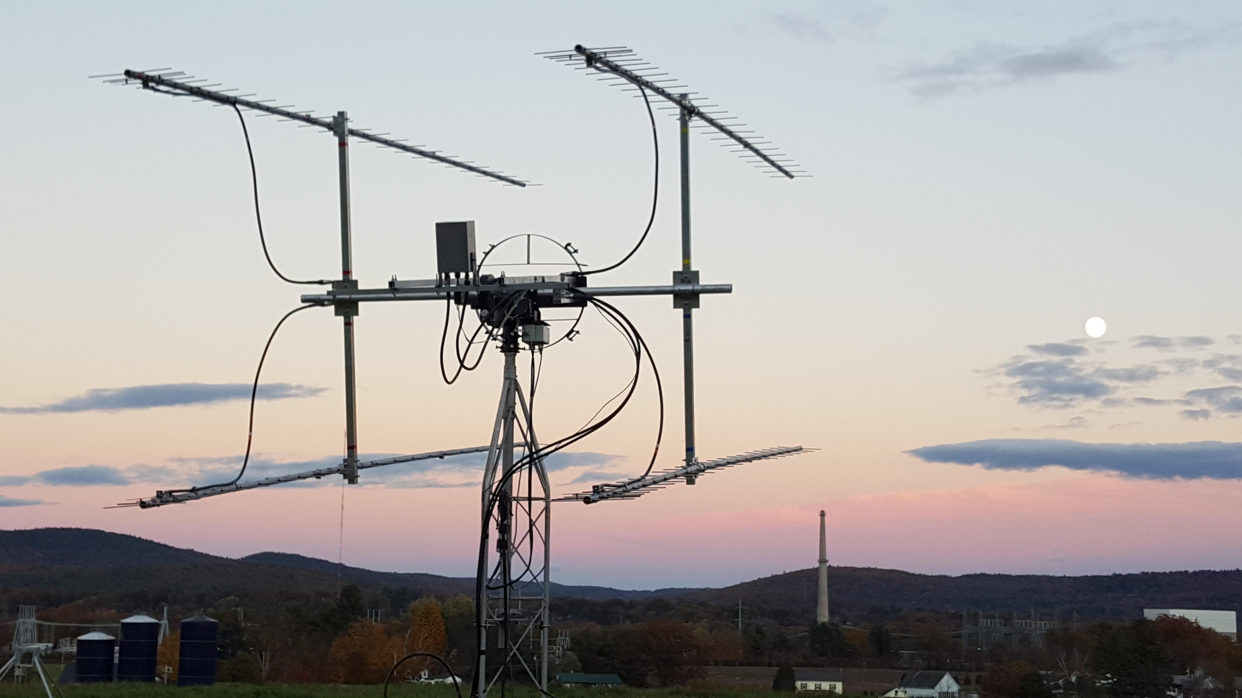
N1VT 4 x FO25 yagis with 900 W at feed used on 432

N4PZ: Steve n4pz(x)live.com is now more active off the Moon -- My EME energy level has returned. My 2.3 GHz system is a month away from being QRV. I will have a DEMI transverter - thanks to KL7UW building it, an AGO preamp, my 4.9 mr dish with the 13 cm feed offset and nested in the choke ring of my 23 cm feed and 150 W at the feed thanks to K5GW. This arrangement was used by me with good success on a 6/3 cm dish some years ago. It is a compromise I know, but so far has shown no noticeable effect on 23 cm. We’ll see how it works on 2.3 GHz. [Steve was also quite active on 23 cm during the contest weekend].

NC1I: Frank frank(x)NC1I.COM had a busy month; besides his dxpedition activity report under N1VT, he was QRV from home -- I had very little time to operate from home. The VT portable station utilizes my FTDX5000 from my home 432 station, so I will not be QRV on 70 cm until after our upcoming 144 operation in CT in late Nov.
Since my last report, I have worked the following on 1296 using JT65C, on 23 Oct at 2146 TO2EME (O/O) and 2358 W3HMS (12DB/10DB), on 24 Oct at 0057 W7MEM (16DB/10DB), on 26 Oct at 0320 W6YX (4DB/4DB), on 28 Oct at 0103 UA9YLU (11DB/5DB) and 0145 VE3NXK (20DB/9DB), on 29 Oct at 0105 PJ7/PE1L (O/O), and on 7 Nov at 1053 SP5GDM (11DB/10DB), 1103 PA3FXB (13DB/7DB) and 1121 DC9UP (13DB/8DB). I will be on 432 and 1296 from home for the final contest weekend. If W1QA is able to assist, we will spend quite a bit of time on both bands. If I am by myself, I'm not sure whether I will spend more time on 432 or 1296. I am also not sure, which mode I will operate the most. I don't expect to be on the entire time, but will try and be active a significant amount of time. My TX power on 432 will be down about 2 dB from normal. Hopefully by mid-Dec we will be back up to our normal power on this band.

OK1CA: Franta strihavka(x)upcmail.cz sends info his recent operation – On 6 Oct, I made my first QSO on 3.4 GHz using JT65C with 5B/DL2NUD. I also worked OK1KIR and I heard HB9Q, PA3DZL, PA0BAT, OH2DG and ES5PC. I was QRV on 24 GHz during 1.25 cm AW in Oct. I worked at 23 Oct using JT4F OZ1FF (15DB/15DB) for digital initial {#3} and I heard LX1DB on CW. I started on Saturday using JT4F in a sked with VK7MO without success, and then I worked on CW VK3NX (M/M), OK1KIR (559/549), LX1DB (559/559), F2CT (M/O) for initial #12, IK2RTI (O/O) #13 and W5LUA (559/O). I worked JT4F with OK1KIR (13DB/13DB) and was heard by EA3HMJ (14DB) with only 180 cm dish. I worked on Sunday JA1WQF (O/O) CW, JA6CZD (O/O) CW and PA0BAT (15DB/14DB) JT4F {#4}. I heard G3WDG on CW and JT4F with good copy, but Charlie not answer me. I changed 10 GHz later on Sunday and worked using JT4F LU8ENU (14DB/14DB) for a new DXCC - very easy QSO and good signal from Juan. The weather was good during weekend, only the humidity was very high – around 90%. It was a very nice weekend on microwave EME – great thanks to LX1DB for good idea. I was active in ARRL EME Contest on 432 on 31 Oct and worked using CW I2FHW, OH2PO, UA3PTW, DL7APV, SP7DCS, SP6JLW, SM3JQU for initial #174, OH2DG, W8TXT, VE6TA, SM4IVE, DF3RU and SM7GVF #175. My score on 70 cm is 13x8. I continued on 1 Nov on1296 and I completed initials with SP2HMR, LU1CGB and the N1VT to bring me to #317. My total score on 23 cm was 55x18.

OK1KIR: Vlada and Tonda vladimir.masek(x)volny.cz report of their clubs Oct EME activity – We worked on 70 cm using JT65B on 23 Oct at 2140 TO2EME (21DB/23DB) for digital initial {#136} and a new DXCC, on 30 Oct at 0424 N1VT(13DB/13DB) {#137} and 0454 W5RZ (25DB/O) {#138} in AR for our 47th US state, on 31 Oct at 0101 PE1ITR {#139} – while unsuccessfully looking for PJ7/, on 5 Nov at 0904 N0IRS (23DB/25 DB) {#140} and MO for our 48th US state. For 432 WAS we now need only SC and HI. We QSO’d on 23 cm using JT65C on 23 Oct at 2228 TO2EME (13DB/11DB) for digital initial {#226} and a new DXCC, on 29 Oct at 0100 PJ7/PE1L (13DB/O) {#227} and 109 DXCC and on 31 Oct at 0258 N1VT (25DB/O) {#228}, and using CW on 23 Oct at 2248 TO2EME (O/O) for initial #383 and on 29 Oct at 0210 PJ7/PE1L (O/O) #384. We QSO’d on 13 cm using JT65C on 25 Oct at 2102 OK1YK (16DB/14DB) for digital initial {#36}, 2208 TO2EME (17DB/O) {#37} and new DXCC and FK field, on 30 Oct at 0250 PJ7/PE1L (13DB/O) {#38} and new DXCC, and using CW on 25 Oct at 2322 TO2EME (O/O) #145. We were also QRV for the 24 GHz AW initiated by LX1DB and found excellent activity and good conditions supported by low degradation (Moon close to perigee) and moderate spreading most of time. We worked using CW on 24 Oct at 1603 VK3NX (M/O), 1723 OK1CA (549/559), 1751 F2CT (M/O) for initial # 21, 1805 F4KJM (M/O) and 2249 on random IK2RTI (O/O), and on 25 Oct at 0001 W5LUA (559/449) and 1603 JA1WQF (549/559), 1618 JA4BLC (O/O), 1713 G3WDG (O/O), 1739 JA6CZD (559/549), 1806 LX1DB (569/569) and using SSB at 1813 LX1DB (54/54), and with JT4F (WSJT10) on 24 Oct at 1546 VK7MO (15DB/11DB) with horizontal pol, 1849 OZ1FF (14DB/8DB) for digital inital {#31} and 1901 OK1CA (13DB/13DB), and on 25 Oct at 1915 PA0BAT (14DB/13DB). In total we worked 11 stations on CW and 4 on JT4F. We were heard by DL7YC and VE4MA, unfortunately both were unable to TX. One-way JT4F TX tests with newbie stations were very promising. Good signals received by EA3HMJ (13DB), EB3FRN (15DB), ES5PC (15DB) and SM7FWZ (8DB). Signal reports unfortunately become confusing as a growing number of stations use the new WSJT-X, which gives much higher DBs than the older WSJT10 or 9 (roughly by 10 dB). Hopefully this success will motivate them to develop some watts on TX. On 24 Oct, we measured a sunnoise of 15.2 dB (El 25 degs), a moonnoise of 3.0 dB (14/40 degs) and a “close” moon/sky noise 1.85 dB (at 14 degs El). The 24 GHz AW with its high participation demonstrates the potential for one band contests, which is not possible with multiband contests where a “jump” to the higher MW bands impacts the total score reachable on lower bands. It also allows much longer time to be spent on the higher band.

OZ1FF: Kjeld kjeld(x)oz1ff.dk was QRZ for the 24 GHz AW – I worked during the Oct AW on CW F1PYR and using JT4F OK1CA, OK1KIR, G3WDG and PA0BAT. My station consists of a 2.4 m Prodelin 244 offset dish with linear vertical feed and 10 W from an SSPA at feed. I was also heard by DL7YC, EA3HJM, LX1DB and F2CT.

OZ4MM: Stig vestergaard(x)os.dk sends news on his recent activity -- On 432, I worked TO2EME, who had a FB signal. Later during the week to my great surprise, I found N1VT testing their setup in VT and exchanged (559/549). Then over the same weekend, was PJ7/PE1L worked with a huge signal on JT65B, but at the time they were very busy, so there was no chance for CW QSO. Later, however, they did switch to CW and we worked on CW. During Sunday morning in the contest, I found only 4 stations QRV on 432 during my 1 hour operating window. On 1296, I had initials using JT65C with 5B4/DL2NUD, TO2EME, PJ7/PE1L and N1VT, and on CW with XE1XA. During the 2 hours I was able to be active on 1296, I QSO’d 23 stations, which shows the contrast in CW activity between 432 and 1296. I had planned to be more active during the contest (operating only CW in the contest), but had a QRL emergency call that forced me to miss most of the weekend’s moon time. I hope for better luck in the final contest leg.

PA2DW: Dick’s qtc(x)kpnmail.nl activity report on his recent 23 cm EME -- To some dismay of my XYL I went extremely early to sleep last night, in order to get up at 3 am local time. My mission was working TO2EME! I did manage to work this FB dxpedition, but almost made a fatal error in the process. In my first attempt, I had my rig set on LSB. I think I was still a bit sleepy, Hi. I could see some vague traces, but TO2EME did not see me at all. But my own echoes on CW were speaker copy. Strange, I thought. I decided to try with XE1XA on CW and made a perfect QSO with Max for a new DXCC. I then went back to the frequency of TO2EME and only then discovered my error. With my K3 in USB, TO2EME was easily received, and even better, they now received me! A second new DXCC for the night went into my log. Next I tried with W7MEM and also this QSO went smooth for another initial. For a nice desert, I made my second QSO with KL7UW after we first had tried to call each other during the same period. I am running a 2.4 m dish with 500 W, a G4DDK LNA and K3/TR1296H. [Dick was QRV for the EME contest on Saturday and operated on Sunday PI9CAM, but his report has not yet been received].

PA2V: Peter peter(x)pa2v.com was active on 432 in the ARRL EME Contest and writes -- My new antennas has been working well but at the suggestion of G0KSC, I moved the yagis a little closer together in hope of getting a cleaner pattern. I now seem to have more gaps in my very noisy environment. I had good contacts with HV0A, TO2EME and PJ7/PE1L for new DXCCs and worked on random SM7GVF, who is using single yagi. Also my K4EME preamplifier, at the top of the mast, seems to be giving better performance. My log reads as follows: on 31 Aug at 0254 HV0A (29DB/29DB) for first HV0 – PA, on 5 Sept at 0711 NC1I (13DB/O), on 6 Sept at 1104 NC1I (10DB/11DB), on 26 Sept at 1847 JA6AHB (15DB/13DB), 2029 DL7APV (16DB/O) and 2217 DL6KAI (26DB/23DB) for mixed initial #75*, on 29 Sept at 1941 DL8DAU (28DB/27DB) #76*, on 10 Oct at 1210 DL7APV (21DB/O), on 23 Oct at 1943 SM4IVE (559/579) CW, 1959 ES5PC (15DB/16DB), 2121 TO2EME (28DB/24DB) #77* for new DXCC and 2144 OK1DFC (18DB/6DB), on 27 Oct 1825 PI9CAM (11DB/8DB), 2005 UA3PTW (13DB/3DB), 2014 S51ZO (23DB/15DB), 2024 UT6UG (21DB/15DB) #78*, 2037 DF3RU (15DB/11DB) and 2047 SM7GVF (26DB/O) #79*, on 29 Oct at 2031 YL2GD (27DB/21DB), on 30 Oct at 0651 N1VT (18DB/28DB) #80* and 0715 W6YX (28DB/18DB) #81*, in the EME contest on 31 Oct at 0405 KN0WS (23DB/O), 0415 K4EME (21DB/O), 0426 OH2PO (11DB/O), 0459 W6YX (26DB/O), 0537 YL2GD (26DB/18DB), 0545 DL7APV (14DB/10DB), 0605 UT5DL (27DB/15DB), 0641 SM2A (22DB/O), 0700 VE6TA (429/O) CW #82*, 0800 DF3RU (19DB/O), 0809 UT6UG (26DB/O), 2005 OK1DFC (18DB/7DB), 2023 PA2CHR (28DB/O), 2111 PI9CAM (11DB/4DB), 2119 HB9Q (13DB/O), 2137 UX5UL (20DB/20DB) #83* and 2154 JA6AHB (18DB/13DB), on 1 Nov at 0421 K2UYH (22DB/O), 0430 UA3PTW (17DB/O), 0452 PJ7/PE1L (29DB/22DB) #84* new DXCC, 0519 DK3WG (13DB/10DB), 0533 PA0PLY (22DB/21DB), 0551 G4RGK (22DB/O), 0636 W5LUA (19DB/17DB) #85*, 0718 WA4NJP (14DB/10DB), 0929 ES5PC (15DB/O), 0941 W7MEM (25DB/O) and 1020 DL5FN (22DB/21DB) for at total of 28x21, and after the contest on 4 Nov at 1000 G3LTF (329/559) on CW #86* and 1029 OK1DFC (17DB/7DB). All QSOs were JT65B unless indicated. My new antennas have been up since the end of Aug and hopefully will survive much longer than the previous ones, which lasted for only half a year. The first autumn storms just arrived, but did not harm the array yet. I have started to experiment with 10 GHz and am planning to have a small 10 GHz EME setup running in two years. I hope that this band will finally cure my “noise and everlasting birdie problems”. This project has just started, so I need some time to get a feeling for this new band.

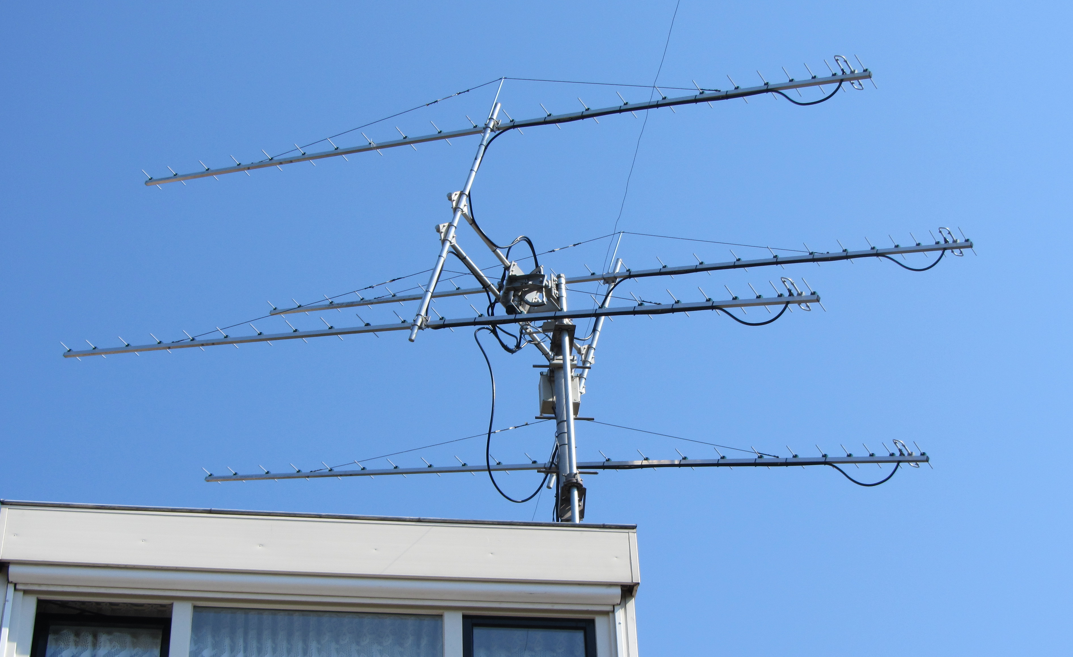
PA2V’s resized 432 array

PI9CAM: Jan (PA3FXB) jvm(x)netvisit.nl reported that on Saturday 31 Oct PI9CAM would be active starting at bout 2030 in the ARRL contest and possibly again on Sunday morning. The planned to run on 70 cm 400 W (x) feed and on 23 cm 120 W to the big 25 m Dwingeloo dish - see www.camras.nl. [Their contest report has not yet arrived].

PJ7/PE1L & TO2EME: Jurgen (PE1LTW) pe1lwt(x)me.com reports that the Saint Maarten dxpeditions from both the French and Dutch locations was a great success – The equipment used at both locations was on 432 a single DK7ZB 9 wl yagi with 350 W and a 0.9 dB NF LNA, on 1296 a HB foil covered 1.8 m dish, 150 W and a 0.25 dB NF G4DDK LNA, and on 2320 same dish with also 150 W and 0.34 dB G4DDK LNA. We were surprised by the amount of callers after our first CQ on 1296. A highlight was QSOs with small stations such as DJ2DY and EA1RJ and working CW stations. Even without a CW filter, we managed to work a few of them. Operation was first from the Dutch side as TO2EME. We began with a remarkable 70 cm CW QSO with DL9KR. Jan is now 80 years old and will celebrate that with his children and grandchildren. He could not be QRV during our planned 432 day, so we gave him a birthday present. After working him, we made a tropo contact with Guadaloupe, FG4KH, with good signals. After moonrise we had to wait until we saw the moon. We had trees at moonrise and moonset. For moonrise we needed at least 20 degs and moonset 15 degs. Our 23 cm station was ready earlier than we expected. We decided to give it a try and the results were very promising (12 JT and 1 CW QSO). The first station was OK1DFC. Zdenek came through the trees even before any 144 signal was seen. After that one after the other, the QSOs came into the log. On 70 cm, we QSO’d DF3RU, DK3WG, DL5FN, DL7APV, DL9KR (CW), ES5PC, G4RGK, HB9Q, I1NDP, K2UYH, K3MF, LZ1DX, OH2DG, OK1DFC, OK1KIR, ON4AOI, OZ4MM, PA2V, PI9CAM, PY2BS, UA3PTW, UT5DL, W7MEM and WA4NJP for a total of 23. On 23 cm, we worked DF3RU, DG5CST, DJ2DY, DJ9YW, DK0SF, DK3WG, DL6SH, EA1RJ, ES5PC, ES6FX, ES6RQ, G3LTF (CW), G4CCH, G4CCH (CW), G4RGK, HB9Q, HB9Q (CW), I1NDP, IK2MMB, IK3COJ, K2UYH, K2UYH (CW), K5DOG, KL7UW, LU1CGB, LX1DB (CW), LZ1DX, NC1I, OE5JFL, OE5JFL (CW), OH2DG, OH2DG (CW), OK1CS, OK1CS (CW), OK1DFC (CW), OK1DFC, OK1KIR (CW), OK1KIR, OK1YK, OK2DL (CW), OK2DL, OZ4MM, PA0BAT, PA2DW, PA3CQE, PA3CSG, PA3DZL, PA3FXB, PA7JB, PE1CHQ, PI9CAM, PY2BS, PY2BS (CW), RA3AUB, RD3DA, SP3XBO, SP5GDM, TI2AEB, UA3PTW, UA4HTS, UA4LCF, UA9YLU, VE3KRP, VE6TA (CW), VK2JDS, VK4CDI, W3HMS, W5LUA, W6YX, W7MEM, YL2GD, YO3DDZ and ZS6JON for a total of 63 initials on either JT, CW or both. 13 CW initials were made. On 13 cm, we QSO’d ES5PC, G3LTF (CW), HB9Q (CW), HB9Q, IK3COJ, K2UYH, OH2DG, OK1DFC, OK1KIR (CW), OK1KIR, OZ4MM, OZ5G, PA0BAT, PA3CQE, PA3DZL, PA7JB, PY2BS, UA3PTW, UA4HTS and W5LUA for a total of 18 initials on JT, CW or both, and 3 CW initials. Everything was not smooth at TO2EME. We do some dish repairing. During a tropical storm, the dish came down and 4 out of the 12 ribs where damaged. J & J went to a local hardware store and bought the tools to fix it. tools to fix it. (During future dxpeditions we plan to take some spare ribs with us. We were visited by VE1KG and his XYL, who were on vacation on the island. At PJ7/PE1/L we had bad luck on 2320. Our QTH was situated between 3 communication towers and surrounded by apartments emitting WiFi interference. We tried several different preamps, but even our AD6IW preamp, which had proven its worth in the past failed there. As a result our 2320 results from PJ7 are not as good as from the TO2 location. On 432 we had a schedule change due to a broken preamp, but fortunate we were able to fix it. From FJ7/PE1L, we QSO’d on 432 DF3RU, DK3WG, DL5FN, DL7APV, DL8GP, DL9KR (CW), ES5PC, G4RGK, HB9Q, I1NDP, JA6AHB, K2UYH, LZ1DX, OH2DG, OH2PO, OK1DFC, ON4AOI, OZ4MM, PA2V, PI9CAM, UA3PTW, UT5DL, UT6UG, W5LUA, W6YX, W7MEM and WA4NJP for a total of 27 including one CW QSO. On 1296 we worked DC9UP, DF3RU, DG5CST, DJ9YW, DK3WG, DL6SH, ES5PC, ES6FX, ES6RQ, G4CCH (CW), G4CCH, G4RGK, HB9Q, HB9Q (CW), I1NDP, IK3COJ, IK5VLS, JA6AHB, K2UYH (CW), K2UYH, K5DOG, LZ1DX, N1VT, NC1I, OE5JFL (CW), OH2DG, OK1CS, OK1DFC, OK1KIR, OK1KIR (CW), OK2DL, OZ4MM, PA0BAT, PA2DW, PA3CQE, PA3CSG, PA3DZL, PA3FXB, PA7JB, PE1CHQ, PI9CAM, PY2BS, RA3AUB, RD3DA, SP3XBO, SP5GDM, UA3PTW, UA4HTS, UA9YLU, VE3KRP, VK4CDI, W5LUA, W6YX, W7MEM, WA2FGK, YL2GD, YO3DDZ and ZS6JON for a total of 54 initials on JT, CW or both and 5 CW QSOs. On 2320 we QSO’d ES5PC, HB9Q, K2UYH, OH2DG, OK1DFC, OK1KIR, PA0BAT, PA3DZL, PA7JB, PY2BS, SP3XBO, UA3PTW, UA4HTS and W5LUA for a total of 14. Operators on 1296/2320 were Johan (PA3FPQ) and Jurgen (PE1LWT) - (J&J). Operators on 432 were Marshall (K5QE) and Rene (PE1L). More information and media can be found on our website at www.emelogger.com/fs.

UA3PTW: Dmitry ua3ptw(x)inbox.ru send news of his Oct activity – I worked on 432 using JT65B F6CPI, TO2EME, UT5ST, W1PV, DK4RC, EB2FJN, N1VT, RA9DA, DD0NM, W5RZ, YO2BCT, DK1KW and PJ7/PE1L, on 1296 using JT65C 5B/DL2NUD, WA3RGQ, DH2SAV, TO2EME, OE9GLV, N1VT, PJ7/PE1L and WA3FGZ, and on 2320 5B/DL2NUD, OK1YK, TO2EME and PJ7/PE1L. [TNX DK3WG for forwarding this report].

UA9YLU: Victor ua9ylu(x)mail.ru is QRV on 1296 from Asiatic Russia with a 4.5 m dish, RA3AQ feed and 300 W. In Oct he worked on CW on 1296 VE6TA, XE1XA, DL4DTU, LX1DB, SP6JLW, F5SE/p, Dl3DBJ, KL6M, SP7DCS, OK1CH and N0OY, and using JT65C VK2KFJ, 5B/DL2NUD, YO3DDZ, DJ2DY, TO2EME, DF3RL, IK3GHY, PE1HNG, W3HMS, VE3NXK, PJ7/PE1L, N1VT, K2UYH and VA7MM. [TNX DK3WG for forwarding this report].

VE3KRP: Fast Eddie eddie(x)tbaytel.net continues his regular 1296 operation – I QSO’d using JT65C unless noted on 14 Oct TO2EME for a digital initial {#} and new DXCC, on 29 Oct PJ7/PE1L {#}, and on 31 Oct (during the EME contest) N1VT {#}, SP5DGM, PA3FXB, YL2GD, OK2DL, ES6FX, DF3RU, UA3PTW, PJ7/PE1L, WA2FGK, G4EZP {#}, HB9Q, SV2CAL, W6YX, VE4MA, WA3FGZ {#}, JA1WQF {#}, EA8DBM {#} and new DXCC, RA3AUB, PE1CHQ, LZ1DX, PI9CAM, K4EME {#}, VK3UM (CW), VK4CDI and RW0LDF {#} for a score of 27x25; N4PZ was CWNR. I added using JT65C on 14 Nov KN0WS {#} and on15 Nov VA6EME - this was Randy's first EME QSO on 23 cm. (He said he had been waiting for a "big" station to work him, to his surprise he was received here at (24DB) with his 3 m dish and only 60 W for an easy QSO). Many thanks to the various dxpedition teams and new initial stations worked, and my apology to those missed. I hope to work you on the next round. Good luck to all.

VE6TA: Grant ve6ta(x)xplornet.com send news on his recent activity -- I had the 23 cm feed in and was looking for an opportunity to work TO2EME guys on CW. They obliged me with a sked and we worked easily on 25 Oct. I then switched feeds to 432 for a sked with ON4AOI. Guy has a great station and we worked easily. During the ARRL contest, I was primarily looking for initials over the weekend and to satisfy a few sked requests on 432. I was on 432 the first pass and worked on CW OK1CA, SM4IVE (Lars had a huge signal), OH2PO, DF3RU, I2FHW for an initial (#), SP7DCS, PA2V (#), SM7GVF (#) and VK3UM for a total of 9. I was surprised to hear that SM7GVF is a single yagi station as he is quite good copy and a FB operator. I switched feeds again to 1296 for the second pass and worked I1NDP, OK1CA, PI9CAM, OK1CS, SM3AKW, LZ2US, DF3RU, RA3EC, S53MM, DL3EBJ, DK3WG for an initial (#), SM7FWZ, ON5RR (?) – much QRM, VE6BGT, VE4MA, F5SE/P, SP7DCS, W6YX, OE5JFL, I5MPK, SM4IVE, K9KFR, VA7MM, G3LTF, N0OY, KL6M, JA6AHB and UA9YLU for a total of 28x22. I plan to be on 1296 a bit more at the end of Nov as the weather allows. If anyone wants to try 902 or 222 during the contest, I can be QRV. Let me know and we can give it a try. Thanks for all the QSOs and fun.

VK4CDI: Phil vk4cdi(x)gmail.com had problems with Murphy during the contest weekend – At moonrise, the first pass of contest, my receiver was dead. It turned out that I had some water in the preamp - birds seem to like my plastic waterproofing for nest building. The next morning, I found a broken wire in a connector. Despite these problems, I still worked about 25 stations, mainly on 23 cm JT. I had about half a dozen CW QSO's. I added 4 initials including PJ7/PE1L and TO2EME (before the contest) for new DXCCs. I am working on 10 GHz and looking for a reasonable PA.

VK4EME: Allan vk4eme(x)westnet.com.au reports on his 70 cm activity from VK -- I had a good time on 70 cm during the weekend before the contest with some very nice signals exchanged. I guess people were checking out their systems for the following weekend's ARRL contest or maybe, just maybe, there is a renewed interest in this brilliant band, (I hope). On 24 Oct I worked, RK6MC (15DB/O) for mixed initial #111*, DL5FN (15DB/O), UT5DL (14DB/17DB), DL7APV (7DB/10DB), R7LV (15DB/O) #112*, DL8DAU (18DB/O), ES3RF (15DB/24DB) and UX5UL (18DB/22DB), on 25 Oct DL8DAU (18DB/26DB), ON4AOI (10DB/20DB), UT6UG (10DB/16DB), OH6UW (18DB/O), LZ1OA (15DB/23DB) #113*, and during the contest on 31 Oct JA6AHB (20DB/O), W6YX (19DB/O), K3GNC (27DB/27DB) #114*, JE1TNL (15DB/26DB), KN0WS (16DB/21DB), W7MEM (11DB/21DB), JS3CTQ (19DB/28DB, HB9Q (6DB/O), OK1DFC (6DB/18DB), UT5DL (16DB/O) and YL2GD (15DB/O), and on 1 Nov K2UYH (16DB/O), K7ULS (25DB/27DB) #115*, K4EME (13DB/O), YO2BCT (18DB/26DB) #116*, DL7APV (7DB/17DB) for a total of 16x14. I will do my best to spend more time on the CW end of the band for the next leg, but my QRP makes it difficult for most. Unfortunately I had no joy working PJ7/PE1L copied (19DB to 22DB) most of the time, but he could not hear me. I am looking forward to the next leg of the ARRL contest (and the weekend before too). Skeds on JT and CW are very welcome; please email me.

W1PV: Skip flathood(x)rcn.com is now QRV on 432 EME -- I've been on 2 m EME for about a year and on 70 cm for less than a month. I'm really happy with my 70 cm results and know what improvements I need (more antenna and power!). My xcvr (Kenwood TS-790) is also equipped with 23 cm and that seems the logical next step in view of the high level of activity there. I have started look for a dish. I should be on again for the final contest weekend – look for me.

W6XY: Gary (WA6FP) ad6fp(x)lbachs.com sends the Stanford group’s comments on the contest -- We operated both 70 cm and 23 cm for both passes of the Contest WE. The station performance on 70 cm was improved this year by doubling the number of yagis to 8x12 el thanks to a donation by K6MYC. This made a significant difference in performance allowing us to surpass last year’s total for two weekends on just the first weekend. Unfortunately we’re still short of operating CW on 432. All of the contacts were JT65. On 70 cm KJ6SDF and KG6NUB operated the station. We ended the weekend with a best to date total of 23x17. On 23 cm the station was upgraded in tracking accuracy and a new isolation relay and AD6IW preamp were installed. These improvements made a noticeable difference in our hearing. The previous tracking system using relays to control the 3-phase motors that drive the positioner had 1 deg accuracy and was resulting in 5+ dB of deltas in signal levels as the dish would drift off the moon. The new system using Hitachi 3-phase variable frequency motor drives maintains less than 0.5 deg accuracy and signal level deltas are now less than a dB. AD6IW operated the 23 cm station and was assisted by me (AD6FP). At the beginning of the first moon pass we experienced severe libration making CW copy difficult for even the strongest signals. We operated 11 hours on the first moon pass and 10 hours on the second. Most of the time was spent operating CW with just 2 hours on the first pass on JT65 and 1 hour on the second pass. MAP65 was used to spot new calls on JT allowing us to quickly transition from the CW operation to pick them up. Linrad was used on CW by the assisting operator to identify new calls in hunt and pounce mode. The European activity level seemed quite good, but as usual when the window to EU closed, the NA activity took a nose dive. All in all we had a good time operating and were able to achieve our best yet first weekend result with a final tally of 85x46.

WA2FGK: Herb wa2fgk(x)yahoo.com is now QRV on 13 cm EME -- After many hours of tinkering, I made several EME contacts on 2304. My first contact with WD5AGO on CW.Then I worked K2UYH, G3LTF and W5LUA. My system still needs receive improvements, but we are getting there. My dish is 12’ and we are running 100 W at the feed. I'm only doing CW right now due to the amp not having enough cooling. During the EME contest, I was only able to be QRV for the first pass. The moon was spotted around 0300 and the fun began. This is the first time I had everything fired up, working well, and ready to go. I started on 144 but after a few hours switched over to 432 to see what was going on. Immediately I saw some birdies that could not be explained. My JT waterfall was very difficult to find a decent frequency to call CQ. I was rewarded with a few nice contacts, but the birdies were brutal. I moved up to 1296, got my dish on the moon and called CQ. My first call was from RA3AUB and then the run continued. I even had thePJ7/PE1L give me a call. I worked about 8 stations and started noticing my transmissions were not jiving with other stations. It turns out, my battery was going bad in the computer. Not only did I have clock trouble, but the JT65 program was doing some weird jumps. Being a bit disgusted, I went back to 2 m. It continues to amaze me how dead things go, when Eu looses moon. I again tried 432 but the birdies were horrible. My total on 432 was only 2 contacts. On 1296, I had 11 QSOs. The moral of the story equipment wise is this. I replaced the computer for 1296, which I should have done before the contest, with a faster version. (I had no idea before the contest that the battery was going bad). Another problem was my computer’s video driver. We have a camera on the azimuth compass and a small monitor. On Sunday, I found out the monitor was throwing out enough energy on 432 that I could have drove my 8938 with it! I smashed it to bits. I will play catch-up the next leg of the contest.

WA3GFZ: Paul dogfaces(x)comcast.net writes that he spent several days getting his 1296 equipment "up to snuff" for the EME contest -- I adding another W6PQL amplifier to bring my power up to 230 W output. It paid off with 21 JT65C contacts. I added DXCCs included Bulgaria, Russia, Czech, Switzerland, and Japan. I still tired from staying up all night, but what fun!

WA6PY: Paul pchominski(x)maxlinear.com was QRV in the Oct/Nov part of the ARRL EME Contest – I spent most of my time on 1296, but monitored 432 and 144 from time to time. On 432, I QSO'd I2FHW. I Heard I2FHW and my echoes on pure horizontal pol, but he didn't hear me well. When I switched to vertical on TX, he heard me much easier. I heard OH2PO calling CQ, but it was probably his last CQ on CW for the morning. I came too late. Jumping between bands is not that easy. So I had only one 70 cm QSO. On 1296, I QSO'd DL3EBJ, F5SE/p, G3LTF, HB9Q, I5MPK, IK5VLS, JA1WQF, JR4AEP, K1DS, K9KFR, KL6M, N0OY, N4PZ, OE5JFL, OK1CA, OK1CS, OZ4MM, PI9CAM, RA3EC, S53MM, SM3AKW, SM4IVE, SM7FWZ, SP6JLW, VE4SA, VK3UM, W6YX, WA9FWD and WB2BYP for a total of 29x24. I heard K2UYH, G4CCH, SM2CEW and VK4CDI. I was not QRV during the first Moon pass during JA/VK window. Sunday morning, JA stations came thru with strong signals, but with very bad libration, at the same time KL6M and N0OY’s signals were very clean. Trees in the direction of my moonrise have grown up during the years and now my min EL can be limited to 10 deg depending on AZ. I plan to be QRV only for the first night of the second part of ARRL EME Contest.

WA9FWD: John jstefl(x)wi.rr.com found the ARRL EME contest especially exciting -- I now have a short western window. I have never worked a VK or JA on 1296 as I was blocked by trees. The tree that was my biggest problem is gone. I now have a western window down to about 23 degs el. The remaining blockage is from trees across the street from me. This gives me a little over an hour into VK and JA land. I started the contest with the intention to put the majority of my efforts into working new stations in my new window. I worked 27 in the first pass of the contest, all on 1296 CW. Stations worked were F5SE/p, DL3EBJ, RA3EC, SP6JLW, K2UYH, W6YX, VE4MA, VK3UM for initial #97, JR4AEP #98, JA4BLC #99, VK5MC #100 and N0OY. In the second pass, I added I1NDP, WA6PY, I5MPK, OE5JFL, W1AIM, HB9Q, SM4IVE, PI9CAM, OK2DL, G3LTF, K1DS #101, K9KFR, VA7MM, N4PZ #102 and KL6M for 15 more and a score of 42x40. I plan to be operational for the final leg, and will put more time into the EU window.

K2UYH: I alkatz(x)tcnj.edu had a fun weekend during the contest although Murphy was around this year. The contest team consisted of NE2U, K2BMI, K2TXB and me. We operated on 23 cm the first night and 70 cm the second. We probably should have switched band, but activity kept us in place, except for the short time window between the end of the EU window and the start of JA/VK activity - less than 2 hours; it did not seem worthwhile to switch then. We started off the contest on a low by blowing two preamps in succession due to a new software control program for my TX2000X. It was a handy program, but once we turned it off, no more preamps were lost. By the time we realized the cause, I had made two trips to the feed in darkness. There was more activity on 1296 than 432. Contacted on 23 cm were at 0410 LZ1DX (O/O) on JT65C, 0434 OK2DL (559/559) CW, 0445 IK5MPK (579/599) CW, 0455 F5SE/p (589/579) CW, 0500 SP6JLW (579/579) CW, 0505 F5JWF (559/559) CW, 0512 OK1CS (579/579) CW, 0518 RA3EC (559/589) CW, 0524 G4RGK (559/559) CW, 0530 IK5VLS (559/559) CW, 0534 WA8RJF (559/559) CW, 542 K1DS (559/579) CW, 0547 XE1XA (569/569) CW, 0553 UA3PTW (559/559) CW, 0558 DL3EBJ (579/589) CW, 0603 N4PZ (569/579) CW, 0610 OH1LRY (559/579) CW for initial #361 (worked before on CW but not counted), 0614 VE6BGT (559/559) CW, 0626 OZ4MM (589/579) CW, 0631 SV3AAF (589/579) CW, 0652 PA3FXB (559/559) CW, 0657 WA3GFZ (O/O) JT65C, 0702 W2LPL (O/O) JT65C, 0705 ES6FX (O/O) JT65C, 0713 EA3HMJ (O/O) JT65C, 0721 G4EZP (O/O) JT65C for mixed initial #510*, 0725 SV1CAL (O/O) JT65C, 0731 SP5GDM (O/O) JT65C #511*, 0735 K4EME (O/O) JT65C #512*, 0746 DF3RU (O/O) JT65C, 0755 I0NAA (O/O) JT65C #513*, 0800 RA3AUB (O/O) JT65C, 0808 K6JEY (O/O) JT65C, 0812 KL7UW (O/O) JT65C, 0819 PA2DW (O/O) JT65C, 0831 HB9Q (O/O) JT65C, 0847 N1VT (O/O) JT65C #514*, 0901 W7MEM (O/O) JT65C, 0907 LU1CGB (O/O) JT65C, 0913 VA7MM (O/O) JT65C , 0925 IK2MMB (O/O) JT65C, 0931 EA8DBM (O/O) JT65C, 0957 WA9WCD (559/559) CW #362 and #515* (worked before but not counted), 1006 G4CCH (579/579) CW, 1034 W6YX (O/O) JT65C. 1107 VE4MA (O/O) JT65C, 1137 WA9FWD (559/559) CW, 1202 N6OVP (559/559) CW, 1209 JH1KRC (557/559) CW, 1228 JR4AEP (559/569) CW, 1258 JA1WQF (559/579) CW, 1317 VK2JDS (559/559) CW #363, 1338 JA4LJB (569/589) CW, 1339 VK5MC (569/569) CW, 1403 RW0LDF (O/O) JT65C #516*, 1412 VK5FA (O/O) JT65C #517*, 1418 K5DOG (O/O) JT65C, 1440 JA4BLC (559/569) CW, 1454 N0OY (579/579) CW and 1506 UA9YLU (O/O) JT65C #518* (3 degs to 3 degs!) for a total of 60x51. On 432 we only made 30 contacts, but new stations kept showing up pretty much over the whole window. There was very little CW activity although we kept trying to find stations. The low CW may have been a result of our being QRV on the second day. We called N8CQ repeatedly on CW with no response. Worked using JT65C unless noted at 0402 DL7APV (O/O), 0415 UA3PTW (O/O), 0418 DF3RU (O/O), 0423 PA2V (O/O), 0427 OH2PO (O/O), 0436 DL6KAI (O/O), 0521 PJ7/PE1L (O/O), 0534 I2FHW (569/O) CW, 0543 OZ4MM (569/549) CW, 0604 W6YX (O/O) for mixed initial #895*, 0619 G4RGK (O/O), 0637 YL2GD (O/O), 0649 PA2CHR (O/O), 0705 K7ULS (O/O), 0724 W4ZST (O/O) #896, 0736 DL1SUZ (O/O) #897*, 0742 OK2POI (O/O), 0758 YO2BCT (O/O) #898*, 0810 LU8ENU (O/O), 0820 W5LUA (O/O), 0842 N0IRS (O/O) #899, 0853 UT5DL (O/O), 0905 HB9Q (O/O), 0920 NR5M (O/O), 0926 OH1LRY (O/O), 0933 SM2A (O/O) #900*, 0930 WA4NJP (O/O), 1031 DL5FW (O/O) #901*, 1050 F5APE (O/O) #902*, 1411 JA6AHB (O/O), 1503 VK4EME (O/O) and 1510 partial JS3CQT (O/O) for a total of 30x25. We also ended on a low. Very near moonset (at 8 degs - while trying to work JS3CQT) our SWR went sky-high! It turned out that repeated polarization rotation, (we needed to rotate pol between TX and RX much of the night), caused the connector to the feed to loosened up and partially disconnected. This also caused the T/R relay to burn up. I also lost a pin in 7/8" feed line to burn up. We lost less than 15 minutes of Moon window, but it was a disappointing end. Overall conditions seemed quite good. Signals on 1296 were very good, and on 432 were certainly not bad. A contest highlight was QSOing on 23 cm UA9YLU with the Moon at 3 degrees at both of our QTHs (his rising, ours setting). We are looking forward to the final contest weekend and catching some of the stations we missed. Before the contest I worked on 5 Oct, on 1296 at 1055 WA3RGQ (559/O) on CW #357 and on 7 Oct at 1014 5B/DL2NUD (22DB/20DB) JT65C for #507*, on 23 Oct, on 432 at 2226 TO2EME (24DB/21DB) JT65B #891* and DXCC 124, on 23 Oct, on 1296 at 2241 TO2EME (17DB/O) JT65C #508* and DXCC* 106, and on 432 at 2350 W1PV (24DB/18DB) JT65B #892*, on 24 Oct, on 432 at 0008 K9MRI (14DB/21DB) JT65B #893*, 0012 DK4RC (14DB/21DB) JT65B #894*, 0029 K9MRI (O/O) CW #735, on 1296 at 0150 TO2EME (O/O) CW #358, on 25 Oct, on 2304 at 0034 TO2EME (14DB/O) JT65C for mixed initial #81* and DXCC* 31, 0100 WA2FGK (559/559) CW #80 and #82*, 0115 W5LUA (569/579) CW, and on 1296 at 0358 W7MEM (559/559) CW #359, 0958 PJ7/PE1L (16DB/12DB) JT65C #509* and DXCC* 107, 1008 PJ7/PE1L (O/O) CW #360, and 30 Oct, on 2304 XB at 0402 PJ7/PE1L (25DB/O) JT65C [Rs there but did not decode] #83* and DXCC 32 and 0427 UA4HTS (559/559) CW.

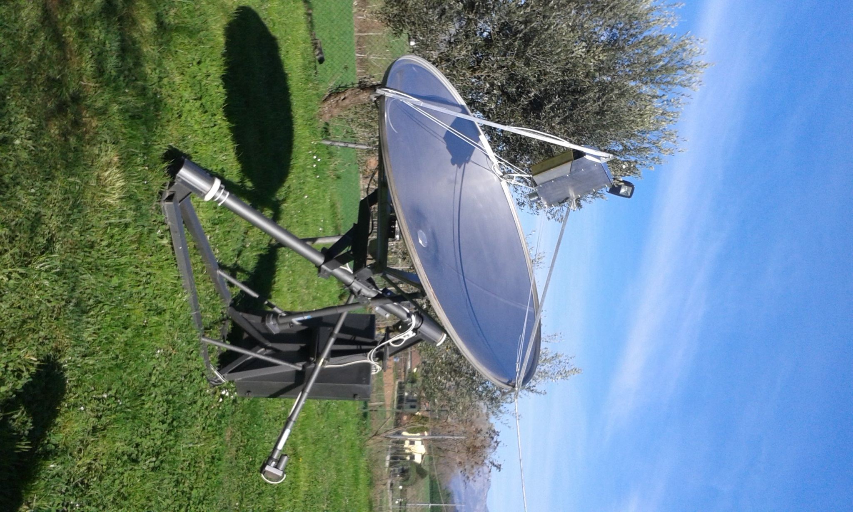
IW5BHY 2m dish used on 3 cm

NET/REFLECTOR NEWS: IW5BHY in (JN54fb) is QRV on 10 GHz with a 2 m dish, spectrum feed (circular pol) and 40 W from a TWTA. F6AJW (IN93ek) reports copying the DK7LJ 3 cm beacon via tropo using a 75 cm off-set dish - no Doppler shift was copied! JA8ERE now is using a 4 m solid dish and is operational on 5760. He will be on 10 GHz soon. JA8IAD has a 3 m TVRO dish and is now also operational on 6 cm. JA1WQF and JA6CZD were active during the 24 GHz AW. VK3UM was QRV on random CW during the ARRL contest weekend.

FOR SALE: EA1DDO/HK1H has a 4/6 GHz Vector Network Analyzer for sale. Contact Máximo ea1ddo(x)hotmail.com for details. FR5DN has some UHF power modules along with Anaren hybrid couplers 1H0264-3 designed for operation from 440 to 880 MHz available. Phil has not tried these couplers on 432 and wonders if they performed well or not. Contact him at fr5dn(x)izi.re. K5FM has two KD5FZX 23 cm cavities with GS15 tubes and water jackets installed, and one spare GS15 with water jacket, and one spare without water jacket. He also has two Kuhne MKU DIV 1300-1n combiner splitters for combining the two cavities. All of the items are unused. He is asking $800US for the lot. Contact Will at wshingleton3(x)con.net, if interested. LZ1DX needs one or two PTFA2413001E transistors. If you can help, contact Ned at lz1dx(x)lz1dx.org. He is willing to pay or barter.

TECHNICAL: 10/24 GHz EME JT MODE EXPERIMENTS AT G3WDG -- I have been experimenting with a prime focus 1.3 m dish for 10 GHz EME over the past few weeks as a candidate for future portable operations. The dish has an f/D ratio of 0.33 and seems to work well with the same linear pol SM6FHZ feed that I used with my 76 cm dish. I managed to make a number of JT4F QSOs with it using the 2 x TGA2623-CP GaN 50 W PA. Worked were OZ1LPR (13DB/16DB) best 8DB, OK1KIR (9DB/12DB), WA3LBI (12DB/14DB) and HB9Q (10DB/9DB). I also did some one-way tests with VK7MO with the same system, who reported reliable decodes with a 113 cm prime focus dish at his end, with some 7 dB margin. Rex commented that it ought to be possible to get decodes using his 77 cm dish, but this has yet to be tried. At the time of this test, conditions were favorable – near to perigee with a degradation of only 0.1 dB and low libration spreading. Below is shown WSJT-X v1.6.0 wide graph plots of my tuning tone and JT4 message received by VK7MO.

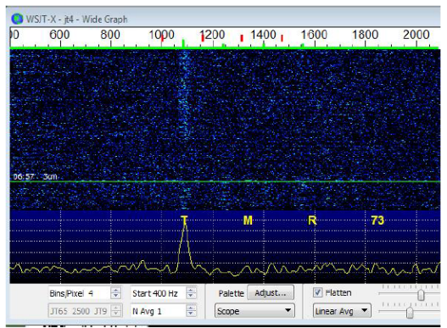
Single tone from G3WDG received by VK7MO
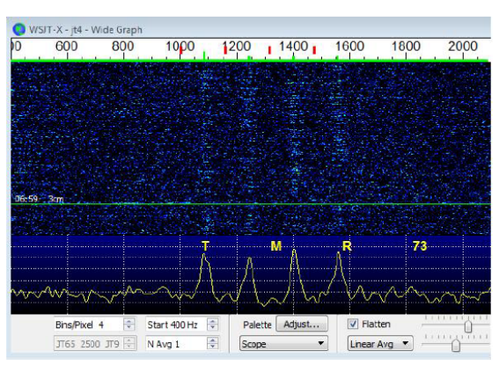
JT4F transmission from G3WDG received by VK7MO

Echo tests with the 1.3m dish were tried using WSJT-X Echo mode and the signal was seen on the waterfall, as well as in Echo Graph. Predicted signal spreading at the time was fairly low (70 Hz), which tends to make echoes easier to see than with high spreading.

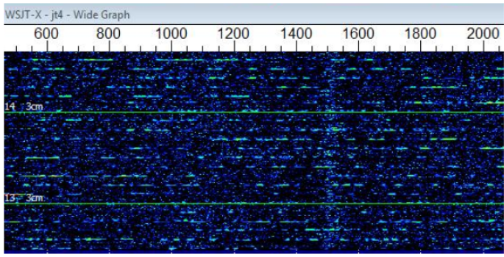
1.3 m dish echoes (at 1500 Hz)

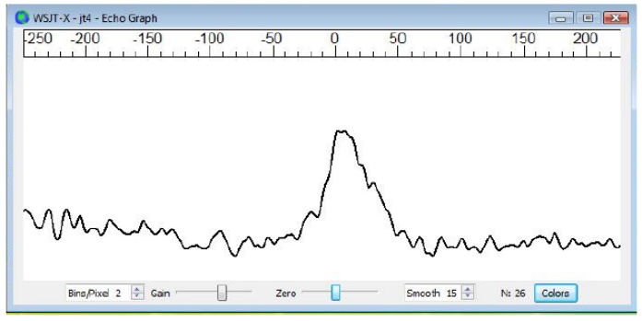
Echo Graph display (accumulation of 26 echoes)

Using my 3 m dish, I just managed to work G4CBW on 10 GHz using Tony’s tropo system with (18DB/10DB) reports. Tony’s tropo system is a 1 m offset dish with approximately 18 W at the feed. Tony commented that his tropo system is not really optimized for EME operation, having an SMA relay, various adaptors, etc, which together probably cost about 1.5 dB in performance. I got one single line decode from Tony (calls + locator), while averaging was needed to pull out the report. Another recent JT4 QSO was with LU8ENU (17DB/13DB) for a new country and continent. The QSO took place initially with a 45 deg spatial offset – after that I tried rotating polarization and LU8ENU’s signal increased by 3 dB to (14DB). Also with the 3 m dish, some tests were carried out with VK7MO with Rex trying reduced power levels on his 76 cm dish. Good decodes were obtained at 15 W with (15DB) signal level and at 10 W a couple of good sync/DT frames were received with (18DB to 19DB) signal level. Had more time been available, decodes should have been possible using averaging. I dusted off the equipment for the 24 GHz EME Activity period in Oct and managed to make several JT4 and CW QSOs including OZ1FF (12DB/12DB) for a new country, and was heard by EA3HMJ using a 1.5 m dish.
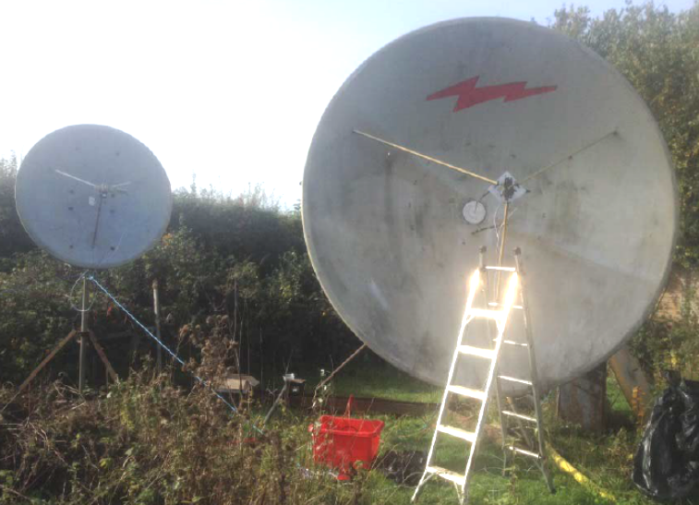
G3WDG’s dish “farm”
FINAL: The 2016 EME contest dates should be 24/25 Sept for the 2.3 GHz and up weekend (WE), and 22/23 Oct and 19/20 Nov for 50-1296 WEs.

There has been much discussion on the last minute ARRL EME Contest rules change with regard to the use of the reflectors. This change came as a complete surprise. I had been told that the rules would remain the same. I personally would have preferred that they were not changed. I am most interested in having fun and working a lot of stations. Winning is secondary. I hope this change did not cause anyone to not operate the contest.

There was also a great deal of heated discussion about trying to operate on up to 5 bands in one weekend for the microwave (MW) part. Obviously a weekend per band would be wonderful, but I do not see how we can fit in more contest weekends. I tend to believe "Less can be More". I already see a drop in activity during some of the DUBUS MW Contest weekends. Very few of us can operate at full throttle every weekend. Not all the DUBUS contests are taken as seriously as I feel they should be. It seems as if there is a contest every weekend. A contest needs to be special, if you want a large turnout and intense operation.

CORRECTION – My report on W5LUA completing WAC on 3 cm in the last NL was in error. Although he did achieve WAC on 9 cm as did several others by working 5B/DL2NUD Cypress, which is in Asia, he does not as yet have WAC on 3 cm. He still needs Africa for WAC. This was due to my misinterpretation of Al’s report and not W5LUA’s error in any way.

EME Örebro 2016? SM4IVE is asking if he should run the Swedish EME Conference in 2016 or wait to 2017. Let Lars know your view by emailing him at sm4ive(x)telia.com. From what I have seen, the consensus is to wait till 2017, after the meeting in Venice this Aug.

OMARC’s big 60’ dish in NJ is nearing being QRV. SP6JLW calling CQ during the contest as heard at the site can be found at http://n2mo.org/audio/sp6jlw.m4a.

A great resource is PA0PLY’s EME directories at www.pa0ply. nl/directory.htm. Thanks Jan!

Sorry, but I have to stop even though I have more. It will have to wait until next month. I had intended to have this NL out 2 weeks ago and there is now no more time. I shall be on for in contest and looking for all of you off the Moon. I hope you enjoy the EME contest WEs as much as I have (despite Murphy – hi)! 73, Al – K2UYH

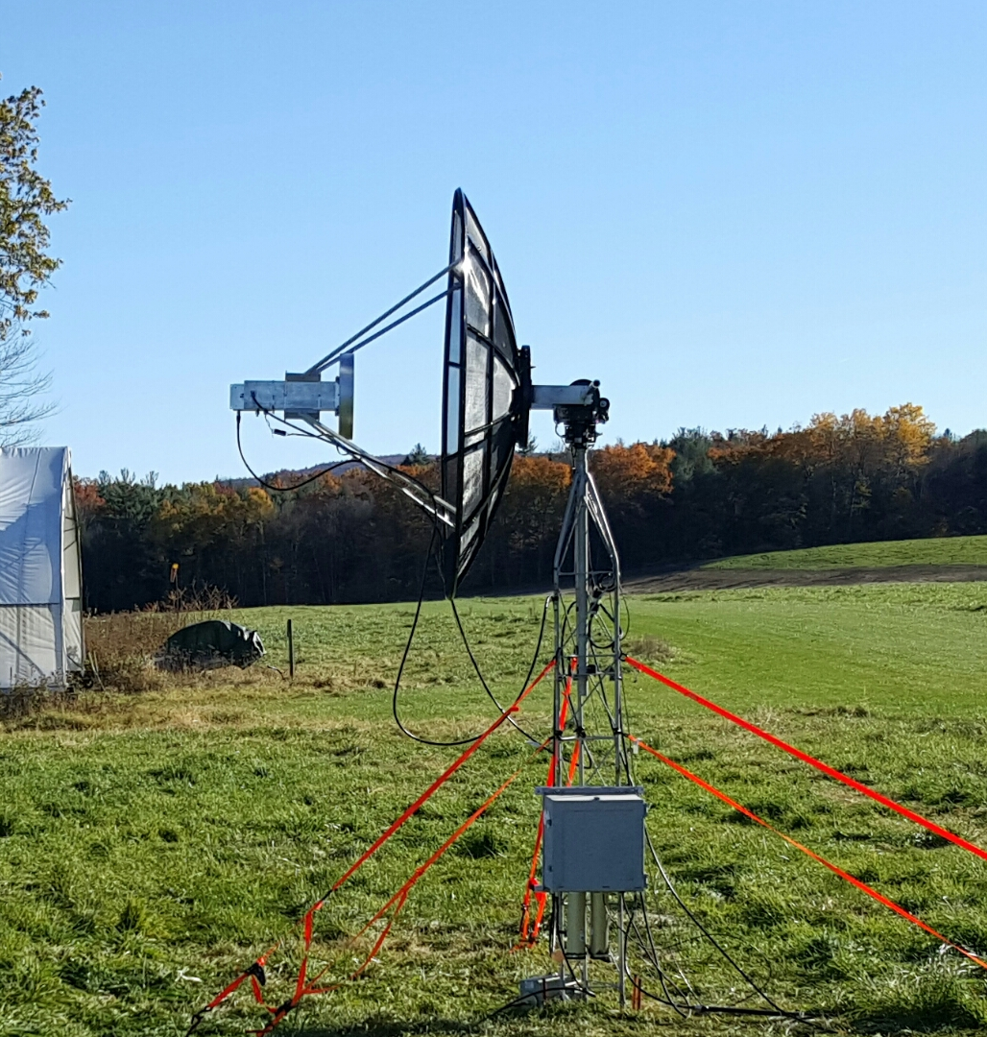
N1VT’s 2.4 m dish used on 23 cm

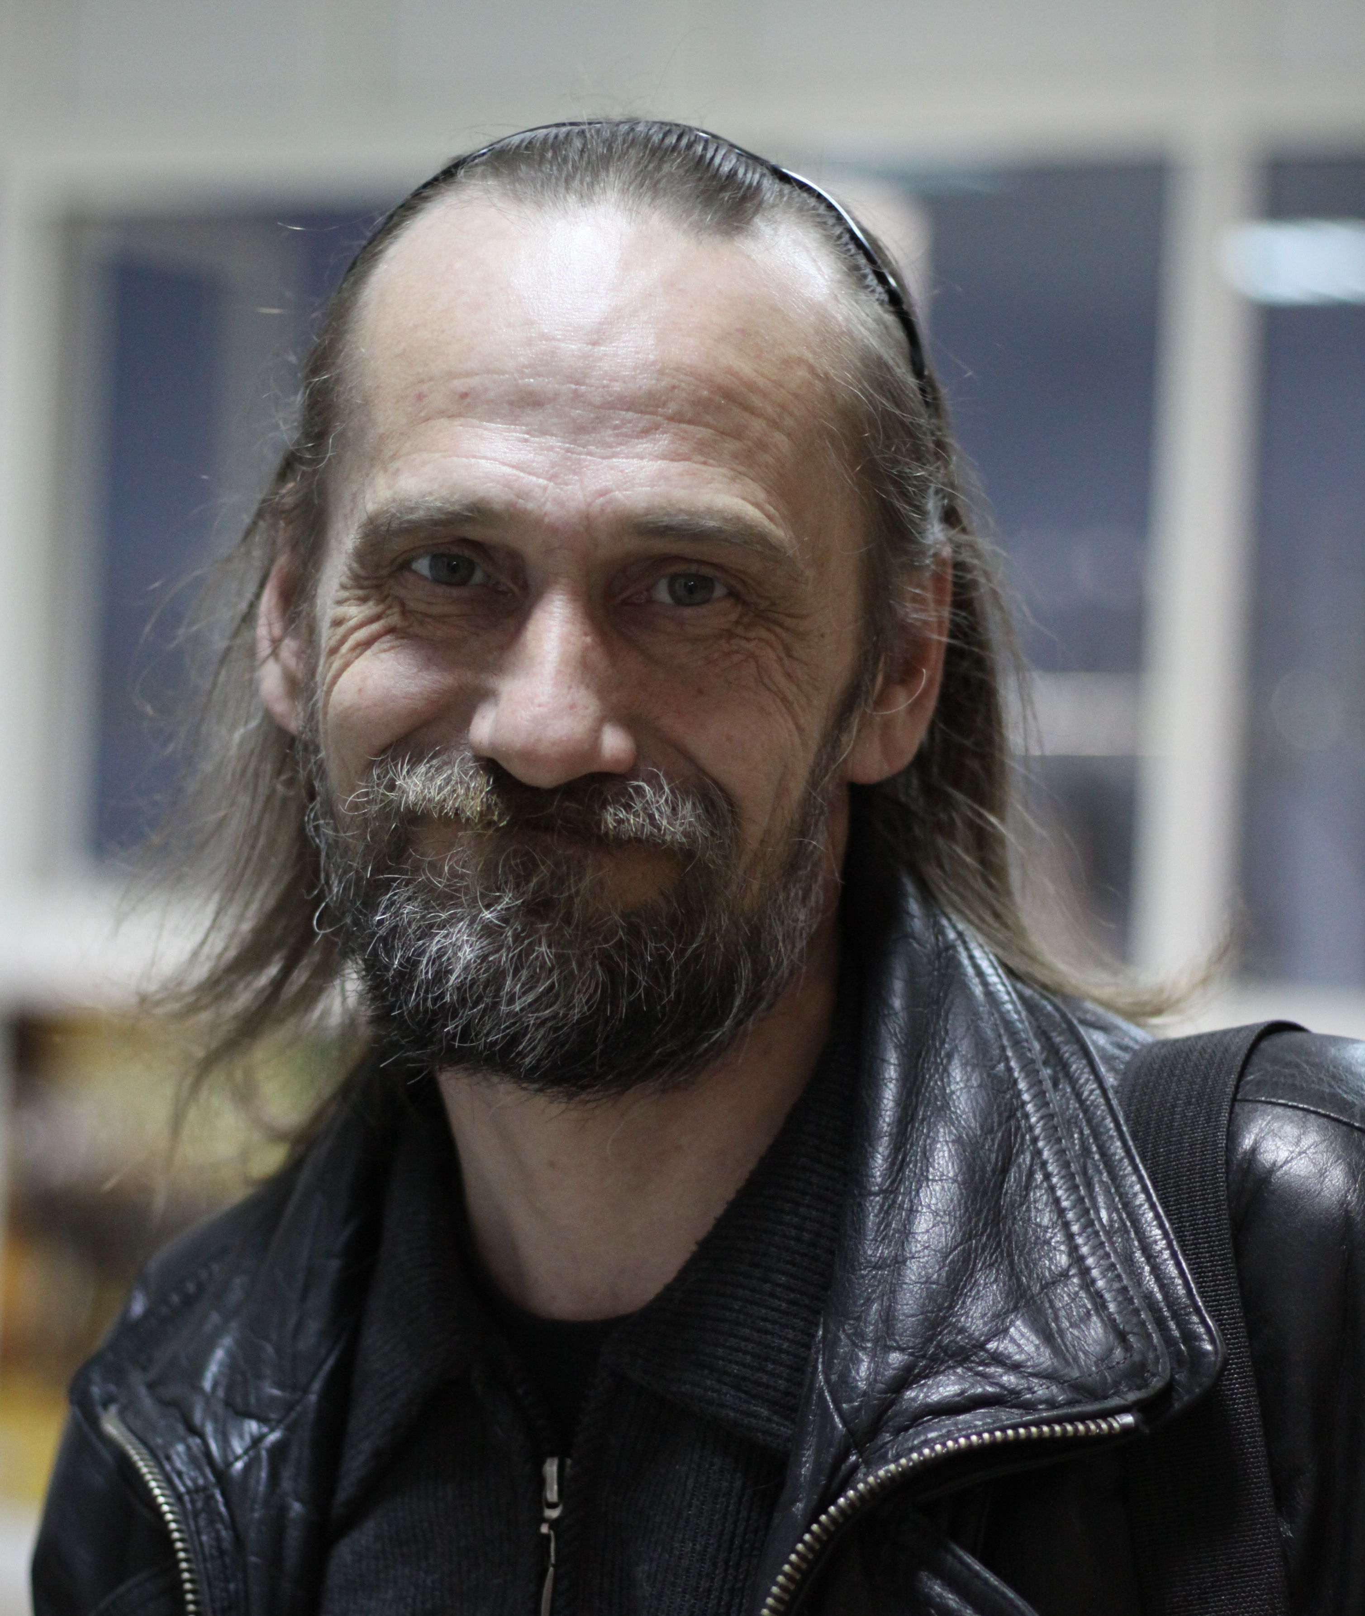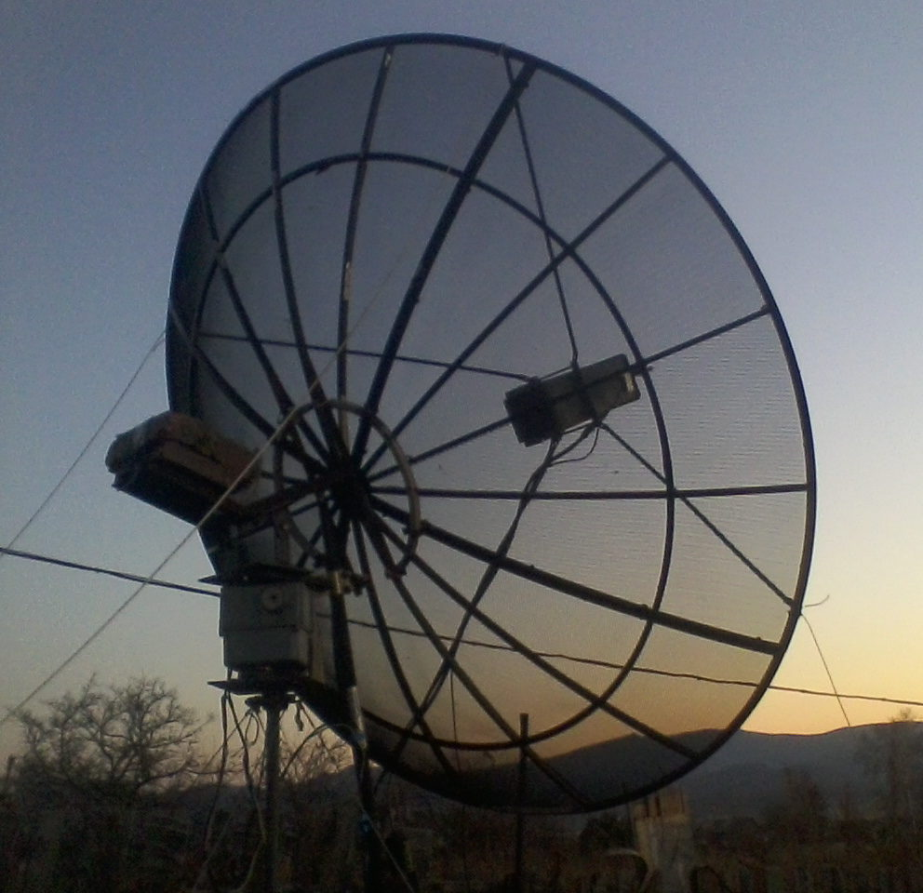
RW0LDF was QRV on 1296 in the contest with a new dish that replaced one damaged in a storm in Sept

