432 AND ABOVE EME NEWS
OCTOBER 2018 VOL 47 #9

EDITOR: AL KATZ, K2UYH; DEPT. ELECTRICAL/COMPUTER ENGINEERING, THE COLLEGE OF NEW JERSEY, PO BOX 7718 EWING, NJ 08628, TEL (W 609-584-8424), (C 609-047-3889), E-MAIL alkatz(x)tcnj.edu
ASSOCIATE EDITOR AND Reflector/NETNEWS Matej Petrzilka, Simunkova 1609/21, 18200, Praha 8, Czech Republic, TEL (+420 603 489 490), E-MAIL ok1teh(x)seznam.cz
CW INITIAL LIST G4RGK, DAVID DIBLEY, E-MAIL zen70432(x)zen.co.uk, AT: http://www.zen70432.zen.co.uk/Initials/index.html
SUN & EXTRATERRESTRIAL NOISE LIST MANAGED BY OK1TEH: http://www.ok2kkw.com/next/nl_k2uyh/sun_table.xls
EME INFORMAL NETS: 14.345, ~1500 SATURDAY AND SUNDAY, NET COORDINATOR: OPEN
ON0EME EME BEACON, 1296.000 IS QRV WHEN MOON >10°, SEND RX REPORTS TO WALTER (ON4BCB) on4bcb(x)gmail.com
DL0SHF 3 CM EME BEACON, 10368.025, SEND INFO & QUESTIONS TO Per (DK7LJ) per(x)per-dudek.de.
NL EMAIL DISTRIBUTION and EMAIL LIST CORD: WARREN, W2WD wbutler(x)ieee.org [PDF]
THE NL WEB VERSION IS PRODUCED BY REIN, W6SZ rein0zn(x)gmail.com, AT http://www.nitehawk.com/rasmit/em70cm.html

CONDITION: EME2018 came off spectacularly! Special thanks must go to PA3FXB and his XYL Marian for a truly exceptional job. Each conference has its own individual features that make it special. The arrangements with everything in one building were particularly nice. The two days of pre-conference tours including the visit to Dwingeloo were very well organized and attended. The technical sessions were a high point. The Saturday dinner with music by PA0SSB and company was something else! What a talented group we have! See the end of this newsletter (NL) for links to EME2018 Information and pictures. Operating wise this is an interim NL with big events on either side. There was the ARI Fall EME Trophy Contest that seemed to have more turnout than I can remember in the past. The top QSO count reported in this NL was from SM4GGC with 35 QSOs on 1296. There were no major dxpeditions this past month. TR8CA did show up on 432 from Gabon and has QSO’d at least 4 stations – see DL7APV’s report. It is not clear how long he will be on. 4U1ITU will be QRV on 24 Sept – see report in this NL. There is little dxpeditions news for the remainder of 2018. However, coming up on 29/30 Sept is the first of the three ARRL EME Contest Weekends (27/28 Oct and 24/25 Nov); this one is for the microwave (MW) bands 13 cm and up. It should be a great contest. I hope you can make it on. HB9Q has announced a major renovation of his EME reflector – see the end of this NL.

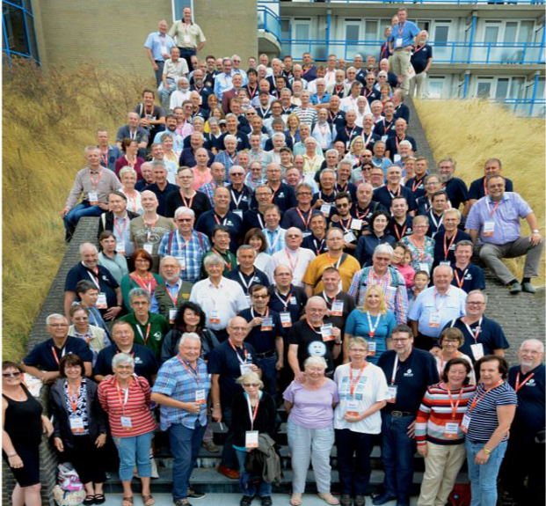
EME2018 the Netherlands family photo
OH2PO: Matti has joined the silent keys. He was enthusiastic about everything he did and he never gave up. He built the first and largest HB (50’) EME dish and kept it on the air for years despite repeated storm damage. His group was active during the ARRL EME Contests on 432 and usually had the winning score with their big signal. He will be hugely missed. Our condolences to his family and many friends - RIP Matti.

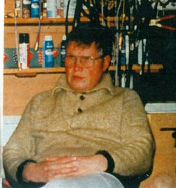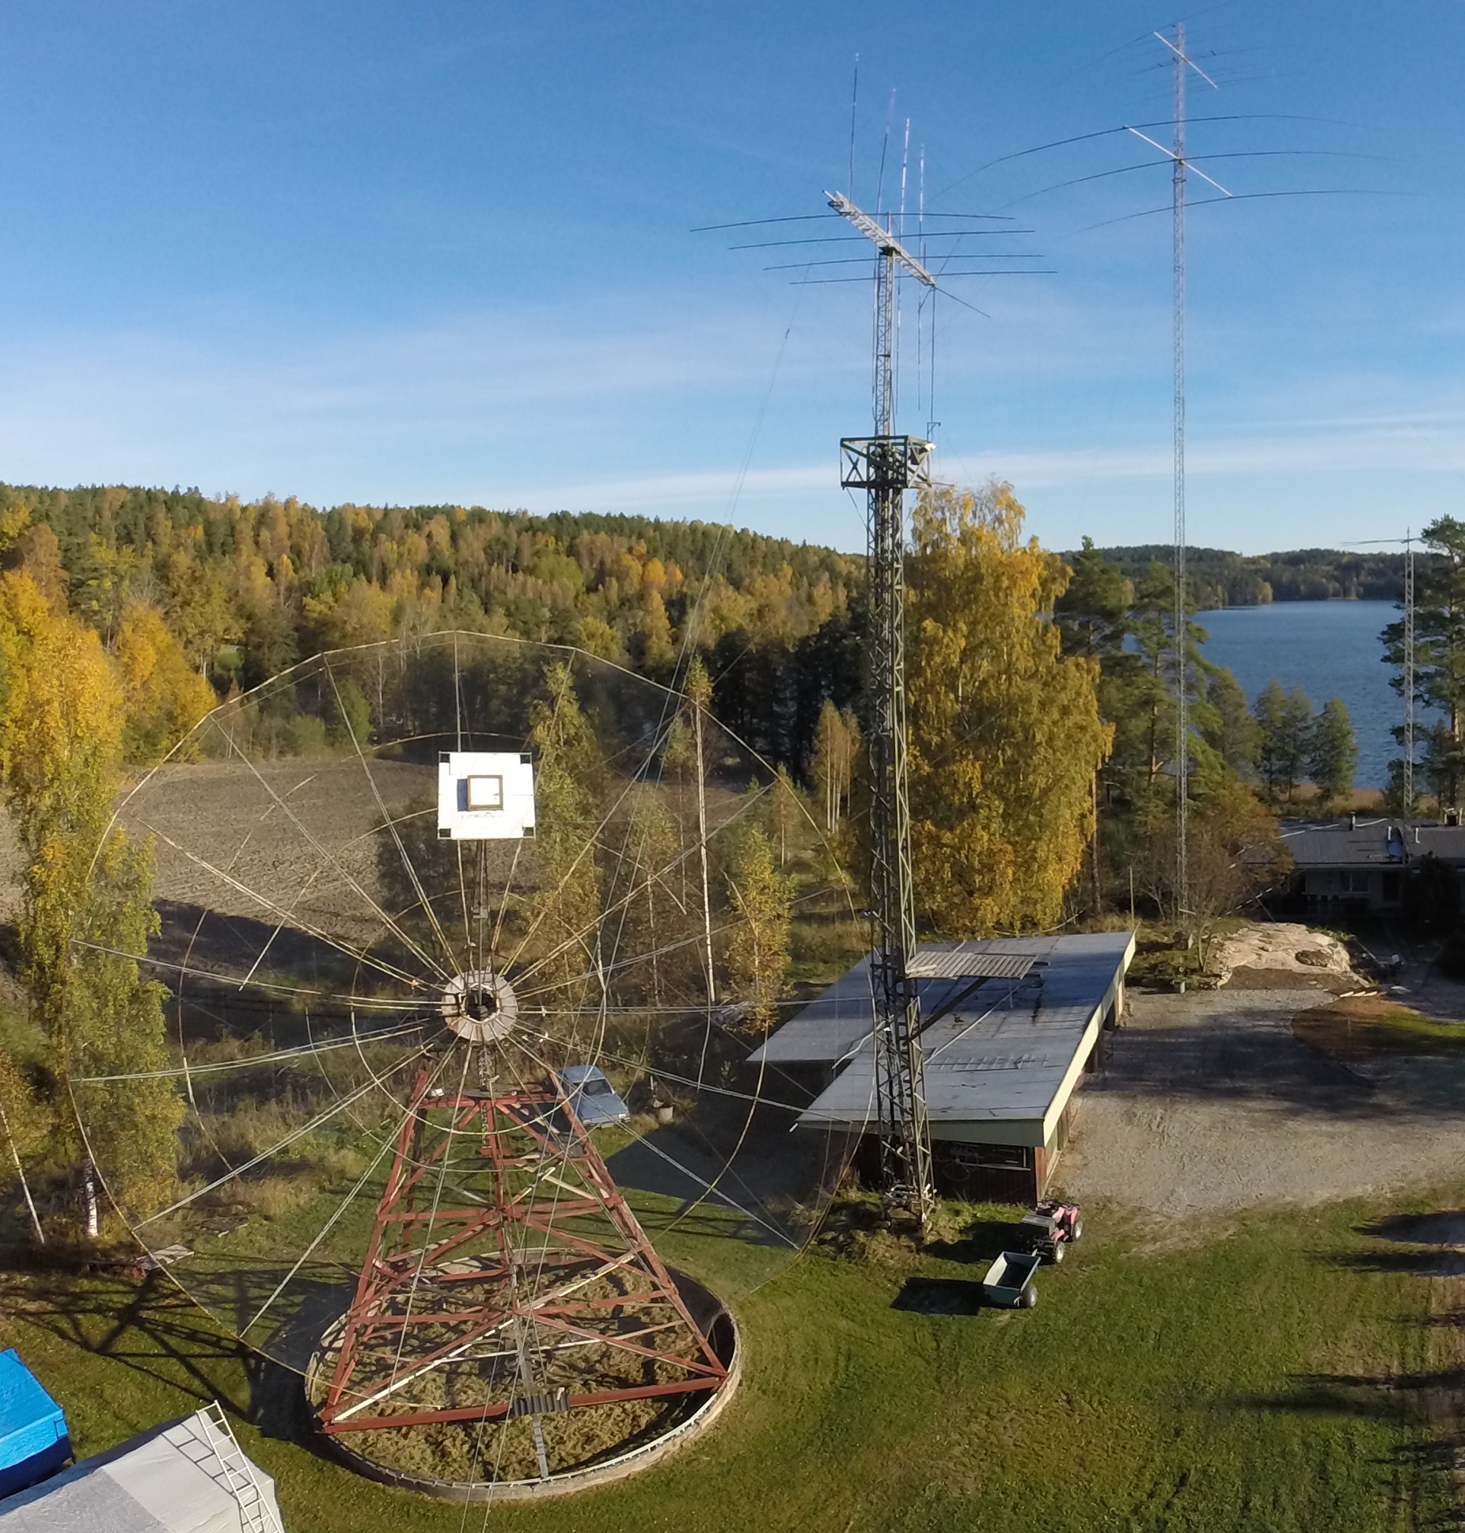
Matti, OH2PO and station

4U1ITU: Zdenek (OK1DFC) ok1dfc(x)seznam.cz sends latest news for EME operation on 7 bands from ITU (JN36bf): 432 thru 24 GHz on 22 Sept thru 1 Oct -- Time is running and date is getting close. I have tested the 24 GHz system and it works fine. I was able to work OK1KIR (18DB/23DB) using JT4F with 300 Hz of spreading and rainy weather with very high humidity - (worse combinations for 24 GHz band). OK1KIR was also received (13DB) on QRA64D and speaker copy. The RX performance of my 180 cm dish is great. I have 10.7 dB of Sun noise, CS/G of 2.4 dB and Moon noise of 1.1 to 1.3 dB depending on clear sky or clouds. OK1DAK from the OK1KIR team calculated the spreading during the dxpedition and as a result I have changed the band plan to give the best possible spreading for the upper MW bands. In the new band plan we will be QRV on 24 Sept on 70 cm (1738 to 0303) – alternate band is 6 cm, on 25 Sept on 23 cm (1803 to 0401) – alternate 3 cm, on 26 Sept on 13 cm (1828 to 0432) – alternate 1.25 cm, on 27 Sept on 1.25 cm (1855 to 0502) – alternate 9 cm, on 28 Sept on 3 cm (1925 to 0530) – alternate is 23 cm, on 29 Sept on 6 cm (2000 to 0605) – alternate 70 cm, and on 30 Sept on 9 cm (2040 to 0530) – alternate 13 cm. See the last NL for more details and also any last minute info http://www.ok1dfc.com/peditions/4u1itu/4u1itu_2018.htm. Please pay attention to our notices about traffic in JT, QRA and CW modes and for possible sked coordination during the dxpedition on the HB9Q reflector.

DK3WG: Jurg dk3wg(x)web.de reports on his Aug/early Sept EME – I worked on 432 using CW G0JLO and on JT65B VK1JA, W5KDA and TR8CA for DXCC136. On 1296 I added using JT65C DK5YA, EA/PA3DZL, IK7UXW, EI2FK for a new DXCC, IW8RRF for my 250th grid square (!), RN6MA and G4FQI.

DL7APV: Bernd dl7apv(x)gmx.de is back from EME2018 and writes -- It was really nice to meet so many old and new friends. Jan and Marian (PA3FXB) did an absolutely outstanding job! Hearing a pulsar at Dwingelo was big thrill! I also especially enjoyed the live music by PA0SSB and ON5GS at the barbeque. My new super array is stable and working very well with a new preamp from DJ3FI (NF 0.23 dB). I now have 22 dB Sun. 0.6 dB more than with my old LNA. Theoretically I should have only 0.2 dB better Sun with the new one; 0.6 was a happy surprise. I receive Cygnus 5.6 dB, Cassiopeia 5.2 dB, M17 5.5 dB and Saggitarius 7.6 dB. Next is to flatten my RX gain over 2 MHz for Pulsar hunting. In ARI EME Contest I worked on 70 cm 24 stations including SM2CEW using CW (589/599). New stations, all using JT65B were TR8CA (Gabon with a single 21 el yagi and 40 W), W5KDA (EM41), R3VE (LO16 with a single 26 el yagi and 60 W) and RA3VGV (LO06). I also worked MX0CNS again but this time with a dipole only and 60 W. We worked on our first try (27DB/21DB). Conditions on 432 seemed excellent. I am starting to remove all QRM sources from my shack to try to get 2 MHz free for pulsar detection. So far I have removed 12 switching power supplies and 3 monitors!

EA/PA3DZL: Jac PA3DZL(x)planet.nl reports on the results of his mini holiday operation from (JN11mu) in Calonge, Spain on both 70 and 23 cm EME – This was not a dxpedition but just some activity during the morning hours while the family still were sleeping. I had a lot of fun with my small portable setup. You do not need much to be QRV on EME! On 70 cm I made 5 QSOs and 5 initials, and had a great CW QSO with DL9KR. On 23 cm I made 34 QSOs and 30 initials. The smallest station worked was LA3EQ with a 2.3 m dish. I also had a great CW QSO with G3LTF. My 432 was a single 10 el 2.2 wl yagi (H/V rotation manually) with IC-9100 barefoot for 55 W (x) ant, and a 0.6 dB NF preamp. I worked using JT65B on 4 Aug DL7APV, UA3PTW and HB9Q, on 8 Aug NC1I (13DB) speaker copy and using CW DL9KR during super conditions. Heard were I1NDP and DF3RU. On 23 cm I used a single 67 el SHF 2367 yagi, IC-9100 with GPS lock, PE1RKI SSPA giving 120 W (x) ant and G4DDK 0.3 dB NF LNA. I worked using JT65C on 5 Aug PA3FXB, UA3PTW, I1NDP, OZ4MM, HB9Q, PAØBAT, DK3WG, ZS1LS, HB9Q (2nd time), DL7UDA, PA7JB, IK5VLS, DGØFE, LZ1DX and IK3COJ, on 6 Aug G4CCH, KA1GT, SM4GGC, OK1IL, DF2GB, IK1FJI, LA3EQ and VA6EME, on 7 Aug F1RJ and DF3RU, on 8 Aug PE1LWT and on CW G3LTF – very nice signal, on 9 Aug G4CCH (2nd time), DL8FBD, PA3CSG, PA3FXB (2nd time), ON4AOI, DL4DTU and F1RJ (2nd time). I also heard was IK7UXW.

F6ETI: Philippe f6eti(x)wanadoo.fr sends news on his recent Moon 1296 activity – My operating time has been low the last few months. But I was on during Saturday of ARI EME Trophy contest on 23 cm. I made 11 random QSOs all on CW with LZ1DX, OE5JFL, G4CCH, DL3EBJ, G3LTF, LZ2US, RA3EC, OH2DG, I1NDP, K5DN for an initial (#) and SP6ITF. I did lose IK3COJ before we could complete. My rig is a 3 m 0.37 F/d dish, OK1DFC Septum feed, 300 W DF9IC SSPA, and G4DDK 0.26 dB NF VLNA. The sun was not far from the moon, but with a 3 m dish there was enough separation. Recordings of some my QSOs (OE5JFL, G3LTF, G4CCH and own echoes) can be found on my web page http://ph-martin.pagesperso-orange.fr/f6eti/index.

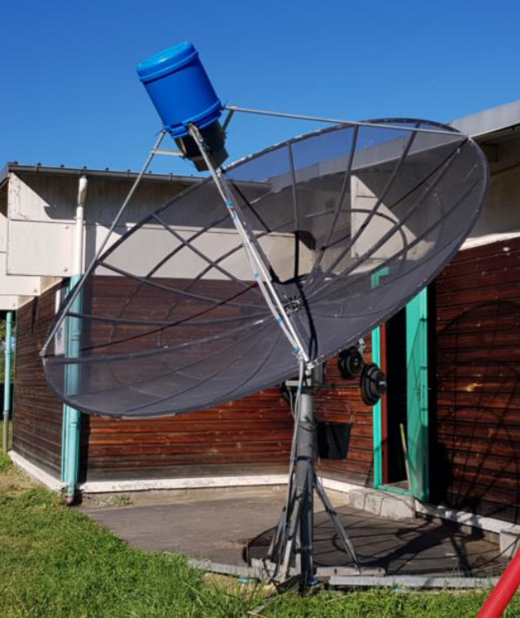
F6ETI’s 3 m dish

G0JLO: Keith keith(x)analog.co.uk, back on 70 cm after 35 year was QRV in the ARI contest -- I was on calling CQ using CW on Saturday on 432.021 (to avoid a spurious on 019) between 0630 and moonset. I am using an HB 8 x 20 el yagi array feed with open line feed, 7651 PA and ~0.3 dB NF Preamp. Unfortunately, at the end of a QSO with K2UYH my solid-state driver blew up. My PA has a high input VSWR that may have proven too stressful with all the contest operation. I have spares but need get better reliability. I am thinking of going back to a tube driver. Hope to see my friends in the ARRL contest in Oct.

G3LTF: Peter moon(x)moonbounce.info was active on 23 cm in the ARI Contest – I worked on 8 Sept with CW SM4GGC for an initial (#), SP6ITF, IK5VLS, OK2DL, OE5JFL, DL7UDA, LZ1DX, DL3EBJ, IK3COJ, PA3FXB, G4YTL, G4RGK, F6ETI, LZ2US, IK1FJI, RA3EC, W4AF, EI2FG, K5DOG, XE1XA and F5KUG, and then changed to SSB for VE3KRP, K5DN, and IK1FJI, and on 9 Sept back on CW IZ1BPN, JH1KRC, and IW2FZR. Then my driver PSU failed with 1.3 kV arcing across a tag strip in the rectifier stack. By the time I had located the fault and built a new stack, the Moon – Sun separation had gone from 5 degs to 1 deg; so that was the end of my activity! I ended with a total of 27 QSOs. My Sun noise on Sept 8 was 20.9 dB with an SF 67!

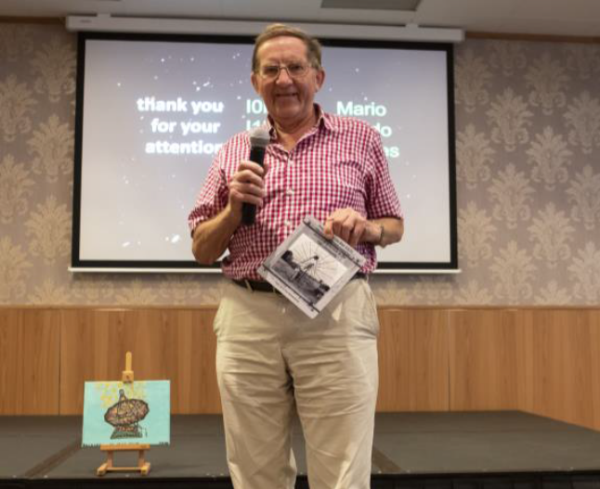
G3LTF received the Lifelong EME Achievement Award
at EME2018

G4BAO: John john(x)g4bao.com was active on 9 cm in Sept -- I have now fixed my problems with my 9 cm system and am looking for QSOs (both CW and JT). I have 30 W to my 1.9 m dish and SM6FHZ septum feed. On RX I have a 0.6 dB NF G4DDK VLNA. I copied G3LTF's CW well but we were just short of a QSO due to my QRP.

G4RGK: Dave zen70432(x)zen.co.uk had a terrific time meeting everyone at EME2018; a report of his post conference activity follows -- I was active in the ARI EME Contest over the weekend of 8/9 Sept. As the Sun was very close to the Moon, I did not bother with 432 and instead concentrating of 23 cm using my dish. Conditions seemed OK. I had a total of 33 QSOs during 8 hours of operating time - 6.5 hours on Saturday and 1.5 hours Sunday. I worked on CW DL3EBJ, OE5JFL, G3LTF, IK3COJ, I1NDP, RA3EC, SP6ITF, IK1FJI and SM6CKU, and on JT65C IK5VLS, ES6FX, IW8RRF, PA3FXB, LZ1DX, OK1IL, UA9FA, G4YTL, F1RJ, SM4GGC, DL3EBJ, UA4AAV, DL7UDA, G4BAO, W2HRO, OE9GLV, KN0WS, VE3KRP, K5DN, EI2FG, I1NDP, DF2VJ and ON4AOI. My newly rebuilt 4.6 m dish [see picture in June NL] seems to be working well.

GB6GHY: Brian (G4NNS) bcg4nns(x)gmail.com sends the story of the recent Goonhilly Dish EME Tests -- On the 1st and 2nd of Sept a group including myself, G8GTZ, G8GKQ and G3VZV were able to activate the 32 m antenna, GHY6, at Goonhilly Down on the Lizard peninsular in SW England. This site is a centre for Satellite communications, but as satellites became more sensitive an powerful and with the advent of undersea fibre optic cables the larger antennae have become redundant. GHY6, is to be re purposed for the deep space network and we had what is probably the last chance to use this antenna for amateur radio before this happens. We operated on 9 cm and 6 cm. Despite the weekend and times available not being ideal for EME, we had 16 QSOs on 9 cm and 19 on 6 cm. We were running about 50 W on 9 cm but the feed system return loss was only 8 dB as we were below the design frequency of the feed. We did add an isolator to protect the PA. On 6 cm we were running 40 W. We received plenty of (599) reports so the system was working. Thanks to all those who came on to call us. QSLs requests should be emailed me and I will QSL direct. We were also able to give some operators new to microwave EME a chance to operate with this system and to give demonstrations to visitors to Goonhilly Earth Station. When conversion of GHY6 for the deep space network starts it will no longer be available for amateur radio, but we are hoping that GHY3, a 29.6 m antenna with a conventional Cassegrain feed may be available. So, we are thinking of suitable feeds and looking for ideas.

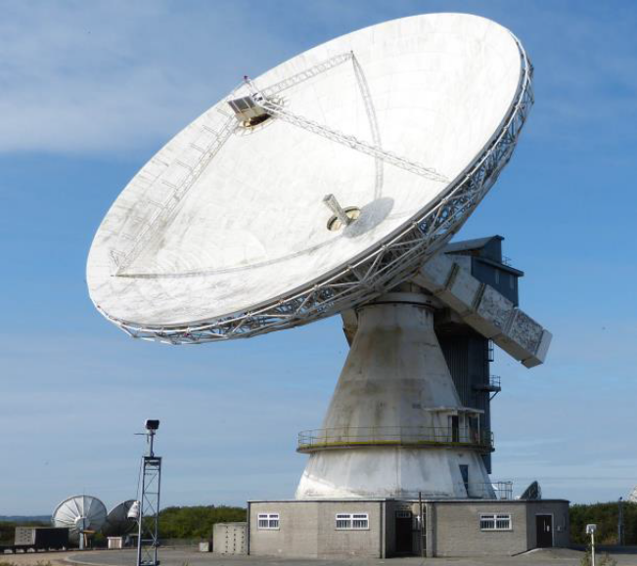
Goonhilly Earth Station 32 m dish

HB9Q: Dan dan(x)hb9q.ch sends a summary of his group’s initials worked from March to mid Sept – We QSO’d on 70 cm using JT65B SM4GC, RD4HU, CR2EME, VK2CPM (his first EME), DH0OK, AA4ZZ, TA1FIV, KE7NR/p, UA9CFH, YU7C, VE2PN, W2HRO, IZ5YFU (his first EME), R3VE, VK1JA, ZL4ZAG, EA/PA3DZL and TR8CA for our DXCC 163 and up to mixed initial #1050*; on 23 cm using JT65C unless noted BV3CE, IK7UXW (his first EME), 3B8MB for our DXCC 121, KA1GT, Z66EME (his first EME) for DXCC 122, PA0HRK, EA6/HB9COG using CW, DL1KDA (his first EME), DL0GM using CW, SM4GGC, EA/PA3DZL, G4FQI and RN6MA to bring us to mixed initial #651*; on 13 cm using JT65C unless noted JA4AHB using CW, IK7UXW (his first EME), Z66EME (his first EME) for our DXCC 61 and EA6/HB9COG using CW for DXCC 62 to bring us to mixed initial #170*; on 9 cm using JT65C unless noted Z66EME (his first EME) for our DXCC 32, VE6BGT using CW, SA6BUN using CW, HA/G3WDG using QRA64D for DXCC 33 and DL3EBJ to bring us to mixed initial #75*; on 6 cm BD4SY using QRA64D for our DXCC 33, UR5LX using CW, Z66EME using JT4F for DXCC 34, EA6/HB9COG using CW for DXCC 35 and HA/G3WDG using QRA64D for DXCC 36 to bring us to mixed initial #80*; and on 3 cm EA6/HB9COG using CW for our DXCC 33, VK7MO using QRA64D in grids QG52, QG53, QG41, QG43, QG44, QG45, QG35, QG46, QG36 and QG56, KN0WS using QRA64D (his first EME), VK7MO using QRA64D in grids QG38, QG39, QH30, QH31 and QG32, BD4SY using QRA64D (his first EME) for DXCC 34, HB9BBD using CW and VK7MO using QRA64D in grids QH23, QH24, QH16 and QH17 to bring us to mixed initial #157*. On 1296 we still need the following 11 states to complete WAS: AL, AR, DE, KY, MS, MT, NV, OR, SD, WV and WY. We can easily work stations running 1 yagi (40-70 el) and 15 W or 1.5 m dish and 10 W. Any help is very much welcome!

IK1FJI: Valter valter_dls(x)yahoo.it operated the recent ARI EME Contest on CW and SSB – On 1296 using CW I worked back on 14 July F6KRK (559/559) and PA2DW (O/O). I was active again in the ARI Contest and QSO’d on 8 Sept DL3EBJ, G3LTF, LZ2US, IK5VLS, LZ1DX, PA3FXB, DL3EBJ (dup), SM4GGC, DL3EC, SP6ITF, I1NDP, K5DOG, G4CCH and G3LTF (SSB), and on 9 Sept IK3COJ, G4RGK, SM6CKU, DL7UDA, OK2DL, K2UYH and LZ1DX – all on CW except G3LTF for a total of 20. On Saturday I found quite nice conditions, but due to the noise from the close Sun QSOs on CW were not easy. After the contest on 10 Sept, I had a nice CW QSO with OE5JFL (579/579).

KA1GT: Bob ka1gt(x)hotmail.com continues to focus on 23 cm EME although also QRV on 70 cm -- I'm now up to initial #82 since becoming QRV on 1296 in April of this year. I now have MAP65 running to monitor 1296 activity. My current project is expanding the dish to 3 m, which should be completed before the end of the month. I've also trimmed some trees to give me a better shot to the west for VK, JA, ZL etc. If anyone needs Maine on 1296, I'm available for skeds pretty much anytime.

KL6M: Mike melum(x)alaska.net write about the EME Conference and recent activity -- The EME2018 Conference was GREAT! It was wonderful to meet almost 40 folks who I have worked off the Moon. I met the op of GB6GHY (G4NNS) in person and then later worked him on 9 cm and 6 cm from Goonhilly. He had terrific SSB echoes on 9 cm. During the ARI weekend I worked K5QE on 222 CW (O/O) for a new initial (#). I also worked K5QE (O/O) on 70 cm CW along with NC1I (589/589), JE2UFF (O/O), VK4EME (O/O), and on 9 cm VK4CDI (O/O) for another initial (#). My plan for the ARRL MW Contest weekend is operate 13 cm on my first Moon pass on 29 Sept), then quickly switch to 9 cm (1500) for US/VE/JA/VK and EU moonrise. On 30 Sept I will switch to 6 cm (2200) for the rest of the contest.

KN0WS: Carl carlhasbargen(x)q.com is getting ready for the ARRL Contest -- I was not very active this summer. Although I put the mesh on my 6 m dish up at my northern QTH in May; I did not use it in May or June or July or Aug. I did get on the Moon from my home QTH backyard on 3 cm using my 1.2 m dish and 23 W to work on 10 June HB9Q (20DB/22DB) with QRA64D, on 19 June OZ1LPR (14DB/23DB) for my initial 10 GHz QSOs. This was the last of my moon work until the night of 29 Aug. I had replaced the worm gear drive of my 4.8 m polar mount in May and wanted to visually check alignment with the Moon on a clear night. It was low declination and I was on from midnight to 4 am local time. Three stations stayed up to work me - all initials on 23 cm: DL8FBD (18DB), W2HRO (24DB) and KA1GT (17DB). I next went to my site early on 7 Sept to finally try 70 cm this year. At 6 am the Moon had already been up several hours. I spent 2 hours setting up camp and my gear, only to discover I could not get my BEKO amplifier to work. I had some trouble with it last year during the ARRL contest. The factory says to use it indoors under specific temperature and humidity conditions. In the past 5 years, I am not sure my outdoor conditions have ever been within their specifications! I decided to tear down the 70 cm gear and setup for 23 cm. There was a 45 min unexpected rain delay. I had not taped and covered things properly because it was supposed to be clear, so everything got wet! Then 2.5 hours later I was ready, but it was at EU moonset. I listened for another 5.5 hours, but no one from NA, SA or the far east ever showed up. Thus, no QSOs for my 12 hours of trying on a Friday. The next morning was the ARI Contest. I was disappointed for the first hour because ON0EME was 12 dB WORSE than the week before. After the previous day of failures, I was disheartened. I have to work pretty hard to setup for my EME QSO’s and it seemed like all my work this weekend would be for nothing. I wondered if I was cutout for this hobby. But a new pre-amplifier later and after some re-pointing, thinks worked out. With the very first QSO, I was rejuvenated! I worked G4BAO (21DB), LZ1DX (7DB), DK0ZAB (14DB), VE3KRP (18DB), W2HRO (20DB), ES6FX(10DB), I1NDP (5DB), PA3FXB (14DB), IK5VLS (14DB), KA1GT (16DB), K5DOG (16DB) and VA6EME (14DB). I had initials with G4RGK (16DB), DL7UDA (11DB), IW8RRF (19DB), DJ9YW (11DB), EI2FG (23DB), K5DN (13DB) and JA8SZW (DB14). These 7 have me up to mixed initial #101* on 23 cm. I ended with 19 QSOs. For the Sept ARRL weekend I hope to do 13 cm and possibly 9 cm on my 4.8 m dish. I will also take my 1.2 m dish up north to try some 3 cm, as well. I have never tried more than 1 band at a time on a moonpass, but will take some extra cables and switches and see what happens.

MX0CNS: Tom m0aba1970(x)gmail.com continues to do what seemed impossible a few years ago -- Bernd and his super array has done again! Operating during the morning of 8 Sept in the ARI contest, I made my usual test QSO with DL7APV with my 17 el yagi. After watching signal increase to a steady (10DB) Bernd suggested we try on my dipole. This antenna is my DG7YBN GTV 2 with its reflector removed. After a single call Bernd answered; signals (21DB/27DB)! This contact was made with my normal power level of 60 W at the feed and the Blade dipole driven element of the little GTV2 – amazing!

N5BF: Courtney’s courtney.duncan.n5bf(x)gmail.com Aug 1296 EME report – I added one initial this month, PE1LWT for #131 and also made a dozen other 23 cm EME QSOs. I was calling CQ to the west on Sunday evening 13 Aug when my Alfa Spid rotator stopped going forward in AZ. I was able to park it properly (going the other way) before doing some basic troubleshooting and sending it off for repair. Unhappily, it was out so long that I missed the ARI Contest weekend. I do plan to be QRV again in late Sept.

NC1I: Frank frank(x)NC1I.COM had limited time for radio in Sept but did get on some and focused on 432 -- Despite what seemed to be low activity, I did manage to add seven initials and one new country. On 432, I logged with JT65B unless noted on 1 Sept DL7APV and G4ALH, on 2 Sept GW3XYW, on 8 Sept ON4AOI, DL8DAU, G4YTL, GW3XYW, PY2RN, TR8CA (25DB/22DB) using 1 x 21 el yagi and 50 W for a mixed initial (#*) and a new country, OK2AQ, DL9LBH, 4Z5CP, ON4CGX, DJ8MS (19DB/17DB) using1 x 19 el and 300 W (#*), W5KDA (10DB/O) (#*), XE2AT, IT9CJC (27DB/28DB) using 1 x 13 el yagi and 50 W (#*), LU8ENU, PA2CHR, G4BRK using 1 x 21 el and 50 W (#*), W4NH, K5QE, AA4ZZ using 4 x 19 el yagi and 500 W (#*), JE2UFF, KL6M on CW, and JA4UMN using 4 x 25 el yagi and 500 W (#*). On 1296, I QSO’d with JT65C on 1 Sept DL8FBD and 4X1AJ, on 8 September IW8RRF for mixed initial #288*, LZ1DX, DL3EBJ, and SM4GGC #289*. My fall activity will be focused on 432, but I will be active on 1296 as well. If W1QA is able to get to my QTH over the activity and contest weekends, we will try to stay on 432 and 1296 simultaneously. W1QA, W9JJ and I are still trying to put together a 432 dxpedition for the fall. I have been working on a new portable antenna system for 432 that includes full polarity rotation. We will sacrifice about 2 dB from our previous 432 portable EME setup, but I think most would agree it’s well worth the sacrifice. I should have everything ready to go for Nov or early Dec. However, there are still some obstacles related to all of our schedules and the availability of possible sites, so it is possible we will postpone the dxpedition to the spring. Hopefully by next month we will have something definitive to announce.

OK1KIR: Vlada and Tonda vlada.masek(x)volny.cz report on their early Sept EME results -- We made only some 1.25 cm tests as part of OK1DFC’s preparation for 4U1ITU dxpedition. Zdenek used his prime focus 1.8 m dish. However, on 3 Sept we did not find his signal and only worked with QRA64D at 0040 G3WDG (13DB/12DB). OK1DFC did received our signal well. The next day Zdenek found that his power measured only about 1 W, which explained the failed test. After some effort, he was able to increase his power to about 5 W. On 4 Sept we succeeded with OK1DFC at 0405 using JT4F (23DB/18DB) for our 24 GHz digital initial {#40} even though the spreading was 360 Hz (!) and with extremely high humidity. The next day with better conditions, we made a number of QSOs with OK1DFC starting at 0953 using QRA64D (18DB/11DB) at spread of ≈164 Hz, 1014 JT4F (20DB/17DB) at spread of ≈134 Hz, 1040 QRA64D (18DB/15DB) at spread ≈93 Hz and 1058 JT4F (19DB/12DB) at spread ≈64 Hz. Afterwards we worked at 1100 DC7KY using JT4F (18DB/17DB) {#41} and 1112 with QRA64D (14DB/16DB) at spread only 60 ~ 40 Hz. At 1148 we repeated with OK1DFC using QRA64D (20DB/15DB) at spread of only ≈28 Hz. After that we even tried a QSO with JT65C (22DB/24DB) but did not completed due to increasing spread (≈50+ Hz). Later on at 1350 when spread increased to ≈250 Hz, we lost our own echoes at an elevation of 9 deg; while Moon noise was still ≈ 0.9 dB. The tests again demonstrated that 24 GHz EME QSOs are highly dependent on spreading and atmospheric attenuation, related to air humidity, along the EME slant path, which rapidly increases at lower elevations. Moving heavy clouds provide additional random attenuation particularly at low elevations. The impact of these factors is multiplied by additional attenuation due to (small) errors in Moon tracking; the accuracy of which on 24 GHz becomes critical even with moderate size (1 ~ 2 m) dishes. With bigger dishes it becomes mandatory that tracking errors must be less than several hundreds of deg to maintain the echo level stable as the major part of the signal is bounced only by the small central part of the Moon. Underestimating these factors can easy create disappointment with 24 GHz EME.

PA2DW: Dick pa2dw(x)veron.nl is setting up for 3 cm – I have a 2.4 m dish that I plan to initially under illuminate to make tracking easier with the available SpidRas rotator. This will give me less gain but easier pointing. I will have about 12 W at the feed. He thanks PA3ACJ for his assistance with the feedhorn calculations and OZ1LPR and PA0MJK his WG TR relay.

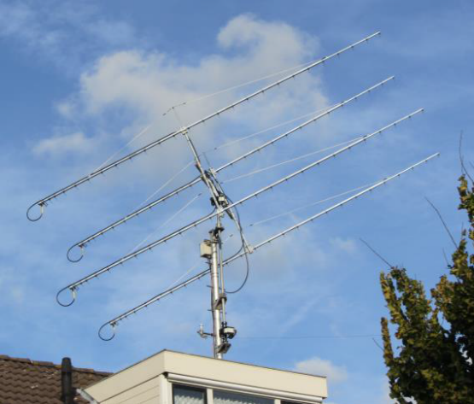
PA2V’s new 4 x 27 el (10 WL) yagi array

PA2V: Peter p.gouweleeuw2(x)kpnplanet.nl is back on 432 EME after his antenna disaster -- I have my station up and running again. I was QRT since Sept 2017 after storm damage. This last year I almost totally renewed my station. I have new (SPID) rotators, fully PC controlled now, new amplifiers and most important new yagis. The last 6 months I have been testing and building the antennas. I ended up using the YU1CF’s yagis design, which tested best. Since 14 Sept the system has been in operation. All the tropo beacons are audible and come in fine. Despite bad EME conditions, I have heard DL9KR on CW and DL8DAU on JT65. I am using a 4 x 27 el (10 WL) yagi array. It should give 1 dB more gain than my previous array and lower noise. The neighborhood sounds seem a bit quieter. Time will show the real performance. With this setup I hope I will stay on the air without that damage that I have experienced nearly every year. One of the very bad disadvantages of living close to the North Sea coast. Because the the array is on my house, it always is a major job getting it repaired.

SM4GGC: Stig stig.ake.larsson(x)gmail.com was on 23 cm in Aug/Sept -- I did have a great time at EME2018. Many thanks to PA3FXB and his wife for a truly excellent event. Since the last NL, I made on 1296 2 CW QSOs on 4 Aug OZ4MM (569/559) and on12 Aug PI9CAM (579/559). In ARI EME Contest there where many good signals on Saturday despite rain here. On Sunday Sun noise was more of a problem and I had a PA failure caused by a bad solder connection to one of the transistors. As a result my power was reduced to about 150 W. Consequently, I ended with 25 JT65C and 10 CW QSOs for a total of 35. I worked using CW on 8 Sept OE5JFL (559/559), G3LTF (559/549), OK2DL (559/449), OH2DG (559/449), DL3EBJ (449/559), RA3EC (559/559) and IK1FJI (559/559), and on 9 Sept DL6SH (569/569), I1NDP (579/559) and SM6CKU (579/559). I used a 3 m dish with septum feed, G4DDK preamp, and a DF9IC SSPA normally providing 240 W at the feed.

SM4IVE: Lars moon(x)moonbounce.info sends some bad news; he is QRT as a result of a major lightning strike -- On 29 July we had a big lightning hit. It came in via the telephone line and possibly the 220 V line as well. I saw flashes coming from the wall and could smell Ozone in the shack. We don’t have any HV lines in the area, so it is not clear how this happened; but it did! The only HV lines are 20 kV to a transformer some 300 m away. All the radios were killed. My TS2000X works on RX, but PTT and CAT are dead. My Flex5000A, SDR IQ, FT245RL, F1EHN tracking system, Magnetometer, 2 Yaseu G-1000 rotators, 3 computers, 3 power supplies, 3 ethernet switches, the ADSL modem and the charge station for my robomower all have major problems. I don’t know the status of the US digital readout in the dish - the interface is dead, also not sure about the LNAs. I just managed to get my main computer working by buying a new motherboard. I will probably find more stuff damaged when I start to repair; right now, I don’t know where to start.

SM6CKU: Ben moon(x)moonbounce.info is back on 23 cm -- I had a very enjoyable Sunday on 23 cm after nearly 11 years since last QSO on this band. Now I have a better mount, new SM4DHN SSPA with 400 W to the feed, new preamp and nice tracking of my 8 m dish. The feedhorn is the same as I used for my very first QSO on 1296 in 1982. It still works! I worked all on CW during the ARI Contest on 9 Sept the following stations: I1NDP (599/599), LZ1DX (579/599), DL7UDA (569/579), RA3EC (569/569), IK5VLS (569/579), SM4GGC (559/579), DL3EBJ (589/589), I5YDI (559/549), SP6ITF (579/589), IK1FJI (559/579), G4RGK (559/579), PA3FXB (559/569), UA3PTW (589/599), K5DN (579/569), IK3COJ (569/569), DF2GB (559/559), DL8FBD (559/559), SM3AKW (559/579), K2UYH (579/569) and finally VE3KRP (559/459) for a total of 20. Most stations are initials. Many thanks to SM6PGP, who has helped me a lot to get back to 23 cm!

UA3PTW: Dmitry ua3ptw(x)inbox.ru was active in Aug/Sept. He worked initials on 70 cm using CW with G0JLO and JT65B with EA/PA3DZL and DL4ZAG. On 1296 he QSO’d using JT65C with EA/PA3DZL and RN6MA. [TNX DK3WG for forwarding this report].
UA4AAV: Victor was active in Aug on 23 cm using JT65C. He worked G4YTL, DJ2DY, IK7UXW, DK5YA, DF2GB, I7FNW, DJ9YW, OK1IL, KA1GT and IK5VLS. [TNX DK3WG for forwarding this report].

VE3KRP: Fast Eddie eddie(x)tbaytel.net sends an update on his recent 23 cm EME -- We had an exceptional summer here, which kept me out of the shack for the most part. To catch up here is a summary of my activity. Most QSOs were on JT65C unless noted. I worked on 15 June the AA1KK dxpedition for a mixed initial (#*), IK1FJI and K5DOG, on 16 June DL6SH, DL6SH on SSB, F1RJ, SP6ITF, LA3EQ and K5DN, on 14 Aug EI2FG (#*), KA1GT, W1PV, IK7UXW (#*) and DK5YA (#*), on 7 Sept K5DOG, F1RJ and EA5DOM (#*), on 8 Sept during the ARI contest ES6FX, DL7UDA, PA3FXB, OK1YK, DL3EBJ, LZ1DX, OE9GLV, G4RGK, KN0WS, K5DOG, W2HRO, IW8RRF, IK5VLS, I1NDP, W1PV, VE3NXK, KA1GT, G3LTF on SSB, G4CCH on CW and EI2FG, on 9 Sept with extreme Sun noise during the second day of the ARI Contest DK0ZAB (#*), I1NDP (DUP), VA6EME, SM6CKU on CW, K2UYH and DF2VJ – all the activity was nice, and on 10 Sept after the contest IK1FJI and G4FQI (#). Snow has already been reported in the western Canadian provinces; too soon for me!

VK4CDI: Phil vk4cdi(x)gmail.com is QRV again on 9 cm -- I have my 9 cm feedback in my 3.6 m dish after my Toshiba 50 W PA caught fire during the last AW. I have installed my 16 W backup PA, and worked using CW on 18 July SA6BUN and in early Sept VK4AFL followed by KL6M several days later. During the ARI Contest I was on 23 cm for an hour on the second day and worked 10 EU stations on JT65C, but ran out of moon before I could get down to the CW end of the band. I will be QRV on 9 cm for the ARRL MW EME Contest and Zdeneck’s dxpedition. I repaired my 50 W PA and hope to have it on for the contest.

VK7MO: Rex rmoncur(x)bigpond.net.au is planning a new major grid dxpedition to ZL during which he hope to extend the international EME distance record; his plans follow -- At the end of my last grid tour the OK1KIR group asked "What is next, ZL?". They got me thinking. It is not so easy to take my car to ZL. The big problem is how to get a dish over there. The solution I came up with was to cut-up my second 1.13 m dish into a central section and 6 petals to make a flyable dish that fits in a standard luggage case. Based on Sun noise measurements, the cutting up process has cost 0.3 to 0.5 dB. My plan is to activate as many ZL grid locators as possible. I also want to see if I could increase the all-band EME World Distance Record (19708 km set on 2 m by CT1HZM and ZL1WN in 2007). Breaking this record is impossible from home stations as both stations need a 0 deg take-off. Even then the common window will be very short – estimated ~ 4 min. A more precise estimate by VK1XX indicates the window might be as long as 12 min. G3WDG have been exploring options and will take a portable station to Northern Spain. It was established by OK2AQ that two 1.2 m dishes and 40 W could make the QSO in good conditions. There would be little reserve for possible added ground noise and absorption loss/noise from the atmosphere. My experience over the ocean indicates that ground noise is significantly reduced over water. I suspect that with horizontal pol, the water reflects cold sky rather than emits microwave radiation. Absorption losses at low angles are much more difficult to assess. To get a handle on the noise cost of working down at the horizon, I have conducted noise measurements from a cliff looking over the ocean; and It does seem that the noise is much lower over the sea. VPol rises to ground noise at low elevations below -5 degs, even though the antenna is still looking at the sea, while HPol is much lower. There is, however, a peak on HPol that rises to 2.8 dB above cold sky right at the horizon - just not what we wanted. I have assessed this extra noise at the horizon to be 84 K, which will cost us 2.5 dB in S/N. In addition there is the attenuation due to absorption of around 1.3 dB at the RX end and slightly less at the TX end which will start at around 0.8 degs. My best estimate is that we have to cope with around 4.8 dB of additional loss at low elevations. We will be right at the limits with the planned systems. For success we will need to find a time when the spreading is exceptionally low and low lunar degradation. Also both sites need to be as high as possible and for our antennas to see only the water to minimise ground noise. G3WDG plans to increase his power to about 65 W. Another issue is the need to use prefixes for the countries in which we are operating. We may not be able to take full advantage of the coding. We are trying to understand this as it could cost us up to 3.2 dB. There are a lot of other things to resolve to set-up a portable EME operation such as transport, power supplies, dish mounts, etc. I was not considering a trip until sometime next year, but when I looked at Moonsked the very best time to try is 24 Oct this year. I can find no better time for at least the next 2 years. The low spreading is an opportunity we just cannot pass up. What I decided was that rather than do a full grid tour, I would break it into two trips. The first will be a shake-down trip to work out if what I have in mind for the grid tour is viable, but it will focus on the World Record EME distance. Then sometime next year I will do the grid tour. For the initial trip I am being supported by ZL3RC, who will provide transport, power supplies and generator, internet liaison, tools etc, and Dave ZL3FG who is providing his IC910-H. For the shake-down trip I want to arrange some tests with some of the big guns, primarily to prove the system is working prior to the World Record attempt. At this time I cannot give detailed times for skeds until I get to ZL and get set up. If there is time, we will work anyone else who can copy us, but the Eu window will be very short. Our grid locator will be RE66 in Christchurch. I plan to arrive on 18 Oct and expect to have assembled the station on 18 or 19 Oct. I would like to run some tests with OK1KIR, HB9Q, W5LUA and VK3NX to establish that I am operational before G3WDG drives down to Spain. I have reserved 23-25 Oct for record attempt. I will pack up on the 27th and returning to VK on the 28th. Once I have completed the proving tests, we can try QSOs with others depending on sleep and the weather. In ZL Internet liaison will be via ZL3RC at roger.corbett(x)corbie-solutions.co-nz. Please keep in mind that our focus will be on the world record and that there will be plenty of opportunities to work ZL on 3 cm when we return for the grid dxpedition.

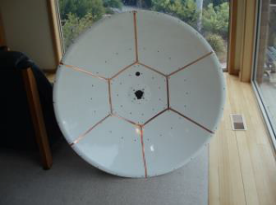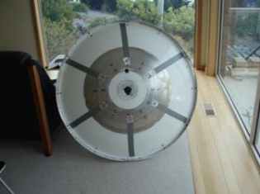
VK7MO’z cutup dish to allow air transport for world distance record and ZL grid dxpedition

W3XS: Bill billw3xs(x)gmail.com is now living on the coast of Oregon (CN74xk) –I am doing weak signal stuff on VHF and would like to get on 1296 EME for the ARRL Contest. I need an SSPA and antenna. Ideas would be appreciated.

WA6PY: Paul’s pchominski(x)maxlinear.com report for late Aug/early Sept -- I was active for GB6GHY Moon tests on 1 and 2 Sept. Besides working GB6GHY, on 9 cm, I QSO’d OK1CA, SM6PGP and DL7YC, and on 6 cm G3LTF and SM6PGP. GB6GHY’s signals were excellent on both bands; easy speaker copy. I plan to be QRV for ARRL EME Contest MW weekend. I will be on 10 GHz both days, and on 13 cm the first day. I am not sure yet which bands 13, 9 or 6 cm I will operate on the second day.

WD5AGO: Tommy wd5ago(x)hotmail.com sends his plans for the ARRL MW Contest -- For the first leg of the contest we will be on both 13 cm and 6 cm. It is more than likely we will operate on 13 cm the first day and on 6 cm the second unless it is raining; and then the change won't be made and we will stay on 13 cm. We were on 13 cm for the ARI Contest; however, no stations were heard on 13 cm - disappointing. We will also try to be on 70 cm during the last two legs of the EME contest.

K2UYH: Al alkatz(x)tcnj.edu was not very active in Aug because of travel to EME2018 – I was in EU for more than 2 weeks. Sally and I visited with Liuda, F5SE’s XYL and greatly enjoyed the tours, socializing and sessions at EME2018. After our return, I worked on improving my 3 cm system (new sharper feed) and on a new higher power SSPA for 13 cm in prep for the MW EME Contest. I wanted to do some testing during the weekend of 8/9 Sept but it rained the whole weekend. Instead I put some operating time into the ARI EME Contest. I was on 432 on Saturday and QSO’d using JT65B unless noted at 1503 XE2AT (21DB/19DB), 1548 PD7RKZ (19DB/O) for mixed initial #967*, 1602 W4NH (23DB/O), 1610 SM2CEW (559/569) using CW, 1623 G0JLO (569/449) using CW for initial #744, 1705 PA2CHR (14DB/18DB), 1720 LU8ENU (17DB/22DB), 1840 K5QE (4DB/18DB), 2056 JE2UUF (15DB/25DB), and on 9 Sept at 1257 4Z5CP (17DB/19DB) #969* for a total of 10 QSOs. I then switched to 1296 to work using CW at 1419 OK2DL (579/579), 1420 DL3EBJ (569/569), 1423 I1NDP (579/579), 1428 RA3EC (569/579), 1434 IK1FJE (559/569), 1439 SP6ITF (559/579), 1447 DL7UDA (559/579) and 1459 SM6CKU (569/579), and on JT65C at 1516 PA3FXB (8DB/O), 1517 VK3KRP (8DB/16DB), 1512 LZ1DB (5DB/O), 1527 W1PV (9DB/14DB), 1535 DL3EBJ (1DB/O), 1540 DL7UDA (9DB/8DB), 1544 LA3EQ (10DB/O) and 1603 PE1CHQ (11DB/14DB), and back on CW at 1632 XE1XA (559/549) for a total of 17 contacts. I was surprised by the level of CW activity during the ARI contest, especially on 1296. I think of this contest primarily a JT contest. Possibly this is the result of counting both JT and CW contacts for contest points separately. I plan with the usual team to be QRV in the ARRL EME Contest. During the MW weekend we plan to start on 13 cm, switch later to 3 and then back to 13 cm close to moonset. The next day we will start on 6 cm, switch later to 9 cm and back to 6 cm close to moonset.

NET/REFLECTOR NEWS: TR8CA is QRV from Gsbon on 432 with a single 21 el yagi and 40 W. Alain has worked DL7APV, NC1I, HB9Q and DK3WG thus far. HB9BBD is now QRV on 3 cm EME and getting excellent echoes with a 1.8 m dish. JA6XED uses on 10 GHz a horn for a 0.7 f/d dish to concentrate his RF energy at center of his 0.5 f/d dish where he has a finer mesh. K5QE operated 432 EME on 8/9 Sept during the ARI Contest, which also corresponded to ARRL Sept VHF [Tropo] Contest with a 16 x 28 el M2 yagi array (horz), 950 W and a tower mounted preamp. Marshall reports very good success this time. [Unfortunately his announcement arrive too late for the pre contest NL]. N4PZ when he checked Sun noise in Aug was surprised by about a 5 dB drop. Steve thought something was wrong but his CS/G noise was where it should be near 6 dB. He has since confirmed that Sun noise was down significantly. Look for Steve on 13 cm during the MW EME Contest. OZ1LPR is interested in skeds/tests on 10, 5.7 and 24 GHz. If anyone wants to try RX it is OK. Peter has on 6 cm 100 W, on 3 cm 350 W and on 1.25 cm 45 W to a 2.4 m offset dish. PE1CHQ had a great experience as part of the EME2018. After starting EME in the early 80’s, Harry is now on 1296 with a 4.5 m dish and N2UO feed; and plans to be more QRV now that the conference is over. VK4AFL (QG62om) is QRV on 9 cm and recently QSO’d VK4CDI. He will TX on 3399.8 and look on 3400.8. VK5ABN is setting up for 3 cm EME and has a 3.6 m dish, PE1RKI septum, 0.6 dB NF LNA, WG switch and rotator. Berndt wulf(x)ping.net.au is looking for SSPA ideas. W2HRO is extending his dish from 3 to 4.2 m.

FOR SALE: WD5AGO has 9 cm and 6 cm CP feedhorns, either SMA or N connectors. Contact Tommy at wd5ago(x)hotmail.com. He also has some excellent LNAs available. WA2ODO has 26.5 GHz SMA transfer relays, 24 Vdc, with indicator terminals (35 pieces) for $20 + S, 6 for $100 + S, or all 35 for $600 shipped. Trades considered. If interested email Pete at pmanfre(x)gmail. com. DF6NA is selling for 6 cm a complete TWTA capable of 700 W at 5760. See tps://www.ebay.de/itm/Vertex-RSI-700W-C-Band-TWTA-incl-Power-Supply-VTC-6361A3-6cm-EME-5760-MHz/132734897046?hash= item1ee79dcb96:g:sfcAAOSwcqZbab4M. He also has a brand new TWT (AEG YH1151) capable of up to 2 kW on 23 and 13 cm and 900 W on 9 cm, at a good price. See https://www.ebay.de/itm/ 132705371652. If interested in either of these contact Rainer directly at df6na(x)df6na.de if interested. K1DS has for sale a 13 cm preamp 13LNAH from DEMI with 0.7 dB NF and 17 dB gain for $60, and a AGO 9 cm LNA with 0.47 dB NF and 27 dB gain for $60. If interested contact Rick at rick1ds(x)hotmail.co. KK4X has for sale a BEKO 432 MHz 1 kW SSPA model HALVE 1100. It is hardly used. If interested contact Ed kk4x(x)tampabay.rr.com or cell 813-728-0207.

FINAL: Do to time constraints some of the regular NL features are missing this month, but all should be back to normal next.

► Some final words from EME2018 conference organizer Jan, PA3FXB -- The conference is history now. My thanks to all participants! I hope you all had a safe and smooth journey home. The EME 2018 website will be online for a while but not very long. We are gathering as many pictures and videos as possible and will put them on the CAMRAS website in future. It will take a while but I will announce when it is ready. If you were at the conference, you may have noticed two video guys running 4 cameras during the presentations. They were also with us on Friday during the visit to Westerbork and Dwingeloo. They shot large amount of video, and are now editing, which because of the quantity may take some time. When editing is completed, we will put it up a free download on the CAMRAS website. Some may have heard that a wallet was lost (maybe even stolen). The good news is the wallet was found by hotel personnel after the conference! Some may have heard that luggage was missing at the end of the conference. It appeared that the video crew took it home by accident. It is now back with it’s right full owner. Finally, you may be aware that we went over our budget a bit. A spontaneous fundraising action was organized to cover the overrun. I was really overwhelmed by this action. I often refer to our EME community as the EME family. This action is the best proof of this being true! What an extraordinary group of people this EME family is! Many, many thanks! Next week the project manager of the hotel will be back from holiday and she will do the final calculations. But as it looks to me now there should be enough money to close the gap!! My wife and I loved organizing EME 2018 and we loved every minute of it. It took some time and we did not too much sleep during the conference, but it was worth it. For me, showing you all the big dish in Dwingeloo was a great moment. We have run this old lady now already for more than 10 years and it almost becomes normal to us. But I realize that we are incredibly lucky to have the use of such a wonderful instrument. It’s an honor and a privilege to us Dutch guys to have this dish at our disposal. We are looking forward to Prague 2020 already! I can’t wait to see you all again.

► For all the EME2018 information and pictures see:
https://ok1teh.rajce.idnes.cz/18th_International_EME_Conference_Holland_2018/
https://ok1teh.rajce.idnes.cz/18th_International_EME_Conference_Holland_2018_PA3FXB/.

► HB9Q has announced an all-new EME Logger to replace the more than 10 year old existing one that plays a major role in todays 432 and up EME activity. The goal is to make it more user-friendly. Some of the new features are: 1) Very easy to use, 2) Intuitional functionality - you can try any button to find out what it does without risk, 3) Pleasant to work with, 4) One logger for each EME band (6 m to 3 cm), 5) Ability to (customize) the bands you are interested in, 6) Ability to attach to your messages pictures, sound-files, videos, pdf and txt files, and screenshots, 7) Semi-automated (easy way) to address messages, 8) Easy to find messages (highlighted in your color) when there is a lot of traffic, and 9) Easy and quick search traffic-history. For security reasons you will have to register a new account to use the new logger - apologize for the inconvenience. If all goes well, the new logger will go online early Oct and announces in moon-net.

► The dates for 2019 EU-DUBUS/REF EME Contest Weekend have be released: 2 m/70 cm is 16/17 Feb, 13 cm is 16/17 March, 23 cm 13/14 April, 3 cm and up 11/12 May, 6 cm 8/9 June, and 9 cm 29/30 June.

► The associated SSB Funtest will be for 23 cm on 19 Jan (2000 18 Jan to 2000 19 Jan) and for 13 cm 20 Jan (2100 19 Jan to 2100 20 Jan) - more info next time.

► SM4IVE has announced he will again hold SM 432 & UP meeting in 2019. It will be the same style as before with an emphasis on high tech and superb speakers. RW3BP, G3LTf and HB9BBD have already agreed to speak… More info to follow.

► WAC Club – at EME2018 it was decided that the WAC club should include 432 even though it is not a microwave band. G4RGK is had at work on the initial list of club members. It has become apparent that if we want to generate this list the information must come from you. Please send the bands and dates that you received your WAC certificates (if you have not done so already) to G4RGK at zen70432(x)zen.co.uk.

► TNX for all the reports. We are trying to get this NL out with some lead time before the first leg (13 cm up) of the ARRL EME Contest. We are looking forward to seeing you off the Moon and if possible QRV on 2300 up in the contest. 73, Al - K2UYH and Matej – OK1TEH

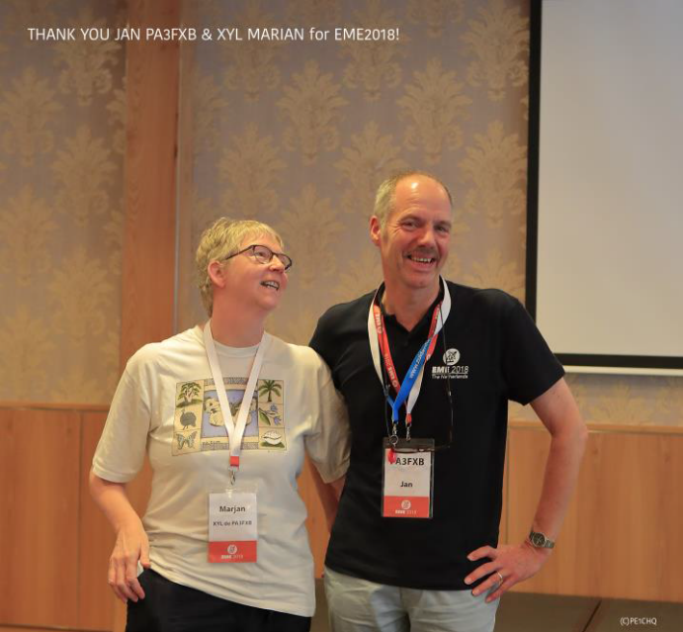
TNX PA3FXB and Marian for terrific EME2918!

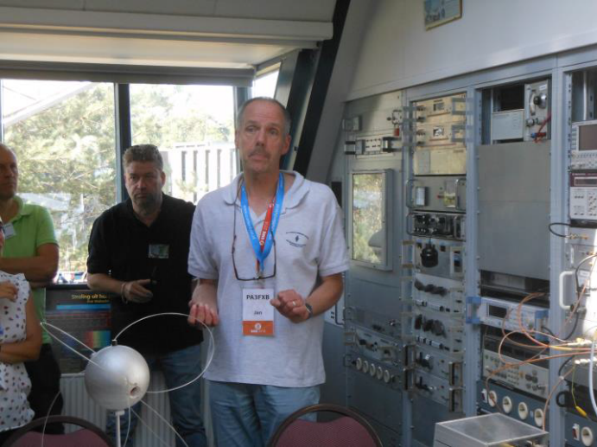
PA3FXB demonstrating pulsar reception at Dwingelo

