432 AND ABOVE EME NEWS
SEPTEMBER 2014 VOL 42 #8

EDITOR: AL KATZ, K2UYH; DEPT. ELECTRICAL/COMPUTER ENGINEERING, THE COLLEGE OF NEW JERSEY, PO BOX 7718 EWING, NJ 08628, TEL (W 609-584-8424) OR (H 609-443-3184), FAX (609-631-0177), E-MAIL alkatz(x)tcnj.edu
NETNEWS EDITOR (based Reflector News) REIN, W6SZ pa0zn(x)arrl.net WITH HELP OF N4PZ AND WB2BYP
INITIAL LIST G4RGK, DAVID DIBLEY, E-MAIL zen70432(x)zen.co.uk, AT: http://www.zen70432.zen.co.uk/Initials/index.html
EME INFORMAL NETS: 14.345, ~1500 SATURDAY AND SUNDAY, NET COORDINATOR: Steve Gross, N4PZ n4pz(x)live.com
ON0EME EME BEACON, 1296.000 IS QRV WHEN MOON >10°, SEND RX REPORTS TO WALTER (ON4BCB) on4bcb(x)gmail.com
NL EMAIL DISTRIBUTION and EMAIL LIST CORD: WARREN, W2WD wbutler(x)ieee.org [TXT OR PDF OR "ON WEB" NOTICE]
THE NL WEB VERSION IS PRODUCED BY REIN, W6SZ AND AVAILABLE AT http://www.nitehawk.com/rasmit/em70cm.html

CONDITIONS: The reports are down again this month, but not from a lack of interesting EME. The 70 cm CW activity time period (ATP) was one of the best in months. Let’s hope the Aug ATP does as well, on 16 Aug 2230-0030 and 17 Aug 0730-0930. There should be plenty of stations around as the DUBUS 70 cm Digital EME Championship is the same weekend. If you are primarily a JT operator, give CW a try during the ATP. SP/OK5EME will be on demonstrating EME on 13 and 3 cm from Polish Microwave/EME Conference this same weekend – see Zdenek’s report in this newsletter (NL). The EI9E dxpedition did an excellent job on their first try at 1296 EME – see their report too. HK1H is supposed to be QRV on 1296 from Columbia on 8 to 31 Aug, but I have no additional information. KG7HF is also scheduled to be on from HK 16 to 25 Aug but on 432. Coming up in Sept, 5B4/PE1L will be on from Cyprus on 1296 EME for the Saturday 13 Sept moonpass, and the Z21EME dxpedition to Zimbabwe is from 31 Sept to 9 Oct. PA2CHR was recently on testing their 1296 system. Details of both were in the Aug NL. Also in Sept on the 13th/14th is the ARI’s 21st CW/SSB EME Contest.

EME2015 BRITTANY EME2014 Last Minute News: Professional equipment for measuring measuring NF, gain, RL, IL and high power up to 47 GHz will be available for your use at the conference. You must register your call sign and item information on the EME 2014 Conference Schedule. Special gifts will be awarded for the best performance – see www.EME2014.fr. There also be door prizes with a first place price of an Icom IC7100, the 2nd a EME 144 MHz X polar long boom yagi, 3rd a Wavenode Digital wattmeter and much more! For those who cannot attend EME 2014, you can order on line a copy of the Proceedings including the CDROM with extras at the following http://eme2014.fr/reservations/index.php?id_product=54&controller=product&id_lang=2.

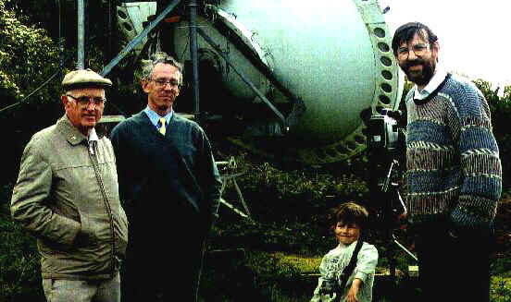
VK2ALU is a silent Key – see info at end of this NL. This picture shows L to R VK2ALU, G8AGN, G3WDG junior and G3WDG during a 1995 visit to Charlie’s (& Petra’s, G4KGC) QTH at Rushden, UK. Charlie's large dish, used about a year later to set the then distance record on 10 GHz with Lyle is behind the group.

MICROWAVE ACTIVIITY WEEKENDS (AWs) FROM G3LTF: This year, for a number of reasons, I did not suggest to the microwave EME community dates for AWs. My apologies and thanks to those who have prodded me. For new readers, an AW is when we attempt to get all those with capability on a specific band to come on and make QSOs, run tests for those needing signals, test new feeds, preamps etc. No pressure, no scoring, use the reflector, use any mode, just activate the band! After taking soundings I suggest the following AWS: 16/17 Aug 6 cm, 20 Sept (Saturday only) 3 cm, and 21 Sept (Sunday) 9 cm. I know this is not ideal and I know that 16/17 Aug is the 70 cm digital contest, but I don’t think there are too many stations that will find that a big conflict. It’s not a contest after all, and an AW is an opportunity to give the gear a check before the ARRL Microwave Contest on 11/12 Oct. If you can be there good, if not, CU in Oct. Next year it seems we finally start to get a better alignment of high declination with low path loss and I will suggest dates in the first months of the year.

BD5RV/4: Michael michael.bd5rv(x)gmail.com writes that he has been busy because of the arrival of a new baby boy in Feb. He is working on a 5 m mesh dish and hopes to eventually be QRV on 70 and 23 cm with it – possible this fall.

DC9UP: Hermann radio.dc9up(x)googlemail.com is now QRV on 23 cm on CW, SSB and JT with a FB signal – I started transmission on 23 July with 400 W at the feed of my 3.2 m dish from a BEKO PA. On SSB and CW I can run up to 750 W. My biggest problem is trees all around my QTH. So far I have worked 25 stations with JT65C and also N1NDP on SSB. I worked my friend VK3NX just before the Moon went behind trees on 3 Aug. It was my second QSO with Charlie and was done with JT4F. My first was on 10 GHz under my F5VKQ call on 16 April 2007. Charlie told me that he will be on 23 cm for at least a couple of weeks. I tried to QSO K2UYH (559/-) on 31 July on CW after we worked on JT, but I ran into the trees before we could complete.

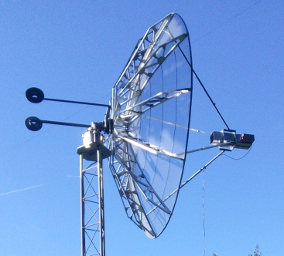
DC9UP’s 3.2 m dish

EI9E: John (EI2FG) johnhearne(x)eircom.net and his dxpedition team are operating from IO41tu at this writing. They are on 1296 EME with a single Wimo 67 el yagi and 200 W. They started on 10 Aug and will conclude activity on 14 Aug. Operation was on 1296.050. I do not have their final report, but know that they have QSO’d 12 stations including OK1KIR, IK2COJ, I1NDP, G4CCH, HB9Q, JA6AHB and K2UYH. All QSOs were on JT65C, but I know they were making a serious try for CW QSOs as well. I tried to prearrange skeds, and even sent out an announcement to the NL’s distribution list, but received very few takers. They were on the HB9Q logger. Originally they were going to use EI9E/p but for simplicity decided to drop the /p as it is not legally required.

G3LTF: Peter pkb100(x)btinternet.com found a bit more activity this month -- I had no window for the first section of the 70 cm CW ATP (20 July). In the second window activity was definitely the best this year. There were 3 seriously big signals on the band: SM4IVE, UA3PTW and NC1I. The ATPs are definitely worth the attention of anyone with a small system who has not tried CW before. The only problem was that Faraday rotation was in its summer daylight default position of ~90 degs, however 2 of the 3 big signals had variable polarization and so could deal with this. I worked SM4IVE, K2UYH, UA3PTW, N4GJV, G4RGK, UT5DL, NC1I and DG1KJG. Also heard was SP6JLW. Finally I was delighted to work VE4MA who had only a 10’ dish with switchable polarization. This was our first 432 QSO since 1991! Barry was peaking at about 10 dB in 100 Hz, but the peaks were not regular; every so often the signal would jump out of the noise. This is why I like to run 2.5 min periods rather than the 1 minute that the JT people favor when you try and work them on CW. It gives me more time to optimize pol angle. Faraday had a sharp peak, which is good (rather than a broad peak) and always gives better signals. I think my feed improvements plus adding a baffle to the reflector as suggested by SM6FHZ’s modeling have definitely improved my dish’s noise performance - probably 0.5~0.8 dB (see http://www.2ingandlin.se/EME _2012_Unexplored_Areas_of_432_MHz_Feeds_post_conference_version.pdf). Using Cygnus as the standard, I believe the G/T at 432 to be close to 20 dB. On 13 cm on 19 July I worked PE1LWT for initial #118 and his first 13 cm QSO, and after him PA0BAT. With the 13 cm feed in the dish, I have been making a daily measurement of Moon noise with the aim of investigating the constancy of the Moon’s temperature at 2.3 GHz. By making measurements of Cygnus and Taurus using the Spectravue software, I believe I can measure G/T quite accurately up to 13 cm. For 9 and 6 cm, I have to use to Moon as the standard. I can easily measure to 0.02 dB the Softrock SDR after I made a few changes such as insulating the preamp from solar heating! I plan to be active on 9 and 6 cm for the recently announced AWs.

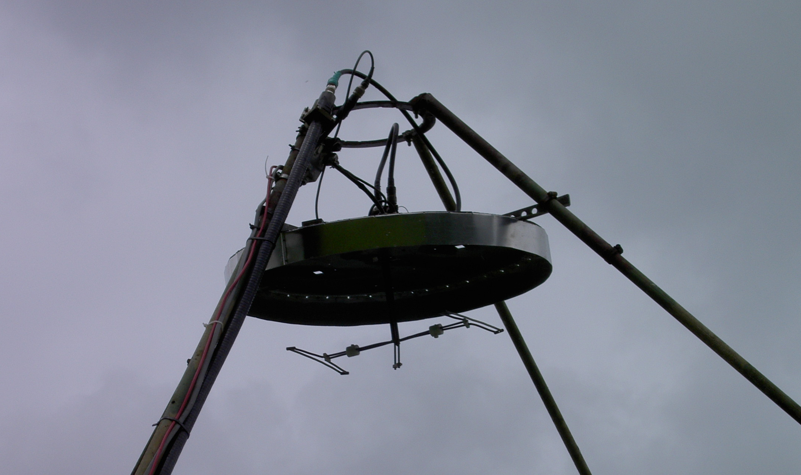
G3LTF’s improve 432 feed with baffel

JA4BLC: Yoshiro’s ja4blc(x)web-sanin.co.jp EME report -- I worked on 3 cm on 12 July JA8ERE (O/O), JA6CZD (559/569) and JA1WQF (559/559), and on 23 cm on 20 July JA1WQF (559/559), JA6AHB (559/O) and JA8ERE (559/549), and on 26 July JA6XED (559/449). There is very good news on 13 cm. In late July the Japanese Radio Authority sent out a request for public comment on spectrum usage for 2400 – 2405 MHz by Japanese moonbouncers. If they receive positive comments, they will permit operation on a new band after 5 Jan. 13 cm moonbouncers need to prepare receiving gear for 2400. I am not sure if we will lose 2424 after Jan 2015. My hope is that both bands remain usable.

K3MF: Wayde k3mf(x)aol.com updates us on his station’s status – I have been QRT for a while because of moving my QTH. I have finished the 432 EME station here at my new QTH in Fawn Grove, PA. I moved from FM19xp in Maryland to FM19sr in PA. [Because of his change in State, Wayde should now count as a new initial.] The 8 x 25 K1FO array is working great. My azimuth and elevation system has also been changed to an OR2800 and a MT-3000. The noise level here is also a lot lower. I am now using an 8938 amplifier putting out 1200 W. I worked so far from the new QTH on 2 Aug LU7HI for an initial for me (#) and KD5CHG (#), and on 3 Aug VK4CDI, LZ1DX, UT5DL, ES3RF, LU8ENU (#) and DL7APV. All QSO's were JT65B.

KD5CHG: Matt m4187(x)yahoo.com is QRV on 432 with an excellent signal – I am running 4 x 12 el FO yagis and 1 kW. Recently I installed a WA2ODO preamp with a lower NF and a bit more gain so I can drive a splitter and run LINRAD/MAP65 with my ICOM rig. I hope to improve efficiency that way and use LINRAD's filters to improve my CW copy. [Matt is looking for any stations QRV in Africa on 432 EME to finish off WAC. – see the Z22EME dxpedition info.]

N4GJV: Ron qstdemb(x)yahoo.com sends his July 70 cm CW ATP report -- I found signals to be remarkably good during the July ATP. Conditions seemed to be on par with those I would normally expect during a good mid winter session. That said, some stations were contacted when the polarity alignment was apparently sub-optimal for my fixed polarity array as they were later heard with much stronger signals. QSOs were logged with SM4IVE, G3LTF, K2UYH, and NC1I. Other stations heard include G4RGK, UT5DL, UA3PTW, and DG1KJG. Unfortunately, I had no opportunity to call the latter 4 stations as they were only heard while in QSO with other stations or when replying to the CQs of others. I did attempt to call CQ, for a while (1000 to 1030), but I was unable to hear any replies. Many thanks to all for the activity! I plan to be QRV again in Aug.

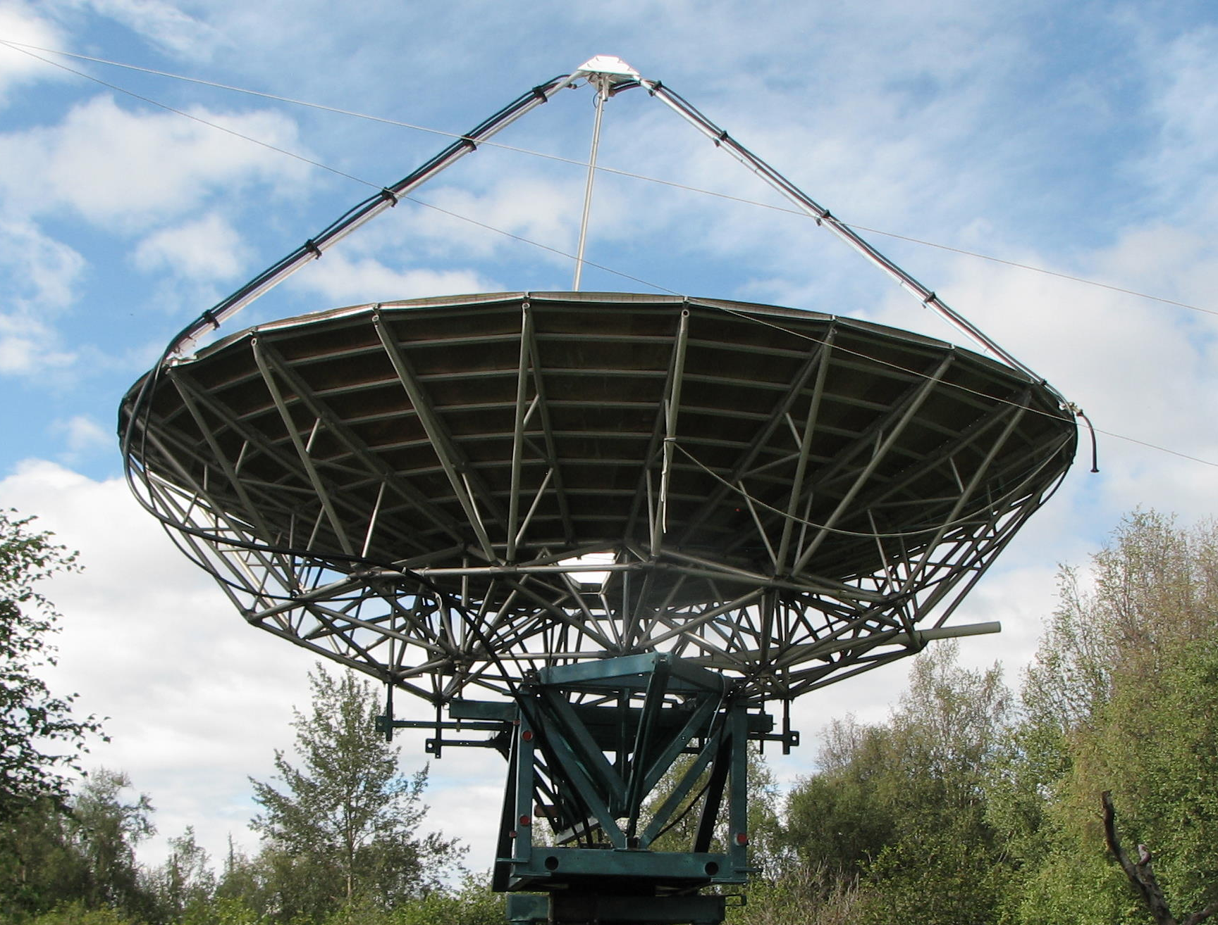
KL6M has his 30’ dish back in operation with both coax for low bands and waveguide feed for 6 cm

OK1KIR: Vlada and Tonda vladimir.masek(x)volny.cz send news on EME during July-Aug – Our July activity was mainly occupied by VK7MO, who was on and continued his now famous long journey through Australia’s mainland with his portable 10/24G EME station. We were also involved with providing 10 GHz EME signals for a demonstration organized by W5LUA. WA5YWC assembled with the help of Al a truly portable 3 cm EME QSO at Central States VHF Society Conference in Austin, TX on 25 July. The station used only an 88 cm dish and 21 W from a TWTA. We were pleased to be on the second end of EME path. In addition, we worked on 20 July on 10368 CW at 0104 VK3NX (559/569) and 0118 OK2AQ (O/569) for initial #84, on 19 July at 1046 W5LUA (16DB/15DB) with JT4F while testing WA5YWC’s portable rig for the Austin presentation, on 20 July at 0155 OK2AQ (13DB/13DB), on 25 July at 0328 VK7MO (14DB/11DB) from QF46 for digital initial {#35}, 0334 VK2JDS (14DB/14DB), at 1308 random OK2AQ (15DB/DB12) and finally at 1429 WA5YCW (18DB/16DB) {#36} in Austin, and on 31 July at 0910 VK7MO (17DB/16DB) from QF28 {#37}. This Moon pass was only 2.0/2.6 dB (close/50 deg), 4 dB G/CS and Sun 12+ dB - (later we found decreased system NF due to the backlash in our WG switch). On 24048 we worked on 13 July 2044 VK7MO (17DB/18DB) in QF32 for digital initial {#9}. (Moon close/50 deg = 1.4/2.2 dB, CS/G = 2.9 dB). Later on, at 2220 worked G3WDG (15DB/13DB). We added on 19 July at 2352 VK7MO (18DB/14DB) {#10} from QF34 (Moon noise close to 1.2 dB and CS/G 2.95 dB). We added on 1 Aug at 1124 VK7MO (18DB/17DB) QF28 for {#11}. The Moon was 0.9/1.9 dB (close/50 degs), CS/G = 2.8 dB and Sun 13.7 dB. We send our TNX to the DUBUS 2014 committee. We have already received the contest awards (arrived on 23 July) even though the closing day for log submission was 15 May!

OK2AQ: Mirek mirek(x)kasals.com was active on 3 cm EME from his country QTH in July -- On Sunday 20 July, I worked VK3NX (14DB/14DB) on JT4F for mixed initial #3* then OK1KIR (569/O) on CW and (13DB/13DB) on JT4F. Later in the morning I worked LX1DB (559/O) CW #4*. The next day we repeated with VK3NX (14DB/14DB) on JT4F. On 25 July we worked randomly OK1KIR (12DB/15DB) on JT4F. My equipment is 1.8 m dish, 20 W and 1 dB NF. Sun noise was measured at 10.5 dB and Moon noise at 0.8 dB. More details can be see on http://www.urel.feec.vutbr.cz/esl/files/EME/EME.htm.

ON0EME: Eddy ejespers(x)telenet.be sends latest news on the 1296 Moonbeacon -- The beacon was re-activated on Friday 18 July. All is looking well. We are monitoring both PA and box temperatures. They are running up to 60°C when the outside temperature goes above 30°C. We had found some humidity damage under the PCB’s in the power amplifiers. The output boards where replaced and one FET needed to be replaced as well. We decided to install a heater in the beacon box. It is a 1 kW heating element that will start working below 15°C. We hope this will eliminate the humidity problem. We also installed a temperature controlled switch for the fans that cool the beacon box, so that at very low ambient temperatures the fans do not circulate humid air anymore. Our monitoring and control system occasionally displayed some glitches. The control system was rebuild and in the coming weeks new software will be installed. A new directional coupler was installed to monitor FWD and REF power. Previously this function was built into the output hybrid, but it burned out and we lost its monitoring feature. Output power is very stable. In addition we did some tree trimming that will eliminate blockage at lower elevations. Hopefully it will be a few years before we need to make more revisions.

PA0EHG: Hans h.v.alphen(x)planet.nl reports copying the 10 GHz EME Beaconwith a small dish -- I found the beacon, not strong but at a max of 4 dB above noise on my SDR in a 12 Hz RBW. I am using a 48 cm dish! I have not yet tried to decode the JT; the CW signal is sometimes just audible, but too weak to copy. I have problems with low elevation as my window is just about clear, but cannot determine if I still get ground noise, probably I do have some ground noise contribution.

PA0HRK: Harke harke.smits(x)hccnet.nl is hearing on 23 cm and hopes to be on TX soon -- I recently received my first EME signals. I have constructed a stress type 2.4 m prime focus dish that can be dismantled in triangular sections. The support structure is made of 8 mm fiberglass rods, used in the kite industry. It is like a classic wheel with 12 spokes, 1.2 m each. A rim forces the spokes into a parabolic shape. Spokes and rim are connected by means of hard soldered T shaped brass tubing. The reflector is made of triangular pieces of 10 mm mesh. I need only four ropes to make the structure rigid enough for use as a dish. The system can be set up in about one hour. Normally it's in the garage. The 23 cm feed is OK1DFC circular horn; the LNA is a WA2ODO design (NF 0.25 dB). I also made a RA3AQ feed for 13 cm, but I am focusing first on 23 cm. I only have 6 dB of Sun noise, but that's probably because I cannot find a good cold direction in my small back yard. I have only a slot of two usable hours. I have heard SM4IVE and I1NDP, both on CW. I now need to work on the TX. I already have a 150 W PA. I will be attending the EME conference in Brittany (also for the first time) and am looking forward to meet other more experienced EMEers there.

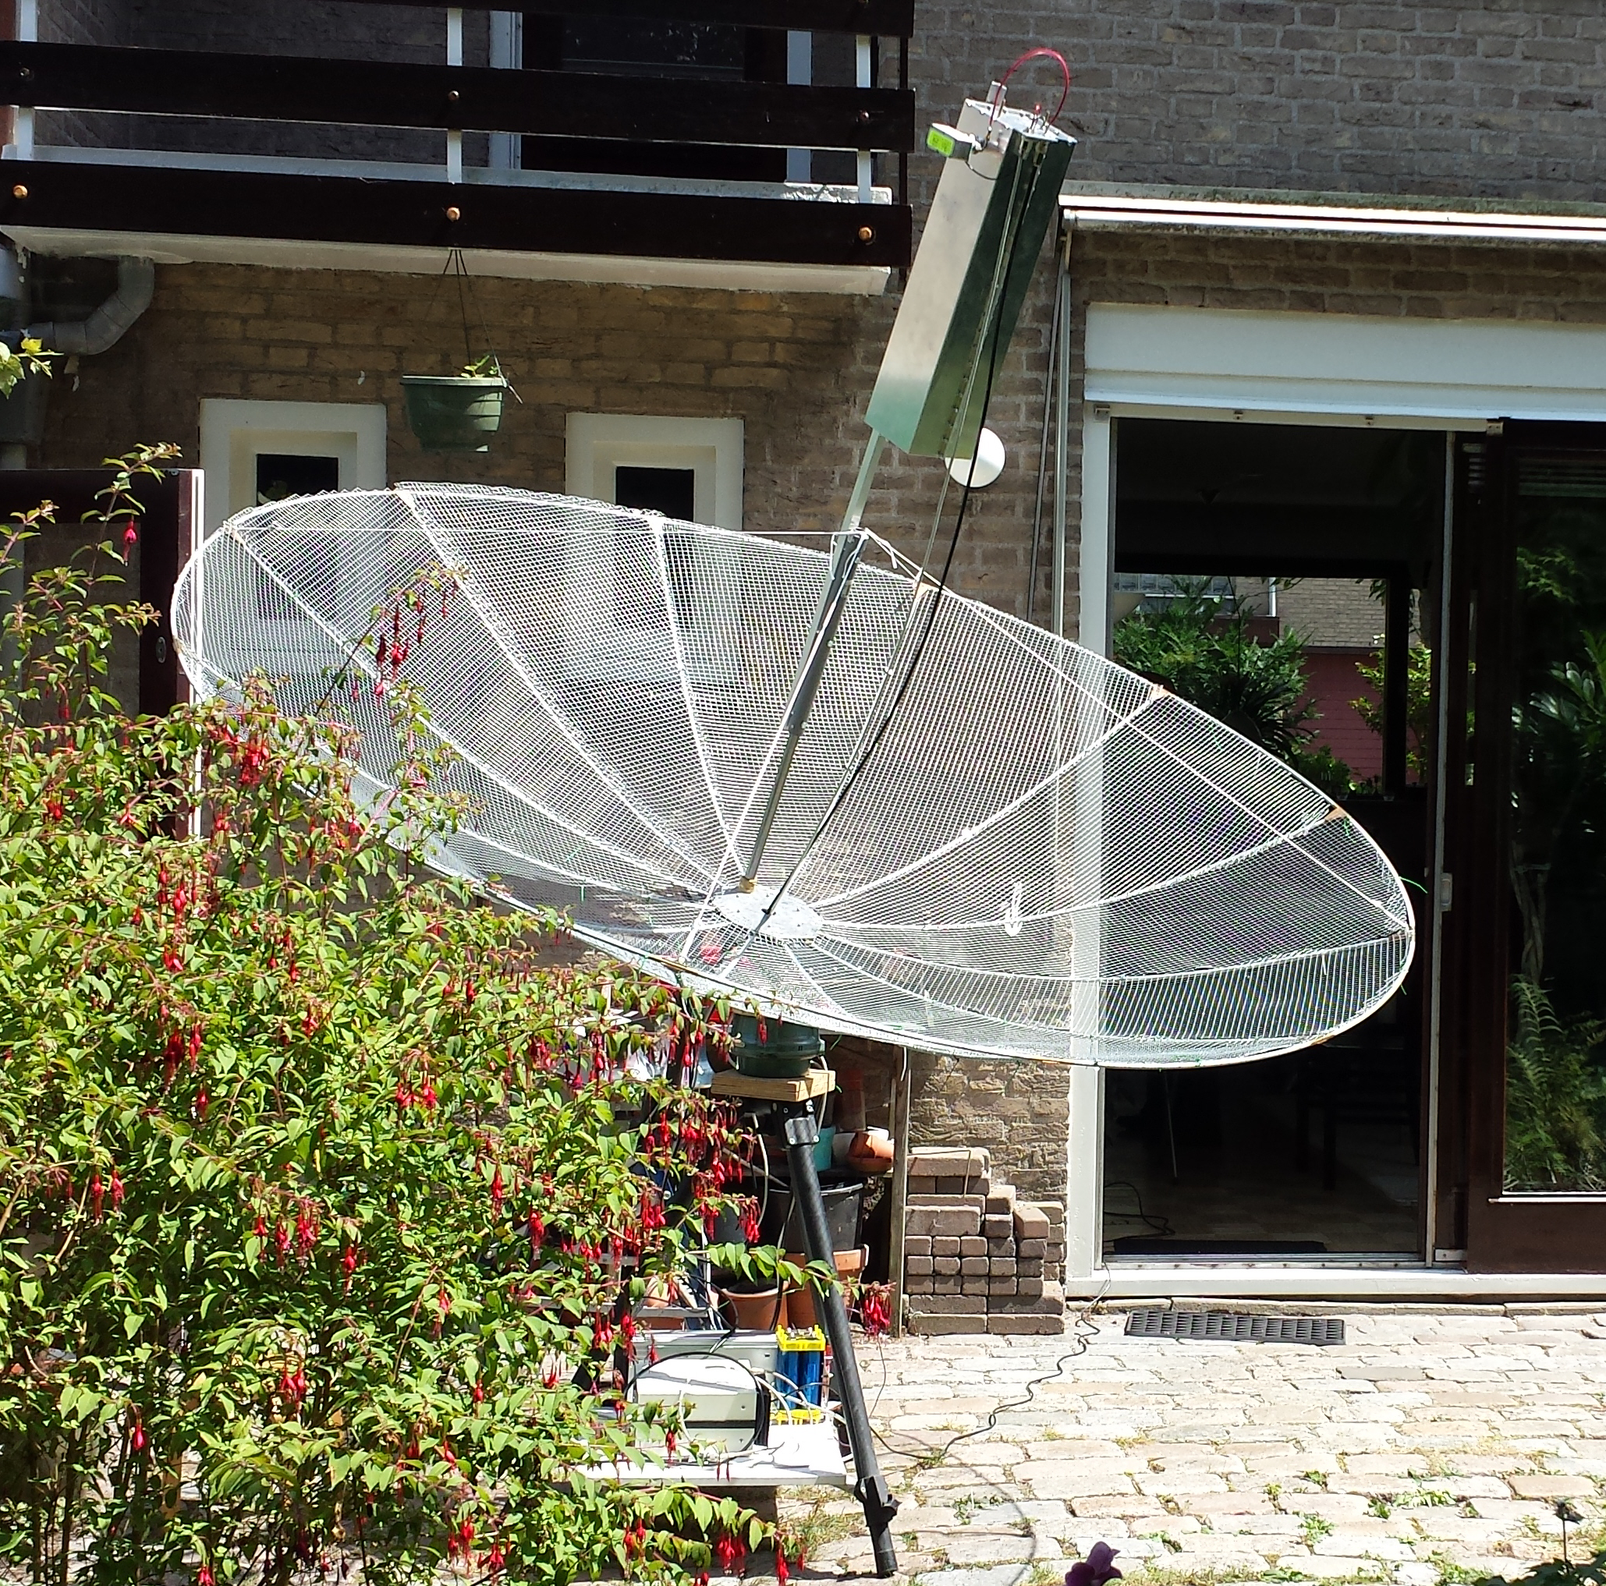
PA0HRK’s portable 2.4 m dish

PA2CHR: Chris post(x)pa2chr.nl is checking out his 1296 system from his home QTH (JO32db) in prep for its use for the upcoming Z21EME Zimbabwe dxpedition in Nov. The station is a 67 el SHF yagi and about 120 W. He was QRV on 12 Aug after 0500 and QSO’d several stations including W6YX, PY2BS, OK1KIR, OZ4MM and K2UYH all on JT65C.

SM4IVE: Lars sm4ive(x)telia.com sends an update on his problems and recent activity -- My dish has not been used since the early spring due to water damage in the preamp box. On 18 July, I spent 7 hours climbing up and down the service tower to remove all the relays. I went inside and took all of them apart and cleaned them. (This was not easy due to bad sensitivity problem with my hands.) And finally I went back up the tower to remount them. The morning of 20 July, I was back on 23 cm. My echoes were huge. I heard SP6ITF on CW. He was the only CW station I copied, but there was lots of digital activity. What a negative way EME has taken. I am afraid that we will see the same negative trend in CW activity on the higher bands as on 2 m. I called CQ for 1 hour with no answer. I then checked in on HB9Q and said I was calling CQ on CW. YO8RHI gave me a call and we rapidly completed on CW for an initial (#). I then worked PA3CQE(#) and UA9YLU (#) on CW ofcourse. Then I switched to 70 cm, but found the same situation, digital but no CW. UT5DL heated up his PA and gave me a call; later VE4MA showed up and we worked followed by PA2V for an initial (#). I was on again on 27 July and worked following initials on 23 cm DG5CST (#), WA9FWD (#) and W4OP (#). We traveled with our motor home on 30 July to meet with PA2DW and his XYL Beatrijs at Hornborgar lake (in SM6 area) and did some bird watching for Cranes, Eagles and Ospreys. We spent 4 days together and had a wonderful time mixed bird watching, geocaching, and enjoying some Dutch Corn wine and Lachouffe. I have started work the 2015 Swedish EME Conference (focused on CW EME) - see details as they develop at info.www.sm4ive.com. [See more information at the end of this NL].

SQ7DQX: Matt sq7dqx(x)poczta.onet.pl plans to be on 10 GHz EME for tests the weekend of 16/17 Aug -- I am using only 0.25 cm dish with PE1RKI linear feed, a 17 W SSPA and a DB9NT transverter and WR90 preamp. I performed some echo tests and I can see my own echo constantly, but due to high libration extensive signal spread was observed and echo was just visible, but not constantly audible (audible in moments of good reflection). I have no good tracking yet (just 0.5 deg, but 0.1 planned). I hope to make a JT QSO, if not CW. Please email for skeds.

SP/OK5EME: Zdenek (OK1DFC) writes that he will be active during the Microwave and EME meeting in Poland. The meeting, which is organized by the SP EME group in Zieleniec is on 14 to 17 Aug – see http://splashurl.com/m4pse58. I will be there with my 3.2 m portable dish and 250 W at the feed and TRV for all 13 cm possible band segments. I will have also available a 10 GHz unit with 35 W at the feed and will try some contacts on 10 GHz too. This is the same setup I am expecting to use during my expedition to ZA in future. The 10 GHz equipment will be tested for the first time to give me some experience with how the system, especially my mesh dish with a 0.2° BW, will work. My plan is on Friday 15 Aug to build and test station on 13 and 3 cm, on Saturday 16 Aug to operate 13 cm for my full Moon window, and on Sunday 17 Aug do 10 GHz tests, then wrap up and drive home in the evening.

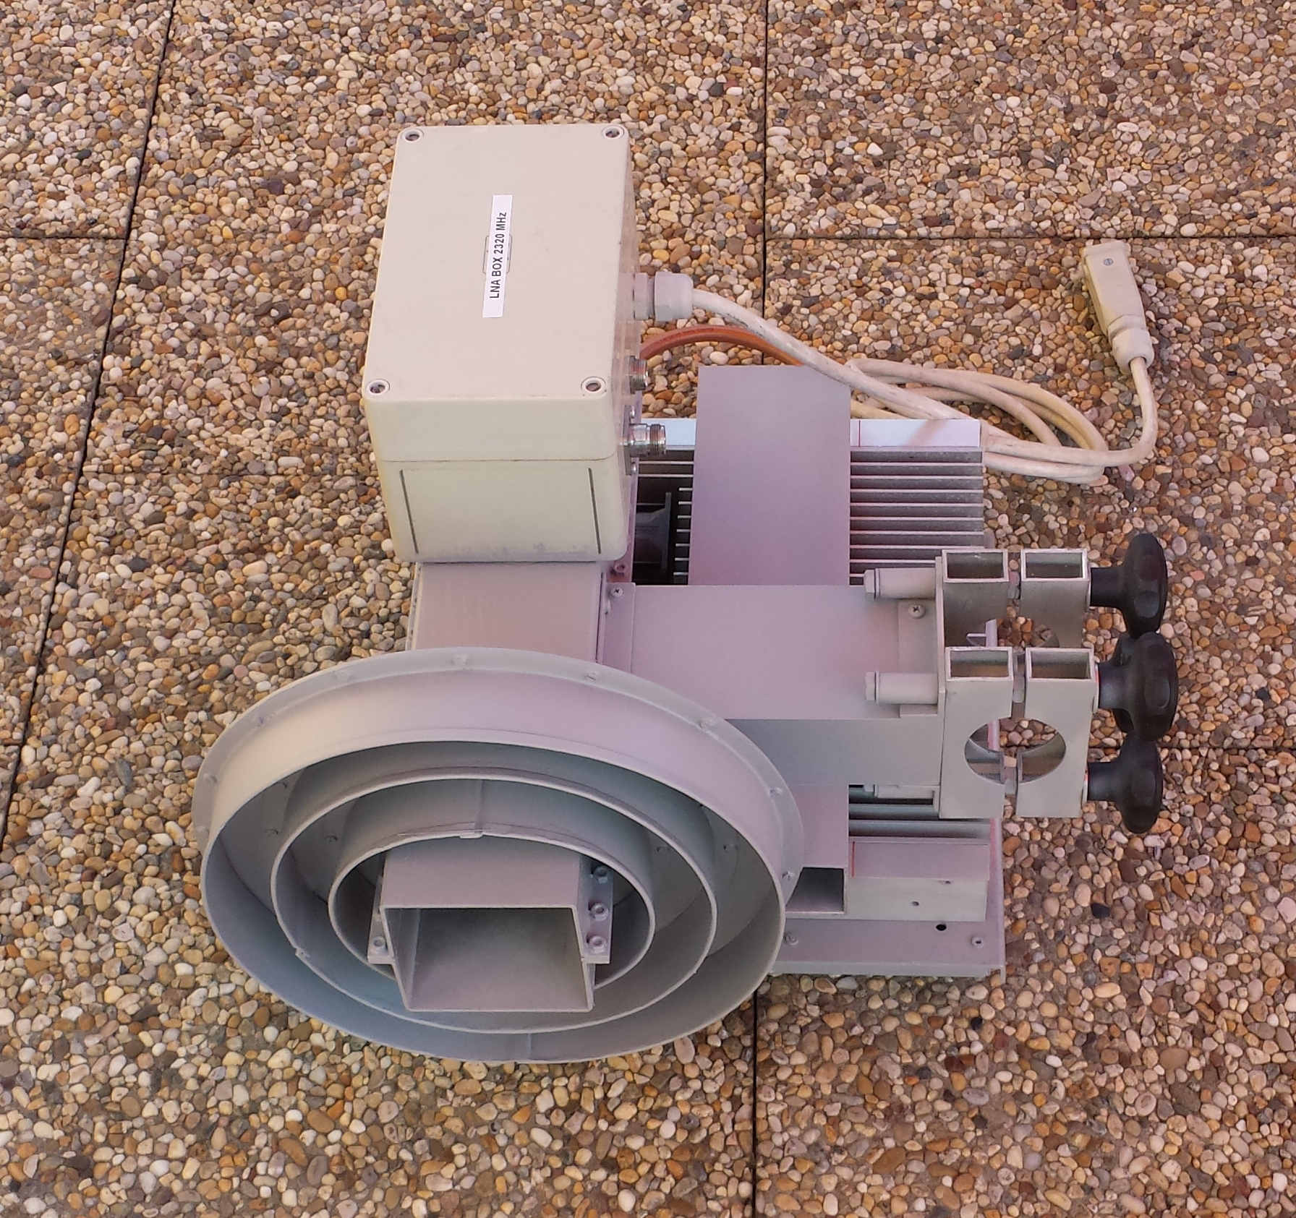
OK1DFC’s 13 cm feed with 250 W SSPA and LNA

TM16EME: Guy (F2CT) F2CT(x)wanadoo.fr that in conjunction with the EME Conference TM16EME will be QRV on 5.7 GHz SSB/CW on 5760.108. There will also be operation on 2 m under the TM8PM call. Activity will be on Thursday 21 Aug 0240 to 1530, Friday 22 Aug 0330 to 1610, Saturday 23 Aug 0430 to 1645, Sunday 24 Aug 0525 to 1715, Monday 25 Aug 0625 to 1740 (activity during breaks, lunch and afternoon), Tuesday 26 Aug 0725 to 1805 (activity during breaks, lunch and afternoon) and Wednesday 27 Aug 0830 to 1830. Skeds are welcome.

VE4MA: Barry ve4ma(x)shaw.ca decided to get back on 432 for the first time in years to help promote CW activity – I was QRV on 432 for the 70 cm ATP on 20 July with a 10’ dish running my tropo station, RIW at only about 500 W in the shack with my old K3BPP dual polarity (2 x EIA standard gain with coax feedlines). The feed was backed up a bit from the focus in order to get a good VSWR, but then this dish is so small on 432 that I don't think that is a big issue. I still see 6.4 dB of Sun noise and worked G3LTF, SM4IVE, UA3PTW, NC1I and K2UYH. Signals were very good, although when I worked Al the signals seemed to be poor. The Sun was finally up by then. I have copied many 4 yagi stations using WSJT and only a few hundred watts.

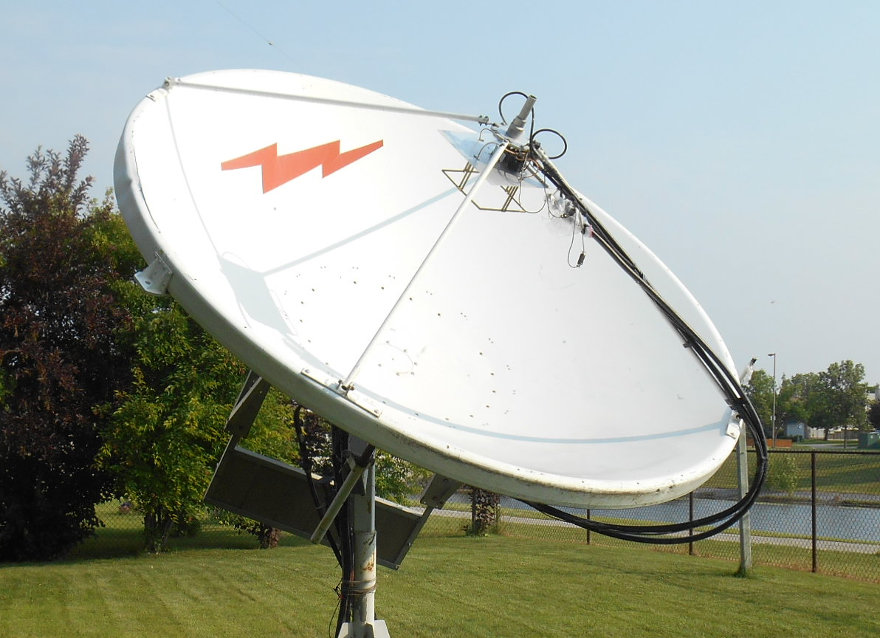
VE4MA 10’ dish on 432 with feed

VE6BGT: Skip macaulay.skip(x)gmail.com is near ready for 13 cm operation -– I have my 2.3 GHz modified water cooled Spectrain amplifier half done. I have one PA completed and am presently working on the second to combine with the first. I didn’t want to do the normal fan cooling because the noise from 10 fans on 2 units would sound like a F18 jet taking off. My 1296 amp worked so well with water cooling that I decided that I would do the same for this amp project. I took the original Spectrain chassis and stripped all the circuitry out of it and milled all the air cooling fins off the aluminum chassis. Then I built two heat exchangers from 1” blocks of aluminum that the water flows through and bolted them to the underside of the amp chassis where the air cooling fins used to be. The 2 heat exchangers are plumbed into common inlet and outlet brass manifolds. At the front of the chassis under the small enclosure is a bar graph display, which is driven by little DC current monitoring boards that are in series with each of the 24 V lines feeding each separate board. These sensor boards take up to 30 amps each and give a 0-5 volt representation of the current. I feed these voltages into a simple bargraph chip, which drives the big square LEDs for a nice output indicator for each Spectrain board. I have driven this amp to a full 180 W out and have seen a increase of temperature using a laser temp gun on each FET of only 2 to 3 degs, key down. This is all dependent on the water cooling and for testing I was just using around 4 liters of water and no radiator air cooling. I decided earlier not to use the preamp that comes with the Spectrian amp because the first one was bad. So to get my 1 W transverter to have enough drive with lots to spare for interconnecting line loss, I build a separate chassis that makes up a separate booster amp and splitter to drive the two water cooled power amps. I made the driver from the other half of the original Spectrain chassis that had the 48 V converters mounted on. I bought three more Spectrain boards seperatly and use one as the driver. It is powered by 12 V and takes 1 W to more than enough power to drive the amps through a ring rat race splitter. I have so much power that I use a small length RG174 coax as an attenuator and also have a 2 dB attenuator on the input SMA connector. I can adjust the drive from my transverter to get 5 to 40 W of RF output. I have driven the one finished power amp with 3’ of coax and have no problem driving it to full output with the line loss in the coax jumper. The driver amp/splitter also uses these small current monitoring sensors. These feed the PIC circuit, which is on the LCD display. I have various ways of showing output power in the form of a scrolling bar graph or as text in watts. Another screen shows the actual current being drawn in amps for each of the two output boards. There are also 2 temperature sensors under each of the two output boards on the metal that monitor the heat sink temperature and are displayed on the LCD. The heat sink doesnt get real hot, but I am planning to hang a small DC fan that will be variable speed controlled by the PIC and the temperature sensors.

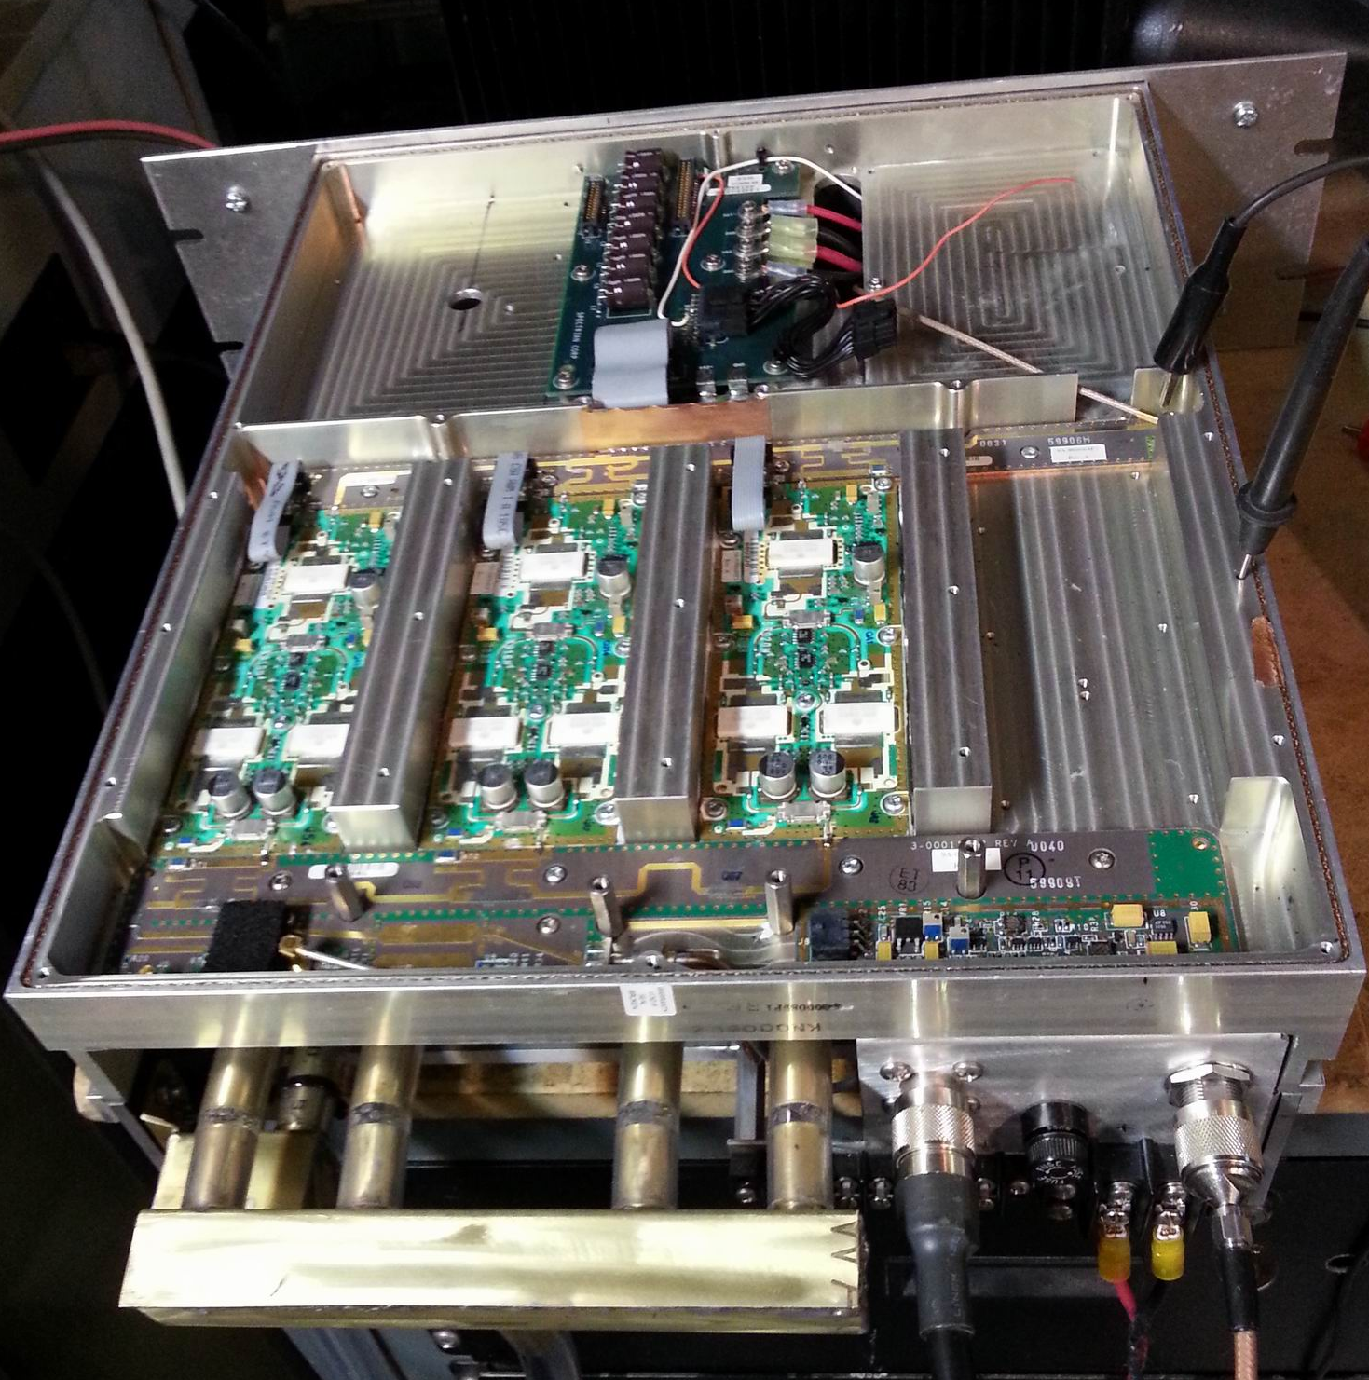
VE6BGT’s water-cooled 13 cm SSPA

VK5APN/8: Wayne vk5apn(x)aapt.net.au has been making a grid hoping dxpedition around Australia’s VK8 area, primarily on 2 m EME, but is also taking a 432 yagi with him. He made his first 70 cm EME QSOs earlier in the month with HB9Q, DL7APV and possibly DL9KR – [I do not have all the details]. Wayne use a 21 el 70 cm yagi and a barefoot IC910H (no external preamp). He says he will be on 70 cm during the DUBUS Digital EME Competition on 16/17 Aug. But He will not be QRV all the contest time – most likely on the 16th, but nothing is certain.

W2PU: Joe k1jt(x)ARRL.NET reports that the club station at Princeton University is now QRV on 432 -- We're continuing to make good progress on the 70 cm EME setup at W2PU. Our antenna is now an array of 4 rear-mounted, 15-el dual-polarization yagis. With the present solar flux (S-410 = 45 SFU on 7 Aug), we see nearly 10 dB of Sun noise. The TX power is about 600 W. In the first few hours of being QRV, we put JT65B EME QSOs with LU8ENU, K3MF, and KD5CHG in the log. The latter two were done at an especially poor time of the month, with degradation around 5 dB. We hope add many more initials during the coming DUBUS 432 Digital EME Championship event! [Since this report W2PU has added several additional QSOs].

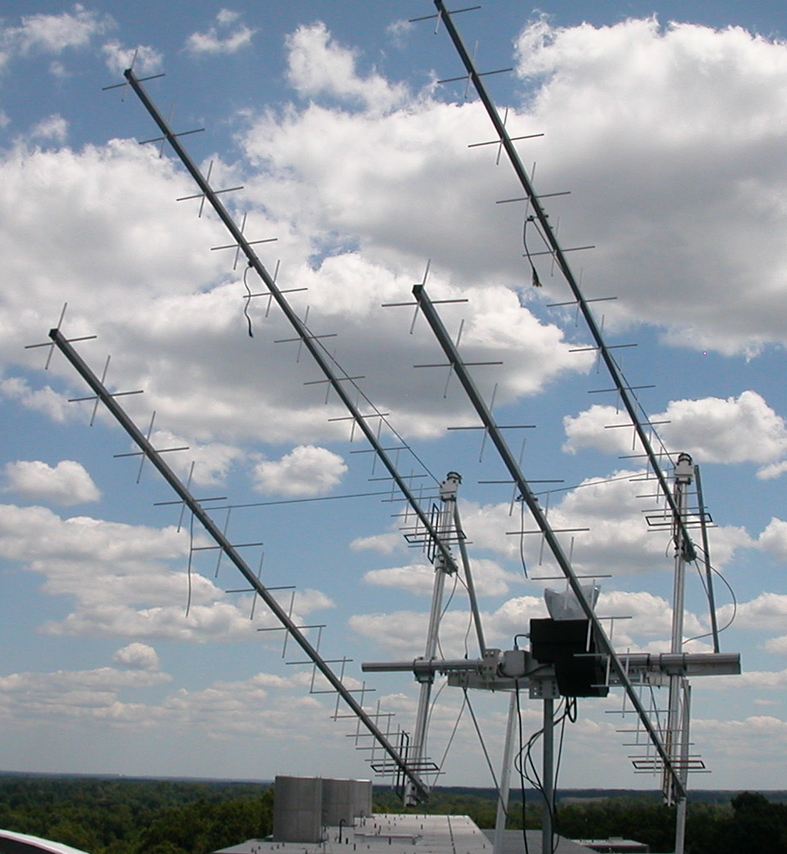
W2PU’s 4 x 15 el cross yagis on 432

W5LUA: Al’s w5lua(x)sbcglobal.net July EME report -- I had a pretty good month on 24 GHz working VK7MO/P in QF22, QF31 and QF32 using JT-4F for 2 new initials. I was also pleased to work VK3NX on 24 GHz 2X CW with (M/O) reports. We then proceeded to work each other using JT-4F. I also worked VK7MO/P on 10 GHz using JT-4F in QF31, QF32, QF46 and QF28. I ventured back to 432 and worked VE3ELE, K5DOG, K2UYH, NC1I, and WA4NJP bringing my initial count up to mixed #207*. My first 200 initials were made over 20 years ago! I am just getting back into 432. Having had a great amount of success in working VK7MO in multiple grids with Rex’s 0.9 m dish and 50 W, I decided to put together a similar small EME station for a demonstration on 25 July at the Central States VHF Society Conference in Austin, TX. I used my terrestrial setup, which consisted of a DEMI transverter, homebrew 2 stage LNA with about a 1.2 dB NF and a 20 W TWTA. I also incorporated an N5AC A-32 PLL board so that the transverter could be locked to a 10 MHz TCXO. I then take the 2M IF and convert it to 10 m with a W1GHZ mini-verter with the 116 MHz LO obtained with an N5AC VHF Apollo board, which is also locked to the 10 MHz TCXO. The 10 m signal is then connected to a Flex-1500 as an IF. This setup was mated to a 36” prime focus dish and mount built by WA5YWC. Bob used ¾” copper pipe in a shepherd’s hook configuration and a VE4MA feed with scalar ring. During our test, Moon degradation was nearly 2 dB as it was close to apogee, but WA5YWC was able to QSO OK1KIR with (16DB/18DB) reports using JT-4F. Our Sun noise measured 5 dB. We were also able to measure 0.2 to 0.25 dB of Moon noise, which helped us in tracking the Moon. Interest in small station EME was very high at the conference. I was very pleased with this demo.

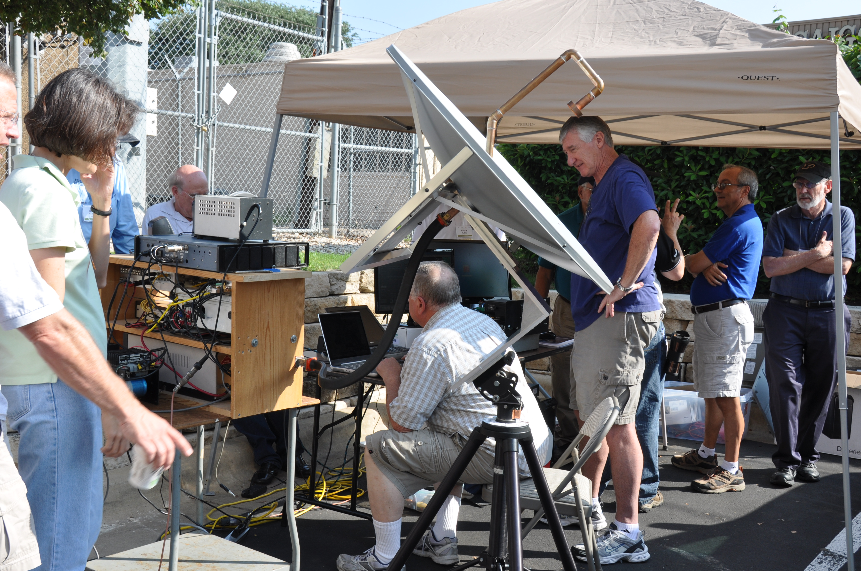
Portable 10 GHz EME demonstration at CSVHF Conference. WA5YWC at controls in QSO with OK1KIR. (Station was built by W5LUA and W5YWC)

W6YX: John (K2YY) johnhill5000(x)gmail.com writes -- After completing a successful 144 leg of the DUBUS Digital EME Championships, Team W6YX is hard at work gearing up for its 432 leg. We hope to QSO with many of you on this band, as we'll be using this event to experiment with a viable 70 cm setup for use during the ARRL EME contest this fall.

K2UYH: My a.katz(x)ieee.org July/Aug report is only a little longer than last month’s. On 19 July I was on 5760 to work at 0746 SM6FZH (559/O) for initial #28. I spent some time at about 0830 sending QRZs, but the station was too weak. I then repositioned my feed position – I was experimenting with a new IMU feed. The change in position significantly improved my echoes, but by this time just about everyone was QRT. The following day while on 432 disaster struck. I send my 6 cm IF up the same feed line as I use for TX on 432 and 1296. While rotating the pol on 432, a wire snagged causing the feedline relay to switch. 1 kW of 432 power was sent to the 6 cm transverter. The result was not pretty. I am temporarily QRT on 6 cm until I get the transverter fixed. It is a mess. On 20 July, I was on 432 for the ATP and QSO’d at 0813 SM4IVE (589/579), 0820 partial UT5DL (449/?) – lost, 0830 G3LTF (559/559), 0836 OH2DG (559/559), 0851 G4RGK (559/559), 0909 DG1KJG (559/549), 0945 N4GJV (559/559) – also called earlier, 0945 QRZ? and 1025 VE4MA (O/O) – weak. I was on 432 again on 27 July to QSO at 2200 JE1TNL (19DB/26DB) on JT65B for mixed initial #871* and later on CW (O/O) for CW initial #732. On 1296, I worked on 31 July at 1744 DC9UP (14DB/15DB) on JT65C for mixed initial #475* and had a partial on CW (559/-) because Hermann lost his Moon window, and on 11 Aug at 0242 EI9P (26DB/20DB) JT65C #476*. Plans are to be on for the Aug 70 cm ATP and to give some points in the DUBUS Digital EME Contest.

NETNEWS: KD3UY who is presently active on 6, 2 and 432 EME is planning to move up to 1296 and is looking a dish and feed designs. SM6FHZ was active on 6 cm in July and worked K2UYH and S59DCD and heard IZ2DJP and SV3AAF. G4BAO in JO02cg is QRV on 13 cm with a 1.9 m dish, 200 W to a septum plus choke ring feed and G4DDK VLNA13, and is looking for skeds. SV3AAF is looking for random CQ QSOs on the microwave EME bands 13 to 3 cm… Be on the lookout for his call.

FOR SALE: AA2UK has for sale a DB6NT 250 W out, 15 W in 23 cm SSPA with built in sequencer and factory fan/heat sink option (never used) for $US1200. If interested contact Bill at b.lentz(x)certifiedrf.com or Cell 609-377-0022. PA2CHR is looking for a stable 1296 transverter. Contact Chris at post(x)pa2chr.nl. DF2ZC, Bernd (and DH7FB) to satisfy at least some of their 70 cm friends during their hopefully many future dxpeditions, are looking for a small 200 W or so SSPA, and also for an LNA. The amp is their first priority. If you can help contact Bernd at df2zc1(x)googlemail.com.

TECHNICAL: DJ2DY’s 48 EL 23 CM YAGI - Rainer sends the details of his yagi shown in the July NL. The antenna was build 25 years ago for portable, contests and field day operation following the DL6WU modular design. This type of yagi can be cut to any length from 0.5 to > 6 m. I build mine 4 m long with 48 elements and an estimated gain of 18.1 dB with H and V beamwidths of about 15 degs. All I needed was in stock at the homebrewer market. Alu four cornered tubes for the boom and 4 mm alu rods for the directors. The dipole were made from 4 mm copper wire and the reflector is an alu plate (23 x 23 cm). The complete antenna has a weight of only 2 kg. The tolerance of the element lengths (+/- 0.5 mm) is critical as is the cumulative spacing of the elements position. The elements are securely connected to the metal boom. My greatest problem was the driven element. With a network analyzer, I found out that the original dipole, build 25 years ago was not resonant at 1296. So I made a new one based on VK5DJ`s yagi calculator. After the fifth try and error and lot of tuning, I got a return loss of 17.7dB. It seems to be working well. Behind the reflector plate is a plastic box with a Narda TR relay and G4DDK LNA connected with 9 cm UT141 semi rigid to the balun. From the relay to my W6PQL PA is only 2.5 m of Ecoflex15 with 0.29 dB attenuation. This may be the reason my signal is relative strong. More info on the DL6WU yagi design can be found on the Internet. In UKW-Berichte 1-1982 and DUBUS 2-1994 are detailed descriptions. VK5DJ has his yagi calculator program on the VK4ADC website.

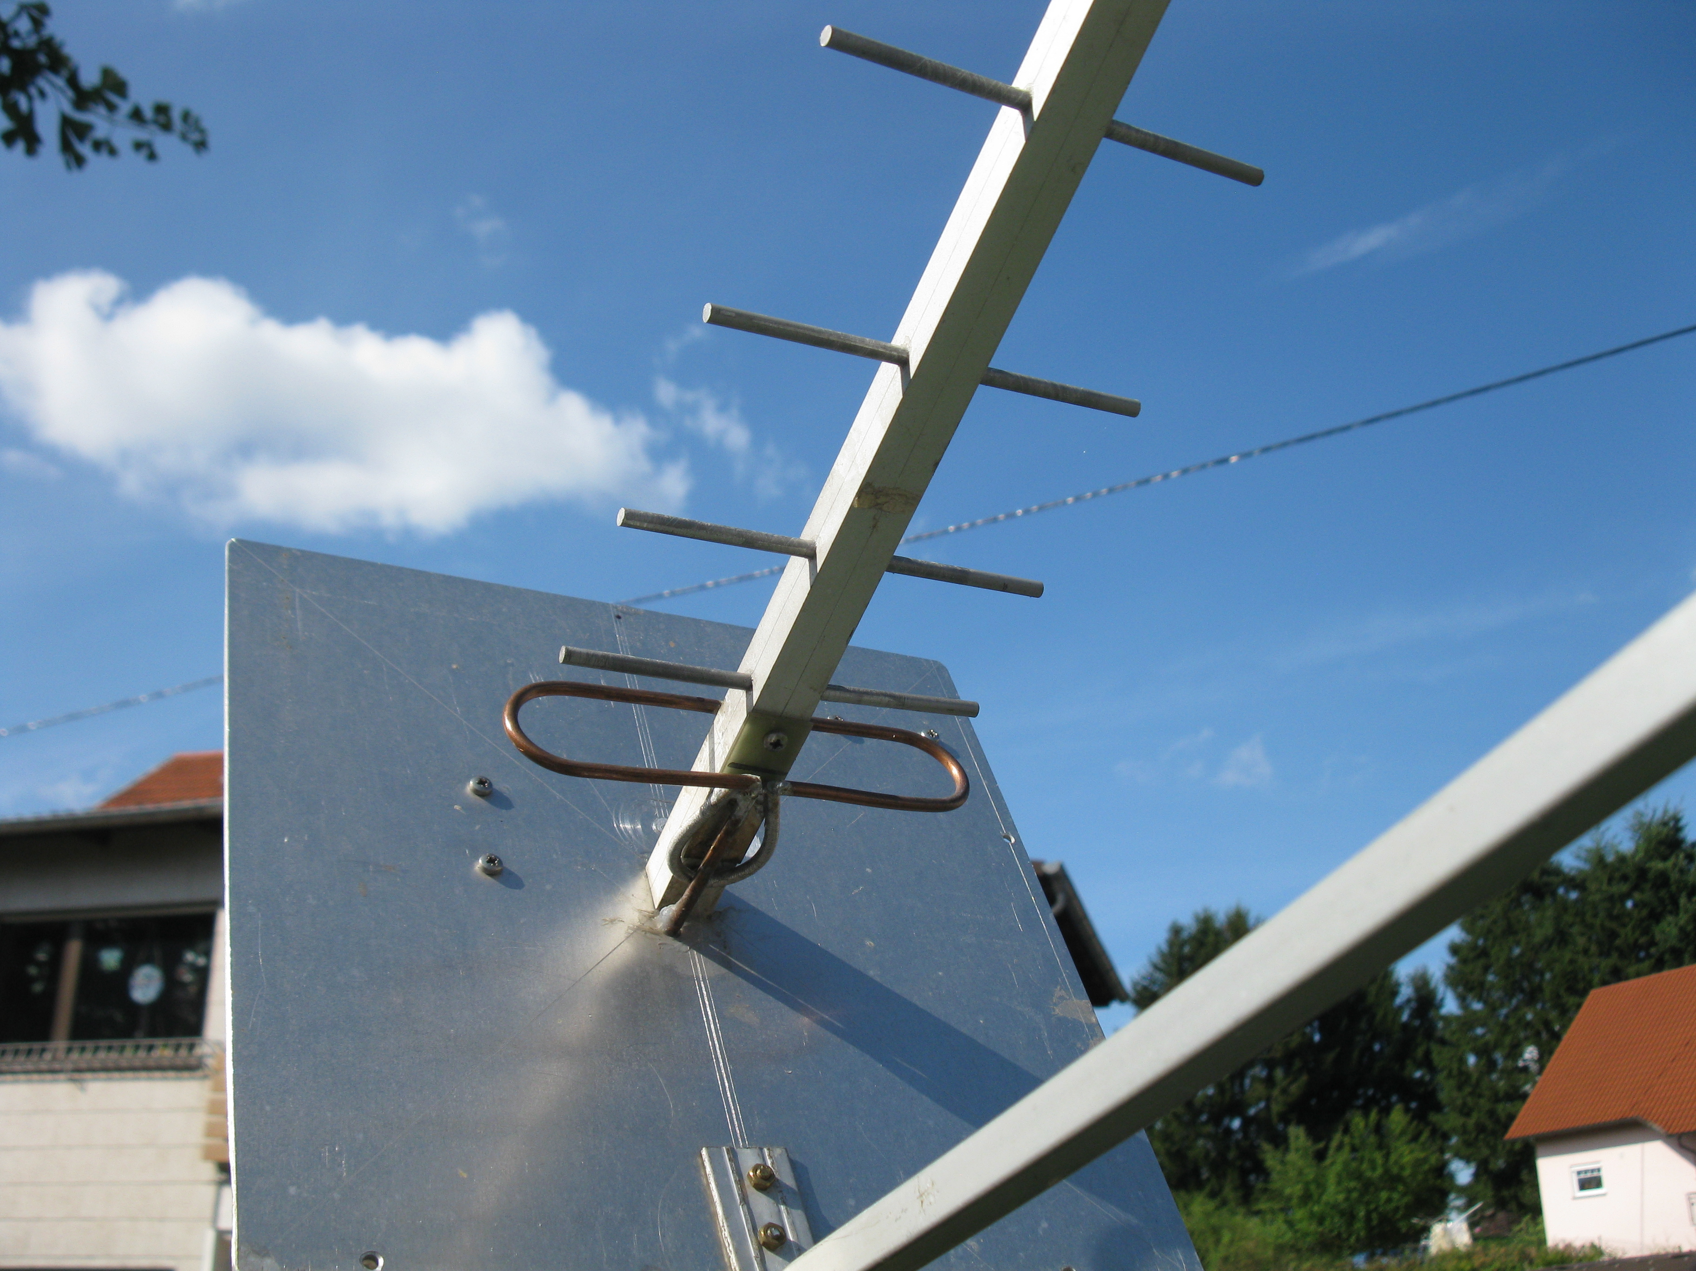
DJ2DY’s yagi feed – see full yagi picture in July NL

SOME PERSONAL THOUGTHS ON THE ARRL EME CONTEST BY RICK, K1DS: Several stations have capability on 7 bands, and knowing which to operate and when is a challenge, as there is no current agreement between EME aficionados on activity windows for each band, in addition to the moon window being continually in motion during the contest weekends. Prior to the contest, several operators posted their band-plans and times, to facilitate activity, especially as there are varying frequency allocations for amateurs in the 2300 MHz and 10 GHz bands for different countries. Ingolf, SM6FHZ as well as others found their Software Defined Radio (SDR) very useful to monitor band activity. Stations with multiple feeds, dishes and other directional antennas and a system for rapid band-switching are at an advantage for scoring. Peter, G3LTFW reported the round trip from the shack to the dish is 100 m and he walked that at least 20 times changing feeds. And, yes, it is sad that F2TU had that fall and such a severe result. Even for myself, with the potential now of operating 4 bands (144, 432, 1.2 and 2.3) I find it hard to even consider doing more than 1 band for an entire weekend. I will be glad to share these thoughts with Joe, K1JT and Al, K2UYH. In addition, I will copy the new ARRL Contest Director, Matt, W1MSW. I am not sure that the most recent Ad-hoc VUAC Advisory Committee is still functional. I had a sense that it may have been disbanded last year. But surely we'll find out. I have a sense that Steve, N2CEI (Down East Microwave) and Wayne, N6NB might have been involved with that committee also. Of course, times have changed. It is now far more common to have stations with multiband capability as we have seen growth in the 13, 9, 6, 3 & 1 cm band activity. (2.3, 3.4, 5.7, 10 & 24 GHz). I don't have the full DUBUS EME Contesting schedule, so I can't easily compare what they are doing. I personally have not been involved with the VUAC, but as an author for the contest results of QST for over 10 years, writing up the June VHF, 10 GHz and Up and now the EME, I have had lots of unsolicited feedback about the rules and results, and have passed most everything on up to the ARRL staff. So, I will gently pass these thoughts on -- and perhaps will solicit additional feedback from the EME Ops I see in France at the upcoming meetings. Change is good, as long as it is good change!

FINAL: I have sad news one of the EME pioneers, Lyle, VK2ALU (more recently VK6ALU) has passed away. From comments by G3LTF and VK3UM -– Lyle was a real enthusiast in the days when you built everything, operating a 30’ dish from just south of Sydney, and gave first VK QSOs to many of us on 432 and 1296 in the 1970s and early 80s. His shack was vandalized at least twice, but like a true determined Aussie, he rebuilt and got back on. He eventually had to quit the big dish and moved up to 10 GHz and made many firsts on that band. I believe his QSO with G3WDG stood as the distance record until very recently. [I knew that Lyle was in a bad way for some years. He was one of the last to received the NL in paper format and at that time already in a nursing home. He was my first VK EME QSO and part of the group of early EMEers that started and helped maintain regular 432 and up EME activity back in 1971. A true pioneer, who did not give up. Even after being forced from his big dish, he returned with a smaller dish on 10 GHz. From the early group, Lyle now joins Cor, VE7BBG as a silent key. I am not sure of the status of WA6HXW, but he is listed in QRZ.COM. I believe all the rest are still active.]

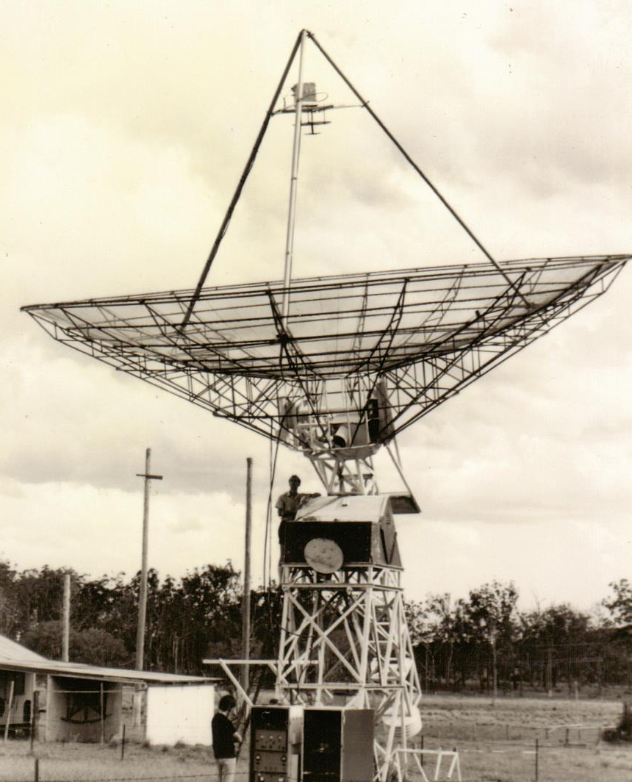
VK2ALU with his original dish in Walagong
DK7LJ reports that the 10368.025 EME Beacon is up again after adding water cooling to the TWTA. It is running at normal power (50 W) and the JT mode is not yet changed.

Lars, SM4IVE has start work on the 2015 Swedish EME Conference, which he is promoting as The 432 & UP EME meeting with the aim of keeping CW alive! The dates will be 29-31 May on Friday-Sunday and at negative dec. Lars says that the conference is for active EMEers and those that plan to become active on 432 & Up and share the same interest, CW and technik! Please start to prepare your talks. It will be at the same hotel (Scandic Hotel) as last year. All meeting rooms are newly renovated as are the hotel rooms.

The Mid-Atlantic VHF States VHF Conference is 26-28 Sept at Holiday Inn, Bensalem, PA. All the info is at www.packratvhf.com. The conference includes Fri 26 Sept Hospitality and table-top selling, Technical equipment testing by Rohde & Schwarz, and Antenna range testing. There are a many conference talks of interest to EMEers. Among the speakers are K1JT, W1GHZ and K2UYH. Questions to Rick, K1DS at rick1ds(x)hotmail.com.

The website for MUD 2014 is up and running, this year’s event is being hosted in Rochester, NY by the Rochester VHF Group. We are currently taking registrations and arranging presentations. The URL is http://www.microwaveupdate.org/

I had hoped to get this sent out sooner. I leave in a day for France and EME2015. I look forward to seeing many of you there. I will also be looking for you off the Moon before I leave. 73, Al – K2UYH

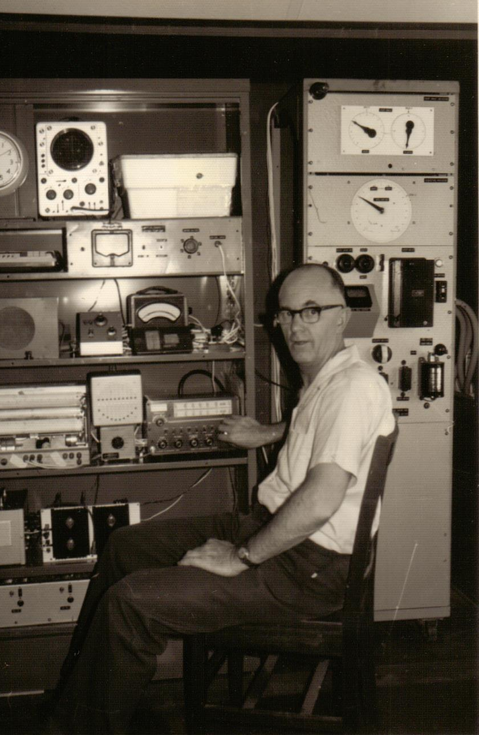
Lyle at original operating position of VK2AMW

