432 AND ABOVE EME NEWS
MARCH-APRIL 2024 VOL 53 #2
EDITOR: AL KATZ, K2UYH; DEPT. ELECTRICAL/COMPUTER ENGINEERING, THE COLLEGE OF NEW JERSEY, PO BOX 7718 EWING, NJ 08628, TEL (W 609-584-8424), (C 609-947-3889), E-MAIL alkatz(x)tcnj.edu
ASSOCIATE EDITOR AND Reflector/NETNEWS Matej Petrzilka, OK1TEH, Simunkova 1609/21, 18200, Praha 8, Czech Republic, TEL (+420 603 489 490), EMAIL ok1teh(x)seznam.cz
CW INITIAL LIST G4RGK, DAVID DIBLEY, E-MAIL zen70432(x)zen.co.uk, AT: www.g4rgk.co.uk/Initials
SUN & EXTRATERRESTRIAL NOISE LIST MANAGED BY OK1TEH: http://www.ok2kkw.com/next/nl_k2uyh/sun_table.xls
EME INFORMAL NETS: 14.345, ~1500 SATURDAY AND SUNDAY, NET COORDINATOR: OPEN
ON0EME EME BEACON, 1296.000 [PRESENTLY NOT QRV]. IT IS NORMALY ON WHEN MOON >10°, SEND RX REPORTS TO WALTER (ON4BCB) on4bcb(x)gmail.com
DL0SHF 3 & 1.2 CM EME BEACONs, 10368.025, 24048.025, SEND QUESTIONS TO Per (DK7LJ) per(x)per-dudek.de
EME DIRECTORY BY JAN, PA0PLY IS AT www.pa0ply.nl/directory.htm
NL EMAIL DISTRIBUTION and EMAIL LIST CORD: WARREN, W2WD* wbutler(x)ieee.org
THE NL WEB VERSION IS PRODUCED BY REIN, W6SZ rein0zn(x)gmail.com, AT: http://www.nitehawk.com/rasmit/em70cm.html
INTERNATIONAL EME MEETING 2024 IN TRENTON, NJ: www.EME2024TRENTON.org

CONDITIONS: There are 4 contests to report on this month; as we only have a few reports for ARI Contest, we will delay reporting on it until we have more. ARI activity seemed down due to the low declination (DEC) and also poor weather (WX) conditions in parts of Europe (EU). The F5SE Memorial 1296 SSB Funtest on 11 Feb turned out to be quite competitive despite scores being significantly down from last year, probably due to the lower DEC. After several years OK2DL is back as top Fun Maker with 25x7 for 34300 points. [Awards for this year and 2023 will be presented at the EME Conference this summer]. There are very few reports for the DUBUS 432 CW Contest. The top reported score is from SP9VFD with a total of 16x16. The turnout for the 9 cm DUBUS Contest was a nice surprise. G3LTF again has the lead score with a total 23x20, significantly ahead of his last year’s total. Coming up is the 13 cm SSB Funtest on Saturday 13 April, the day before the 13 cm leg of DUBUS Contest (14 April). It could also be used as an open 13 cm Activity Day. This can fit with the Funtest concept and might warm things up for the Dubus event.

The ARRL EME Contest Official Results https://contests.arrl.org/scores.php?cn=eme are now available: Top score Single Op all modes and bands was PA5Y with 1,568 mil, 2nd place was N1AV 1,050 mil. Top score Multi Op all modes and bands was UA5Y with 8,140.5 mil, 2nd place was K5QE 7,924.8 mil. Top score Single Op CW and all bands was G3LTF 630,000. Top score Multi Op CW all bands was SP6JLW 495,000. Top score Single Op all modes 432 was SM4GGC 22,500, 2nd place was VK2CMP 281,200. Top score Single Op all modes 1296 was OK1DFC 1,489.2 mil, 2nd place was OK2DL 1,363.2 mil. Top score Multi Op all modes 1296 was SP3YDE with 603,200, 2nd place was IQ2DB 582,400. Top score Single Op CW 1296 was G4CCH with 390,600. Top score Single Op all modes 2.3 GHz was KL6M with 322,500. Top score Single Op all modes 5.7 GHz was OK1CA 33,600. Top score Single Op all modes 10 GHz was OZ1LPR with 198,400. Top score Multi Op all modes 10 GHz was GB2FRA with 159,500. Top score Multi Op all modes 24 GHz was OK1KIR with 100.

DXPEDITION NEWS: There is not much dxpedition news this month. SZ5RDS was to be QRV on 432 EME from Rhodes on 70 cm by the X-Team of DH7FB and DF2ZC. They were to be on the island from 4 to 20 April with 2 x 17 el hpol yagis and 200 W on 432. However, illness has postponed the trip, see updates at https://xteamdxps.blogspot.com/. KA6U is starting another round of State/grid EME dxpedition activity on 902 and 432 with some 1296 starting in TX on 22 April and to be on the road until about 6 May. See Peter’s report in this newsletter (NL). N1V and W2HRO’s dxpedition to KH6 (5 ~ 10 March was a huge success with record breaking QSOs on 902, 1296, 2304 and 10 GHz. See their report later in this NL. Also discovered that VK0DS is QRV on 1296 with a 2.4 m dish and 70 W linear pol from Antarctica (MC81xk) for a year. This is basically a one-person operation by Dave (VK2DJS).

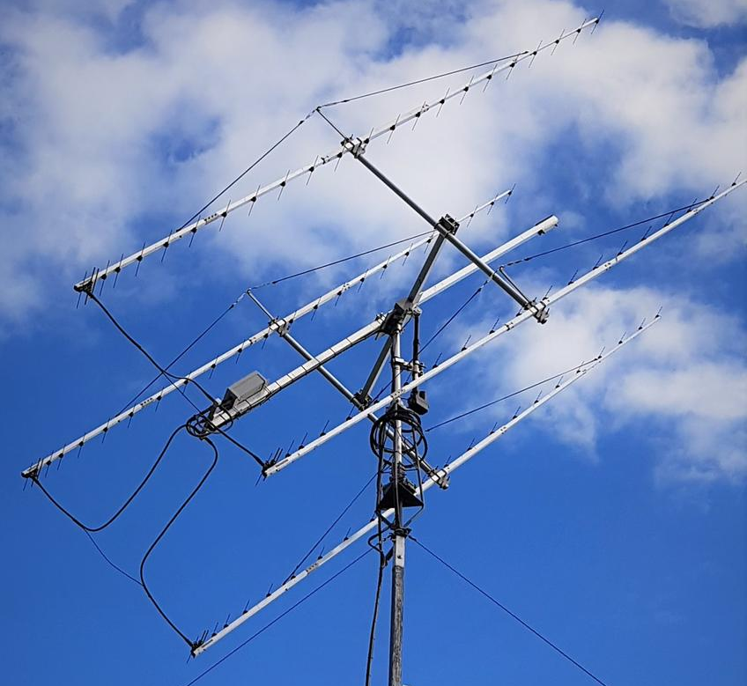
PA5Y 432 4 x PA432-23-6B yagi array used to win ARRL Contest single Op all modes all bands

SAD NEWS: We mourn the loss of long time EMEer W4TJ (also active as K3QCQ for many years). Bill is now a Silent Key (SK). He was primarily active on 432 EME. He was also well known for his work for NRAO as a producer/designer of radio astronomy LNAs. Unfortunately, we do not have a lot of information on his passing. Bill was among the pioneers of 432 EME and well remembered. RIP old friend.
CT1DMK: Luis ct1dmk(x)gmail.com after a long absence is back to EME. I have updated my initials (all CW/SSB) with G4RGK as my last update was many years ago. I am now up to on 432 #79, on 1296 #225, on 2320 #77, on 5760 #47 and on 10368 #27. I am restoring my stuff to its former glory and so far I have the 23 cm working, and had my dish on the Moon for a few weeks. I now have 6 cm running but will place 13 cm at the feed, just as soon as I have a sunny day.
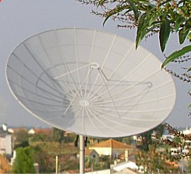
CT1DMK’s dish at new QTH in IN50OR
DB6NT: Michael db6nt(x)gmx.de brings us up to date on his recent activity – On 17 March I was QRV in the 9 cm DUBUS Contest and worked using CW OK1DFC, OH1LRY, DF3RU, SP6JLW, G4CCH, PA3DZL, KL6M, DL6SH, ES5PC, SP9VFD, G3LTF, PA0BAT, OH2DG, WA6PY and K2UYH for a total of 15x15 or 22,500 points. I also heard WA9FWD. The weather (WX) conditions were good.

DK3WG: Jurg dk3wg(x)darc.de continues to add initials – In Feb I added on 70 cm using Q65B UD2F and YO5TP; and on 23 cm using SSB OE9ERC and also with Q65C.

DL9KR: Jan <Bruinier(x)t-online.de> had planned to be active during the DUBUS 432 CW Contest but had problems -- on 2 Dec a large branch of a neighboring fir tree came down due to an excessive snow load and damaged several of my 16 long yagis. Due to adverse WX, I was unable to make repairs in time. I hope all did well in the contest and hope to be QRV again soon using the CLASSIC mode!

G3LTF: Peter g3ltf(x)btinternet.com reports on the DUBUS 70 cm and on DUBUS 9 cm CW/SSB Contests -- On 18 Feb I worked the following stations on 432 random CW: UA3PTW, I2FHW, OE5JFL, OH2DG, UA5Y, PA2V, OK1DFC, G4RGK, SP9VFD, DK4RC, DL6SH, VE6BGT, WA6PY, KL6M and K2UYH for a total of 15x15. I also heard DL7UCC? Conditions seemed quite good with little obvious Faraday rotation. It’s just a pity that CW activity on 70 cm was not higher; I do miss working the pile-ups and find 70 cm CW operation is so much more of an interesting challenge than 23 cm. If you were not on 3400 on 17 March, you missed a good one. I worked the following stations on random CW: OK1DFC, KL6M, PA3DZL, DL6SH, DL3WDG, SP6JLW, SP9VFD for initial #81, G4CCH, DF3RU, OH2DG, OH1LRY, DB6NT, SP3XBO, DB6NT, PA0BAT, ES5PC, OK1KKD, G4RFR, WA9FWD, WA6PY, VE6BGT, VE6TA, and K2UYH for a total of 23x20. My sunnoise on 16 March was18.8 dB with SF 129 and a moonnoise of 1.1 dB. The WX was very kind for a change with no wind at all, so near perfect tracking. The next morning, I worked VK3NX crossband (XB) to 3398.1 with excellent signals.

IQ2DB: Alessandro (I2SVA) i2sva(x)i2sva.it reports on his group’s activity in the 1296 SSB EME Funtest back in Feb -- The activity was a lot of fun on our side. We had a target of 4-5 QSOs and ended up with 11 QSOs! Unfortunately, there were no US stations in the log. Making EME SSB QSOs with a 3 m dish requires a lot of patience and time; moreover, operating practice is very important to facilitate the exchange of calls and info. We had a fantastic QSO with XE1XA! [I must apologize. I had a computer problem and lost their logs and thus do not have the full report - Al].

IZ1BPN: Stefano iz1bpn(x)libero.it reports of his results in the 23 cm Funtest – I worked all on SSB/SSB on 11 Feb PI9CAM (58/57) JO, OE9ERC (57/57) JN, OK2DL (59/57) JN, G0LBK (55/55) JO, SP6JLW (55/55) JO, DL4DTU (55/55) JO, UK2ULQ (55/57) JN, SK0CT (55/55) JO, DF3RU (55/56) JN, PA3DZL (55/55) JO, IQ2DB (59/59) JN and SP3XBO (55/55) JO for a score of 2x12x2x100 = 4800 points. I used an 8 m dish with IK1MTZ Septum feed, 500 W SSPA, DB6NT LNA.

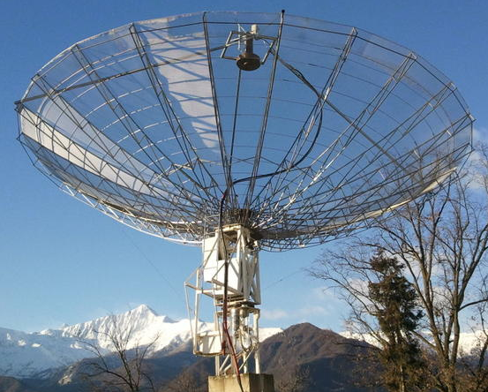
IZ1BPN 8 m dish with 23 cm feed

KA6U: Peter petervanh143(x)gmail.com is starting another round of State/grid EME dxpedition activity on 902 and 432 with some 1296 – I will start in TX on 22 April and plan to be on the road until about 6 May. The basic plan is to head north to ND and then turn right and go to ME. The goal is to activate all needed states without stations on these bands that are the furthest from FL. There are 15 days available. I don't know if I have the energy or the WX to be on every day but will do as many days as possible. Possible States include KS, MO, AR, SD, ND, MN, ME, VT, NH, RI, MA, DE and PA. The Moon will not be very high during these times so this will be mostly a North America event. [Peter will be at EME2024 Trenton Conference (9-11 Aug) with his station in operation. Expect him to 13 cm in the future].

N0AKC: Charlie cmbetz(x)charter.net writes that he is now active on 13 cm EME -- On 6 March I worked W5LUA and N1AV for my first two EME contacts on the band. I was hoping to work N1V in HI, but I only got one decode of Jay and he never heard me. During the same time N1V was on the air I worked OK1DFC, OK1KIR, HB9Q, IK3COJ, OE9ERC, PA3DZL, PA0BAT, G5CCH, DL1SUZ and DL4DTU. A number of these stations were worked on both digital and CW. My biggest surprise was working OE9ERC. After completing on CW, Erich called me on SSB and we completed there as well for my first ever SSB EME QSO! I am using a DEMI transverter with a 150 W amp into a 3 m dish. I have a WD5AGO LNA on RX. I can TX on 2304 and RX on both 2304 and 2320 but am not yet set up for 2400; I hope to be there soon. WX and time permitting I will try to get on for the DUBUS 13 cm Contest. I use the same 3 m dish for 33 cm and 23 cm operation. I put the 902 feed back on the dish after N1V completed his two days on 13 cm and worked Jay on 902 for a new State. I'm looking forward to following KA6U on his 432/902 EME rove coming up in April.

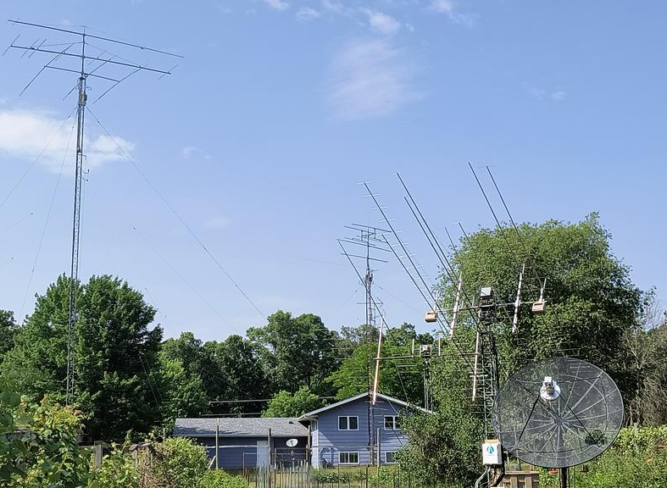
N0AKC QRV from 160 to 9 cm EME

N1V [in KH6]: Jay whereisjay(x)gmail.com reports on his March dxpedition to HI with W2HRO – We had a very successful trip with activity on 902, 1296, 2304 and 10 GHz. This was the 1st time 2304 had been activated since 2007 from HI, and the 1st time ever a "dxpedition" put a multi-day serious effort into 3 cm from the island. Congrats to DL8FBD for WAS state #50 on 1296. I am glad we were able to make it happen this year. Stations worked on 10368 (1 m dish) all using Q65D were W7CJO (7DB/19DB), DL3WDG (20DB/27DB), OK1KIR (17DB/23DB), PA3DZL (23DB/22DB), PA0BAT (16DB/18DB), W5LUA (17DB/18DB) - for Al’s 2nd HI QSO, F5VKQ (21DB/20DB), F4VTA (25DB/25DB), OK1DFC (24DB/32DB) and OZ1LPR (18DB/19DB). KM0T was also heard (20DB) but not worked. Worked on 902 were W5AFY (24DB), W5LUA (22DB), W6TCP (21DB) - 1st CA to HI on 902, K0DSP (23DB) 1st NE to HI on 902 (2.4 m sub-lunar to 2.4 m sub-lunar dish), W7JW (19DB) 1st MI to HI on 902, WA3RGQ (17DB), N0AKC (22DB) 1st WI to HI on 902, N1AV (remote control) (22DB) 1st AZ to HI on 902, N7GP (26DB), W2HRO (remote control) (18DB) 1st NJ to HI on 902. Worked on 1296 using Q65C unless noted were K6DOG (19DB), FG8OJ (22DB) 1st KH6 to FG), N5TM (20DB), AA4MD (DB17), VK4CDI (23DB), K5DN (16DB) his 1st HI, OK2DL (17DB) his 1st HI, G4YTL (19DB) his 1st HI (2 States left for WAS), SM5DGX (17DB), G0LBK (18DB) his 1st HI, OE9ERC (13DB) his 1st HI, OH3LWP (22DB) his 1st HI, DL1AT (22DB) his 1st HI, PA3FXB (22DB), NX9O (25DB) his 1st HI (2.4 m sub lunar to 2.4 m sub lunar dish), G4CCH (15DB), DF2VJ (25DB) his 1st HI, VE6TA (15DB), KB2SA (25DB), N0AKC (28DB), KB2SA (18DB) using Q65-30B, DL8FBD (23DB) State #50 for WAS, OK1UGA (14DB) and DJ2DY (22DB). Worked on 2304/2320 were OK1DFC (11DB) XB, OE9ERC (15DB) XB, OK1KIR (25DB) XB, W5LUA (23DB), IK3COJ (19DB) XB, PA3DZL (17DB) XB 1st PA to KH6 on 13 cm, PA0BAT (19DB) XB and again OE9ERC (14DB) XB. More details can be found at https://www.n1rwy.org/?p=989. We are already making plans for N1V in 2026 (NOT 2025). We are planning on 6 and 3 cm for multiple days. Maybe 2304 again if the need is high and KH6FA does not get on that band - (his current plan is for 902/1296). We thank everyone including our XYLs for all the patience with our holiday style EME activation. We can't control the WX out there.

W2HRO (L) & N1AV (R) - 10 GHz 1 m dish thru window

OE9ERC: Erich erich(x)oe9erc.com is back on EME from (JN47vl) with a big signal from his 31 m offset dish after an absence of many years; here is his report for the 1296 SSB Funtest – On 11 Feb I worked on 23 cm SSB to SSB unless noted OK2DL (57/57) JN, PI9CM (59/59) JO, SP6JLW (57/57) JN, IZ1BPN (57/57) JN, SP3XBO (55/55) JO, OK2ULQ (55/58) JN, IK3COJ (55/53) JN, G0LBK (54/55) JO, OK2PE (54/56) JN, DL4DTU (56/57) J0, F5JWF (55/59) JN, SK0CT (57/57) JO, DK2DB (54/54) JN, DF3RU (57/58) JN, DL1SUZ (53/53) JO, SM6PGP (54/54) JO, G4YTL CW/SSB (449/54) IO, K5DN (54/54) EL, XE1XA (54/54) EK and K2UYH (57/55) FN for a total (19x2+1)6x100 = 23400. I am also QRV on 13 and 9 cm and gave some points out during the DUBUS Contest.

OK1DFC: Zdenek ok1dfc(x)seznam.cz was QRV in the DUBUS 432 EME CW Contest – I found activity was very low. I was able to work DF3RU, DK4RC, DL6SH, G3LTF, G4RGK, I2FHW, KL6M, OE5JFL, OH1LRY, OH2DG, OK1KIR, PA3DZL, SP9VFD, UA3PTW, UA5Y and VE6BGT. I heard in QSO and did not find calling CQ DL4DTU and PA2V. One station was calling me, but I was never able to get the call because of speed and libration. So, I ended with a total of 15x15. [OK1DFC was also QRV for the 9 cm DUBUS Contest, but we do not have his report].
OK1KIR: Vlada vlada.masek(x)volny.cz report on their recent EME activities – We responded to request from CT1BYM to be QRV on 3 cm on 17 Feb for demonstration by EA4URG at the EA and CT EME MW meeting in Madrid. We QSO’d using Q65D at 1043 VK7ZBX (12DB/6DB), but at 1114 switched to CW for PA3CSG (589/589), then switched back to Q65D at 1145 IK6CAK (10DB/7DB), 1208 JA1WQF (6DB/5DB), 1240 PA3DZL (6DB/4DB), 1240 EA4URG (14DB/9DB) using only a 90 cm offset dish and 40 W for digital initial {#251}, 1339 UR3VKC (12DB/9DB), 1440 PE1CKK (11DB/7DB), 1811 DJ7FJ (7DB/7DB) and 1840 N0OY (8DB/9DB) {#252} also mixed #332* and KS for our 13th US State. On Sunday 18 Feb we were on 70 cm for CW DUBUS Contest but found no new CW stations; however, using Q65B worked at 1141 OE3JPC (18DB/21DB), 1259 JO4KVP (16DB/19DB) for digital initial {#349} pol offset was 60 degs on both RX and TX, 1400 JH7PAV (27DB/25DB), 1424 JR7PJS (20DB/19DB), 1514 UD2F (21DB/21DB) {#350}, 1522 OK1JG (16DB/32DB) {#351}, 1604 IZ2DJP (19DB/17DB), 1614 OK2AQ (22DB/25DB), 1622 YO5TP (20DB/31DB) {#352} also mixed #704*, 1645 GW4ZHI (16DB/14DB), 1650 2M0ETJ (26DB/15DB) and 1725 NC1I (8DB/5DB). The HI dxpedition was at a low Moon DEC and troublesome on 11 March when N1V started on 3 cm. During our short window Jay was able only to decode us at (19DB). However, the next day, 12 March brought a longer window and we succeeded using Q65D at 1811 N1V (23DB/17DB) for {#253} and #333* and 1st KH6-OK QSO on 3 cm, new BL field (40) and State 14. Our Moon noise was 3.2 dB. The next day, 13 March, on 13 cm we worked using CW at 1701 G4CCH (589/589) and 1840 N0AKC (O/O) for initial #198 and using Q65C at 1810 N0AKC (8DB/10DB) for digi initial {#98} and WI State, and 1914 N1V (23DB/17DB) for mixed initial #233*. During the DUBUS 9 cm CW Contest, we suffered from troubles with our transverter’s transposition oscillator. Despite this problem, we heard 15 stations, but added only one initial with PE1LWT. We QSO’d with Q65C only at 1318 OZ5G (10DB/23DB). On 20 March we were QRV on 24 GHz and worked on random with Q65E at 1338 LZ4OC (17DB/13DB) for digi initial {#55} and mixed initial #69*. It was our 1st LZ-OK 24 GHz QSO and our DXCC 23. Later on we added at 1454 JA1WQF (17DB/9DB). We copied the 24Ghz beacon DL0SHF at (12DB). Annoying were decodes with signal levels of (32DB). The reason was later found to be that we forgot after precedent WSJTX reinstallation, to refresh the reference spectrum. Moon noise measured only at 2.2 dB with heavy cloudy WX. On 26 March we installed our 23 cm rotatable linear pol feed for the VK0DS dxpedition. While waiting, we worked with Q65C at 2058 PH0V (15DB/12DB) and 2127 DK0TE (16DB/19DB); and on 30 March at 0051 SP7EXY (3DB/9DB) {#562} and 0147 VK0DS (21DB/10DB) in Antarctic {#563} and mix #856* and new field MC as (88). We succeeded with Moon at 13 degs el, just over our 11 deg horizon, which contributed an additional 2 dB of ground noise. The pol of VK0DS signal was turned by +20 degs according to prediction of the pol offset.
OK1TEH: Matej ok1tehlist(x)seznam.cz coninutes to improve his 9 cm EME system -- I added 4th initial on 9 cm EME in March. I worked G4CCH (22DB/21DB) using Q65D. I used my 1 m dish with 20 W at feed and manual AZ/EL tracking on the balcony of my QTH. G4CCH had a 5.4 m dish and 100 W at feed. I tried with K2UYH, but Al could not copy me. I also decoded PA3DZL (19DB) and I hope to work Jac during next perigee. I'm currently working to get ready the CAT control of my FT847 for automatic Doppler compensation, which should make finding me easier.

OK2DL: Marek ok2dl(x)seznam.cz again had an excellent score in the 23 cm SSB EME Funtest -- The contest was announced at low lunar declination so there was only a short window for everyone to QSO many stations. Some didn't even operate because their short window didn't allow them enough operating time. In total I logged 25 contacts and 7 multipliers all on two-way SSB except 1 for 34300 points. In between I made a few Q65 contacts. I was delighted with the interest of my granddaughter, who was busily listening to the reflections from the Moon. Worked were DL4DTU (57/53) JO, VK5MC (55/55) QF, OH3LWP (CW/SSB) (559/55) KP, SP6JLW (57/58) JO, SP3XBO, 55 JO, PI9CAM (59/59) JN, DL1AT (53/55) JO, OK2PE (55/57) JN, OE9ERC (57/57) JN, DJ7FJ (53/55) JN, SK0CT (55/57) JO, OK2ULQ (57/59) JN, G0LBK (55/55) JO, DF2VJ (53/54) JO, IZ1BPN (57/59) JO, F5JWF (57/59) JN, PA3DZL (57/57) JO, DF3RU (57/59) JN, IQ2DB (57/57) JN, SM6PGP (55/56) JO, LX1DB (59/59) JN, K5DN (57/55) EL, XE1XA (57/57) EK, IK3COJ (55/57) JN and K2UYH (58/56) FN. I used my 6 m dish with 1 kW at feed, DDK LNA and OE5JFL tracking system.

OK2ULQ: Petr ok2ulq(x)seznam.cz reports on the 1296 SSB Funtest -- I used my 3.7 m dish and on Sunday was QRV in the SSB competition. It was fun even though I couldn't hear many stations at the beginning. By the end I had QSO’d OK2DL, PI9CAM, SP6JLW, SK0CT, OE9ERC, IZ1BPN, UA3TPW, G0LBK, DL4DTU, OK2PE, PA3DZL and DF3RU for a score of 12x3. OE9ERC was an initial with a nice signal. Later I tried some more CQs on Q65C and called DL1SUZ and another new station LZ4FR. I also made my first QSOs on 70 cm EME. It seemed that 432 should be an ideal EME band and decided to give it a try in the DUBUS 432 Contest on 18 Feb. I used my tropo gear, an 18 el yagi with a 200 W SSPA and HA8ET LNA. I initially decoded UR3VKC and PA2V and quickly hooked up the TX. I called NC1I (11DB) and my rotator stopped working. So, It took a little while to complete the QSO. I then easily added OK1DFC but didn’t go further as it was getting cold and I was happy. [TNX for translation by OK1TEH].

OK2PE: Karel ok2pe(x)kbb.cz sends info on his results in the 1296 EME Funtest – I QSO’d all using 2-way SSB OK2DL (57/55) JN, PI9CAM (57/56) JO, SP6JLW (57/54) JO, OE9ERC (56/54) JN, OK2ULQ (55/53) JN and DF3RU (57/56) JN for a total score of (6x2)x2x100 = 2400 points. I used my 8 m dish with 500 W QPL SSPA at feed and 0.3 dB DDK LNA.

PI9CAM: Jan (PA3FXB) jvm(x)netvisit.nl reports his group’s results during the 1296 SSB Funtest using the 25 m Dwingeloo dish in JO32et – We had 120 W (x) feed and contacted with SSB to SSB unless noted on 24 Feb OK2DL (59/59) JN, SP3XBO (55/55) JO, DL1AT (54/53) JO, DL4DTU (57/57) JO, OK2PE (56/57) JN, SP6JLW (59/59) JO, DJ7FJ (55/56) JN, OE9ERC (59/59) JN, OH3LWP (CW/SSB) (599/57) KP, G0LBK (55/55) JO, IK3COJ (55/57) JN, OK2ULQ (55/59) JN, DF2VJ (55/55) JO, SK0CT (57/57) JO, IZ1BPN (57/58) JN, PA3DZL (59/57) JO, DF3RU (57/58) JN, OZ6OL (55/57) JN, 9H1BN (53/51) JM, SM6PGP (55/56) JN, F5JWF (56/59) JN, IQ2DB (56/57) JN, K5DN (57/55) EL, XE1XA (55/57) EK, K2UYH (57/57) FN, N5TM (55/55) EL and LX1DB (59/59) JN for a score of (23x2+1)x6x100 = 28200 points.

SK0CT: Lars (SM0KAK) smokak(x)yahoo.com sends the log and info on his club’s 1296 SSB EME Funtest effort – About 20 of us made it thru snow and ice to get to our hilltop QTH in JO99bm on 11 Feb. We used a 6 m dish and spectrum feed with 800 W SM0EER PA and SM0RJV LNA. QSOs were all SSB to SSB with OK2DL (57/55) JN, PI9CAM (57/57) JO, OK2ULQ (55/57) JN, DL4DTU (55/54) JO, IZ1BPN (55/55) JN, DF3RU (55/55) JN, PA3DZL (53/52) JO, G0LBK (51/54) JO, OK2PE (51/55) JN, UA3PTW (55/57) KO, OE9ERC (57/57) JN, SP3XBO (53/52) JN, IQ2DB (52/52) JN, SP6JLW (55/55) JO, LX1DB (57/57) JN, XE1XA (51/54) EK, K2UYH (53/55) FN and K5DN (51/53) EL for a total of (18x2)6x100 = 21300 points. Operators were SA0CAN, SM0ERR, SM0KAK, SM0KBD, SM0LQB and SM0RJV.

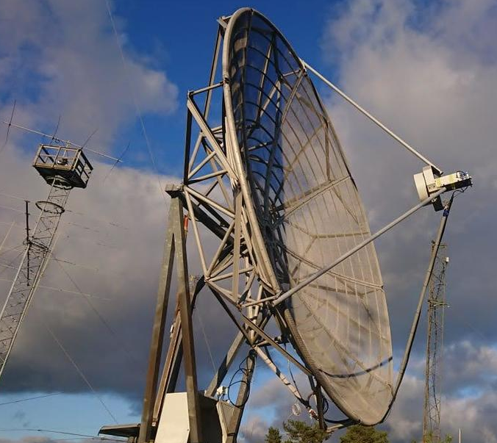
SK0CT 6 m dish used in 23 cm SSB Funtest

SM3BYA: Gudmund <SM3BYA(x)wannberg.net> writes on the loss of 9 cm in Sweden and the DUBUS 9 cm EME Contest -- Looks like a very good turnout with several new calls that were not yet QRV when we lost the band in 2020 (SP9VFD and DL6SH). I still remember so vividly how clear the EME signals sounded there and how easy and enjoyable it was to work stations - provided you were actually aiming at the Moon; I had an AZ backlash problem all the time. How I envy you guys who can still be QRV on 9 cm - keep up the good work! [Is there any possibility of applying for a permit for just a weekend on EME – aiming above the horizon]?
SP9VFD: Raf SP9VFD sp9vfd(x)protonmail.com sends news on his participation in the DUBUS 70 cm and 9 cm CW EME Contest – I was active on 432 on 18 Feb and had 16 QSOs purely random CW QSOs with OK1DFC, UA3PTW, DF3RU, PA3DZL, DL6SH, I2FHW, G4RGK, DK4RC, OE5JFL, G3LTF, UA5Y, OH2DG, VE6BGT, WA6PY, KL6M and K2UYH for a score of 16x16. I also heard PA2V but didn't have a chance to call him. This year I was surprised to hear my own echoes quite well most of time. This has not been the case in the recent past. On 432, I can smoothly rotate polarization (have homebrew (HB) "pancake" loop feed based on OK1DFC description and a superjack electric screw drive). But pol rotation wasn't necessary. Signals were coming from the Moon H pol almost all the time. I never thought that my first operation on 9 cm would be so much fun. This band is just awesome, thanks to all the FB random CW QSOs. I was active on Sunday 17 March after 1220. This band is amazingly clear here without significant interference. I made 22 random CW QSOs with DF3RU, G3LTF, KL6M, SP6JLW, OH1LRY, PA3DZL, DB6NT, ES5PC, OK1DFC, G4CCH, OH2DG, DL3WDG, OK1KKD, G4RFR, PA0BAT, SP3XBO, DL6SH, VE6BGT, VE6TA, WA9FWD, WA6PY and K2UYH for a score of 22x19. Also heard with a big signal OE9ERC. My sunnoise measured was 15.5 dB. It seems that my 9 cm system needs some optimization to get more sunnoise and better RX performance. VK3UM’s EMEcalc predicts a significantly higher level. I'm going to be active 13 cm EME in the next leg of the DUBUS Contest on 14 April.

SM6JLW: Andrzej (SP6JLW) sp6jlw(x)wp.pl reports on his group’s (+ SP6OPN and SP6OQG) results in the 1296 SSB Funtest and 9 cm DUBUS Contet – We were not active in the 70 cm part of the DUBUS Contest because our array was in need of repair. UV radiation has destroyed approx 500 insulators. We decided to wait for warmer WX. On 11 Feb we QSO’d all on SSB to SSB OK2DL (58/57) JN, SP3XBO (55/55) JO, DL4DTU (55/55) JO, PI9CAM (59/59) JO, OK2PE (54/56) JN, OE9ERC (57/57) JN, OK2ULQ (54/58) JN, IZ1BPN (55/55) JN, PA3DZL (57/57) JO, DF3RU (58/58) JN, F5JWF (55/59) JN, IQ2DB (55/55) JN, SK0CT (55/55) JO, G0LBK (54/54) JO and LX1DB (59/59) JN for a total of (15x2)x2x100 = 6000 points. Equipment used was their 6.5 m dish with 1 kW SSPA using 6xBLV958s and DG0VE LNA. During the 9 cm event, the WX was good, and all worked smoothly. We QSO’d OH1LRY, OK1DFC, DF3RU, DB6NT, ES5PC, G4CCH, PA3DZL, KL6M, G3LTF, SP3XBO, SP9VFD, DL3WDG, DL6SH, OH2DG, G4RFR, OK1KKD, OE9ERC, K2UYH, WA6PY, VE6BGT and VE6TA for a total of 21X18. This year all contest activity will be under the SP6JLW call.

W2ZQ: Al (K2UYH) alkatz(x)tcnj.edu reports on the Delaware Valley Radio Assn’s (DVRA) 2023 ARRL EME Contest effort – It was a joint effort of the club station (W2ZQ) that now includes a 16’ solid dish on a high accuracy mount that provided all the 1296 QSOs (lead operators were K1JT, W2HRO and W2LPL among other club members learning the art of EME; K2UYH provided all 432 and microwave band QSOs from his home station using his 28’ dish on all bands; K2TXB provided all the 144 QSOs using two long yagis; and W2HRO provided 902 EME QSOs from his home station using a 2.6 m folding dish. The club was pleased to end up with the third highest multi-operator, muti-mode and all band score.

WA6PY: Paul pchominski(x)maxlinear.com was QRV in the DUBUS 70 cm CW EME Contest with his single yagi, and the 9 cm Contest – On 432, I QSO’d G3LTF, I2FHW, SP9VFD, UA3PTW and KL6M for a total of only 5x5. I started on Sunday 18 Feb at 0000. It was almost the end of the EU window. I called CQ for 20 mins and gave up. Next, I started at 2200. A new pine tree on a neighbor’s lot has become high enough to limit my window to EL > 17 degs. During all QSOs, I used Vert pol for TX and I heard all station on Horiz pol. My own echoes were at a 90 deg reversed pol. The low dec severely limited my contest time - very unfortunate for myself and stations wishing a QSO with me. On 3400, I QSO’d on 16 March SP9VFD, G4CCH, DF3RU and OE9ERC; and during the DUBUS Contest on 17 March KL6M, VK3NX, SP6JLW, WA9FWD, OE9ERC, DL6SH, G4CCH, DF3RU, OH2DG, DB6NT, G3LTF, PA3DZL, ES5PC, SP9VFD, VE6BGT, OK1DFC and VE6TA for a score of 17x16. At the beginning of my window, I had partial dish blockage causing higher noise and weaker echoes. Few stations called me at the start and it was difficult to catch callsigns. On the western horizon, I was looking for DU3T and VK4AFL, but had no luck. I will be on 13 cm in April for both the SSB and DUBUS Completions.

XE1XA: Max general.manager(x)corix.us sends info on his activity in the 1296 SSB Funtest -- I participated for only two hours in the SSB Funtest on 11 Feb, and always with the same enthusiasm for being able to communicate on 23 cm EME with voice! There weren’t many Big Guns active in the time period I was active, but their signals were mostly speaker copy. Worked all SSB to SSB were PI9CAM (57/55) JO, DF3RU (56/56) JN, OK2DL (57/57) JN, SK0CT (55/54) JO, OE5ERC (54/54) JN for an initial, 1655 LX1DB (57/56) JN, IQ2DB (53/53) JN, OE9ERC (DUP) (57/55) JN, 1804 K2UYH (54/55) FN for a score of (9x2)3x100 = 5400 points. The radio spectrum around 1296 in Mexico City is making good reception more difficult with many more birdies present.

K2UYH: I (Al) alkatz(x)tcnj.edu had a disappointing Feb to April on EME due to too many conflicting activities and equipment problems/inadequate preparations. The 1296 SSB Funtest was at the top of my list, but when I tried to operate, I discovered I had a crazy power supply problem. It took a while to find, as it failed only under load. By that time, I had it fixed, I’d missed most of my EU window. I QSO’d on 11 Feb all 2xSSB PI9CIM (55/55) J0, SK0CT (53/55) JN, 1632 OE9ERC (55/57) JN, 1647 OK2DL (58/58) JN and 1802 XE1XA (55/55) EK for only a score of (5x2)3x100 = 3000 points. On 14 Feb, I finally worked on 3400 at 1848 G4RFR (10DB/17DB) using Q65C for mixed initial #57. We tried on CW (559/-) but I lost them as they had run out of window. I planned to be QRV for the DUBUS 432 Contest on 18 Feb but was not feeling well and never made it on. I was especially disappointed to miss the N1V/W2HRO dxpedition but there was no time with TCF’24 on 16 March. I was QRV for the 9 cm DUBUS EME Contest and QSO’d on 17 March using CW DL6SH (559/579), SP6JLW (569/569), G4CCH (579/579), PA3DZL (569/569), DF3RU (559/569), OH2DG (559/579), KL6M (569/549), G3LTF (569/569), DB6NT (559/559), ES5PC (559/559), VE6BGT (579/569), SP9VFD (569/569), VE6TA (559/559) for a total of 13x12. I had a strange problem -- at one point, I had a high noise level show up that caused me to lose my Moon tracking. I started tracking it rather than the Moon. By the time I was aligned again, I lost about an hour of prime moontime. I was also QRV for a short time during the ARI Contest on 432 and plan to be QRV on 13 cm for DUBUS Contest and SSB Funtest. Please look for me on 2304.

NET NEWS: VK0DS (VK2JDS) is QRV from Antarctica (MC81xk) on 1296 EME for a year. Dave has a 2.4 m dish with a linear loop feed and 70 W. He packed also a septum feed, but is facing a challenge how to install it in the rough local environment. OH2DG is downsizing a bit. After 40 years, he has taken down his big dish and passing it on, but he is not going QRT. Eino will remain QRV off the Moon on 13 cm up with a 3 m dish. PA3DZL is getting serious in completing WAS on 70 cm. Jac needs KY, MS, NE, ND, NV, RI, TN and HI. VA3ECO is working on a 1296 EME station (11’ dish and 150 W SSPA). He has already completed one QSO on 432 with DL7APV with a single yagi. He expects to be QRV on 23 cm very soon. You can reach Chris for info/skeds at bigelowisland(x)gmail.com. DL1SUZ is now QRV on 6 cm for the 1st time using a 3.2 m dish with Septum feed, 35 W SSPA at feed and 1 dB NF LNA. He has already QSO’d DL6SH, IK0HWJ, OE9ERC, IK3COJ, DF3RU and HB9Q. Please contact Uwe at dl1suz(x)t-online.de for skeds. F5HRY is taking down his 2.4 m dish after 25 years of EME operation and #106 initials. Herve is disappointed by the growth of digital operation on 23 cm. [Although digital operation is up on 1296, there is still plenty of CW activity. See the turnout for the DUBUS 23 CW Contest in May].
TECHNICAL: Thoughts on using Q65-15A vs. -30B for EME on 1296 by K1JT -- I discussed these issues at some length with KA1GT a few years ago. Here are the relevant details. We could make a version of Q65-15A that can decode after normal EME delays. However, It would not be a very good fit for the channel. This is because the duration of a Q65 transmission is 12.8 s, and the transmission starts at t = 0.5 s into the 15-second sequence. Add a 2.7 s EME delay and you're already 1 second into the next sequence – even without any clock errors. You could make the TX duration smaller, say 10 s. Then, if the transmission starts at t=0.5 s and there's a 2.7 s EME delay, reception would be complete at t=10.5 + 2.7 = 13.2 s, and (if clocks were spot on) the decoder would have 1.8 s to do its thing. Even this is not really enough, because clocks are not always "spot on". Moreover, you would lose an additional 10*log(12.8/10.0) = 1 dB of sensitivity. WSJT moders do a lot to gain every 0.1 dB of sensitivity, so we certainly don't want to do that! Fifteen-second sequences are not an efficient choice for a path with delays as large as 2.7 s. If there were many times more EME activity than at present, so that very fast QSOs were desirable in contests, and if nearly everybody had many dB's to spare on the EME path, something like Q65-15A might be desirable. As things stand, our advice is to use Q65-30B for EME on 1296.
For Sale: DL1SUZ has for sale a 13 cm 300 W SSPA (28V). It's based on Ericsson PA using 3x MRF21120s including a 60 W driver. He is asking 250EU + shipping. If interested contact Uwe at DL1SUZ(x)darc.de. PA3DZL has for sale 6 cm 40 W (60 mW in) SSPAs. If interested email Jac pa3dzl(x)icloud.com. DU3T has this year produced CLNAs for 6 cm, XLNAs for 3 cm and working on additional 24 GHz LNAs. If you are interested in any of these send Jan (PA0PLY) a message at info(x)pa0ply.nl. SM4IVE has for sale some heavy-duty coaxial relays 4 Kw+ power handling, 90 dB isolation, 7/8 con with 28 V coil for 400 EU each + shipping; a 23 cm Aluminum N2UO 1296 feed with DDK LNA and isolation relay; a 23 cm 500 W SSPA based on 2xBLF6G13l-250P for 800 EU; and heavy duty 19" rack with 432 TH347 cavity and 1296 cavity with TH293; some TH293 (5 V heater) and 1 TH313. The 19" racks has all the voltages, you need only 3-5 kV dc (very heavy) for 1500 EU.
FINAL: EME2024 Trenton is now less than 4 months away! See WWW.EME2024TRENTON.ORG. All is going well. Registrations are now over 100, but only about 60% have paid. We plan to have the preliminary program schedule available in about a week. Talks will start at 9 am each day and be organized into 60 minute blocks alternating between Power point and interactive sessions with time for socialization. We now have more than 25 speakers signed up. If you have not yet sent in your speaker info, please do so ASAP. One conference goal is to give everyone an opportunity to present. The hotel is filling up rapidly. We have a backup hotel that is not far away. But if you want to be at the main hotel get your hotel reservations in soon. Make EME2024 a family holiday. Trenton-Mercer Airport is very near to the hotel and offers super “cheap” flights all over the USA – see Frontier Airline. There 3 local tours are on: Thursday to Thomas Edison National Historic Park (for all), Friday to the Grounds for Sculpture (spouses), and Saturday a Super Outlet Shopping Extravaganza (spouses). The one-day (Friday) EME101 Intro to EME (how to get started on EME) course for “Not Yet EMEers” is starting to fill. It is only $50. Regular conference attendees can sit in on the course, but it is intended to get new people into EME. Info is also available on social media. The conference program will be a combination of talks (PPT) and interactive (poster) social sessions about 50% of the time. K1JT has agreed to give the banquet keynote on gravity waves. The link is up for purchasing EME2024 Apparel that will be delivered when you arrive at the conference. We also are planning to have decretive conference mugs available. ICOM will be exhibiting its latest equipment at the conference. Our next planning meeting will be on 9 May at 1600. Email K2UYH for the Zoom link. You are welcome to join in or just listen in, we need more volunteers.

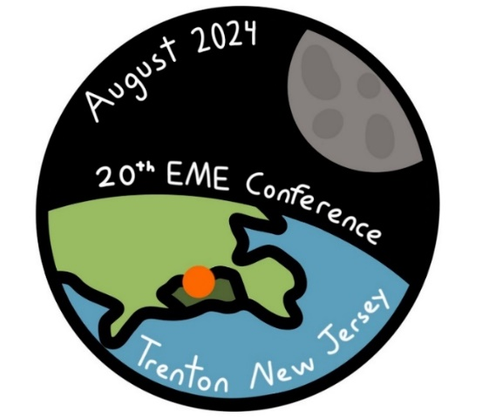
9, 10 & 11 Aug 2024 at TCNJ

► DK7LJ reports that 3 cm Beacon is back in operation. Per has installed a completely new design AZ drive and the beacon has since been performing well.
►The Central States VHF Society’s 2024 Conference will be held in Cedar Rapids, IA on 25-28 July. K0DAS is looking for presentations/papers. If interested, please contact Rod at rod.blocksome(x)gmail.com. This is its 56th year!
► W1PV has our TNX for his quick and thorough write up of the results of 2023 ARRL EME Contest. See Skip’s complete report at https://contests.arrl.org/ContestResults/ 2023/EME-2023-FinalQSTResults.pdfr.
► This has been another difficult month. We had planned to get this NL out before the start of April. We are holding the reports from the ARI EME Contest for the next NL, which we hope to have out in May. As this is being written (13 April), the 13 cm SSB Funtest has begun. We hope to have this posted before the Start of the EU window. The following day (14 April) is the 13 cm leg of the DUBUS CW EME Contest. Based on recent interest in 2300, we are expecting a good turnout! Coming up on 11 and 12 May is the BIG ONE – The VK3UM Memorial Contest and 1296 DUBUS CW weekend. We are planning to be active in it; as well as the 13 cm activity later this weekend. We hope you all have a great time on the Moon. 73, Al – K2UYH and Matej – OK1TEH

